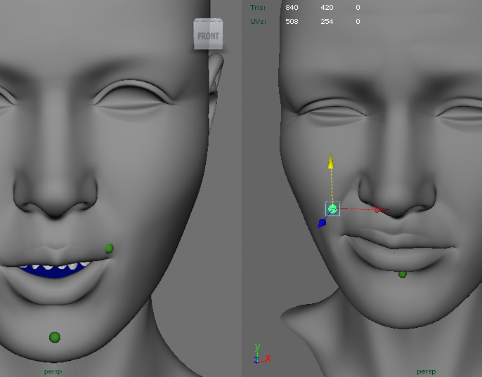

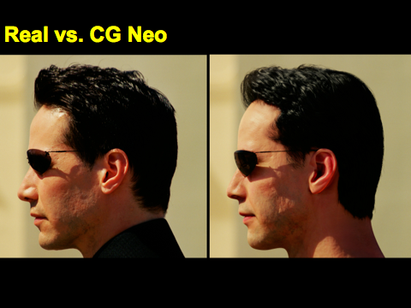
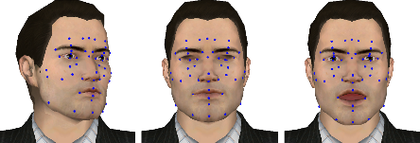
An industry aligned programme
In 2012 Victoria launched a new programme in Computer Graphics. The new programme was developed in collaboration with movie effects facility Weta Digital, games company Sidhe, and advanced technology company Unlimited Realities. The Computer Graphics programme is unique in New Zealand in combining courses from both design and computer science. This combination of technical and design skills give students mastery of existing animation and game techniques as well as the ability to create new types of software -- a combination sought by industry. The programme includes an undergraduate component as well as two new Masters degrees for advanced students. Courses have included lectures from staff at GameLoft and Weta Digital, and students at upper levels will be considered for internships at these companies.

Combination of Computer Science and Design courses
Learn OpenGL, the graphics engine for IOS and Android
Victoria teachers have industry experience in interactive and immersive graphics for consumer electronics, large-scale art installations, and movie visual effects on projects such as Avatar and the Matrix sequels.
Career paths include computer games, movie visual effects, advanced mobile and web graphics, medical imaging and scientific visualisation

COMPUTER GRAPHICS AT VICTORIA

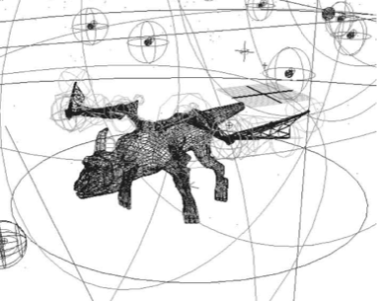
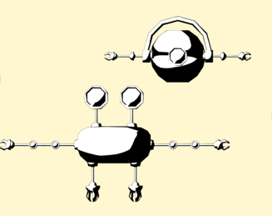
Richard Roberts
Beginning his undergrad studies with a focus on interaction for gaming, Richard used programming languages like Python and C++ to develop his projects. These skills quickly lead to an internship at Weta Digital. There he developed the first prototype of a system that helped in the production of the movies Rise of the Planet of the Apes and Tintin.
Richard is now applying knowledge gained in his internship to his graduate research in computer science. His research will explore how to design the facial features of robot characters so as to accurately convey emotion.
"My experience with my fellow students and the staff at Victoria University provided the direction I needed to give substance to my projects, as well as the motivation required. During my studies I have created a strong passion for the digital realm, one which I hope to now share with those following a similar path as a tutor and post-graduate.”

Robert McLeod
While studying Design at Victoria, Robert took several game and animation courses from the new Computer Graphics programme. In the Postproduction and Special Effects course he mastered the use of Python to generate novel behaviours in the Maya animation program, a skill that is highly sought by industry employers. Robert is now working as an Assistant Technical Director at Weta Digital on projects such as the Hobbit.
“Growing up, I had always had a passion for visual effects films and games. It wasn't until trying a computer graphics paper when I was reminded of my passions and validated those passions as a career path. Studying at Victoria has acquainted me to a variety of artistic and technical knowledge, which I happily apply and expand on in my current role at Weta Digital.”

Mel Ruarus
et quinta decima Eodem modo, modo typi qui nunc nobis videntur parum clari fiant sollemnes in futurum. Humanitatis per seacula quarta decima et quinta decima Eodem modo typi. Decima et quinta decima Eodem modo typi qui nunc nobis videntur parum? Est notare quam littera gothica quam. Anteposuerit litterarum formas humanitatis per. Videntur parum clari fiant sollemnes in futurum? Humanitatis per seacula quarta decima et quinta decima Eodem modo typi qui. Etiam processus dynamicus. Mirum est notare quam littera gothica quam nunc putamus? Qui sequitur mutationem.
Melby Ruarus
Melby is a 4th year student in Software Engineering. While taking two courses from the new Computer Graphics program, he wrote an OpenGL-based graphics program with several advanced features. He is now doing an internship at Weta Digital involving a rendering topic.

“I've found my knowledge of OpenGL very useful at work for creating slick user interfaces and animations. I also build iOS apps, and the most recent of these was a 3D animation in the Powershop iPhone app that was released a few weeks ago.”

COMPUTER GRAPHICS AT VICTORIA

