HI,

Thanks for taking the time to have a look at the functionality, mark-up and styling I put together from the image you provided.

From the offset I decided to use bootstrap as the framework for this project. This is mainly because Bootstrap provides most of the grid layouts and responsive functionality, leaving more time to focus on the JavaScript.

The JavaScript framework I used for the graph was gustguage.com, a freely online plugin with various charts and graphs. <http://justgage.com/>

The remaining bar chart was constructed by html, css and jquery, By using the height properties of the divs I was able to create the functionality needed.

I used jQuery to help with some functionality and to make any get/ajax calls. On this occasion, I just used CSS but in the past I have used sass or scss. Some of the functionality Included is the ability to sort, filter, refresh and show more. Some of these functions use are ‘if statements’, ‘string manipulation’, ‘data traversing’ and looping.

HTML, CSS

HTML, CSS

Just gauge

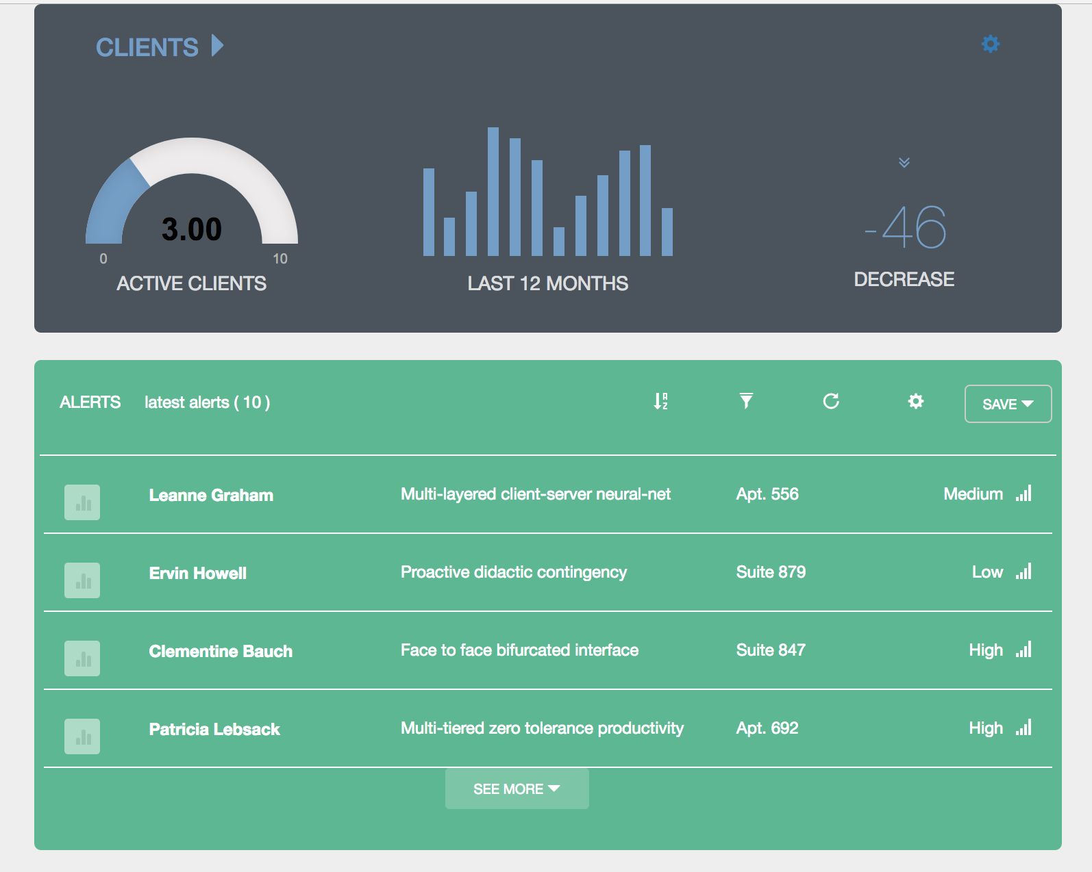

Looping rows

Show more

Refresh

Filter

Sort