Database Manipulation
FORMATIVE ASSESSMENT 2

Vuyisile Nqono
20240466

Table of Contents
Introduction and Project Overview: 1
Business rules implemented: 1
Section A: Database Design and Implementation 2
Entity Relationship Diagram 2
Relational schema 3
Referential integrity and invalid loans 3
SQL creation script and sample data 4
Section B: C# Windows Forms User Interface 5
Main menu or dashboard 5
Member Management form 5
Book Title and Book Copy Management form 6
Loan and Return Management form 7
Section C: Database Connection and CRUD Functionality 8
Database connection 8
Create and Read operations 8
Update and Delete operations 8
Loan transaction logic 8
Secure SQL execution 9
Section D: Search, Reporting, Validation and Error Handling 10
Search and filtering 10
Reports and useful queries 10
Input validation 10
Exception handling and user feedback 10
Section E: Testing, Documentation and Presentation 11
Testing evidence 11
Design decisions 12
Application quality and demonstration readiness 12
Conclusion 12
Submission checklist 13

Introduction and Project Overview:
Khayelitsha Community Library currently records members, books and loans manually. The library needs a desktop application that allows staff to register members, capture book titles and physical copies, issue and return books, search records and view basic operational reports. This project implements that solution as a C# Windows Forms application connected to a Microsoft SQL Server database named KhayelitshaLibraryDB.
The system was developed in Visual Studio using .NET Framework 4.8. Database access is handled with ADO.NET and System.Data.SqlClient. The connection string is stored in App.config so the application can be pointed at LocalDB or SQL Server Express without changing the source code. The complete SQL creation script is included in the project under Database/KhayelitshaLibraryDB.sql.

Business rules implemented:
The design follows the business rules from the assessment brief:
- Each member has a unique MemberID, full name, address, phone number and join date.
- A book title may have several physical copies.
- Each physical copy has a unique CopyID and a status such as Available, On Loan, Lost or Damaged.
- A member may borrow several copies over time.
- A physical copy may appear in many historical loan records, but may have only one active loan at a time.
- Each loan records the member, book copy, staff member, loan date, due date and return date.
- A staff member may process many loans.

Section A: Database Design and Implementation

Entity Relationship Diagram
The Entity Relationship Diagram shows the five entities required by the brief: Member, BookTitle, BookCopy, Staff and Loan. Primary keys and foreign keys are labelled clearly. Crow's foot notation is used to show cardinality and optionality. There is no many to many relationship left unresolved. Loan acts as the associative table that links members, copies and staff.
BookTitle has a one to many relationship with BookCopy. Member, Staff and BookCopy each have a one to many relationship with Loan. On the parent side the relationship is mandatory one. On the child side it is zero or many, because a member or staff member can exist before any loans are created, and a title can exist before copies are registered.
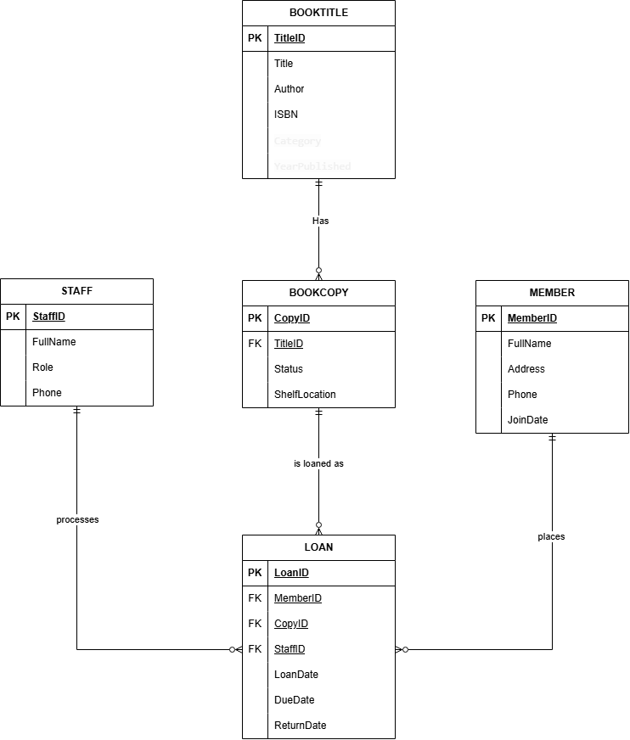
Figure 1: Entity Relationship Diagram for KhayelitshaLibraryDB

Relational schema
The relational schema below matches the tables created in KhayelitshaLibraryDB.sql. Primary keys are underlined and foreign keys are marked as FK.
Member
Member(MemberID, FullName, Address, Phone, JoinDate)
BookTitle
BookTitle(TitleID, Title, Author, ISBN, Category, YearPublished)
BookCopy
BookCopy(CopyID, TitleID FK, Status, ShelfLocation)
Staff
Staff(StaffID, FullName, Role, Phone)
Loan
Loan(LoanID, MemberID FK, CopyID FK, StaffID FK, LoanDate, DueDate, ReturnDate)
Table | Primary key | Foreign keys | Important constraints
Member | MemberID INT IDENTITY | None | FullName, Address, Phone and JoinDate are NOT NULL
BookTitle | TitleID INT IDENTITY | None | ISBN may be NULL; YearPublished CHECK between 1900 and 2100
BookCopy | CopyID INT IDENTITY | TitleID -> BookTitle(TitleID) | Status CHECK: Available, On Loan, Lost, Damaged
Staff | StaffID INT IDENTITY | None | FullName, Role and Phone are NOT NULL
Loan | LoanID INT IDENTITY | MemberID, CopyID, StaffID | ReturnDate may be NULL for active loans; DueDate >= LoanDate

Table 1: Relational schema summary for KhayelitshaLibraryDB

Referential integrity and invalid loans
Referential integrity is enforced with foreign key constraints on Loan.MemberID, Loan.CopyID, Loan.StaffID and BookCopy.TitleID. This means a loan cannot be created for a member, copy or staff member that does not exist in the related parent table. SQL Server rejects the insert if the foreign key values are invalid.
The same idea protects deletes. If a member still has loan history, the foreign key prevents that member from being deleted while related Loan rows remain. In the application this is also checked before delete, and a clear message is shown to the user. Together, the database rules and the application checks stop incomplete or orphaned loan records from being saved.

SQL creation script and sample data
The complete SQL creation and sample data script is submitted with the project at KhayelitshaLibraryApp/KhayelitshaLibraryApp/Database/KhayelitshaLibraryDB.sql. The script creates KhayelitshaLibraryDB, builds all five tables with primary keys, foreign keys, NOT NULL rules and CHECK constraints, then inserts sample records.
Sample data includes five members, five book titles, eight book copies, three staff members and five loan records. Three of the loans are active (ReturnDate is NULL) and two are returned. This gives enough data to demonstrate issue, return, search and reporting.
Excerpt from the Loan table definition:
CREATE TABLE Loan
(
LoanID INT IDENTITY(1,1) NOT NULL PRIMARY KEY,
MemberID INT NOT NULL,
CopyID INT NOT NULL,
StaffID INT NOT NULL,
LoanDate DATE NOT NULL,
DueDate DATE NOT NULL,
ReturnDate DATE NULL,
CONSTRAINT FK_Loan_Member FOREIGN KEY (MemberID) REFERENCES Member(MemberID),
CONSTRAINT FK_Loan_BookCopy FOREIGN KEY (CopyID) REFERENCES BookCopy(CopyID),
CONSTRAINT FK_Loan_Staff FOREIGN KEY (StaffID) REFERENCES Staff(StaffID),
CONSTRAINT CK_Loan_DueDate CHECK (DueDate >= LoanDate)
);

Section B: C# Windows Forms User Interface
The interface is organised around a main menu with separate forms for members, books, loans and reports. Each form uses labelled controls, action buttons and DataGridView grids so staff can see and update records easily.

Main menu or dashboard
MainForm is the entry point of the application. It shows the project name "Khayelitsha Community Library System" and the assessment subtitle. Navigation buttons open Member Management, Book Management, Loans and Returns, and Search and Reports. A MenuStrip provides the same routes under Navigate, and File > Exit closes the application. When the form loads, DatabaseHelper.TestConnection() checks that the SQL Server connection works.
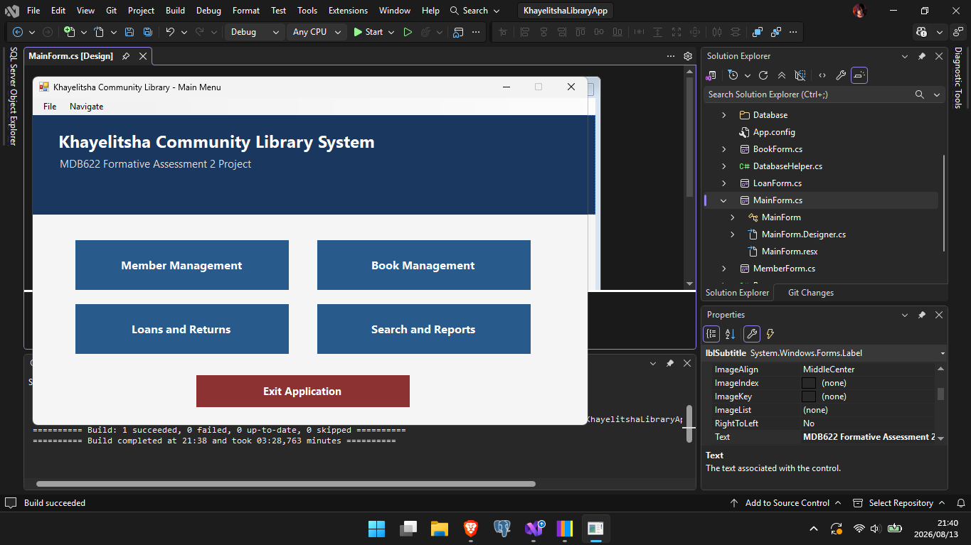
Figure 2: Main menu dashboard with navigation buttons and MenuStrip

Member Management form
MemberForm captures MemberID, Full Name, Address, Phone and Join Date. The MemberID field is filled when a grid row is selected. Buttons include Add, Update, Delete, Clear, Search and Refresh. Member records are displayed in a DataGridView. Search works by name or MemberID.
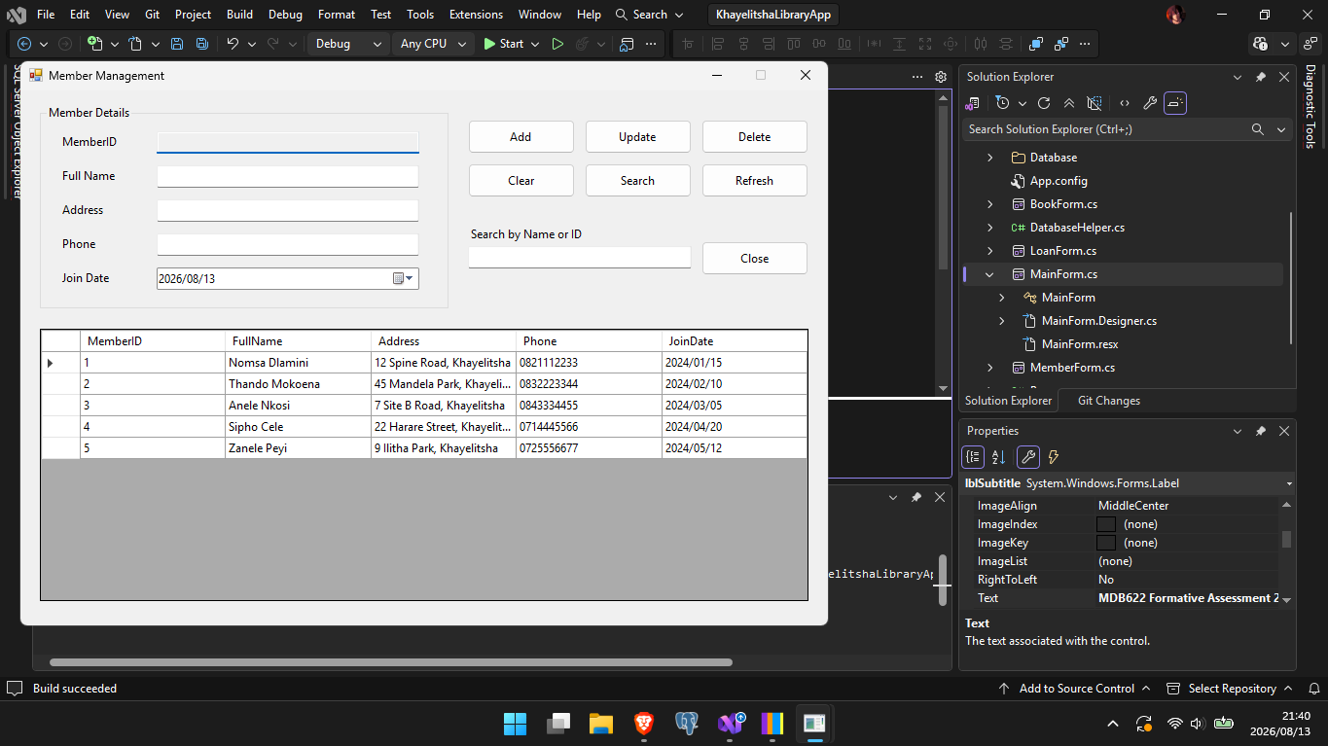
Figure 3: Member Management form showing sample members

Book Title and Book Copy Management form
BookForm is split into title details and physical copy details. Title fields include Title, Author, ISBN, Category and Year Published using a NumericUpDown control. Copy fields include a ComboBox for the linked title, a Status ComboBox and Shelf Location. Two DataGridView controls list titles and copies. Titles can be searched by title or author.
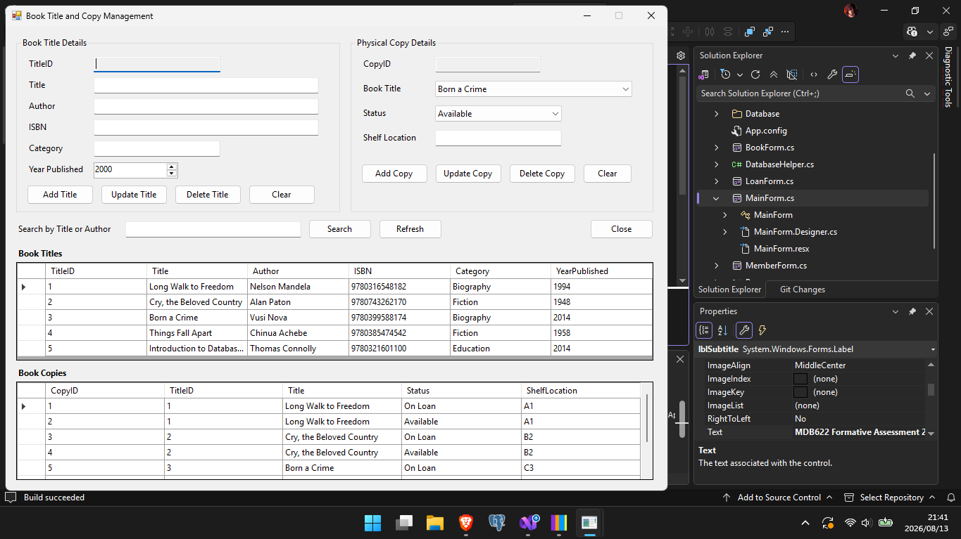
Figure 4: Book Title and Copy Management form

Loan and Return Management form
LoanForm lets the user select a member, an available book copy and a staff member from ComboBox controls. Loan Date and Due Date are captured with date pickers. Issue Book creates a new loan and marks the copy as On Loan. Return Book sets ReturnDate and marks the copy Available again. A filter ComboBox can show All, Active, Returned or Overdue loans, and the DataGridView shows current and historical loans with status.
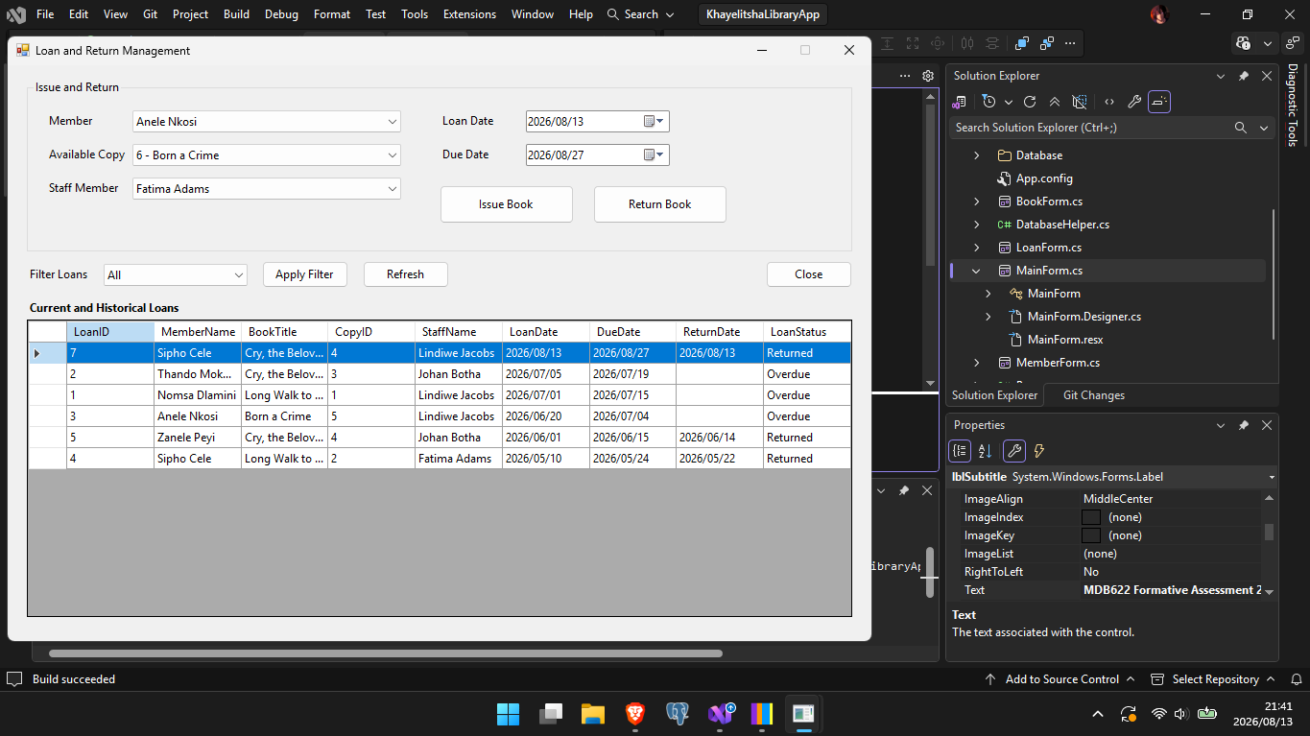
Figure 5: Loan and Return Management form

Section C: Database Connection and CRUD Functionality

Database connection
The connection string is stored in App.config under the name LibraryDb. By default it points to (LocalDB)\MSSQLLocalDB and the KhayelitshaLibraryDB database using Integrated Security. DatabaseHelper reads this value through ConfigurationManager and opens SqlConnection objects for queries. If the connection fails, TestConnection shows a clear error message instead of crashing the application.
<add name="LibraryDb"
connectionString="Data Source=(LocalDB)\MSSQLLocalDB;Initial Catalog=KhayelitshaLibraryDB;Integrated Security=True;Connect Timeout=30"
providerName="System.Data.SqlClient" />

Create and Read operations
Create operations insert new member, book title, book copy and loan records from the forms. Read operations load tables into DataGridView controls using DatabaseHelper.ExecuteSelect. After a successful insert, update or delete, the related grids are refreshed so the user immediately sees the latest data.
For example, adding a member inserts FullName, Address, Phone and JoinDate with parameterized values, then reloads the member list. Book titles and copies follow the same pattern on BookForm. Issuing a loan inserts into Loan and updates BookCopy.Status in one transaction.

Update and Delete operations
Selected member and book records can be updated after they are chosen from the grid. Delete asks for confirmation with a Yes/No message box before any row is removed. The application also checks for related loan or copy records. If related rows exist, deletion is blocked and the user is told why. Foreign keys in the database provide a second layer of protection if a delete still reaches SQL Server.

Loan transaction logic
Only copies with Status = Available appear in the issue ComboBox. When Issue Book runs, the code checks again inside a SQL transaction that the copy is still Available and that it does not already have an active loan (ReturnDate IS NULL). If either check fails, the transaction is rolled back and a warning is shown. On success the loan is inserted and the copy status changes to On Loan.
Return Book works the other way. The selected loan must still be active. ReturnDate is set to today's date and the copy status returns to Available. Both steps run in one transaction so the loan history and copy status stay consistent.
Selected issue logic from LoanForm.cs:
// Only Available copies may be issued
if (status != "Available") { /* warn and rollback */ }
// Prevent two active loans for the same copy
SELECT COUNT(*) FROM Loan WHERE CopyID = @CopyID AND ReturnDate IS NULL
INSERT INTO Loan (...)
UPDATE BookCopy SET Status = N'On Loan' WHERE CopyID = @CopyID

Secure SQL execution
User supplied values are passed with SqlParameter objects. SQL text is not built by joining TextBox values into the command string. DatabaseHelper methods accept parameters and add them to SqlCommand. Connections, commands and adapters are created inside using blocks so they are closed and disposed reliably even when an error occurs.
string sql = @"INSERT INTO Member (FullName, Address, Phone, JoinDate)
VALUES (@FullName, @Address, @Phone, @JoinDate)";
DatabaseHelper.ExecuteNonQuery(sql,
new SqlParameter("@FullName", txtFullName.Text.Trim()),
new SqlParameter("@Address", txtAddress.Text.Trim()),
new SqlParameter("@Phone", txtPhone.Text.Trim()),
new SqlParameter("@JoinDate", dtpJoinDate.Value.Date));

Section D: Search, Reporting, Validation and Error Handling

Search and filtering
Members can be searched by name or MemberID on MemberForm and again on ReportsForm. Books can be searched by title or author. Loans can be filtered to All, Active, Returned or Overdue on LoanForm. Active means ReturnDate is NULL and DueDate is still in the future or today. Overdue means ReturnDate is NULL and DueDate is earlier than today.

Reports and useful queries
ReportsForm shows an overdue loans report with member name, book title, due date, copy ID and days overdue. It also shows loans per member using COUNT and GROUP BY. The overdue query uses JOIN, WHERE and ORDER BY. The loans per member query uses LEFT JOIN so members with zero loans still appear.
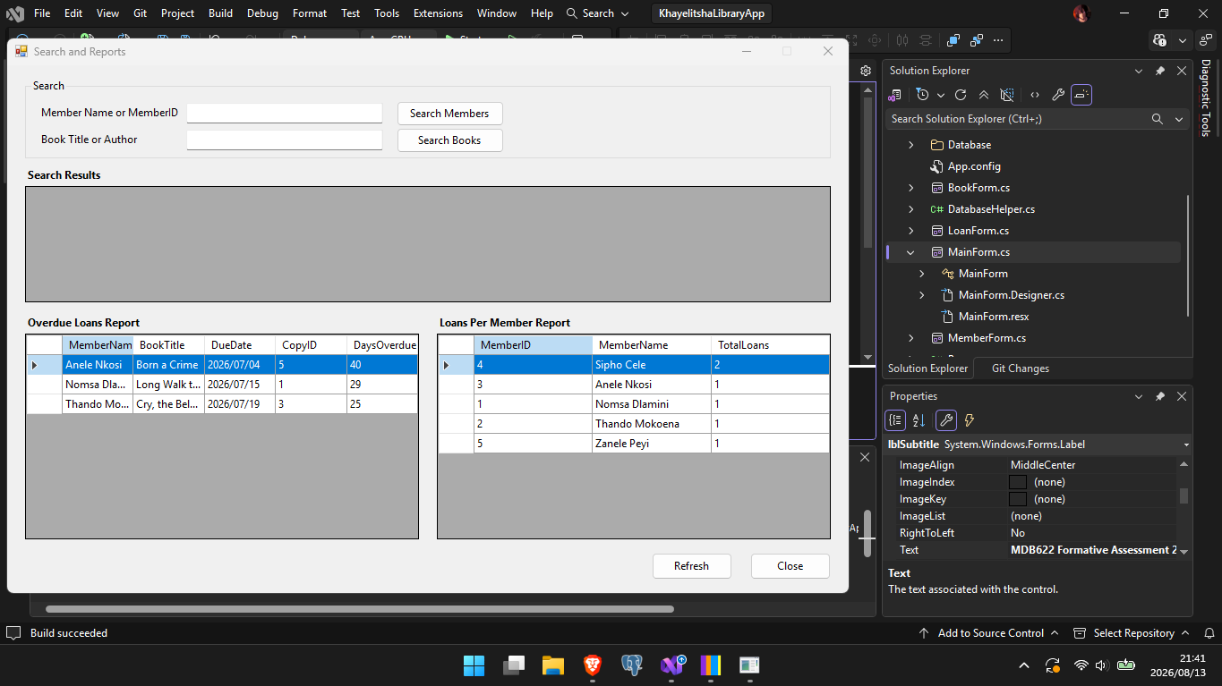
Figure 6: Search and Reports form with overdue and loans per member reports

Input validation
Required fields are checked before insert or update. Member phone numbers must be 10 digits. Join Date cannot be in the future. Book titles need Title, Author and Category. Copies need a selected title, status and shelf location. On the loan form, Due Date cannot be earlier than Loan Date. These checks stop incomplete or invalid data before it reaches the database.

Exception handling and user feedback
Database operations are wrapped in try catch blocks. Success messages confirm completed actions. Warnings are used for validation problems and blocked deletes. Errors show the exception message in a friendly dialog. Because exceptions are caught at the form level, the application continues running instead of terminating unexpectedly.

Section E: Testing, Documentation and Presentation

Testing evidence
The test table below covers normal use, invalid input and boundary cases. Actual results are based on running the completed application against KhayelitshaLibraryDB with the sample data.
ID | Test case | Input / action | Expected result | Actual result | Status
T01 | Add valid member | Full name, address, 10 digit phone, join date today | Member inserted and grid refreshes | Member added successfully and appears in grid | Pass
T02 | Blank required field | Add member with empty Full Name | Validation warning, no insert | Message: Full Name is required | Pass
T03 | Invalid phone | Phone = 12345 | Validation warning for 10 digits | Message: Phone number must be 10 digits | Pass
T04 | Future join date | Join Date after today | Validation warning | Message: Join Date cannot be in the future | Pass
T05 | Issue available copy | Select member, Available copy, staff, valid dates | Loan created, copy status On Loan | Success message; status updated; loan listed | Pass
T06 | Due date earlier than loan date | Due Date before Loan Date | Validation warning, no issue | Message: Due Date cannot be earlier than Loan Date | Pass
T07 | Prevent second active loan | Try issuing a copy that is already On Loan | Issue blocked | Copy not listed as available; active loan check blocks issue | Pass
T08 | Return active loan | Select active loan and click Return Book | ReturnDate set, copy Available | Success message; status Available; loan shows Returned | Pass
T09 | Delete member with loans | Delete a member who has loan history | Delete blocked with explanation | Message: cannot be deleted because loan records exist | Pass
T10 | Overdue report | Open Search and Reports | Overdue loans listed with days overdue | Overdue grid populated using JOIN and WHERE | Pass
T11 | Search book by author | Search text = Mandela | Matching titles returned | Long Walk to Freedom returned in results | Pass
T12 | Failed database connection | Wrong connection string then start app | Clear connection error message | Database Connection Error dialog shown | Pass

Table 2: Test cases for KhayelitshaLibraryApp (normal, invalid and boundary data)

Design decisions
Design decision 1: separate BookTitle and BookCopy tables
I modelled titles and physical copies as two tables instead of one. This matches the business rule that one title can have many copies, and it keeps bibliographic details in one place. Status and shelf location belong to the copy, not the title. Loan then references CopyID, which makes historical loans clear when several copies of the same book exist.
Design decision 2: DatabaseHelper for shared data access
All forms use a shared DatabaseHelper class for connections, SELECT, non query and scalar commands. This keeps connection handling and parameterized SQL in one place and reduces repeated code on each form. It also made it easier to store the connection string in App.config and to close resources with using blocks across the application.

Application quality and demonstration readiness
The solution compiles and runs in Visual Studio. Forms use a consistent layout, clear labels and readable grids. The main menu, member form, book form, loan form and reports form can be demonstrated end to end, including connection testing, CRUD, loan issue and return, search and reporting. The SQL script, ERD and this report support the practical demonstration.

Conclusion
This project delivers a working library management system for Khayelitsha Community Library. The database design covers the required entities and relationships, and the Windows Forms application provides the required menus, forms and database operations. Parameterized SQL, validation, exception handling and loan transaction rules help keep the data reliable. The ERD, schema, screenshots, code explanations and test evidence in this report meet the documentation requirements of MDB622 Formative Assessment 2.

Submission checklist
Item | Location / notes
Visual Studio solution | KhayelitshaLibraryApp/KhayelitshaLibraryApp.slnx
SQL create and sample script | Database/KhayelitshaLibraryDB.sql
ERD diagram | Docs/ERD/KhayelitshaLibraryDB.png
Application screenshots | Docs/Screenshots/
This project report | Docs/Report/ (this document)
Connection configuration | App.config connection string LibraryDb
GitHub Repository | https://github.com/vuyi-codes/KhayelitshaLibraryDB.git

