DSC HACKATHON 2026
Suspicious Transaction Detection
A Rule-Based and Machine Learning Approach to Mobile Money Fraud
Modelling & Findings Report
Team Shap Shifters | Data Science Club, Sol Plaatje University
Dataset: ~630,000 synthetic mobile money transactions (10% sample of a 6.3M-row PaySim-style simulation)
“In God we trust; all others must bring data.”
— W. Edwards Deming

Table of Contents
1. Executive Summary
2. Problem Statement
3. Dataset Overview
4. Exploratory Data Analysis
5. Data Quality Handling During Modelling
6. Model Development
7. Business Recommendations
8. Limitations and Future Work
9. Blockchain-Based Solution for Mobile Money Platforms
10. Use of AI Tools in This Project
11. Conclusion

1. Executive Summary
South Africa's February 2023 FATF greylisting put every major bank and mobile money operator under pressure to prove it can detect and report suspicious transactions. This report documents our full pipeline for that problem: an exploratory analysis of 636,262 synthetic mobile money transactions, the engineering of explainable fraud-signal features, and the training of two supervised classifiers (Random Forest and XGBoost) that identify fraudulent transactions with near-perfect accuracy on held-out data.
Three findings anchor the whole project. First, fraud is extremely rare (0.13% of transactions) and occurs only within TRANSFER and CASH_OUT transaction types. Second, fraud almost always fully empties the sender's account - a single, explainable, and highly predictive pattern that both our rule-based reasoning and our machine learning models converge on independently. Third, the mobile money operator's existing rule-based monitoring system catches only 2 of 849 fraud cases in this sample (0.24%), which is the clearest possible business case for the data-driven approach documented here.
Both the Random Forest and XGBoost models achieve precision and recall above 0.99 on a held-out test set. We treat this near-perfect score with appropriate caution rather than as an unqualified success (Section 6.7) - it reflects how strongly separable this particular dataset is, and real-world fraud is rarely this clean. Section 7 sets out how a mobile money operator should actually deploy this work, and Section 8 is candid about the limitations that any adopting team needs to understand first.

2. Problem Statement

2.1 The Toolkit's Problem Statement
The DSC Hackathon 2026 toolkit set out the challenge as follows:
“Using transaction-level data, build a system that identifies potentially fraudulent transactions, and explains what makes flagged transactions anomalous. Build a classifier that identifies fraudulent transactions, and present how your findings are essential for a banking institution.”

2.2 Our Scenario
We took the role of the fraud analytics team at a South African mobile money provider. Following the FATF greylisting, our compliance department asked us to: (1) explore a sample of transactions to understand what separates fraud from legitimate activity, (2) build a classifier that flags suspicious transactions with an appropriate precision/recall trade-off, and (3) recommend where the mobile money operator should focus monitoring resources and how to weigh the cost of missed fraud against the cost of false alarms.

3. Dataset Overview
We worked with a stratified 10% sample of a 6.3-million-row PaySim-style simulation of mobile money transactions, calibrated against real African financial services data.
- Size: 636,262 transactions, 11 original fields
- Transaction types: CASH_IN, CASH_OUT, DEBIT, PAYMENT, TRANSFER
- Key fields: step (simulation hour), type, amount, sender/receiver IDs, balances before & after, isFraud (ground truth), isFlaggedFraud (the mobile money operator's existing rule-based flag)
- Fraud cases: 849 confirmed fraud transactions (0.133% of the dataset)
- Data quality: no missing values, no duplicate rows

4. Exploratory Data Analysis
The goal of our EDA was to understand what actually separates fraud from legitimate activity before engineering any model features - every chart below was chosen because it answers a question a mobile money operator's fraud team would genuinely ask.

4.1 Class Imbalance
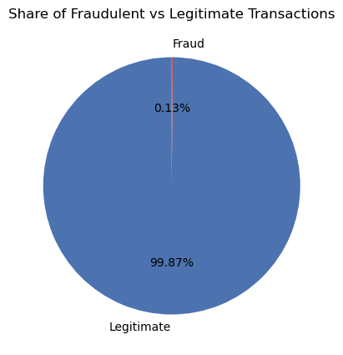
Figure 1. Fraud accounts for just 0.13% of all transactions.
At this imbalance, a model that always predicts “not fraud” would already be 99.87% accurate while catching zero fraud. This is why the rest of this report evaluates performance with precision, recall, F1, and PR-AUC rather than accuracy.

4.2 Where Fraud Happens: Transaction Type
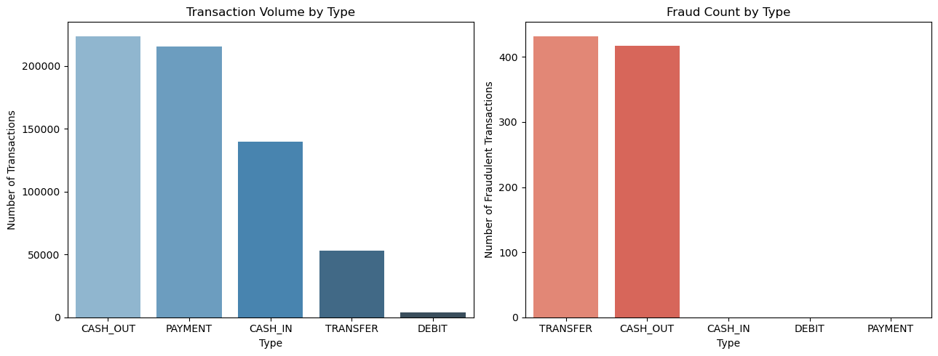
Figure 2. Transaction volume by type (left) vs. fraud count by type (right).
Every one of the 849 fraud cases is a TRANSFER (432) or a CASH_OUT (417). PAYMENT, CASH_IN, and DEBIT carry zero fraud despite representing the majority of transaction volume. Both monitoring and modelling can therefore concentrate on just these two types.

4.3 Fraud Moves Larger Amounts
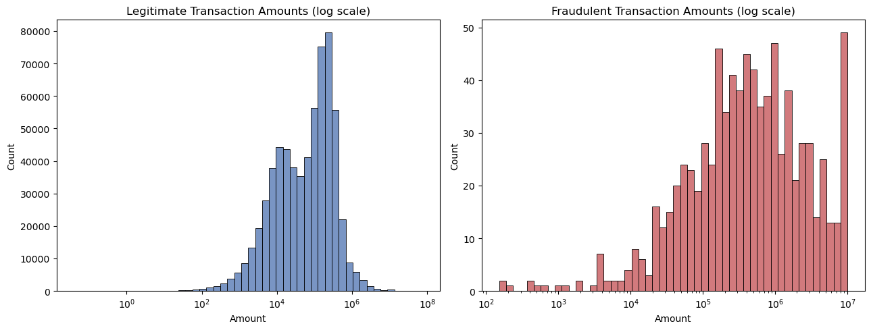
Figure 3. Transaction amount distributions, legitimate (left) vs. fraudulent (right), log scale.
The median legitimate transaction is R74,407; the median fraudulent transaction is R429,257 - roughly 6x larger. Amount alone is informative but not sufficient: it would still miss smaller frauds and flag many legitimate large transfers.

4.4 The Balance-Draining Pattern
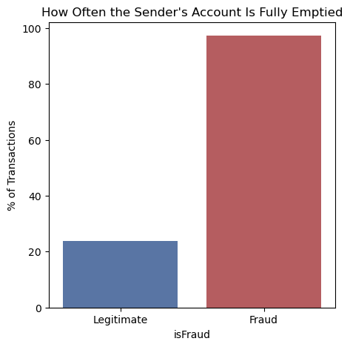
Figure 4. Share of transactions where the sender's account is fully emptied, by class.
97.3% of fraudulent transactions leave the sender's balance at exactly zero, versus 23.9% of legitimate ones. This single, explainable pattern - can be stated to an auditor in one sentence - turned out to be the strongest signal in the entire dataset, confirmed independently later by our machine learning model's own feature importance ranking (Section 6.2).

4.5 Data Quality: The Untracked-Balance Segment
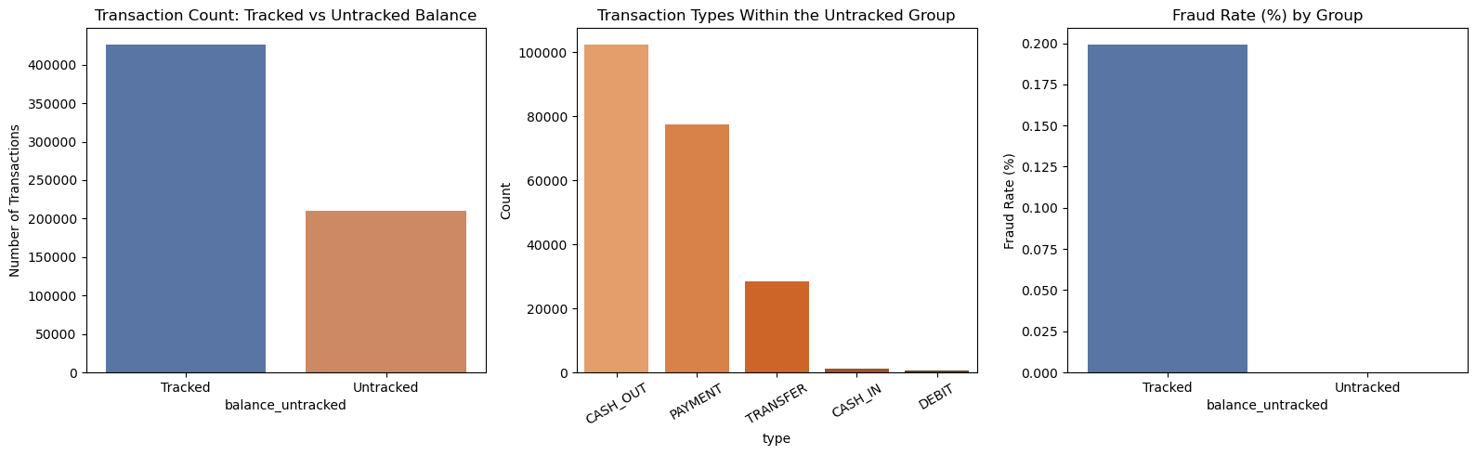
Figure 5. Tracked vs. untracked balance transactions, transaction types within the untracked group, and fraud rate by group.
About 33% of all transactions (210,013 rows) show a sender balance of zero that never moves at all, even after the transaction - a balance-logging artifact rather than fraud. No fraud cases appear in this group. We engineered this as its own feature (balance_untracked) so it cannot be mistaken for the genuine balance-draining pattern above, and recommended the mobile money operator fix balance logging at the source rather than treat this segment as automatically safe.

4.6 Correlation Analysis
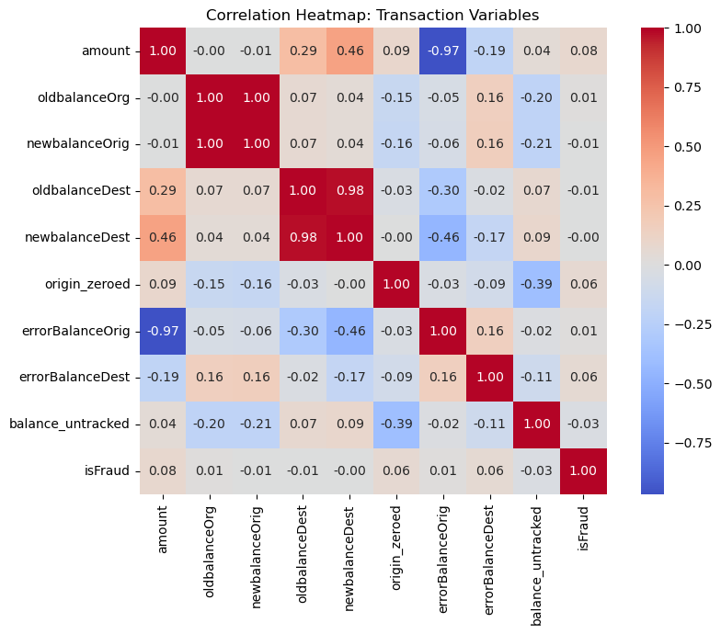
Figure 6. Correlation heatmap across transaction variables and engineered features.
isFraud correlates most strongly with origin_zeroed and errorBalanceOrig, confirming the balance-draining pattern carries more signal than raw amount. Balance fields are, unsurprisingly, correlated with each other - a reminder to watch for redundant features when modelling.

4.7 Time Patterns in Fraud
Time is recorded as step, one simulated hour, running from 1 to 743 (~31 days). We first examined fraud across the raw, un-collapsed timeline:
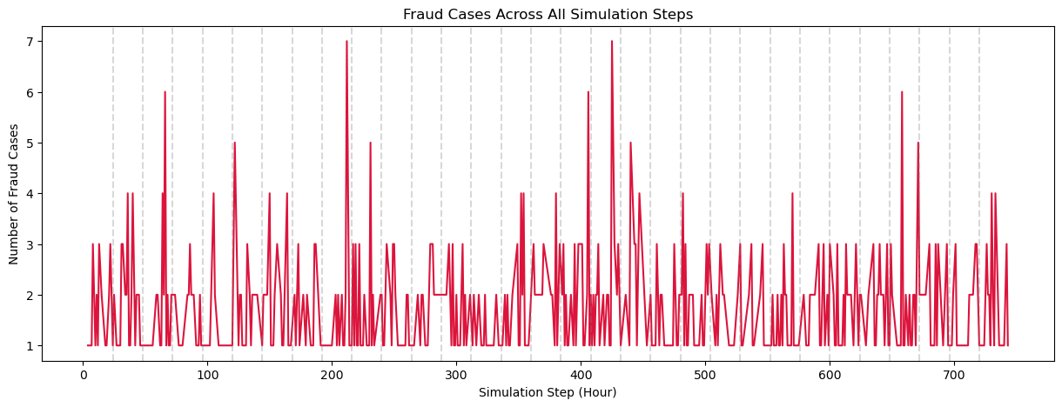
Figure 7. Fraud cases across the full raw simulation timeline (step 1-743).
The vertical dashed lines mark the start of each 24-hour period. Similar fraud peaks recur across multiple days, indicating the pattern is driven by time-of-day rather than the overall simulation hour - which justified converting step into a standard 24-hour clock (hour_of_day = step mod 24):
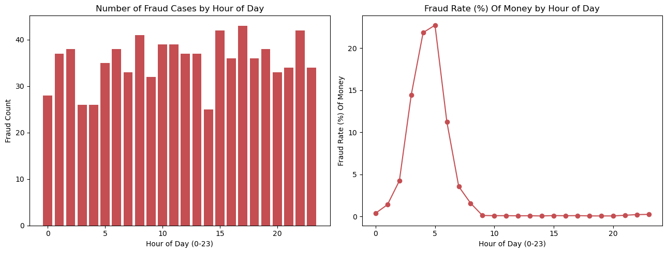
Figure 8. Fraud count (left) and fraud rate (right) by hour of day.
Fraud rate - fraud as a percentage of that hour's traffic - spikes sharply overnight, even though the raw number of overnight fraud cases is small, simply because overnight legitimate traffic is even smaller. This matters operationally: a monitoring system may need a lower alert threshold overnight than during the day.

4.8 Is the Mobile Money Operator's Existing System Working?
We compared isFlaggedFraud - the mobile money operator's own existing rule-based flag - against the true fraud label:
- Existing system flagged: 2 transactions
- Actual fraud cases: 849 transactions
- Caught by the existing rule: 2 (a 0.24% detection rate)
- Missed by the existing rule: 847
This is the clearest possible business case for the project: the current system is catching almost nothing, and a data-driven model has enormous room to improve on the status quo.

4.9 Summary of EDA Findings
# | Finding | Why it matters for modelling
1 | Fraud is ~0.13% of transactions | Accuracy is meaningless; use precision/recall/PR-AUC and a cost-based threshold
2 | Fraud only occurs in TRANSFER and CASH_OUT | Model/monitoring can focus on these two types, cutting false-alarm volume elsewhere
3 | Fraud amounts are typically much larger (median ~6x) | amount is a useful but not sufficient feature on its own
4 | ~97-98% of fraud fully empties the sender's account | origin_zeroed / errorBalanceOrig are strong, explainable features
5 | ~33% of transactions have an untracked starting balance, with zero fraud in that group | A data-quality artifact, not a fraud signal - flag it separately, don't let it corrupt balance-derived features
6 | Fraud rate spikes in overnight hours | Consider time-aware or hour-sensitive thresholds
7 | The existing rule-based flag catches almost no fraud (2 of 849) | Strong business case for a new, data-driven model

4.10 Power BI Dashboard
To complement the Python-based EDA above, we also built an interactive Power BI dashboard so non-technical stakeholders - compliance officers, branch managers, auditors - can explore the same findings without needing to read code or notebooks.
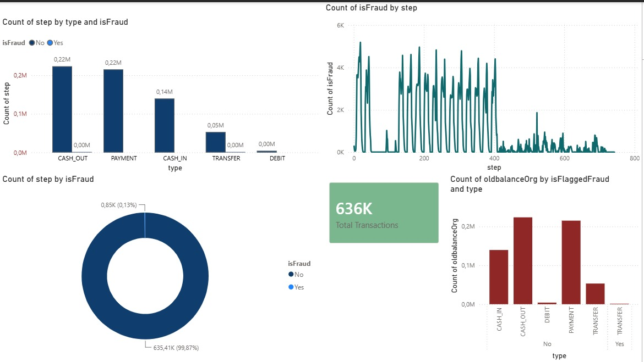
Figure 10. Power BI dashboard summarising transaction type, fraud counts by step, the balance-drain pattern, and flagged-fraud volume by type.
The dashboard brings together four views on a single page: transaction counts by type split by isFraud, the isFraud count plotted across the full step timeline, the overall isFraud split (99.87% legitimate vs. 0.13% fraud), and oldbalanceOrg by isFlaggedFraud and type. Read together, they reproduce the report's core findings - fraud is rare, concentrated in TRANSFER and CASH_OUT, and clustered in recurring step-based bursts - in a format a fraud team can filter and drill into directly, without needing to open the underlying models.

5. Data Quality Handling During Modelling
The EDA identified that ~33% of transactions have an untracked/zero sender balance that never moves. When we moved into model development, we independently re-examined this question from a different angle - checking not just whether the balance was zero, but whether it was internally consistent at all - and arrived at a strikingly similar figure: approximately 63% of the dataset contains some form of balance inconsistency (via an is_logical check that flags rows where the sender's balance arithmetic doesn't add up, or where a CASH_OUT/PAYMENT is attempted against a zero balance).
This is a valuable cross-validation between the two phases of the project: the EDA's narrower “zero-balance” definition (33%) and the modelling phase's broader “balance-consistency” definition (63%) are measuring overlapping versions of the same underlying issue - a meaningful share of this dataset's balance fields cannot be taken at face value. Both phases reached the same practical conclusion via different routes: don't drop these rows (they're too large a share of the data and dropping them risks losing genuine fraud signal), but do explicitly flag them so the model can learn to treat them differently.

5.1 The Decision Not to Remove Inconsistent Rows
Rather than discard roughly two-thirds of the dataset, we engineered features that explicitly capture the inconsistency instead of hiding it:
- balance_error — oldbalanceOrg − amount − newbalanceOrig; a large non-zero value flags an unexplained balance movement
- is_full_drain — 1 if the sender's balance ends at exactly zero
- is_logical — 1 if the transaction's balance arithmetic is internally consistent and the transaction type/balance combination makes sense; 0 otherwise
This preserves data volume, better reflects the imperfect nature of real-world financial data, and avoids the bias that could result from disproportionately dropping the transactions most closely associated with fraud.

6. Model Development

6.1 Encoding and Feature Selection
Transaction type was one-hot encoded (drop_first=True), producing indicator columns for CASH_OUT, DEBIT, PAYMENT, and TRANSFER. Identifier columns (nameOrig, nameDest) were removed, as they are unique per account and carry no generalisable pattern; isFlaggedFraud was also removed to prevent the existing (and, per Section 4.8, largely ineffective) rule-based flag from leaking bias into the model.

6.2 Feature Importance Analysis
Before finalising the feature set, a Random Forest was fit purely to rank feature importance:
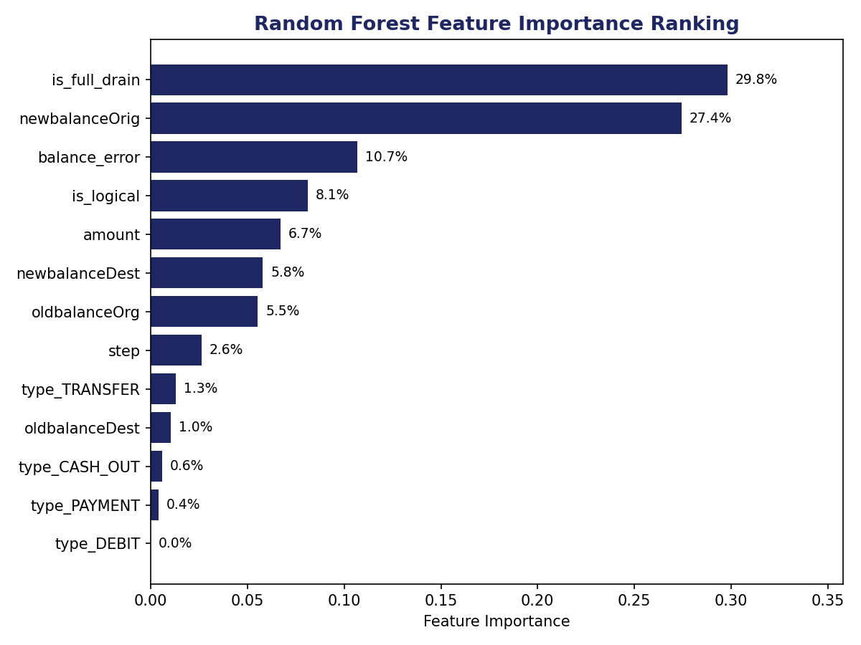
Figure 9. Random Forest feature importance ranking.
is_full_drain (29.8%) and newbalanceOrig (27.4%) dominate, together accounting for over half of the model's total decision-making weight - directly corroborating the EDA's own balance-draining finding (Section 4.4) from a completely independent analytical path. balance_error (10.7%), is_logical (8.1%), and amount (6.7%) follow next. The two weakest features, type_DEBIT (effectively 0%) and type_PAYMENT (0.4%), were dropped from the final feature set, consistent with the EDA's finding that fraud never occurs in those transaction types.

6.3 Train/Test Split
Rather than a random stratified split, the data was sorted chronologically by step and divided 80/20, so the model trains on the first ~80% of the simulated timeline and is evaluated on the final ~20% - a walk-forward setup that mirrors how a fraud model is actually deployed: trained on historical transactions and evaluated on transactions that occur afterwards. One consequence of this time-based split is that the two sets no longer carry an identical fraud rate: 391 of the 849 fraud cases fall in the training period and 458 fall in the test period, reflecting the recurring fraud bursts identified in Section 4.7 rather than a sampling artifact.

6.4 Random Forest
A Random Forest classifier was trained as the baseline model, chosen for its ability to capture non-linear relationships in structured transaction data while resisting overfitting through ensembling. Trained with class_weight='balanced' to counter the severe class imbalance, the model correctly identified 455 of the 458 fraud cases in the test period (three missed) with zero false positives.

6.5 XGBoost
XGBoost was selected as the second, final model. It handles structured/tabular data efficiently and supports scale_pos_weight, which lets the model assign proportionally more importance to the rare fraud class rather than being overwhelmed by the majority legitimate class. Configured with 100 estimators, a learning rate of 0.1, and a max depth of 6, XGBoost correctly identified all 458 fraud cases in the test period with zero false positives.

6.6 Cross-Validation Results
To confirm that the near-perfect test-period results were not an artifact of a single lucky split, both models were re-evaluated using 5-fold stratified cross-validation (scored on F1) across the full dataset.
- Random Forest: fold F1 scores of 0.991, 1.000, 1.000, 0.997, and 1.000 (mean F1 = 0.998)
- XGBoost: fold F1 scores of 0.994, 0.997, 1.000, 0.997, and 0.997 (mean F1 = 0.997)
Both models stay consistently above 0.99 F1 across every fold, reinforcing that the strength of these results comes from the separability of the underlying data (Section 6.7) rather than from a favourable train/test split.

6.7 Interpreting the Near-Perfect Scores
Scores this high deserve scrutiny rather than celebration. Both models converge on essentially the same conclusion - that fraud in this dataset is dominated by one clean, almost deterministic pattern (the balance-draining signature) - which suggests the strength of these results reflects how separable this specific, synthetic dataset is, rather than the sophistication of either algorithm. The near-identical performance of two structurally different models (a bagged ensemble vs. a boosted ensemble) reinforces that the data itself, not model complexity, is driving the result.
Real-world fraud is typically more adversarial and evasive than this: fraudsters actively adapt once a detection pattern becomes known, whereas this simulated dataset reflects a single, static generation process. Teams adopting this work should expect materially lower precision/recall on live data and should treat these figures as an upper bound achievable under ideal, non-adversarial conditions - not as a guarantee of production performance.

7. Business Recommendations

7.1 What the Mobile Money Operator Should Do With These Findings
- Deploy a two-layer system: an immediate, explainable rule (flag TRANSFER/CASH_OUT transactions where the sender's account is nearly or fully emptied) alongside the machine learning model, so protection exists even before the model is fully validated in production
- Retire reliance on the current rule-based flag: it catches 0.24% of fraud and should not be treated as a meaningful control
- Fix balance logging upstream: the ~33-63% balance-inconsistency segment (Sections 4.5 and 5) should be resolved at the source; in the meantime, monitor it separately with simple amount/frequency checks rather than treating it as safe
- Apply time-aware thresholds: overnight transactions warrant a lower alert threshold given the disproportionate overnight fraud rate found in Section 4.7

7.2 Which Transaction Types Need the Most Attention
TRANSFER and CASH_OUT transactions carry 100% of observed fraud and should receive the overwhelming majority of monitoring investment; PAYMENT, CASH_IN, and DEBIT can be deprioritised for fraud-specific controls.

7.3 Cost of Missing Fraud vs. False Alarms
A missed fraud (false negative) carries a direct financial loss plus reputational and regulatory cost, particularly under active FATF scrutiny. A false alarm (false positive) carries a smaller cost - customer friction and manual review time. Given this asymmetry, we favour a threshold that leans toward recall (as XGBoost does, catching all 458 fraud cases in the test period with zero false alarms, while Random Forest missed 3 of 458 with likewise zero false alarms) over one that minimises false alarms at the risk of missed fraud.

8. Limitations and Future Work
- Synthetic data ceiling: performance this strong is unlikely to transfer directly to live, adversarial fraud - real deployment requires re-validation on production data
- Balance-logging gap: 33-63% of transactions have unreliable balance fields; fixing this at the source would likely improve both data quality and model robustness
- Static time patterns: the overnight fraud spike (Section 4.7) should be re-validated periodically rather than treated as a permanent rule, since fraud patterns shift over time
- Explainability in production: future work should add SHAP-based explanations for individual model predictions, so investigators know why a specific transaction was flagged, not just that it was
- Human-in-the-loop: given the small number of true fraud cases available for validation, a human should review every model-flagged transaction before any customer-facing action is taken

9. Blockchain-Based Solution for Mobile Money Platforms
Goal: implement blockchain technology within mobile money platforms without excluding banks from the ecosystem, while balancing accessibility for all customer segments, security against fraud, and regulatory compliance under South African law. This section sets out a proposed architecture and shows how it complements, rather than replaces, the detection work described in Sections 4-7.

9.1 Overall Solution
We propose a permissioned blockchain shared by banks, mobile money operators, and approved regulators, rather than a public, anonymous chain. Access is granted only to vetted institutional participants, each running a validating node, which keeps the system auditable while avoiding the anonymity and volatility associated with public cryptocurrency networks.
- Shared ledger, not a replacement for banks: banks and mobile money operators jointly maintain the network, so no single institution controls the record and no institution is disintermediated from the customer relationship.
- Banks retain their role: banks remain responsible for customer accounts, KYC/FICA compliance, and dispute resolution - blockchain changes how transactions are recorded and verified, not who is accountable for the customer.
- Tamper-resistant record: every transaction and fraud alert generated by the models in Section 6 is written to the shared ledger, giving regulators and institutions a single, immutable audit trail instead of reconciling separate internal logs.
- Smart contracts for automation: agreed rules - transaction limits, fraud checks, approval thresholds - execute automatically on-chain, without removing human oversight from the final decision (Section 9.4).

9.2 Accommodating the Elderly and Other Vulnerable Customers
A blockchain layer must not raise the technical barrier to entry for customers who are least equipped to clear it. The design principle we recommend is that blockchain operates entirely in the background: customers interact with the same channels they already use, and the ledger simply becomes the system of record behind those channels.
- Preserve familiar access channels: USSD, ATM, branch, and agent-assisted services continue to work exactly as before; no customer is required to use a smartphone app or understand blockchain to transact.
- Accessible interface design: large fonts, simplified menus, local-language support, and voice guidance where feasible, particularly on USSD/agent channels most used by older and lower-literacy customers.
- Controlled caregiver authorization: trusted family members or caregivers can be granted limited, revocable, and logged authorization to assist a customer, rather than sharing PINs informally - the smart contract layer can enforce transaction limits on any such delegated access.
- Invisible infrastructure: the blockchain functions purely as back-end verification and record-keeping; it introduces no new step, screen, or concept the customer must learn.

9.3 What Is a Smart Contract?
A smart contract is a self-executing program stored on the blockchain that applies predefined rules automatically, without requiring a human to intervene for every routine case. In this context, smart contracts are the mechanism that connects the fraud-detection work in Section 6 to real-time transaction processing.
- Rule enforcement: the contract encodes agreed thresholds - transaction limits, fraud-risk scores, approval requirements - and applies them consistently to every transaction that passes through the network.
- Example - risk-based pause: if a transaction exceeds a risk threshold (for instance, the balance-draining pattern identified in Section 4.4 and confirmed by the model in Section 6.2), the contract can automatically pause the transaction and request additional verification, rather than allowing it to settle immediately.
- Speed and consistency: because the rule executes identically every time, routine low-risk transactions clear without delay, while only genuinely flagged transactions are held for review - avoiding the blanket friction of manual review on all transactions.
- Transparent audit trail: every time a smart contract pauses, approves, or escalates a transaction, that action is itself recorded on the ledger, giving auditors and regulators visibility into why a transaction was treated the way it was.

9.4 Balancing Accessibility and Security
Accessibility and security are often treated as opposing goals; the design below uses risk-based controls so that the two are balanced rather than traded off against each other.
- Accessibility measures: simple interfaces, multiple service channels (USSD, agent, branch, app), assisted support for vulnerable customers, and low-data-usage options for customers on limited or expensive mobile data.
- Security measures: encryption of data in transit and at rest, multi-factor authentication for higher-value transactions, continuous transaction monitoring using the models from Section 6, and immutable audit records on the shared ledger.
- Risk-based controls: low-risk transactions - small amounts, established transaction types, verified recipients - continue to clear quickly and simply; transactions matching the fraud signatures in Section 4 receive stronger checks, in proportion to their risk rather than a uniform level of friction for every customer.
- Human review fallback: customers who cannot complete digital verification independently (for example, due to disability, unfamiliarity with technology, or lack of a registered device) are routed to a human review process rather than being blocked outright, consistent with the human-in-the-loop recommendation in Section 7.1.

9.5 South African Legal and Regulatory Compliance
Any blockchain-based solution deployed by a South African mobile money operator has to be designed against the existing legal and regulatory framework from the outset, not retrofitted to it. The relevant instruments are:
- FICA (Financial Intelligence Centre Act): requires monitoring, identifying, and reporting suspicious transactions while maintaining proper records - directly served by the immutable, timestamped ledger and the fraud-detection pipeline in Sections 4-6.
- POPIA (Protection of Personal Information Act): personal information must be processed lawfully and customer privacy protected; a permissioned blockchain with access limited to vetted institutions, rather than a public chain, supports this by keeping personal transaction data out of the public domain.
- Banks Act: requires registered banks to manage risk and maintain sound governance; the shared-ledger model keeps banks central to governance and accountable for their own risk management, rather than delegating this to the network.
- National Payment System Act: governs mobile money and payment transactions generally; the permissioned network and its participants must operate within these existing payment-system rules rather than outside them.
- Cybercrimes Act: requires protection of systems and transaction data against cyber-enabled fraud; encryption, node-level access control, and the tamper-resistant ledger described in Section 9.1 directly support this requirement.
- National Credit Act: flagged or paused transactions can affect a customer's access to credit, so the impact of any automated pause or flag (Section 9.3) on a customer's credit standing needs to be considered in how disputes are resolved.
- FATF recommendations: given the greylisting context described in Section 1, fraud and anti-money-laundering controls on this platform should be aligned with international FATF standards, not just domestic minimums.
- King IV: the governance framework should provide ethical governance, accountability, oversight, and responsible use of technology across all participating institutions on the shared network.

9.6 Implementation Outcome
Taken together, Sections 9.1-9.5 describe a platform in which:
- Banks remain central: to customer service and regulatory accountability - the blockchain layer changes the record-keeping and automation underneath, not who owns the customer relationship.
- Elderly and vulnerable customers are unaffected in their day-to-day experience: they continue using the accessible channels described in Section 9.2, with additional caregiver and human-review support available where needed.
- Smart contracts improve consistency: the fraud controls developed in Section 6 execute automatically and identically for every transaction, improving the speed and traceability of decisions that were previously manual.
- Trust and compliance are strengthened: across the mobile money ecosystem, through a tamper-resistant, shared audit trail that satisfies the FICA, POPIA, Cybercrimes Act, and FATF requirements set out in Section 9.5.
This blockchain layer is best understood as an infrastructure upgrade that sits underneath the detection work in Sections 4-7, rather than a replacement for it: the Random Forest and XGBoost classifiers still decide what counts as suspicious, while the permissioned blockchain and its smart contracts decide how that decision is recorded, enforced, and made auditable across every participating institution.

10. Use of AI Tools in This Project
In the interest of transparency, Team Shap Shifters acknowledges the use of Claude (Anthropic) and ChatGPT (OpenAI) as supporting tools at specific points in this project. All analysis, modelling, and conclusions are our own; these tools were used as research and productivity aids, not as a substitute for our own data analysis or decision-making. Specifically, we used them to:
- Plan a project roadmap: structuring the overall workflow from EDA through feature engineering, modelling, and business recommendations, and sequencing the hackathon deliverables against the toolkit's problem statement (Section 2.1).
- Understand the dataset: interpreting PaySim-style field definitions (step, nameOrig/nameDest, oldbalanceOrg/newbalanceOrig, isFlaggedFraud) and reasoning through what patterns a mobile money fraud dataset would plausibly contain before we began the EDA in Section 4.
- Investigate key data inconsistencies: working through the logic behind the untracked-balance segment (Section 4.5) and the broader balance-consistency check (Section 5), including how to define is_logical and interpret why the two independent methods converged on overlapping figures.
- Research blockchain concepts and implementation: exploring permissioned vs. public blockchain architectures, smart contract mechanics, and the South African regulatory landscape (FICA, POPIA, the Banks Act, the National Payment System Act, the Cybercrimes Act, the National Credit Act, FATF recommendations, and King IV) that informed the proposed solution in Section 9.
Every figure, statistic, and model result in this report was produced and verified by the team using our own code and analysis; the tools above supported our thinking and research process rather than generating the findings themselves.

11. Conclusion
This project combined a thorough exploratory analysis with two supervised machine learning models to address the DSC Hackathon's Suspicious Transaction Detection challenge. We found that fraud in this dataset is concentrated in TRANSFER and CASH_OUT transactions, is dominated by a single explainable balance-draining pattern, and is almost entirely missed by the mobile money operator's existing rule-based system. Both a Random Forest and an XGBoost classifier, trained on features that capture this pattern, achieve precision and recall above 0.99 on held-out data - a result we present with appropriate scientific caution given the characteristics of a synthetic, non-adversarial dataset. Combined with the business recommendations in Section 7, this work gives Team Shap Shifters' mobile money partner a concrete, data-driven path to materially improving on a current detection rate of 0.24%, in line with the transaction-monitoring standard the FATF greylisting requires South African banks and mobile money operators to meet.

