Module 1: AI-Based Public Transport Priority Detection and Signal Management
This module focuses on identifying approaching public transport vehicles, tracking their movement, estimating their arrival at an intersection, and dynamically requesting traffic signal priority.
The main objective is:
When a bus approaches a traffic intersection, the system should intelligently determine whether it deserves signal priority and adjust the traffic signal to reduce its waiting time.
This is more than simply detecting a bus using YOLO. You need to build a complete detection, tracking, prediction and decision-making pipeline.
1. How the Module Works
Imagine a four-way road intersection.
There are four directions:
- North
- South
- East
- West
A CCTV camera monitors the intersection.
A public transport bus approaches from the North direction while the traffic signal is red.
Your system should:
- Detect the approaching bus.
- Identify it as a public transport vehicle.
- Track its movement.
- Estimate its distance from the intersection.
- Estimate its arrival time.
- Check the current traffic signal.
- Determine whether priority should be granted.
- Request an appropriate signal adjustment.
Let's understand each step.

2. Step-by-Step ML/DL Implementation
Step 1: Vehicle Detection Using YOLO
Technology: YOLO + PyTorch + OpenCV
First, you need to identify vehicles from CCTV footage.
For example, your camera captures this scene:
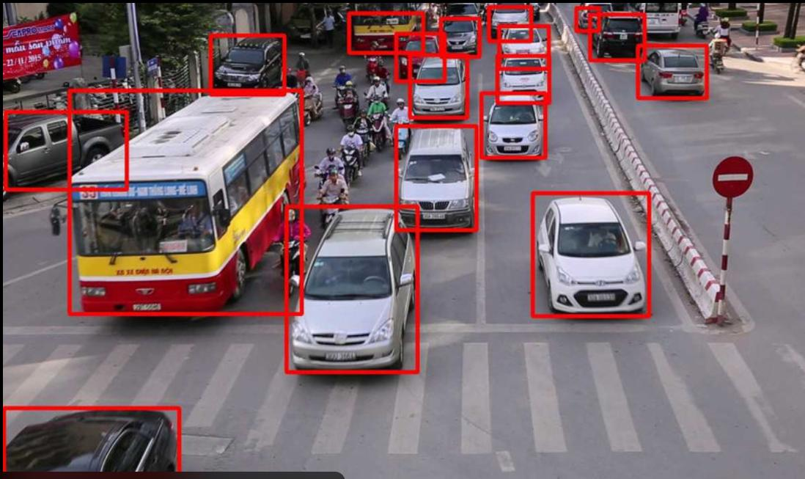
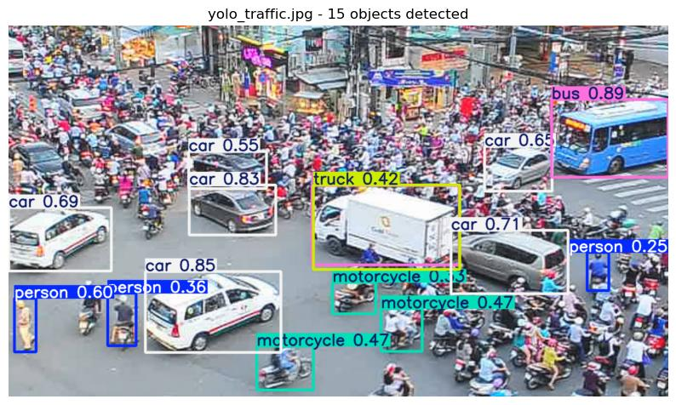
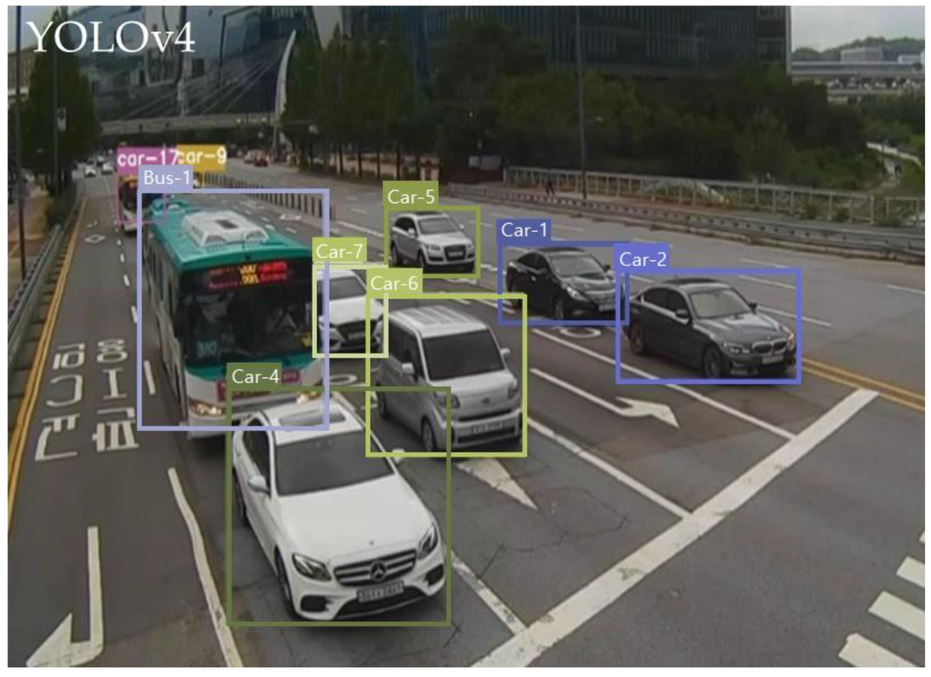
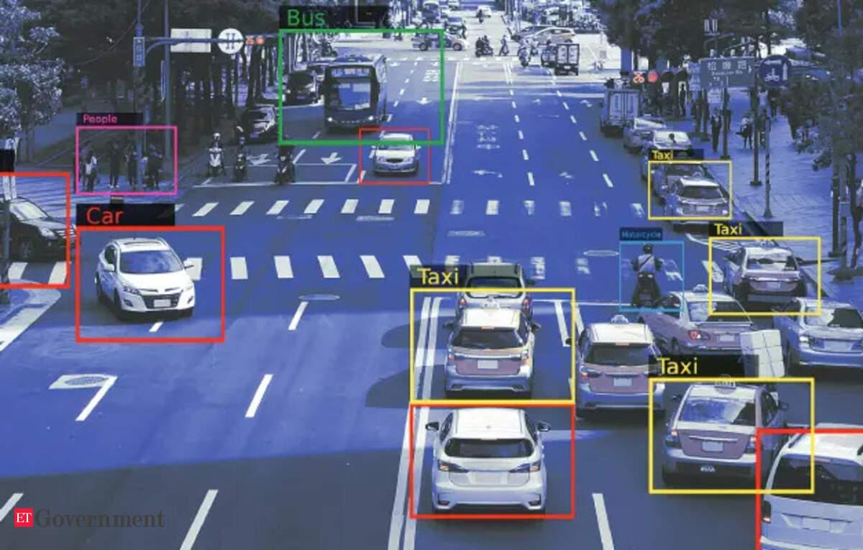
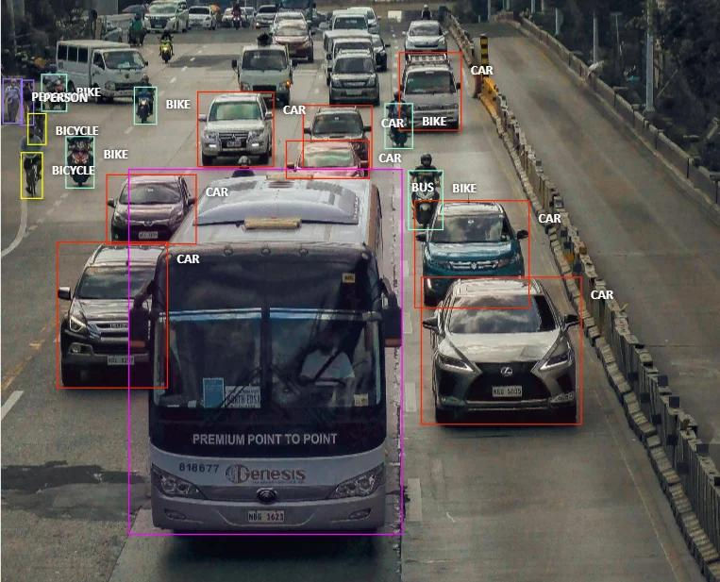
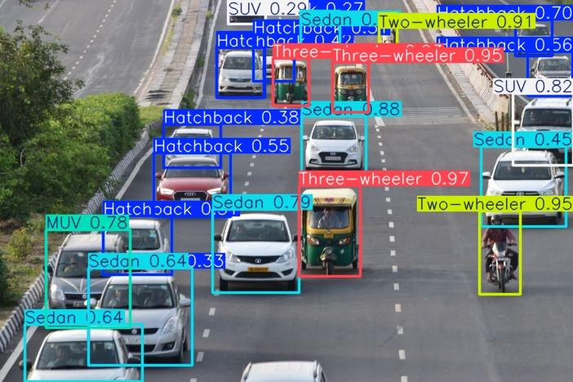
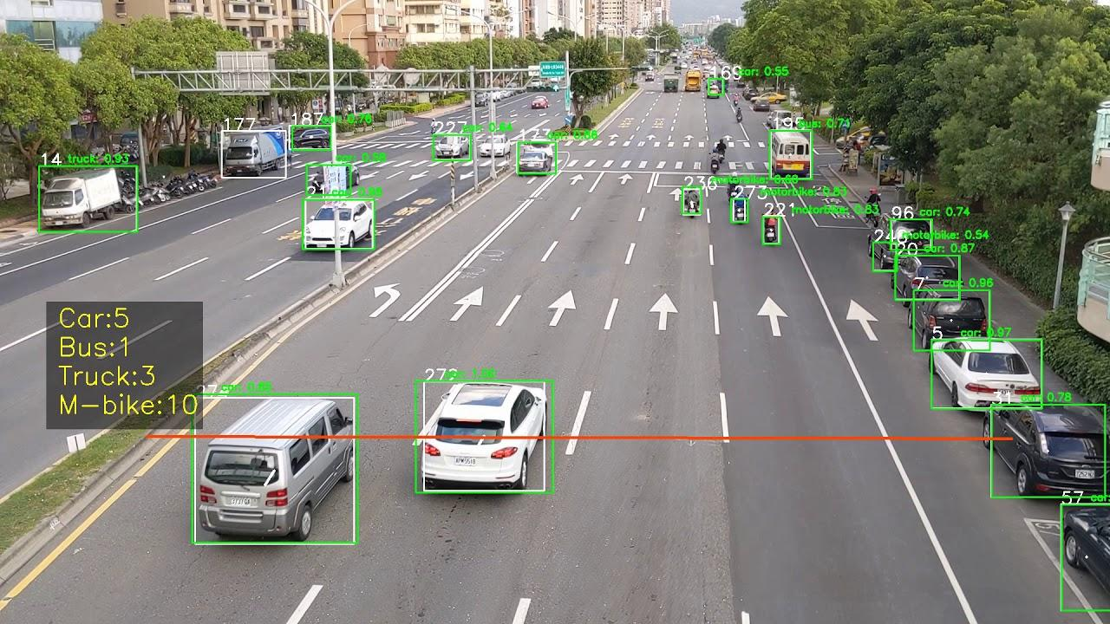
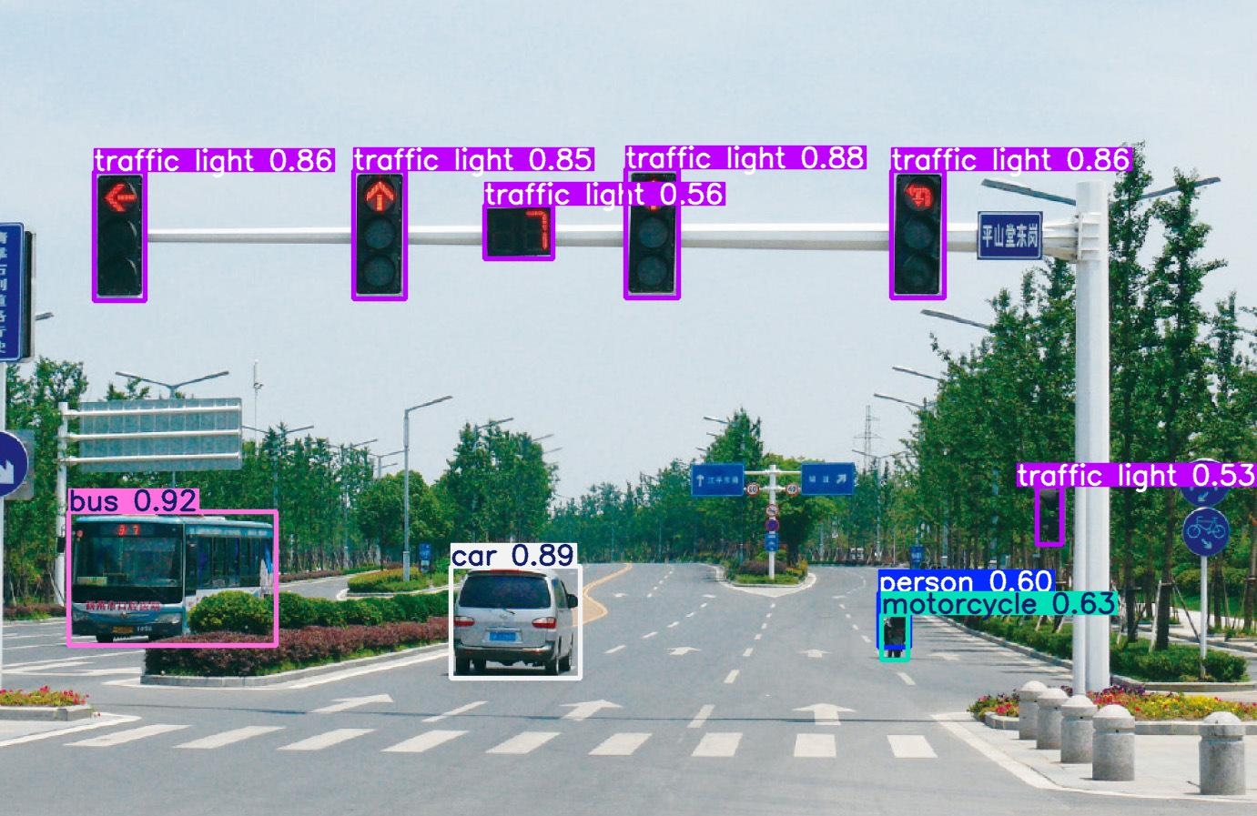
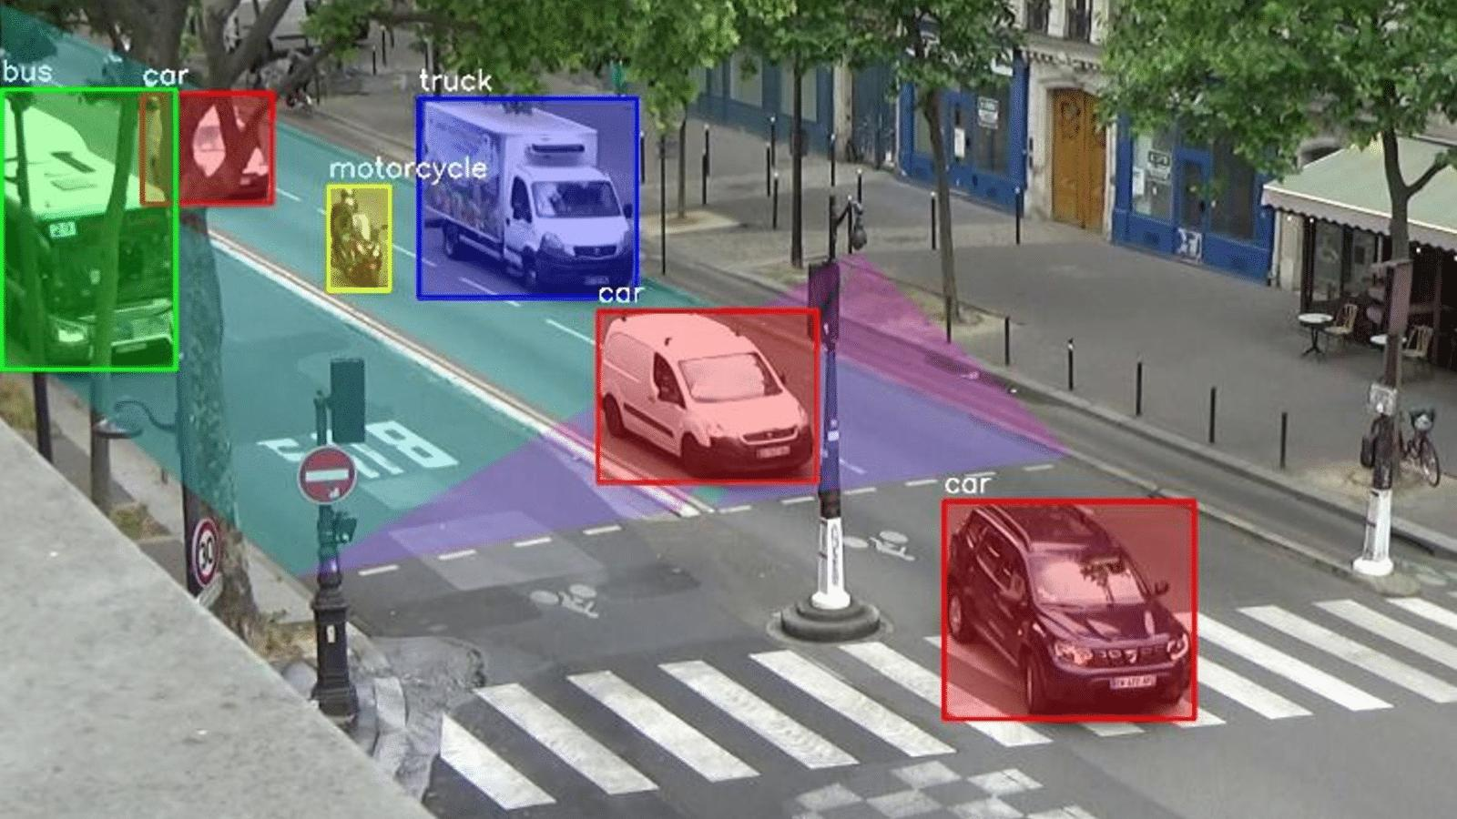
YOLO detects objects and generates bounding boxes.
Your system should identify:
Vehicle | Class
Car | Car
Bus | Bus
Truck | Truck
Motorcycle | Motorcycle
Auto-rickshaw | Additional custom class
Example output:
Frame: 120

Vehicle 1: Car
Confidence: 94%

Vehicle 2: Bus
Confidence: 97%

Vehicle 3: Motorcycle
Confidence: 91%

Vehicle 4: Truck
Confidence: 89%
Important: YOLO's standard pretrained COCO model can detect buses, cars, trucks and motorcycles. However, it does not reliably distinguish public buses from every other type of bus or identify auto-rickshaws as a separate class.
You may need custom training for your specific vehicle categories.
Step 2: Vehicle Tracking
Technology: ByteTrack
Detection alone is insufficient.
Suppose YOLO detects a bus in 100 consecutive frames.
How will your system understand that all 100 detections belong to the same bus?
This is where object tracking comes in.
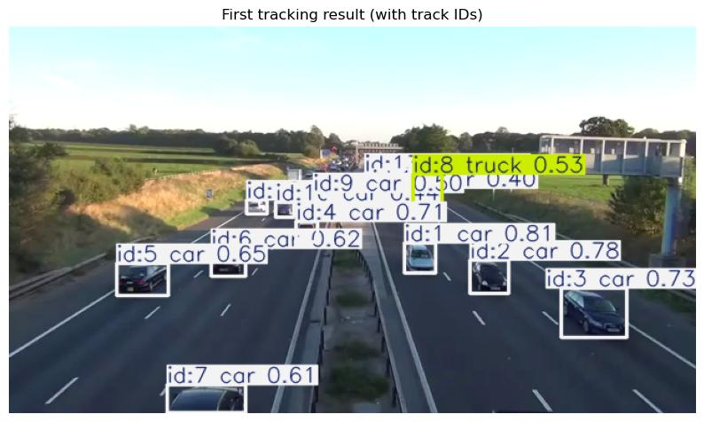
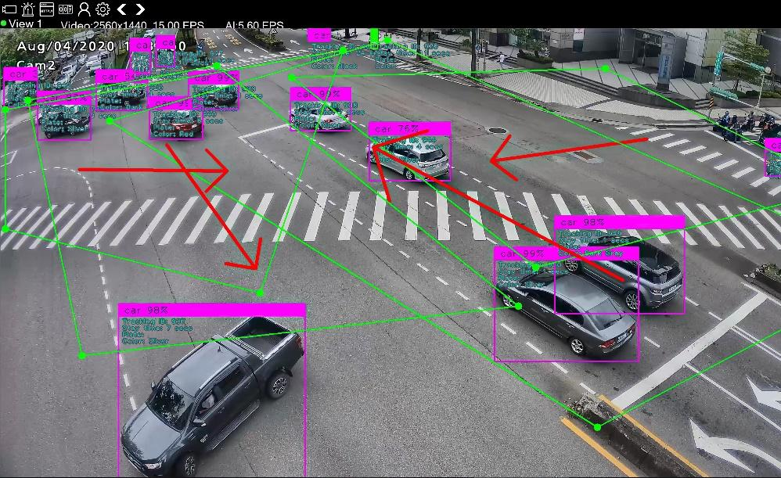
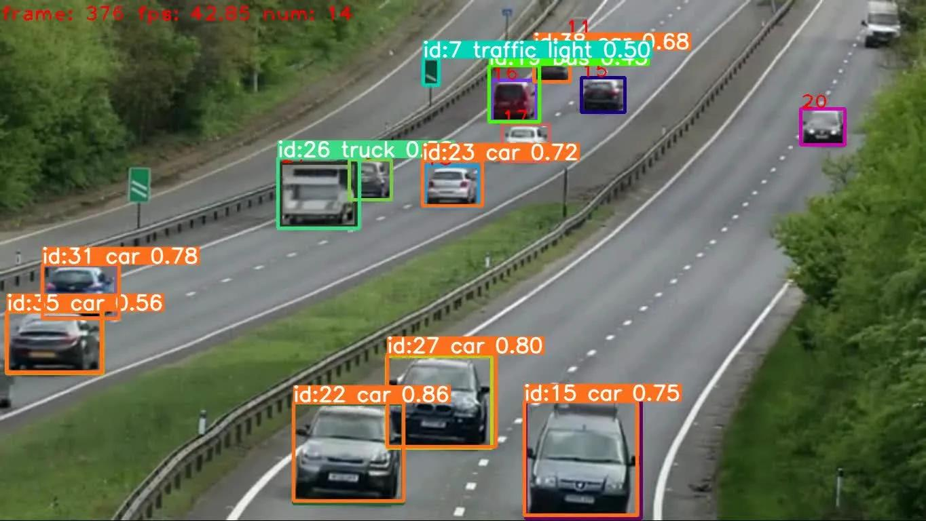
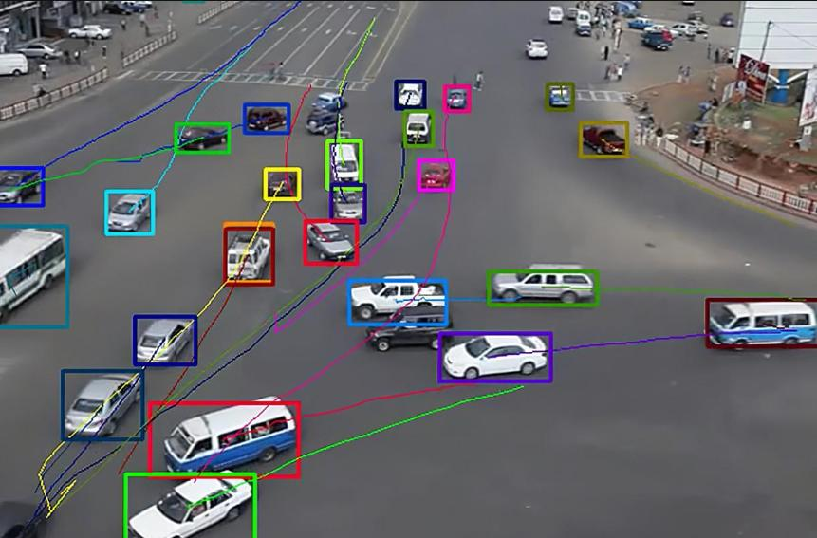
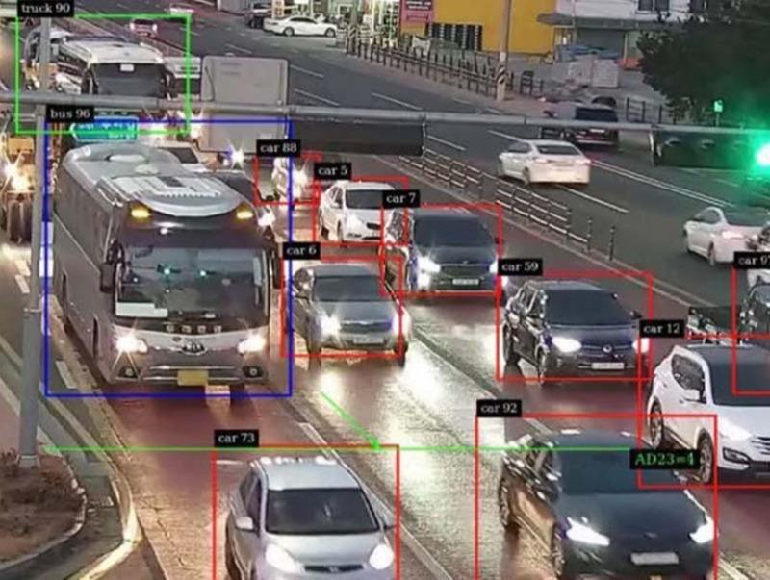
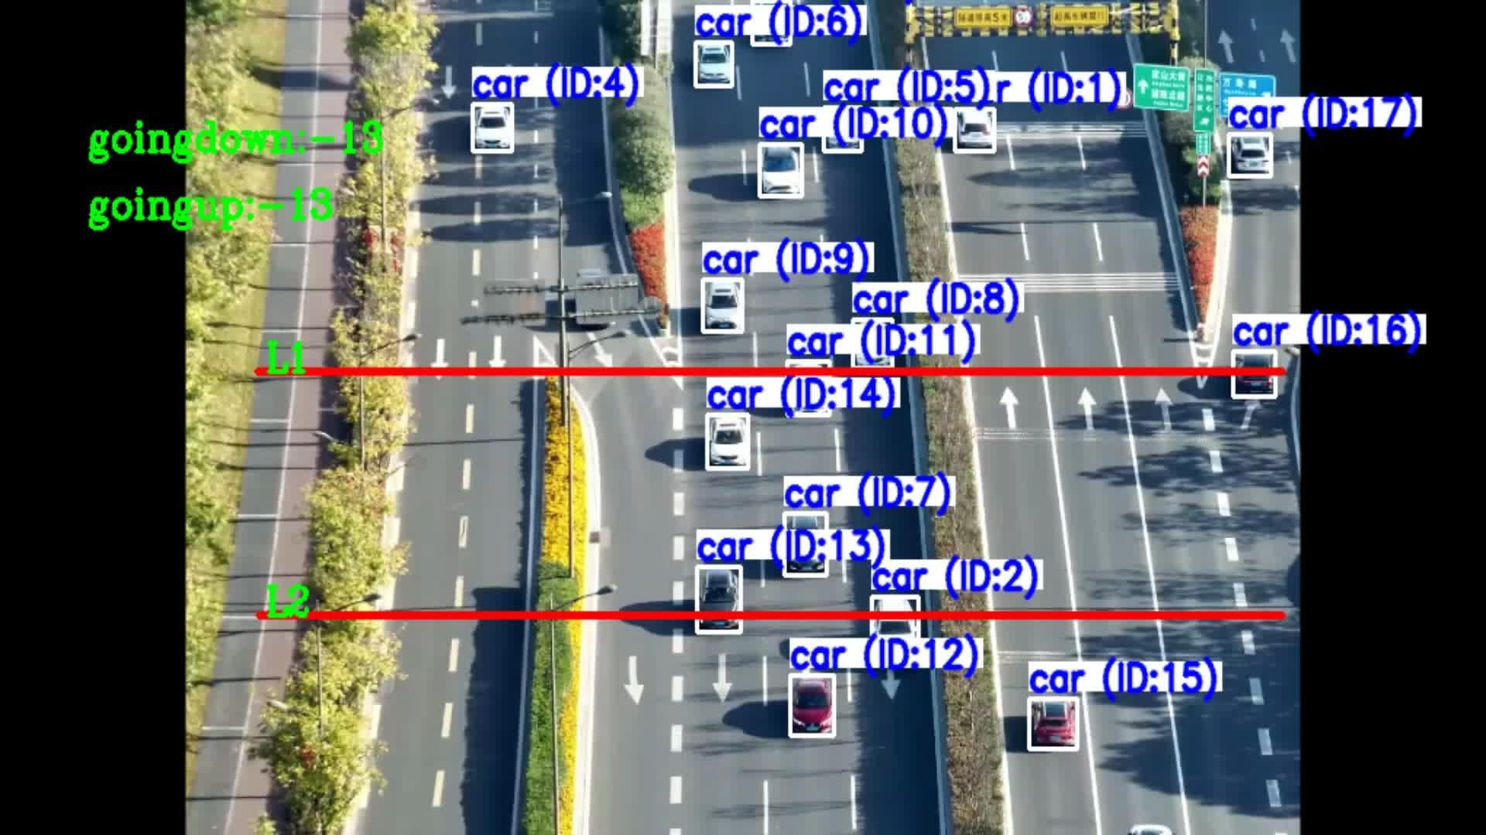
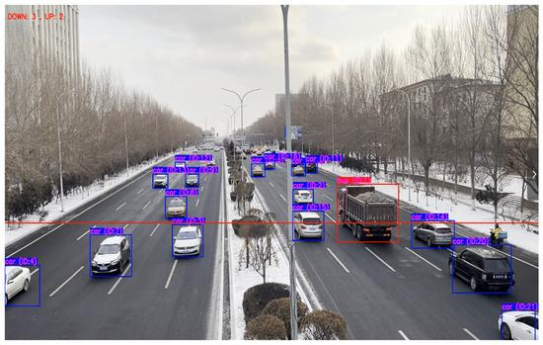
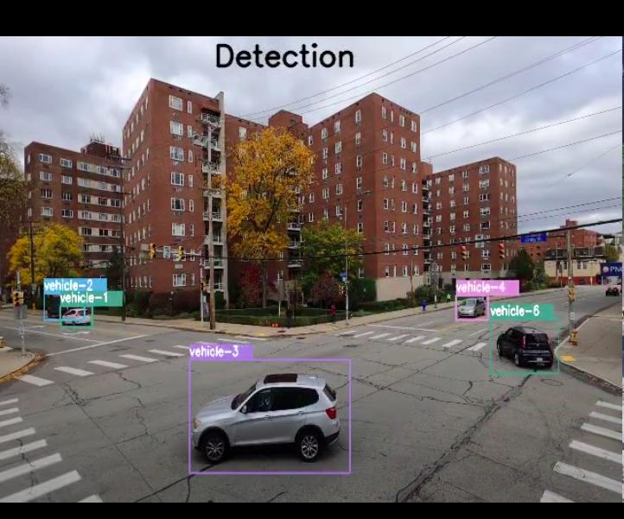
ByteTrack assigns unique tracking IDs to detected vehicles.
Example:
Vehicle ID: 101
Class: Bus
Direction: North
Status: Moving

Vehicle ID: 102
Class: Car
Direction: East
Status: Moving

Vehicle ID: 103
Class: Motorcycle
Direction: South
Status: Moving
Now your system can continuously monitor individual vehicles.
You can extract:
- Vehicle ID.
- Vehicle category.
- Movement direction.
- Position in the video.
- Movement history.
- Approximate speed.
Step 3: Identify Approaching Public Transport Vehicles
Now comes the important part.
You need to identify whether a bus is actually approaching the intersection.
For this, define a Region of Interest (ROI).
An ROI is a specific area of the video that your system monitors.
For example:
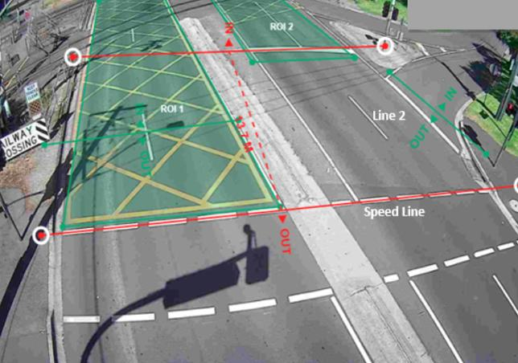
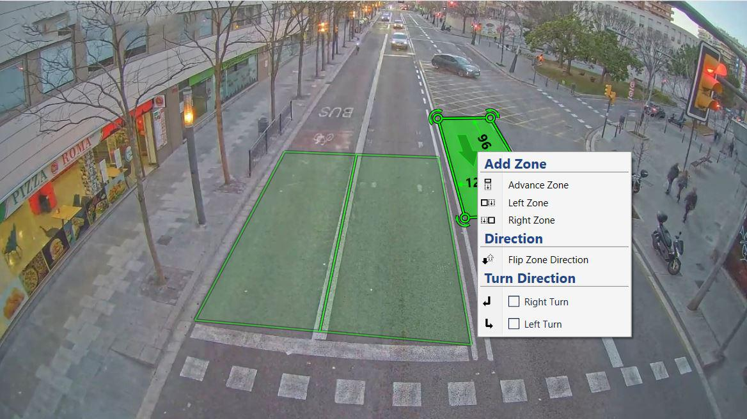
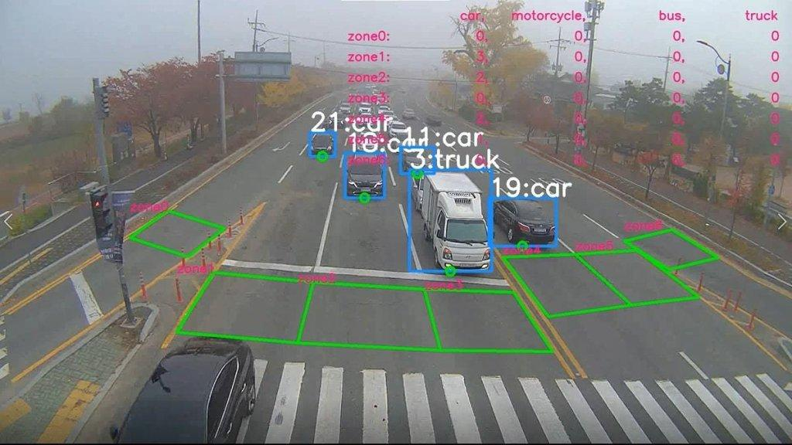
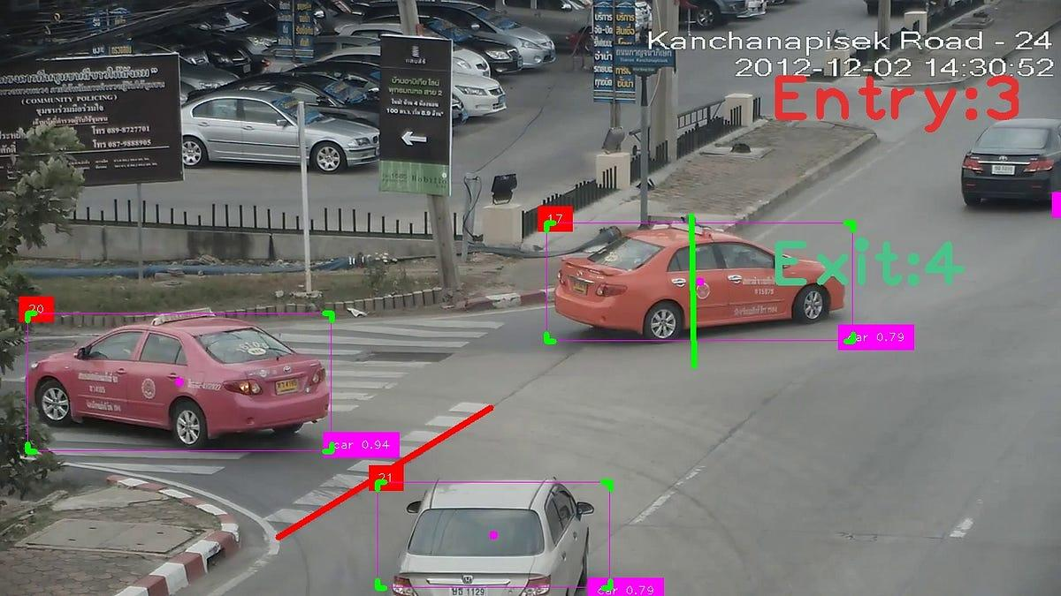
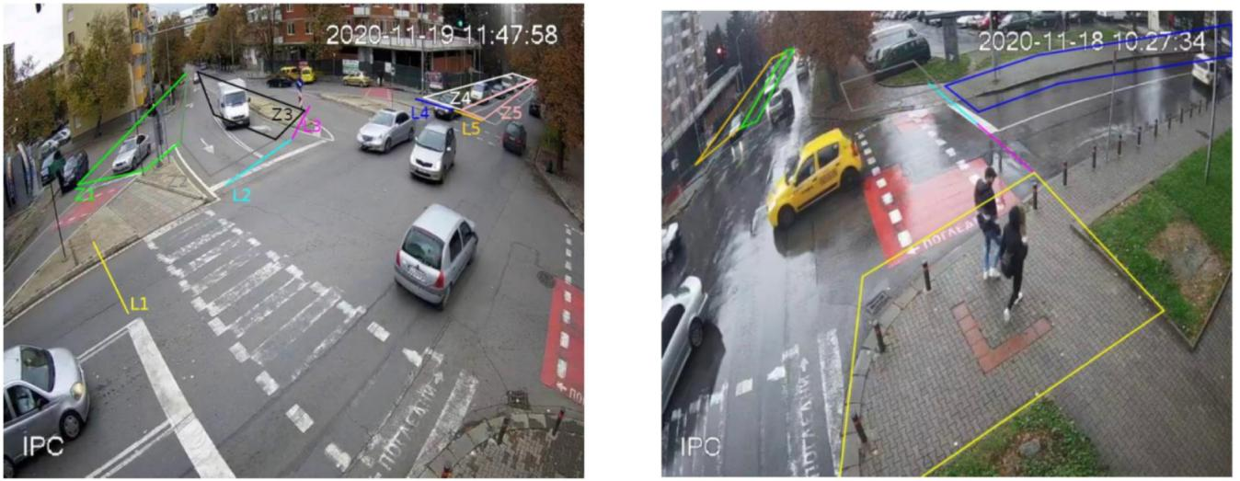
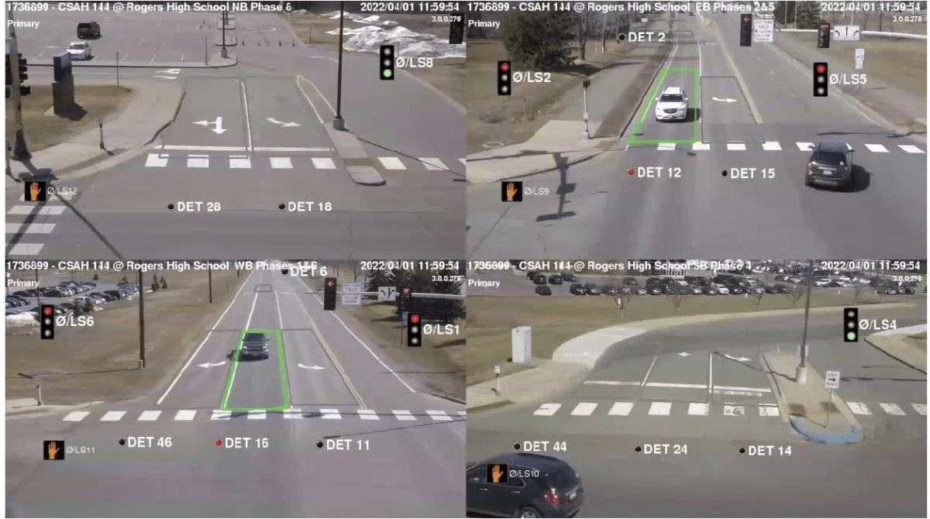
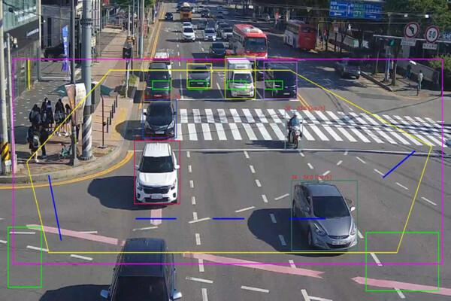
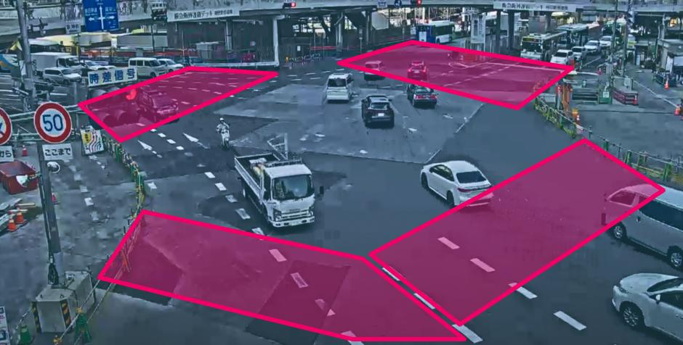
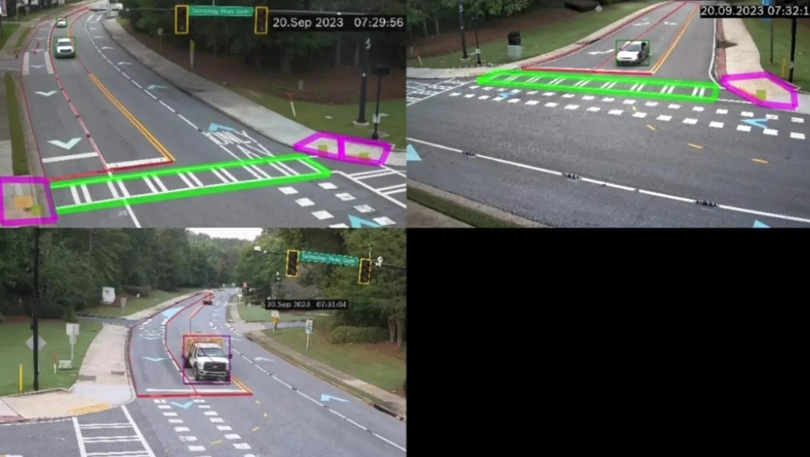
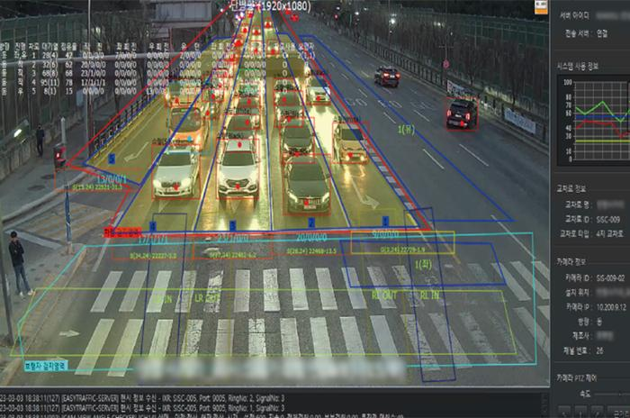
Divide the intersection into four approach zones:
NORTH
|
[Bus Detection]
|
|
WEST ----------+---------- EAST
|
|
[Bus Detection]
|
SOUTH
Your system identifies the bus's location and movement direction.
Example:
Vehicle ID: 101

Class: Bus
Current Direction: North
Position: 120 pixels from intersection
Movement: Approaching
You can calculate the vehicle's approximate distance from the intersection using camera calibration.
Note: Pixel distance alone is not real-world distance. For accurate distance and speed estimates, use camera calibration or perspective transformation.
Step 4: Estimate Bus Speed and Arrival Time
This is where your project becomes more intelligent.
Knowing that a bus is approaching isn't enough.
You should estimate how long it will take to reach the intersection.
For example:
Vehicle ID: 101

Vehicle: Bus

Distance: 100 metres

Estimated Speed: 30 km/h

Estimated Arrival Time: 12 seconds
The basic mathematical formula is:
$$T=\frac{D}{V}$$
Where:
- T = Estimated arrival time.
- D = Distance from intersection.
- V = Vehicle speed.
Convert speed into metres per second before calculating.
For example:
$$V=\frac{30}{3.6}=8.33 m/s \\ T=\frac{100}{8.33}=12 seconds$$
You can initially use this mathematical approach.
Later, you can improve arrival-time prediction using ML models.
Possible algorithms:
- Linear Regression.
- Random Forest Regression.
- XGBoost Regression.
Input features could include:
- Current vehicle speed.
- Distance from intersection.
- Historical speed.
- Traffic density.
- Queue length.
Output:
Predicted bus arrival time.
Step 5: Public Transport Priority Decision
Now your system knows:
- Whether a bus is approaching.
- Its distance.
- Its speed.
- Its estimated arrival time.
- Current traffic conditions.
The next step is deciding whether to prioritize it.
For example:
Condition | Value
Bus detected | Yes
Distance | 100 metres
Speed | 30 km/h
Arrival time | 12 seconds
Current signal | Red
Traffic density | High
Your system evaluates the situation.
A simple initial decision engine could use:
if bus_detected and bus_approaching:

if arrival_time < 20:

if traffic_signal == "RED":

request_bus_priority()
However, a real traffic management system needs more conditions.
For example:
- Is the bus carrying a high number of passengers?
- Is another direction experiencing heavy congestion?
- Is the pedestrian crossing active?
- Is there a minimum green-time requirement?
- Can the current signal phase safely be changed?
You can initially implement a rule-based decision engine and later introduce optimization algorithms.
Step 6: Dynamic Traffic Signal Adjustment
This is the final stage.
Suppose the current signal timings are:
Direction | Signal
North | Red
South | Red
East | Green
West | Green
A bus approaches from the North.
Your system sends a priority request to the traffic signal controller.
The controller:
- Checks whether the request is safe.
- Completes the minimum required green time for the current phase.
- Provides the required clearance interval.
- Activates the North-South green phase.
- Allows the bus to pass.
- Returns to normal adaptive signal operation.
For your project, simulate this using SUMO rather than connecting to actual road traffic signals.

3. Complete Architecture of Module 1
Here is the architecture I recommend implementing.
CCTV VIDEO INPUT
|
v
FRAME EXTRACTION
|
v
YOLO DETECTION
|
v
BYTE TRACKING
|
v
VEHICLE CLASSIFICATION
|
v
PUBLIC TRANSPORT IDENTIFICATION
|
v
APPROACHING BUS DETECTION
|
v
SPEED AND DISTANCE ESTIMATION
|
v
ARRIVAL TIME PREDICTION
|
v
PRIORITY DECISION ENGINE
|
v
TRAFFIC SIGNAL OPTIMIZATION
|
v
SUMO SIMULATION
4. Dataset Requirements
You can start with publicly available datasets.
Dataset | Application
BDD100K | Vehicle detection
UA-DETRAC | Vehicle detection and tracking
AI City Challenge | Traffic monitoring
Custom CCTV footage | Bus approaching intersection
You don't necessarily need to train YOLO from scratch.
Start with pretrained YOLO weights and fine-tune them only if your vehicle categories or camera conditions require it.

5. What Should Your Final Output Look Like?
Imagine your Streamlit dashboard.
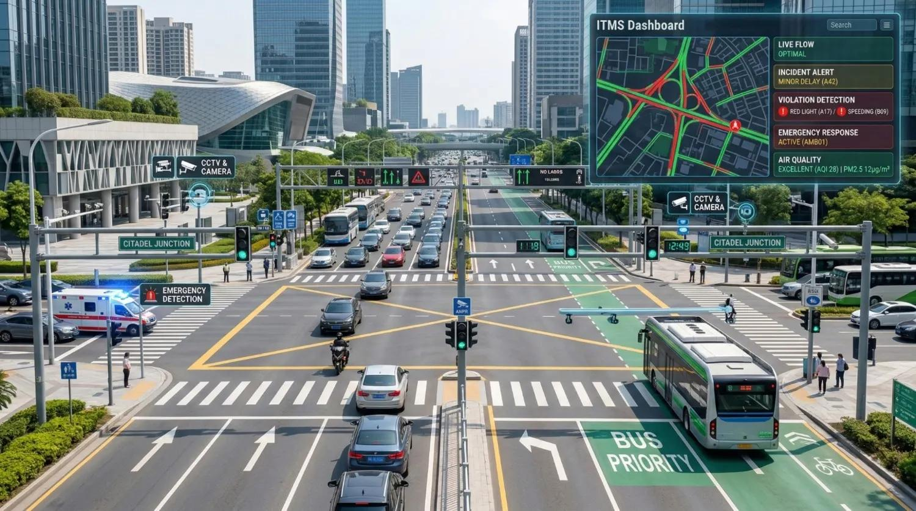
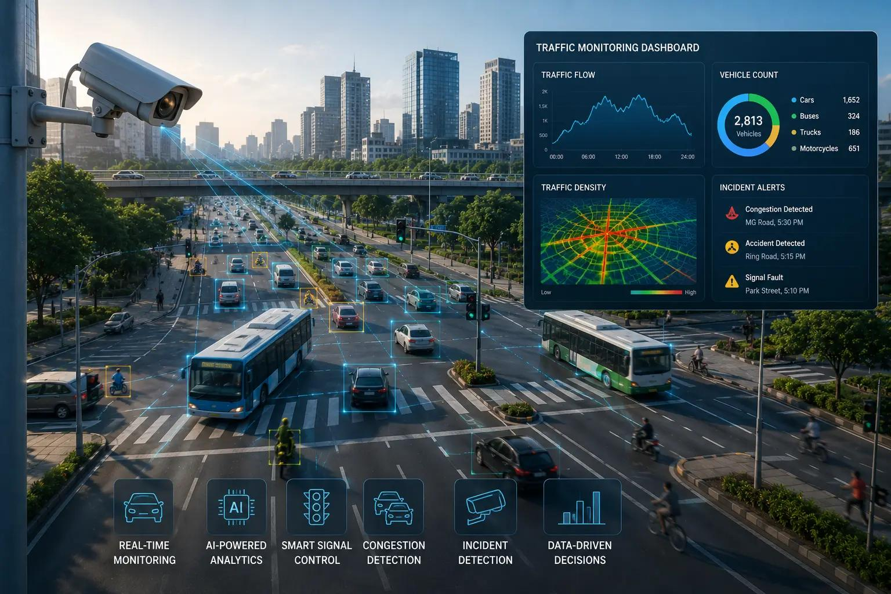
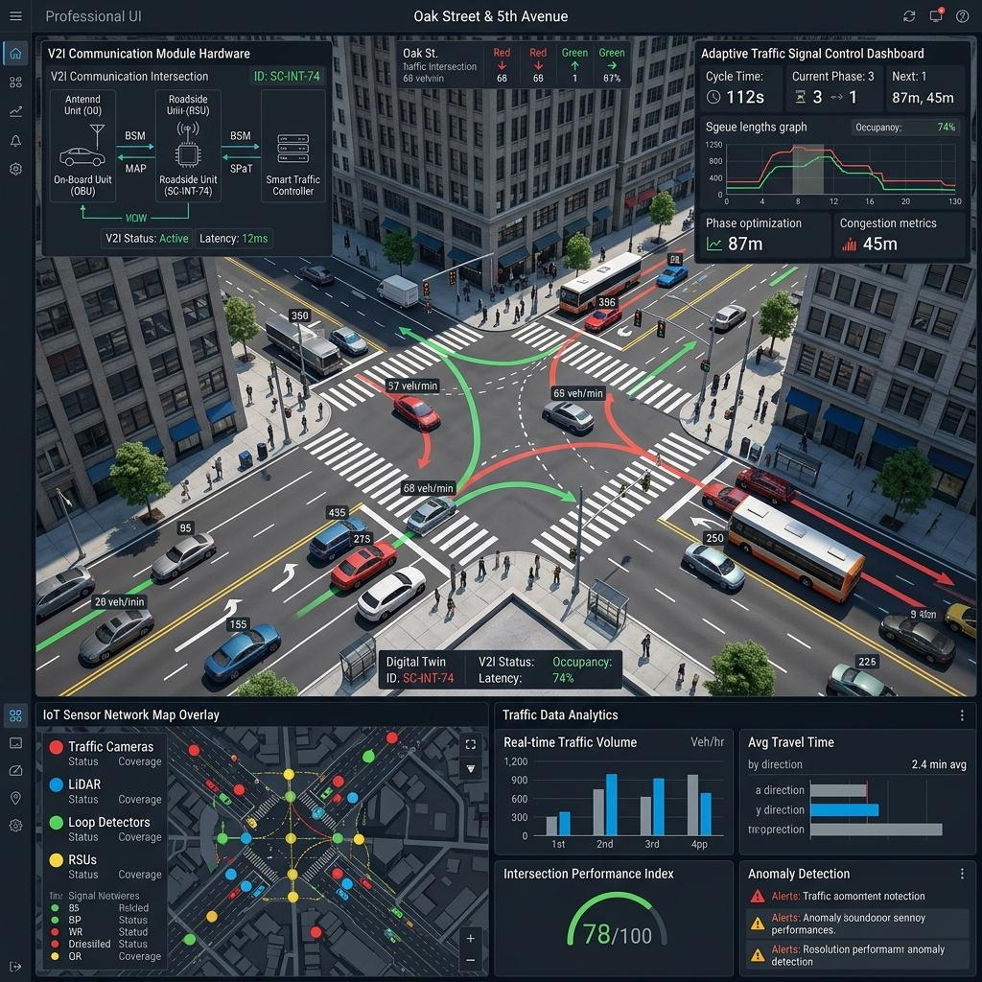
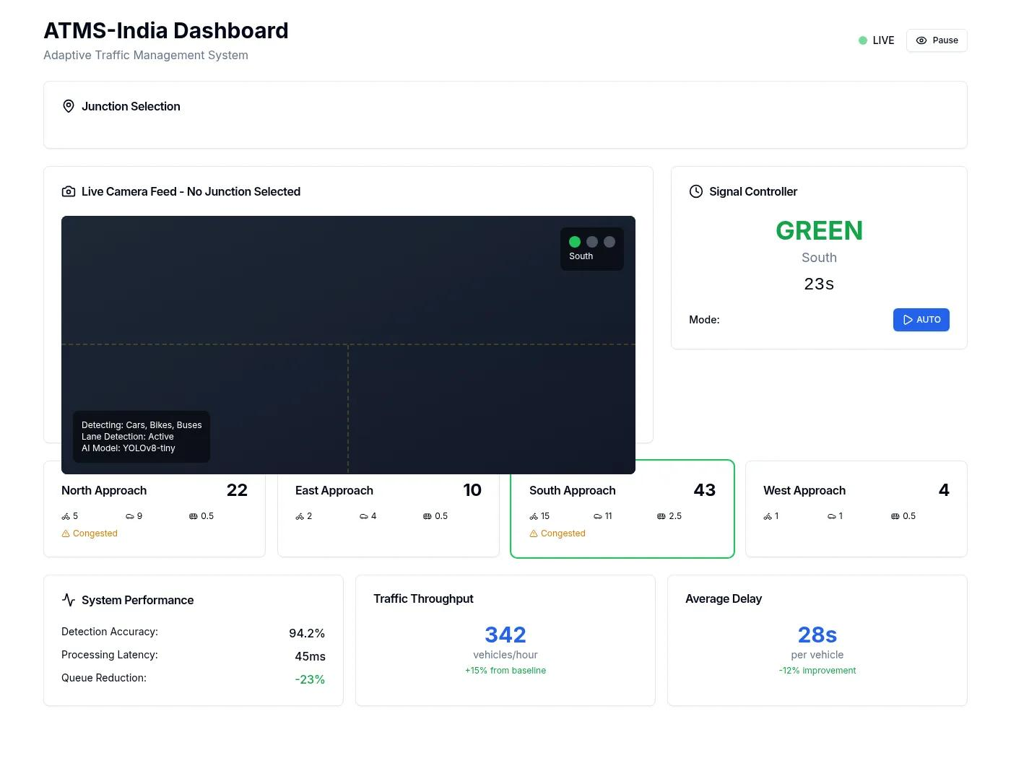
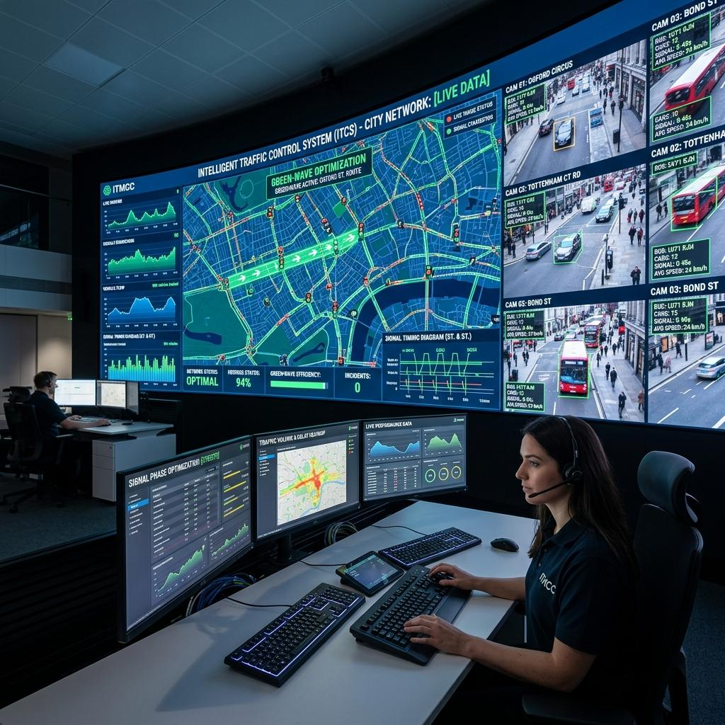
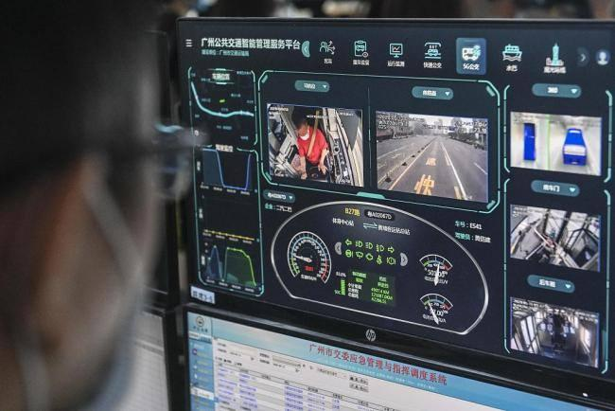
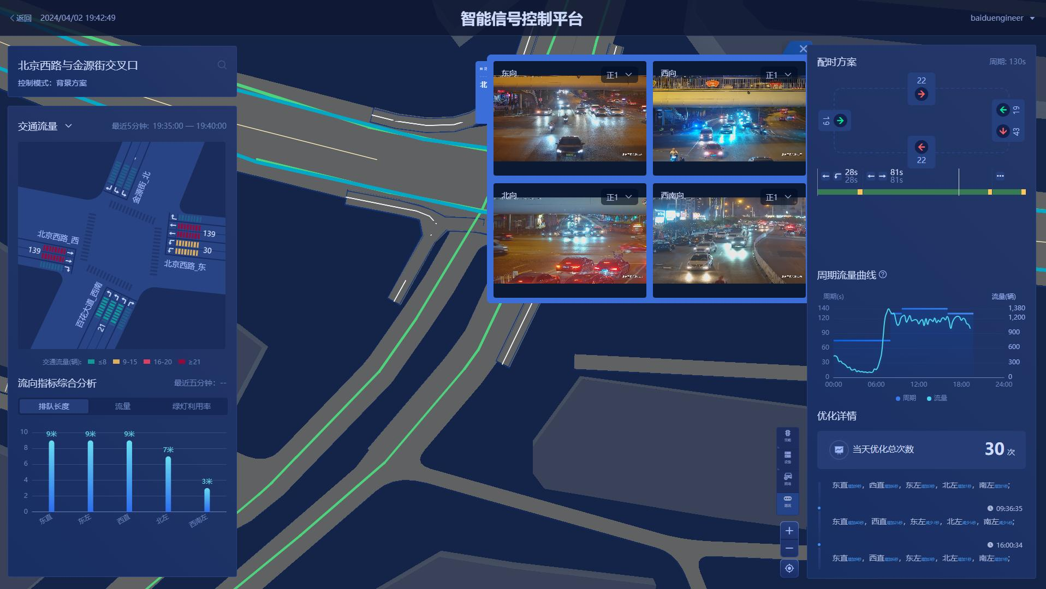
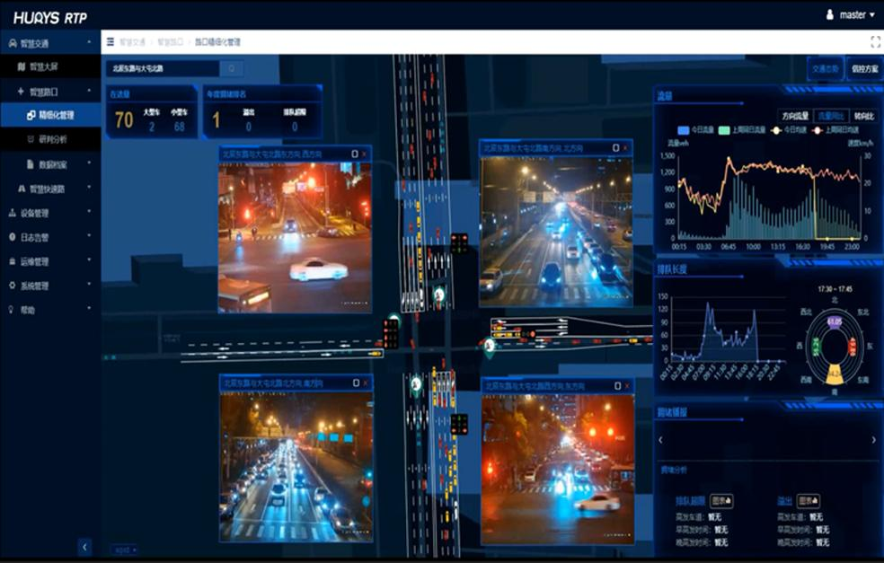
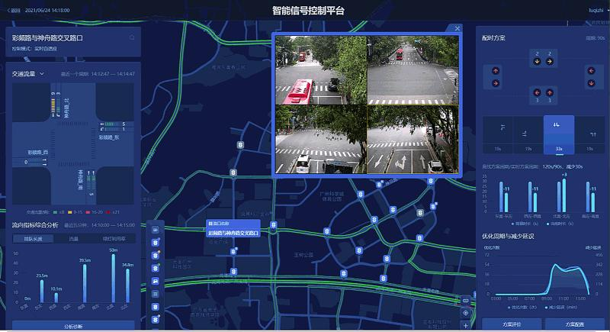
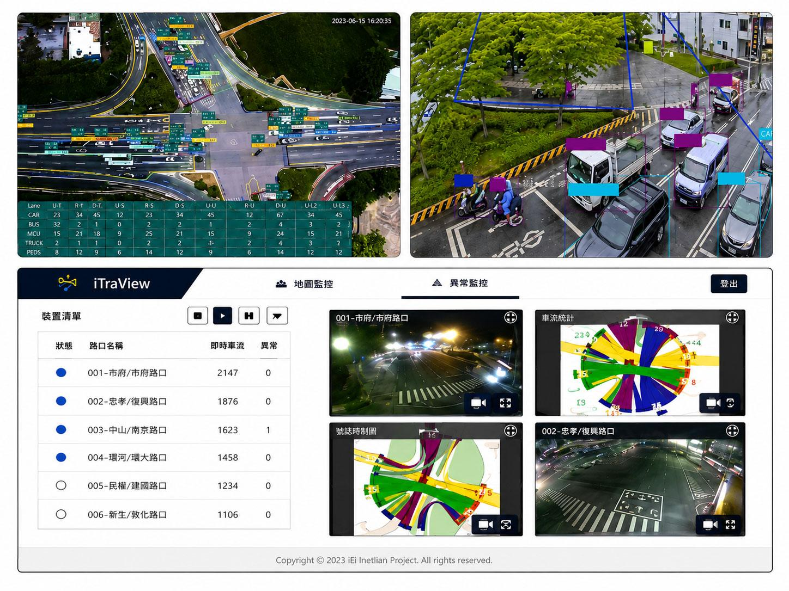
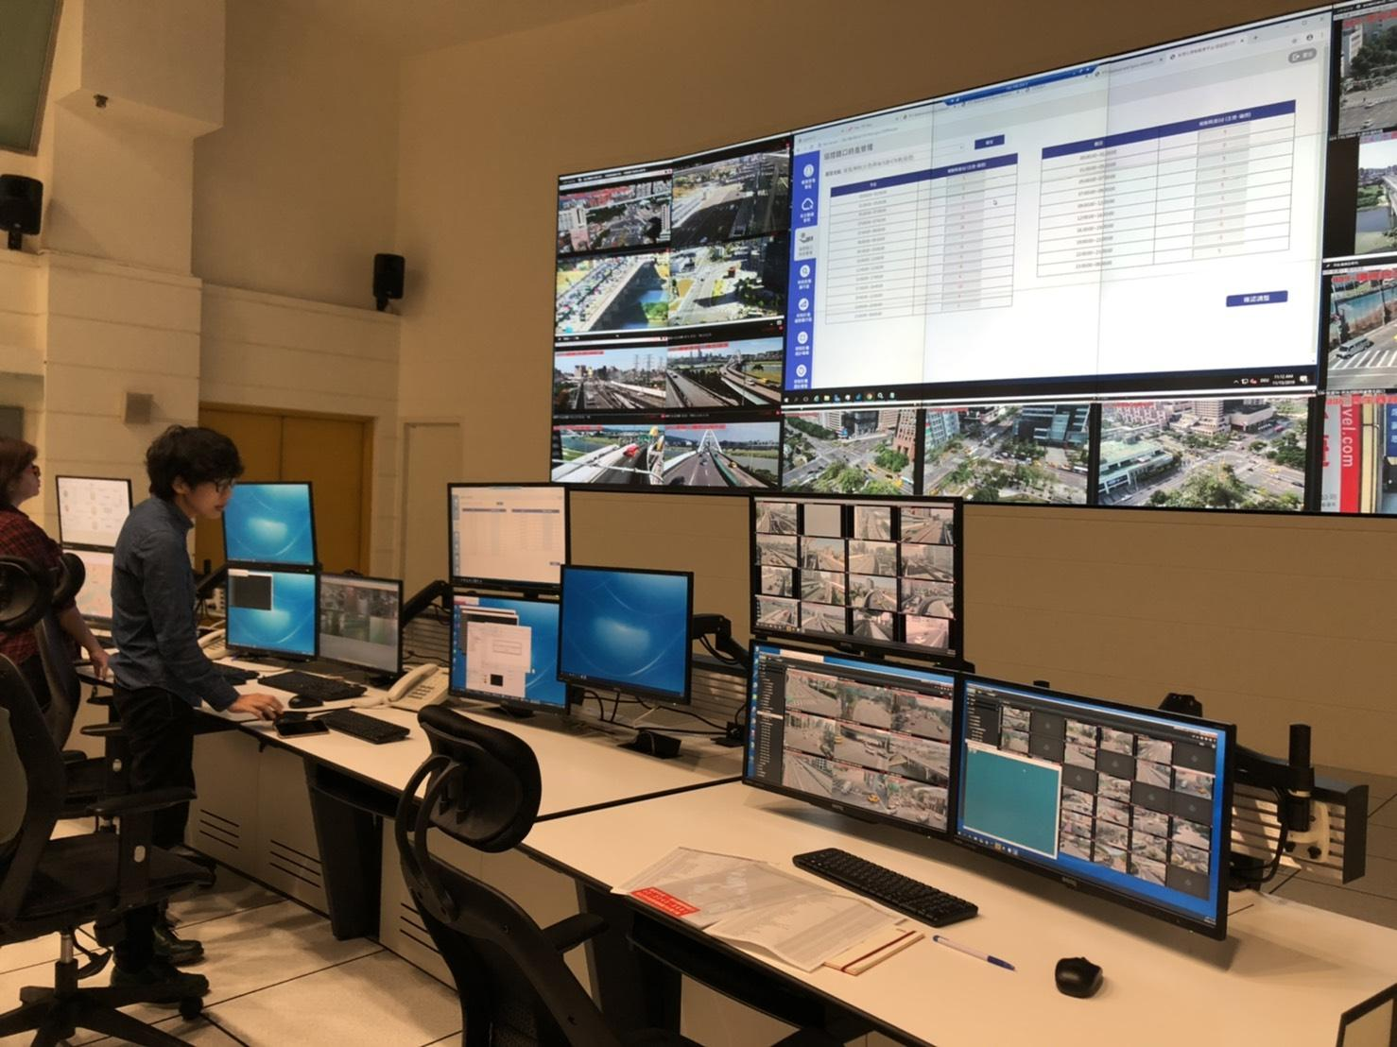
It should display:
Live Traffic Monitoring
Intersection: Junction 01

Detected Vehicles: 32

Cars: 15
Buses: 3
Trucks: 4
Motorcycles: 10
Public Transport Monitoring
Bus ID: 101

Direction: North

Distance: 100 metres

Speed: 30 km/h

Estimated Arrival: 12 seconds

Priority Status: REQUESTED
Signal Management
Current Signal: East-West Green

Bus Priority: Requested

Decision: Accepted

Next Signal: North-South Green

Priority Duration: 15 seconds
These are illustrative values, not actual measured results.

6. Recommended Development Order
Don't implement everything simultaneously.
I would build Module 1 in this order:
Phase | Task | Difficulty
1 | YOLO vehicle detection | Easy
2 | ByteTrack vehicle tracking | Medium
3 | Bus identification | Easy
4 | Intersection ROI detection | Medium
5 | Speed and distance estimation | Medium–Hard
6 | Bus arrival-time prediction | Medium
7 | Priority decision engine | Medium
8 | SUMO traffic signal integration | Hard
7. One Important Improvement I Recommend
Consider adding Passenger-Based Priority Estimation.
Think about this:
- A car carries 2 passengers.
- A bus carries 35 passengers.
- Both are waiting at the intersection.
Prioritizing the bus can potentially benefit more people.
You could calculate a priority score using:
$$P=w_{1}A+w_{2}D+w_{3}Q+w_{4}O$$
Where:
- A = Estimated bus arrival urgency.
- D = Bus delay.
- Q = Traffic queue conditions.
- O = Estimated passenger occupancy.
- w = Assigned weights.
This is an optional enhancement. You would need occupancy estimation or external passenger-count data to use O reliably.

My Verdict
For Module 1, the most important technologies are:
- YOLO: Vehicle detection.
- ByteTrack: Vehicle tracking.
- OpenCV: Video processing and vehicle movement analysis.
- Machine Learning: Arrival-time prediction.
- Optimization: Priority decision-making.
- SUMO: Traffic signal simulation.
One distinction worth remembering:
YOLO detects vehicles. ByteTrack tracks vehicles. ML predicts their arrival. The optimization engine decides whether to prioritize them.
Together, these components make Module 1 a genuine applied AI/ML project rather than a basic object detection demonstration.

