Module 2: AI-Based Vehicle Breakdown Detection and Intelligent Incident Alert System
This module focuses on identifying vehicles that unexpectedly stop on roads or near intersections, determining whether the stoppage represents a potential breakdown or road obstruction, and automatically alerting traffic authorities.
The main objective is:
Use AI and computer vision to detect unexpected vehicle stoppages, distinguish them from normal traffic behaviour, estimate their impact on surrounding traffic, and generate real-time incident alerts.
This is more than detecting a stationary vehicle using YOLO.
You need to build a system that understands vehicle movement over time and identifies abnormal behaviour.
1. How the Module Works
Imagine a four-way road intersection.
A car is travelling normally. Suddenly, its engine fails, and it stops in the middle of the road.
This creates a potential hazard:
- Vehicles behind it start slowing down.
- A traffic queue develops.
- Other vehicles may try to overtake it.
- The road becomes congested.
- The possibility of secondary collisions increases.
Your AI system should identify this situation automatically.
The overall process:
- Detect vehicles using CCTV footage.
- Track individual vehicles.
- Monitor their movement and speed.
- Identify unexpected stationary vehicles.
- Determine whether the stoppage is abnormal.
- Estimate the severity of the obstruction.
- Generate an incident alert.
- Display the incident on the traffic management dashboard.

2. Step-by-Step ML/DL Implementation
Step 1: Vehicle Detection Using YOLO
Technology: YOLO + PyTorch + OpenCV
First, your system needs to identify all vehicles visible in CCTV footage.
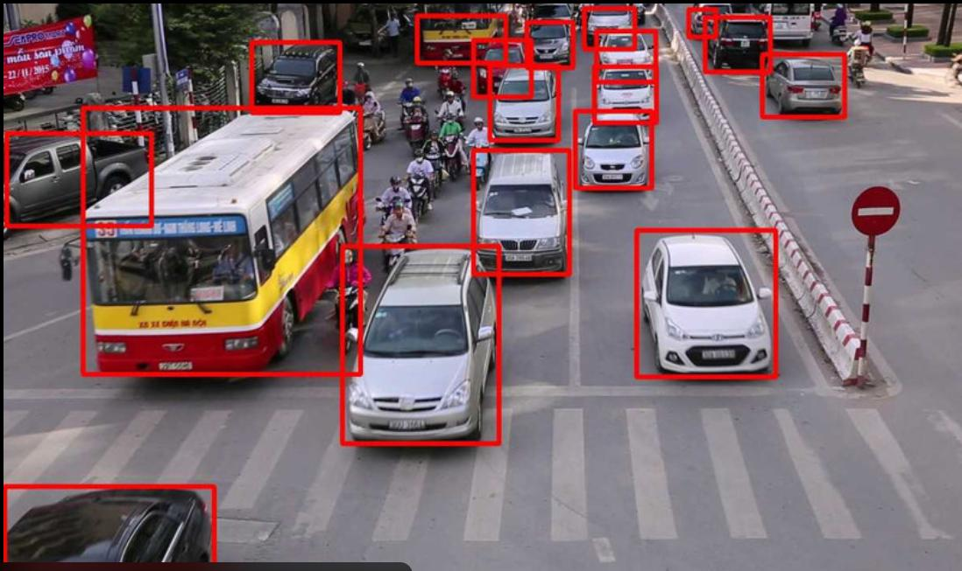
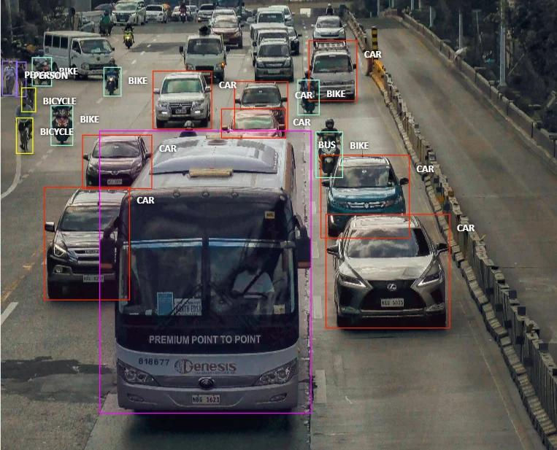
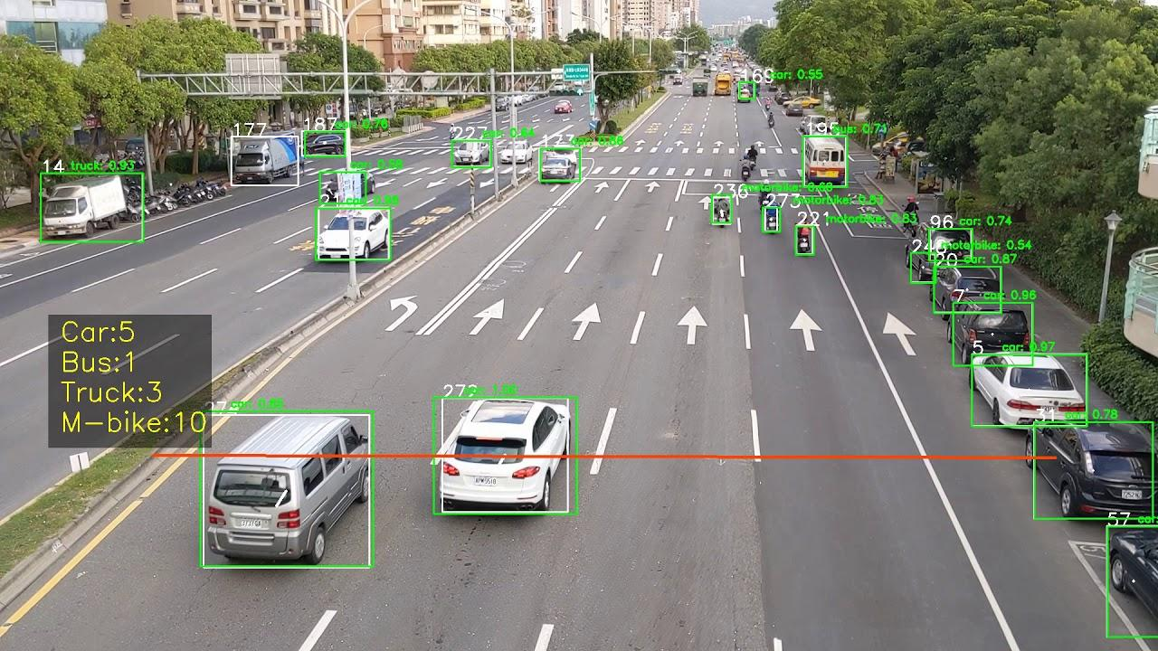
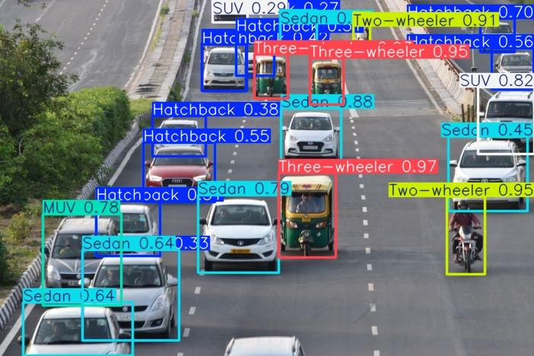
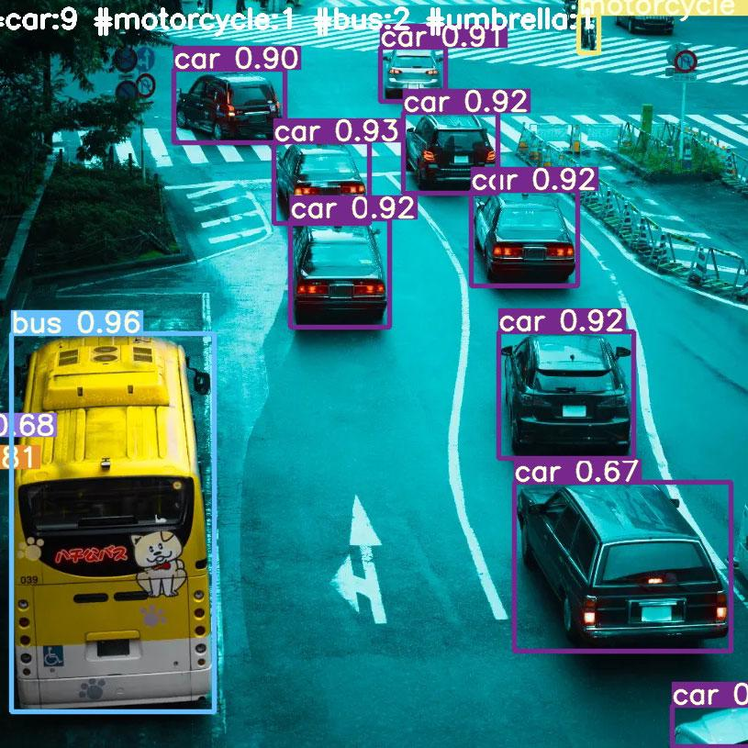
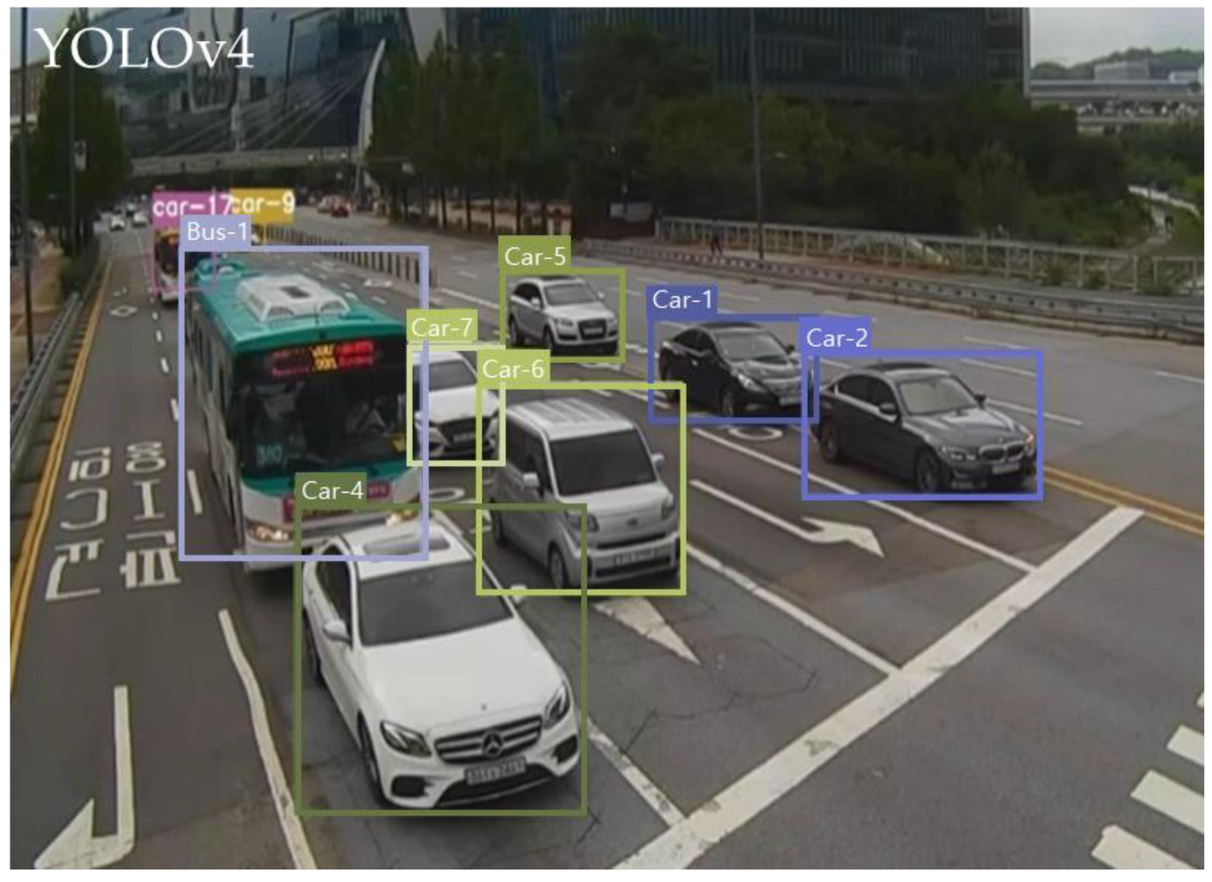
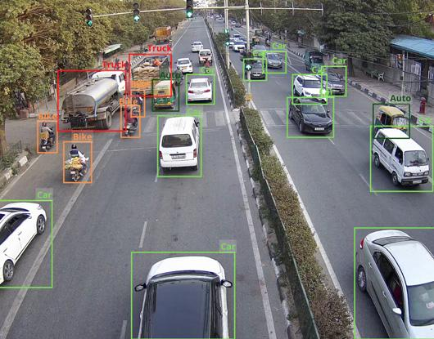
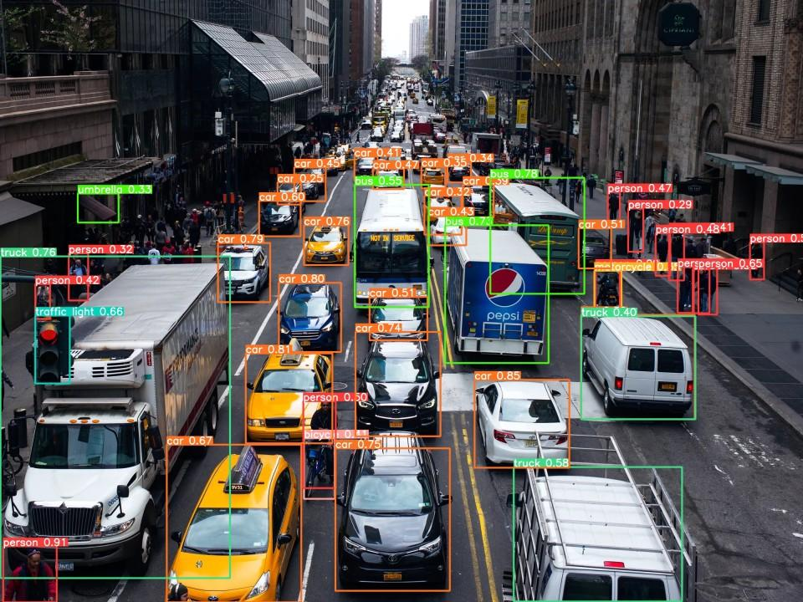
YOLO detects vehicles and classifies them into categories.
For example:
Vehicle | Detection
Car | Detected
Bus | Detected
Truck | Detected
Motorcycle | Detected
Auto-rickshaw | Custom class if required
Example output:
Frame: 250

Vehicle ID: 101
Class: Car
Confidence: 96%

Vehicle ID: 102
Class: Bus
Confidence: 94%

Vehicle ID: 103
Class: Truck
Confidence: 91%
At this stage, you are only identifying vehicles.
You cannot yet determine whether a vehicle has broken down.
Step 2: Vehicle Tracking
Technology: ByteTrack
This is one of the most important steps.
Suppose a car appears in 200 consecutive video frames.
Your system needs to understand that these detections belong to the same vehicle.
ByteTrack assigns a unique tracking ID.
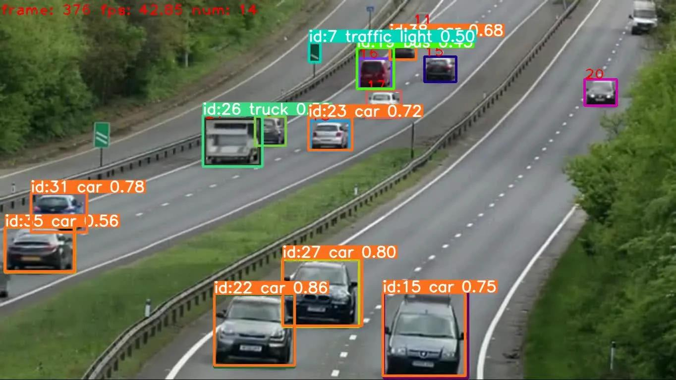
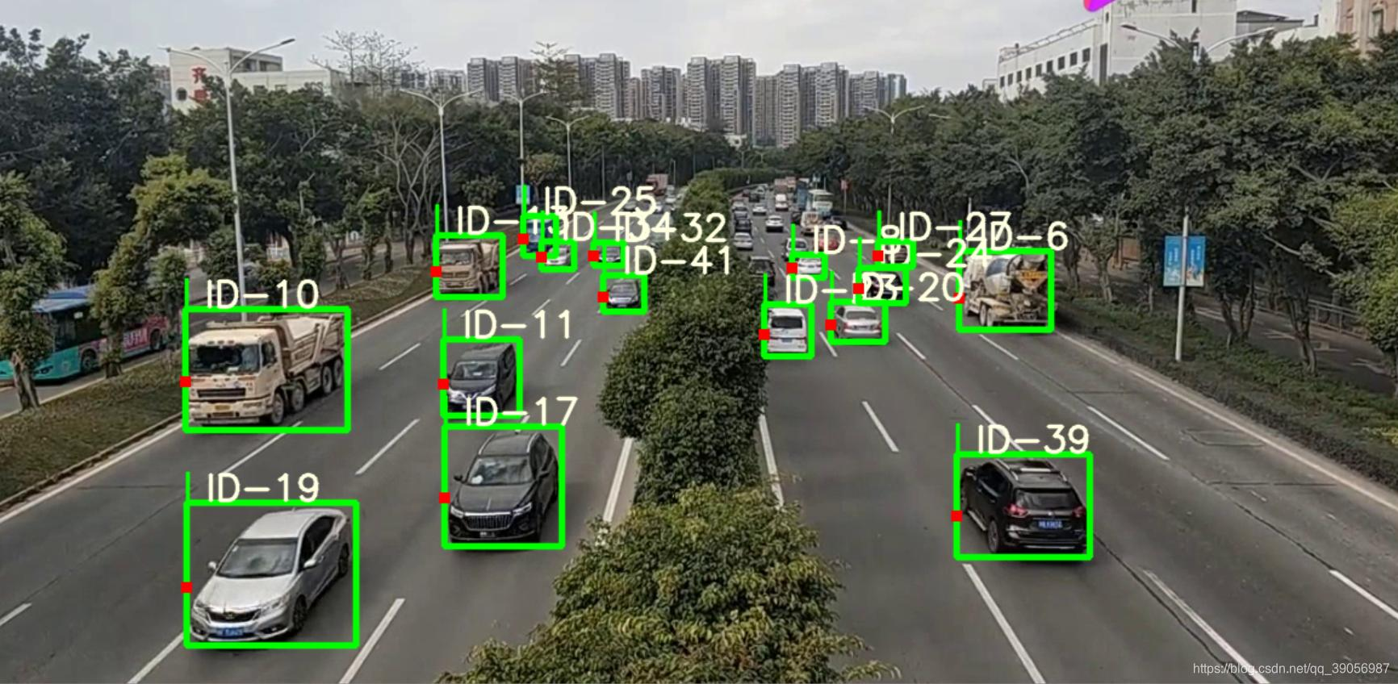
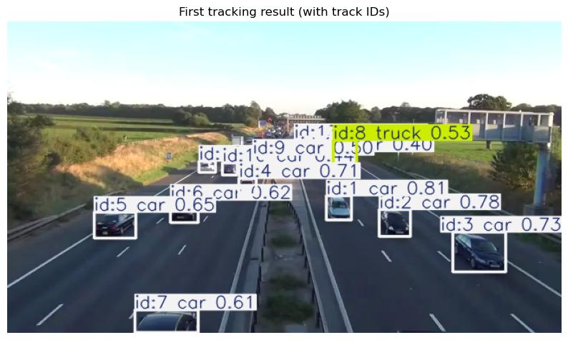
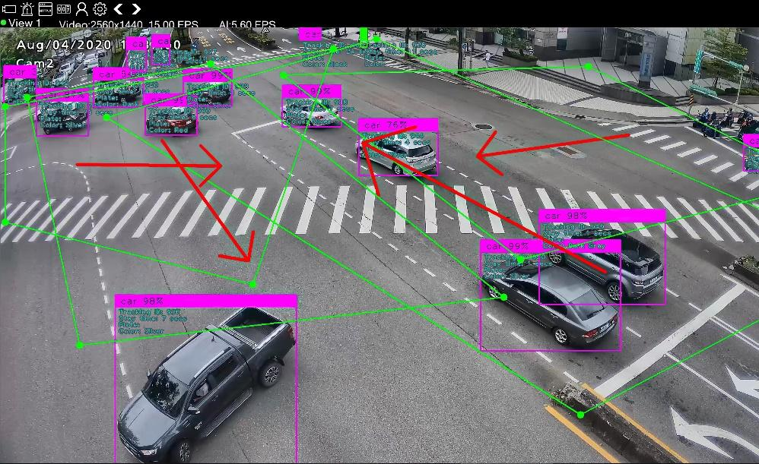
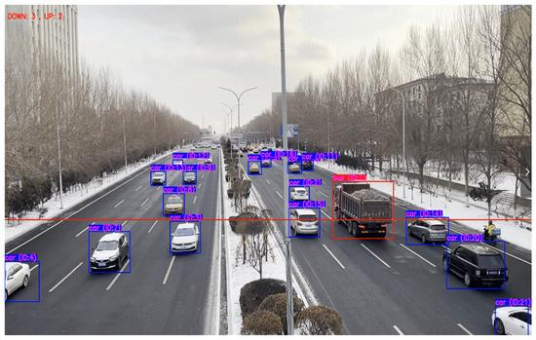
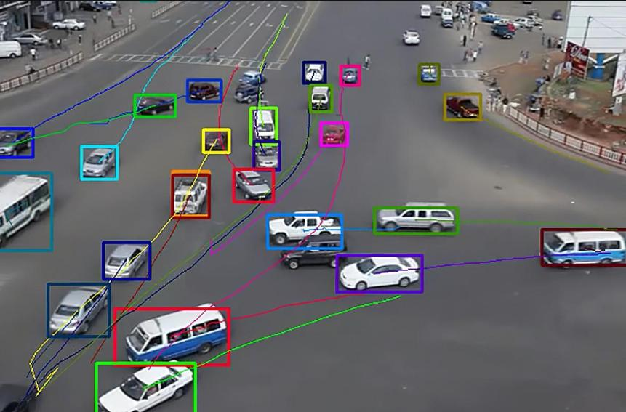
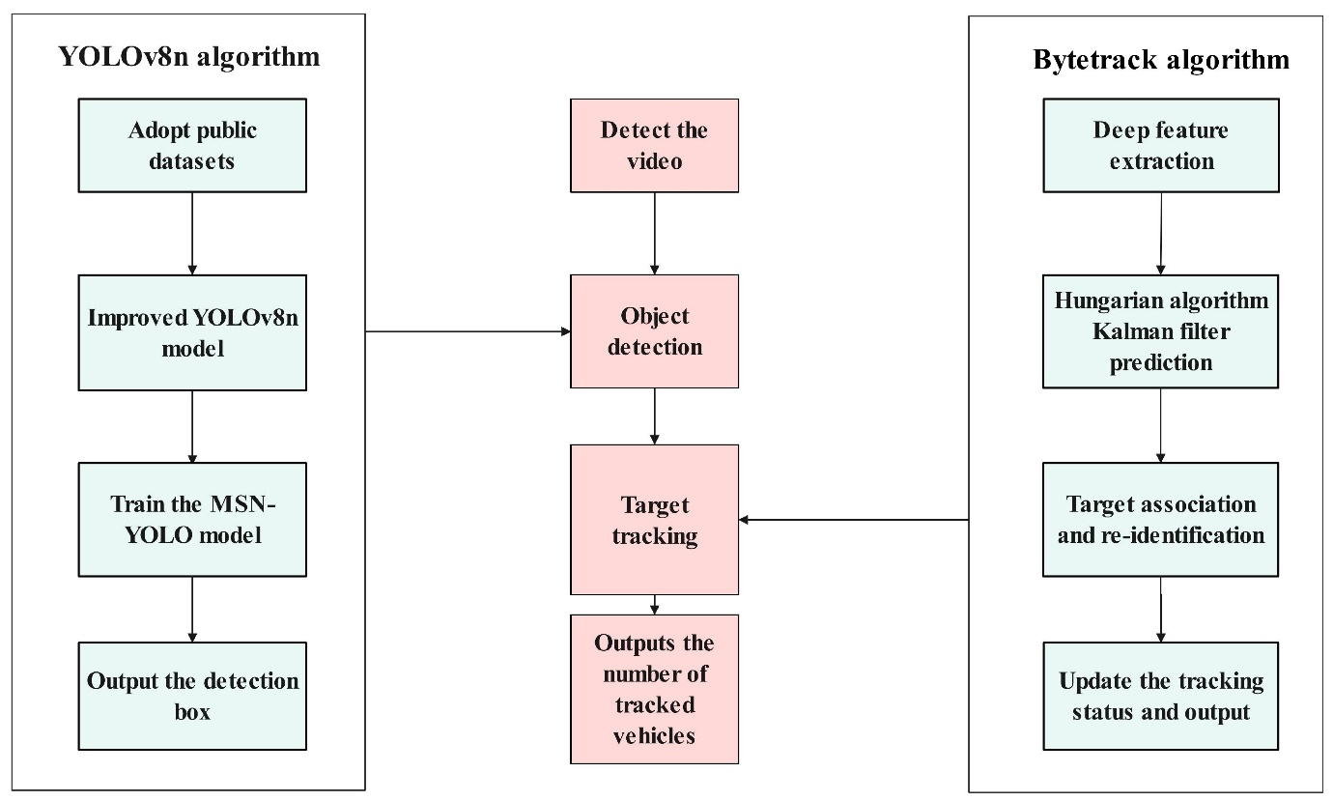
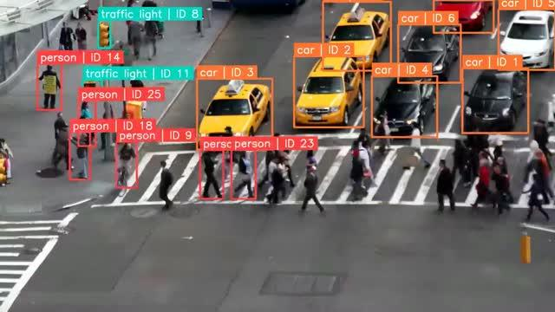
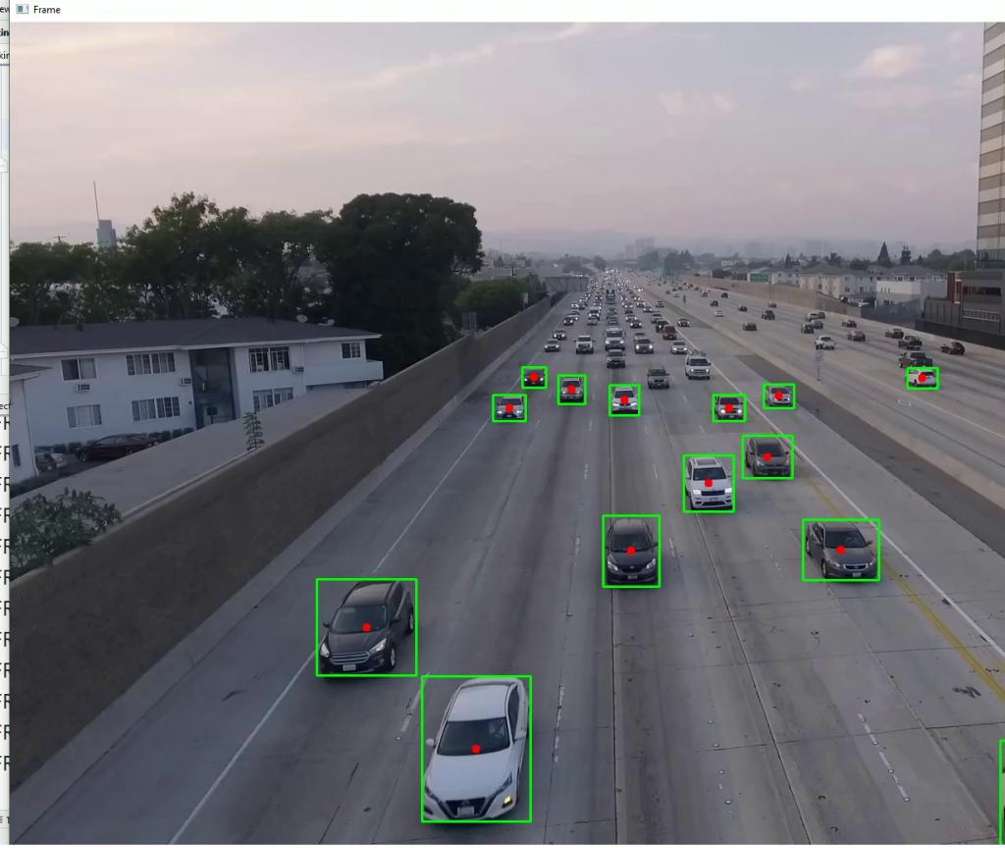
Example:
Vehicle ID: 101
Class: Car
Position: (450, 320)
Movement: Moving

Vehicle ID: 102
Class: Bus
Position: (600, 280)
Movement: Moving
Now you can continuously monitor each vehicle.
You can extract:
- Vehicle ID.
- Vehicle position.
- Movement direction.
- Previous positions.
- Current position.
- Movement history.
- Approximate speed.
Why is tracking necessary?
Because a single video frame cannot tell you whether a vehicle is moving or stationary.
You need information from multiple consecutive frames.
Step 3: Vehicle Speed Estimation
Now comes the important part.
Your system needs to estimate whether a vehicle is moving or has stopped unexpectedly.
For this, calculate the displacement of the vehicle across consecutive frames.
Suppose:
Frame | Vehicle Position
1 | (100, 200)
2 | (120, 200)
3 | (140, 200)
4 | (140, 200)
5 | (140, 200)
6 | (140, 200)
The vehicle initially moves, but its position stops changing.
You can estimate displacement using:
$$D=\sqrt{{\left(x_{2}-x_{1}\right)}^{2}+{\left(y_{2}-y_{1}\right)}^{2}}$$
Where:
- $x_{1},y_{1}$= Previous vehicle position.
- $x_{2},y_{2}$= Current vehicle position.
If displacement remains very small over a specified period, the vehicle may be stationary.
However, pixel displacement is not real-world speed.
For more accurate speed estimation, you should use:
- Camera calibration.
- Perspective transformation.
- Frame timestamps.
- Vehicle tracking history.
Step 4: Unexpected Stoppage Detection
This is the core intelligence of Module 2.
Not every stationary vehicle is a broken-down vehicle.
Consider these situations:
Situation | Interpretation
Vehicle stops at red signal | Normal
Vehicle stops in heavy traffic | Normal
Vehicle stops in a designated parking area | Normal
Vehicle unexpectedly stops in a moving lane | Potential incident
Vehicle remains stationary in the middle of an intersection | Potential incident
Vehicle stops and creates a growing queue | Potential incident
Your system must distinguish between normal and abnormal stoppages.
How can you implement this?
Use a combination of:
- Vehicle tracking.
- Speed estimation.
- Stoppage duration.
- Road-region information.
- Traffic signal status.
- Surrounding vehicle movement.
Example:
if vehicle_speed < speed_threshold:

if stopped_duration > 15:

if vehicle_in_moving_lane:

if traffic_signal != "RED":

possible_incident = True
This is a simplified starting rule, not a complete breakdown classifier.
A vehicle could stop because of congestion, a pedestrian, an obstruction or a driver choosing to stop.
Therefore, the system should initially classify such events as potential unexpected stoppages, not confirmed mechanical breakdowns.

3. Can We Use ML/DL for Breakdown Detection?
Yes. In fact, this is where you can introduce a more meaningful ML component.
I recommend two approaches.
Approach A: Rule-Based Stoppage Detection
Use:
- YOLO.
- ByteTrack.
- OpenCV.
- Speed estimation.
- Stoppage duration.
Advantages:
- Easy to implement.
- Requires less training data.
- Good for an initial working prototype.
Approach B: ML-Based Anomaly Detection
Train an ML model to identify unusual vehicle behaviour.
For example, collect features such as:
Feature | Description
Average speed | Average vehicle speed
Speed variation | Change in speed
Stoppage duration | How long the vehicle remains stationary
Lane position | Whether it is in a moving lane
Traffic density | Number of surrounding vehicles
Surrounding speed | Movement of nearby vehicles
Signal state | Red, yellow or green
You can experiment with:
- Random Forest.
- XGBoost.
- Isolation Forest.
The output could be:
Vehicle ID: 101

Predicted Behaviour:
Unexpected Stoppage

Anomaly Score: 0.91

Incident Probability: HIGH
These values are illustrative.
My recommendation: Start with rule-based detection. Once it works, introduce Isolation Forest or XGBoost to improve abnormal-behaviour classification.
Do not claim that an anomaly detection model can diagnose actual mechanical breakdowns without appropriate labelled data.

4. Step 5: Incident Severity Estimation
Detecting a potential incident is only half the problem.
You also need to determine how seriously it affects traffic.
Consider two situations.
Situation A:
A car stops near the road shoulder.
Traffic continues normally.
Situation B:
A truck stops in the middle of a busy intersection.
Traffic behind it becomes congested.
Both are stationary vehicles, but their impact is different.
You can calculate incident severity using:
$$S=w_{1}D+w_{2}T+w_{3}Q+w_{4}L$$
Where:
- D = Vehicle obstruction level.
- T = Stoppage duration.
- Q = Surrounding traffic congestion.
- L = Lane blockage level.
- w = Assigned weights.
For example:
Condition | Severity
Stopped near road shoulder | Low
Stopped in a moving lane | Medium
Blocking an intersection | High
Blocking multiple lanes | Critical
You can initially use a rule-based severity engine.
Later, you can train an ML classifier if you have sufficient labelled incident data.
5. Step 6: Automatic Incident Alert Generation
Once a potential incident is identified, your system should generate an alert.
Example:
TRAFFIC INCIDENT ALERT

Incident ID: INC-001

Vehicle ID: 101

Vehicle Type: Car

Location: Intersection 01
Direction: North

Stoppage Duration: 45 seconds

Road Obstruction: HIGH

Incident Type:
Possible Unexpected Stoppage

Severity: HIGH

Status: ACTIVE
The system should also save:
- Incident timestamp.
- CCTV camera ID.
- Vehicle location.
- Screenshot of the incident.
- Vehicle tracking ID.
- Incident severity.
You can display these alerts in your Streamlit dashboard.
For the project, you can simulate sending alerts to traffic authorities rather than connecting to actual emergency services.

6. Step 7: Detect Secondary Traffic Congestion
This is an important enhancement.
Your system should not only detect a stopped vehicle but also understand how it affects surrounding traffic.
For example:
A truck breaks down.
Vehicles behind it begin slowing down.
A queue starts forming.
Your system should identify this growing congestion.
You can calculate:
- Number of vehicles behind the stopped vehicle.
- Average speed of surrounding vehicles.
- Queue length.
- Traffic density.
- Number of blocked lanes.
Example:
INCIDENT ANALYSIS

Stopped Vehicle: Truck

Vehicles Behind: 18

Average Speed: 4 km/h

Queue Length: 120 metres

Blocked Lanes: 1

Traffic Impact: HIGH
This information can also be shared with the main traffic optimization engine.
For example, if an incident blocks the North approach, the traffic controller can adjust signal timings to reduce unnecessary vehicle accumulation there.

7. Complete Architecture of Module 2
Here is the architecture I recommend.
CCTV VIDEO INPUT
|
v
FRAME EXTRACTION
|
v
YOLO DETECTION
|
v
BYTE TRACKING
|
v
VEHICLE MOVEMENT ANALYSIS
|
v
SPEED ESTIMATION
|
v
STOPPAGE IDENTIFICATION
|
v
NORMAL VS ABNORMAL STOPPING
|
v
ANOMALY CLASSIFICATION
|
v
INCIDENT SEVERITY ANALYSIS
|
v
SURROUNDING TRAFFIC ANALYSIS
|
v
INCIDENT ALERT GENERATION
|
v
TRAFFIC DASHBOARD

8. Dataset Requirements
You can use existing datasets for vehicle detection and tracking.
Dataset | Application
BDD100K | Vehicle detection
UA-DETRAC | Vehicle tracking
AI City Challenge | Traffic surveillance
CADP (Car Accident Detection and Prediction) | Traffic incident and accident-related research
Custom CCTV videos | Unexpected stoppage scenarios
One important point: existing vehicle detection datasets don't necessarily contain labels for mechanical breakdowns.
You will likely need to create a small custom dataset containing different stoppage scenarios.
For example:
- Normal traffic signal stopping.
- Heavy traffic stopping.
- Unexpected vehicle stopping.
- Roadside parking.
- Intersection obstruction.
You can annotate these scenarios and use them for training or evaluation.

9. Recommended Technology Stack
Component | Technology
Vehicle detection | YOLO
Object tracking | ByteTrack
Video processing | OpenCV
Feature extraction | NumPy, Pandas
Speed estimation | Computer Vision
Anomaly detection | Isolation Forest
Classification | Random Forest / XGBoost
Backend | FastAPI
Dashboard | Streamlit
Database | SQLite
You don't need to introduce every technology immediately.
Start with YOLO + ByteTrack + OpenCV.
Then add the ML anomaly detection component.

10. What Should Your Final Dashboard Look Like?
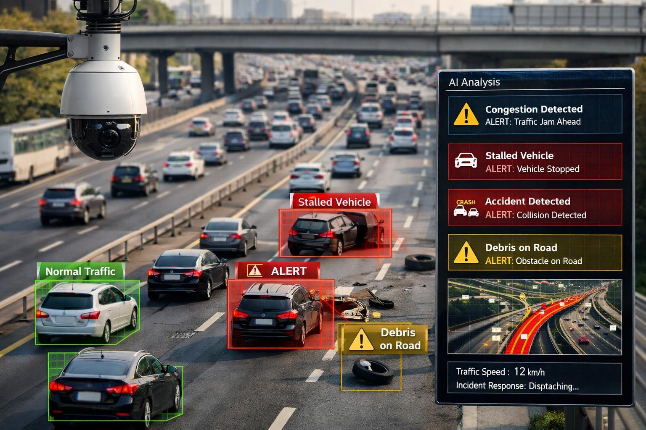
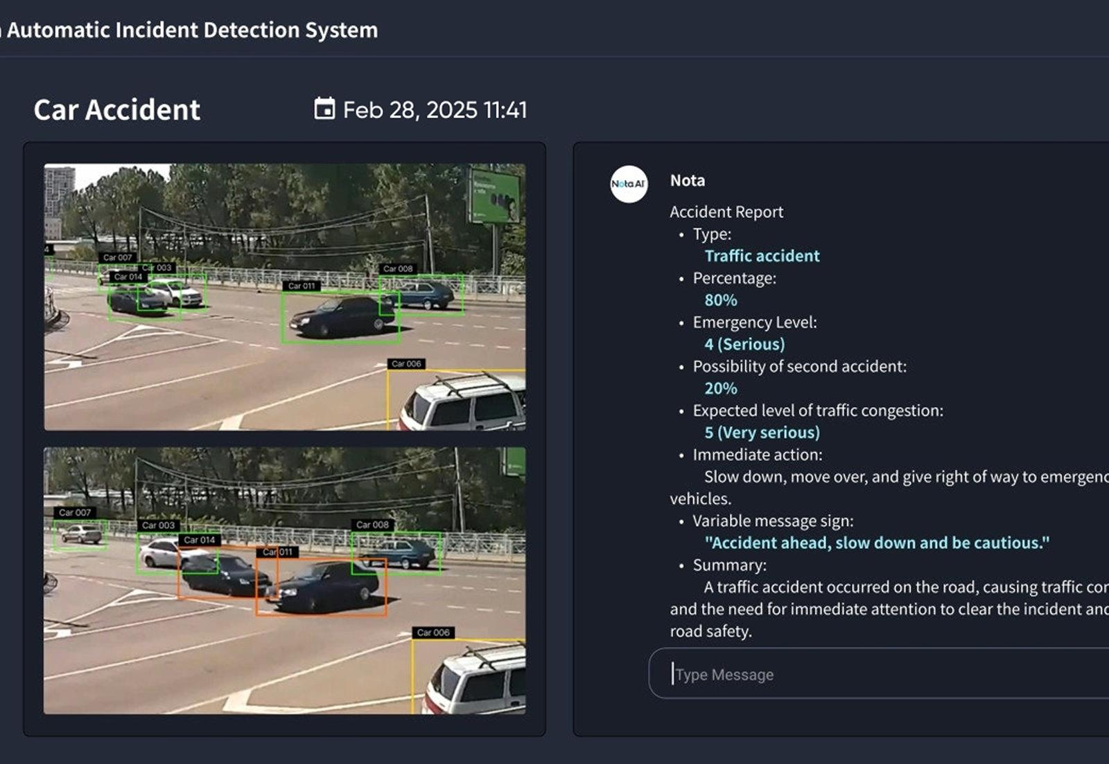
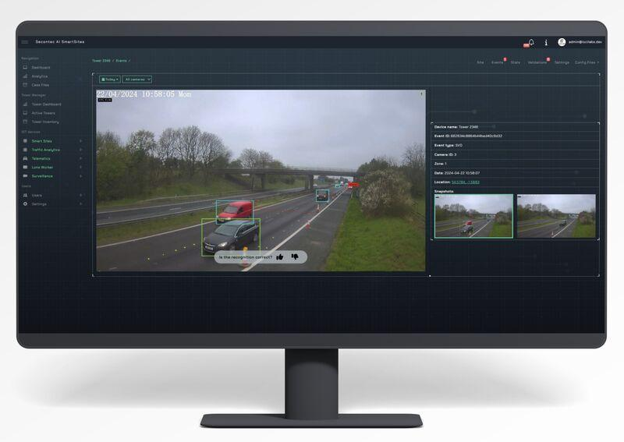
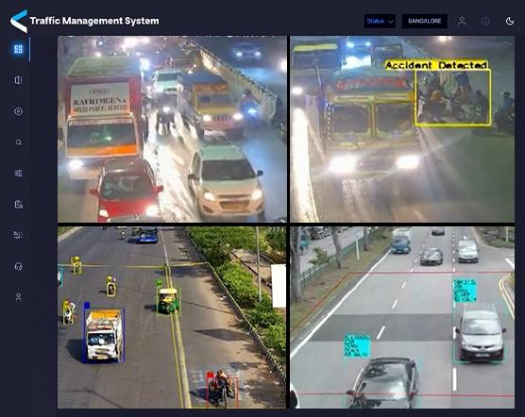
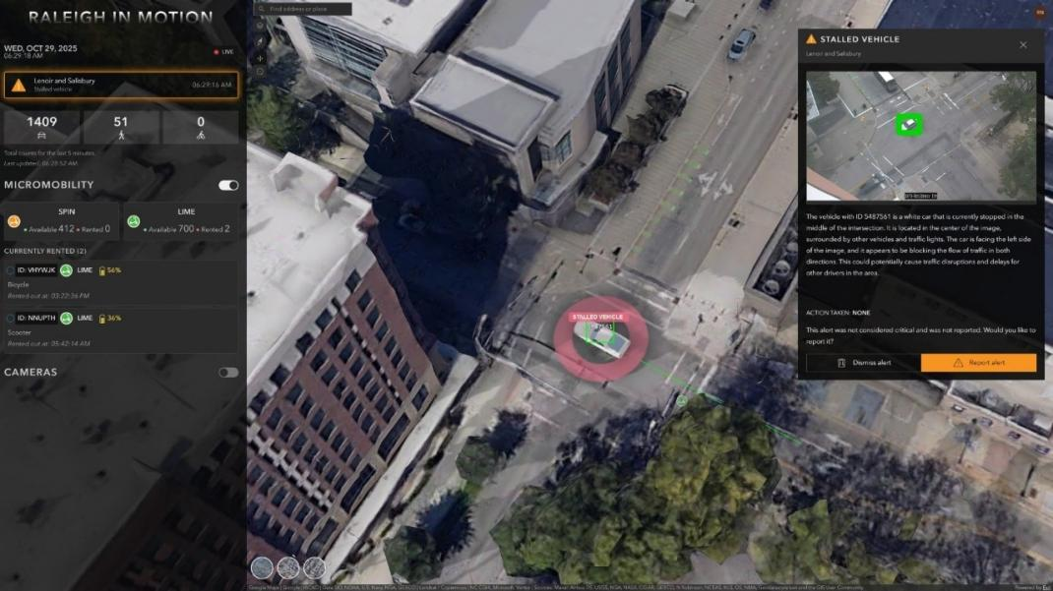
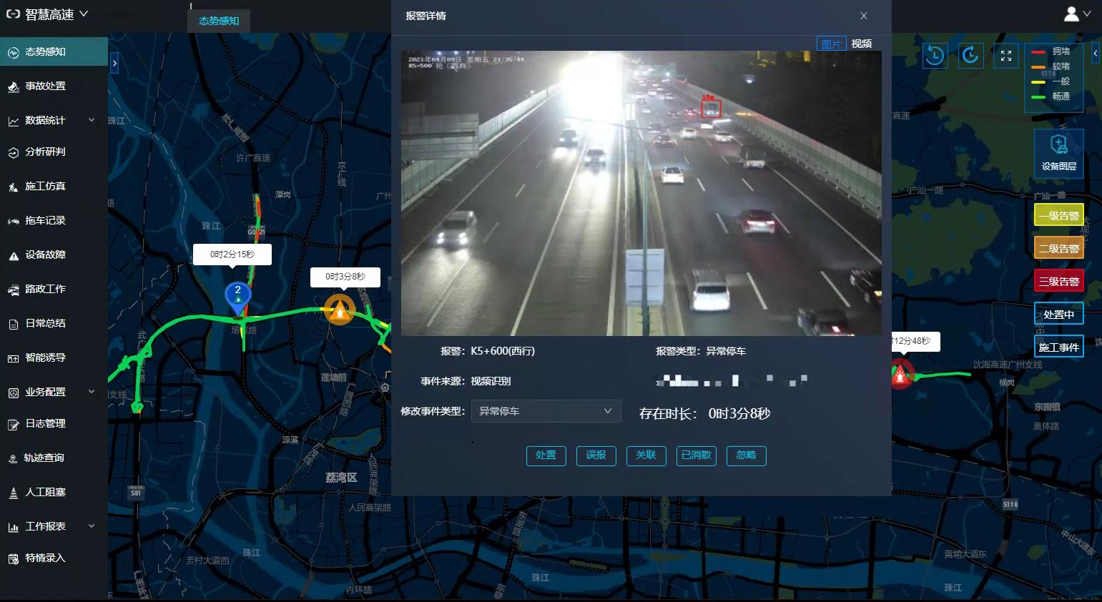
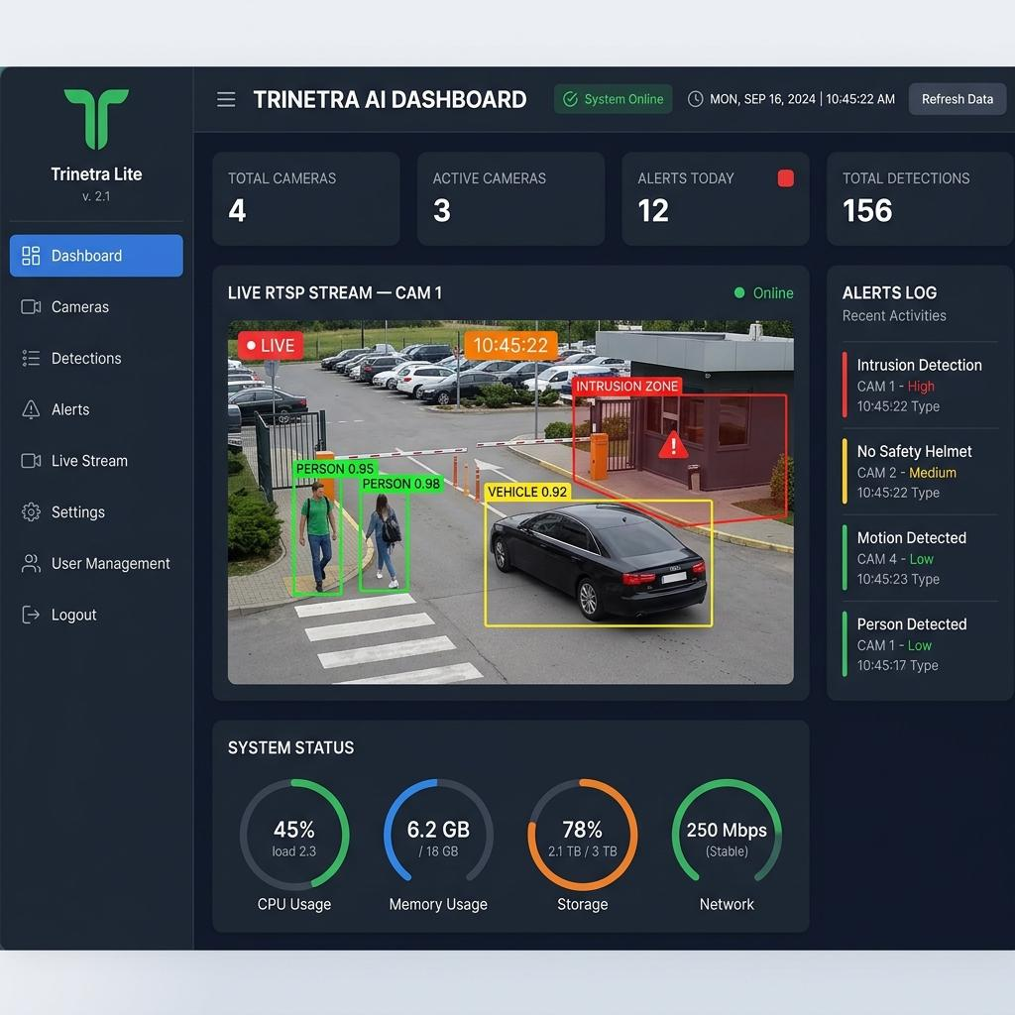
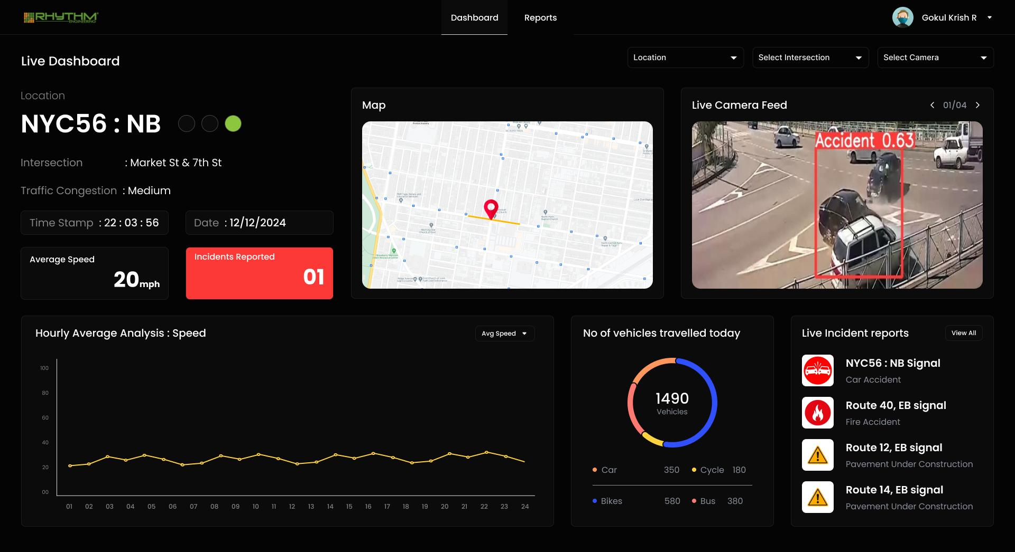
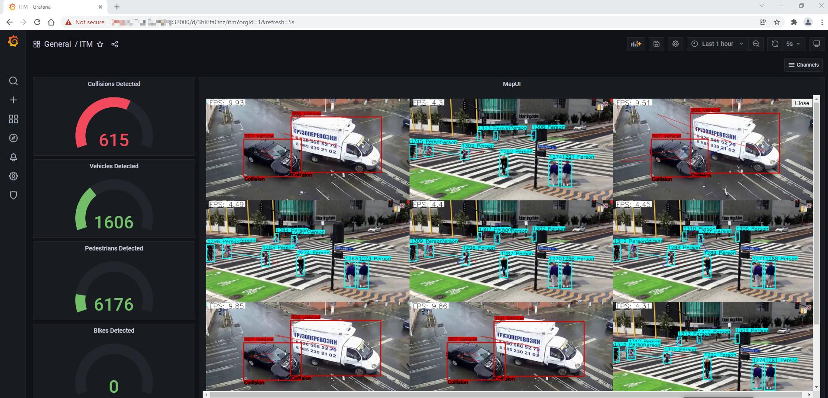
Your dashboard should contain four sections.
A. Live Traffic Monitoring
Total Vehicles: 42

Cars: 20
Buses: 5
Trucks: 7
Motorcycles: 10
B. Vehicle Stoppage Monitoring
Vehicle ID: 101

Vehicle Type: Car

Current Speed: 0 km/h

Stoppage Duration: 45 seconds

Detection Status: Abnormal
C. Incident Alerts
Active Incidents: 2

INC-001: High Severity
INC-002: Medium Severity
D. Traffic Impact Analysis
Affected Direction: North

Queue Length: 120 metres

Average Vehicle Speed: 4 km/h

Road Obstruction: HIGH
All these are example values.

11. Development Phases
I recommend developing Module 2 in this order.
Phase | Development | Difficulty
1 | YOLO vehicle detection | Easy
2 | ByteTrack vehicle tracking | Medium
3 | Vehicle speed estimation | Medium
4 | Stationary vehicle identification | Medium
5 | Normal vs abnormal stoppage detection | Medium–Hard
6 | ML-based anomaly detection | Medium–Hard
7 | Incident severity estimation | Medium
8 | Automatic alert generation | Easy
9 | Dashboard integration | Easy

12. One Important Enhancement I Recommend
Incident-Aware Traffic Signal Optimization
This is where Module 2 connects with your complete project.
Imagine:
- A truck breaks down in the North direction.
- 20 vehicles are waiting behind it.
- The East direction has relatively low traffic.
- A bus approaches from the South.
Your integrated system can:
- Detect the stopped truck.
- Identify the blocked North approach.
- Generate an incident alert.
- Notify the traffic management engine.
- Consider alternative signal timings.
- Prioritize the approaching bus if safe.
- Reduce unnecessary traffic accumulation.
This makes the three modules work together rather than functioning as independent applications.

My Final Recommendation
For Module 2, concentrate on these five components:
Component | Technology
Vehicle detection | YOLO
Vehicle tracking | ByteTrack
Movement and speed analysis | OpenCV
Abnormal stoppage detection | Isolation Forest / XGBoost
Incident severity and alerts | Decision engine
The most important distinction:
- YOLO tells you that a vehicle exists.
- ByteTrack tells you where that vehicle moves.
- Movement analysis tells you whether it has stopped.
- Anomaly detection determines whether the stoppage is unusual.
- Incident analysis determines how severely it affects traffic.
Together, these components form an AI-powered vehicle incident detection system.
One thing I particularly recommend: Reuse the YOLO detection and ByteTrack tracking pipeline from Module 1. You don't need to build those components again. Both modules can share the same traffic perception engine, which will make your final integrated project more efficient and easier to maintain.

