Module 3: AI-Based Intelligent U-Turn Management and Adaptive Traffic Signal Optimization
This module focuses on identifying vehicles waiting for U-turns, estimating U-turn queue lengths, monitoring traffic density in different directions, and dynamically adjusting U-turn signal timings.
The main objective is:
Develop an intelligent traffic management system that monitors U-turn queues and dynamically allocates signal time based on real-time traffic conditions, reducing unnecessary waiting times and traffic congestion.
This module is particularly interesting because it combines Computer Vision, Machine Learning and Traffic Signal Optimization.
Unlike a traditional traffic signal that operates using fixed timings, your system makes decisions based on actual road conditions.
1. How the Module Works
Imagine a busy four-way intersection.
Vehicles are waiting to take a U-turn.
However:
- The U-turn signal has a fixed duration.
- Sometimes too many vehicles are waiting.
- Sometimes very few vehicles need a U-turn.
- Other directions may experience unnecessary delays.
Your system should intelligently manage these situations.
For example:
Situation A:
- 20 vehicles waiting for a U-turn.
- 5 vehicles moving straight.
- High U-turn traffic.
Your system should consider increasing the U-turn signal duration.
Situation B:
- 2 vehicles waiting for a U-turn.
- 25 vehicles waiting to move straight.
- Low U-turn traffic.
Your system should allocate less time to the U-turn phase.
The system continuously observes traffic and adjusts signal timings accordingly.

2. Step-by-Step ML/DL Implementation
Step 1: Vehicle Detection Using YOLO
Technology: YOLO + PyTorch + OpenCV
First, your system needs to detect all vehicles approaching the intersection.
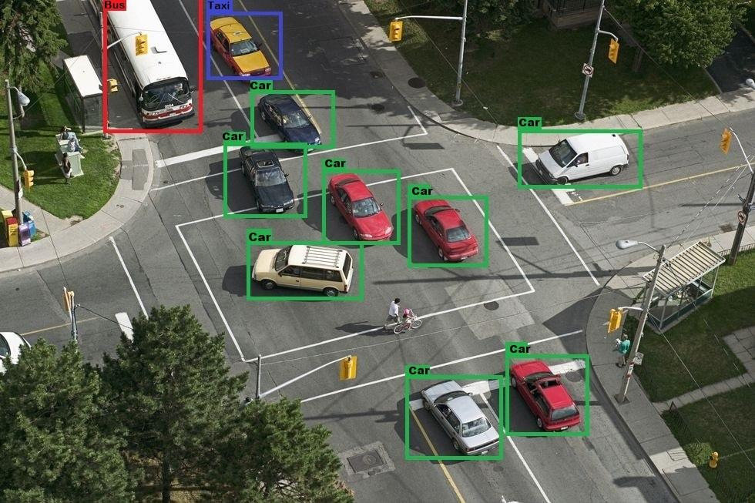
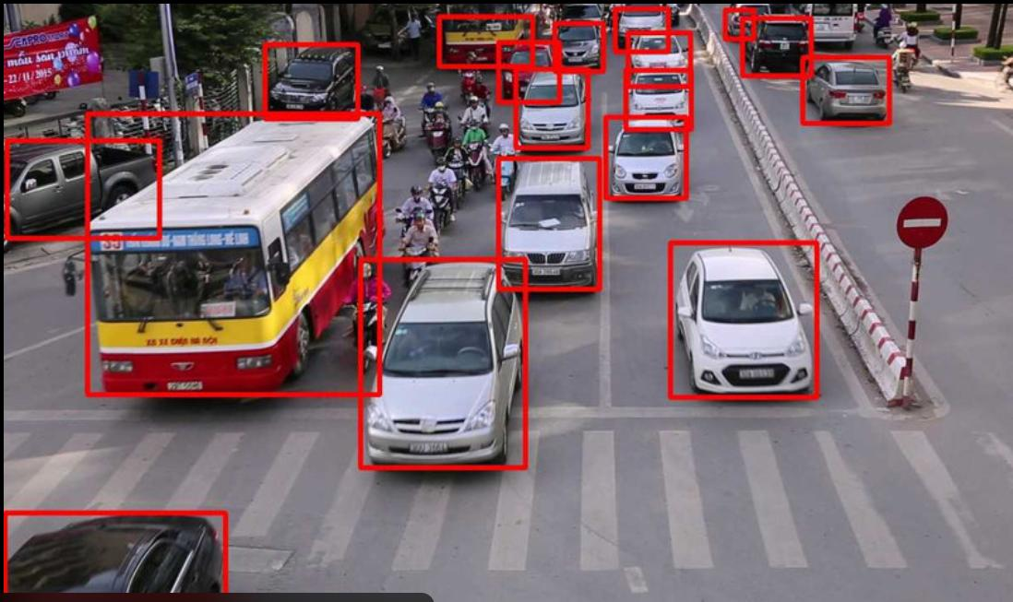
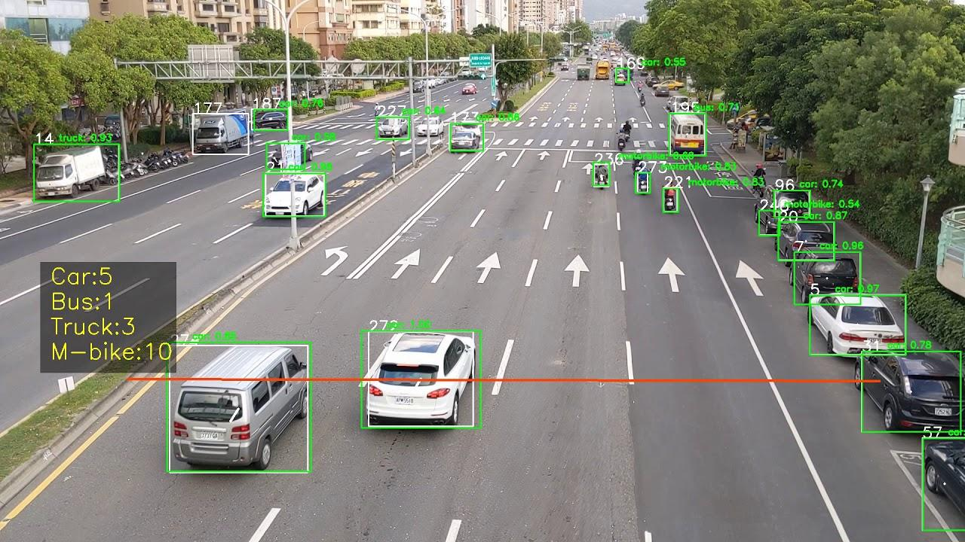
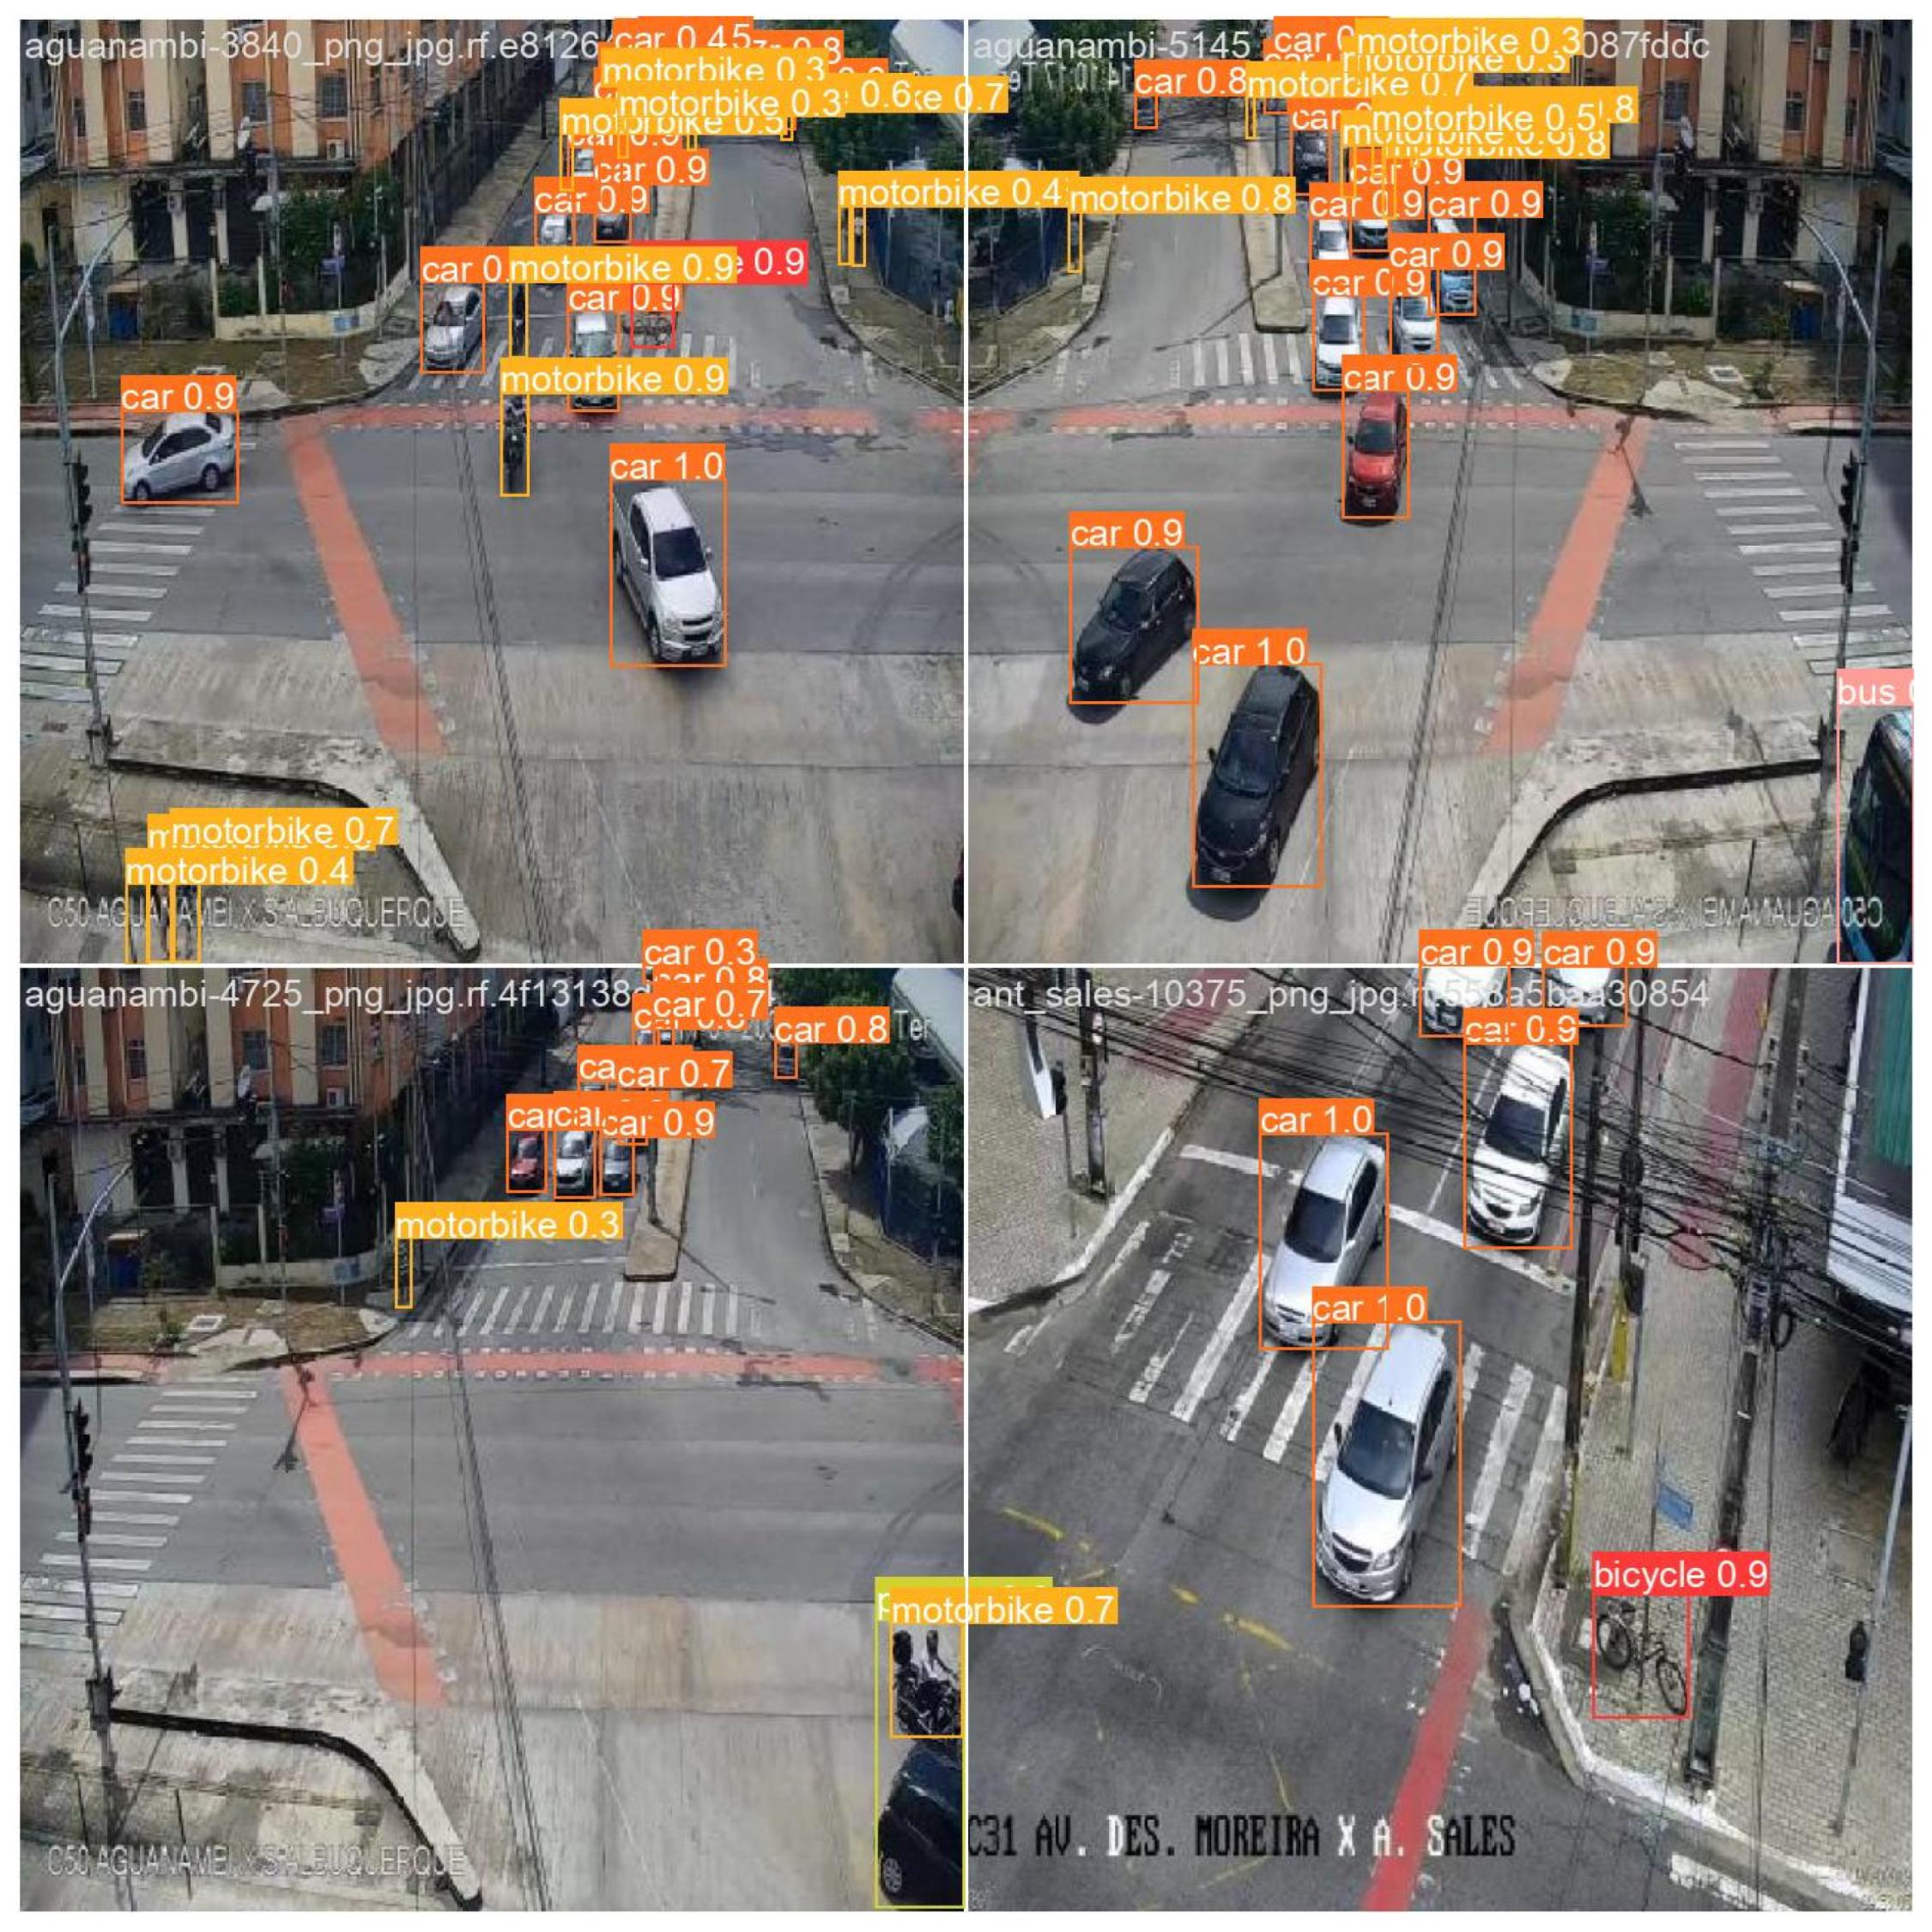
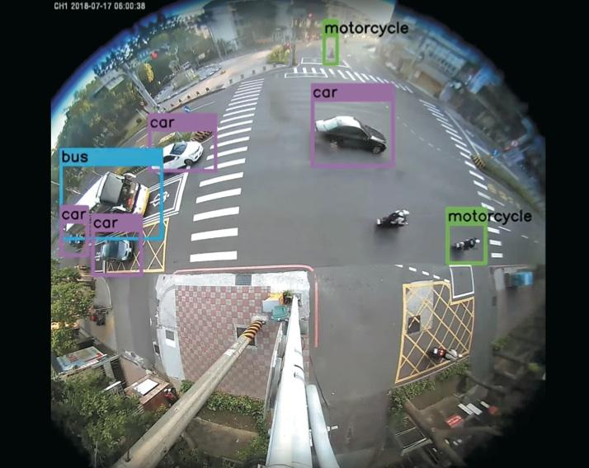
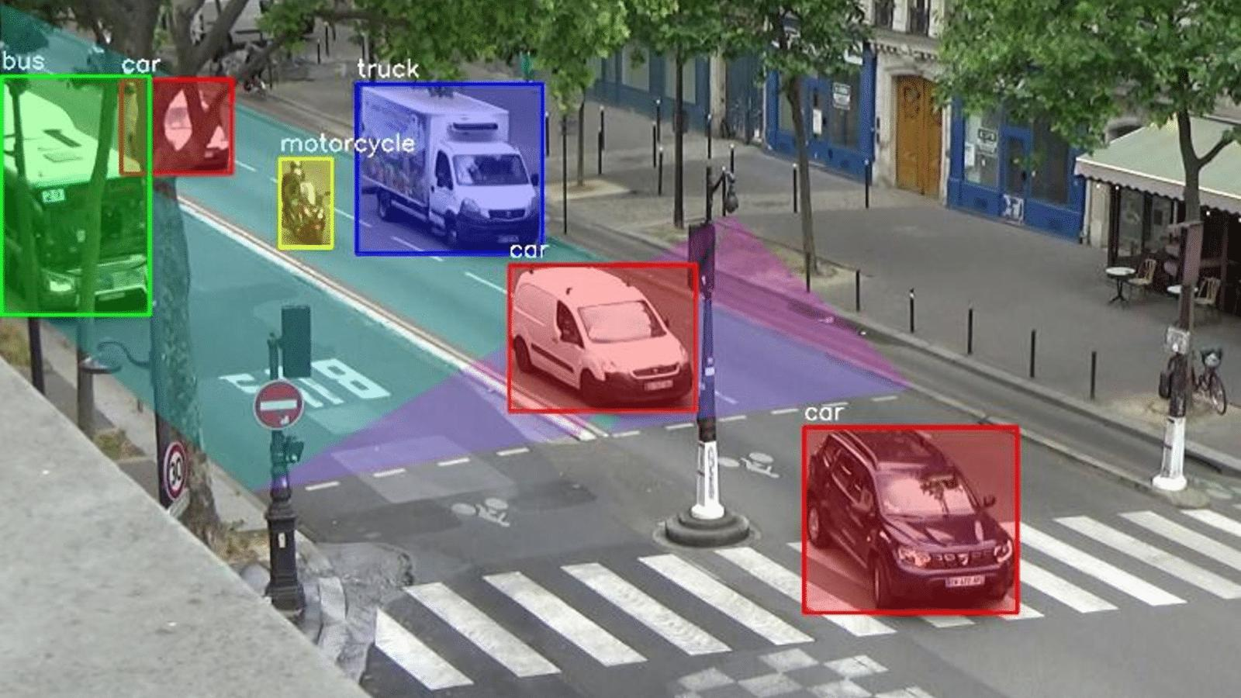
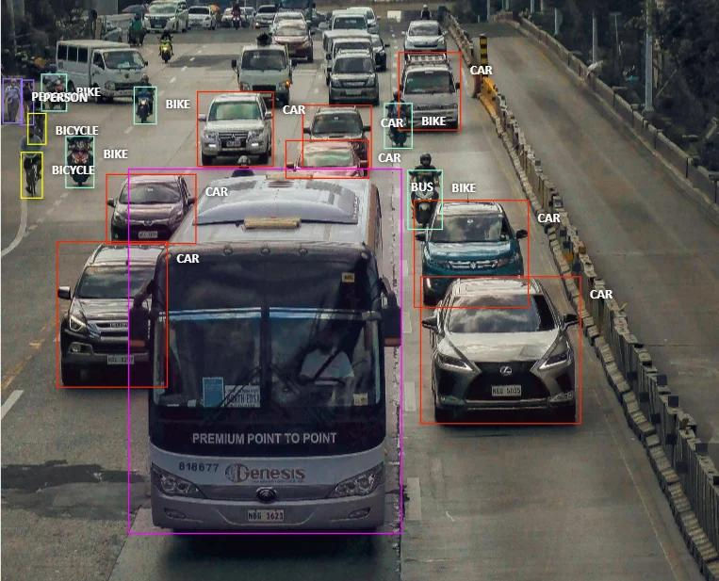
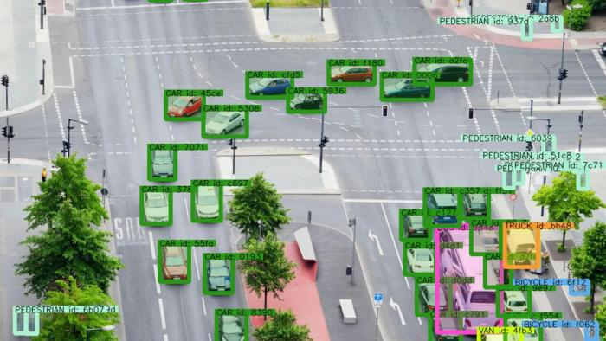
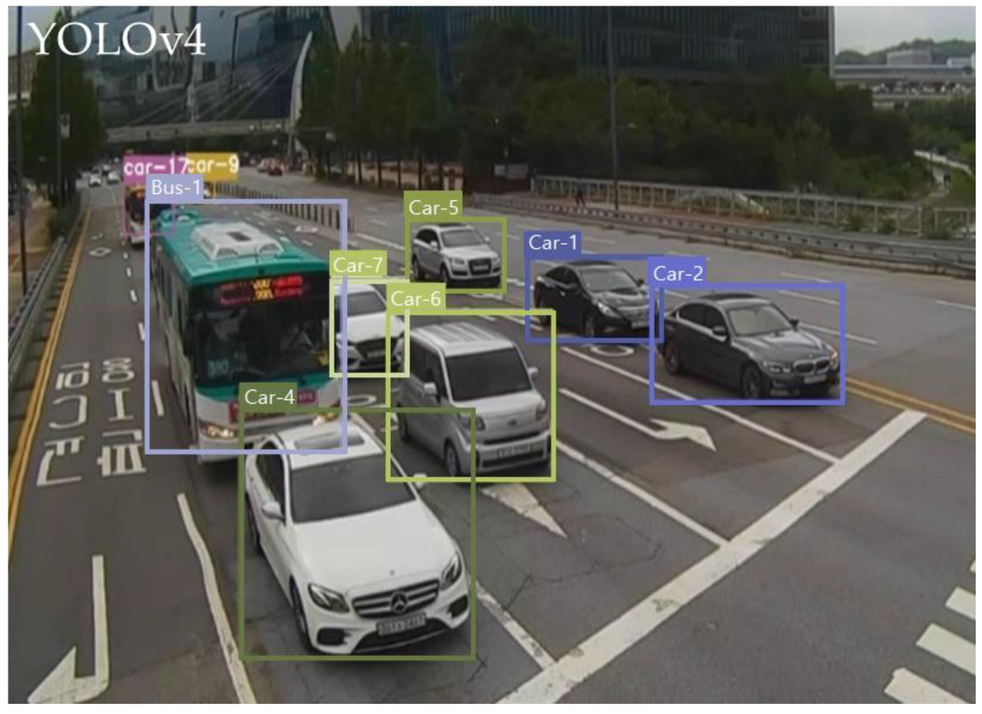
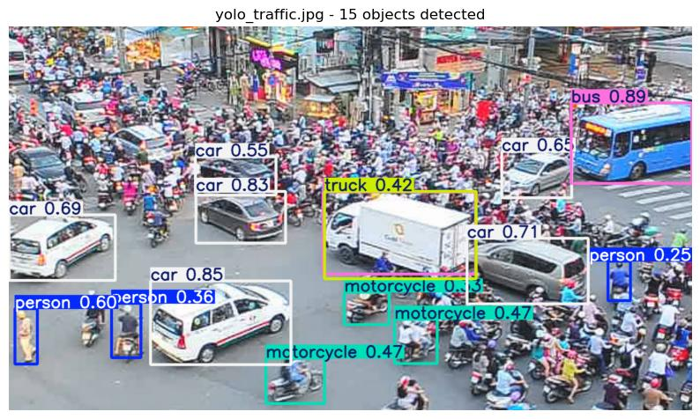
YOLO identifies vehicles from CCTV footage.
For example:
Frame: 150

Vehicle 1: Car
Vehicle 2: Motorcycle
Vehicle 3: Bus
Vehicle 4: Auto
Vehicle 5: Car
Your system should detect:
- Cars.
- Buses.
- Trucks.
- Motorcycles.
- Auto-rickshaws.
You can use a pretrained YOLO model initially.
Important: This is the same detection pipeline you developed for Modules 1 and 2.
You don't need to train another vehicle detection model.
Step 2: Vehicle Tracking Using ByteTrack
Technology: ByteTrack
Detection alone cannot determine which vehicles are waiting for U-turns.
You need to track their movement.
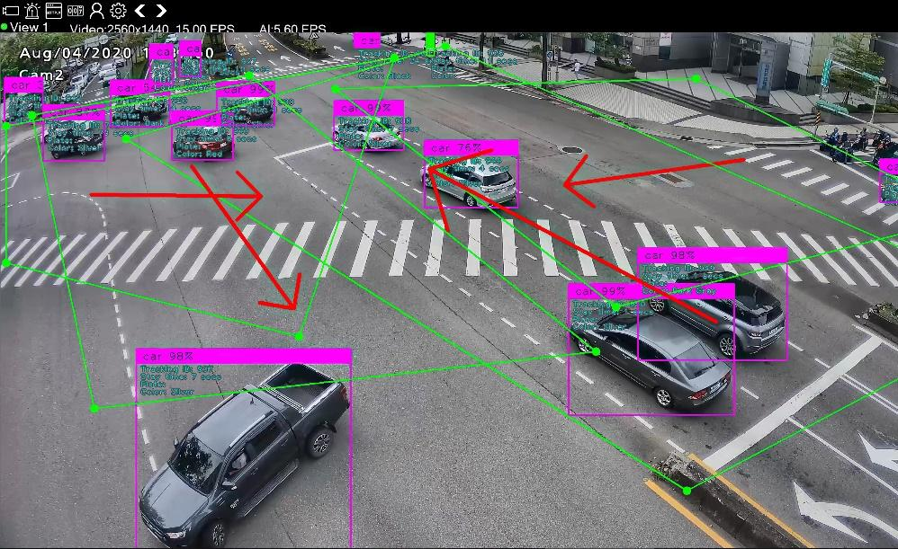
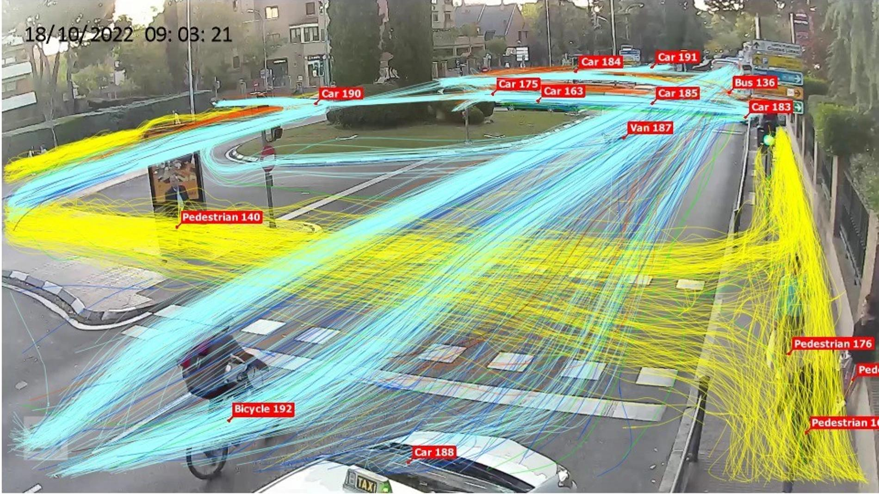
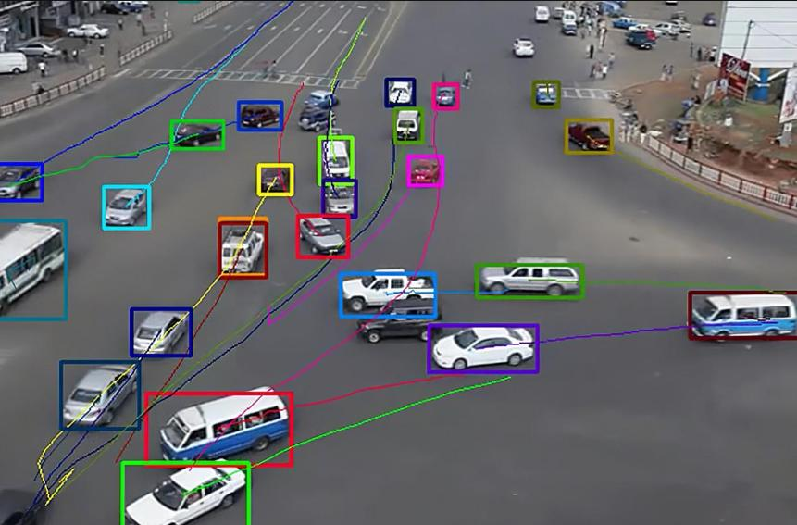
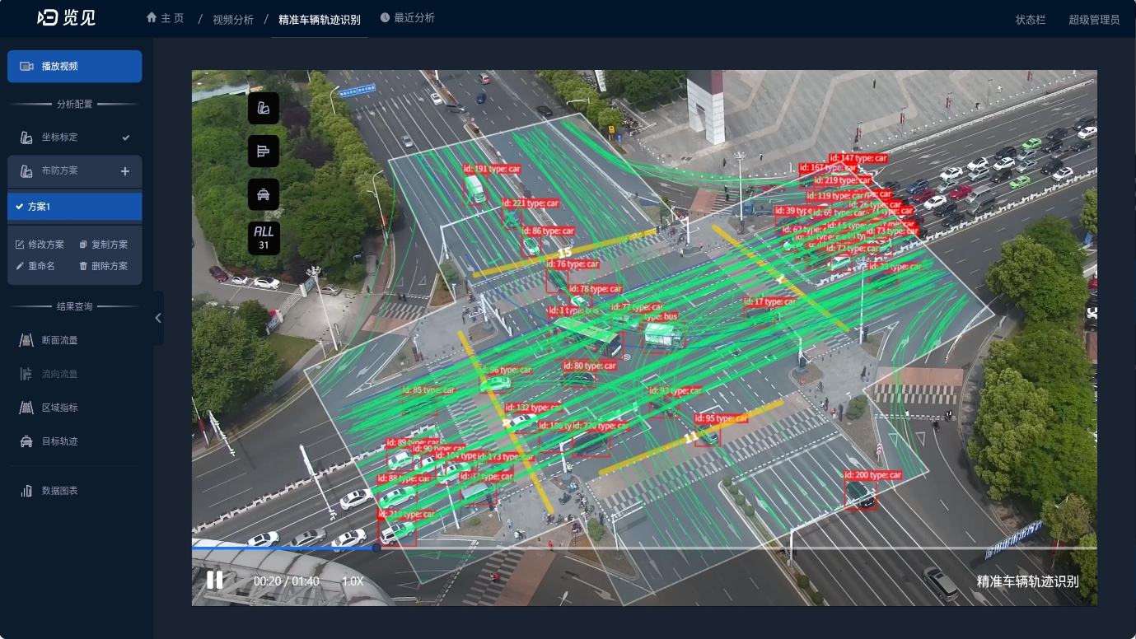
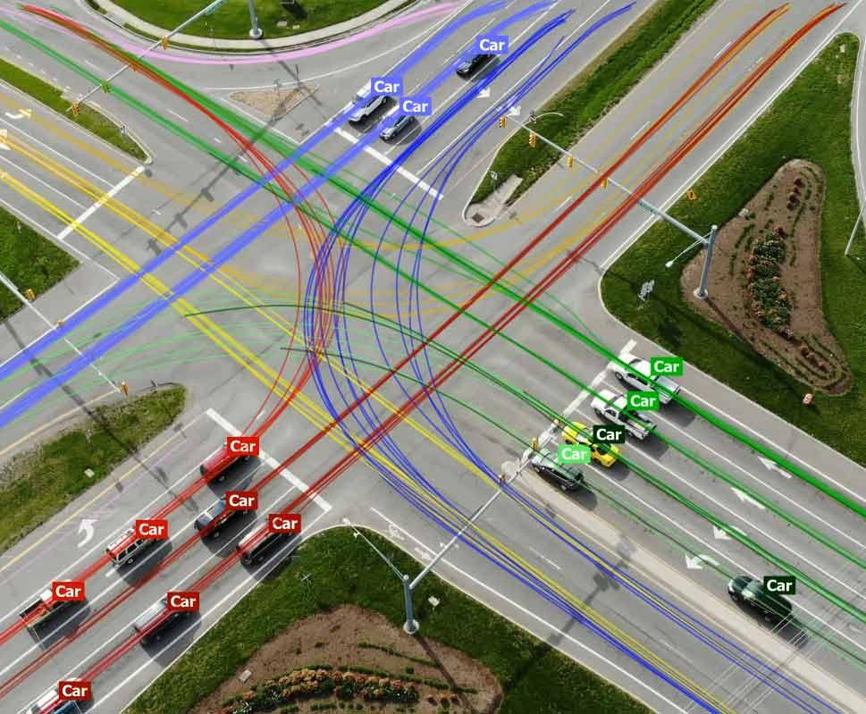
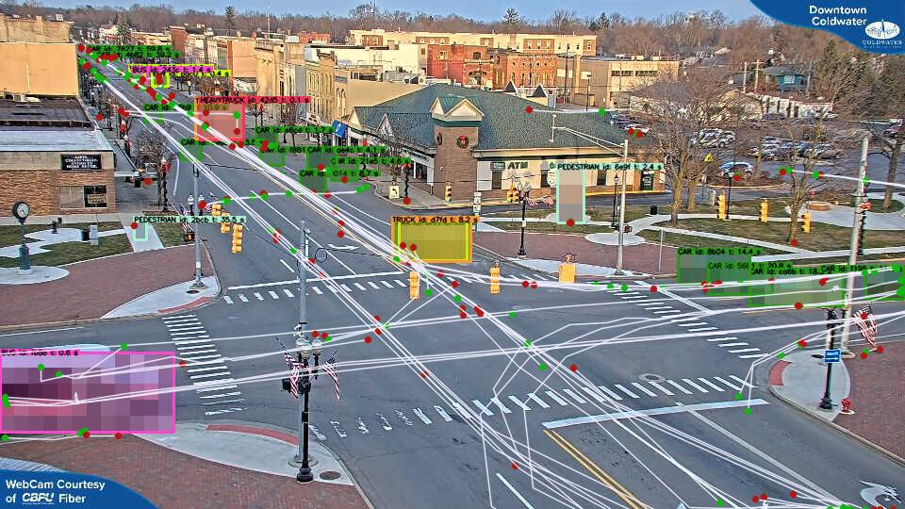
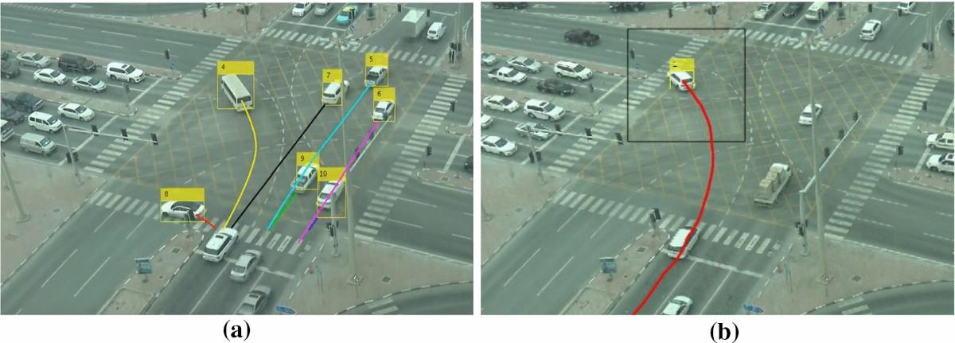
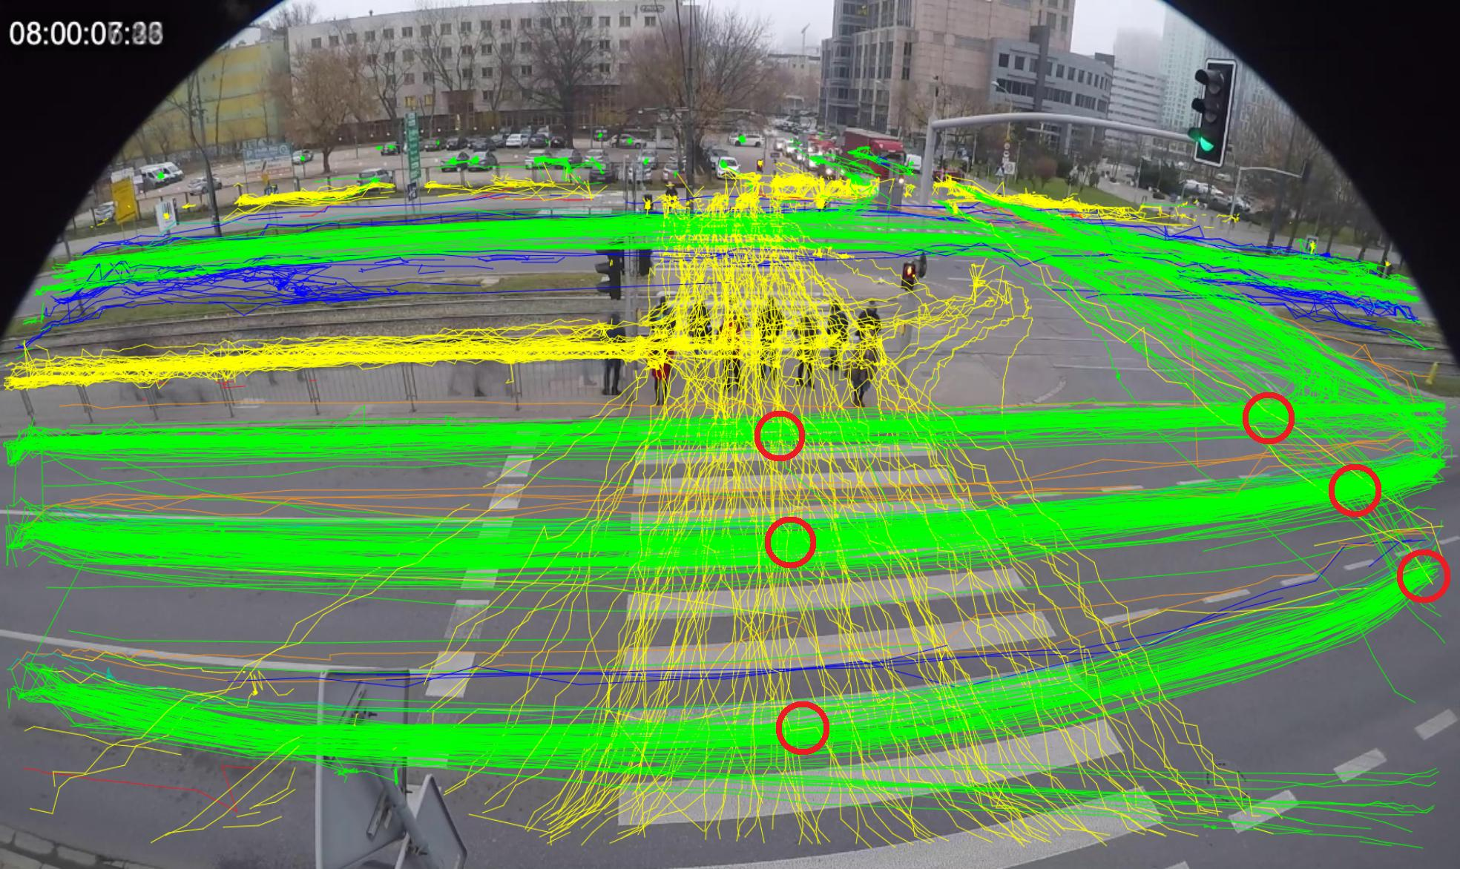
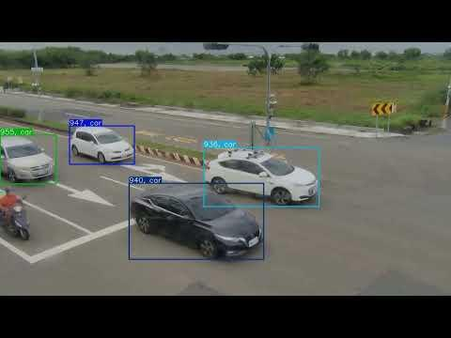
ByteTrack assigns unique IDs to vehicles.
Example:
Vehicle ID: 101
Class: Car
Direction: North
Movement: Approaching intersection

Vehicle ID: 102
Class: Motorcycle
Direction: North
Movement: Waiting

Vehicle ID: 103
Class: Bus
Direction: East
Movement: Moving
Now your system can monitor each vehicle's movement over time.
You can extract:
- Vehicle ID.
- Vehicle position.
- Vehicle trajectory.
- Movement direction.
- Waiting duration.
- Approximate speed.
Step 3: Identify U-Turn Lanes and Regions
Technology: OpenCV + Region of Interest (ROI)
This is one of the most important steps.
Your system needs to understand which vehicles are waiting for a U-turn.
For this, divide the intersection into different regions.
For example:
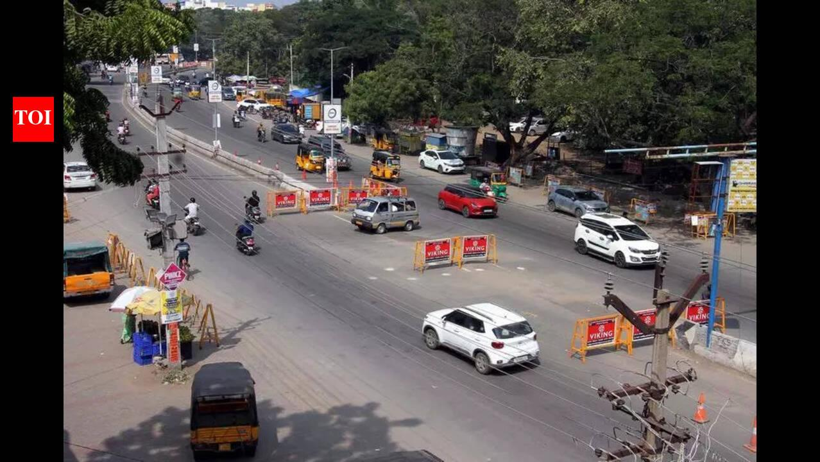
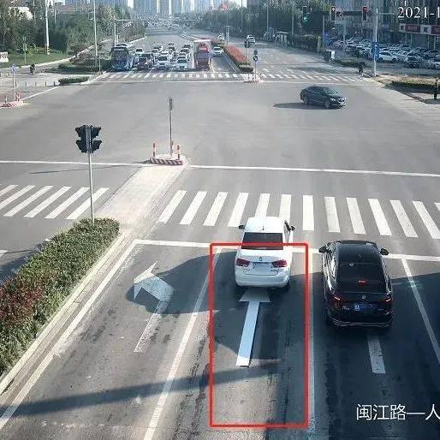
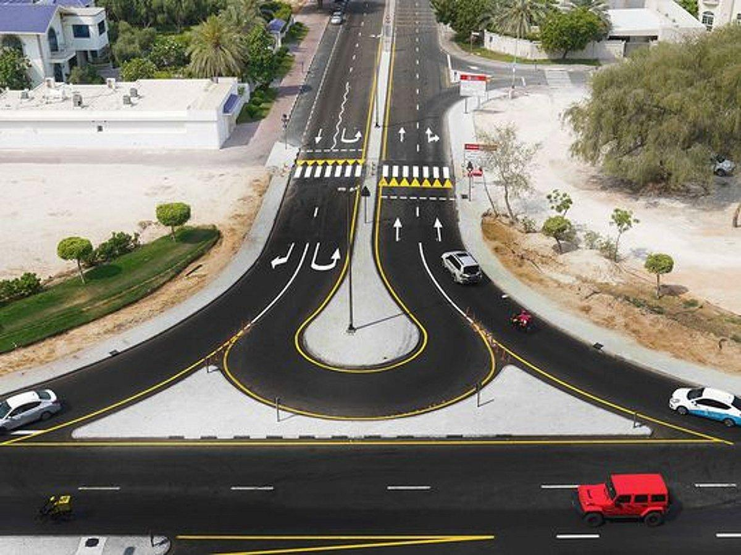
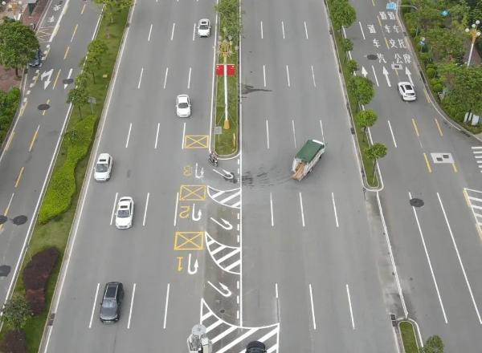
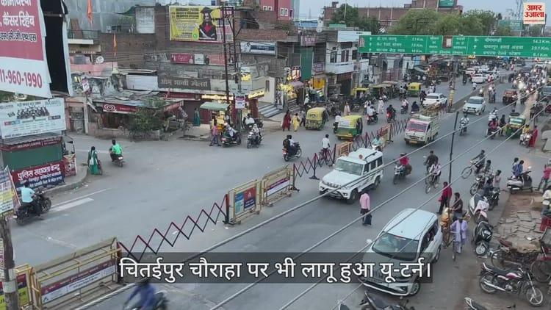
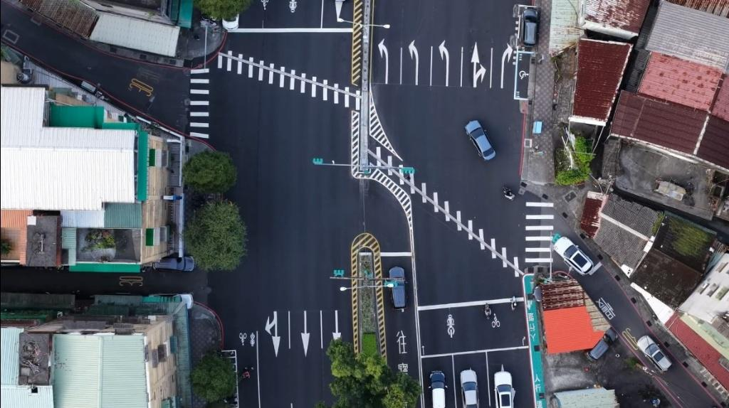
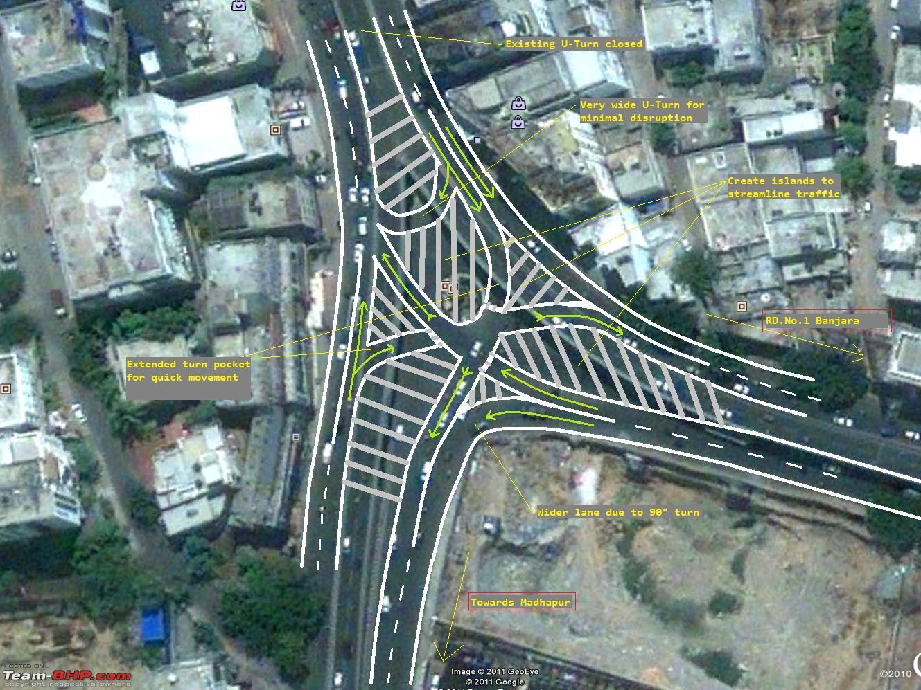
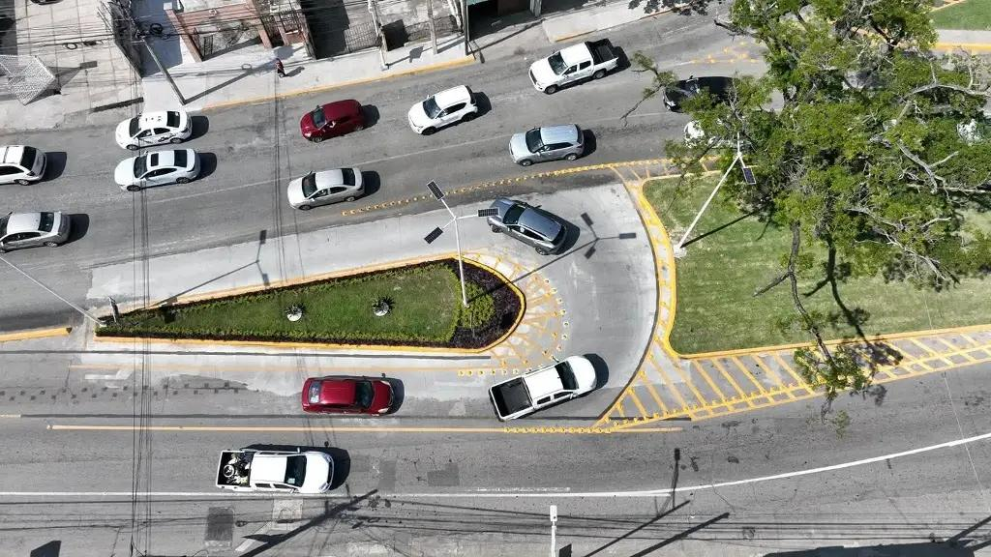
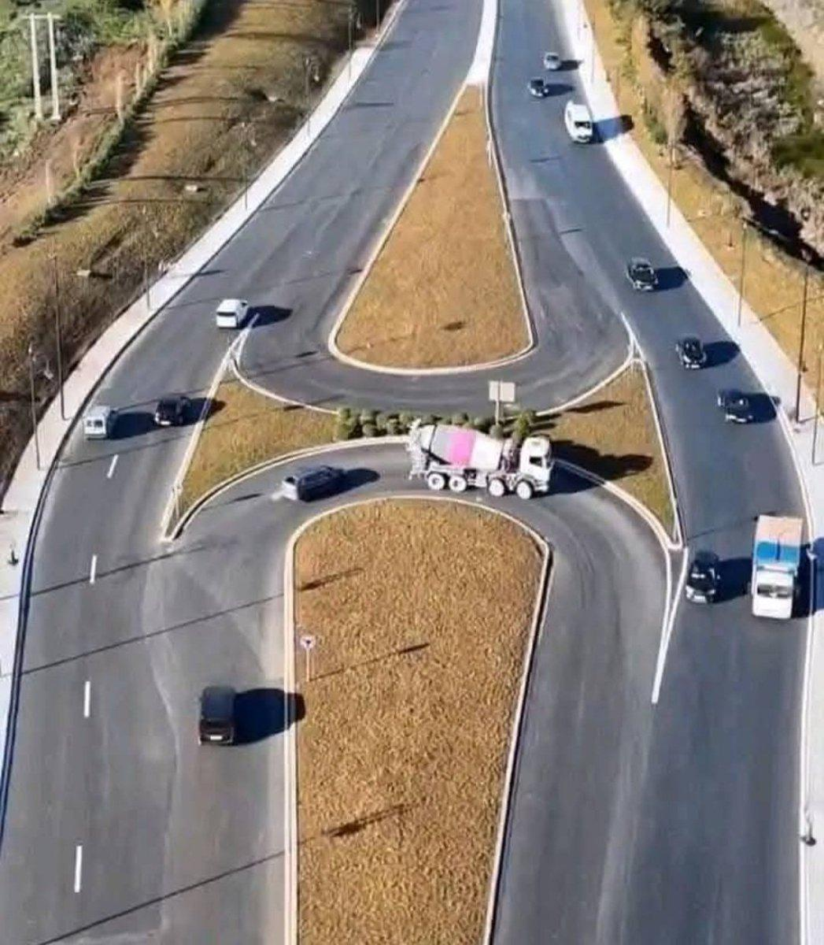
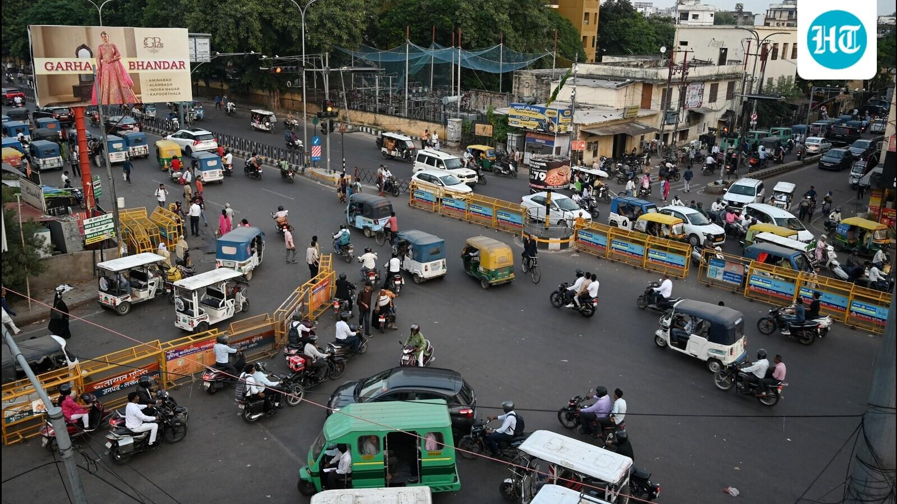
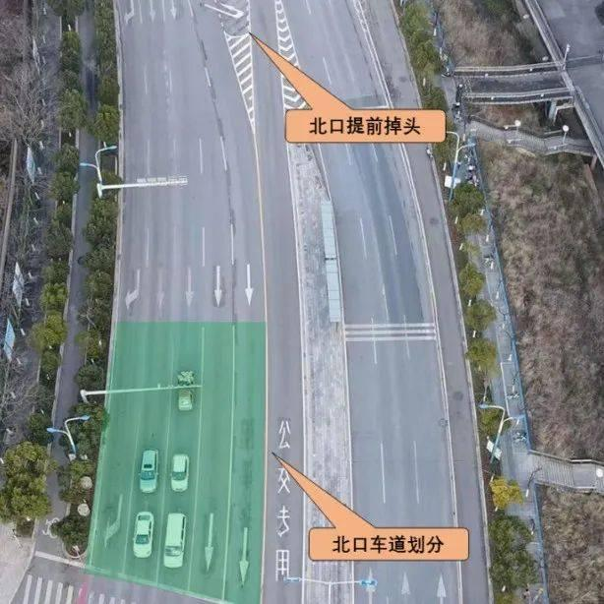
Define separate regions:
- Straight-moving lane.
- Left-turn lane.
- Right-turn lane.
- U-turn waiting lane.
These regions can be configured manually using polygon coordinates on the CCTV footage.
Example:
NORTH ROAD
|
[U-TURN ROI]
|
|
WEST ----------+---------- EAST
|
[STRAIGHT ROI]
|
SOUTH ROAD
When a vehicle enters the U-turn ROI, your system starts monitoring it.
Example:
Vehicle ID: 101

Lane: U-Turn Lane

Position: U-Turn Waiting Zone

Movement: Stationary

Waiting Duration: 12 seconds
Important: ROI alone cannot establish that a vehicle intends to take a U-turn. You should also analyse its trajectory, lane position and movement direction. For a more advanced version, you can use trajectory classification.
Step 4: U-Turn Queue Estimation
Now comes the core functionality.
Your system needs to calculate how many vehicles are waiting for U-turns.
For example:
U-Turn Queue:

Cars: 10
Buses: 2
Motorcycles: 8
Trucks: 1

Total Vehicles: 21
You can calculate queue length using:
- Number of tracked vehicles.
- Vehicle positions.
- Distance between vehicles.
- Waiting duration.
There are two useful measurements.
A. Queue Count
Number of vehicles waiting in the U-turn lane.
$$Q_{c}=\sum_{i=1}^{n}{I_{i}}$$
Where $I_{i}=1$if vehicle $i$belongs to the waiting queue.
B. Queue Length
Approximate physical length occupied by waiting vehicles.
You can estimate this using camera calibration and vehicle positions.
Example:
U-Turn Queue Count: 21

Estimated Queue Length: 85 metres

Average Waiting Time: 42 seconds
These are illustrative values.
Step 5: Traffic Density Estimation
Now your system should analyse traffic in all directions, not just the U-turn lane.
Why?
Because increasing U-turn signal duration might unnecessarily delay vehicles moving straight.
Your system should consider the entire intersection.
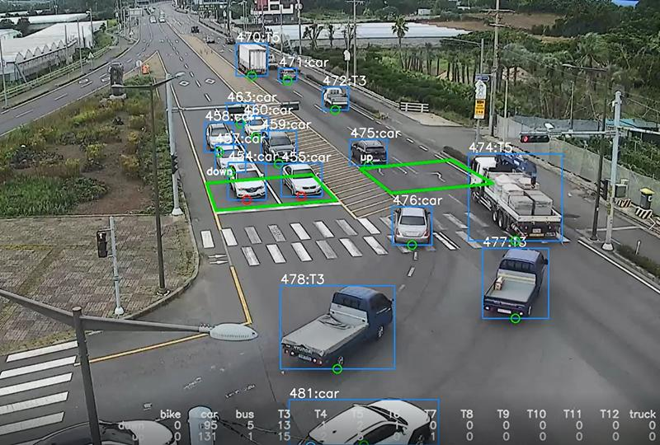
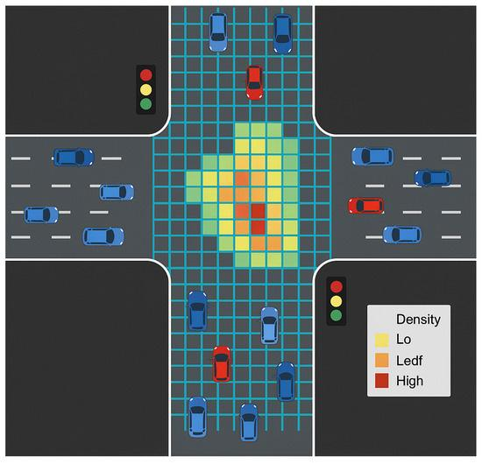
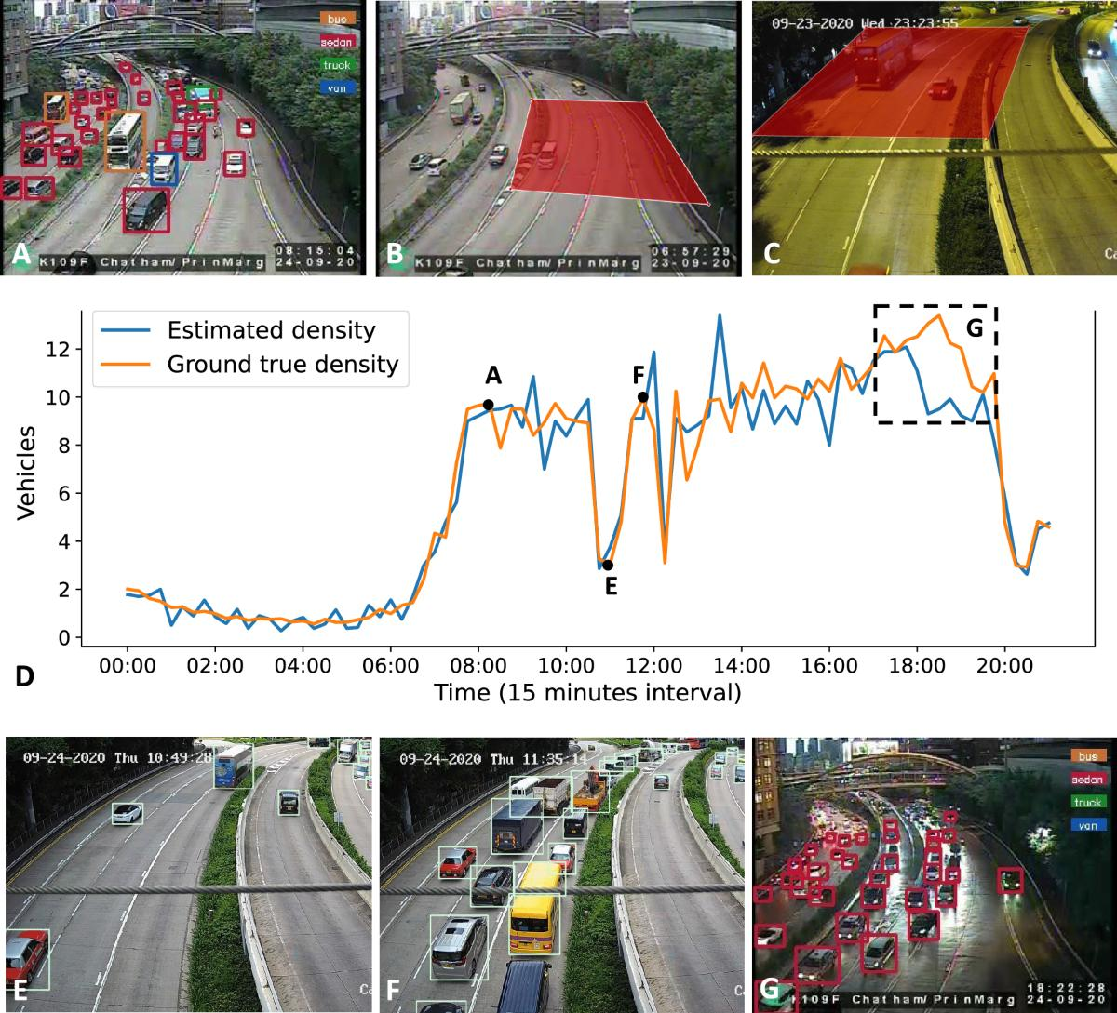
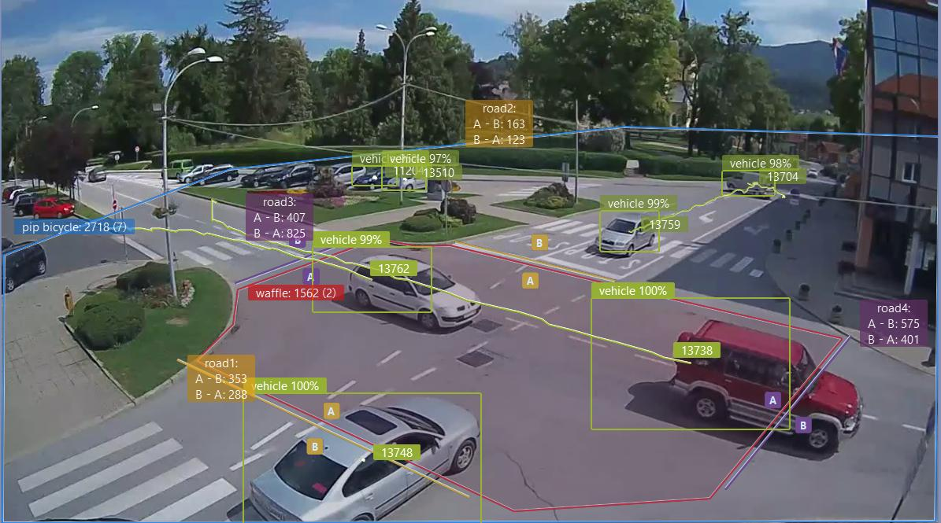
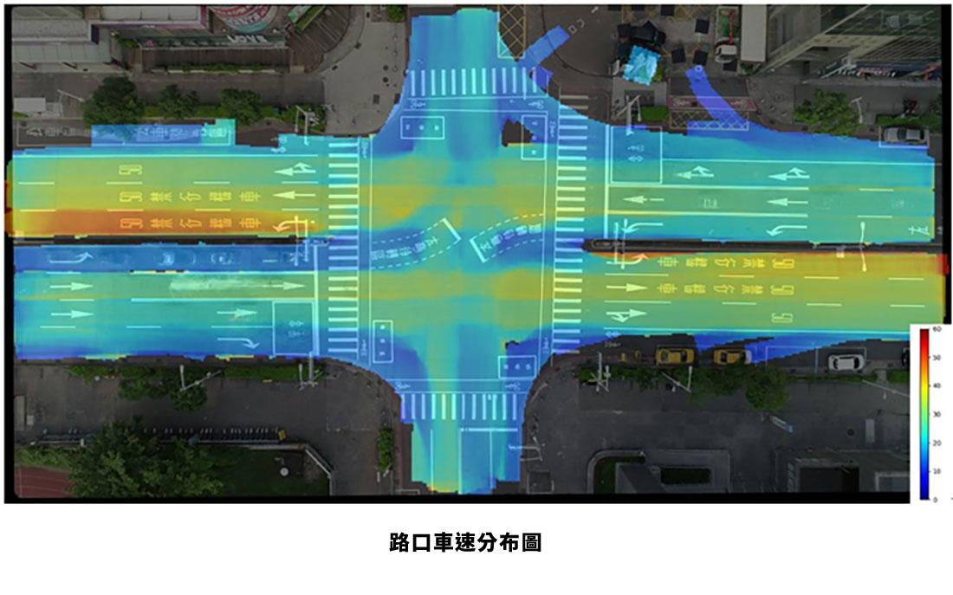
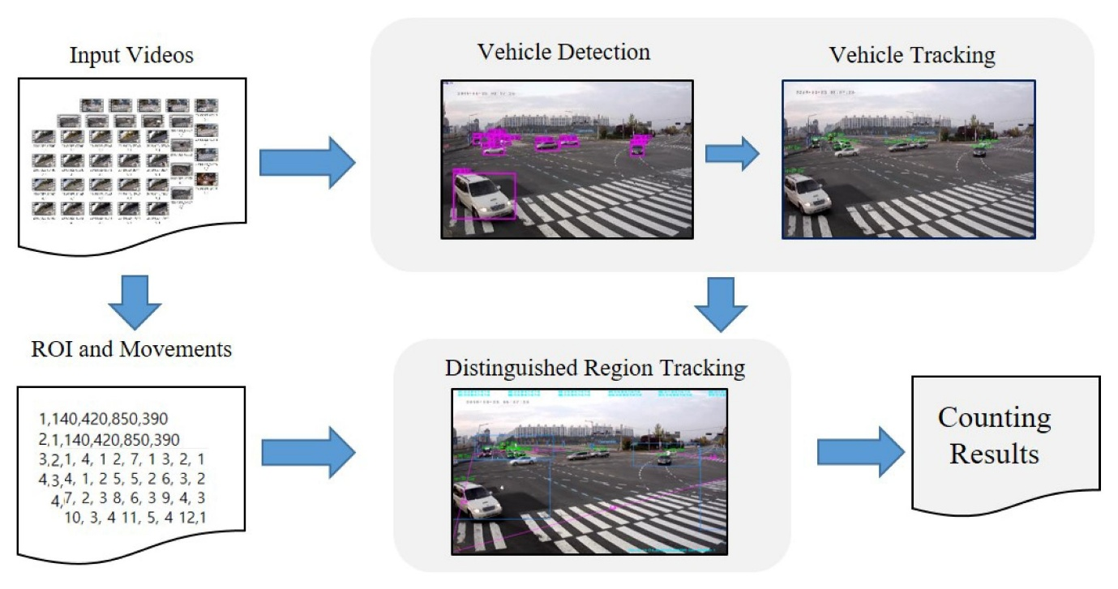
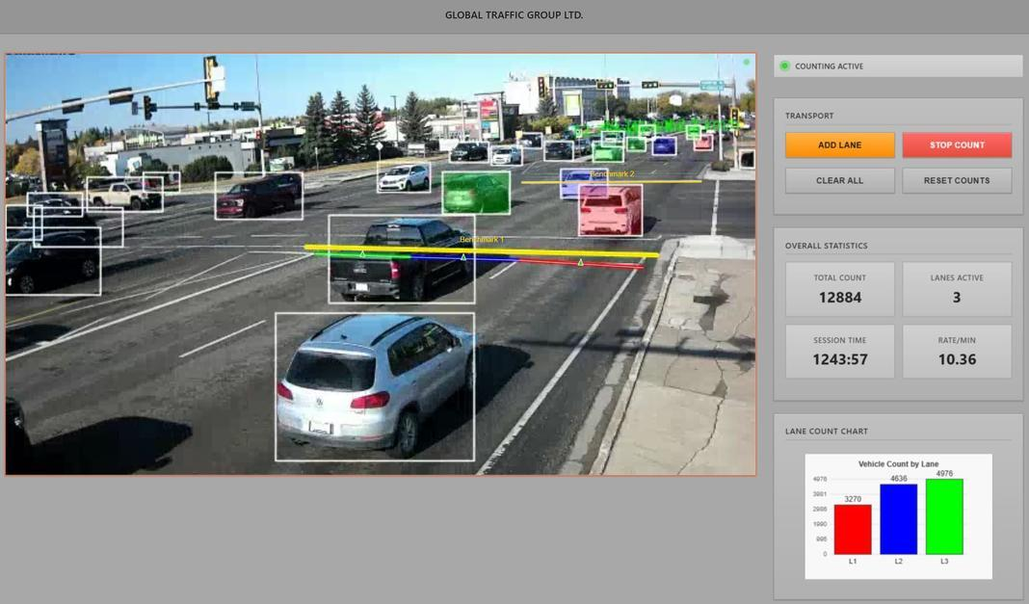
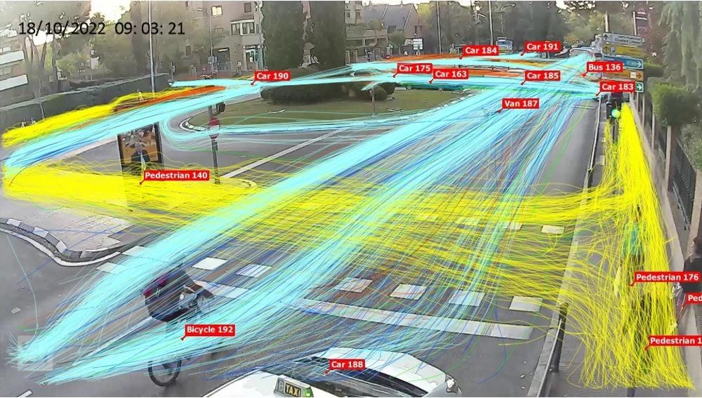
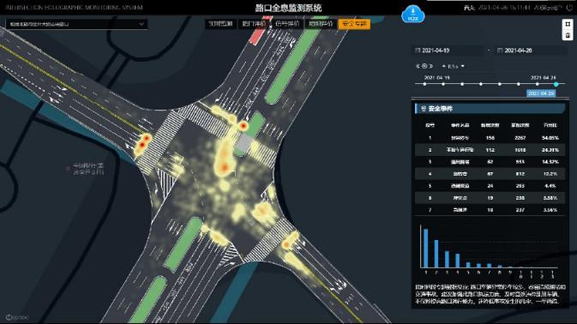
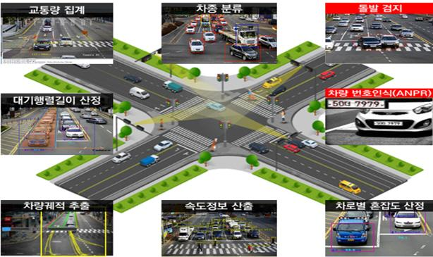
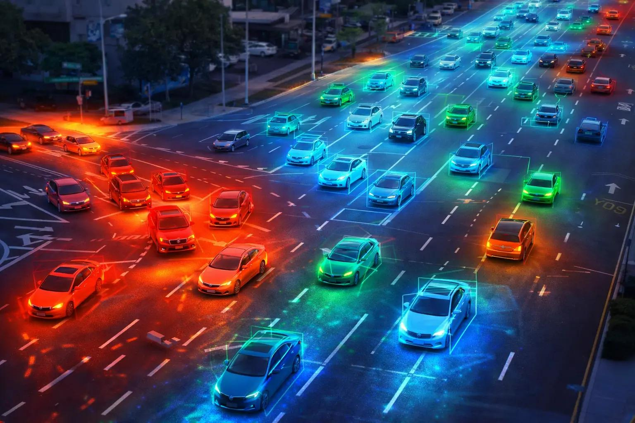
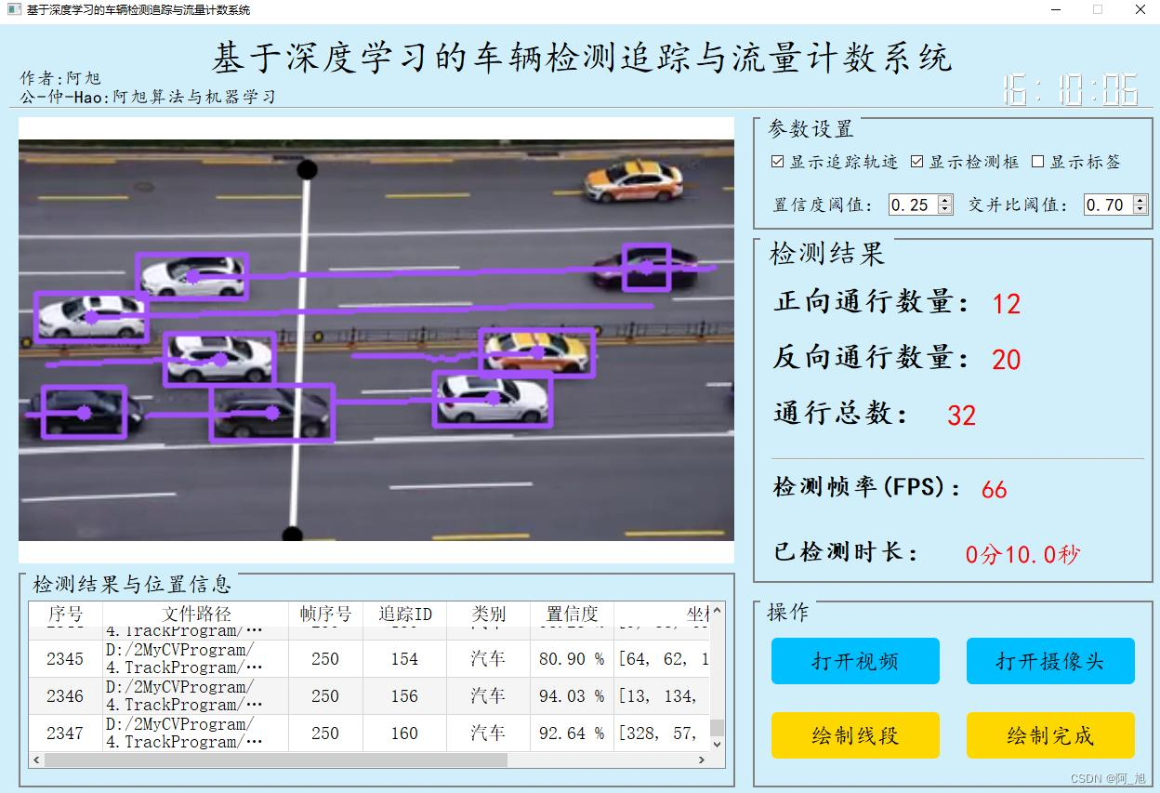
Calculate traffic density for each direction.
Example:
Direction | Vehicle Count | Traffic Density
North | 25 | High
South | 12 | Medium
East | 8 | Low
West | 30 | High
You can calculate density using:
- Vehicle count.
- Road occupancy.
- Queue length.
- Average vehicle speed.
For a simple implementation, start with vehicle count and queue length.
Later, introduce ML-based traffic prediction.

3. Step 6: Predict U-Turn Traffic Using Machine Learning
This is where you can introduce a proper ML component.
Your system can predict how many vehicles will be waiting for U-turns in the near future.
For example:
Currently:
U-Turn Queue: 10 vehicles
Predicted after 30 seconds:
U-Turn Queue: 24 vehicles
This allows the system to prepare for increasing traffic.
Which ML algorithms can you use?
Algorithm | Application
Linear Regression | Basic traffic prediction
Random Forest Regressor | Queue-length prediction
XGBoost Regressor | Traffic volume prediction
LSTM | Time-series traffic forecasting
My recommendation: Start with XGBoost.
Possible input features:
- Current U-turn queue count.
- Previous queue counts.
- Current traffic density.
- Average vehicle speed.
- Time of day.
- Historical traffic volume.
Output:
Predicted U-turn queue count after a specified time interval.
You don't need to use deep learning for this prediction unless you have sufficient sequential traffic data.

4. Step 7: Intelligent U-Turn Signal Timing
This is the most important component of Module 3.
Your system now knows:
- Number of vehicles waiting for U-turns.
- Estimated queue length.
- Average waiting time.
- Traffic density in other directions.
- Predicted U-turn traffic.
It must decide how much green signal time to allocate.
Consider this example:
Existing Fixed-Time Signal
Signal | Duration
Straight | 40 seconds
Right turn | 20 seconds
U-turn | 15 seconds
Left turn | 15 seconds
The problem is that these timings remain unchanged even when traffic conditions change.
Your AI-Based Adaptive Signal
Suppose the system detects:
Signal | Traffic Condition
Straight | Medium
Right turn | Low
U-turn | Very High
Left turn | Low
Your system can recommend:
Signal | New Duration
Straight | 30 seconds
Right turn | 15 seconds
U-turn | 30 seconds
Left turn | 15 seconds
These are illustrative timings, not universal signal settings.
The actual timings must respect minimum and maximum green times, pedestrian clearance, amber intervals, all-red clearance and conflicting movements.
How do you implement this?
Initially, use a rule-based decision engine.
if uturn_queue > 20:
uturn_green_time = 30

elif uturn_queue > 10:
uturn_green_time = 20

else:
uturn_green_time = 10
This is only a starting example.
A better implementation considers competing queues:
if uturn_queue > straight_queue:
increase_uturn_priority()

elif straight_queue > uturn_queue:
prioritize_straight_traffic()

else:
maintain_balanced_timing()
Eventually, you can use optimization algorithms to allocate signal time across all competing directions.

5. Step 8: Traffic Signal Optimization Using SUMO
Technology: SUMO (Simulation of Urban Mobility)
I strongly recommend using SUMO for this module.
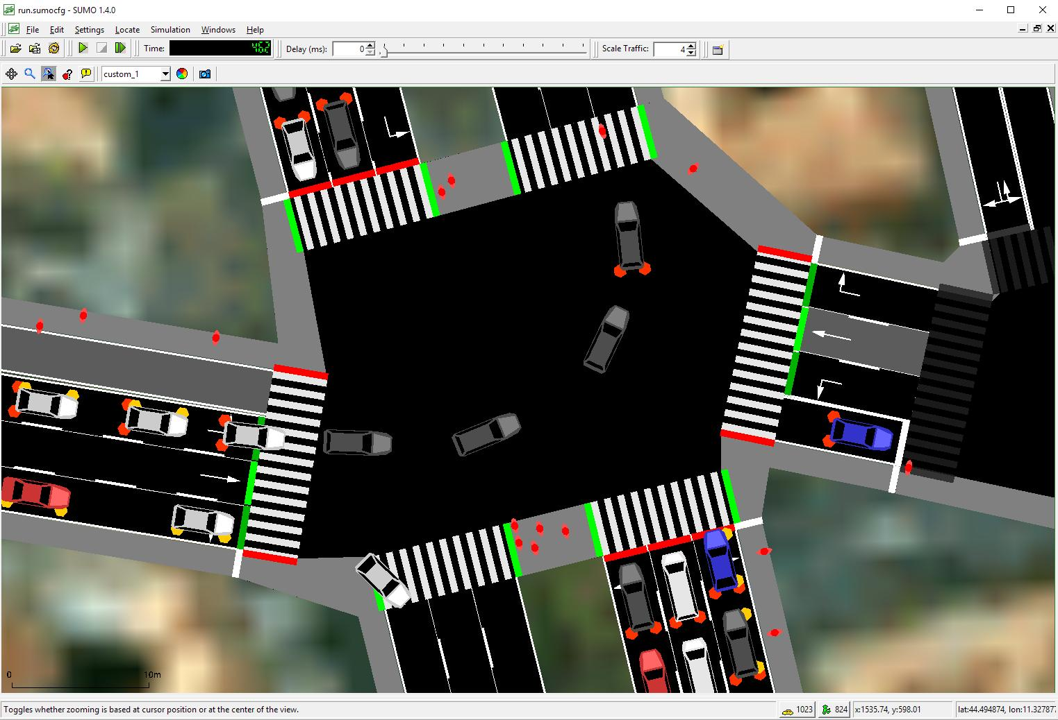
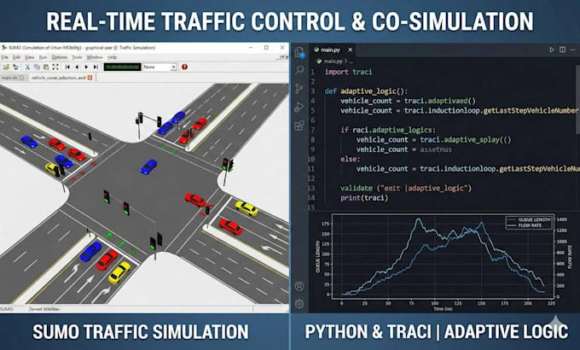
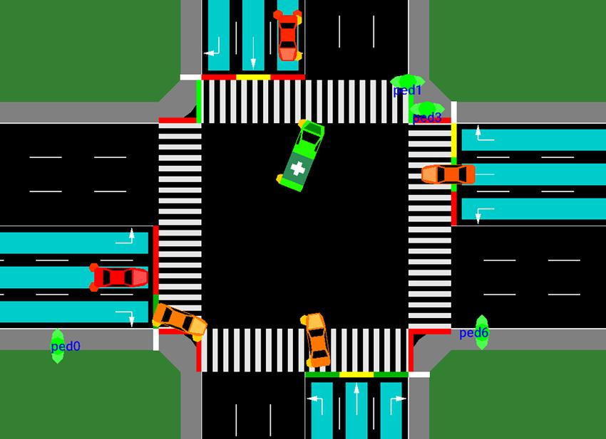
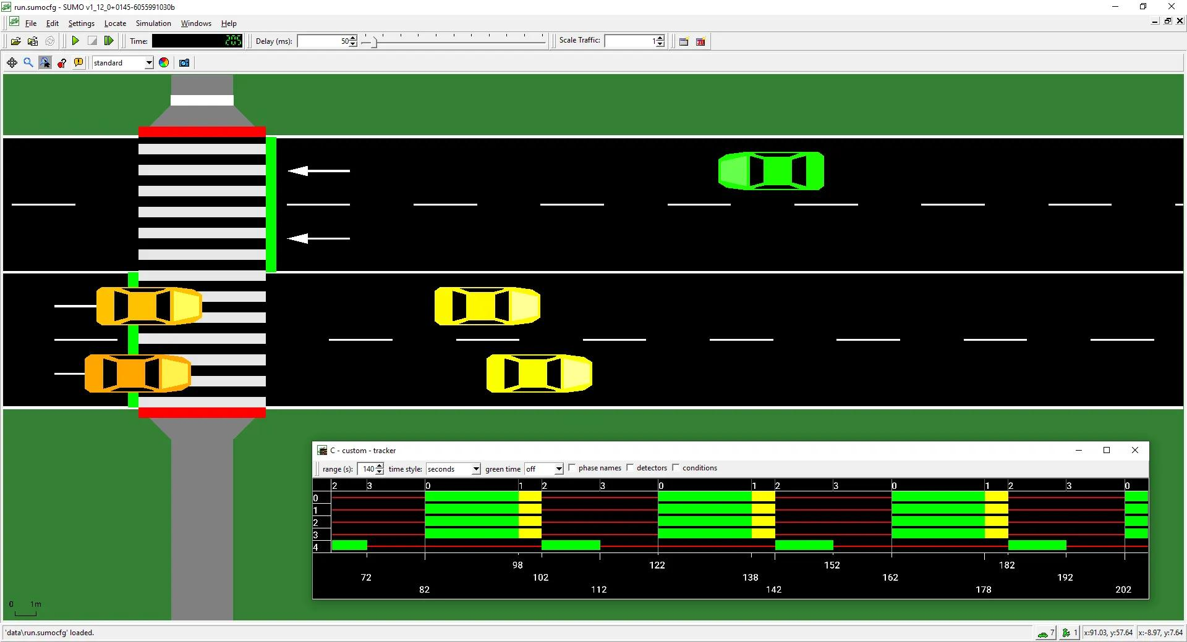
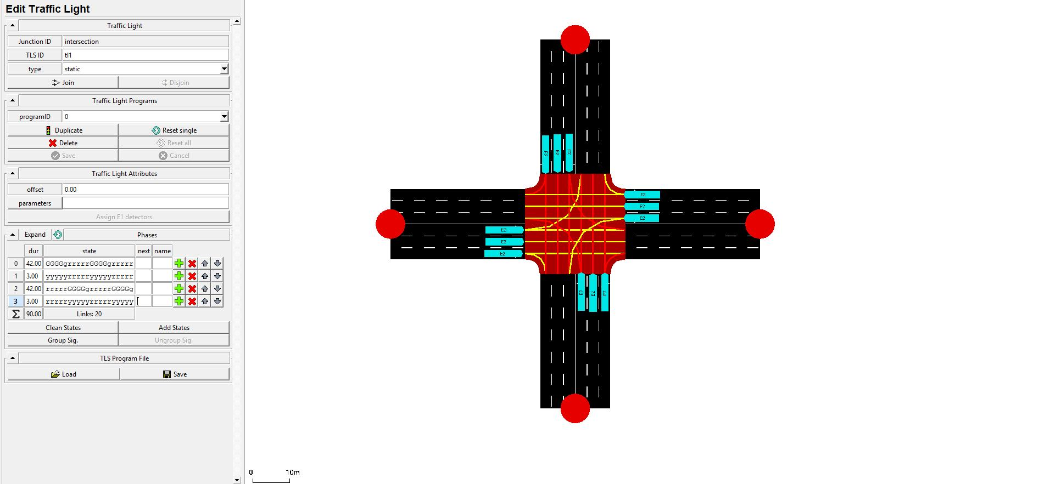
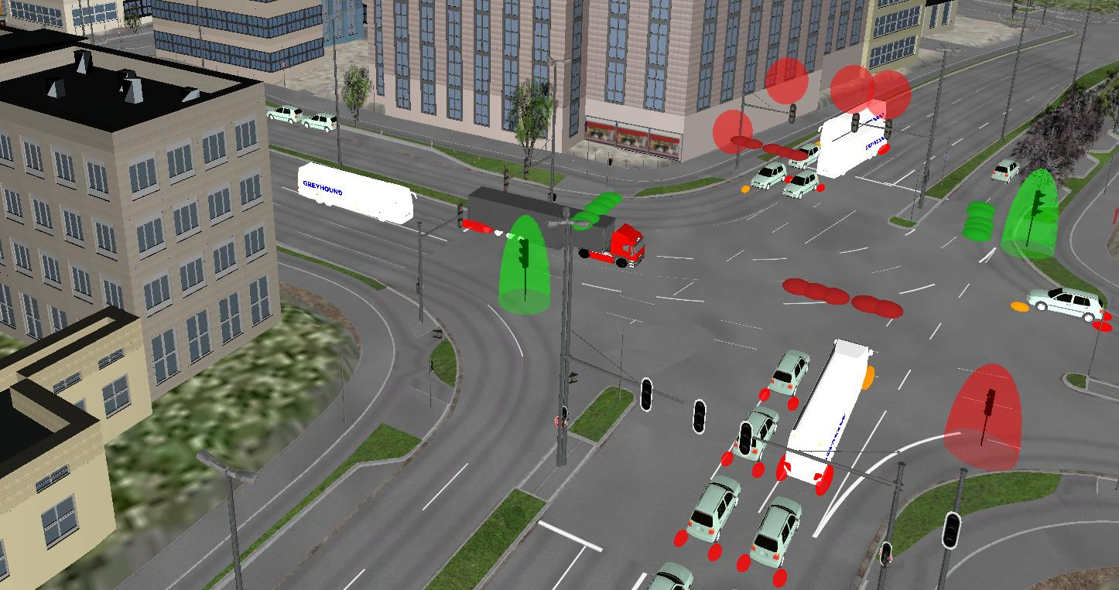
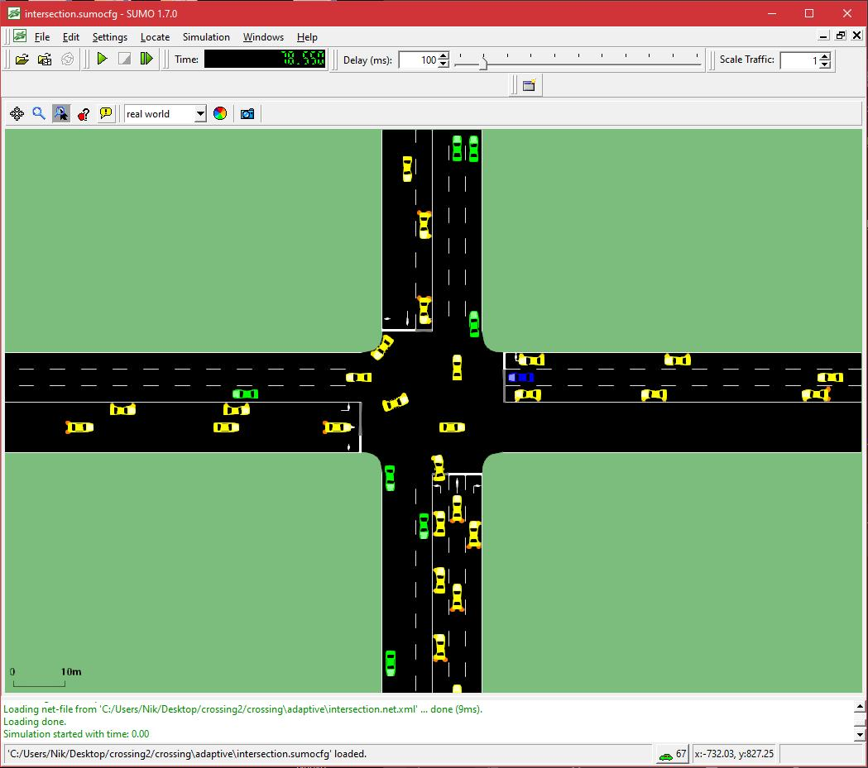
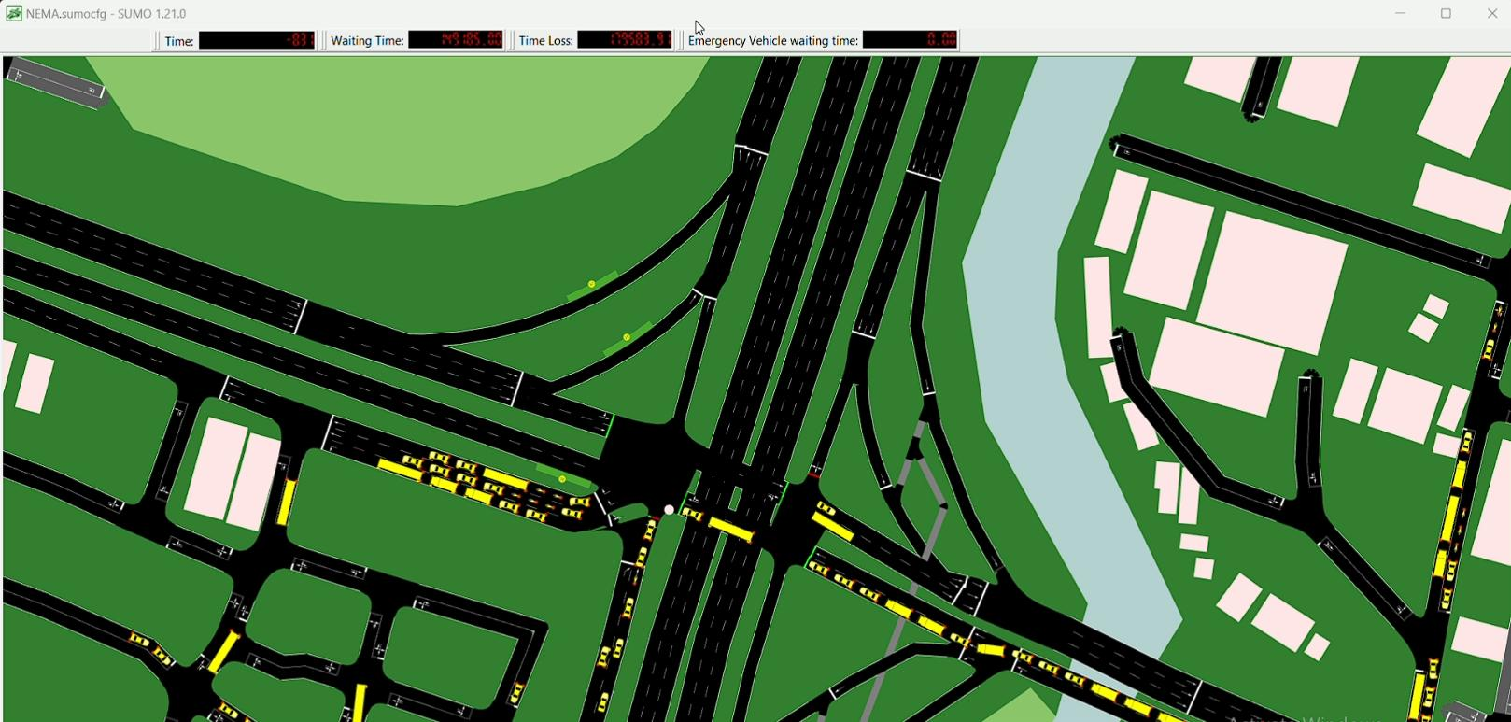
SUMO allows you to create virtual road intersections and simulate vehicles.
You can:
- Create a four-way intersection.
- Define U-turn lanes and permitted movements.
- Generate vehicles.
- Simulate different traffic volumes.
- Connect your Python decision engine.
- Dynamically change traffic signal timings.
- Compare traffic performance.
For example:
Scenario 1: Traditional Signal
U-Turn Green Time: 15 seconds

Average Waiting Time: 65 seconds
Scenario 2: Your Adaptive Signal
U-Turn Green Time: 30 seconds

Average Waiting Time: 35 seconds
These numbers are hypothetical examples. Your actual results must come from SUMO experiments.
This comparison will help demonstrate whether your proposed approach improves traffic flow.

6. Complete Architecture of Module 3
Here is the architecture I recommend.
CCTV VIDEO INPUT
|
v
FRAME EXTRACTION
|
v
YOLO DETECTION
|
v
BYTE TRACKING
|
v
VEHICLE MOVEMENT ANALYSIS
|
v
LANE AND ROI IDENTIFICATION
|
v
U-TURN VEHICLE IDENTIFICATION
|
v
QUEUE ESTIMATION
|
v
TRAFFIC DENSITY ESTIMATION
|
v
ML-BASED TRAFFIC PREDICTION
|
v
SIGNAL TIMING OPTIMIZATION
|
v
SUMO SIMULATION
|
v
TRAFFIC DASHBOARD

7. Dataset Requirements
You can use publicly available traffic datasets.
Dataset | Application
BDD100K | Vehicle detection
UA-DETRAC | Vehicle detection and tracking
AI City Challenge | Traffic surveillance
Custom intersection CCTV videos | U-turn queue identification
SUMO-generated traffic data | Signal optimization and testing
One important point:
Public datasets may contain general traffic information, but they might not provide explicit U-turn queue labels.
You may need to annotate your own intersection videos.
For your initial implementation, you can manually define U-turn ROIs and use vehicle trajectories to estimate the queue.

8. Recommended Technology Stack
Component | Technology
Vehicle detection | YOLO
Vehicle tracking | ByteTrack
Video processing | OpenCV
Lane identification | ROI + OpenCV
Vehicle trajectory analysis | Computer Vision
Queue estimation | Computer Vision
Traffic prediction | XGBoost
Signal optimization | Python optimization engine
Traffic simulation | SUMO
Backend | FastAPI
Dashboard | Streamlit
Database | SQLite
You don't need to implement every technology immediately.
Start with YOLO, ByteTrack, OpenCV and manually defined lane regions.
Then introduce prediction and optimization.

9. What Should Your Final Dashboard Look Like?
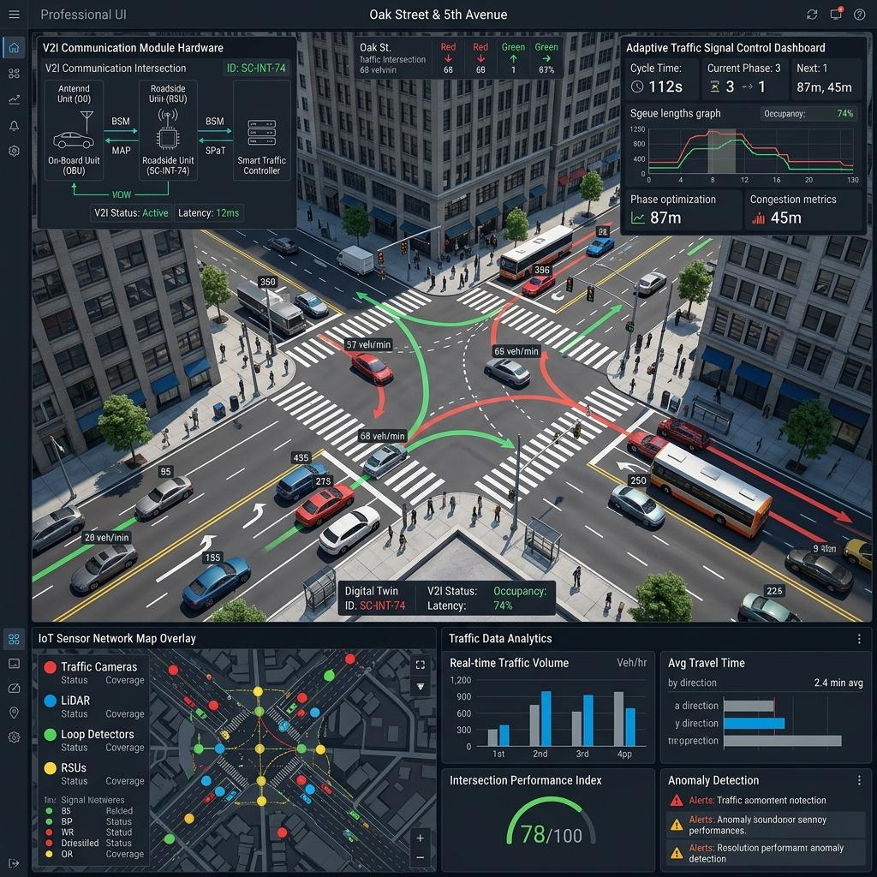
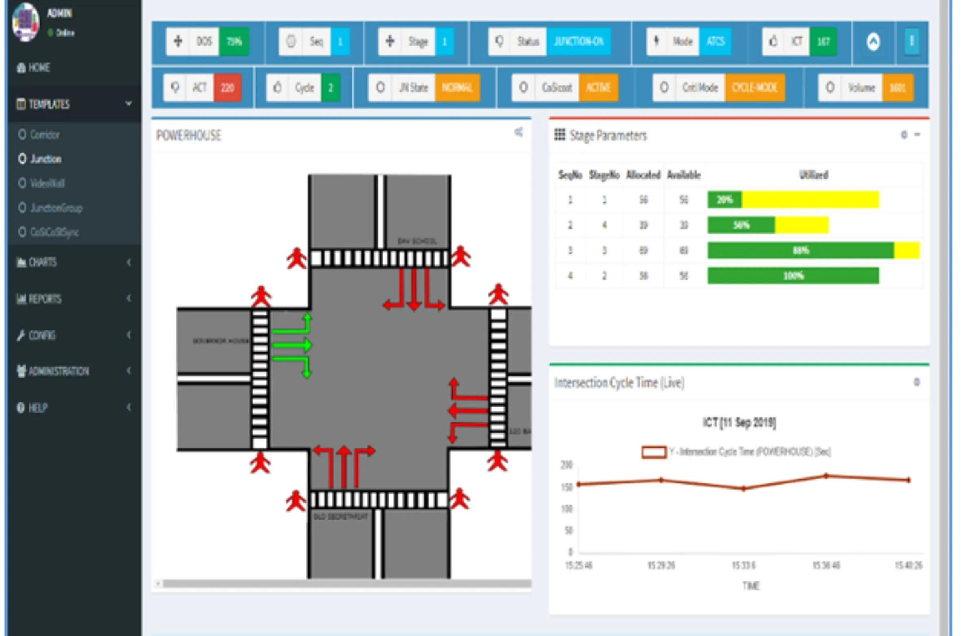
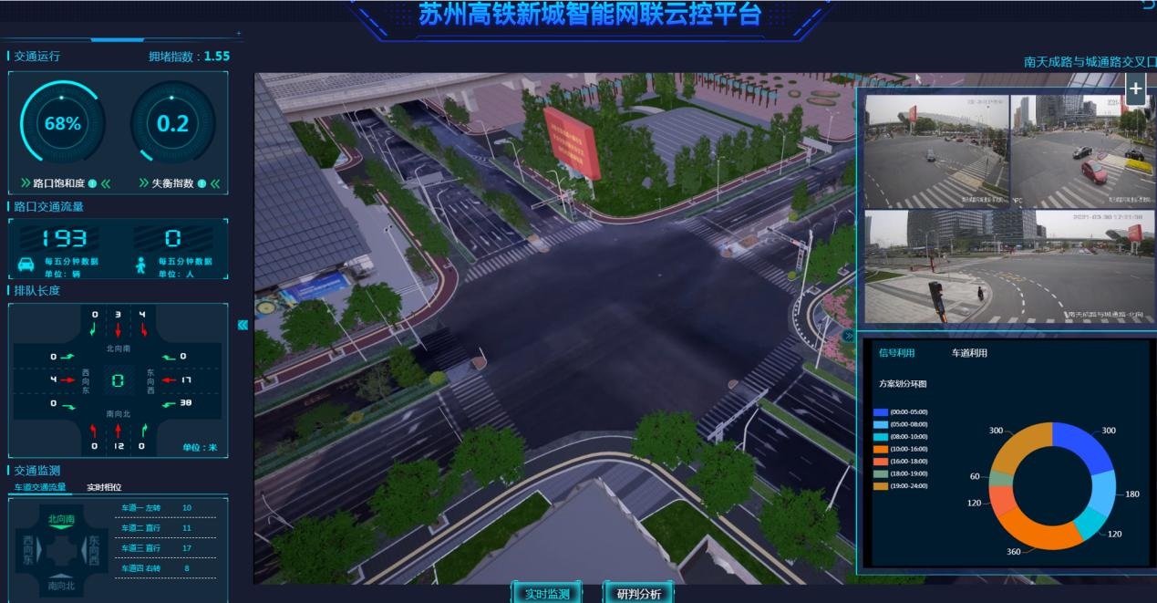
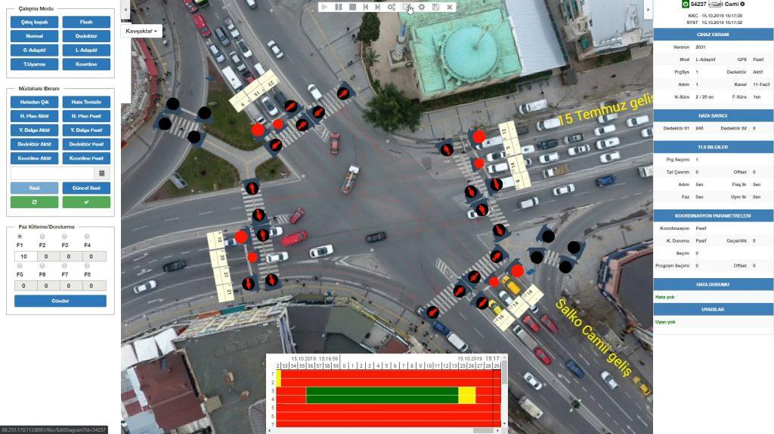
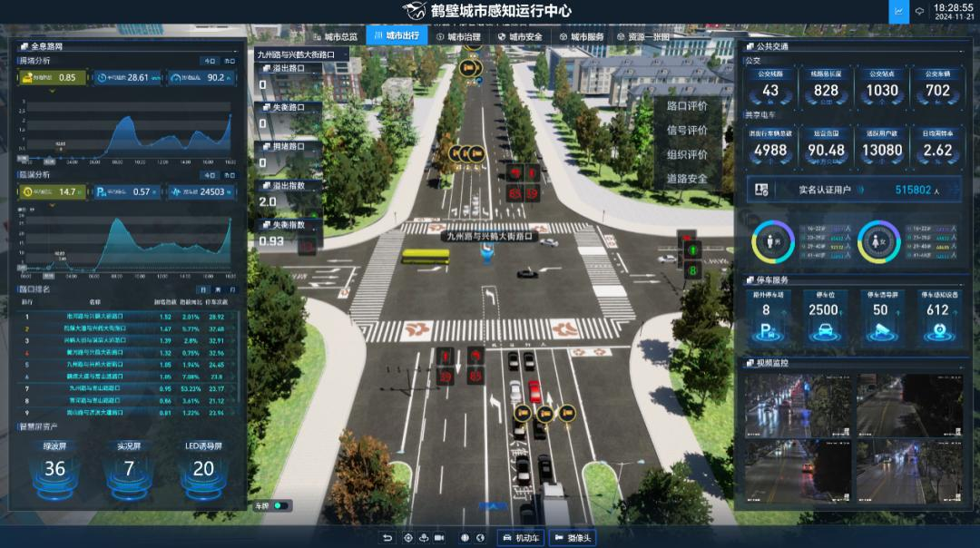
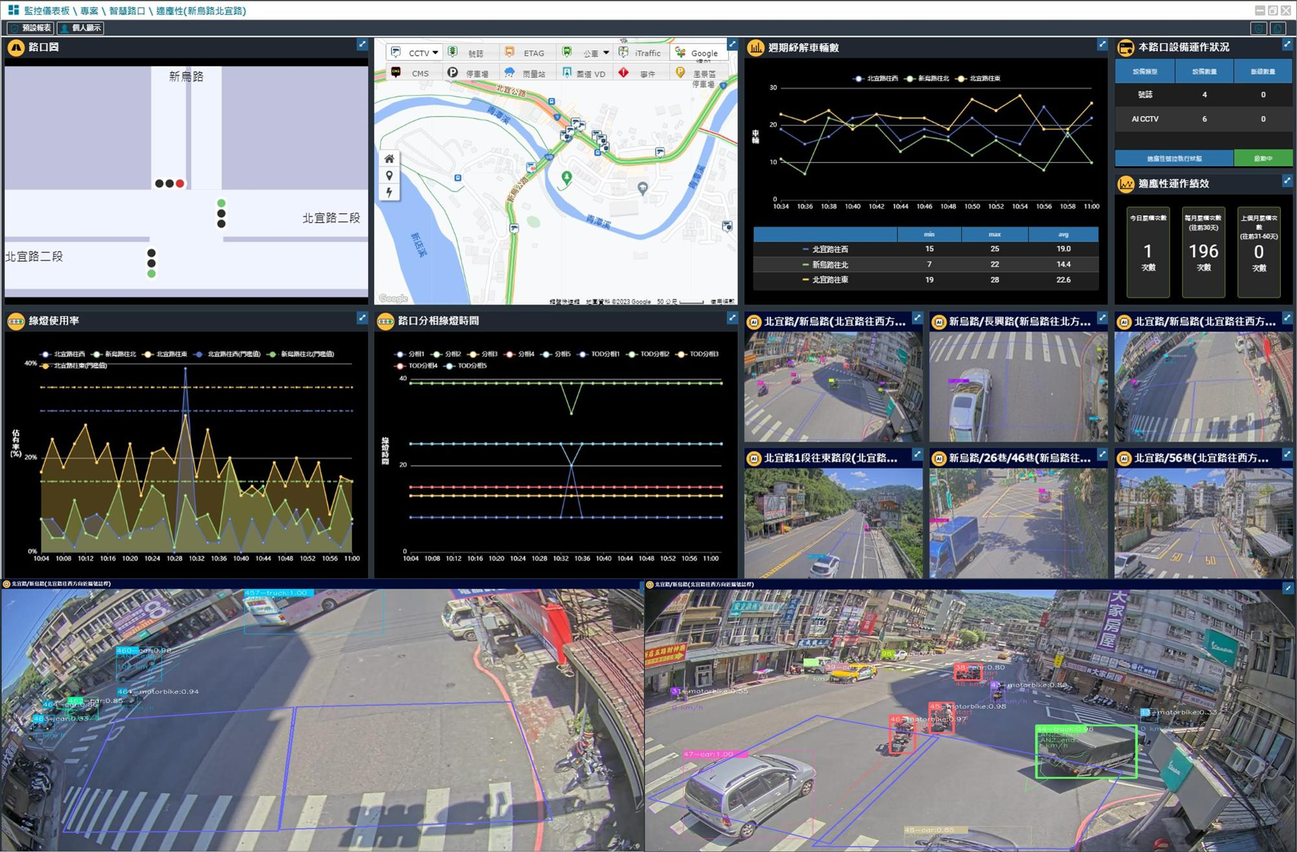
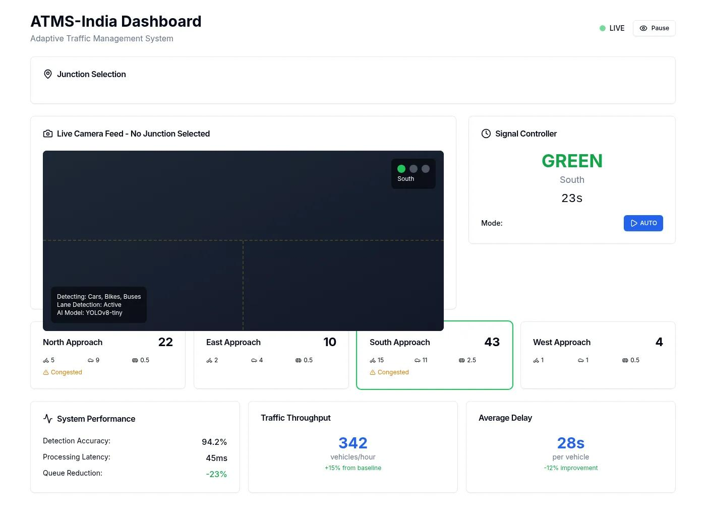
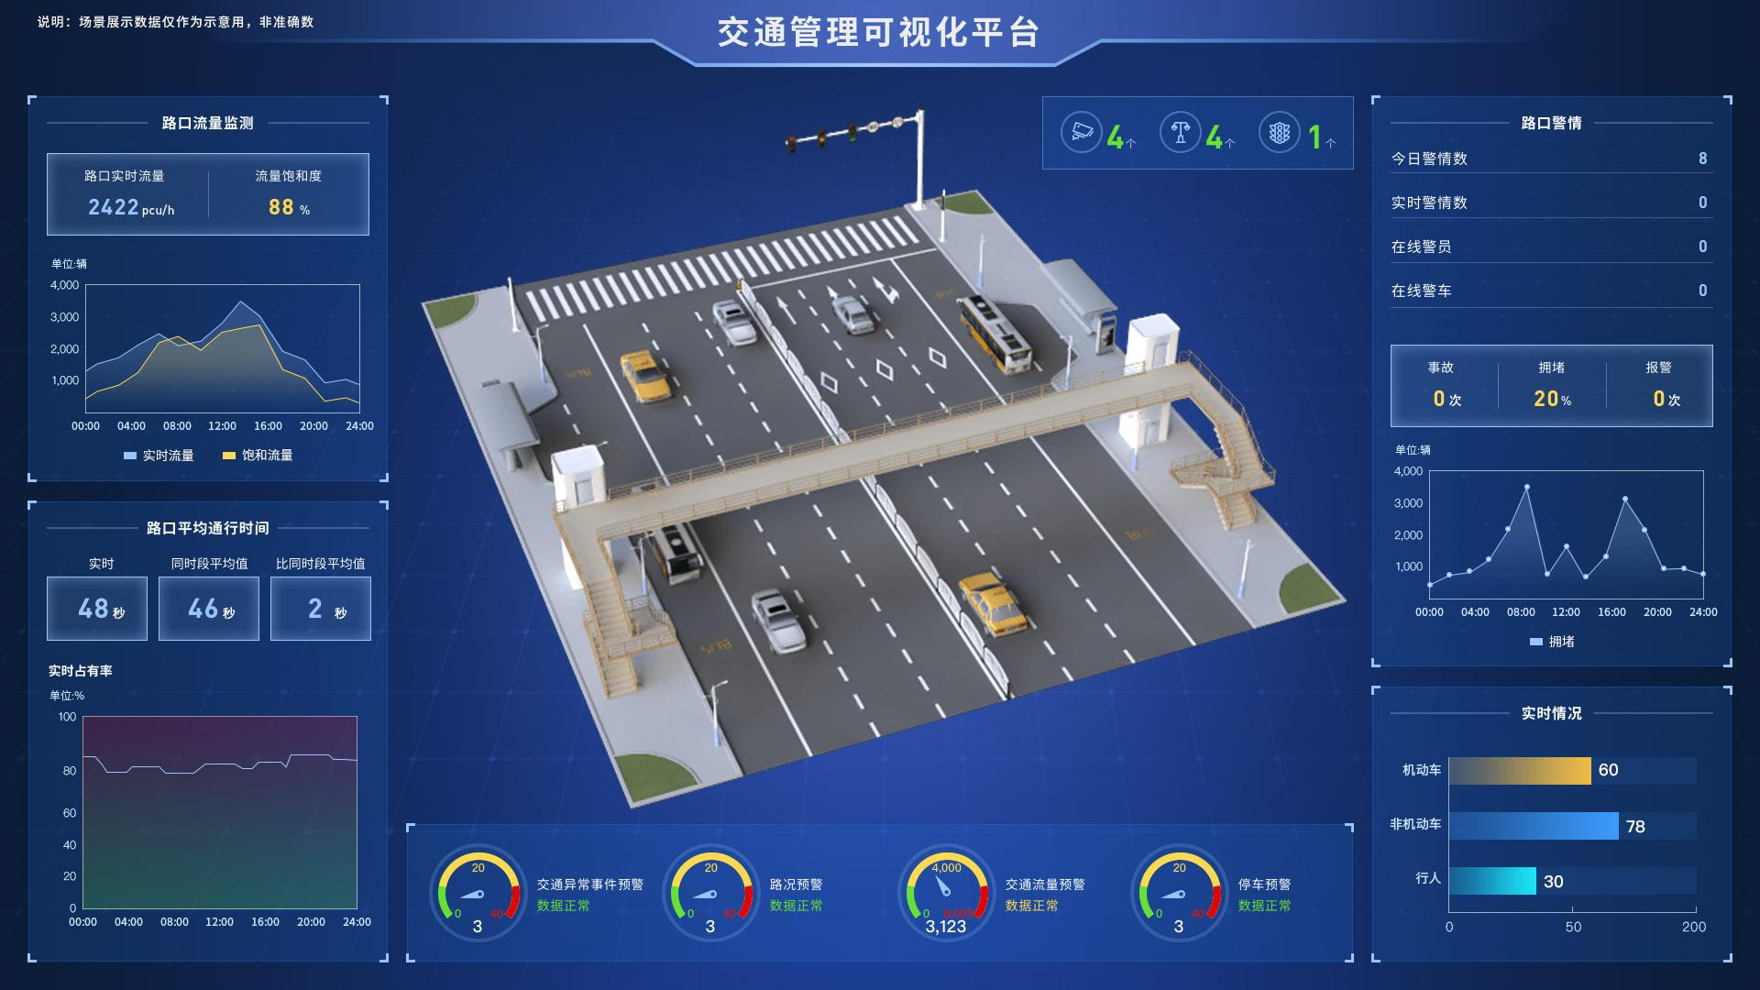
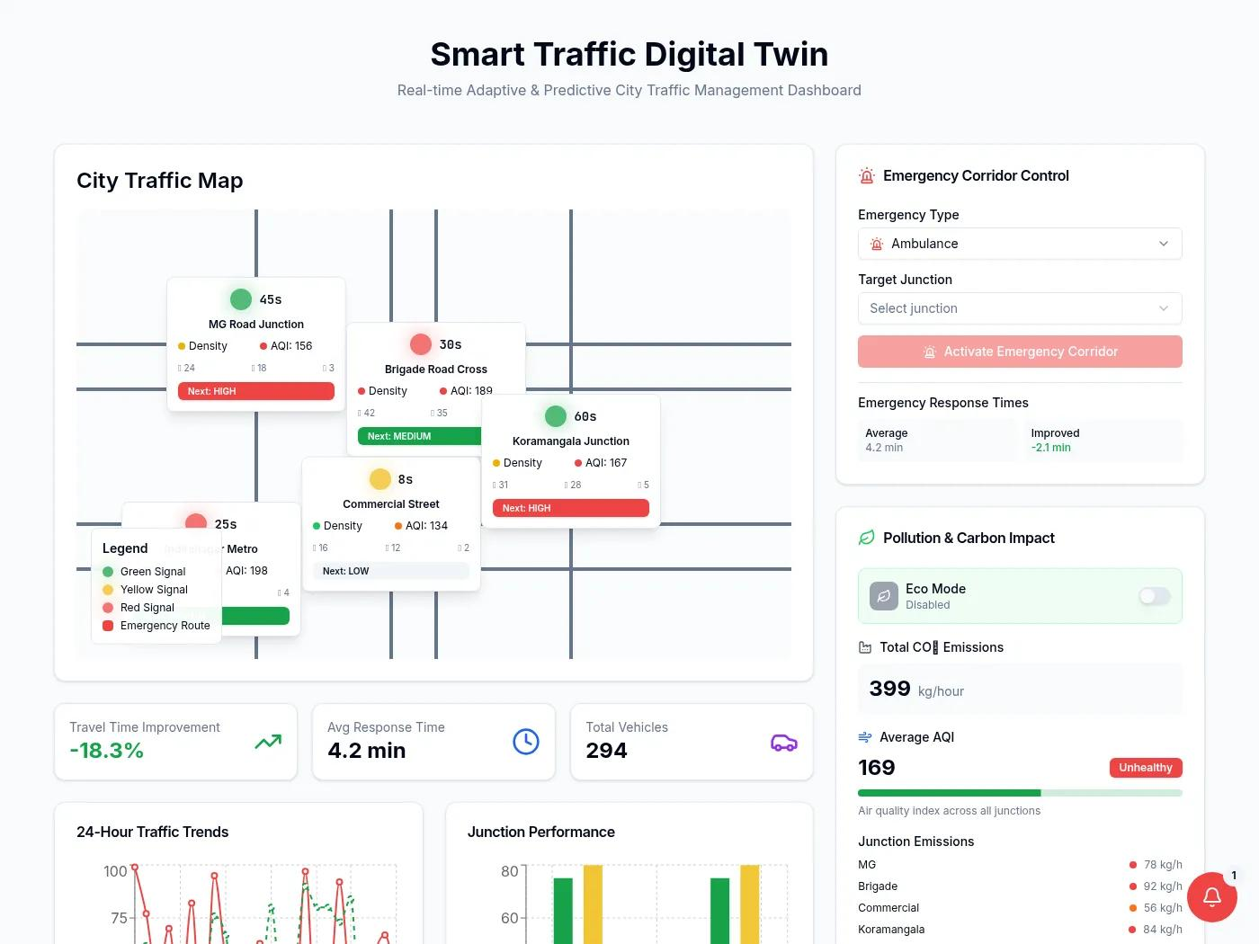
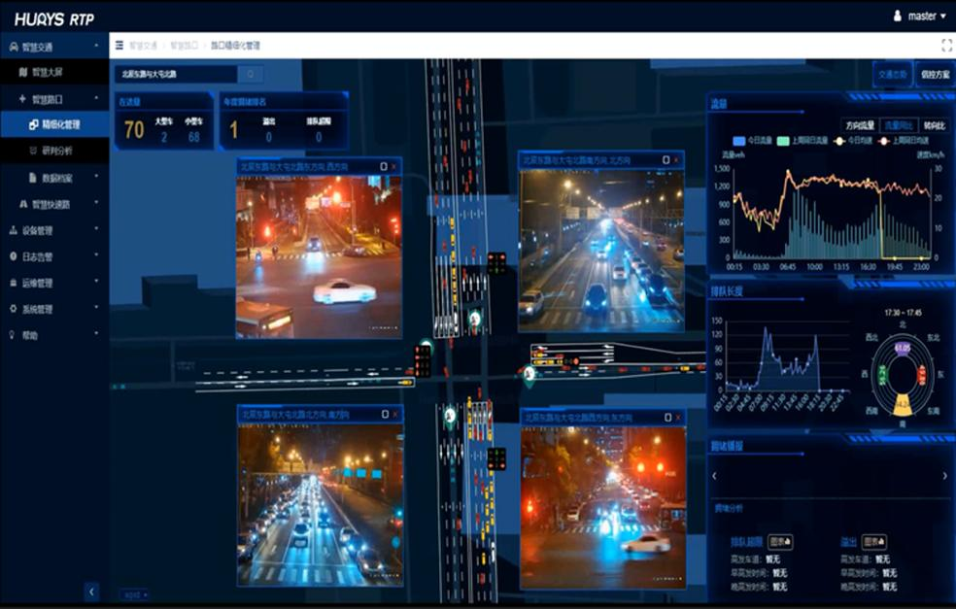
Your Streamlit dashboard should contain four major sections.
A. Live Intersection Monitoring
INTERSECTION: JUNCTION 01

Total Vehicles: 75

North: 25
South: 12
East: 8
West: 30
B. U-Turn Queue Monitoring
U-TURN QUEUE ANALYSIS

Waiting Vehicles: 21

Estimated Queue Length: 85 metres

Average Waiting Time: 42 seconds

Queue Status: HIGH
C. Traffic Prediction
PREDICTED TRAFFIC

Current U-Turn Queue: 21

Predicted Queue (30 sec): 28

Traffic Growth: HIGH
D. Adaptive Signal Management
SIGNAL OPTIMIZATION

U-Turn Green Time: 30 sec

Straight Green Time: 25 sec

Decision: U-TURN PRIORITY

Status: ACTIVE
All these are illustrative dashboard values.

10. Development Phases
I recommend developing Module 3 in this order.
Phase | Development | Difficulty
1 | YOLO vehicle detection | Easy
2 | ByteTrack vehicle tracking | Medium
3 | Lane and ROI identification | Medium
4 | U-turn vehicle identification | Medium
5 | Queue count and length estimation | Medium
6 | Traffic density estimation | Medium
7 | ML-based traffic prediction | Medium–Hard
8 | Adaptive signal timing | Hard
9 | SUMO integration | Hard
10 | Dashboard integration | Easy

11. One Important Enhancement I Recommend
Multi-Directional Traffic Optimization
Don't limit your project to U-turn signals alone.
Make your system consider the entire intersection.
Imagine:
- 20 vehicles waiting for U-turns.
- 30 vehicles waiting to move straight.
- 5 vehicles waiting to turn right.
- A bus approaching from another direction.
- A breakdown blocking one lane.
Your integrated system should evaluate all these conditions.
This is where Module 3 connects with Modules 1 and 2.
Module | Information Provided
Module 1 | Approaching bus and priority request
Module 2 | Road obstruction and incident alerts
Module 3 | U-turn queues and traffic density
The central decision engine combines these inputs and determines the safest and most efficient signal plan.

12. My Final Recommendation
For Module 3, concentrate on these six components:
Component | Technology
Vehicle detection | YOLO
Vehicle tracking | ByteTrack
U-turn identification | ROI + Trajectory Analysis
Queue estimation | Computer Vision
Traffic prediction | XGBoost
Signal optimization | Python + SUMO
Important distinction
- YOLO detects vehicles.
- ByteTrack tracks vehicles.
- ROI and trajectory analysis identify U-turn movements.
- Computer Vision estimates queue length.
- XGBoost predicts future traffic.
- The optimization engine determines signal timings.
- SUMO evaluates whether those decisions improve traffic flow.
You now have three interconnected AI modules:
- Module 1 – Public Transport Priority Management.
- Module 2 – Vehicle Breakdown and Incident Detection.
- Module 3 – Intelligent U-Turn and Adaptive Signal Management.
One architectural decision I strongly recommend
Don't develop these three modules as three independent projects.
Build one shared AI Traffic Perception Engine containing:
- YOLO vehicle detection.
- ByteTrack vehicle tracking.
- Vehicle classification.
- Vehicle movement analysis.
- Traffic density estimation.
Then connect three independent intelligence modules to it.
This avoids duplicate work, reduces computational overhead and makes your final project much more coherent.
Your actual research and development contribution should focus on how these three modules communicate with a unified traffic signal optimization engine.

