**Synopsis of Stock Price Prediction**

**Name: Vivek Varma**

**UID : 18BCA1292**

**6th Semester Major Project**

**HOD: Prof. Manisha Malhotra**

**Mentor: Prof. Appoorva Bansal**

**Acknowledgement**

I take this opportunity to express my profound gratitude and deep regards to my Project Mentor and Prof. Appoorva Bansal for her exemplary guidance, monitoring and constant encouragement throughout the course of this project. The blessing, help and guidance given by them time to time shall carry me a long way in the journey of life on which I am about to embark.

|  |  |
| --- | --- |
| **Page No.** | **Topic Title** |
| **1** | Title of the project  Acknowledgement |
| **3** | Introduction of the Project |
| **4** | Abstract of the Project |
| **5** | Objective of the Project |
| **6** | Scope of the Project |
| **7** | Reports of the project |
| **7** | Modules of the Project |
| **8** | Input data and validation of the project |
| **9** | Features of the project |
| **10** | Software Requirement Specification |
| **11** | Identification of need |
| **12** | Feasibility Study |
| **13** | System design of the project |
| **14** | User Interface Design |
| **15** | Preliminary Product Descriptions |
| **17** | Project Category |
| **18** | Implementation Methodology |
| **19** | Tools and Platform – Software Requirements |
| **19** | Tools and Platform – Hardware Requirements |
| **20** | System Analysis |
| **22** | Data Dictionary |
| **23** | Conclusion of the Project |
| **24** | Future scope of the Project |
| **25** | Limitations of the Project |
| **26** | Bibliography and references |

**Introduction of the Project Stock Price Prediction:**

One of the most prominent use cases of machine learning is “Fintech” (Financial Technology for those who aren't buzz-word aficionados); a large subset of which is in the stock market. Financial theorists, and data scientists for the better part of the last 50 years, have been employed to make sense of the marketplace in order to increase return on investment. However, due to the multidimensional nature of the problem, the scale of the system, and inherent variation with time, it has been an overwhelmingly tough challenge for humans to solve, even with the assistance of conventional data analytics tools. However, with the onset of recent advancements in machine learning applications, the field has been evolving to utilize non-deterministic solutions the “learn” what is going on in order to make more accurate predictions.

In this article I will demonstrate a simple stock price prediction model and exploring how “tuning” the model affects the results. This article is intended to be easy to follow, as it is an introduction, so more advanced readers may need to bear with me.

The stock market is known as a place where people can make a fortune if they can crack the mantra to successfully predict stock prices. Though it’s impossible to predict a stock price correctly most the time. So, the question arises, if humans can estimate and consider all factors to predict a movement or a future value of a stock, why can’t machines? Or, rephrasing, how can we make machines predict the value for a stock? Scientists, analysts, and researchers all over the world have been trying to devise a way to answer these questions for a long time now.

In this article, I will try to demonstrate an approach towards so-called Algorithmic Trading. This is a complete research purpose-based approach. Please do not invest based on this algorithm. So, let’s start.

The Whole Idea

A stock price may depend on several factors operating in the current world and stock market. We will try to take into account a combination of mainly two factors:

The impact and correlation of stock prices of other companies i.e, how the increase and decrease of stock prices of the other companies affect the stock price of a given target company

The past performances and records of the target company

I have seen several blogs that have mostly focussed on one of the factors, mostly 2nd factor. I think if we can manage to bring both these factors into effect, we can make our predictor a bit more robust.

As a result, I have tried to achieve this using a combination of three deep learning models. Firstly, a neural network-based Regressor model which takes into account the impact of other companies on the target company. Secondly, a Recurrent Neural Network Model to study the past behaviour of the target company and give results accordingly. For this purpose, I have used an LSTM layer. And, lastly, an Artificial Neural Networks which takes in both their predictions and helps reach a firm and robust conclusion.

**Abstract of the Project Stock Price Prediction:**

Stock market is a very volatile in-deterministic system with vast number of factors influencing the direction of trend on varying scales and multiple layers. Efficient Market Hypothesis (EMH) states that the market is unbeatable. This makes predicting the uptrend or downtrend a very challenging task. This research aims to combine multiple existing techniques into a much more robust prediction model which can handle various scenarios in which investment can be beneficial. Existing techniques like sentiment analysis or neural network techniques can be too narrow in their approach and can lead to erroneous outcomes for varying scenarios. By combing both techniques, this prediction model can provide more accurate and flexible recommendations. Embedding Technical indicators will guide the investor to minimize the risk and reap better returns.

The purpose of Stock Price Prediction is to automate the existing manual system by the help of computerized equipment’s and full-fledged computer software, fulfilling their requirements, so that their valuable data/information can be stored for a longer period with easy accessing and manipulation of the same. The required software and hardware are easily available and easy to work with.

Stock Price Prediction, as described above, can lead to error free, secure, reliable and fast management system. It can assist the user to concentrate on their other activities rather to concentrate on the record keeping. Thus, it will help organization in better utilization of resources. The organization can maintain computerized records without redundant entries. That means that one need not be distracted by information that is not relevant, while being able to reach the information.

The aim is to automate its existing manual system by the help of computerized equipment’s and full-fledged computer software, fulfilling their requirements, so that their valuable data/information can be stored for a longer period with easy accessing and manipulation of the same. Basically, the project describes how to manage for good performance and better services for the clients.

**Objective of Project on Stock Price Prediction:**

The main objective of the Project on Stock Price Prediction is to manage the details of Open, High, Low, Close, Volume. It manages all the information about changes in those values. The project is totally built at administrative end and thus only the administrator is guaranteed the access. The purpose of the project is to build an application program to reduce the manual work for managing the variations in data and indicating clear cut instances for profitability.

**Prominent features of the Project:**

1. Analysing stock data.

We have obtained stock data of some companies that affect the Sensex. The data is from 2nd January 2006 to September 2007.The data has date as well as the value of the company’s stock at the end of trading session of that date.

1. Analysing the factors.

We have to obtain the data in the same period for the following factors.

1. Dollar value: We will obtain the variation of dollar value as compared to the rupee.
2. Corporate results: Companies declare their performance results and profit at the end of each quarter.
3. Inflation: From financial experts we can obtain inflation rate over a period of time.

We have to analyse the variations in the stock value of the companies with respect to these factors using some data mining algorithms. We will also verify our results with the results obtained by “DB miner” software.

**Scope of the project Stock Price Prediction**

It may help collecting perfect management in details. In a very short time, the collection will be obvious, simple and sensible. It will help a person to know the management of passed year perfectly and vividly. It also helps in current all works relative to Stock Price Prediction. It will be also reduced the cost of collecting the management & collection procedure will go on smoothly.

Our project aims at Business process automation, i.e. we have tried to computerize various processes of Stock Price Prediction.

* In computer system the person has to fill the various forms & number of copies of the forms can be easily generated at a time.
* In computer system, it is not necessary to create the manifest but we can directly print it, which saves our time.
* To assist the staff in capturing the effort spent on their respective working areas.
* To utilize resources in an efficient manner by increasing their productivity through automation.
* The system generates types of information that can be used for various purposes.
* It satisfies the user requirement
* Be easy to understand by the user and operator
* Be easy to operate
* Have a good user interface • Be expandable
* Delivered on schedule within the budget.

**Application of Analysis of stocks in our selected domain:**

Stock MarketAnalysis of stocks using data mining will be useful for new investors to invest in stock market based on the various factors considered by the software**.**

Stock market includes daily activities like Sensex calculation, exchange of shares. The exchange provides an efficient and transparent market for trading in equity, debt instruments and derivatives.

Our software will be analysing Sensex based on company’s stock value. The stock values of company depend on some of the following factors:

1. Dollar value: The fluctuations in the dollar value day by day will be playing crucial part in the stock values of companies (basically I.T based companies) The impact of dollar values will be different for different companies.
2. Corporate results: This will be regarding to the profits or progress of the company over a span of time say 3 months.
3. Inflation: The overall rise in price of all the products which affects purchasing power.

The stock value depends on other factors as well, but we are taking into consideration only these particular factors.

**Reports of Stock Price Prediction:**

* It generates the report on changes in stock values
* Provide filter reports on Profit points
* You can easily export PDF for all the details
* Application also provides excel export for Open, High, Low, Close. You can also export the report into csv format for all values.

**Modules of Stock Price Prediction:**

* Data feeding Module: Used for Stock data input.
* Analysis Module: Used for Analysis of input data.
* Email Notification Module: Used for managing the details of Email Notification
* Customer Management Module: Used for managing the information and details of the Customer.
* Delivery Module: Used for managing the Delivery details
* Bill Module: Used for managing the Bill information
* Login Module: Used for managing the login details
* Users Module: Used for managing the users of the system

**Input Data and Validation of Project on Stock Price Prediction**

* All the fields such as Stock data, Variations, Transactions are validated and does not take invalid values
* Each form for Courier, Customer, Email Notification cannot accept blank value fields
* Avoiding errors in data
* Controlling amount of input
* Integration of all the modules/forms in the system.
* Preparation of the test cases.
* Preparation of the possible test data with all the validation checks.
* Actual testing done manually.
* Recording of all the reproduced errors.
* Modifications done for the errors found during testing.
* Prepared the test result scripts after rectification of the errors.
* Functionality of the entire module/forms.
* Validations for user input.
* Checking of the Coding standards to be maintained during coding.
* Testing the module with all the possible test data.
* Testing of the functionality involving all type of calculations etc.
* Commenting standard in the source files.

**The software quality plan we will use the following SQA Strategy:**

* In the first step, we will select the test factors and rank them. The selected test factors such as reliability, maintainability, portability or etc, will be placed in the matrix according to their ranks.
* The second step is for identifying the phases of the development process. The phase should be recorded in the matrix.
* The third step is that identifying the business risks of the software deliverables.

The risks will be ranked into three ranks such as high, medium and low.

**Features of the project Stock Price Prediction:**

* Product and Component based
* Creating & Changing Issues at ease
* Query Issue List to any depth
* Reporting & Charting in more comprehensive way
* User Accounts to control the access and maintain security
* Simple Status & Resolutions
* Multi-level Priorities & Severities.
* Targets & Milestones for guiding the programmers
* Attachments & Additional Comments for more information
* Robust database back-end
* Various level of reports available with a lot of filter criteria’s •
* It contains better storage capacity.
* Accuracy in work.
* Easy & fast retrieval of information.
* Well-designed reports.
* Decrease the load of the person involve in existing manual system.
* Access of any information individually.
* Work becomes very speedy.
* Easy to update information

**Software Requirement Specification**

The Software Requirements Specification is produced at the culmination of the analysis task. The function and performance allocated to software as part of system engineering are refined by establishing a complete information description, a detailed functional and behavioural description, an indication of performance requirements and design constraints, appropriate validation criteria, and other data pertinent to requirements.

**The proposed system has the following requirements:**

* System needs store information about new entry of Courier.
* System needs to help the internal staff to keep information of Customer and find them as per various queries.
* System need to maintain quantity record.
* System need to keep the record of Delivery.
* System need to update and delete the record.
* System also needs a search area.
* It also needs a security system to prevent data.

**Functional Requirements**

1. User Interface: The user is required to select which company is he interested in amongst the various companies that have been provided.
2. Visual Studio 2010 to Stock Database connectivity: As communication with user is performed in C#.net and data required for processing is in a Database, a connectivity has to be implemented between the Database and Asp .Net application
3. Database to DB miner connectivity: Pattern Analysis on the data in the database has to be performed using various mining tools provided by Db miner. Hence a connectivity between the two is required.

**Identification of need:**

The old manual system was suffering from a series of drawbacks. Since whole of the system was to be maintained with hands the process of keeping, maintaining and retrieving the information was very tedious and lengthy. The records were never used to be in a systematic order. there used to be lots of difficulties in associating any particular transaction with a particular context. If any information was to be found it was required to go through the different registers, documents there would never exist anything like report generation. There would always be unnecessary consumption of time while entering records and retrieving records. One more problem was that it was very difficult to find errors while entering the records. Once the records were entered it was very difficult to update these records.

The reason behind it is that there is lot of information to be maintained and have to be kept in mind while running the business. For this reason, we have provided features Present system is partially automated (computerized), actually existing system is quite laborious as one has to enter same information at three different places.

**Following points should be well considered:**

* Documents and reports that must be provided by the new system: there can also be few reports, which can help management in decision-making and cost controlling, but since these reports do not get required attention, such kind of reports and information were also identified and given required attention.
* Details of the information needed for each document and report.
* The required frequency and distribution for each document.
* Probable sources of information for each document and report.
* With the implementation of computerized system, the task of keeping records in an organized manner will be solved. The greatest of all is the retrieval of information, which will be at the click of the mouse. So, the proposed system helps in saving the time in different operations and making information flow easy giving valuable reports.

**Feasibility Study:**

After doing the project Stock Price Prediction, study and analysing all the existing or required functionalities of the system, the next task is to do the feasibility study for the project. All projects are feasible - given unlimited resources and infinite time.

Feasibility study includes consideration of all the possible ways to provide a solution to the given problem. The proposed solution should satisfy all the user requirements and should be flexible enough so that future changes can be easily done based on the future upcoming requirements.

1. **Economic Feasibility**

This is a very important aspect to be considered while developing a project. We decided the technology based on minimum possible cost factor.

* + All hardware and software cost has to be borne by the organization.
  + Overall, we have estimated that the benefits the organization is going to receive from the proposed system will surely overcome the initial costs and the later on running cost for system.

1. **Technical Feasibility**

This included the study of function, performance and constraints that may affect the ability to achieve an acceptable system. For this feasibility study, we studied complete functionality to be provided in the system, as described in the System Requirement Specification (SRS), and checked if everything was possible using different type of frontend and backend platforms.

1. **Operational Feasibility**

No doubt the proposed system is fully GUI based that is very user friendly and all inputs to be taken all self-explanatory even to a layman. Besides, a proper training has been conducted to let know the essence of the system to the users so that they feel comfortable with new system. As far our study is concerned the clients are comfortable and happy as the system has cut down their loads and doing.

**System Design of Stock Price Prediction**

In this phase, a logical system is built which fulfils the given requirements. Design phase of software development deals with transforming the client’s requirements into a logically working system. Normally, design is performed in the following in the following two steps:

* 1. **Primary Design Phase:**

In this phase, the system is designed at block level. The blocks are created on the basis of analysis done in the problem identification phase. Different blocks are created for different functions emphasis is put on minimising the information flow between blocks. Thus, all activities which require more interaction are kept in one block.

* 1. **Secondary Design Phase:**

In the secondary phase the detailed design of every block is performed.

**The general tasks involved in the design process are the following:**

* 1. Design various blocks for overall system processes.
  2. Design smaller, compact and workable modules in each block.
  3. Design various database structures.
  4. Specify details of programs to achieve desired functionality.
  5. Design the form of inputs, and outputs of the system.
  6. Perform documentation of the design.
  7. System reviews.

**User Interface Design**

User Interface Design is concerned with the dialogue between a user and the computer. It is concerned with everything from starting the system or logging into the system to the eventually presentation of desired inputs and outputs. The overall flow of screens and messages is called a dialogue.

**The following steps are various guidelines for User Interface Design:**

* 1. The system user should always be aware of what to do next.
  2. The screen should be formatted so that various types of information, instructions and messages always appear in the same general display area.
  3. Message, instructions or information should be displayed long enough to allow the system user to read them.
  4. Use display attributes sparingly.
  5. Default values for fields and answers to be entered by the user should be specified.
  6. A user should not be allowed to proceed without correcting an error.
  7. The system user should never get an operating system message or fatal error.

**Preliminary Product Description:**

The first step in the system development life cycle is the preliminary investigation to determine the feasibility of the system. The purpose of the preliminary investigation is to evaluate project requests. It is not a design study nor does it include the collection of details to describe the business system in all respect. Rather, it is the collecting of information that helps committee members to evaluate the merits of the project request and make an informed judgment about the feasibility of the proposed project.

**Analysts working on the preliminary investigation should accomplish the following objectives:**

* + Clarify and understand the project request • Determine the size of the project.
  + Assess costs and benefits of alternative approaches.
  + Determine the technical and operational feasibility of alternative approaches.
  + Report the findings to management, with recommendations outlining the acceptance or rejection of the proposal.
  + **Benefit to Organization**

The organization will obviously be able to gain benefits such as savings in operating cost, reduction in paperwork, better utilization of human resources and more presentable image increasing goodwill.

* + **The Initial Cost**

The initial cost of setting up the system will include the cost of hardware software (OS, add-on software, utilities) & labour (setup & maintenance). The same has to bear by the organization.

* + **Running Cost**

Besides, the initial cost the long-term cost will include the running cost for the system including the AMC, stationary charges, cost for human resources, cost for update/renewal of various related software.

* + **Need for Training**

The users along with the administrator need to be trained at the time of implementation of the system for smooth running of the system. The client will provide the training site.

We talked to the management people who were managing a the financial issues of the centre, the staff who were keeping the records in lots of registers and the reporting manager regarding their existing system, their requirements and their expectations from the new proposed system. Then, we did the system study of the entire system based on their requirements and the additional features they wanted to incorporate in this system.

Reliable, accurate and secure data was also considered to be a complex task without this proposed system. Because there was no such record for keeping track of all the activities, which was done by the Stock Price Prediction on the daily basis.

The new system proposed and then developed by me will ease the task of the organization in consideration. It will be helpful in generating the required reports by the staff, which will help them to track their progress and services.

Thus, it will ease the task of Management to a great extent as all the major activities to be performed, are computerized through this system.

**Project Category**

Relational Database Management System (RDBMS) : This is an RDBMS based project which is currently using MySQL for all the transaction statements. MySQL is an opensource RDBMS System.

**Brief Introduction about RDBMS :**

A relational database management system (RDBMS) is a database management system (DBMS) that is based on the relational model as invented by E. F. Codd, of IBM's San Jose Research Laboratory. Many popular databases currently in use are based on the relational database model.

RDBMSs have become a predominant choice for the storage of information in new databases used for financial records, manufacturing and logistical information, personnel data, and much more since the 1980s. Relational databases have often replaced legacy hierarchical databases and network databases because they are easier to understand and use. However, relational databases have been challenged by object databases, which were introduced in an attempt to address the object-relational impedance mismatch in relational database, and XML databases.

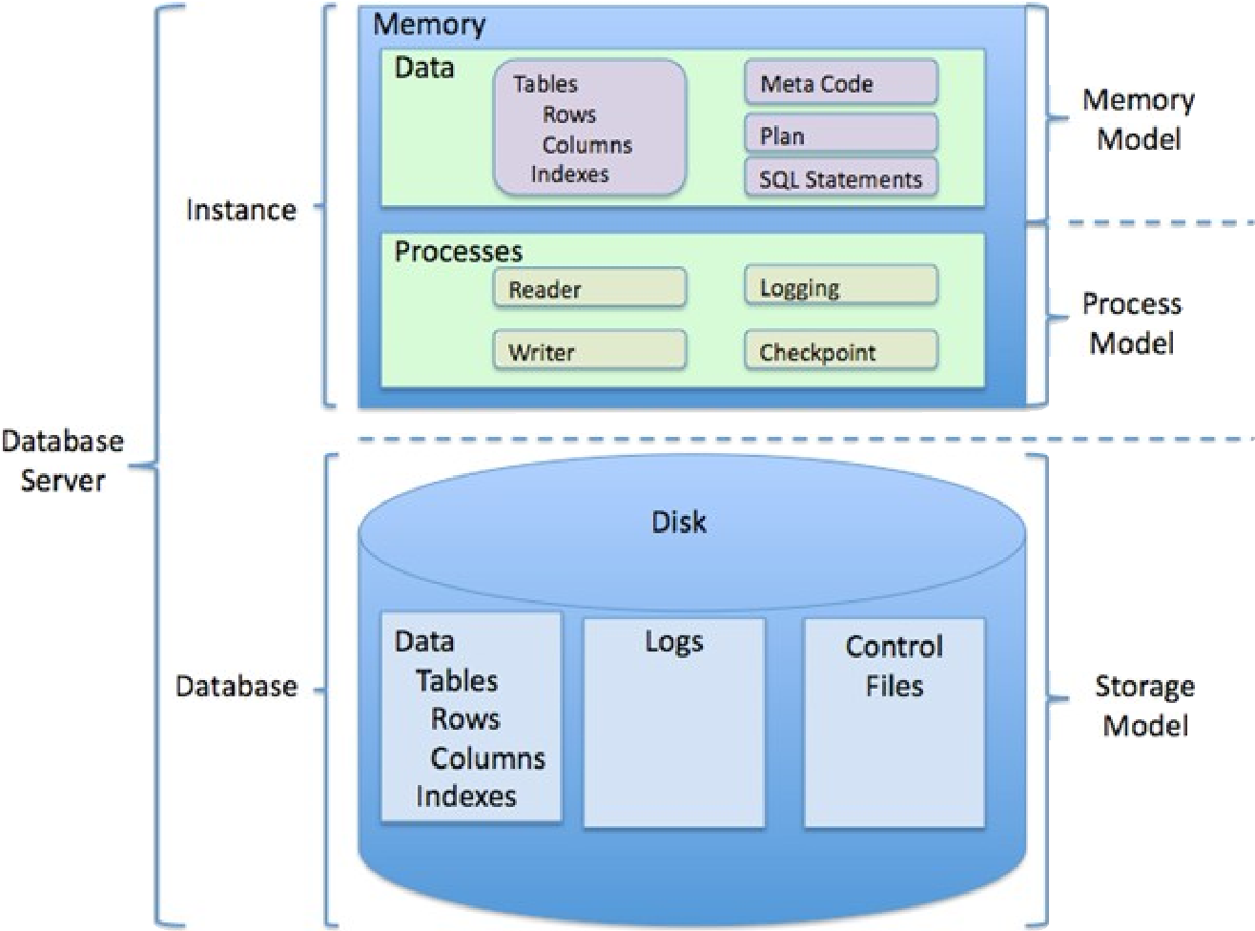

**Implementation Methodology:**

Model View Controller or MVC as it is popularly called, is a software design pattern for developing web applications. A Model View Controller pattern is made up of the following three parts:

* **Model** - The lowest level of the pattern which is responsible for maintaining data. • **View** - This is responsible for displaying all or a portion of the data to the user.
* **Controller** - Software Code that controls the interactions between the Model and View.

MVC is popular as it isolates the application logic from the user interface layer and supports separation of concerns. Here the Controller receives all requests for the application and then works with the Model to prepare any data needed by the View. The View then uses the data prepared by the Controller to generate a final presentable response. The MVC abstraction can be graphically represented as follows.

**MVC (Model View Controller Flow) Diagram**

|  |  |
| --- | --- |
| **Name of component** | **Specification** |
| **Operating System** | Windows 98, Windows XP, Windows7, |

**DATA FLOW DIAGRAMS**

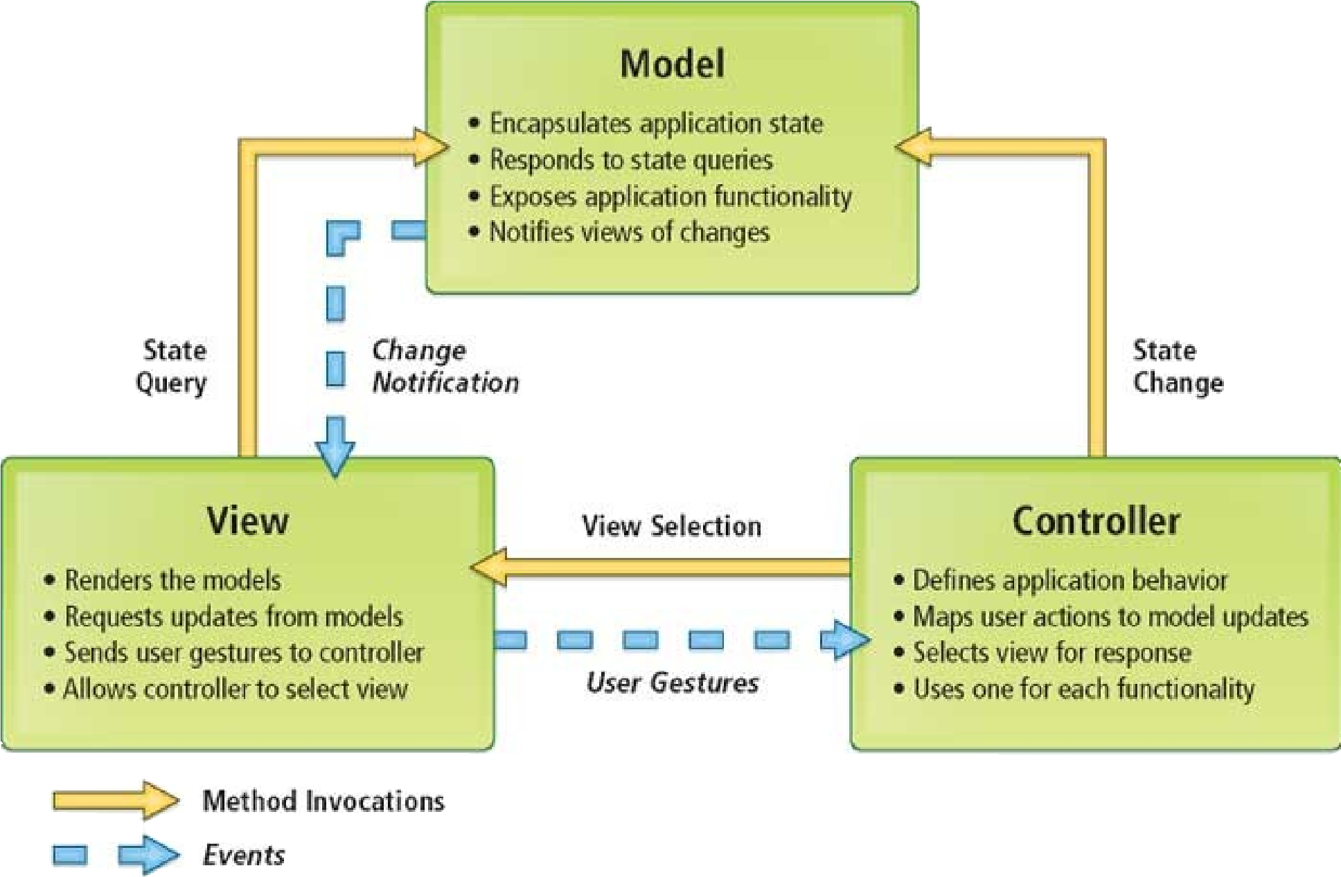

**Tools/Platform,**

**Hardware and Software**

**Requirement**

**specifications:**

**Software**

**Requirements:**

|  |  |
| --- | --- |
| **OS** | Windows |
| **Language** | Python3 |
| **Database** | MySQL Server |
| **Browser** | Any of Mozilla, Opera, Chrome etc |
| **Web Server** | MySQL Server |
| **Software Development Kit** |  |
| **Scripting Language Enable** | JSP (Java Server Pages) |
| **Database JDBC Driver** | MySQL Connector |
| **Hardware Requirements:** |  |
| **Name of component** | **Specification** |
| **Processor** | Pentium III 630MHz |
| **RAM** | 128 MB |
| **Hard disk** | 20 GB |
| **Monitor** | 15” colour monitor |
| **Keyboard** | 122 keys |

**System Analysis:**

System analysis is a process of gathering and interpreting facts, diagnosing problems and the information about the Stock Price Prediction to recommend improvements on the system. It is a problem-solving activity that requires intensive communication between the system users and system developers. System analysis or study is an important phase of any system development process. The system is studied to the minutest detail and analysed. The system analyst plays the role of the interrogator and dwells deep into the working of the present system. The system is viewed as a whole and the input to the system are identified. The outputs from the organizations are traced to the various processes. System analysis is concerned with becoming aware of the problem, identifying the relevant and decisional variables, analysing and synthesizing the various factors and determining an optimal or at least a satisfactory solution or program of action. A detailed study of the process must be made by various techniques like interviews, questionnaires etc. The data collected by these sources must be scrutinized to arrive to a conclusion. The conclusion is an understanding of how the system functions. This system is called the existing system. Now the existing system is subjected to close study and problem areas are identified. The designer now functions as a problem solver and tries to sort out the difficulties that the enterprise faces. The solutions are given as proposals. The proposal is then weighed with the existing system analytically and the best one is selected. The proposal is presented to the user for an endorsement by the user. The proposal is reviewed on user request and suitable changes are made. This is loop that ends as soon as the user is satisfied with proposal. Preliminary study is the process of gathering and interpreting facts, using the information for further studies on the system. Preliminary study is problem solving activity that requires intensive communication between the system users and system developers. It does various feasibility studies. In these studies, a rough figure of the system activities can be obtained, from which the decision about the strategies to be followed for effective system study and analysis can be taken.

**Existing System of Stock Price Prediction:**

In the existing system the exams are done only manually but in proposed system we have to computerize the exams using this application.

* Lack of security of data.
* More man power.
* Time consuming.
* Consumes large volume of pare work.
* Needs manual calculations.
* No direct role for the higher officials

**Proposed System of Stock Price Prediction:**

The aim of proposed system is to develop a system of improved facilities. The proposed system can overcome all the limitations of the existing system. The system provides proper security and reduces the manual work.

* Security of data.
* Ensure data accuracies.
* Proper control of the higher officials.
* Minimize manual data entry.
* Minimum time needed for the various processing.
* Greater efficiency.
* Better service.
* User friendliness and interactive.
* Minimum time required.

**Data Dictionary:**

This is normally represented as the data about data. It is also termed as metadata some times which gives the data about the data stored in the database. It defines each data term encountered during the analysis and design of a new system. Data elements can describe files or the processes.

Following are some major symbols used in the data dictionary

* = equivalent to
* + and
* [] either/ or
* () Optional entry

**Following are some rules, which defines the construction of data dictionary entries:**

* 1. Words should be defined to understand for what they need and not the variable need by which they may be described in the program.
  2. Each word must be unique. We cannot have two definition of the same client.
  3. Aliases or synonyms are allowed when two or more enters shows the same meaning. For example, a vendor number may also be called as customer number.
  4. A self-defining word should not be decomposed. It means that the reduction of any information in to subpart should be done only if it is really required that is it is not easy to understand directly.

Data dictionary includes information such as the number of records in file, the frequency a process will run, security factor like pass word which user must enter to get excess to the information.

**Conclusion of the Project Stock Price Prediction:**

Our project is only a humble venture to satisfy the needs to manage their project work. Several user-friendly coding has also adopted. This package shall prove to be a powerful package in satisfying all the requirements of the school. The objective of software planning is to provide a frame work that enables the manger to make reasonable estimates made within a limited time frame at the beginning of the software project and should be updated regularly as the project progresses.

In this project, we propose that existing work may integrated into a robust model to predict NSE stock market accurately. This model can be improved upon by defining refined fuzzy rules. Improving upon the training data’s scale and timeframe can result in better prediction. A trading model using the proposed methodology can be developed to compute total returns or investments in real time. This can prove the accuracy of the model. This model can successfully recommend the best stocks for investment.

**At the end it is concluded that we have made effort on following points…**

* A description of the background and context of the project and its relation to work already done in the area.
* Made statement of the aims and objectives of the project.
* The description of Purpose, Scope, and applicability.
* We define the problem on which we are working in the project.
* We describe the requirement Specifications of the system and the actions that can be done on these things.
* We understand the problem domain and produce a model of the system, which describes operations that can be performed on the system.
* We included features and operations in detail, including screen layouts.
* We designed user interface and security issues related to system.
* Finally, the system is implemented and tested according to test cases.

**Future Scope of the Project:**

National Stock Exchange of India (located in Mumbai) ranks at 12th largest in the world. NSE India has 1659 companies listed for public trading. Out of this only 50 (known as Nifty50) are focused on by investors. Nifty50 acts as a barometer for Indian stock market growth. Indian economy relies mostly exporting agricultural goods and services like software and technical support. Unfortunately, only 4 % of India’s GDP is derived from stock market exchange. This is much less compared to that of other developing countries which range from 20 to 40%. This untapped resource can be monetized more efficiently to contribute to development of India.

**Limitation of Project on Stock Price Prediction**

Although I have put my best efforts to make the software flexible, easy to operate but limitations cannot be ruled out even by me. Though the software presents a broad range of options to its users some intricate options could not be covered into it; partly because of logistic and partly due to lack of sophistication. Paucity of time was also major constraint; thus, it was not possible to make the software fool proof and dynamic. Lack of time also compelled me to ignore some part such as storing old result of the candidate etc.

Considerable efforts have made the software easy to operate even for the people not related to the field of computers but it is acknowledged that a layman may find it a bit problematic at the first instance. The user is provided help at each step for his convenience in working with the software.

**List of limitations which is available in the Stock Price Prediction:**

* Excel export has not been developed for Data transfer due to some criticality.
* The transactions are executed in off-line mode, hence on-line data rest features cannot be delivered.
* Off-line reports of Analysis cannot be generated due to batch mode execution.

**References and Bibliography:**

* Hellstrom, T. and Holmstrom, K. 1998, 'Predicting the Stock Market', Technical Report SeriesIma-TOM-1997-07.
* M. Usmani, S. H. Adil, K. Raza and S. S. A. Ali, "Stock market prediction using machine learning techniques," 2016 3rd International Conference on Computer and Information Sciences (ICCOINS), Kuala Lumpur, 2016, pp. 322-327.
* R. C. Cavalcante and A. L. I. Oliveira, "An autonomous trader agent for the stock market based on online sequential extreme learning machine ensemble," 2014 International Joint Conference on Neural Networks (IJCNN), Beijing, 2014, pp. 1424-1431.
* P. D. Yoo, M. H. Kim and T. Jan, "Financial Forecasting: Advanced Machine Learning Techniques in Stock Market Analysis," 2005 Pakistan Section Multitopic Conference, Karachi, 2005, pp. 1-7. 1.
* A. Porshnev, I. Redkin and A. Shevchenko, "Machine Learning in Prediction of Stock Market Indicators Based on Historical Data and Data from Twitter Sentiment Analysis," 2013 IEEE 13th International Conference on Data Mining Workshops, Dallas, TX, 2013, pp. 440-444.5.D. Rao, F. Deng, Z. Jiang and G. Zhao, "Qualitative Stock Market Predictingwith Common Knowledge Based Nature Language Processing: A Unified View and Procedure," 2015 7th International Conference on Intelligent Human-Machine Systems and Cybernetics, Hangzhou, 2015, pp. 381-384.
* P. D. Yoo, M. H. Kim and T. Jan, "Machine Learning Techniques and Use of Event Information for Stock Market Prediction: A Survey and Evaluation," International Conference on Computational Intelligence for Modelling, Control and Automation and International Conference on Intelligent Agents, Web Technologiesand Internet Commerce (CIMCA-IAWTIC'06), Vienna, 2005, pp. 835-841.
* M. Qasem, R. Thulasiram and P. Thulasiram, "Twitter sentiment classification using machine learning techniques for stock markets," 2015 International Conference on Advances in Computing, Communications and Informatics (ICACCI), Kochi, 2015, pp. 834-840.
* M. Tirea and V. Negru, "Text Mining News System -Quantifying Certain Phenomena Effect on the Stock Market Behavior," 2015 17th International Symposium onSymbolic and Numeric Algorithms for Scientific Computing (SYNASC), Timisoara, 2015, pp. 391-398.