**UNIVERSITÀ’ DEGLI STUDI DELL’INSUBRIA**

DIPARTIMENTO DI SCIENZE TEORICHE E APPLICATE (DiSTA)

CORSO DI LAUREA MAGISTRALE IN INFORMATICA

**INTELLIGENT SYSTEM PROJECT**

RELAZIONE DI:

Vladi VALSECCHI matr 730030

Gianluca MOLTENI matr 730113

ANNO ACCADEMICO 2020/2021

**INTRODUCTION**

In this project we will proceed to the classification of two datasets, using two classification models and varying their metrics. We will then carry out an analysis of the results obtained for the single algorithm and an overall analysis of the performances.

Our goal is to understand which classification algorithm performs better on the inputs considered. The project includes a main file and a function file made on Jupyter Notebook in Python language (.ipynb format) using a Python 3.6 environment generated in Anaconda in which we implemented methods for choosing the features to be used for the classification and subsequently the actual classification.

**PART A**

***What are supervised methods?***

Supervised learning is a type of machine learning. Its goal is to classify data based on samples provided for reference. Each sample is associated with a label (represents the class). Consequently, the expression <pattern-class label> is used to indicate the association.

The characteristic of supervised methods is the separation of the data provided in input into two subsets called training set and test set. The first is the set used for learning and creating the model, the second is used for validating the model.

A mapping function is used to associate the input data with the most suitable class.

Supervised methods can be divided in two categories:

* Classification: is the process of prediction of the class based on the provided data. Classes are called targets/labels or categories;
* Regression: provides us with a simple linear relationship of two or more variables within a dataset.

The classification must be performed with a consistent set of data, this is because the performance varies according to the goodness of the training data provided in input. Another factor affecting performance is the amount of data provided. In this case, may happen a situation of:

* Overfitting - when there are many parameters that must be taken in account. The result is a high precision but fails in the generalization process ;
* Underfitting - few parameters are provided during the training phase, in which the classifiers suffer from an excessive discrepancy .

**PART B**

***Introduction***

For the realization of the project we relied on two supervised classification models.

With classification we mean the processes of prediction of data classes of points. The classes are also called target/labels or categories. Classification models require a set of input variables (X) and a mapping function (f) which associate each input with an output. The result (Y) is a discrete variable. Given an input x∈X and W classes ⍵1,...,⍵W we must find W decision functions d1(x),...,dW(x) with the property that a given x belongs to the class ⍵I iff di(x)>dj(x) with j=1,...,W and j≠i. The function f is also called the discriminant function and it helps us to understand where two classes are separated. Such a decision boundary between two classes (ωi, ωj) is given by the value of x for which di(x)=dj(x).

The difference between two classes is given by:

dij(x) = di(x) - dj(x) = 0

dij(x) > 0 → x appartiene a ωi

dij(x) < 0 → x appartiene a ωj

The supervised classifiers chosen are Minimum Distance Classifier (MDC) and K-Nearest Neighbor (KNN).

***MINIMUM DISTANCE CLASSIFIER (MDC)***

The Minimum Distance Classifier or MDC is a supervised classification algorithm that associates a given x to the class based on the minimum distance. The classifier makes use of Minkowski distances:

*d(x,y)=(Σi=1,N(xi-yi)λ)1/λ*

where λ is an integer and determines the metric:

* λ=2: Euclidean distance;
* λ=1: Cityblock/Manhattan distance;
* λ→ ∞: Chessboard;

The process includes the computation of a prototype vector for each class. An unknown pattern is compared with the prototype and assigned to the nearest class.

|  |  |
| --- | --- |
| **ADVANTAGES** | **DISADVANTAGES** |
| Low demand for training data | Statistical information are ignored |
| Heuristic rule | Works well when the distance between means is large |
| Easy to design |  |
| Low computational complexity |  |

***K - NEAREST NEIGHBOR***

The K Nearest Neighbor or KNN is a supervised classification algorithm that associates a given x to the class based on the quantity of elements of a given class in a given range. KNN is also based on Minkowski distances and the most used for this algorithm is the Euclidean distance. The classifier does not require a separate training phase and doesn’t make statistical assumptions on the distribution of classes. KNN is a lazy learner because it doesn’t learn a discriminative function from the training data but memorizes the training dataset instead.

Given W classes and N supervised training samples. To classify a pattern x, the distance is computed (using a predefined metrics) between the pattern x and k nearest samples. The class that has the most elements will be the class associated with the pattern.

|  |  |
| --- | --- |
| **ADVANTAGES** | **DISADVANTAGES** |
| Easy to design and understand | Computational time at test time |
| No time to train |  |

**PART C**

The datasets used for the experiment are:

* Iris;
* Wine.

Both datasets come from the *sklearn.datasets* library.

The newly imported datasets are in the form of an array and were subsequently converted into dataframes using the *pandas* library, in order to better manage the data.

***Dataset analysis***

**Iris**

The dataset presents 150 instances divided into 3 classes Iris-Setosa, Iris-Versicolor and Iris-Virginica. Each class comprises 50 instances. The attributes that characterize the dataset are 4:

* sepal length in cm;
* sepal width in cm;
* petal length in cm;
* petal width in cm.

The data presents the following characteristics:

|  |  |  |  |  |
| --- | --- | --- | --- | --- |
| **Feature** | **Min** | **Max** | **Mean** | **SD** |
| *sepal length* | 4.3 | 7.9 | 5.84 | 0.83 |
| *sepal width* | 2.0 | 4.4 | 3.05 | 0.43 |
| *petal length* | 1.0 | 6.9 | 3.76 | 1.76 |
| *petal width* | 0.1 | 2.5 | 1.20 | 0.76 |

We use a correlation matrix to determine the best correlation between the features. The greater the color intensity, the greater the relationship between features

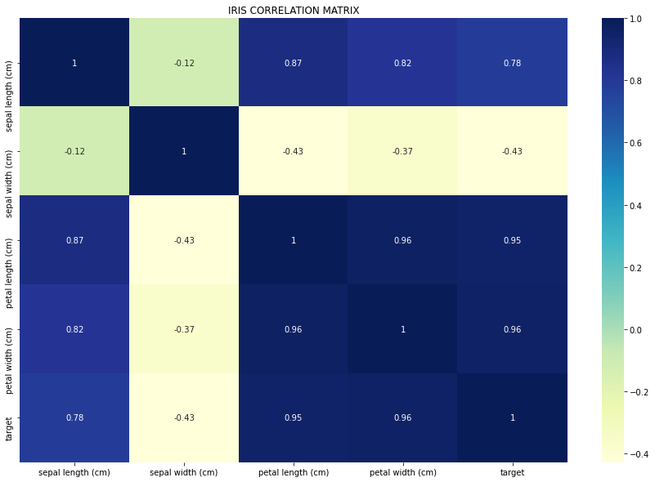

**Wine**

The dataset presents 178 instances divided into 3 classes class-0, class-1 and class-2. The classes contain 59, 71 and 48 instances respectively. The attributes that characterize the dataset are 13:

* alcohol;
* malic_acid;
* ash;
* alcalinity_of_ash;
* magnesium;
* total_phenols;
* flavonoids;
* nonflavonoid_phenols;
* proanthocyanis;
* color_intensity;
* hue;
* od280/od315_of_diluited_wines;
* proline

The data presents the following characteristics:

|  |  |  |  |  |
| --- | --- | --- | --- | --- |
| **Feature** | **Min** | **Max** | **Mean** | **SD** |
| *alcohol* | 11.0 | 14.8 | 13.0 | 0.8 |
| *malic_acid* | 0.74 | 5.80 | 2.34 | 1.12 |
| *ash* | 1.36 | 3.23 | 2.36 | 0.27 |
| *alcalinity_of_ash* | 1.06 | 30.0 | 19.5 | 3.3 |
| *magnesium* | 70.0 | 162.0 | 99.7 | 14.3 |
| *total_phenols* | 0.98 | 3.88 | 2.29 | 0.63 |
| *flavonoids* | 0.34 | 5.08 | 2.03 | 1.00 |
| *nonflavonoid_phenols* | 0.13 | 0.66 | 0.36 | 0.12 |
| *proanthocyanis* | 0.41 | 3.58 | 1.59 | 0.57 |
| *color_intensity* | 1.3 | 13.0 | 5.1 | 2.3 |
| *hue* | 0.48 | 1.71 | 0.96 | 0.23 |
| *od280/od315_of_diluited_wines* | 1.27 | 4.00 | 2.61 | 0.71 |
| *proline* | 278 | 1680 | 746 | 315 |

Again we used a correlation matrix to analyze the relationship between features, and the results are represented below:

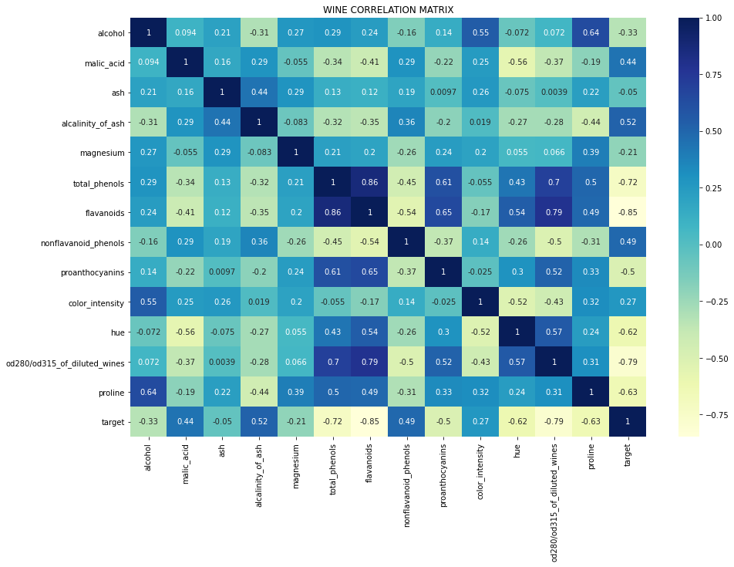

**FEATURE SELECTION**

For the feature selection operation we relied on the SelectKBest feature selector, coming from the *sklearn.feature_selection.SelectKBest* library. The selector uses chi2, so it computes chi-squared stats between each non-negative feature and class and it is used to select the n_features (n_features=2) features with the highest values for the test chi-squared statistic.

**K Best Iris**

Analyzing the dataset and applying the feature selection method, we have:

|  |  |  |
| --- | --- | --- |
| **Feature** | **Score** | **Pval** |
| sepal length | 10.817821 | 4.476515e-03 |
| sepal width | 3.710728 | 1.563960e-01 |
| petal length | 116.312613 | 5.533972e-26 |
| petal width | 67.048360 | 2.758250e-15 |

So, the k best features for Iris based on score are: **petal length, petal width**.

**Kbest Wine**

The same approach is applied on Wine dataset

|  |  |  |
| --- | --- | --- |
| **Feature** | **Score** | **Pval** |
| alcohol | 5.445499 | 6.569389e-02 |
| malic_acid | 28.068605 | 8.034890e-07 |
| ash | 0.743381 | 6.895678e-01 |
| alcalinity_of_ash | 29.383695 | 4.163050e-07 |
| magnesium | 45.026381 | 1.669728e-10 |
| total_phenols | 15.623076 | 4.050346e-04 |
| flavonoids | 63.334308 | 1.766565e-14 |
| nonflavonoid_phenols | 1.815485 | 4.034340e-01 |
| proanthocyanis | 9.368283 | 9.240664e-03 |
| color_intensity | 109.016647 | 2.124887e-24 |
| hue | 5.182540 | 7.492483e-02 |
| od280/od315_of_diluited_wines | 23.389883 | 8.335878e-06 |
| proline | 16540.067145 | 0.000000e+00 |

The k best features for Wine based on score are: **proline, color_intensity**.

***CLASSIFIERS UTILIZED***

The models chosen for the experiments on the two mentioned datasets are the supervised classifiers:

* Minimum Distance Classifier;
* K-Nearest Neighbor.

**MDC**

For the use of this classifier, we have divided the training set and test set with a proportion of 70% and 30%. The number of resampling that is performed is also set to 40.

Metrics

Within the classifier class, you can set the metric for the distance calculation. The default metric is the Euclidean distance. Besides this metric we also used Manhattan distance and Chessboard (Chebyshev) distance.

**KNN**

Within the project we have implemented a second algorithm for the classification of patterns: the K-Nearest Neighbor.

K-Nearest Neighbor makes use of Minkowski's metrics, but in this case, we only used the default metric, which is the Euclidean metric.

At the beginning we divided the dataset into training set and test set, with a proportion of 70% - 30%.

We applied KNN with k increasing from 1 to 40 inclusive. We thus obtain <k - accuracy> pairs and we have analyzed a general case (k=5), the worst case and the best case.

This is implemented to see how the classifier performs in various scenarios.

**Classifiers Evaluation**

For the evaluation of the performance of the MDC with the three metrics used, we relied on accuracy. Accuracy is the number of correctly classified data instances out of the total number of data instances.

$$accuracy =\frac{true negative + true positive}{true negative + true positive + false positive + false negative}$$

Regarding the KNN we made use of the *confusion_matrix* and *classification_report* functions. Classification report provided us with the following parameters:

* Precision is the ability of the classifier not to label as positive a sample that is negative.
$$precision = \frac{true positive}{true positive + false positive}$$

* Recall, indicates the percentage of true positives and the value;
$$recall = \frac{true positive}{(true positive + false negative)}$$

* F1-Score, is the harmonic mean between precision and recall and is a better measure of precision. The value fluctuates between 0 and 1;
$$f1-score =2 * \frac{Precision * Recall}{Precision + Recall}$$

* Support, is the number of occurrences of each class in y_test;
* Accuracy;
* Macro-AVG, Calculate metrics for each label, and find their unweighted mean. This does not take label imbalance into account.
* Weighted-AVG, calculate metrics for each label, and find their average weighted by support (the number of true instances for each label).

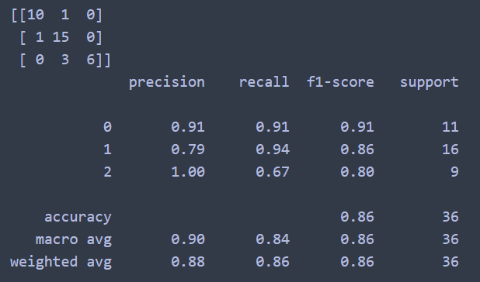

In order to compare the performance of MDC and KNN with the same accuracy metric, for the KNN we have chosen to rely exclusively on the accuracy metric.

The data that will be commented in the next sections are the results obtained from our experiment and may vary with new executions of the code. The performance evaluation of the two classifiers is based on these data.

**MDC Euclidean Performance EVALUATION**

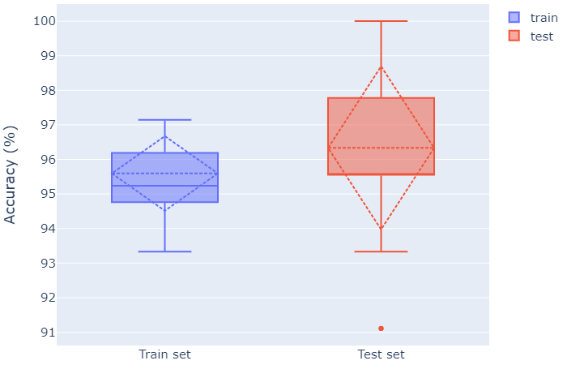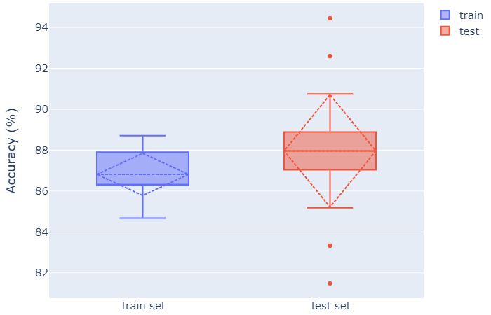

Iris dataframe Wine dataframe

As can be seen from the boxplot, the MDC with Euclidean metric, performs better in terms of accuracy, in the test phase, on the Iris dataframe, with an average accuracy of 96.33%, minimum outlier value of 91.11% and maximum of 100% while for the Wine dataframe an average of 87.96% is obtained, a minimum outlier value of 81.48% and a maximum outlier of 94.44%. The best distribution in the test phase is obtained for the Wine dataframe despite its values are significantly lower than those obtained by the Iris dataframe.

Using the Euclidean metric, the MDC performs better both in the train phase and in the test phase for the Iris dataframe.

**MDC Chessboard Performance EVALUATION**

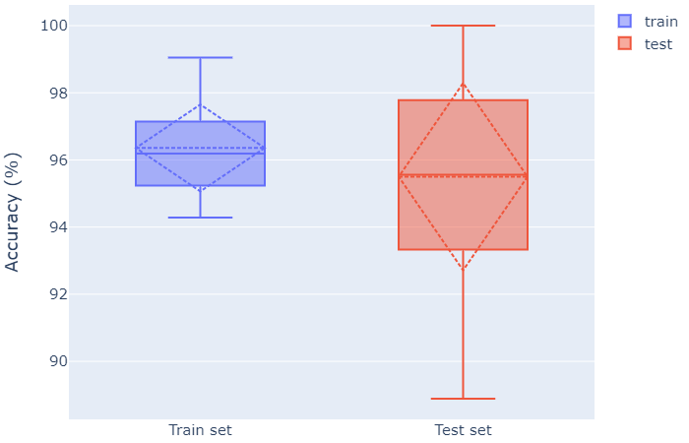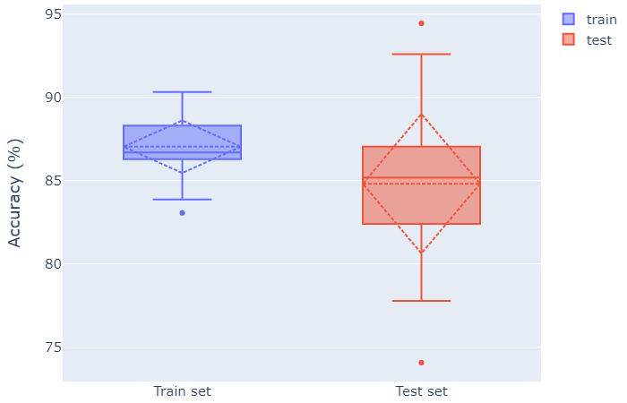

Iris dataframe Wine dataframe

According to the boxplots, the MDC with Chessboard metrics performs better in terms of accuracy, in the test phase, on the Iris dataframe, with an average accuracy of 95.50%, a minimum value of 88.89% and a maximum of 100% while for the Wine dataframe an average of 84.81% is obtained, a minimum outlier value of 74.07% and a maximum outlier of 94.44%. With this metric you have a better distribution in the test phase for the Iris dataframe.

Using the Chessboard metric, the MDC performs better in both the train and test phase for the Iris dataframe.

Considering the results seen so far we can say that the MDC achieves better accuracy values with all three metrics for the Iris dataframe. The distribution of these values, most of the time, is better for the Iris dataframe while in the case with Euclidean metrics the distribution of the data is in favor of the Wine dataframe, despite having obtained worse accuracy values.

**KNN Performance EVALUATION (Iris dataframe)**

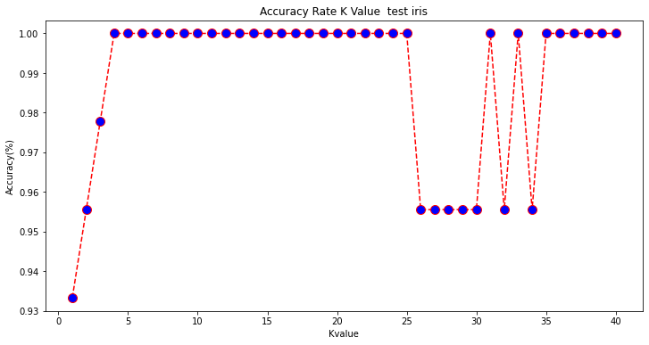The analysis continues with the variation of the k value in the test phase, where we noticed a rapid increase in accuracy right from the start (k = 1 93%, k = 4 100%) with the increase of the k value by a few unit. The accuracy is kept stable up to a high number of k (k = 25) and then decreases in value (k = 26-30 95.5%) and then rises swinging up to stabilize with very high k (k = 35- 40 100%). The accuracy in these 40 k remains high in most cases.

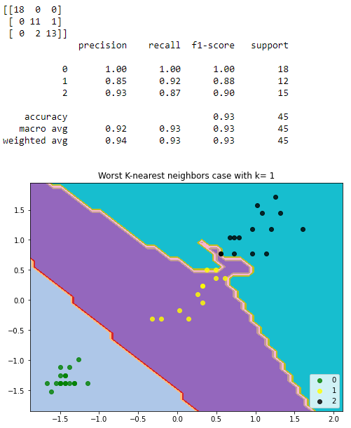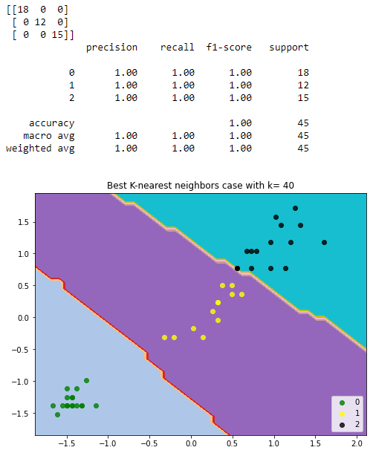

*Worst k for Iris dataframe (k=1) One of the best k for Iris dataframe (k=40)*

**KNN Performance EVALUATION (Wine dataframe)**

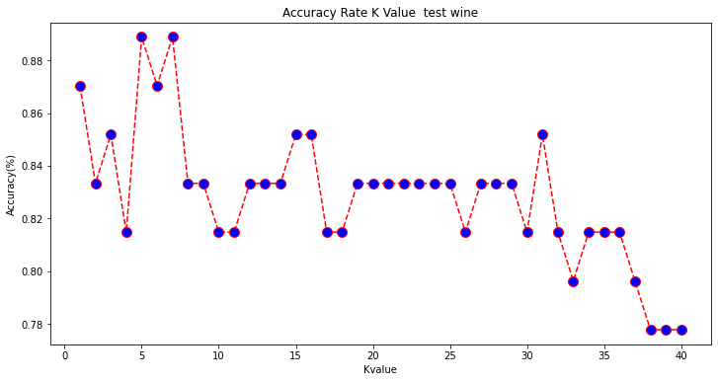By varying the value of k in the test phase for the Wine dataframe, we notice a fluctuating trend, with 2 points of maximum accuracy (k = 5 and k = 7, 89%). The accuracy level in the general tendence is decreasing until reaching very high k values (k = 38,39,40) where the lowest accuracy level is obtained (78%).

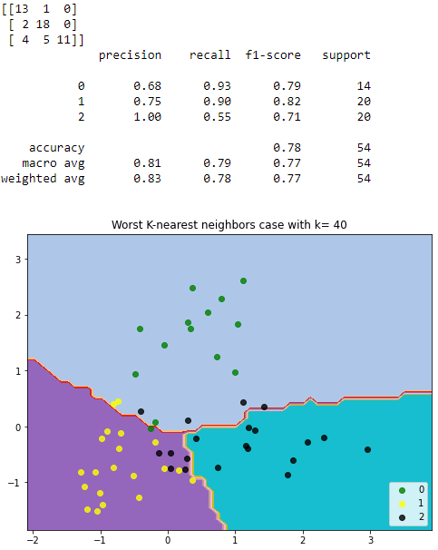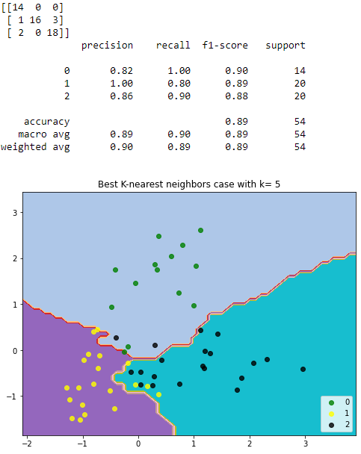

*One of the worst k for Wine dataframe (k=40) One of the best k for Wine dataframe (k=5)*

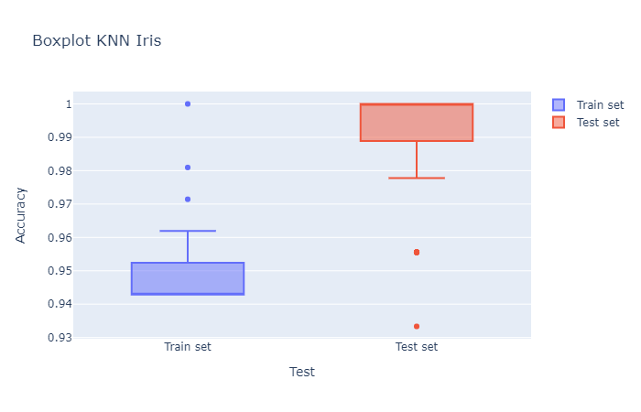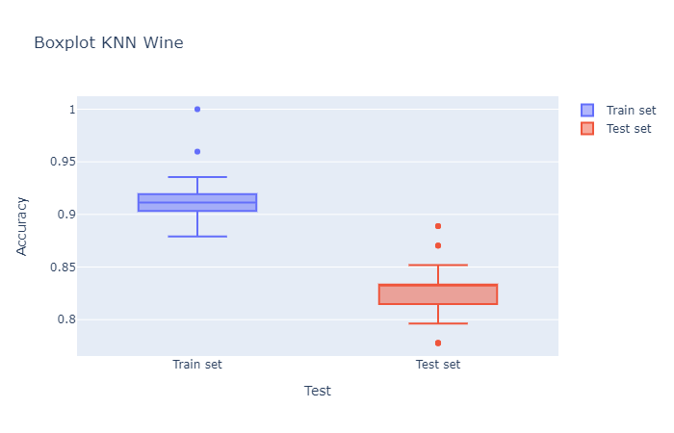

*Iris dataframe KNN boxplots Wine dataframe KNN boxplots*

The distribution of the accuracy values in the test phase is better for the Iris dataframe, with a range that varies from 0.98 to 1. There are also 2 outliers of which the minimum is 0.93. Regarding the Wine dataframe, its values are in a range that varies between 0.79 and 0.85. There are 3 outliers of which a minimum with a value of 0.78 and a maximum of 0.89. The KNN in the test phase performs better on the Iris dataframe than the Wine dataframe, which performed worse than the training phase.

Considering the results obtained, we can affirm that the KNN performs better both in the training phase and in the test phase with the Iris dataframe.

**FINAL RESULTS**

According to the results obtained, it is clear that the MDC performs better than the KNN.

In terms of accuracy, the best result was obtained with the MDC with Euclidean metric on the Iris dataframe, while the worst was obtained with the MDC with Chessboard metric on the Wine dataframe.

By averaging the results obtained by varying the distance metric on the MDC, the best result is obtained with the MDC with Euclidean metric and the worst is obtained with the MDC with Chessboard metric.

Based on the difference in the average accuracy value on the two data frames, the classifier that gave us the closest accuracy values for both data frames is the MDC with Cityblock metric and the one with the most different values is the KNN.

In our opinion, the MDC with Cityblock metric performs better as it has managed to provide more similar accuracy values than all the other metrics used for the MDC and KNN.

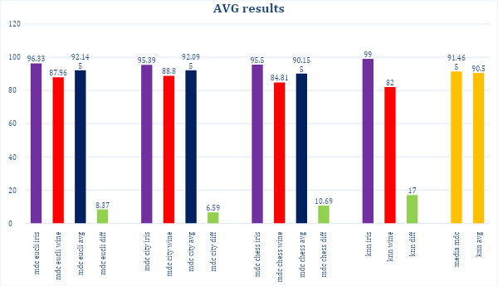

**Bibliography**

* Slides from Intelligent System course
* Slides from Data Science for Business course
* scikit-learn.org
* pandas.pydata.org
* plotly.com
* medium.com