Порождающие матрицы 4 степени в неканоническом и каноническом видах

1. G(X) = X4+ X3 + 1 ~ 11001 (15,11) 2. G(X) = X4+ X + 1 ~ 10011

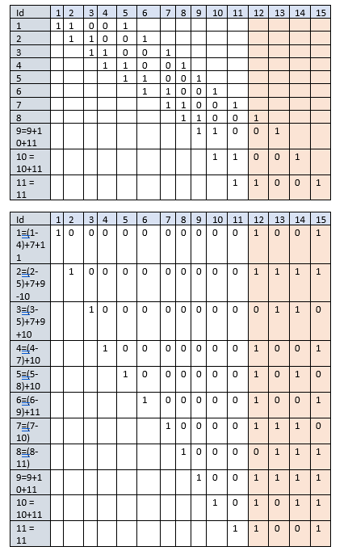 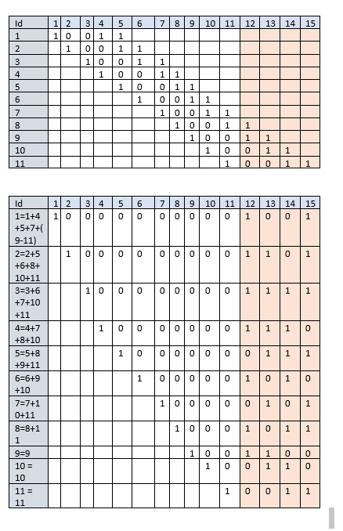

1. G(X) = X4+ X2 + X + 1 ~ 10111 (7,3) 4. G(X)=X4 + X3 + X2 + 1 ~ 11101 (7,3)

|  |  |  |  |  |  |  |  |
| --- | --- | --- | --- | --- | --- | --- | --- |
| Id | 1 | 2 | 3 | 4 | 5 | 6 | 7 |
| 1 | 1 | 0 | 1 | 1 | 1 |  |  |
| 2 |  | 1 | 0 | 1 | 1 | 1 |  |
| 3 |  |  | 1 | 0 | 1 | 1 | 1 |

|  |  |  |  |  |  |  |  |
| --- | --- | --- | --- | --- | --- | --- | --- |
| Id | 1 | 2 | 3 | 4 | 5 | 6 | 7 |
| 1 | 1 | 1 | 1 | 0 | 1 |  |  |
| 2 |  | 1 | 1 | 1 | 0 | 1 |  |
| 3 |  |  | 1 | 1 | 1 | 0 | 1 |

|  |  |  |  |  |  |  |  |
| --- | --- | --- | --- | --- | --- | --- | --- |
| Id | 1 | 2 | 3 | 4 | 5 | 6 | 7 |
| 1=1+2 | 1 | 0 | 0 | 1 | 1 | 1 | 0 |
| 2=2+3 |  | 1 | 0 | 0 | 1 | 1 | 1 |
| 3 |  |  | 1 | 0 | 1 | 1 | 1 |

|  |  |  |  |  |  |  |  |
| --- | --- | --- | --- | --- | --- | --- | --- |
| Id | 1 | 2 | 3 | 4 | 5 | 6 | 7 |
| 1=1+3 | 1 | 0 | 0 | 1 | 0 | 1 | 1 |
| 2 |  | 1 | 0 | 1 | 1 | 1 | 0 |
| 3 |  |  | 1 | 0 | 1 | 1 | 1 |