Chapter 4:

Overlooked model uncertainties may misinform forest management strategies

Victor Van der Meersch1, Isabelle Chuine1

1*CEFE, Univ Montpellier, CNRS, EPHE, IRD, Montpellier, France*

**ABSTRACT**

Rising temperatures and increased frequency of extreme weather events are threatening European forests(cite), thus projections of the suitability of future climatic conditions for forest tree species should guide conservation efforts, forest management strategies and make informed decisions(cite). Many existing forecast models are correlative in nature and they do not evaluate the uncertainties associated with the model projections. Here, we forecast the distribution of six key European tree species using correlative and process-explicit models and the most recent climatic projections. We show that the greatest impacts on forests is likely to be in the Mediterranean, alpine and boreal biomes (provide stats and ranges). We also show that the use of occurrence data to calibrate both correlative and process-explicit models consistently leads to more pessimistic predictions, and that a range of models provides a better assessment of projection uncertainties. Improving the uncertainty budgets for species forecast models is a key step to leading action to mitigating the impacts of climate change on forest ecosystems.

# Introduction

Climate change has direct impact on a myriad of ecosystem processes, and forests are especially vulnerable. European temperatures are rising twice as fast as the global average (Copernicus Climate Change Service, 2024), and unprecedented pulses of tree mortality have benn reported in the last decade, across the range of forest species (Senf et al, 2020). As a consequence, some European forests are now net CO2 sources (Hadden and Grelle, 2016; Karelin et al, 2021), due to decreased growth (Hadden and Grelle, 2016; van der Woude et al, 2023), increased burned areas (Carnicer et al, 2022; Kelly et al, 2024), and increased pest or drought-related dieback driven (Cienciala and Melichar, 2024; Karelin et al, 2021; Latifovic and Arain, 2024). Forests managers are facing unprecedented challenges, as they need to address current issues while promoting forest adaptation to climate change. Implementation strategies are rolled out in spite of the uncertainty of the scenarios.

Predictive ecological models are essential to examine the ecological drivers across scales (Levins, 1993; Mitchell and Dietrich, 2006). Most model-based studies project pronounced species range shifts and forest composition changes in European forests. Oaks (*Quercus robur* L., *Quercus petraea* (Matt.) Liebl.) and beech (*Fagus sylvatica* L.), have been predicted to expand their range towards North-eastern Europe but to decline in Southern Europe and in France (Dyderski et al, 2018; Hanewinkel et al, 2013; Hickler et al, 2012; Saltré et al, 2015; Schueler et al, 2014; Takolander et al, 2019; Wessely et al, 2024). Areas suitable for Mediterranean oak forests should increase (Hanewinkel et al, 2013; Ohlemüller et al, 2006; Takolander et al, 2019). In contrast, coniferous trees, such as spruce (*Picea abies* L.) or pine (*Pinus sylvestris* L.), are expected to loose large portions of their current range (Hanewinkel et al, 2013; Schueler et al, 2014; Wessely et al, 2024). These species shifts are predicted to have major impacts on timber production and on the forest economic sector (Hanewinkel et al, 2013; Wessely et al, 2024). However, uncertainties associated with species range projections are often underappreciated. Most projections have relied on correlative models, and uncertainties are often ignored (Simmonds et al, 2024), or they primarily focused on three sources of errors: the data quality used for model fitting (Barbet-Massin et al, 2010; Chen et al, 2013; Duputié et al, 2014; Faurby and Araújo, 2018), the variation among climate change projections (Beaumont et al, 2007; Diniz-Filho et al, 2009; Thuiller et al, 2019), and the variation among modeling method (Diniz-Filho et al, 2009; Pearson et al, 2006; Thuiller

et al, 2019). The differences between fitting algorithms can be significant, yet previous studies ignore a large part of the methodological uncertainty of the projections, as evidenced in studies based on process-explicit models (Van der Meersch et al, 2024, Cheaib et al, 2012; Keenan et al, 2011a; Morin and Thuiller, 2009; Takolander et al, 2019). These studies, albeit limited, have provided some essential insights into the real uncertainty range of species projections, and to address policy-relevant questions (Urban et al, 2016).

Here we combine a variety of species models to project the future distribution of six tree common species a range of climate projections from the CMIP6 dataset (Noël et al, 2022) and we seek to attribute the sources of uncertainty and to quantify their relative contribution to the total projection uncertainty.

# Methods

## Species distribution models

We selected five correlative models (Valavi et al 2022): a generalized linear model with lasso regularization, a generalized additive model, BRT, a model based on maximum entropy and down-sampled Random Forest. Second, process-explicit models and fitted process-explicit models (a hybrid between the former two approaches). To fit these correlative models, we selected a set of uncorrelated climate predictors, based on their relevance for tree species: minimum temperature of the coldest month (representing frost tolerance), total precipitation (representing available water), growing degree days >5°C between April and September (representing available thermal energy for vegetation growth and fruit maturation), and water balance between June and July (difference of precipitation and evapotranspiration, representing summer drought tolerance). We also included two soil covariates (pH and water holding capacity). We calibrated the models using species occurrences (Van der Meersch and Chuine 2023), based on EU-Forest inventory data (Mauri et al, 2017), and 50,000 background points to properly represent the full range of environmental conditions across Europe (Valavi et al, 2022). For each correlative model and each species, we ran a fivefold environmental cross-validation to estimate model performance in novel extrapolation conditions (Roberts et al, 2017). We then used the training data to calibrate the models in order to favour prediction quality (Roberts et al, 2017).

Then we used a process-explicit model called PHENOFIT, which assesses the fitness of an adult tree by simulating its phenological phases (leaf unfolding, flowering, fruit maturation, leaf senescence), and damages caused by abiotic stress (frost, drought) relatively to the development stages of the different organs. The model parameters were calibrated directly, or based on literature data, and they do not involve species occurrence data. PHENOFIT is forced by daily climate and soil water holding capacity, and it has been validated for a range of tree species (Duputié et al, 2015; Gauzere et al, 2020; Van der Meersch et al, 2024; Morin et al, 2007; Saltré et al, 2013). We also used a version of PHENOFIT calibrated using species occurrence data, with the constraints of the model’s process-explicit structure. Model parameters were optimized using the covariance matrix adaptation evolution strategy (Hansen and Ostermeier, 2001; Van der Meersch and Chuine 2023). To reduce the computational burden, model calibration was applied on subsets of 2000 points (1000 presences and 1000 absences), from the same dataset as correlative models. We calibrated

10 times each species parameter set, with five repetitions on two random subsets of presences/pseudo-absences (except for beech, for which we ran 10 repetitions on 10 subsets).

All approaches output a climate suitability index from 0 to 1 for each species. This suitability index can be converted into a binary predictor, with a threshold that maximizes the true skill statistic (TSS), calculated from a confusion matrix(cite).

Model robustness was assessed by hindcasting the range shifts of five forest tree species across Europe over the last 12,000 years (Van der Meersch et al, 2024). The results indicated that the transferability of PEMs (either expert or fitted) was higher in climates that were significantly different from the historical period.

~~Finally, for beech only, we also included a~~ *~~partially~~* ~~fitted PEM. It was calibrated in the same way as the fitted PEM, but we optimized only some critical parameters that were identified as responsible for errors in the expert PEM simulations (Chapter 3). Other parameters were fixed at the expert values. Note that this partially fitted PEM was not included in the uncertainty partitioning (see below).~~

## Environmental data

Models were calibrated with historical climatic conditions (1970-2000) from ERA5-Land dataset at a 9x9 km resolution (Muñoz-Sabater et al, 2021). Soil data were extracted from EU-SoilHydroGrids (Tóth et al, 2017) and SoilGrids (Hengl et al, 2017) databases. Future simulations were run with the sixth Coupled Model Intercomparison Project climate projections(cite), for five global climate models (GCMs): GFDL-ESM4, IPSL-CM6A-LR, MPI-ESM1-2-HR, MRI-ESM2-0, and UKESM1-0-LL. We also used two shared socio-economic pathways (SSP2-4.5 and SSP5-8.5), because the projected total cumulative CO2 emissions according to two International Energy Agency scenarios fall between these two SSPs (Schwalm et al, 2020).

## Uncertainty partitioning

The partitioning of uncertainties in climate projections followed previous methods (Hawkins and Sutton, 2009, 2011, Lafferty and Sriver, 2023; Yip et al, 2011).

For each species, three sources of uncertainty were partitioned: (i) the climate projection uncertainty related to the different GCMs, SSPs, and their interaction, (ii) the species distribution modeling uncertainty related to the different species distribution models (SDMs), and (iii) the species uncertainty related to the different species-specific responses to climate change. We also quantified the interactions between SDMs and climate projections between SDMs and species, and between species and climate projections.

The suitability of a cell was averaged across as a 21-year moving window centered on the focal year (e.g. 2040-2060 for the year 2050), compared with the historical suitability computed on the period 1970-2000 by calculating the difference. We performed an ANOVA-based variance decomposition to estimate the importance of the two-way interaction effects. The linear ANOVA yielded the sums of squares attributable to each uncertainty source. We then computed 90% uncertainty ranges additively and symmetrically around the mean projection.

Finally, we also partitioned the variance within each

*SS*

species. This implies applying the same ANOVA, but on species-level predictions, and thus dropping the species-related coefficients.

# Results

The mean suitability across simulations was computed relative to the reference period. Alpine and boreal biomes were found to increase in mean suitability (+x% and y% respectively), in contrast with the Mediterranean (-z%, Figure 20). The 90% confidence interval included zero (no change) in all biomes, and uncertainties increased significantly into the future. In Mediterranean and Alpine biomes, confidence intervals were narrower.

0.75 0.75

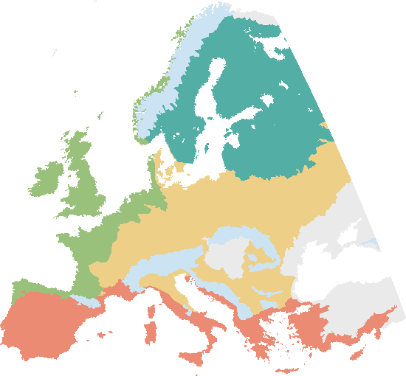

0.50 0.50

0.25 0.25

0.00 0.00

-0.25 -0.25

-0.50

2000 2030 2060 2090

-0.50

2000 2030 2060 2090

0.75

Projected change in suitability relative to 1970-2000

0.50

0.25

0.00

-0.25

Ecoregions

Alpine Atlantic Boreal Continental

Mediterranean Other

-0.50

2000 2030 2060 2090

0.75 0.75

0.50 0.50

0.25 0.25

0.00 0.00

-0.25 -0.25

-0.50

2000 2030 2060 2090

-0.50

2000 2030 2060 2090

Source of uncertainty:  Climate (SSP, GCM)  Climate - SDM  SDM  Species  Species - climate/SDM

**Fig. 20. Changes in climatic suitability change across European biomes for xx tree species.**  all simulations A variance decomposition was performed to partition five uncertainty sources: (i) future climate projections, (ii) interaction between SDM approach and climate projections, (iii) the SDM approach, (iv) tree species, and (v) interactions between species and both climate projections and SDM approaches.

The effects of the climate projections, the species and the modeling approach differed across biomes. Climate projection was the main source of uncertainty in the Alpine biome, explaining 44% of total uncertainty in 2090 (Figure 21b and 21c), while in the Atlantic and Continental biome, differences between species responses was the main source of uncertainty (respectively 56.6% and 42.4% in 2090; Figures 21b and 21c). Interestingly, modelling approach was respectively the first and the second source of uncertainty in the Boreal and the Continental biomes (33.7% and 29.4% respectively, Figures 21c and S27).

Two-way interactions between species and both climate projections and modeling ap- proaches also represent a significant contribution to the total uncertainty (Figure 20). In 2090, they represent the major source of uncertainty in the Mediterranean ecoregion (50.1%;

Figures 21b and 21c), and explain between 15.1% and 20.7% of the total uncertainty of the four other ecoregions. This stresses the importance of using ANOVAs to properly account for these interactions. In particular, the interaction between the species considered and the modelling approach is by far the most important factor (Figure S28), and reveals contrasted trends depending on the model and the species considered (Figure S29).

0.75

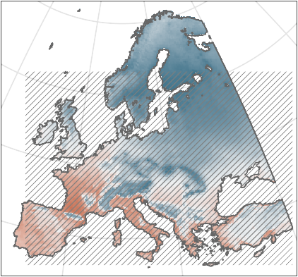

**a.**

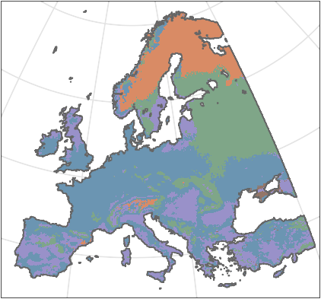

**b.**

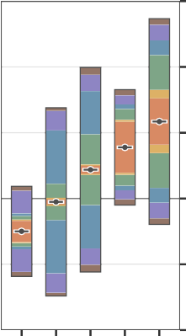

**c.**

Average projected change in suitability

0.50

0.25

0.00

-0.25

 Low model agreement

-0.4 -0.2 0 0.2 0.4

Climate  Climate - SDM  SDM  Species  Species - climate/SDM  Residuals

-0.50

**Fig. 21. Projections of climatic suitability change and main source of uncertainty in 2090.** (a) Overall change in fitness between the projection period 2080-2010 and the reference period 1970-2000, across all GCMs, SSPs, SDM approaches and species. Hashed shading reflects area where the three approaches of SDMs did not agree in the sign of suitability change. (b) Main source of uncertainty over the 2080-2100 period, according to a cell-based ANOVA partitioning. (c) Variance partitioning across Europe’s ecoregions, for the 2080-2100 period. The black line represents the mean projection, across all GCMs, SSPs, SDMs and species. 90% uncertainty ranges were calculated additively and symmetrically around the mean.

Boreal Alpine Contin. Atlantic

Mediter.

At the species level, most uncertainty arises from the discrepancy between the projections of the different SDMs (Figure 22). Except for the Alpine region, SDM approach consistently represents the major source of uncertainty for the four other ecoregions (between 54.2% and 64.8%). For example, in the Continental ecoregion, differences across models account for 73.7% of the total uncertainty of beech future suitability, despite being within the core of its present distribution. Similarly, SDM is the main source of uncertainty for sessile and pedunculate oaks (respectively 57% and 76.8%, Figure 22). In Atlantic and Continental regions, the differences between species are strong: all models agree with a lower suitability for fir and a higher suitability for holm and pubescent oaks, two Mediterranean species (Figure 22).

Our results also revealed that the divergent projections between SDM approaches followed a regular pattern. At the European scale, SDM projections projected systematically stronger decrease in climatic suitability for all species than expert PEMs, especially in Mediterranean and Atlantic ecoregions and in the western part of the Continental ecoregion (Figures 23). Note the exception of holm oak for which the suitability decrease is more significant in the Mediterranean Basin according to PEM projections (though the average suitability across Europe remains more optimistic than other models, Figure S38). Overall, expert PEMs also simulated a higher increase of suitability in the transition zone between Continental and Boreal ecosystems. Fitted PEMs

**Fig. 22. Variance partitioning across Europe’s ecoregions, for each species.** An ANOVA-based variance decomposition was performed to distin- guish between 5 main uncertainty sources: (i) the future scenario (SSP), (ii) the climate model used to generate the climate projections (GCM), (iii) the interactions between the SPP and the GCM, (iv) the species distribution modeling method (SDM approach), and (v) the interactions between SDM approach and climate projections (both GCMs and SSPs). The black line represents the mean projec- tion, across all GCMs, SSPs, SDMs and species. 90% uncertainty ranges were calculated additively and symmetrically around the mean. Inset plot shows the species name in the same order than in the main plot.

0.75

0.5

Average projected change in suitability

0.25

0

-0.25

-0.5

Mediterranean Atlantic Continental Alpine Boreal

 SSP  SSP - GCM  GCM

Silver fir Beech

Sessile oak Pedunc. oak

Pubesc. oak Evergreen oak

 Climate - SDM  SDM  Residuals

projections were closer to CSDM projections in the Southern and Western parts of Europe,

i.e. the trailing edge of the range of most species, whereas they were closer to expert PEM ones in the North-West leading edge (Figures 23, S34, S36, S38, S40 and S42). These discrepancies between modeling approaches can significantly change projected trends at the country level. In Germany for example, beech showed an average suitability decrease of *−*0*.*04 (*±*0*.*09) in 2090 when considering only CSDM and fitted PEMs, i.e. the two SDM approaches entirely calibrated with current species distribution data, whereas the expert PEM simulated a suitability increase (0*.*39 *±* 0*.*15). These discrepancies were also reflected in the simulated distribution for 2090 (Figures 24, S35, S37, S39, S41 and S43). Beech did not show major extinction according to the expert PEM, whereas it was predicted to disappear from a large part of South-Western Europe by the CSDMs and the fitted PEMs (Figure 24). Partially fitted PEM projections were generally closer to expert PEM ones (Figure 23), but still simulate greater extinctions at the distribution limits of beech (Figure 24). Finally, disagreement between models within a model approach (area where less than 80% simulations show same sign of suitability change) varied geographically. For example, for beech, PEM projections mostly disagreed in Mediterranean and Atlantic ecoregions whereas CSDM simulations disagree in the eastern half of Europe (Figure 23).

# Discussion

Differences between model approaches generated high uncertainty in projected climatic suitability change. Across species, in a large part of Europe (Atlantic, Continental and Boreal ecoregions), discrepancies between modeling approaches are a more important source of uncertainty than the differences among climate model projections (GCMs) and socioeconomic scenarios (SSPs). In the Boreal ecoregion – where two very important forestry countries in terms of wood stock, added value, and forest-based workforce are located (Finland and Sweden) – SDM approaches are even a higher source of uncertainty

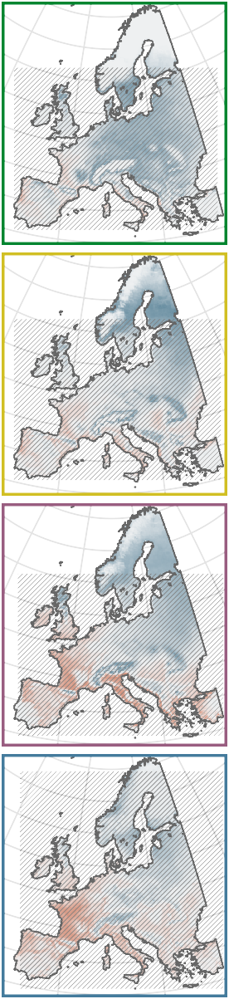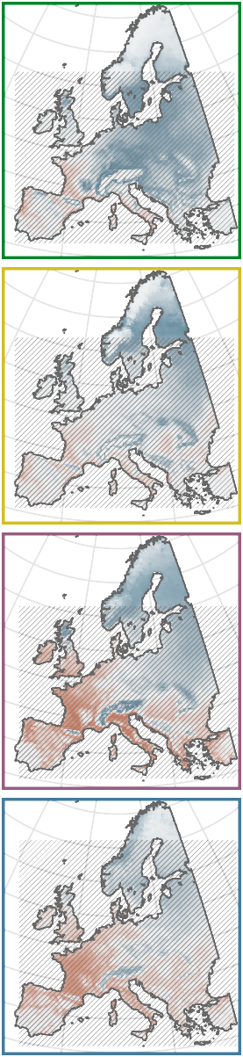2040-2060 2080-2100

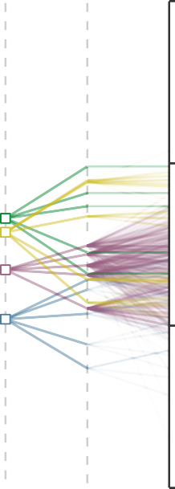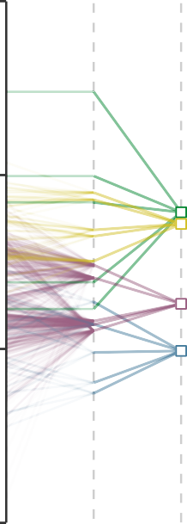0.5

GCMs multi-

calibration mean

Individual

calibration

0.25

0

-0.25

Projected change in suitability relative to 1970-2000

 Correlative SDM  Fitted PEM  Partial. fit. PEM  Expert PEM



-1 -0.5 0 0.5 1

 Low model agreement

**Fig. 23. Discrepancies between model approaches in projected future climatic suitability change for beech.** Models are forced with climatic data from 5 GCMs under scenario SSP2-4.5. Areas with a lack of model agreement (less than 80% of the individual calibrations agree on the sign of the change) are marked by hatching. Each individual calibrated model (i.e. 4 different CSDMs, 100 fitted PEM parameter sets, 10 partially fitted PEM parameter sets, and 1 expert PEM parameter set) was run with the 5 different GCM climatic variables (i.e. 20 CSDM projections, 500 fitted PEM projections, 50 part. fitted PEM projections, and 5 expert PEM projections). Then, they were averaged at the GCM-level within each SDM approach ("*GCMs multi-calibration means*"), and further averaged into one ensemble per SDM approach.

(33.7% on average) than the difference across species (14.4%). In such notable case, it thus seems more critical to encompass the full model diversity rather than the full species diversity to get a comprehensive assessment of the magnitude of climatic suitability change. Note, however, that the models agree on more suitable climatic conditions in this region by the end of the 21st century (Figure 21a). At the species-level, the differences between modelling approaches is the main source of uncertainty for all the species considered here, and explain between 45% and 60% of the total uncertainty on average (Figure 22). One of the striking example is the climatic suitability change of sessile oak in the Atlantic region, where it represents an important cultural and economic value, and for which more than 80% of the uncertainty in climate change impact projections was due to variations among the different approaches of SDMs.

Previous studies had already shown that uncertainties within correlative models can be important (Thuiller et al, 2019). For example, in Wessely et al (2024), the proportion of species from the current European species pool that cannot be sustained throughout the century ranges from 24.5% (GLM) to 76.6% (Random Forest). Here we show that when considering a larger diversity of models, the total uncertainty in species climate suitability is even higher (Figures 22 and S31). Note in addition that we considered only one process-explicit model and focused on diverse approaches along the correlative- process continuum, but differences between process-explicit models can also be higher than differences between climate projections (Asseng et al, 2013). Ignoring the full diversity of models bias the estimation of other effects. For example, for beech, we would have estimated that discrepancies between GCMs would have been the major source of uncertainties (39.8%), higher than the SDM uncertainty (33.8%), whereas it was in reality much lower (18.8%) than SDM uncertainty (51.2%) when considering the three approaches of SDMs. Ignoring a large portion of uncertainty in species range projections due to modelling approaches can thus lead to overly confident predictions about which species will or will not be able to survive in future climates. This becomes increasingly true as we approach the end of the 21st century, where larger climate changes result in larger variation among projections (Figure 20).

CSDM and PEM future projections are known to diverge significantly (Cheaib et al, 2012; Keenan et al, 2011a; Morin and Thuiller, 2009; Takolander et al, 2019). Here we show for the first time that the larger extinctions predicted in South-western Europe is associated to the method of calibration used. Indeed, the modeling approaches – either statistical or process-explicit – that were fit to current species distribution data predict greater extinctions at the southern edge of species ranges than expert PEMs (Figure 24). Interestingly, we observed a gradient from correlative approaches fully determined by the current distribution to process-explicit approaches partially fitted with these data (Figure 23). Although we cannot determine which approach truly overestimates or underestimates future climatic threats (but see Van der Meersch et al, 2024; Chapter 2), we can hypothesize that distribution data are partly responsible for this pattern. This might be due to the fact that contemporary species occurrences are influenced by anthropogenic land use change which bias models calibration and may lead to smaller projected ranges (Ay et al, 2017; Faurby and Araújo, 2018). This bias may be partly removed by including past occurrences data (Faurby and Araújo, 2018), or by taking into account human-driven habitat modifications in the models (Ay et al, 2017). However, at

**Projected suitability**

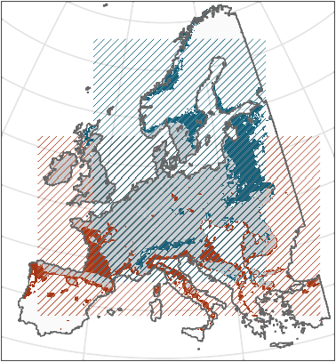

**a.**

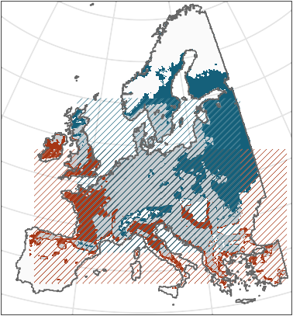

**b.**

No longer sufficient Decreasing

No change Increasing Becoming sufficient

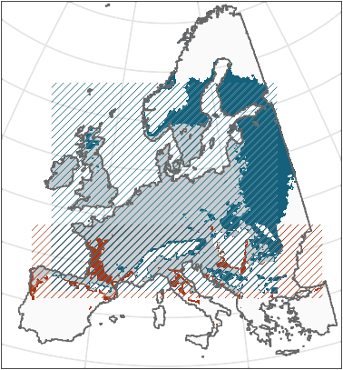

**c.**

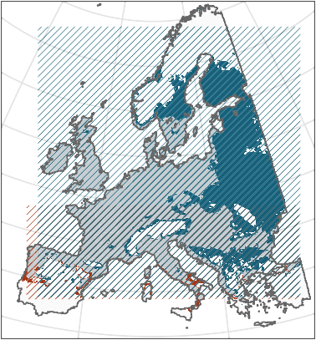

**d.**

**Fig. 24. Projected beech distribution in 2090, according to (a) correlative species distribution models, (b) fitted process-explicit models, (c) partially fitted process-explicit models and (d) expert process-explicit models.** Models are forced with climatic data from 5 GCMs under scenario SSP2-4.5. For each model approach, the species is considered present/absent if more than half of the simulations agree.

the coarse scale of this study (0.1°), the bias may rather be due to the fact that recent distribution data do not cover the entire fundamental niche of the species, and thus that we underestimate the range of climatic conditions where species could survive (Chevalier et al, 2024; Nogués-Bravo et al, 2016). This fundamental niche truncation could be partly corrected by including paleorecords in the calibration process (Maiorano et al, 2013), but it may even increase the magnitude of projected future changes for some plants. For example, in Nogués-Bravo et al (2016), the genus *Fagus* shifted from a conservation status of "*Least Concerned*" to "*Endangered*" by 2050 in Europe when including such very long-term data. Another lever for improvement could be to consider local adaptation potential of species (Benito Garzón et al, 2011), as some populations may be pre-adapted to more challenging climatic conditions. In any case, including past distribution data or refining model with finer-scale data cannot prevent the issue of non-analogue future climatic conditions. Most paleorecords are limited to the Late Pleistocene/Holocene period (but see Chiarenza et al, 2023), i.e. to a cooler climate, and estimating the actual warm niche limits would require going back much further in time where paleorecords become even more challenging to use, and potentially where modern species did not yet exist (Burke et al, 2018; Chevalier et al, 2024). Process-explicit models are not concerned by bias in occurrence data when they are calibrated on experimental data – even though it can be also challenging to represent future climatic conditions in experiments (particularly extreme temperatures) –

and may be more robust to novel climates (Van der Meersch et al, 2024; Chapter 2). In addition to fewer projected extinctions, PEMs, either expert or fitted, also projected more substantial range expansions towards the North and the East of Europe for most species considered here (consistently with other taxa, Buckley et al, 2010). Therefore, interestingly, fitted PEMs exhibited an intermediate behavior between CSDMs and expert PEMs: they lead to both larger extinctions in the South-Western part of Europe like CSDM and to larger climatic suitability increases in the North and Eastern part like expert PEMs. The constraints imposed by the structure of process-explicit models during the calibration may explain why they differ from correlative models, even though mathematical functions alone do not sufficiently constrain the calibration process (Chapter 3).

Beyond the differences between SDM approaches, multi-model projections are particularly useful for identifying general trends and guiding forest management. Such multi-model ensembles have been so far mostly restricted to statistical models (Simmonds et al, 2024), but we show here that there is a strong interest in considering a broader range of models to better characterize projections uncertainty. At the continental scale, it is possible to distinguish several regions that differ in terms of future climate risks and levers of action to address them (Figure 21). Around the Mediterranean Basin and in South-western France, the models agree in predicting generally less favorable climatic conditions for the species we considered here. In particular, the suitability of temperate broadleaf species (sessile and pedunculate oaks, beech) is projected to decrease while that of Mediterranean species (pubescent and evergreen oaks) is projected to increase. In some areas, evergreen oak has already replaced beech (Peñuelas and Boada, 2003). However, process-explicit model projections are more nuanced for deciduous oaks and beech in France, suggesting that some better-adapted populations will survive if the existing standing genetic variation is maintained and promoted by forest managers (Brang et al, 2014). On the contrary, the Scandinavian and Baltic countries, part of Poland and low mountain ranges of Central- Eastern Europe (Carpats, Ore Mountains, Sudetes) are projected to get an overall increase of climatic suitability. Thanks to a more favourable climate and an extended growing season, beech has been shown to be already more competitive at the northern margin of its range (Bolte et al, 2010), and could be favoured to convert pure coniferous stands into mixed forest in order to increase their resilience (Schauer et al, 2023). Climatic suitability is also projected to increase in the Alps and in the Scandinavian Mountains, but these areas are subject to a greater uncertainty related to climate projections (Figure 20), likely due to the more complex topography.

Large zones of Europe though exhibit less clear trends. There is a notable low agreement among models in the Continental ecoregion, which includes some countries with important forest sector (Germany, Romania...), as well as in the British Isles (except Scotland). In those regions, species-related uncertainty plays a major role (Figure 21a) and indicates that one of the strategies to consider is the diversification of tree species, but also an increased genetic diversity within populations, to mitigate the risks associated with uncertain future conditions (Ammer, 2019; Morin et al, 2014; Pretzsch, 2021; Vospernik et al, 2024). Such unclear trends are also visible in the mountainous regions at the transition between Mediterranean and Continental/Atlantic climates (Pyrenees, Massif Central, Balkans). Finally, in some areas where most species are threatened, forest managers may consider introducing new species, more drought-tolerant. However, the lack of hindsight and

experimental data often prevents the development and calibration of process-explicit models for such species.

We assessed uncertainties in species climatic suitability by quantifying the variance across the projections of a set of different models making the important hypothesis of equal likelihood of the projections of each model approach. As with climate models (IPCC, 2021), the spread in the projections could be reduced by weighting models according to their ability to reproduce past observations. A model’s credibility is indeed increased if the model is able to simulate past species range shifts, especially under climatic conditions that significantly differ from the present ones. The ability to reproduce changes in tree distributions during large paleoclimate fluctuations is known to vary across the different approaches of species distribution modeling (Van der Meersch et al, 2024; Chapter 2). In particular, CSDMs showed less accurate predictions of species distribution change since the early Holocene (12,000 years ago) than process-explicit models (Van der Meersch et al, 2024; Chapter 2). Previous studies also pointed out that CSDMS projections for the coming decades would decline steadily in response to increasing climate novelty (Fitzpatrick et al, 2018). However, model evaluations using paleorecords may be biased by the sparse coverage in pollen data they used to infer past species distributions, and the magnitude and rate of future climate change will differ from the changes that occurred between the Last Glacial Maximum and today (the period for which most pollen records are available). It thus seem overly optimistic to summarize model discrepancies in one performance metric and then use it as the unique criteria in a model weighting scheme. Even when multivariate metrics are available, such as for climate models, there is no consensus that model weighting is more reliable than the "one-model-one-vote" strategy (IPCC, 2021).

Our results emphasise that it is critical to consider the diversity of modeling approaches that exist in order to ensure a consistent quantification of all model-related uncertainties in future species range shifts. Failure to fully quantify and report uncertainty, whether intentionally to preserve core messages, or not, leads to overconfidence in model projections (Simmonds et al, 2024), and may negatively impact public trust in scientists (Howe et al, 2019). To ensure the resilience and sustainability of Europe’s forests, forest managers need to adopt adaptive management strategies that take account of all possible future conditions.