From Barbet-Massin et al., 2012

Prevalence : defined here as the ratio of the quantity of presence data to the quantity of absence data used to fit the model

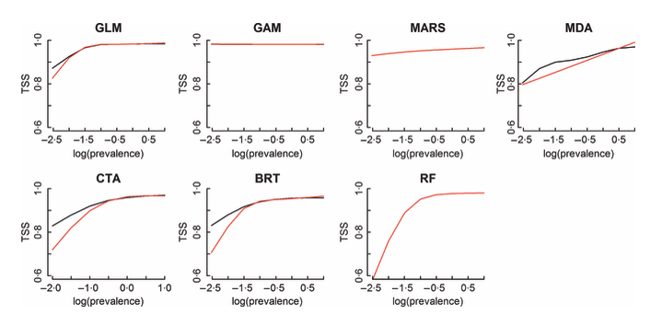
Figure : Evaluation results (TSS) of the mean distribution according to the prevalence. The black and red curves represent results with a weighted and un-weighted scheme respectively.

If prevalence = 1, i.e. number of presence is equal to the number of presence, log(prevalence) = 0.
See blue line on the figure.

