Stages of Sleep Apnea Recovery

Stage 0: Typical sleep Apnea
Having sleep Apnea episodes! Sleeps and a minute later stirs awake, breathes! Back to sleep..
Something like 25 times an hour. The heart rate is high (>70) during sleep. No dreams. spO2 drops by over 4% frequently. Waking up 3-4 times each night. Daytime sleepiness is present. When lying down to sleep, cannot watch TV for more than a few minutes before dozing off.
Internet: Loud Snoring, Breathing pauses, Gasping, choking or snorting that wakes you up. Dry mouth...Excessive daytime sleepiness, tired after a full night's rest//
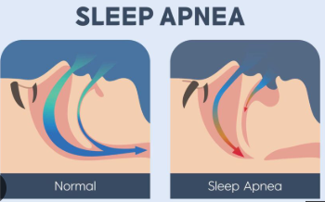

Stage 1: Sleep Recovered, but No dreams (2-3 nights)
Mouthpiece prevents tongue from falling back. spO2 remains high throughout. Waking up at night is once or none. Feeling of having had a good sleep. Heart rate is now low ( <= 60) during sleep. Energy levels good on waking up. Daytime sleepiness is shortened. When lying down to sleep, can stay awake and watch TV for some time.
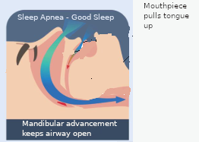
Internet: Many users notice an immediate drop or total cessation of snoring on night one because advancing the mandible and tongue pulls soft tissue away from the back of the throat. For mild-to-moderate obstructive sleep apnea, initial improvements in sleep quality can lead to less daytime fatigue or less urge to nap within a few days to a week.

Stage 2: Dreams recovered (Still going on for 4 days now):
Sleep has dreams. Some can be recalled on waking up. spO2 does show dips (not as much as in stage 0). The dips are periodic, as if occurring during the dream/REM phase. The Heart rate remains low ( <60).
Daytime sleepiness is short and still occurs. When lying down to sleep, cannot watch TV for more than 30 mins, turn it off and sleep.
Supposition: The brain now believes it can dream, and catches up on REM sleep.

Internet: This surge in REM duration and intensity typically peaks during the first few nights and normalizes within a few weeks as your sleep architecture stabilizes. You may experience unusually long or vivid dreams, restless dreaming, morning grogginess, mild disorientation, or headaches.

Supposition: REM sleep causes atonia - deep relaxation, during which breathing may also slow down. This causes spO2 to dip as well, even though the airways are open.
Stage 4: (Expectation after a few weeks): Less dreams. High spO2 with fewer dips due to dreams. Daytime sleepiness is voluntary. This should be the normal sleep cycle without Sleep Apnea.

