

**Python SpaCy2.0.16 Package Installation in Unix Box**

Table of Contents

1. INTRODUCTION 3

2. Procedure 3

3. REFERENCES 6

**rEVISON LOG**

|  |  |  |  |  |
| --- | --- | --- | --- | --- |
| Date | Version | Change Reference | Created /Modified by | Reviewed by |
| 3/12/18 | 1.0 | Initial Draft | Vaibhav |  |
| 4/12/18 | 1.1 | Added installation of xx_ent_wiki_sm-2.0.0 | Vaibhav |  |
|  |  |  |  |  |
|  |  |  |  |  |

# **INTRODUCTION**

This Document will help user to install spacy 2.0.16 package on an Anaconda 3.7 environment in unix box.

Pre-Requisite for Installation of SpaCy Package

* Anaconda 3.7 Installed
* PIP installed on Unix Box

To validate the installation of both please follow the below process.

* Run command “python --version” if this gives you the version of python like in the below screenshot you are good to go else install Anaconda first.

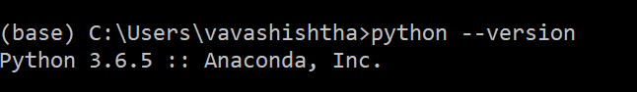

* Run command “pip --version” if this gives you the version of pip like in the below screenshot you are good to go else install pip first.

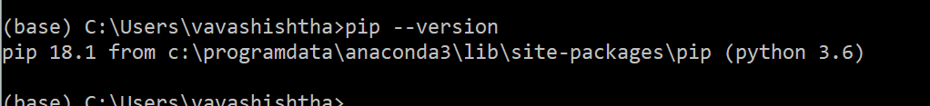

# **Procedure**

1. Download the following packages from Below marked locations, Make sure that they are of same version as mentioned below, else it may cause issues in installation(Download link in refe)
   1. PyHamcrest-1.9.0
   2. ujson-1.35
   3. wheel-0.32.3
   4. cymem-2.0.2
   5. preshed-2.0.1
   6. regex-2018.01.10
   7. numpy-1.15.4
   8. msgpack-numpy-0.4.3.2
   9. requests-2.20.1
   10. murmurhash-1.0.0
   11. plac-0.9.6
   12. dill-0.2.8.2
   13. thinc-6.12.0
   14. msgpack-0.5.6
   15. chardet-3.0.4
   16. idna-2.6
   17. certifi-2018.10.15
   18. six-1.10.0
   19. tqdm-4.28.1
   20. cytoolz-0.9.0.1
   21. wrapt-1.10.11
   22. pyreadline-2.1
   23. toolz-0.9.0
   24. spacy-2.0.16
   25. xx_ent_wiki_sm 2.0.0
2. Then login to Unix box and go to the directory where python is installed (you can know this by running command “which python” ) 
3. Place these downloaded files in the main directory of python, in the above example we can say the main directory of python is **“/data/infa_shared/PAYPAL_PDW/Scripts/anaconda3**”
4. Place all the download files in the above-mentioned folder. You can even create a separate folder in the above path and place all files there.
5. Go to the path where you have place all your files.
6. Run Below commands in the same order they are mentioned.

Command:

* + - 1. pip install PyHamcrest-1.9.0.tar.gz
      2. pip install ujson-1.35.tar.gz
      3. pip install wheel-0.32.3.tar.gz
      4. pip install cymem-2.0.2.tar.gz
      5. pip install preshed-2.0.1.tar.gz
      6. pip install regex-2018.01.10.tar.gz
      7. pip install numpy-1.15.4.zip
      8. pip install msgpack-numpy-0.4.3.2.tar.gz
      9. pip install requests-2.20.1.tar.gz
      10. pip install murmurhash-1.0.0.tar.gz
      11. pip install plac-0.9.6.tar.gz
      12. pip install dill-0.2.8.2.tar.gz
      13. pip install thinc-6.12.0.tar.gz
      14. pip install msgpack-0.5.6.tar.gz
      15. pip install chardet-3.0.4.tar.gz
      16. pip install idna-2.6-py2.py3-none-any.whl
      17. pip install certifi-2018.10.15.tar.gz
      18. pip install six-1.10.0.tar.gz
      19. pip install tqdm-4.28.1.tar.gz
      20. pip install cytoolz-0.9.0.1.tar.gz
      21. pip install wrapt-1.10.11.tar.gz
      22. pip install pyreadline-2.1.zip
      23. pip install toolz-0.9.0.tar.gz
      24. pip install spacy-2.0.16.tar.gz
      25. pip install xx_ent_wiki_sm-2.0.0.tar

1. Please note that a few of the packages might already be installed and could be dependent on some other packages, and hence my give an issue while installing them, if you face similar issue please ignore it. You may have issue with 2 above-mentioned commands **pip install certifi-2018.10.15.tar.gz** and **pip install certifi-2018.10.15.tar.gz** , if you do just ignore the issue and continue the next step. Ex:

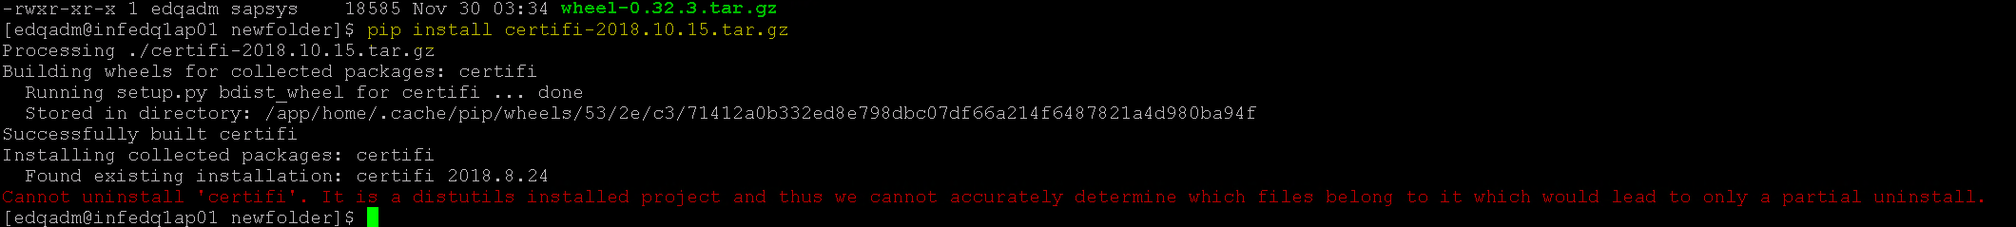

1. Verifying by importing spacy packages
   1. Run command on bash : “**python** “ press enter.
   2. Run “**import spacy**”
   3. If you do not get any issue and the command finishes like in the below screenshot, the installation was successful.
   4. 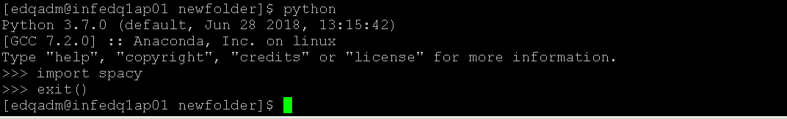
   5. You can exit by suing command **“exit()”**

# **REFERENCES**

To download the above mentioned packages use the below links.

You can even download all the files from <https://paypal-my.sharepoint.com/:f:/r/personal/vavashishtha_paypal_com/Documents/Python_DoNotDelete?csf=1&e=4H3Uig>

If unavailable you can download files from :

1. <https://files.pythonhosted.org/packages/a4/89/a469aad9256aedfbb47a29ec2b2eeb855d9f24a7a4c2ff28bd8d1042ef02/PyHamcrest-1.9.0.tar.gz>
2. <https://files.pythonhosted.org/packages/16/c4/79f3409bc710559015464e5f49b9879430d8f87498ecdc335899732e5377/ujson-1.35.tar.gz>
3. <https://files.pythonhosted.org/packages/d8/55/221a530d66bf78e72996453d1e2dedef526063546e131d70bed548d80588/wheel-0.32.3.tar.gz>
4. <https://files.pythonhosted.org/packages/8b/dc/0976e04cc46f86e0dd3ee3797ec68057eaafebf31daca9a076dc138b9920/cymem-2.0.2.tar.gz>
5. <https://files.pythonhosted.org/packages/0b/14/c9aa735cb9c131545fc9e23031baccb87041ac9215b3d75f99e3cf18f6a3/preshed-2.0.1.tar.gz>
6. <https://files.pythonhosted.org/packages/76/f4/7146c3812f96fcaaf2d06ff6862582302626a59011ccb6f2833bb38d80f7/regex-2018.01.10.tar.gz>
7. <https://files.pythonhosted.org/packages/2d/80/1809de155bad674b494248bcfca0e49eb4c5d8bee58f26fe7a0dd45029e2/numpy-1.15.4.zip>
8. <https://files.pythonhosted.org/packages/a5/7a/01c7c3f14ec4c38b23767b5f19d42db299f74d8fcabce0f735996b2b156d/msgpack-numpy-0.4.3.2.tar.gz>
9. <https://files.pythonhosted.org/packages/40/35/298c36d839547b50822985a2cf0611b3b978a5ab7a5af5562b8ebe3e1369/requests-2.20.1.tar.gz>
10. <https://files.pythonhosted.org/packages/c4/7f/08e169ed91facb1ba8e78b373befafa92eb75dd90cb1e39676132b320d20/murmurhash-1.0.0.tar.gz>
11. <https://files.pythonhosted.org/packages/6c/9b/9e9d461a646d1c874043e105e46cc458c16e5f76f2119c8e670ff5a8db97/plac-0.9.6.tar.gz>
12. <https://files.pythonhosted.org/packages/6f/78/8b96476f4ae426db71c6e86a8e6a81407f015b34547e442291cd397b18f3/dill-0.2.8.2.tar.gz>
13. <https://files.pythonhosted.org/packages/a4/f3/a930b0172244234f8d7ed23202983197bf6c451946ce4517b5900ec6d74f/thinc-6.12.0.tar.gz>
14. <https://files.pythonhosted.org/packages/f3/b6/9affbea179c3c03a0eb53515d9ce404809a122f76bee8fc8c6ec9497f51f/msgpack-0.5.6.tar.gz>
15. <https://files.pythonhosted.org/packages/fc/bb/a5768c230f9ddb03acc9ef3f0d4a3cf93462473795d18e9535498c8f929d/chardet-3.0.4.tar.gz>
16. <https://files.pythonhosted.org/packages/27/cc/6dd9a3869f15c2edfab863b992838277279ce92663d334df9ecf5106f5c6/idna-2.6-py2.py3-none-any.whl>
17. <https://files.pythonhosted.org/packages/41/b6/4f0cefba47656583217acd6cd797bc2db1fede0d53090fdc28ad2c8e0716/certifi-2018.10.15.tar.gz>
18. <https://files.pythonhosted.org/packages/b3/b2/238e2590826bfdd113244a40d9d3eb26918bd798fc187e2360a8367068db/six-1.10.0.tar.gz>
19. <https://files.pythonhosted.org/packages/b0/9b/0b2f9dd0e42da42e17c79883021b21cda31dd3216aa2538205ccdd10cc7a/tqdm-4.28.1.tar.gz>
20. <https://files.pythonhosted.org/packages/36/f4/9728ba01ccb2f55df9a5af029b48ba0aaca1081bbd7823ea2ee223ba7a42/cytoolz-0.9.0.1.tar.gz>
21. <https://files.pythonhosted.org/packages/a0/47/66897906448185fcb77fc3c2b1bc20ed0ecca81a0f2f88eda3fc5a34fc3d/wrapt-1.10.11.tar.gz>
22. <https://files.pythonhosted.org/packages/bc/7c/d724ef1ec3ab2125f38a1d53285745445ec4a8f19b9bb0761b4064316679/pyreadline-2.1.zip>
23. <https://files.pythonhosted.org/packages/14/d0/a73c15bbeda3d2e7b381a36afb0d9cd770a9f4adc5d1532691013ba881db/toolz-0.9.0.tar.gz>
24. <https://files.pythonhosted.org/packages/3a/86/e3c4bc5fde980387c817e57b870ad6b31df507d88df1ea69263ef4c939a2/spacy-2.0.16.tar.gz>
25. <https://github.com/explosion/spacy-models/releases/download/xx_ent_wiki_sm-2.0.0/xx_ent_wiki_sm-2.0.0.tar.gz>