STELLANTIS FINANCIAL SERVICES

Master Document

From Assessment to Action: Transforming SFS into an AI-Ready Organization

February 2026
Prepared by Earley Information Science


Contents
1 Phase 1 5
1.1 Current State Analysis 5
1.1.1 Technology Stack Evaluation 5
1.1.2 Platform Access Gap Analysis 12
1.1.3 Infrastructure & ML/AI Ops Assessment 20
1.2 AI Readiness Assessment 25
1.2.1 Executive Summary 25
1.2.2 Current State: What the Assessment Reveals 26
1.2.3 The "So What?": Why This Matters Now 27
1.2.4 Consolidated Findings & Recommendations 28
1.2.5 Strategic Recommendations: What SFS Should Do 35
1.2.6 Implementation Roadmap: When to Act 39
1.2.7 Success Metrics: How to Measure Progress 43
1.2.8 Conclusion: The Path Forward 44
1.3 Governance Framework (Sanjay/Phil/Seth) 45
1.3.1 Executive Summary 45
1.3.2 Current State Assessment 45
1.3.3 Three-Tier Governance Structure 46
1.3.4 Risk Tiering Framework 49
1.3.5 Identified Governance Gaps 50
1.3.6 Key Governance Risks 51
1.3.7 Implementation Roadmap 52
1.3.8 Success Metrics 52
1.3.9 Implications and Next Steps 53
1.3.10 Executive Summary 54
1.3.11 AI Governance Strategy and Vision 54
1.3.12 Roles and Responsibilities 55
1.3.13 AI Risk Management Framework 55
1.3.14 AI Ethics Principles and Standards 56
1.3.15 Data Governance for AI 56
1.3.16 Model Development Lifecycle 57
1.3.17 Model Validation, Testing & Inventory 57
1.3.18 Bias Detection & Explainability 58
1.3.19 Privacy Protection & Security Controls 58
1.3.20 Third-Party AI & Use Case Approval 59
1.3.21 Monitoring & Incident Response 59
1.3.22 Regulatory Compliance & Change Management 60
1.3.23 Training, Awareness & Audit 60
1.3.24 Sustainability, Human Oversight & IP 61
1.3.25 System Retirement & Continuous Improvement 61
1.3.26 Implementation Roadmap 62
1.4 Technical Architecture 62
1.4.1 API Orchestration Strategy 62
1.4.2 Agent Lifecycle Management Approach 80
1.5 KM Framework 93
1.5.1 Executive Summary 93
1.5.2 KM Maturity Assessment 95
1.5.3 Gap Analysis 102
1.5.4 KM Capability definitions 107
1.5.5 Principles and Standards 116
1.5.6 Roles & Responsibilities 122
1.5.7 Success Metrics 125
1.5.8 Conclusion: The Path Forward 133
2 Phase 2 135
2.1 Business Intelligence 135
2.1.1 Executive Summary 135
2.1.2 Current State Analysis 136
2.1.3 Appendix: Interview Sources 138
2.2 Automated Testing 139
2.2.1 Executive Summary 139
2.2.2 Top Recommendations 139
2.2.3 Assessment Overview 140
2.2.4 Scope 140
2.2.5 Current State Analysis 140
2.2.6 Critical Pain Points 142
2.2.7 Test Execution Effort Imbalance 143
2.2.8 Lack of Test Impact Analysis 144
2.2.9 Vague User Stories 144
2.2.10 Test Data Management 144
2.2.11 Automation Handoff Timing 145
2.2.12 Current AI Usage Assessment 145
2.2.13 AI Tool Constraints 146
2.2.14 Copilot Prompt Analysis 146
2.2.15 AI Opportunities Roadmap 148
2.2.16 Recommendations 149
2.2.17 Implementation Roadmap 151
2.2.18 Appendix 152
2.3 SDLC Recommendations 155
2.3.1 SDLC Workflow Engine 155
2.3.2 Step 6: CI/CD & Preview 159
2.3.3 Feature Development 161
2.3.4 SDLC Report (Phil) 170
3 Phase 3 172
3.1 Results Synthesis 172
3.2 Technology Recommendations (Sanjay) 173
3.3 12-Month Roadmap (Phil/Sanjay) 175
3.3.1 Executive Summary (Phil) 175
3.3.2 Current State Assessment (People, Process, Technology baseline) (Phil) 175
3.3.3 AI Vision & Strategic Objectives (Phil) 175
3.3.4 Proposed AI Projects & Use Cases (Prioritized initiative portfolio with owners and outcomes) (Sanjay’s list) 175
3.3.5 12-Month Implementation Roadmap (Phased timeline, milestones, dependencies) (Phil/Sanjay) 175
3.3.6 Scaling Strategy & Governance (CoE model, scaling criteria, risk & compliance) (Sanjay) 175
3.3.7 Investment, Success Metrics & ROI (Phil) 175

Phase 1

Current State Analysis

Technology Stack Evaluation

Executive Summary
This evaluation assesses the SFS technology stack based on 25+ stakeholder interviews, documentation review, and platform analysis. The assessment identifies current state, fit-for-purpose evaluation, challenges, and underutilized capabilities relevant to AI implementation strategy.
Key Findings:
- Strategic platform decisions are increasingly cost-driven, with Genesys positioned as the primary omnichannel platform at approximately one-third the cost of equivalent Salesforce capabilities.
- Significant AI capabilities are licensed but unused (Genesys AI tokens, Salesforce Einstein), representing both sunk costs and near-term opportunity.
- Platform fragmentation creates integration complexity—case management spans Genesys and Salesforce, transcription spans Observe AI and Genesys, BI spans Tableau and Power BI.
- Legacy systems (SSIS, SAS, data marts) require modernization but cannot be migrated bottom-up; top-down business requirements must drive prioritization.
- Unauthorized AI tool usage (281 ChatGPT, 111 Gemini users) indicates demand for AI capabilities outpacing governance.

Core Platforms
These platforms form the foundation of SFS operations and AI strategy. Strategic decisions about AI implementation must account for their capabilities, costs, and interdependencies.

Salesforce Ecosystem
Components | Service Cloud, Automotive Cloud, Marketing Cloud, Data Cloud, Experience Cloud
Teams | Customer Service, Collections, Remarketing, Marketing, Salesforce Team
Reliance | Primary
Status | Production
Challenges | • High cost driving architecture decisions toward Genesys for omnichannel  • Einstein licensed but awaiting corporate approval; unused licenses  • Case management only released mid-December 2025 - adoption nascent  • Data Cloud/Data 360 implementation needed to enable Agent Force  • Consumption-based pricing model complexity ("nightmare" per Ryan Miller)
Fit Assessment | Strong fit as system of record for customer data and 360-degree view. Cost concerns limiting AI feature adoption. Strategic decision to use Genesys for high-volume interactions while Salesforce handles complex workflows.
Underutilized | Einstein AI capabilities, Agent Force, advanced Data Cloud analytics, Journey Builder for proactive engagement

Genesys Cloud
Components | Voice, IVR, Call Routing, Omnichannel (rolling out), Workforce Management
Teams | Customer Service, Collections, Lease Maturity
Reliance | Primary
Status | Production
Challenges | • AI tokens expiring unused monthly while awaiting implementation resources  • Omnichannel features rolling out now; AI capabilities unimplemented pending SOW  • Observe AI duplication creates expensive redundancy in Collections  • Integration with Salesforce strong on voice side; automation/agentic capabilities may require custom development  • Only basic phone system functionality currently deployed
Fit Assessment | Strategic platform for omnichannel at ~1/3 Salesforce cost (~$0.30 vs $2.00+ per interaction). Platform will serve voice, chat, messaging, dealer mobile, originations. Strong Salesforce partnership ($1.5B) enables integrated experiences.
Underutilized | AI Experience tokens (purchased but unused), predictive routing, native bots, Agent Copilot, speech analytics

Microsoft Fabric
Components | EDW (Fabric Warehouse), Lakehouse, Data Lake, Notebooks, SQL Endpoints
Teams | Enterprise Data Management, BI, Risk Analytics, Economics & Residual, Data Science
Reliance | Primary
Status | Production / Migration
Challenges | • Massive code conversion project underway (hundreds of stored procedures) - target Q2 2026  • Capacity-based licensing creates throttling when teams overconsume  • Real-time monitoring capabilities have significant gaps  • Snowflake mirroring implementation struggling  • 95% of data not tagged for AI use (no PII/sensitivity classification)
Fit Assessment | Strategic data platform supporting EDW migration and analytics modernization. Strong fit for data science workloads with Jupyter notebooks, ML Flow adoption growing. Enables single source of truth replacing legacy data marts.
Underutilized | AI Foundry capabilities (shut down awaiting governance), real-time analytics, streaming capabilities, ontology features (immature)

MuleSoft → Azure API Management
Components | 65 production APIs, experience/process/system layers, JWT/Okta auth
Teams | Integration/APIs, Salesforce Team
Reliance | Primary (transitioning)
Status | Production / Migration
Challenges | • License expiring in ~2 years; targeting 18-month migration  • Azure migration pilot 7-8 months in with platform maturity issues (DNS, certs, RBAC)  • Only ~60-70% of enterprise integrations represented; 30-40% not yet mapped  • New integrations built in Azure while MuleSoft receives only minor enhancements  • Cost tracking less clear in Azure APIM vs. established MuleSoft monitoring
Fit Assessment | Migration strategically necessary for cost reduction and Azure ecosystem alignment. MuleSoft architecture sound (3-tier pattern) but expensive. Azure APIM less mature but improving.
Underutilized | API analytics for cost optimization, gateway-level caching, rate limiting for AI token management

Operational & Specialized Systems
These systems support specific business functions and integrate with core platforms.
Platform | Purpose | Teams | Reliance | Status | Challenges & Fit
DeFi Solutions | Lease servicing, case management | Collections, Lease Maturity, BI/Operational Analytics | Primary | Production | Vendor dependency for roadmap; limited out-of-box functionality; BI analysts query database directly (~100 tables) bypassing EDW governance Fit: Core lease operations system. SFS building Salesforce automation layer on top for flexibility.
Shaw | Loan servicing system | BI/Operational Analytics, Customer Service | Primary | Production | Legacy system; direct queries by analysts bypass EDW governance Fit: System of record for retail servicing data. Integration via APIs.
Observe AI | Call transcription, QA scoring, sentiment analysis, agent coaching | Collections | Primary (Collections) | Production | Creates platform duplication with Genesys capabilities; expensive to run both. Collections extended contract due to Genesys feature gaps. 2 years ahead technologically but creates governance tension. Fit: Strong fit for Collections use case. Organizational pressure to consolidate on Genesys. Voice AI pilot planned Q1 2026.
Okta | Identity management, SSO, authentication tokens | Infrastructure/Security, Integration/APIs | Primary | Production | One-way sync (on-prem → Azure) with 45-minute replication lag Fit: Enterprise identity platform. Integrated with Salesforce and API authentication.
Snowflake | Salesforce data access, analytics | Collections, BI/Operational Analytics | Secondary | Production | Mirroring from Fabric struggling; role relative to Fabric EDW unclear Fit: Supplementary data warehouse. Integration with Fabric evolving.

Legacy & Transitioning Systems
Systems requiring modernization or active migration. AI-assisted transformation represents significant opportunity.

Platform | Purpose | Status | Challenges | Recommendation
SSIS | ETL orchestration | Legacy | 600+ packages running nightly with independent scheduling (no orchestration). Synchronization risks. Prime candidate for AI-assisted modernization. | Prioritize migration to Fabric pipelines with AI-assisted code conversion.
SAS | Statistical analysis, legacy models | Legacy | 50+ licenses. Integration with Fabric challenging for bidirectional data movement. | Migrate analytics workloads to Python/Fabric notebooks. Retain for specialized statistical needs.
Tableau | BI visualization | Production → Migration | Being migrated to Power BI. Reports built on legacy marts require lineage tracing. | Continue Power BI migration using EDW data. Prioritize by business criticality.
SSRS | Microsoft reporting services | Production | Legacy reporting. Part of broader BI modernization scope. | Migrate to Power BI alongside Tableau consolidation.
SharePoint | Knowledge base, document management | Production | Legacy content age and fragmentation. Single OpEx specialist creates maintenance bottleneck. | Foundation for knowledge management. Consider AI-powered content quality assessment.

AI & Emerging Platforms
Platforms supporting or enabling AI capabilities.
Platform | Purpose | Status | Teams | Challenges | Opportunity
Copilot Studio | Agent development platform | Production/Pilot | AI Product, BI Tools, Enterprise Architecture | Early stage adoption. Vector database integration needed for expansion. | Scale internal agents to dealer-facing (planned 2027)
GitHub Copilot | Code AI assistant | Not Approved | Enterprise Data Management (limited) | Not officially sanctioned. QA team wants IDE assistance badly. Security concerns. | High-value productivity gain if governance framework established.
FICO Decision Engine | Decision engine for remarketing | Planned (Q1 2026) | Remarketing, Risk Management | Implementation complexity. Integration with existing workflow. | Model integration for termination prediction, channel management.

Key Issues & Strategic Considerations

Platform Duplication & Fragmentation
Multiple platforms provide overlapping capabilities, creating cost inefficiency and integration complexity:
• Observe AI vs. Genesys AI: Both provide call transcription, sentiment analysis, and agent coaching. Collections runs Observe AI while Genesys AI tokens expire unused monthly. Larry Burgess describes this as "expensive duplication."
• Salesforce vs. Genesys for Case Management: Workflows span both platforms. Agents work in Salesforce screens while Genesys handles call routing. Ryan Miller notes concern about "Frankenstein" integration complexity.
• Tableau vs. Power BI: Active migration underway but both in production. Reports built on legacy marts vs. EDW create parallel reporting universes.

Unused Licensed Capabilities
Significant investment in AI capabilities remains unutilized:
• Genesys AI tokens: Purchased, expiring monthly unused. Implementation blocked on SOW approval and resource constraints.
• Salesforce Einstein: Licensed but awaiting corporate approval. Case management prerequisite only released mid-December 2025.
• Fabric AI Foundry: Multiple experimental instances shut down awaiting governance framework.

Unauthorized AI Tool Usage
Security scans revealed 281 ChatGPT users and 111 Google Gemini users across the organization—tools not officially sanctioned. Security scans revealed unauthorized usage. DNS blacklisting technically challenging. Exposes organization to data/compliance risk.
Recommendation: Establish approved AI tool governance framework before broader deployment.

Cost Visibility & Allocation
Cost tracking for AI and platform consumption is immature:
• All Salesforce and related costs currently roll to Ryan Miller's organization—no granular business unit allocation.
• API costs known in MuleSoft but less clear in Azure APIM. Third-party API costs (FICO, Shaw, DeFi) trackable but not systematically analyzed.
• Fast growth makes cost projection difficult—no stable baseline for forecasting.

Data Governance Gap
Critical finding from Tony Grogan: 95% of data not tagged for AI use (no PII/sensitivity classification). This blocks legitimate AI applications that require governed data access. Flat network architecture (no VLANs) compounds security and access challenges.

Recommendations
# | Recommendation | Rationale | Priority
1 | Establish clear Genesys vs. Salesforce AI decision framework | Cost-driven decisions need structured rubric. Genesys for high-volume, low-complexity ($0.30/interaction); Salesforce for complex, high-value workflows where Agent Force capabilities justify cost. | HIGH - Immediate
2 | Activate purchased Genesys AI capabilities | Tokens expiring unused represent sunk cost. Prioritize speech analytics, native bots, predictive routing for quick wins. | HIGH - Q1 2026
3 | Resolve Observe AI vs. Genesys strategic conflict | Cannot sustain dual platforms long-term. Either expand Genesys AI to match Observe AI capabilities or establish clear boundary (Collections keeps Observe AI, others use Genesys). | HIGH - Q1 2026
4 | Implement data classification for AI enablement | 95% untagged data blocks AI. Prioritize classification of customer-facing datasets to enable compliant AI applications. | HIGH - Foundation
5 | Establish AI tool governance framework | Channel unauthorized AI usage (392 users) into sanctioned tools. Prevents data exposure while enabling productivity. | HIGH - Foundation
6 | Accelerate SSIS modernization with AI assistance | 600+ packages with no orchestration. AI-assisted code generation can accelerate migration to Fabric pipelines. | MEDIUM - 2026
7 | Implement cost tracking for AI consumption | Enable chargeback models and ROI validation. Track token costs by business unit before scaling AI initiatives. | MEDIUM - Foundation
8 | Complete Einstein evaluation post-case management stabilization | With case management now live, re-evaluate Einstein ROI within Salesforce ecosystem. Determine where Agent Force adds value beyond Genesys capabilities. | MEDIUM - Q2 2026

Platform Access Gap Analysis

Executive Summary
This gap analysis identifies AI and platform capabilities that SFS could leverage but is not currently using. It synthesizes insights from 25+ stakeholder interviews, the technology stack inventory, and EIS assessment to highlight the most promising opportunities for AI enablement.

The analysis is organized into four categories:
1. Underutilized Licensed Capabilities — Features already paid for but not deployed (immediate ROI opportunity)
2. High-Value AI Opportunities — Near-term initiatives with strong business cases and stakeholder sponsorship
3. Medium-Value Opportunities — Solid use cases requiring more development or dependency resolution
4. Strategic/Emerging Opportunities — Longer-term capabilities requiring foundational investment

Key Finding: SFS has significant untapped AI value in already-licensed platforms. Genesys AI tokens expire monthly unused, Salesforce Einstein awaits approval, and Fabric AI Foundry instances were shut down pending governance. Activating these capabilities represents the fastest path to AI ROI.

Underutilized Licensed Capabilities
These capabilities are already licensed and available. Deployment would generate immediate ROI from existing investments.
Capability | Platform | Opportunity | Blocker | Priority | Timeline | Impact
Genesys AI Experience Tokens | Genesys Cloud | Speech analytics, topic detection, sentiment analysis, Agent Copilot, predictive routing—all available with existing license | SOW approval pending; implementation resources constrained; Observe AI overlap in Collections | HIGH | Q1-Q2 2026 | Immediate ROI from sunk cost; enables real-time agent guidance and automated QA
Salesforce Einstein | Salesforce Service Cloud | Case classification, next-best-action recommendations, knowledge article suggestions, predictive case routing | Corporate approval pending; case management only released mid-December 2025; cost concerns vs. Genesys alternative | MEDIUM | Q2 2026 (post stabilization) | Enhanced agent productivity within Salesforce workflows; foundation for Agent Force
Salesforce Agent Force | Salesforce Data Cloud | Autonomous case handling for routine inquiries, proactive customer outreach, offline analytics and follow-up automation | Requires Data Cloud implementation; data elements must move from Service Cloud to Data Cloud; cost justification needed | MEDIUM | 2026-2027 | Enables autonomous agents for complex, high-value workflows where Genesys cost premium justified
Fabric AI Foundry | Microsoft Fabric | Document AI for contract extraction, custom ML model deployment, AI-powered data quality monitoring | Awaiting governance framework; data classification (95% untagged) limits compliant usage | MEDIUM | Q2-Q3 2026 | Enterprise AI development platform; enables custom models without separate infrastructure
Genesys Knowledge Workbench | Genesys Cloud | Turn SharePoint knowledge into searchable, AI-surfaced content; reduce agent lookup time | Knowledge base content quality/consistency requires cleanup first; single OpEx specialist bottleneck | MEDIUM | Q2 2026 | Foundation for AI-powered knowledge delivery; prerequisite for effective chatbots

High-Value AI Opportunities
These opportunities have strong business cases, stakeholder sponsorship, and clear implementation paths. They represent the highest-priority new AI initiatives.
Capability | Type | Platform | Opportunity | Blocker | Timeline | Impact
Autonomous Voice Agents - Inbound | Autonomous Agent | Observe AI | Automate 60-65% of calls (payment-related). AI handles routine payment processing, payoff quotes, payment arrangements. Human escalation for complex cases. | Observe AI has this capability; Genesys virtual agents less proven for full call handling. Compliance review required for financial transactions. | Q1 2026 (Collections pilot) | $135K+/month potential savings in Customer Service alone (30K calls × $4.50/call × 50% automation)
Autonomous Voice Agents - Outbound | Autonomous Agent |  | AI-powered outbound calls for payment reminders, commitment confirmations. 2-3x efficiency over human agents. | Compliance review; integration with dialer; customer acceptance testing | Q1 2026 | Offset significant portion of 200-person headcount growth through AI efficiency
NLP Query Interface for EDW | NLP/Analytics | Microsoft Fabric (Data Agents) | Natural language queries against EDW. Adam Rufford's pilot uses 3 tables including 2B+ row account daily values. Enables self-service analytics for non-SQL users. | 25-table limitation in current implementation; hallucination issues with insufficient context; ontology features immature | Q2 2026 (expand pilot) | Democratizes data access; reduces analyst bottleneck; enables faster business decisions
AI-Assisted ETL Code Generation | Code Generation | GitHub Copilot / Fabric | 600+ SSIS packages with no orchestration. AI can generate migration code from rationalization layer through staging to EDW. Templates are repetitive—ideal for AI acceleration. | GitHub Copilot not approved; governance framework needed for code generation tools | 2026 | Accelerates legacy modernization; reduces manual coding effort by 50%+
AI-Powered Data Quality Monitoring | ML/Anomaly Detection | Microsoft Fabric | Detect vendor data anomalies, impossible date sequences, ratio outliers (e.g., 10,000% LTV vs. normal 85-120%). Pattern discovery beyond manual rules. | Requires baseline establishment; data governance maturity | Q2-Q3 2026 | Catches data errors before they impact reports and models; reduces manual QA effort
Code Generation for QA/Testing | Code Generation | GitHub Copilot / IDE | IDE assistance for automation engineers. Convert Gherkin test cases to Python/Playwright. Reduce daily maintenance for flaky tests. | GitHub Copilot not approved at enterprise level | Q1-Q2 2026 | "Significant productivity gain" per testing team; enables scaling without proportional headcount

Medium-Value Opportunities
Solid use cases that require additional development, dependency resolution, or have less immediate ROI. Plan for 2026 roadmap.
Capability | Type | Platform | Teams | Opportunity | Timeline | Source
Conversational Agent - Internal HR/Benefits | Agent/Chatbot | Copilot Studio | BI Tools/Development (Yu) | Scale internal Q&A agent to broader use cases; foundation for dealer-facing agents | 2026-2027 | Business-mentioned
Proactive Customer Engagement | ML/Predictive | Genesys + Salesforce | Collections, Customer Service, Website | Predict payment risk 30+ days ahead; detect customer struggle; offer help proactively before they call | 2026 | EIS-identified
Wrongful Repo Prevention | ML/Real-time Monitoring | Custom / Salesforce | Collections | Real-time monitoring to catch wrongful repos before execution. Currently ~3/month, 50% human error. | 2026 | EIS-identified (Greg Shreve interview)
Test Failure Clustering | ML/Automation | Custom / Testing tools | QA/Testing | Group test failures by root cause across environments; identify patterns in flaky tests | 2026 | Business-mentioned
Test Impact Analysis | ML/Automation | Custom / CI-CD | QA/Testing | Determine which tests to run based on code changes; optimize test execution time | 2026 | Business-mentioned
Market Research Automation | NLP/Research | Custom / Fabric | Economics & Residual | Automate synthesis of recalls, tariffs, discounts research for residual value modeling | 2026-2027 | EIS-identified
Self-Healing Test Locators | Automation | Testing tools | QA/Testing | Auto-fix broken UI test selectors when page structure changes | 2026 | Business-mentioned (Plans)
Customer-Facing Chatbot | Agent/Chatbot | Genesys or Salesforce | Customer Service, Website | Payment processing, FAQ handling, human escalation. Integrate with secured messaging. | 2026 | Business-mentioned (Plans)
Conversational IVR | IVR Enhancement |  | Customer Service | Natural language IVR for payments and payoff quotes vs. menu-based navigation | 2026 | Business-mentioned (Plans)

Strategic & Emerging Opportunities
Longer-term capabilities requiring foundational investment or emerging technology evaluation. Consider for 2026-2027 planning.
Capability | Type | Platform | Description & Rationale | Considerations
Knowledge Graph for Data Relationships | Graph/Advanced Analytics | Neo4j / Azure / Custom | Map relationships across tables, databases, and data marts. Enable pattern detection for data quality monitoring similar to credit card fraud detection. Rationale: Current data landscape has complex lineage (18-hop transformations). Graph representation could simplify discovery and enable AI-powered anomaly detection. | Requires significant investment; evaluate against Fabric ontology features as they mature
GraphRAG for Document Intelligence | RAG/Knowledge Management | Azure AI / Custom | Enhanced RAG combining document retrieval with knowledge graph relationships for policy lookup, compliance guidance, agent knowledge assist. Rationale: Standard RAG may miss relationships between policies, procedures, and exceptions. Graph structure can capture these connections. | Evaluate after baseline RAG implementation proves value
Unified Agent Desktop | Integration/UX | Genesys + Salesforce | Single pane of glass combining Genesys call handling with Salesforce case management. Reduce context switching between systems. Rationale: Current workflow spans both platforms. Ryan Miller concerned about 'Frankenstein' integration. Unified experience could reduce agent friction. | Leverage $1.5B Genesys-Salesforce partnership; may require custom development
AI Cost Orchestration Layer | Platform/Governance | Azure APIM / Custom | Centralized tracking of AI token consumption across Genesys, Salesforce, Azure. Enable cost allocation by business unit and use case. Rationale: Current costs roll to single owner; no granular visibility. Chargeback model needed for distributed AI adoption. | Foundation capability; implement before scaling AI initiatives
Dealer-Facing Conversational Agent | Agent/Chatbot | Copilot Studio / Genesys | Dealer portal assistant for inventory, pricing, lease maturity questions. Extend internal agent capabilities externally. Rationale: Dealers are key customers. Remarketing and lease maturity workflows involve significant dealer interaction. | Plan for 2027; build internal capabilities first

Gap Summary by Platform
Consolidated view of gaps and opportunities organized by platform to inform platform-specific roadmaps.

Genesys Cloud
Gap | Status | Opportunity | Timeline | Dependencies
AI Experience Tokens | Licensed, unused | Speech analytics, sentiment, Agent Copilot, predictive routing | Q1-Q2 2026 | SOW approval; resolve Observe AI overlap
Knowledge Workbench | Licensed, not deployed | AI-powered knowledge surfacing during calls | Q2 2026 | Knowledge base cleanup; SharePoint migration
Native Bots/Virtual Agents | Available | Automated handling of routine inquiries | Q1-Q2 2026 | Intent modeling; integration with Salesforce
Conversational IVR | Planned | Natural language payment processing | 2026 | Antonio Martir ownership; compliance review

Salesforce Ecosystem
Gap | Status | Opportunity | Timeline | Dependencies
Einstein AI | Licensed, not approved | Case classification, next-best-action, knowledge suggestions | Q2 2026 | Corporate approval; case management stabilization
Agent Force | Not implemented | Autonomous case handling, proactive outreach | 2026-2027 | Data Cloud implementation; Data 360 prerequisite
Data Cloud Analytics | Partial | Customer 360 for AI-powered insights | 2026 | Data element migration from Service Cloud
Journey Builder AI | Available | Proactive customer engagement based on lifecycle | 2026 | Marketing Cloud integration; customer segmentation

Microsoft Fabric / Azure
Gap | Status | Opportunity | Timeline | Dependencies
AI Foundry | Shut down | Custom ML models, document AI, advanced analytics | Q2-Q3 2026 | Governance framework; data classification
Data Agents (NLP Query) | Pilot | Natural language EDW queries for business users | Q2 2026 | Expand beyond 3-table pilot; address hallucination
Real-time Analytics | Not explored | Streaming for operational monitoring, alerts | 2026-2027 | Use case definition; capacity planning
Ontology Features | Immature | Relationship modeling for AI context | 2027 | Microsoft roadmap; revisit in 6 months

Development & Testing Tools
Gap | Status | Opportunity | Timeline | Dependencies
GitHub Copilot | Not approved | IDE code assistance for all developers | Q1-Q2 2026 | Enterprise governance framework; security review
AI Test Generation | Manual Copilot use | Automated test case generation from requirements | 2026 | Tool selection; integration with SpiraTest
Self-Healing Locators | Evaluating | Auto-fix broken UI test selectors | 2026 | Tool evaluation; pilot with Playwright tests

Prioritized Implementation Roadmap
Based on the gap analysis, the following prioritization is recommended:

Q1 2026: Quick Wins & Foundation
# | Initiative | Platform | Owner | Success Criteria
1 | Activate Genesys AI tokens | Genesys Cloud | Vic Chopra / Larry Burgess | Speech analytics live for Customer Service; baseline metrics established
2 | Collections Autonomous Voice Agent pilot | Observe AI | Greg Shreve | 2 use cases live within 8 weeks; efficiency metrics captured
3 | Establish AI governance framework | Cross-platform | Nader Afshar | Tool approval process defined; GitHub Copilot evaluated
4 | Data classification pilot | Fabric | Bobby Goodwin | Priority datasets tagged for AI use; PII identified

Q2 2026: Scale & Expand
# | Initiative | Platform | Owner | Success Criteria
5 | Expand NLP Query pilot | Fabric | Adam Rufford | Treasury + BI analysts using; expanded beyond 3 tables
6 | Einstein evaluation | Salesforce | Cassidy Hodge | Business case for Einstein vs. Genesys AI determined
7 | Knowledge base cleanup | SharePoint → Genesys | Customer Service | Content validated; ready for Genesys Knowledge Workbench
8 | AI-assisted ETL code generation | Fabric / GitHub Copilot | Enterprise Data Mgmt | 10+ SSIS packages migrated using AI assistance

H2 2026: Strategic Capabilities
# | Initiative | Platform | Owner | Success Criteria
9 | Customer-facing chatbot | Genesys | Customer Service | Live on website; handling payment inquiries
10 | AI data quality monitoring | Fabric | Enterprise Data Mgmt | Automated anomaly detection for vendor data
11 | Proactive customer engagement | Genesys + Salesforce | Collections / CS | Predictive outreach pilot for at-risk customers
12 | AI cost tracking implementation | Azure APIM | Architecture | Token consumption visible by business unit

Infrastructure & ML/AI Ops Assessment

Executive Summary
This assessment evaluates Stellantis Financial Services' (SFS) current infrastructure and ML/AI operations capabilities, identifying gaps and providing actionable recommendations for building a robust AI-ready foundation. The assessment is based on 15+ stakeholder interviews, technology stack analysis, and comparison against industry best practices.
Overall AI Readiness | Infrastructure Score | Target (Q4 2026)
51% | 43% | 70%+
- Critical Findings
- 392 unauthorized AI users (281 GPT + 111 Gemini invoices ~ 10 users) could creating compliance and security risks
- 30-40% integration documentation coverage with 75,080 EDW tables uncatalogued
- No centralized ML/AI Ops platform for model governance and lifecycle management
- 12+ siloed systems with MuleSoft to Azure APIM migration lacking API catalog
- Tribal knowledge concentration creating single points of failure (Bobby Goodwin, Adam)

Azure/Fabric Environment Assessment
SFS has made significant investments in Microsoft Azure and Fabric, but the environment shows signs of organic growth without centralized governance.

Current Capabilities
- Azure Fabric: Recently deployed with Real-Time Intelligence features unexplored
- Azure APIM: Migration from MuleSoft in progress, lacking comprehensive API catalog
- Azure Purview: Deployment phases planned but not fully operational
- Azure AI Foundry: Available but not configured for sanctioned LLM access

Identified Gaps
Gap Area | Current State | Impact
Workspace Sprawl | Risk groups creating uncoordinated workspaces | HIGH
Capacity Observability | Throttling incidents, Cartesian product issues | CRITICAL
Data Classification | 95% of data untagged for AI use | CRITICAL
Single Point of Failure | Adam - sole Fabric/AI platform knowledge | CRITICAL

Technology Stack Evaluation
SFS operates a diverse technology ecosystem with varying levels of AI capability and governance maturity.

Platform Assessment Matrix
Platform | AI Capabilities | Status | Recommendation
Genesys Cloud | Agent Copilot, Voice Bots, Knowledge Workbench | Tokens purchased, not activated | HIGH PRIORITY - Q1 2026
Salesforce | Einstein AI, Agent Force | Post-stabilization | Evaluate Q2, Activate Q4
Azure/Fabric | AI Foundry, Copilot Studio, ML | MS Copilot rejected | Deploy AI Foundry alternative
GitHub Copilot | Code assistance, Enterprise | Approved | Enterprise deployment
Observe.AI | Call analytics, QA | Duplicates Genesys | Evaluate consolidation

ML/AI Ops Maturity Assessment
The ML/AI Ops maturity assessment evaluates SFS against six key capability dimensions based on industry frameworks.

Maturity Scores by Dimension
Dimension | Score | Level | Key Gap
Strategy & Governance | 66% | Managed | Policy enforcement automation
Data Foundation | 48% | Developing | 95% data unclassified
Infrastructure | 43% | Initial | No MLOps platform
Operations | 43% | Initial | Manual drift detection
Knowledge Management | 43% | Initial | No enterprise search
Talent & Culture | 55% | Developing | Training programs nascent

Technical Architecture Recommendations

API Orchestration Strategy
A robust API orchestration layer is critical for managing AI costs, ensuring scalability, and maintaining governance compliance.
- Recommended Architecture Pattern
- Gateway Proxy Pattern: Route all LLM calls through Azure APIM for centralized cost tracking and rate limiting
- SDK Wrapper Pattern: Standardize AI interactions through common SDK with built-in telemetry
- Async Processing Pattern: Queue-based architecture for non-real-time AI workloads to manage burst capacity

Cost Management Framework
- Embed token tracking in Azure APIM migration from day one
- Implement per-department/project chargeback tagging
- Configure usage alerts at 50%, 75%, 90% of budget thresholds
- Monthly cost reporting by use case and business unit

Model Context Protocol (MCP) Assessment
MCP provides a standardized way to connect AI models with external data sources and tools, critical for SFS's multi-platform environment.

Current Architecture Gaps
- No standard protocol for AI agents to access enterprise data sources
- Fragmented integrations between Genesys, Salesforce, and Azure AI services
- Lack of tool abstraction leading to duplicate integration efforts

Recommended MCP Implementation
- Phase 1 (Q1-Q2): Establish MCP server for Salesforce and EDW access
- Phase 2 (Q3): Extend to Genesys Knowledge Workbench and document stores
- Phase 3 (Q4): Full interoperability across all AI platforms

Agent Lifecycle Management Approach
A platform-agnostic framework for managing AI agents from ideation through decommissioning, ensuring consistent governance across Genesys, Salesforce, and custom deployments.

6-Stage Lifecycle Framework
Stage | Activities | Gates & Artifacts
1. Ideation | Use case identification, business case development, initial risk assessment | Risk tier classification, Approval gate
2. Design | Architecture, data requirements, integration design, guardrails definition | Design review, Privacy impact assessment
3. Develop | Model training, prompt engineering, integration development | Code review, Unit testing
4. Validate | Bias testing, security testing, compliance review, UAT | Validation gate, Bias metrics sign-off
5. Deploy | Production release, monitoring setup, documentation, training | Deployment checklist, Agent registry entry
6. Monitor | Performance tracking, drift detection, continuous improvement, retirement planning | Monthly reviews, Drift alerts

Implementation Roadmap

Phase 1: Foundation (Q1-Q2 2026)
- Initiative 1.1: Genesys AI Token Activation - Enable purchased capabilities for 50K+ monthly calls
- Initiative 1.2: AI Governance Operationalization - Deploy approved tool list, intake process, policy enforcement
- Initiative 1.3: Unified Metadata Schema Design - Azure Purview deployment for data classification
- Initiative 1.4: Agent Registry Implementation - Establish central catalog of all AI agents

Phase 2: Scale (Q3-Q4 2026)
- Initiative 2.1: Customer-Facing Chatbot - 20-30% call deflection target
- Initiative 2.2: GitHub Copilot Enterprise - Full developer team deployment
- Initiative 3.3: AI-Powered SQL Generation - Reduce 10-day BI report turnaround
- Initiative 3.4: Treasury NLP Query Pilot - Natural language access to EDW
- Initiative 4.2: Einstein Activation - Post Salesforce stabilization
- Initiative 4.3: Knowledge Graph Deployment - Map data relationships for RAG

Technology Recommendations

Recommended MLOps Stack
- Azure Machine Learning: Model registry, versioning, and deployment orchestration
- MLflow: Experiment tracking, model packaging, and lifecycle management
- Azure Purview: Data catalog, lineage tracking, and classification
- Azure AI Foundry: Sanctioned LLM access with enterprise controls

Platform Consolidation Recommendations
- Genesys as Primary Contact Center AI: Activate purchased tokens, consolidate Observe.AI capabilities
- Azure as Enterprise AI Platform: Standardize on Azure AI Foundry for custom model deployment
- Platform-Agnostic Governance: Single governance framework across all AI platforms

Risk Mitigation Strategies
- Shadow AI Remediation: Immediate amnesty program for 392 unauthorized users with migration path to sanctioned tools
- Knowledge Capture: Priority sessions with Bobby Goodwin and Adam to document tribal knowledge
- Bank Compliance Preparation: AI governance aligned with FFIEC examination guidelines
- Vendor Lock-in Mitigation: Right to audit clauses, data portability requirements in all AI contracts

Immediate Next Steps
The following actions should be initiated within the next 30 days to maintain momentum and address critical gaps:

Week 1-2: Governance Quick Wins
- Publish approved AI tool list and usage policy
- Establish AI intake process through EA team (Vik, Larry, Puru)
- Begin unauthorized user remediation communication

Week 2-4: Infrastructure Foundations
- Initiate Genesys AI token activation with vendor
- Deploy Azure Purview foundation (Weeks 1-4 phasing)
- Establish Agent Registry (spreadsheet acceptable for initial state)

Week 3-4: Knowledge Capture
- Schedule comprehensive knowledge capture sessions with Bobby Goodwin
- Document Fabric/AI platform knowledge from Adam
- Begin integration documentation gap closure (targeting 90% by Month 6)

AI Readiness Assessment

Executive Summary
The AI Readiness Assessment conducted through 25+ stakeholder interviews reveals that Stellantis Financial Services stands at a critical inflection point. With an overall readiness score of 51%, SFS has established strong governance foundations but faces significant gaps in knowledge infrastructure, operational processes, and technical capabilities that must be addressed before AI initiatives can scale successfully.

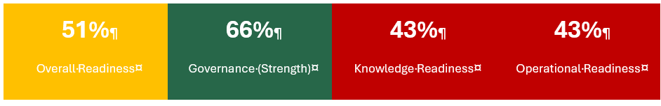

The Core Challenge
SFS has the right intentions but lacks the foundational infrastructure for AI success. Across 12+ siloed systems, 75,080 EDW tables, and 95% untagged data, the organization faces a content and data architecture problem that no amount of AI technology investment can solve on its own. This assessment has identified 15 strategic themes spanning enterprise data foundation, AI governance, customer operations, testing, BI productivity, remarketing, conversational AI, integration, document intelligence, predictive analytics, knowledge management, digital properties, resource allocation, process maturity, and competitive positioning.

The Strategic Opportunity
Industry benchmarks show 86% of financial services organizations with mature AI deployments report revenue lift. SFS can position itself as an industry leader by addressing foundational gaps while delivering quick wins. The End-of-Lease scaling event (14 to 100 agents by 2026) creates both urgency and a natural proving ground for AI-enabled efficiency. Customer service operations, with 90% payment-related calls representing 50,000+ monthly interactions, offer the highest ROI opportunity.

Key Recommendations
- Establish unified data foundation with API catalog, knowledge graph, and data governance before scaling AI
- Address AI governance gap including 392 unauthorized AI users creating compliance risk
- Activate already-purchased AI capabilities (Genesys tokens, Salesforce Einstein) to demonstrate ROI
- Deploy customer service automation targeting 90% payment-related calls
- Transform testing through AI augmentation to address 50% time spent on failure investigation
- Create AI Center of Excellence to coordinate 40-50 concurrent projects with only 20% capacity

Current State: What the Assessment Reveals

Assessment Findings Overview
The AI Readiness Assessment evaluated SFS across four domains: Knowledge Readiness, Operational Readiness, Technical Readiness, and Governance Readiness. The scoring methodology assessed 74 questions across these domains, with scores reflecting the maturity of current capabilities against industry best practices.

Domain | Score | Max | Percentage | Status
Knowledge Readiness | 39 | 90 | 43% | Early Stage
Operational Readiness | 43 | 100 | 43% | Early Stage
Technical Readiness | 42 | 85 | 49% | Gap
Governance Readiness | 63 | 95 | 66% | Strength
Overall | 187 | 370 | 51% | Early Stage

Critical Gaps Requiring Immediate Attention
Six factors scored below 45%, representing foundational gaps that will undermine AI initiatives if not addressed:

Applicability Mapping (35%)
Content does not indicate when or where it applies. Customer data is distributed across DeFy, EDW, Salesforce, Data Cloud without standardization. No mapping exists between content, products, tasks, or user roles that would enable AI to surface the right information in context.

Knowledge Accessibility (40%)
Information is scattered across 12+ siloed systems: Azure/Fabric, TestRail, Genesys, Salesforce, SharePoint, Aspira, Shaw, Observe.AI, FICO, EDW, DeFi Solutions. Employees rely on tribal knowledge and specific individuals. Only 30-40% of enterprise integrations are documented.

Knowledge Organization (40%)
No unified metadata schema exists across systems. Terminology varies by department. Only rudimentary data classifications exist, with 95% of data not tagged for AI consumption. Siloed taxonomies prevent cross-system navigation.

Monitoring & Telemetry (40%)
No AI dashboards or performance monitoring infrastructure exists. Token consumption tracking is listed as a needed capability. Basic system monitoring exists but no AI-specific observability.
Drift Monitoring (40%)
No production AI monitoring capabilities are operational. The AI Governance Policy includes incident response protocols but no drift detection. Manual processes identify issues after user complaints rather than proactively.

Retrieval Performance (40%)
No systematic measurement or tuning processes exist. Limited metadata infrastructure constrains retrieval quality. No automated testing of AI retrieval accuracy.

Organizational Strengths to Leverage
The assessment also revealed significant strengths that provide a foundation for AI transformation:

Governance Structure (80%)
The AI Governance Policy is comprehensive with clear RACI definitions. The AI Governance Committee is active, supported by AI Champions program (though broader representation needed), and should subsume the KM Governance Committee. Vendor assessment processes exist through the committee structure.

Security & Compliance (70%)
Strong regulatory awareness exists with CFPB and FFIEC compliance built into processes. Data privacy considerations are integral to the approval workflow. The security team is engaged and preparing for bank launch requirements.

Culture & Adoption (64%)
Universal enthusiasm for AI exists across all interviewed teams. Shadow AI usage (281 GPT users, 111 Gemini users) demonstrates pent-up demand. Teams are actively experimenting despite limited sanctioned tools. Management appears to favor a cautious, incremental approach to AI implementation that prioritizes small wins, which may inadvertently limit or delay exploration of larger-scale opportunities.

Strategy & Investment (64%)
Executive champion is actively engaged. EIS engagement demonstrates commitment to doing AI correctly. Multiple AI investments have already been made (Genesys, Salesforce Einstein, Azure AI services) though not fully activated.

The "So What?": Why This Matters Now

The Cost of Inaction
Without addressing foundational gaps, SFS faces compounding challenges:
- Scaling Crisis: End-of-Lease operations growing from 14 to 80-100 agents by 2026 will overwhelm current knowledge-sharing approaches. Tribal knowledge cannot scale.
- Wasted Investment: Genesys AI tokens expire unused monthly; Salesforce Einstein remains paid but disabled; Observe AI duplicates Genesys capabilities at additional cost.
- Competitive Disadvantage: Industry benchmark shows 42-50% of financial services organizations have active AI deployments; SFS remains at proof-of-value stage.
- Shadow AI Risk: 392 unauthorized AI tool users create data exposure and compliance vulnerabilities in an environment preparing for bank launch.
- Technical Debt: Multiple ungoverned AI experiments create architectural fragmentation; expensive "pay by the drink" vendor models emerging without coordination.

The Business Case for Action
Industry benchmarks from NVIDIA and Genesys research provide ROI context:

Capability | Industry Benchmark Impact
Voice Self-Service with Virtual Agents | 55-75% call automation, $295K+ annual value
Agent Copilot Auto-Summarization | 18-32% after-call work reduction, $204K+ annual value
Real-Time Agent Assistance | Improved first-call resolution
Predictive Engagement | Reduced delinquency through proactive outreach

For SFS specifically, with 145,000 monthly inbound calls, 90% payment-related, and cost per call of $4.50,even modest automation rates translate to significant value while improving customer experience and enabling operations to scale.

The Window of Opportunity
Several factors create urgency for immediate action:
- End-of-Lease Scaling (2026-2027): Must establish data collection and automation capabilities before the growth curve begins.
- Salesforce Implementation: December 2025 deployment creates integration opportunities; Einstein activation depends on corporate approval.
- Azure Migration: Active migration from MuleSoft to Azure APIM creates architecture decision points; comprehensive API catalog opportunity.
- Genesys Platform: AI tokens purchased but expiring unused; professional services SOW pending approval; immediate activation opportunity.
- Bank Launch Preparation: Heightened regulatory scrutiny requires detailed AI governance before deployment in banking context.

Consolidated Findings & Recommendations
The following 15 themes represent the synthesis of 140+ individual findings from stakeholder interviews across all operational areas. Each theme identifies a systemic challenge, provides context through specific evidence, and offers actionable recommendations tailored to SFS's situation.

1. Enterprise Data Foundation Is Incomplete - Limiting AI Readiness
Finding: Critical data infrastructure gaps prevent effective AI implementation: only 30-40% of enterprise integrations are documented, customer data is fragmented across DeFy/EDW/Salesforce/Data Cloud, 75,080 EDW tables lack comprehensive cataloging, and Azure environment documentation is severely lacking compared to legacy MuleSoft.
Recommendation: Establish unified data foundation before scaling AI initiatives - implement API catalog with governance framework, deploy knowledge graph for entity relationship mapping, create automated data quality monitoring, and complete data lineage visualization. This foundation enables all downstream AI applications while preventing fragmented, unsustainable implementations.
Sources: Meeting with Cassidy and Salesforce team, Data Discovery with Bobby, Data II Bobby & Puru, Product Consideration Meeting, Infrastructure Larry and Puru

2. AI Governance Gap Creates Compliance Risk and Shadow IT
Finding: Despite 281 GPT users and 111 Gemini users operating outside approved channels, SFS lacks comprehensive AI governance framework. Missing elements include token consumption tracking, privacy impact assessments, bias detection, security standards for financial services, and cost allocation models. This creates regulatory exposure in a banking environment while limiting organizational learning from distributed AI experiments.
Recommendation: Implement enterprise AI governance framework immediately - establish AI Center of Excellence, deploy usage monitoring with chargeback capabilities, create tiered tool approval process (enterprise ChatGPT/Claude for general use, specialized tools for technical teams), develop privacy-preserving implementation standards, and build decision rubrics for technology selection. This enables safe innovation velocity while maintaining compliance.
Sources: Security, Infrastructure Larry and Puru, Danny End-of-Lease, Risk & BI Chuck, Internal Meeting, AI Nader

3. Customer Service Operations Offer Highest ROI AI Opportunity
Finding: 90% of 50,000 monthly customer service calls are payment-related, representing massive opportunity for deflection. End-of-lease operations must scale from 14 to 80-100 agents by 2026 with major growth in 2027. Collections manages 400 FTEs. Customer frustration signals (rage clicks, failed attempts) go undetected. Genesys AI capabilities remain underutilized despite purchased licenses.
Recommendation: Prioritize customer-facing AI across three horizons: (1) Immediate - deploy payment-focused chatbot, activate Genesys AI for call transcription/summarization, implement real-time frustration detection; (2) Near-term - agent copilot for real-time knowledge surfacing, automated call classification for 2026 preparation; (3) Strategic - multi-modal AI agents with intelligent escalation, proactive intervention models using telematics data. ROI calculated through reduced hiring needs before end-of-lease scaling begins.
Sources: Matt and UX team, Customer Care, Stakeholder meeting, Collections with Greg, Danny End-of-Lease, Infrastructure Larry and Puru, AI Nader, Project Update Week3

4. Testing Bottleneck Threatens Digital Transformation Timeline
Finding: 50% of automation engineer time spent investigating test failures rather than developing new tests. Manual QA team cannot keep pace with development velocity. 7,000+ PWC tests need distillation. API testing covers only 61 of 700+ endpoints. Azure migration and Salesforce implementation lack adequate test automation. Self-healing capabilities and intelligent test selection are absent.
Recommendation: Transform testing through AI augmentation across SDLC: implement self-healing locator capabilities and AI-assisted failure analysis to reclaim 50% of maintenance time, deploy automated test generation from Gherkin specifications, establish predictive test selection based on code changes, accelerate API test coverage using specification-driven generation, and create AI-powered test impact analysis. Move testing support upstream to prevent downstream defects.
Sources: Testing Deep Dive Swarupa/Stephen/Geeta/Tyler, Manual Testing - Corinne, Automated Testing Stephen, Project Update Week3, AI Nader

5. BI Team Productivity Constrained by Manual Processes
Finding: 10-day report turnaround time despite high demand and 40-50 project pipeline with only 20% capacity. Analysts spend excessive time on data discovery across disparate systems (SQL Server, EDW, SAS, multiple source systems), duplicate work due to inability to find existing reports, manual data quality validation, and repetitive SQL/SAS coding. PhD-level teams (Economics & Residuals, Risk Analytics) spend 25% of time on code development and data engineering rather than analysis.
Recommendation: Deploy AI-powered BI acceleration suite: schema-aware SQL generation from natural language, automated report similarity detection to prevent duplication, pre-execution query optimization analysis, intelligent data source validation, and code generation assistance. Extend agentic data analyst capabilities (Phase 1 proof-of-concept) to generate code with full transparency for analyst review. Target 30-50% productivity improvement enabling backlog reduction without proportional headcount growth.
Sources: BI Shandria, BI-Tricia, Data, Risk Mgt & AI Eric, Economics & Residuals Rene, BI TJ, Data Science & Fabric - Adam, Project Update Week3

6. Remarketing Operations Lack Intelligence Layer for Portfolio Maturity
Finding: As lease portfolio matures toward 10x volume growth, remarketing operates with manual pricing decisions (weekly discussions), uniform pricing rather than VIN-level optimization, limited channel optimization (auction vs. dealer vs. e-commerce), no demand sensing integration, and minimal reconditioning ROI analysis. Current systems cannot scale to handle maturity volumes while maximizing recovery rates.
Recommendation: Build remarketing decision engine in phased approach: (1) Immediate - next-best-action recommendations within Salesforce, basic dealer chatbot, repair recommendation optimization; (2) Near-term - MVP pricing models at VIN-level, dealer scorecarding, demand sensing integration; (3) Medium-term - comprehensive multi-model engine integrating pricing/channel/transportation/timing decisions, bidding platform with demand forecasting, advanced telemetry incorporation for condition assessment. Target 2:1 ROI on reconditioning investments and optimize for portfolio scale.
Sources: Remarketing - Dan, BI TJ, Economics & Residuals Rene, Danny End-of-Lease

7. Conversational AI Implementations Lack Production Rigor
Finding: Multiple conversational AI initiatives (dealer-facing, HR benefits, end-of-lease, customer service) progressing without comprehensive evaluation frameworks, automated testing, or quality monitoring. Teams using trial accounts rather than production infrastructure. No standardized approach to memory management, personality customization, or multi-agent orchestration. Risk of "GM $1 lease quote incident" scenarios when deploying dealer-facing without proper guardrails.
Recommendation: Establish conversational AI excellence framework before scaling: implement 75+ test question evaluation with automated regression testing, deploy vector database automation replacing manual knowledge base updates, develop multi-agent orchestration patterns (LangGraph/LangChain/Crew AI), create platform portability strategy avoiding vendor lock-in, establish role-based personality customization standards, and design fast-track release process for information vs. infrastructure changes. Select one pilot use case for collaborative implementation demonstrating best practices end-to-end.
Sources: BI Yu, Internal Meeting, AI Nader

7. Conversational AI Implementations Lack Production Rigor
Finding: Multiple conversational AI initiatives (dealer-facing, HR benefits, end-of-lease, customer service) progressing without comprehensive evaluation frameworks, automated testing, or quality monitoring. Teams using trial accounts rather than production infrastructure. No standardized approach to memory management, personality customization, or multi-agent orchestration. Risk of "GM $1 lease quote incident" scenarios when deploying dealer-facing without proper guardrails.
Recommendation: Establish conversational AI excellence framework before scaling: implement 75+ test question evaluation with automated regression testing, deploy vector database automation replacing manual knowledge base updates, develop multi-agent orchestration patterns (LangGraph/LangChain/Crew AI), create platform portability strategy avoiding vendor lock-in, establish role-based personality customization standards, and design fast-track release process for information vs. infrastructure changes. Select one pilot use case for collaborative implementation demonstrating best practices end-to-end.
Sources: BI Yu, Internal Meeting, AI Nader

9. Document Intelligence Opportunity Remains Untapped
Finding: Massive unstructured data volumes represent opportunity - underwriting teams manually process variable-format credit reports (1-10 pages), thousands work with policies/training materials/procedures lacking intelligent search, contract data extraction is manual, SharePoint contains years of knowledge without semantic access, and meeting transcripts/call recordings contain insights lost to manual review.
Recommendation: Deploy comprehensive document intelligence pipeline: implement extraction for credit report standardization (immediate underwriting productivity gain), develop enterprise knowledge bot for policies/procedures (reduce HR/support burden), create AI-powered SharePoint search with summarization, establish automated meeting transcription and insight extraction, and build contract intelligence for origination documents. Leverage Azure AI Foundry document capabilities as enterprise document management matures.
Sources: Stakeholder meeting, Matt and UX team, Infrastructure Larry and Puru, Collections with Greg, Data II Bobby & Puru, Internal Meeting

10. Portfolio Growth Demands Predictive and Prescriptive Analytics
Finding: Organization lacks sophisticated forecasting and optimization capabilities needed for portfolio maturity - economic residual forecasting requires PhD-level manual work, termination predictions need accuracy improvement for 20x volume planning, customer lifecycle analytics don't leverage 2B+ account value records, pricing models are reactive rather than predictive, and delinquency interventions are reactive rather than proactive with 2,500+ credit attributes underutilized.
Recommendation: Build advanced analytics infrastructure: deploy ML Ops platform with model governance for banking compliance, implement predictive models for customer lifecycle (termination, upsell, satisfaction indicators), develop automated market intelligence platform monitoring automotive developments, create portfolio scenario analysis for risk management, establish real-time intelligence capabilities for fraud detection and operational monitoring, and optimize collections contact strategies using advanced credit attribute analysis. Ensure continuous learning systems incorporate outcomes into model refinement.
Sources: Economics & Residuals Rene, BI TJ, Data Science & Fabric - Adam, Collections with Greg, Risk & BI Chuck, Risk Mgt & AI Eric, AI Nader

11. Knowledge Management and Training Systems Are Inadequate for Scale
Finding: Tribal knowledge not captured systematically, new employee onboarding is lengthy (analyst onboarding highlighted as pain point), process documentation is incomplete (blocker for project starts per EPMO), dealer education on new systems is minimal, and organizational learning from AI experiments isn't shared. As operations scale (end-of-lease 14 to 100 agents, collections 400 FTEs, testing team expansion), knowledge gaps will multiply.
Recommendation: Leverage the KM Framework, especially the KM Maturity framework, the expertise location, the KM expertise succession planning (ensuring no-single-point-of-failures), the Content Lifecycle Management process, and adding an enterprise-wide search feature. Implement an AI-powered knowledge management ecosystem: create intelligent onboarding assistants for analysts/testers/agents with context-aware help, capture tribal knowledge from experienced team members into AI-accessible formats, develop training programs for AI-augmented workflows, establish cross-functional Center of Excellence sharing learnings and standardizing approaches, accelerate process documentation through interview analysis and automated workflow observation, and build dealer education portal with AI-powered guidance. Design systems that learn from usage patterns and continuously improve.
Sources: Data, BI Shandria, Testing Deep Dive, Manual Testing - Corinne, Economics & Residuals Rene, EPMO - Mike, Remarketing - Dan, Data Science & Fabric – Adam, KM Framework

12. Website and Digital Properties Underperform Customer Expectations
Finding: Public website lacks basic search functionality, customer experience for non-registered users is suboptimal, A/B testing capabilities are absent, below-the-fold content goes unexplored, SFS-to-OEM site integration is fragmented, MySFS portal integration incomplete, and positioning remains service-focused rather than acquisition-focused despite potential for lease-end conversion, refinancing campaigns, and commercial lending growth.
Recommendation: Transform digital properties into intelligent acquisition and retention channel: implement search functionality immediately, deploy customer-facing chatbot leveraging FAQ foundation, establish A/B testing framework for continuous optimization, integrate seamlessly with OEM sites and complete MySFS portal consolidation, develop offer/incentive engine showcasing promotions, implement CEO (Chat Engine Optimization) for AI assistant discoverability, create personalized content recommendations using Clarity analytics, and position site for lease-end-to-new-lease conversion and refinancing capture. Build comprehensive analytics to measure digital channel contribution to business outcomes.
Sources: Web Site - Sana, Matt and UX team, Product Consideration Meeting

13. Strategic Resource Allocation Lacks Data-Driven Prioritization
Finding: 40-50 projects in pipeline with only 20% capacity, meaningful prioritization difficult due to political dynamics, discovery phase becoming backlogged, business case development inconsistent, benefits realization tracking incomplete, and resource allocation based on static monthly heat maps rather than dynamic optimization. AI governance committee evaluates vendor solutions without systematic framework. Project delays common due to undocumented business processes.
Recommendation: Deploy AI-enhanced portfolio and resource management: implement objective project scoring against strategic criteria with AI-powered business case analysis, create resource optimization models incorporating dependencies/skills/velocity, automate discovery phase artifacts (requirements gathering, technical specifications, ARB documentation), establish standardized business case framework with comparative analysis from past projects, develop predictive capacity forecasting identifying constraint risks early, and create vendor AI solution evaluation framework assessing capabilities/integration/TCO. Enable executives with decision-support visualizations overcoming political prioritization reluctance.
Sources: Product Consideration Meeting, EPMO - Mike, Internal Meeting, Risk & BI Chuck

14. Process Maturity Gap Slows Innovation Velocity
Finding: SFS implementing processes that took GMF 12+ years to develop, creating maturity curve compression opportunity. However, manual process documentation, inconsistent change management approaches, limited observability into operational workflows, and inadequate measurement frameworks slow progress. End-of-lease scaling, payments enterprise program (100+ identified challenges), and insurance platform migration all require process excellence.
Recommendation: Accelerate process maturity through AI assistance: automate process documentation via interview analysis and workflow observation, develop standardized templates and artifacts reducing reinvention, implement digital adoption platform (DAP) with real-time process monitoring and proactive issue detection, create comprehensive observability across technology stack identifying optimization opportunities, establish automated KPI monitoring with intelligent alerting, and design change management programs specifically for AI tool adoption across growing populations. Build feedback loops ensuring continuous improvement based on operational data.
Sources: EPMO - Mike, Matt and UX team, BI-Tricia, Danny End-of-Lease, Product Consideration Meeting

15. Competitive Positioning Requires Coordinated AI Strategy
Finding: Individual business units pursuing independent AI initiatives without coordination, expensive "pay by the drink" vendor models emerging, organization moving from cautionary to calculated innovation stance, but lack of unified strategy prevents systematic competitive advantage building. Current approach risks fragmented implementations, duplicated investments, and missed synergies while competitors potentially move faster with coordinated strategies.
Recommendation: Establish enterprise AI strategy with coordinated execution: position SFS as automotive finance industry digital transformation leader through superior customer service automation and operational efficiency, build organizational muscle memory for AI adoption scaling across 2-4 year horizon, create reusable AI infrastructure and patterns preventing one-off solutions, develop vendor-ready posture enabling rapid best-of-breed adoption as market matures, establish measurement frameworks validating initiatives and revealing optimization opportunities, and calculate ROI demonstrating where AI investment offsets labor costs (end-of-lease scaling), reduces vendor dependencies (payment processing), and enables revenue growth (remarketing optimization, product expansion). Move from defensive AI exploration to offensive competitive differentiation.
Sources: Internal Meeting, Project Update Week3, Stakeholder meeting, AI Nader, Risk & BI Chuck, EPMO - Mike, Product Consideration Meeting

Strategic Recommendations: What SFS Should Do
Based on the assessment findings, stakeholder interviews, and industry benchmarks, we recommend six strategic themes that address both foundational gaps and immediate opportunities:

Theme 1: Knowledge Architecture Foundation
Gap Addressed | Knowledge Accessibility (40%), Knowledge Organization (40%), Applicability Mapping (35%)
Rationale | AI systems cannot effectively retrieve information that is unstructured, untagged, and scattered across silos. This is the foundational blocker that must be addressed for any AI initiative to succeed at scale.

Recommended Initiatives
- Unified Metadata Schema: Develop enterprise-wide metadata standards across EDW, Salesforce, SharePoint, and other content repositories. Include applicability indicators for products, tasks, and user roles.
- Content Inventory & Tagging: Systematic inventory of unstructured data assets with priority tagging for AI consumption. Target 99% of frequently accessed content tagged within 18 months (and 95% in 12 months).
- Accelerate API integration documentation and migration efforts to address the 30-40% integration gap outside MuleSoft's current footprint, supporting the 18-month Azure migration timeline.
- Cross-System Taxonomy: Develop controlled vocabulary and classification system that works across departmental boundaries. Address current siloed terminology that prevents cross-functional AI applications.
- Knowledge Graph Foundation: Map relationships across tables, databases, and data marts. Enable multi-hop reasoning and contextual retrieval.
- Content Component Model: Break monolithic documents into reusable components. Create templates for consistent structure.
Expected Outcomes
- AI retrieval accuracy improvement from current inconsistent state to 80%+ relevance
- Analyst time reduction for data discovery (currently significant portion of work)
- Foundation for natural language query interfaces across 75,080 EDW tables
- Reduced duplicate report creation through similar report discovery

Theme 2: Operational AI Enablement
Gap Addressed | Drift Monitoring (40%), Retrieval Performance (40%), Operational Maturity (45%)
Rationale | AI governance policies exist but operational implementation lags. Without monitoring and feedback systems, AI deployments cannot be sustained or improved over time.

Recommended Initiatives
- AI Monitoring Dashboard: Build centralized visibility into AI system performance, token consumption, error rates, and user feedback across all AI implementations.
- Drift Detection Framework: Implement automated monitoring for AI output quality, accuracy, and consistency. Establish thresholds and alerting for model degradation.
- Feedback Loop Infrastructure: Connect insights from AI monitoring back to content improvement cycles. Enable continuous enhancement of knowledge bases.
- SME Workflow Integration: Define workflows for how subject matter experts contribute to and approve AI-consumed content. Protect SME time while ensuring content quality.
- Lifecycle Management System: Implement systematic content review cycles with end-to-end lifecycle management including creation, review, publish, update, and archive.
Expected Outcomes
- Proactive identification of AI performance issues before user impact
- Continuous improvement of AI accuracy through structured feedback
- Reduced reliance on tribal knowledge through formalized SME contribution
- Audit-ready documentation of AI system behavior and changes

Theme 3: Customer Experience Intelligence
Gap Addressed | 50,000+ monthly customer calls (90% payment-related), End-of-Lease scaling from 14 to 80-100 agents, Collections 400 FTEs
Rationale | Customer service represents the highest ROI opportunity for AI investment. Addressing payment automation alone could generate $295K+ annual value while improving customer experience.

Recommended Initiatives
- Genesys AI Activation: Deploy already-purchased Genesys capabilities for call summarization, sentiment analysis, and agent assistance. Stop monthly token waste.
- Payment Automation Priority: Implement voice and chat automation for payment-related inquiries representing 90% of call volume. Target 30% deflection in first year.
- Agent Copilot Deployment: Real-time knowledge surfacing, next-best-action guidance, and automated call wrap-up to improve productivity and consistency.
- Self-Service Expansion: Deploy AI-powered chatbot for common questions on MySFS portal. Intelligent FAQ with escalation paths.
- Proactive Customer Engagement: Predictive analytics for proactive payment communication, excess mileage alerts, and lease-end preparation.
Expected Outcomes
- $295K+ annual value from voice self-service (industry benchmark: 55-75% automation)
- $204K+ annual value from auto-summarization (18-32% after-call work reduction)
- Reduced wrongful repossessions through AI-assisted decision support
- Scalable operations for End-of-Lease growth without proportional headcount increase

Theme 4: Developer & Analyst Productivity
Gap Addressed | 40-50 projects with only 20% capacity, 50% automation engineer time on failure investigation, 10-day report turnaround
Rationale | Development and analytical teams are clamoring for AI assistance. GitHub Copilot is only available via Office365 without IDE integration. Schema-aware SQL generation could dramatically improve BI productivity.

Recommended Initiatives
- Schema-Aware SQL Generation: Deploy LLM with data dictionary context to generate SQL from natural language. BI team spends majority of time on SQL coding.
- GitHub Copilot Expansion: Enable IDE-integrated AI assistance for development and QA teams. Address current limitation of Copilot only through Office365.
- Test Automation Enhancement: AI-assisted test case generation, self-healing locators, and automated failure analysis to reclaim 50% maintenance time.
- Code Quality & Optimization: AI-powered code review, performance optimization suggestions, and standards compliance checking.
- Similar Report Discovery: AI-powered search across existing reports to reduce duplication and accelerate delivery.
Expected Outcomes
- 30-50% productivity improvement for BI and Risk SQL development
- Accelerated test automation from 41% to 70%+ coverage
- Reduced IT remediation burden from poorly performing queries
- Faster delivery on 40-50 project backlog

Theme 5: Data Platform Modernization
Gap Addressed | Technical Foundation (44%), Integration & Orchestration (45%), 95% of data untagged
Rationale | 95% of data is not tagged for AI consumption. The natural language query pilot is limited to 25 tables. Azure migration creates opportunity for governance-by-design.

Recommended Initiatives
- Data Classification Initiative: Systematic tagging of data for AI consumption with PII identification using Microsoft Purview. Target 70%+ of frequently-accessed data classified.
- Unified Data Access Layer: Create consistent access patterns across Azure Fabric, Cosmos DB, Salesforce, and legacy systems. Enable AI systems to query across sources.
- Enterprise Vectorization Strategy: Move beyond pilot-stage RAG to enterprise embedding strategy with refresh processes and quality monitoring.
- Natural Language Query Platform: Expand from current 25-table pilot to enterprise capability across EDW. Build on agentic data analyst proof-of-concept.
- Real-Time Intelligence Activation: Deploy Fabric streaming capabilities for low-latency analytics and real-time decision support.
Expected Outcomes
- AI-ready data foundation with 70%+ classification completeness
- Single source of truth replacing departmental shadow data practices
- Self-service analytics capability for business users
- Foundation for advanced AI use cases requiring multi-source data

Theme 6: AI Governance Operationalization
Gap Addressed | Cross-Functional Alignment (55%), 392 unauthorized AI users, policy-to-practice gap
Rationale | Strong governance policies exist but operational implementation lags. Unauthorized AI usage creates compliance risk while blocking innovation in sanctioned channels.

Recommended Initiatives
- AI Center of Excellence: Establish centralized expertise, reusable components, and best practices. Address current fragmentation across Genesys, Salesforce, and Azure AI initiatives.
- Governance Operationalization: Move AI Governance Policy from documentation to operational workflows. Build approval processes, monitoring, and enforcement into daily operations.
- Unauthorized AI Remediation: Address 281 ChatGPT and 111 Gemini users with approved alternatives and policy enforcement. Convert shadow AI to governed AI.
- Cost Management Framework: Build token consumption tracking and chargeback capabilities. Enable business units to understand and manage AI costs.
- Vendor AI Evaluation Process: Systematic assessment of vendor AI offerings (Genesys vs. Salesforce vs. Azure) for each use case. Prevent lock-in while leveraging investments.
Expected Outcomes
- Coordinated AI initiatives versus current fragmented approach
- Reduced compliance and security risk from shadow AI
- Predictable AI costs with business unit accountability
- Accelerated adoption through proven patterns and reusable components

Implementation Roadmap: When to Act
The roadmap balances foundational work with quick wins to demonstrate value while building sustainable AI capabilities. Initiatives are sequenced based on dependencies, resource availability, and strategic impact.

Phase 1: Foundation (Q1 2026)
Focus: Establish governance operations, activate purchased capabilities, begin knowledge architecture work.

1.1 Genesys AI Activation
Deploy already-purchased Genesys capabilities for call summarization, sentiment analysis, and agent assistance. Stop monthly token waste and demonstrate ROI.
Timing: Weeks 1-8 | Impact: High | Owner: Ryan Miller/IT Ops

1.2 AI Governance Operationalization
Move AI Governance Policy to operational workflows. Establish approval processes, monitoring, and enforcement. Address unauthorized AI usage.
Timing: Weeks 1-12 | Impact: High | Owner: AI Governance Committee

1.3 Unified Metadata Schema Design
Develop enterprise metadata standards across priority systems. Create applicability indicators for AI consumption.
Timing: Weeks 4-12 | Impact: Medium | Owner: Bobby Goodwin/Data Team

1.4 BI Code Generation Pilot
Deploy schema-aware SQL generation for BI team. Target high-frequency query patterns for immediate productivity gain.
Timing: Weeks 4-12 | Impact: Medium | Owner: BI Team/EIS

Phase 2: Quick Wins & Architecture (Q2 2026)
Focus: Scale successful pilots, implement customer-facing automation, build data platform capabilities.

2.1 Payment Automation Deployment
Implement voice and chat automation for payment-related inquiries. Target 30% call deflection based on 90% payment-related call volume.
Timing: Weeks 13-24 | Impact: High | Owner: Customer Service/Genesys

2.2 Test Automation Enhancement
Deploy AI-assisted test case generation and self-healing locators. Address 50% time spent on failure investigation.
Timing: Weeks 13-20 | Impact: Medium | Owner: QA/EIS

2.3 Content Inventory & Tagging
Systematic inventory of unstructured data assets. Implement Purview for data classification. Target 50% of priority content tagged.
Timing: Weeks 13-24 | Impact: Medium | Owner: Data Governance

2.4 AI Center of Excellence Launch
Establish CoE structure, staffing, and initial reusable components. Create support model for business unit AI initiatives.
Timing: Weeks 16-24 | Impact: High | Owner: CDO/Ryan Miller

Phase 3: Operational Maturity (Q3 2026)
Focus: Build monitoring infrastructure, expand developer tools, prepare for End-of-Lease scaling.

3.1 AI Monitoring Dashboard
Deploy centralized monitoring for token consumption, performance metrics, and cost allocation across all AI implementations.
Timing: Weeks 25-32 | Impact: High | Owner: AI CoE/IT Ops

3.2 End-of-Lease AI Preparation
Implement call classification, data collection, and chatbot pilot for End-of-Lease operations scaling to 80-100 agents.
Timing: Weeks 25-36 | Impact: High | Owner: Danny Rodriguez/AI CoE

3.3 GitHub Copilot Deployment
Enable IDE-integrated AI assistance for development teams. Establish usage policies and productivity measurement.
Timing: Weeks 25-32 | Impact: Medium | Owner: Dev Teams/Security

3.4 Natural Language Query Expansion
Scale from 25-table pilot to broader EDW access. Build on agentic data analyst capabilities.
Timing: Weeks 28-36 | Impact: Medium | Owner: Data/AI CoE

Phase 4: Scale & Optimize (Q4 2026)
Focus: Expand successful implementations, optimize based on learnings, achieve industry benchmark performance.

4.1 Collections AI Augmentation
Deploy voice AI and predictive analytics for Collections 400 FTE operation. Leverage credit attribute analysis.
Timing: Weeks 37-48 | Impact: High | Owner: Greg Shreve/AI CoE

4.2 Einstein Activation
Enable Salesforce Einstein capabilities post corporate approval. Integrate with existing Salesforce implementation. Alternatively, leverage Genesys AI to reduce costs while maintaining a cohesive, integrated solution architecture.
Timing: Weeks 37-44 | Impact: Medium | Owner: Salesforce Team

4.3 Knowledge Graph Implementation
Deploy production-grade knowledge graph for enterprise search and AI retrieval across systems.
Timing: Weeks 40-48 | Impact: Medium | Owner: Data/AI CoE

4.4 ROI Validation & 2027 Planning
Measure outcomes against industry benchmarks. Develop 2027 roadmap based on learnings and emerging opportunities.
Timing: Weeks 44-48 | Impact: High | Owner: AI Governance Committee

Success Metrics: How to Measure Progress
Success metrics align with assessment factors, industry benchmarks, and business outcomes. Regular measurement enables course correction and demonstrates value to stakeholders.

AI Readiness Score Targets

Domain | Current | Q2 Target | Q4 Target | Industry
Knowledge Readiness | 43% | 55% | 65% | 70%
Operational Readiness | 43% | 55% | 65% | 70%
Technical Readiness | 49% | 60% | 70% | 75%
Governance Readiness | 66% | 75% | 80% | 85%
Overall | 51% | 62% | 70% | 75%

Business Outcome Metrics
- Customer Service: Call deflection rate (target 30%), average handle time reduction (target 15%), first contact resolution improvement
- Developer Productivity: SQL generation adoption rate, test automation coverage (target 70%), code review cycle time reduction
- Cost Management: Token utilization rate (target 80%+), cost per AI interaction, ROI per use case
- Operational: Content tagging completeness (target 70%), retrieval accuracy (target 80%), monitoring coverage

Leading Indicators
- Weekly: Token consumption trends, error rates, user adoption metrics
- Monthly: Use case pipeline progress, governance compliance, cost variance
- Quarterly: Readiness score reassessment, stakeholder satisfaction, capability maturity

Conclusion: The Path Forward
Stellantis Financial Services stands at a pivotal moment. The AI Readiness Assessment reveals an organization with strong governance foundations (66%) and universal enthusiasm for AI adoption, but significant gaps in knowledge infrastructure (43%), operational processes (43%), and technical capabilities (49%) that must be addressed for AI initiatives to scale successfully. The 15 consolidated findings spanning enterprise data foundation through competitive positioning provide a comprehensive view of both challenges and opportunities.

The recommendations in this document address both the foundational gaps and the immediate opportunities. By pursuing the six strategic themes with the phased implementation roadmap, SFS can:
- Transform knowledge architecture to enable accurate AI retrieval across 12+ systems
- Activate already-purchased AI capabilities to stop waste and demonstrate ROI
- Build operational infrastructure for sustainable AI at scale
- Prepare for the 2026-2027 End-of-Lease scaling event with AI-enabled efficiency
- Position SFS as an industry leader in responsible AI adoption
Critical Success Factors
- Executive Commitment: Sustained sponsorship from Ryan Miller and the AI Governance Committee
- Resource Allocation: Dedicated capacity for foundational work alongside quick wins
- Cross-Functional Collaboration: Breaking down silos between IT, business units, and data teams
- Measured Approach: Crawl-walk-run philosophy with continuous learning and adjustment
- External Partnership: Leveraging EIS expertise to accelerate capability building

The window of opportunity is now. With the End-of-Lease scaling event approaching, Salesforce implementation underway, and Azure migration creating architecture decision points, the decisions made in Q1-Q2 2026 will determine whether SFS builds a sustainable AI foundation or accumulates additional technical debt.

The recommendations in this document provide a clear path from assessment to action. SFS has the governance foundation, executive commitment, and business need to succeed. The next step is to begin execution with the Q1 2026 initiatives while building organizational capability for the journey ahead.

Governance Framework (Sanjay/Phil/Seth)
Governance Foundation | AI governance framework design  Domain controls and audit trails  Security and risk frameworks  Operational request management process  Interview findings | Week 3-4 | Approved governance framework  Clear roles and responsibilities  Established review processes

Executive Summary
SFS has the policy, the executive commitment, and the platform investments. What it lacks is the operational mechanism to turn governance intent into execution velocity.
The organization has invested in Genesys, Salesforce Einstein, Azure AI, and Microsoft Fabric. It has an AI Governance Policy (v1.0), an active AI Steering Committee, and genuine enthusiasm for AI adoption across business units. Yet after more than a year of discussion, execution velocity remains the number one concern across stakeholders. The gap between governance aspiration and governance action has become the primary barrier to AI value delivery.
This document establishes the operational governance framework that bridges that gap. It defines three governance bodies with distinct charters, working agendas, and accountability structures. It identifies 14 governance gaps requiring action, assigns each to a responsible body, and establishes a prioritized action plan with measurable outcomes.
The framework is technology agnostic by design. It focuses on decision-making structures, resource allocation, risk management, and accountability. These are the elements that endure as AI technologies evolve. The structure draws on proven governance patterns from enterprise deployments that have remained effective for more than a decade, adapted specifically for SFS’s organizational structure, regulatory environment, and current maturity level.

Current State Assessment

What Exists Today
SFS has built a governance foundation that many organizations lack at this stage:
- AI Governance Policy v1.0 with defined lifecycle stages (Design, Testing, Deployment, Monitoring, Decommissioning) and CDO accountability.
- AI Steering Committee with executive participation, meeting every 6 to 10 weeks.
- Enterprise Architecture review processes integrated into the EPMO discovery phase.
- Security infrastructure (Zscaler, CrowdStrike, Purview) providing foundational controls.
- Five-tier data classification system (Public through Highly Restricted) with 70% unstructured data tagged.
- AI Champions program supporting distributed awareness and adoption.

What Is Missing
Despite this foundation, critical gaps prevent the governance structure from enabling execution. These are not theoretical risks; they have measurable cost and compliance consequences today.
No tiered review process: Every AI request goes through the same review regardless of risk level, creating unnecessary bottlenecks for low-risk experiments while providing insufficient rigor for high-risk deployments.
- No operational working group: The Committee meets for socialization every 6 to 10 weeks, but no body exists for weekly, action-oriented decision-making on architecture standards, tool evaluations, or policy development.
- No agent registry: SFS cannot govern what it cannot see across Genesys, Salesforce, and Azure. Without a unified inventory, risk assessment is impossible.
- No cost attribution: AI consumption costs are absorbed centrally with no per-BU or per-use-case visibility. This makes ROI measurement and budget advocacy impossible.
- No vendor evaluation framework: Tool decisions are ad hoc, leading to $4.5M in platform duplication between Observe AI and Genesys.
- No shadow IT workflow: significant unauthorized AI tool instances detected with no process for handling access requests or redirecting users to sanctioned alternatives.
- 95% of structured data untagged: Classification has not been applied, hindering metrics, AI use cases including Fabric AI Foundry, compliant model training, and governed chatbots.
- No AI incident response playbook: SFS operates in a heavily regulated financial services environment with no documented procedures for AI-related incidents.

Three-Tier Governance Structure
The governance framework establishes three distinct bodies, each with a clear purpose, cadence, and decision authority. This structure balances strategic oversight with tactical decision-making and operational execution. It directly addresses the velocity concerns raised in the February 16, 2026, working session: the Committee sets direction, the Working Group makes binding operational decisions weekly, and Task Forces execute time-boxed investigations.

AI Steering Committee
Charter
The AI Steering Committee provides strategic direction, executive oversight, and cross-functional alignment for SFS’s AI program. It ensures AI investments align with business strategy, resolves escalated cross-functional conflicts and socializes AI wins and lessons across business units. The Committee approves all Tier 1 (Critical) AI deployments and allocates budget for AI initiatives.
Membership
Role | Member | Function
Chair | Ryan Miller | CDO
Executive Sponsor | Phil Maternowski | CIO
Member | Mike Calaway | CISO
Member | Larry Burgess | MD, Infrastructure & EA
Member | Chuck Berend | Chief Risk Officer
Member | Nader Afshar | AI Product Owner
Member | Mike McKiggan | EPMO
Rotating | BU Representatives | Collections, Customer Service, BI

Cadence
Every 6 weeks, 90 minutes.
Agenda-The standard agenda allocates time across six areas:
- Working Group status report (15 min)
- AI portfolio review and ROI tracking (15 min)
- Tier 1 deployment approvals (15 min)
- Business unit showcase (10 min)
- Escalated issues resolution (10 min)
- Strategic direction discussion with action items (15 min)
Decision Authority
The Committee has final authority on Tier 1 (Critical) AI deployments, AI budget allocation, strategic direction, and escalated issues from the Working Group. It does not make architecture standards or tool-level decisions; those belong to the Working Group. This separation of concerns is essential: the Committee focuses on "what" and "why" while the Working Group decides "how."

AI Governance Working Group
Charter:
The Working Group is the primary decision-making body for AI governance operations. It functions as the AI Architecture Review Board
- Establishing and enforcing architecture standards
- Evaluating tools and vendors against a consistent framework
- Making binding standards decisions
- Managing the AI agent registry
- Tracking cost attribution and ROI.
This is where the governance structure creates velocity: weekly cadence with delegated authority eliminates the bottleneck that results from routing every decision through a 6-week committee cycle.
Membership:
Role | Member | Focus Area
Chair | Ryan Miller | CDO, governance alignment
Co-Chair | Larry Burgess | Architecture, platform strategy
Member | Nader Afshar | AI Product Owner, intake triage
Member | Puru Naktode | AI Architecture, Fabric/Azure
Member | Vik Chopra | Enterprise Architecture
Member | Mike Calaway | Security, compliance
Member | Tony Grogan | IT Governance, data classification
Advisory | EIS advisors | As needed

Cadence and Format
Weekly, 60 minutes.
Agenda:
- Action item review (10 min)
- New AI request triage and tier assignment (10 min)
- Standards and policy deep-dive on a rotating topic (15 min)
- Task Force status reports (10 min)
- Architecture decisions (10 min)
- Risk/compliance updates (5 min).
Decision Authority:
The Working Group has binding authority on architecture standards, tool approvals (Tier 2 and 3), policy development, and vendor recommendations. Per Larry Burgess’s guidance from the working session, business input occurs at the Committee level while technical architecture decisions are made here. All decisions are logged with rationale for audit trail and organizational learning.

3.3 AI Execution Task Forces
Charter
Task Forces are temporary, cross-functional teams chartered to investigate specific governance gaps, conduct technical assessments, execute proofs of concept, and deliver findings and recommendations to the Working Group. Membership is fluid based on the initiative, and each Task Force operates under a time-boxed charter with defined deliverables and success criteria.
Proposed Active and Planned Task Forces
Task Force | Duration | Key Deliverables
Genesys vs. Observe AI Platform Evaluation | 8 weeks | Capability comparison, TCO model, consolidation recommendation
Agent Registry Build | 4 weeks | Metadata schema, initial registry population, maintenance process
Shadow IT Workflow Design | 6 weeks | Request/redirect/approve process, DAP configuration, deployment
Licensed AI Activation | 4 weeks | Dormant capability inventory, business cases, fast-track governance review
AI Incident Response Playbook | 6 weeks | Draft procedures, severity levels, tabletop exercise

Cadence and Format

Bi-weekly, 45 minutes.
Agenda:
- charter review (5 min)
- work stream updates (15 min)
- analysis and findings discussion (15 min)
- escalation decisions (5 min)
- next steps with assignments (5 min).
Each Task Force reports to the Working Group at its weekly meeting and escalates blockers that require cross-functional resolution.

Risk Tiering Framework
Why do organizations with good governance policies still struggle with AI execution velocity? In most cases, the answer is a one-size-fits-all review process. A sandboxed prototype with no customer data goes through the same review as a credit decisioning model. The result is predictable: everything slows to the pace of the highest-risk use case.
The risk tiering framework solves this by making governance rigor proportional to risk. This is the single most important mechanism for addressing the velocity problem at SFS.
Tier | Description | SFS Examples | Approval | Timeline
Tier 1: Critical | Customer-facing financial decisions; restricted data; autonomous actions with financial impact | Credit decisioning AI, autonomous collections agents, fair lending models | Committee + CDO + Legal | 4–6 weeks
Tier 2: High | Customer-facing non-financial; confidential PII; significant operational impact | Genesys virtual agents, wrongful repo detection, Einstein case management | Working Group | 2–4 weeks
Tier 3: Moderate | Internal facing; internal data; augments human decisions | NLP query for BI, AI-assisted ETL, code generation, speech analytics QA | Domain Lead + AI PO | 1–2 weeks
Tier 4: Low | POCs, sandboxes, internal productivity tools; no customer or financial data | Copilot Studio prototypes, internal knowledge base chatbots, test generation | Self-service (register only) | Under 1 week

The tiering framework achieves two goals simultaneously: it accelerates low-risk innovation (Tier 4 self-service in under a week) while ensuring appropriate controls for high-risk deployments (Tier 1 committee review with legal involvement). Every AI initiative at SFS should be classified into one of these tiers at intake, with the Working Group responsible for tier assignment during its weekly triage.

Identified Governance Gaps
The assessment identified 14 governance gaps, prioritized by business impact and urgency. Each gap has been assigned to the appropriate governance body with specific recommended actions. The complete gap analysis with current state, target state, and success criteria is provided in the accompanying Excel workbook.

Priority 1: Immediate Action (Weeks 1–4)
- No tiered governance review process. All requests treated identically regardless of risk, creating unnecessary bottlenecks for low-risk experiments while providing insufficient rigor for high-risk deployments. The risk tiering framework (Section 4) addresses this directly.
- Committee cadence too slow. The 6-to-10-week meeting cycle was characterized as a “book club” in stakeholder interviews. No weekly operational body exists for binding decisions on architecture standards, tool evaluations, or policy development. The Working Group (Section 3.2) fills this gap.
- Shadow AI uncontrolled. Significant unauthorized tool instances detected. Copilot was universally rejected as an inadequate alternative, but no sanctioned coding AI has been approved. Users are routing around governance because governance offers no viable path forward.

Priority 2: Short-term (Weeks 2–8)
- No agent registry or inventory. SFS operates AI agents across three platforms (Genesys, Salesforce, Azure) with no unified view. You cannot govern what you cannot see.
- Platform duplication ($4.5M). Observe AI and Genesys have significant capability overlap. Without structured evaluation, this duplication will continue to accrue cost.
- Licensed AI capabilities unused. Genesys tokens ($15K/month expiring), Salesforce Einstein features, and Fabric AI Foundry capabilities sit idle while teams lack access to sanctioned tools. This is the most immediate ROI opportunity.
- No decision logging. Ad hoc meeting notes with no structured tracking, no rationale capture, and no accountability trail. This creates organizational amnesia that forces repeat discussions.

Priority 3: Medium-term (Weeks 4–12)
Four gaps require the governance bodies to be operational before they can be addressed effectively:
- Data classification for AI (95% of structured data untagged at field level)
- Cost attribution and chargeback mechanisms
- AI incident response playbook development
- Fair lending/bias testing framework.
These are sequenced to begin once the three-tier structure is operational.

Priority 4: Ongoing
Vendor evaluation framework formalization, AI skills and training program, and key person risk mitigation (expertise concentrated in fewer than three individuals). These are continuous improvement items managed through quarterly governance effectiveness reviews.

Key Governance Risks
Ten critical risks require ongoing monitoring and mitigation through the governance structure. The complete risk inventory (49 generic risks with 22 SFS-specific mappings) is maintained in the SFS AI Governance Risks Framework workbook. The top five risks, each with immediate mitigation actions, are:
- Governance perceived as bottleneck (Critical). The framework must demonstrably accelerate, not slow, AI delivery. The weekly Working Group cadence and risk tiering framework are the primary mitigations. Success metric: Tier 4 approvals in under one week.
- Shadow AI data exfiltration (Critical). Financial services data exposed to external AI services creates regulatory and reputational risk. Mitigation: sanctioned alternatives approved within 60 days; shadow IT request workflow deployed within 90 days.
- Duplicate platform costs (High). $4.5M annual overlap between Observe AI and Genesys requires a structured evaluation and consolidation decision within 60 days.
- Licensed AI waste (High). Tokens and licenses expiring unused while teams lack access to sanctioned tools. Every month of delay has a direct, measurable cost. Mitigation: dormant capability inventory and fast-track activation within 30 days.
- Regulatory exposure (Critical). CFPB and FDIC requirements for AI in financial services are intensifying, with no bias testing framework, no AI-specific incident response procedures, and unclear cyber insurance AI coverage. Mitigation: AI incident response playbook within 45 days; bias testing framework within 90 days.

Implementation Roadmap
The roadmap is structured in four phases. Each phase builds on the prior, and the sequencing reflects dependencies: governance bodies must be operational before they can address gaps, and gaps must be closed before the framework can mature.
Weeks 1–2: Foundation
Formalize the three-tier governance structure with approved charters. Convert the current office hours to the first weekly Working Group meeting with a structured agenda. Establish a decision log and action tracking in SharePoint. Begin agent registry design with metadata schema definition. This phase has no external dependencies and should begin immediately.
Weeks 3–6: Operationalize
Deploy the risk tiering framework with an intake form. Commission the Genesys vs. Observe AI evaluation task force. Evaluate enterprise AI coding alternatives to Copilot. Design the shadow IT request workflow with the digital adoption platform. Inventory licensed-but-dormant AI capabilities across Genesys, Salesforce, and Fabric. The Working Group drives all of these through weekly agenda items.
Weeks 6–12: Mature
Begin Purview Data Map deployment for structured data classification. Implement cost tracking and attribution mechanisms. Draft the AI incident response playbook with severity levels and escalation procedures. Deliver the platform consolidation recommendation to the Committee. Activate the first dormant AI capabilities with governance guardrails in place.
Ongoing: Optimize
Quarterly governance effectiveness reviews measuring time-to-decision, shadow AI reduction, cost attribution coverage, and standards compliance rate. Annual framework refresh. Continuous risk register updates. Expanding AI training and enablement programs to reduce key person dependency.

Success Metrics
The governance framework will be measured by four categories of outcomes. If the framework cannot demonstrate measurable improvement in these areas within 90 days, it needs to be adjusted. Governance for its own sake is overhead; governance that enables is infrastructure.
Category | Metric | Target | Frequency
Velocity | Average time from AI request to deployment, by tier | Tier 4: under 1 week; Tier 1: under 6 weeks | Monthly
Control | Shadow AI instance count | Under 50 (from 392) within 6 months | Monthly
Control | Agent registry completeness | 100% of production AI within 90 days | Monthly
Cost | Licensed AI utilization rate | Over 80% | Monthly
Cost | AI spend attribution coverage | Over 90% attributed to BU/use case within 6 months | Quarterly
Compliance | Data classification coverage for AI sources | Over 80% within 12 months | Quarterly
Compliance | AI-related regulatory findings | Zero | Ongoing

Implications and Next Steps
SFS has the governance foundation, executive commitment, and business need to succeed with AI. The missing piece has been the operational mechanism to translate governance intent into execution velocity. This framework provides that mechanism through a technology-agnostic structure of decision-making bodies, clear accountability, risk-proportionate processes, and measurable outcomes.
The framework draws on proven patterns from enterprise governance deployments that have endured for more than a decade precisely because they focus on decision structures rather than specific technologies. As SFS’s AI landscape evolves (from current Genesys and Salesforce implementations through future agentic AI architectures) this governance structure provides the stable foundation for allocating resources, solving problems, and ensuring a return on AI investments.
Three actions should happen this week:
- Ratify the three-tier structure. Circulate the charter to Committee members for endorsement. This requires no budget, no procurement, and no technology decisions.
- Hold the first Working Group meeting. Convert the next scheduled office hours to a structured working session with the agenda defined in Section 3.2. The group already meets; it needs a mandate, not a new meeting.
- Start the agent registry. A spreadsheet-based v1 with known AI agents across Genesys, Salesforce, and Azure takes one person one day. Perfection is the enemy of visibility.
Every week of governance delay has a measurable cost: $15K in expiring Genesys tokens, continued shadow AI data exposure, and $4.5M in unresolved platform duplication. The question is not whether to operationalize governance. The question is whether SFS can afford

Executive Summary
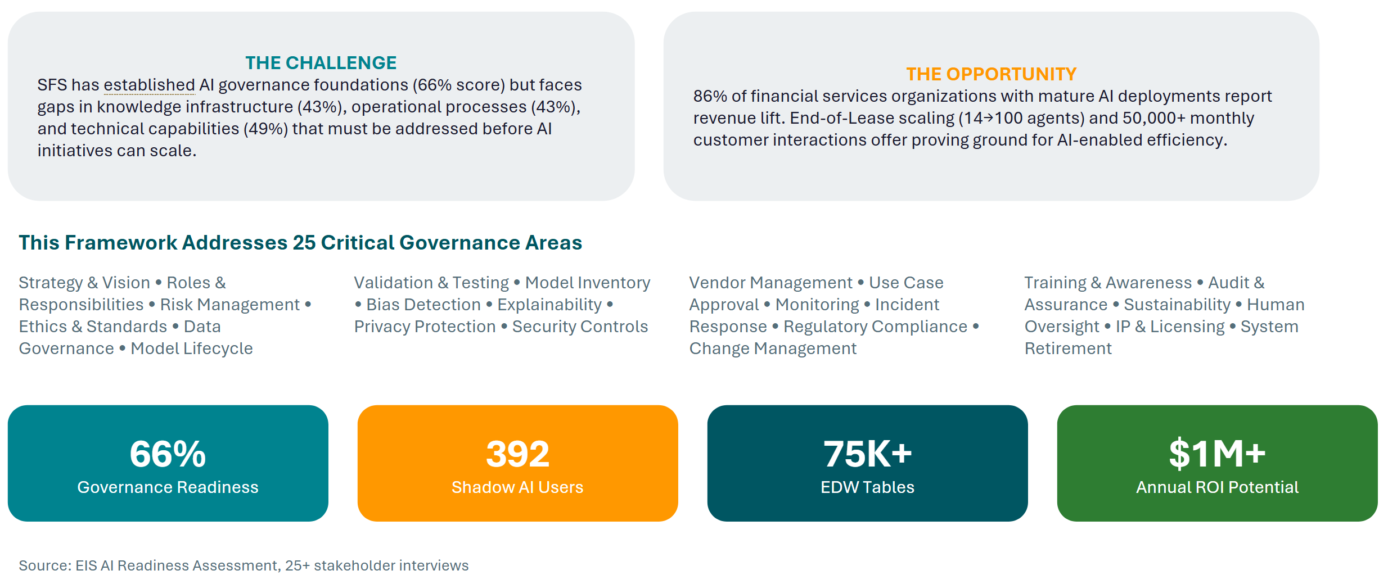

AI Governance Strategy and Vision
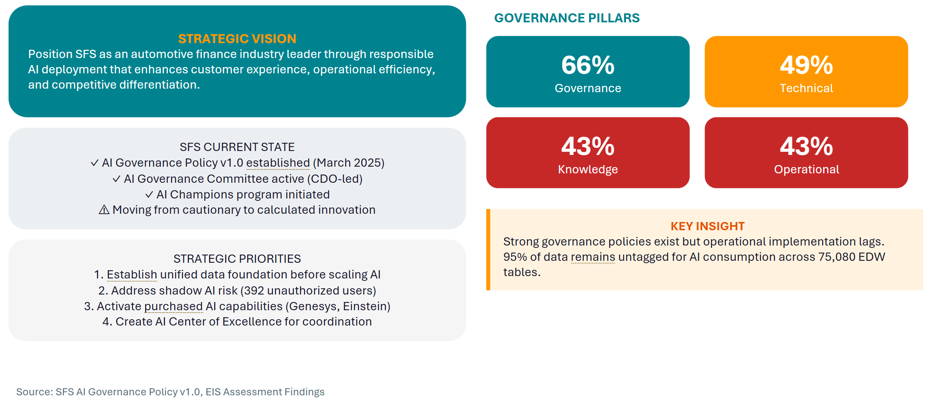

Roles and Responsibilities
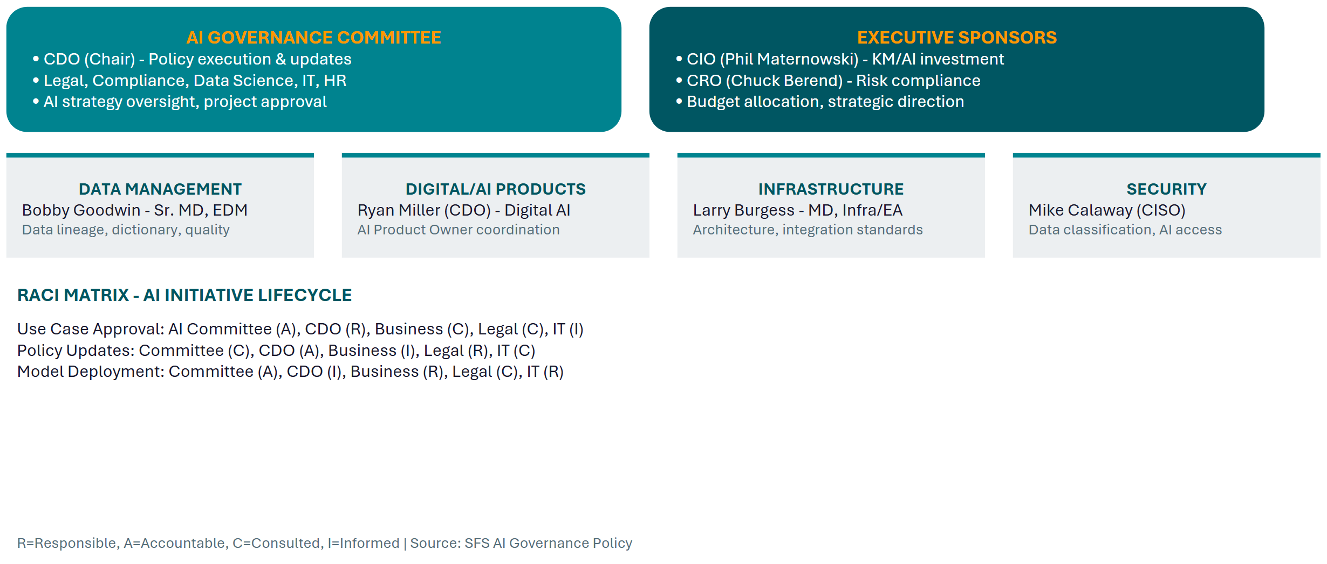

AI Risk Management Framework
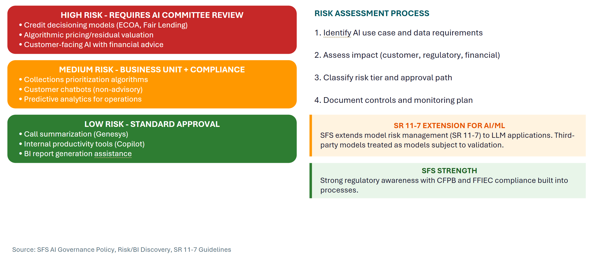

AI Ethics Principles and Standards
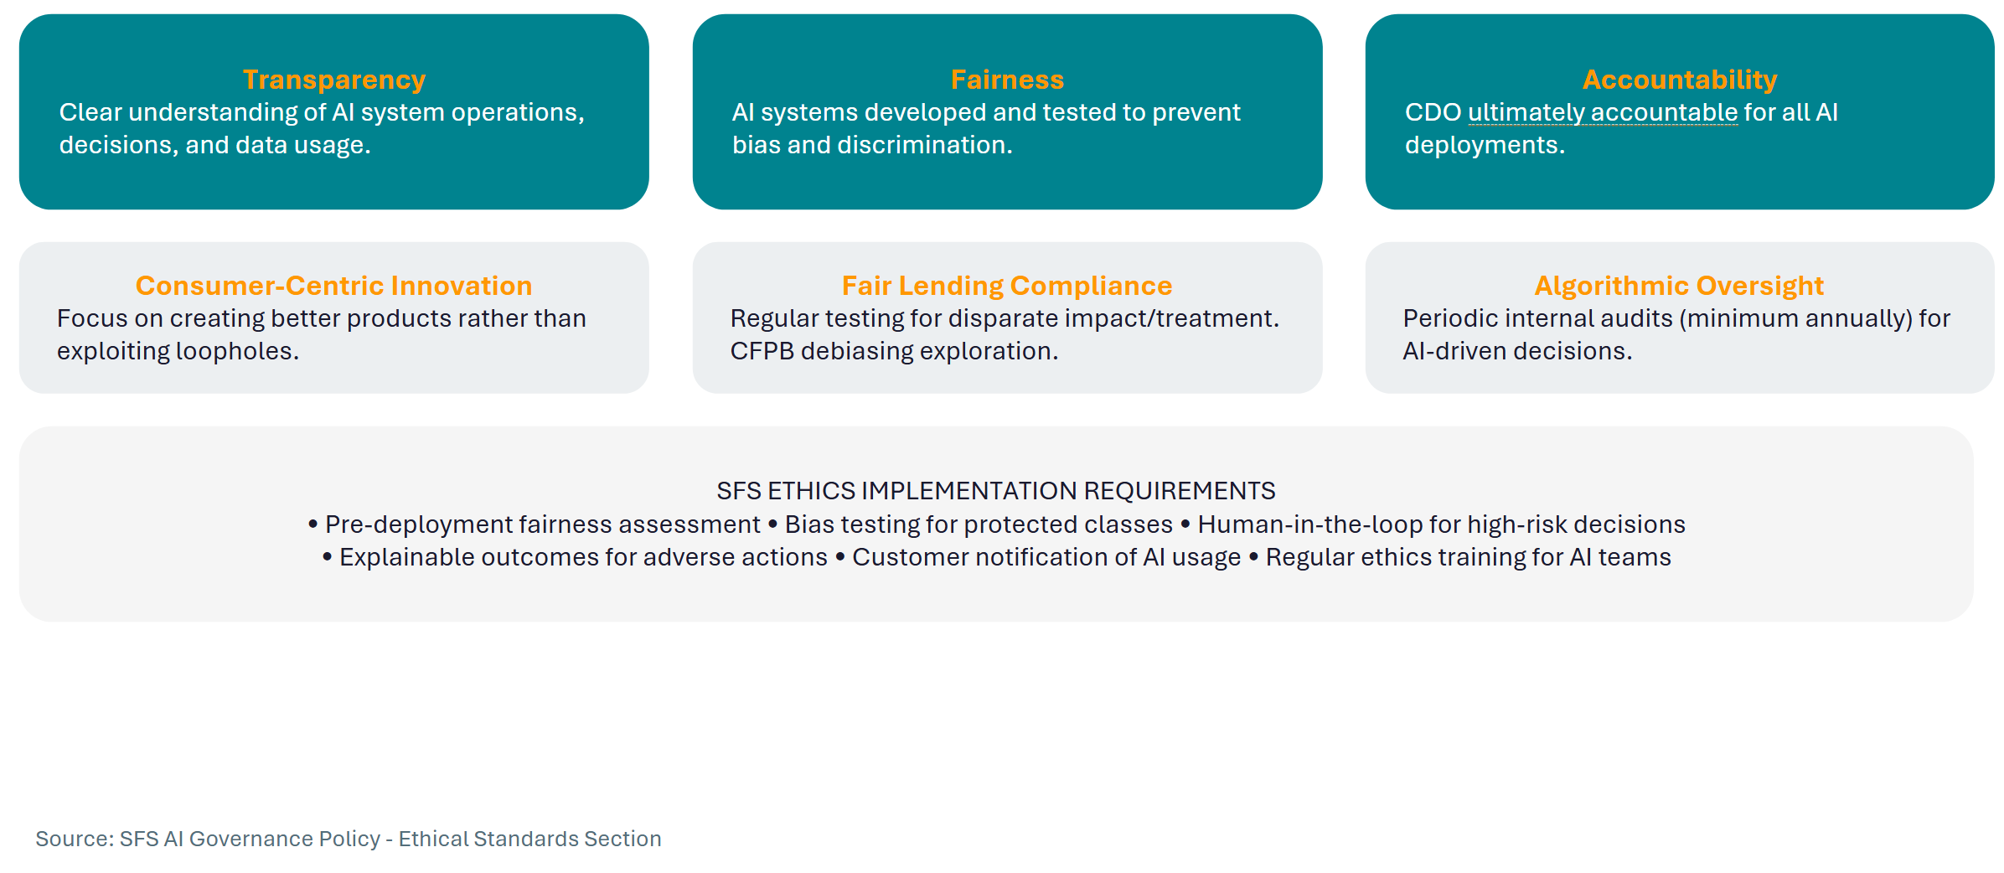

Data Governance for AI
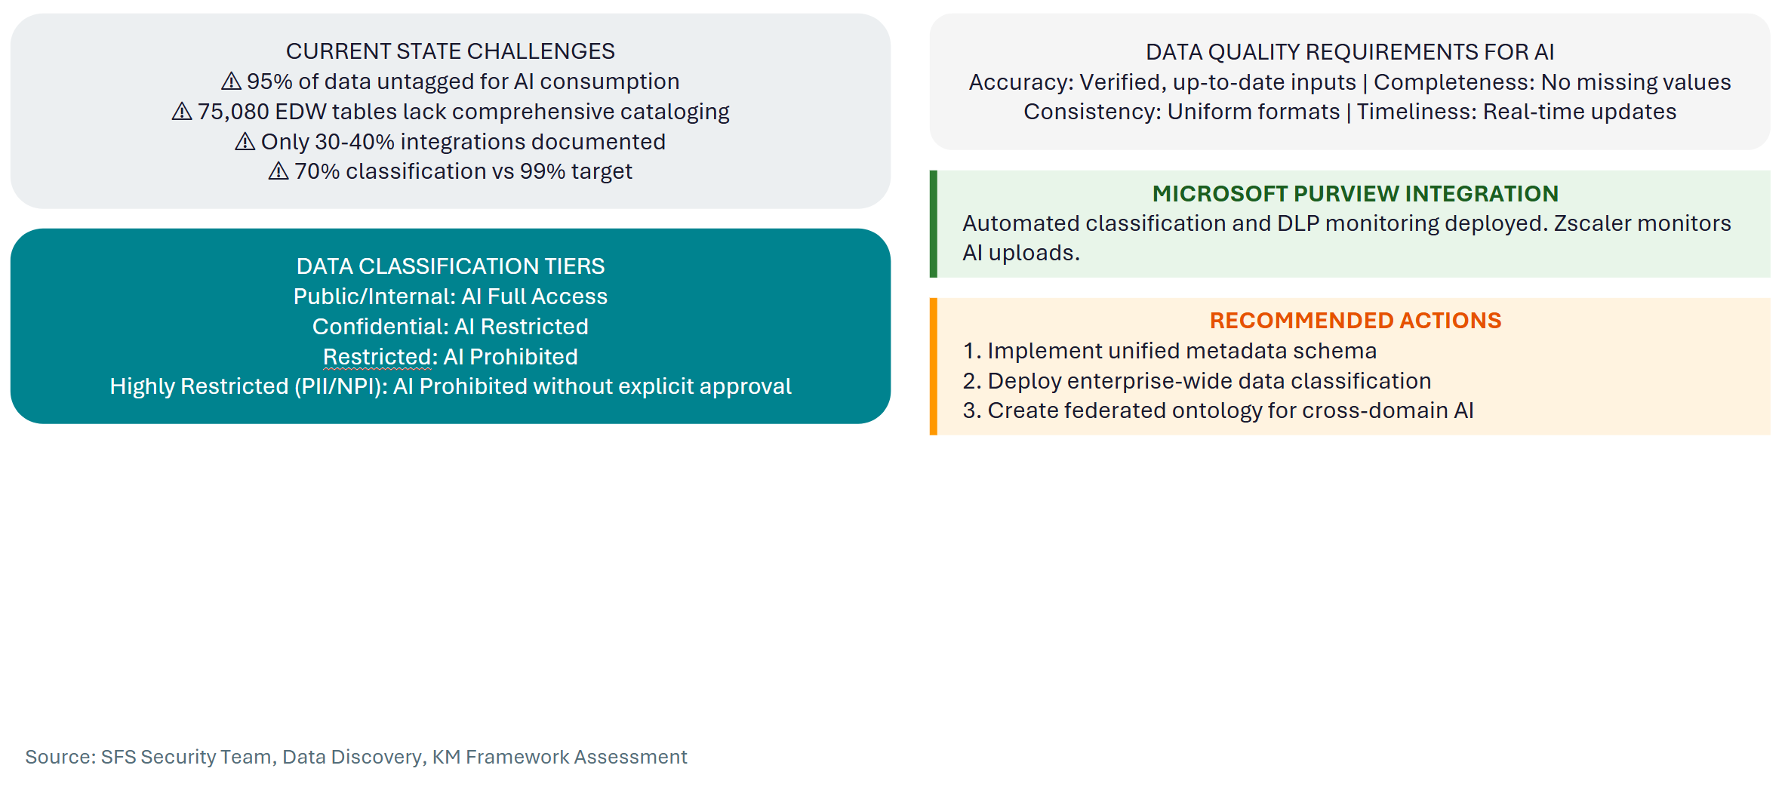

Model Development Lifecycle
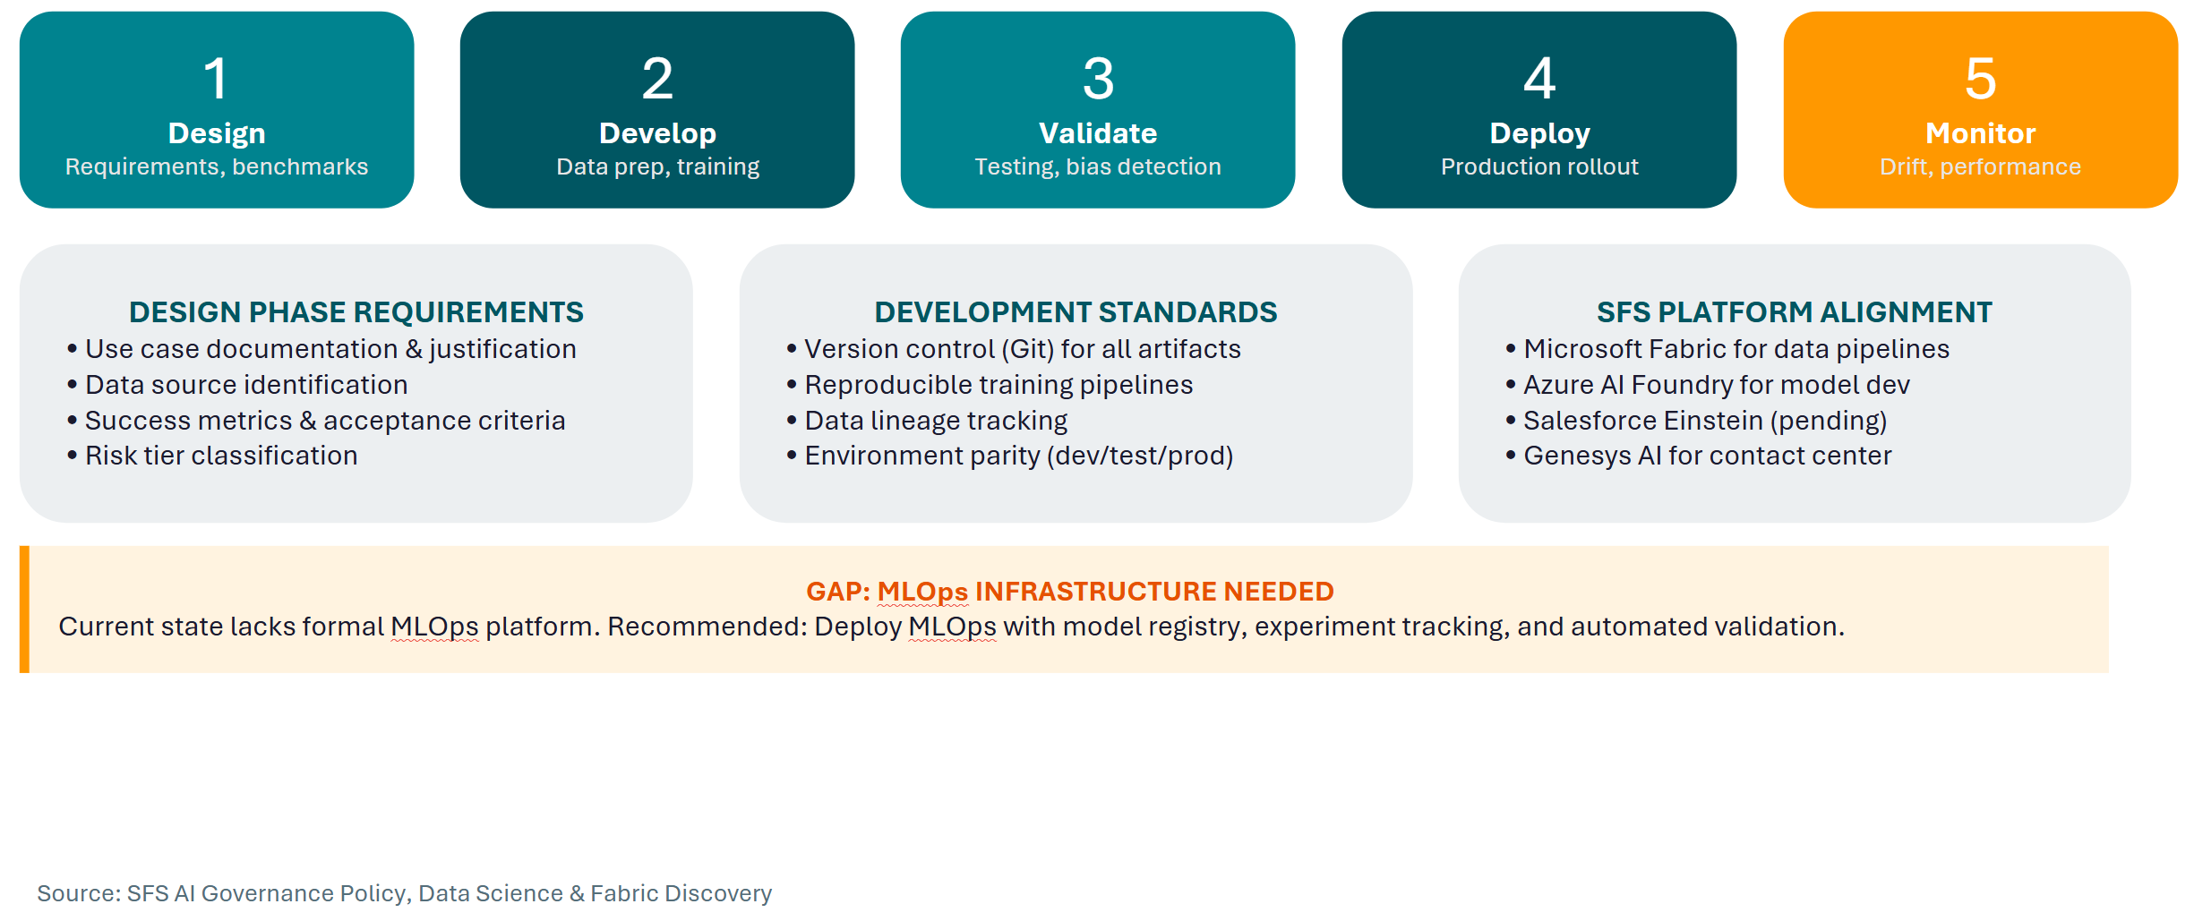

Model Validation, Testing & Inventory
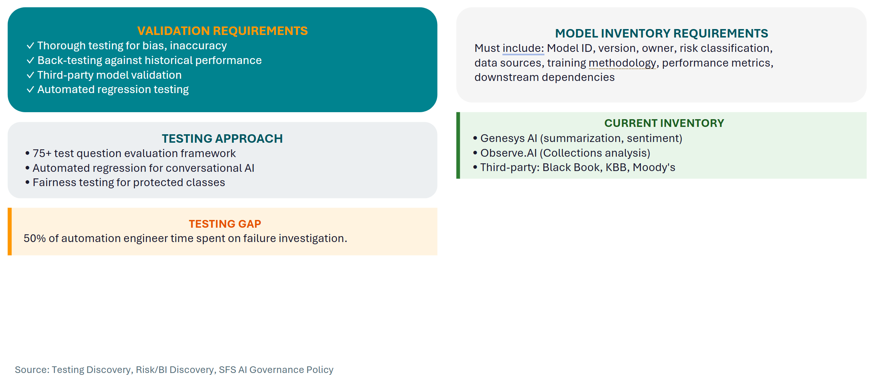

Bias Detection & Explainability
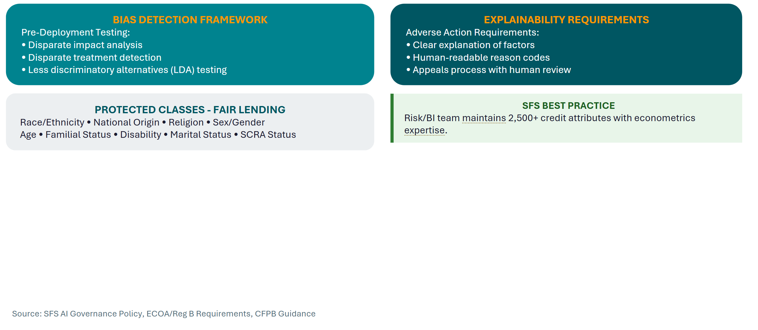

Privacy Protection & Security Controls
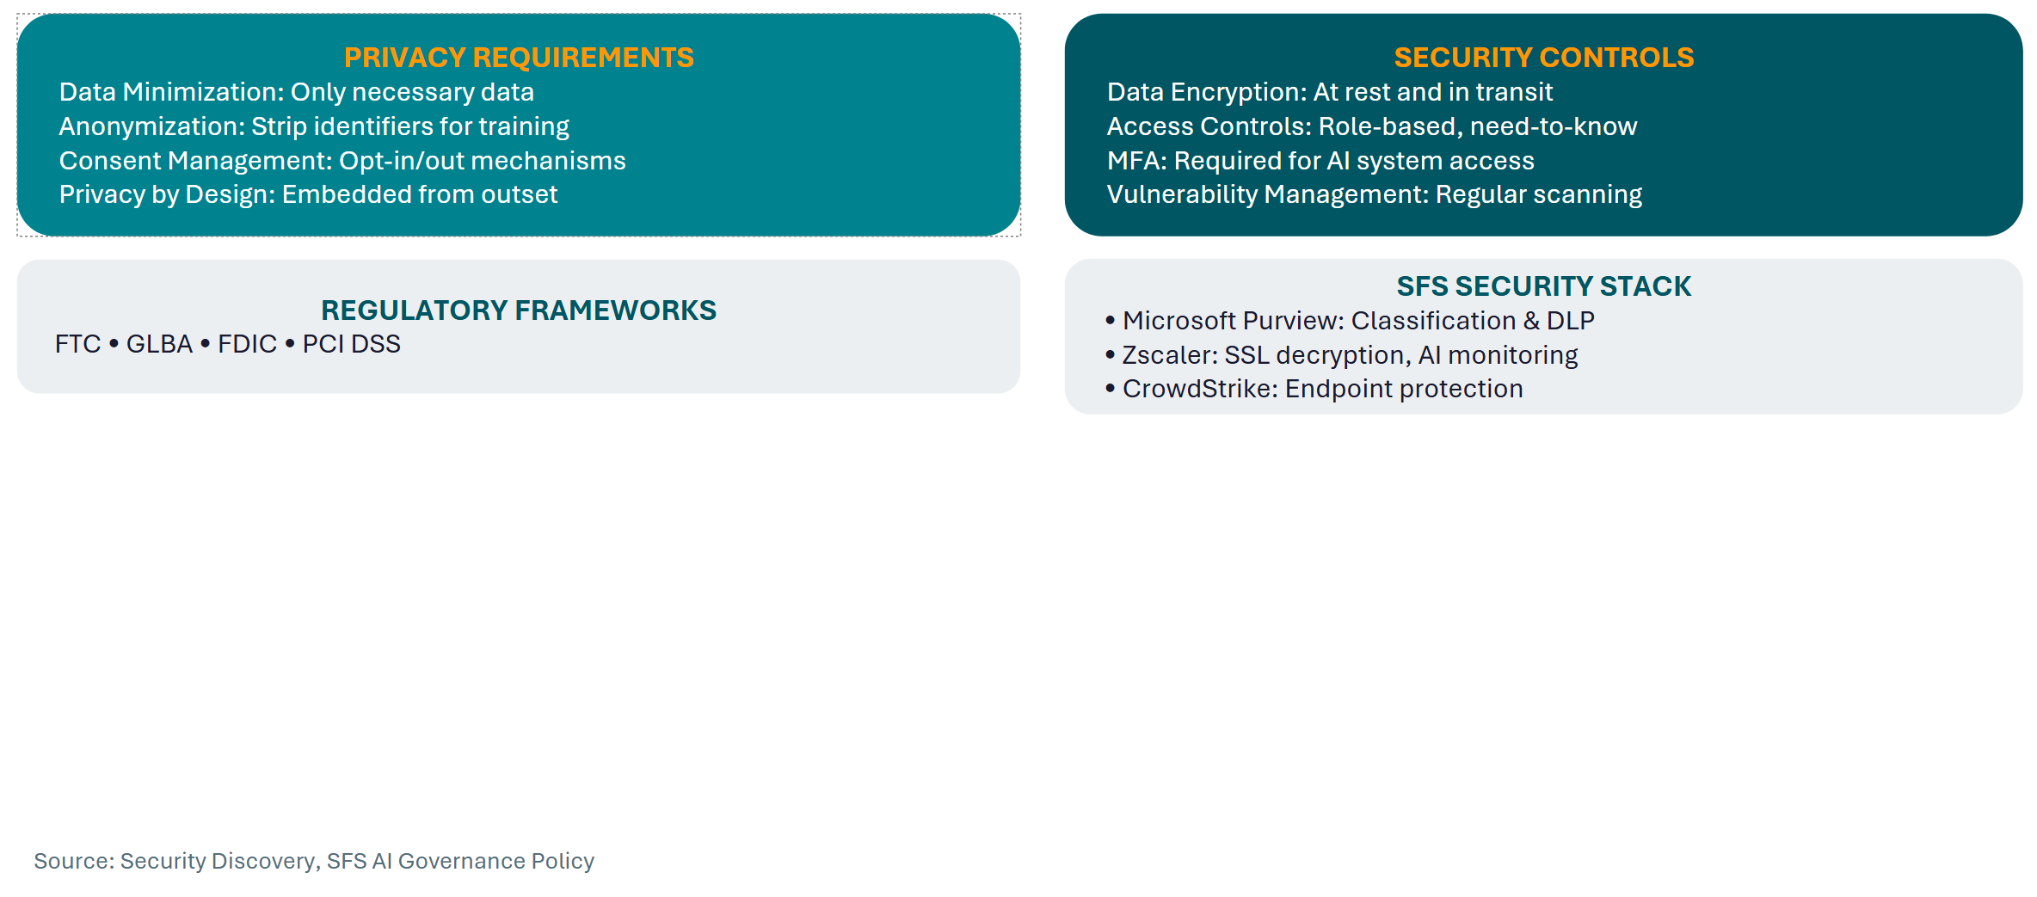

Third-Party AI & Use Case Approval
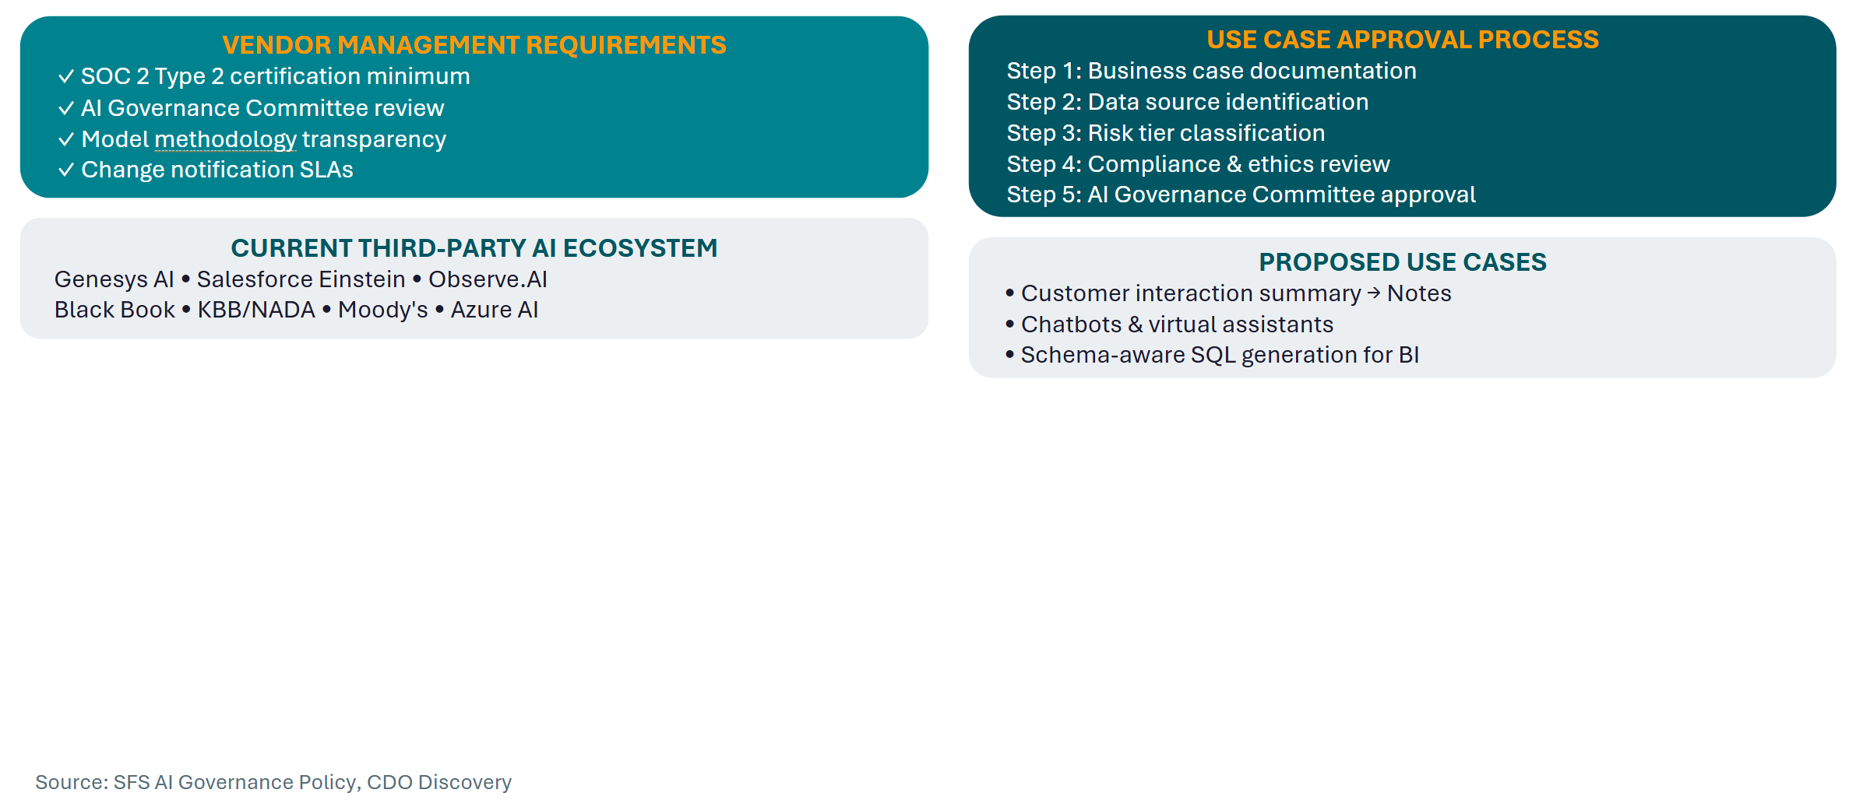

Monitoring & Incident Response
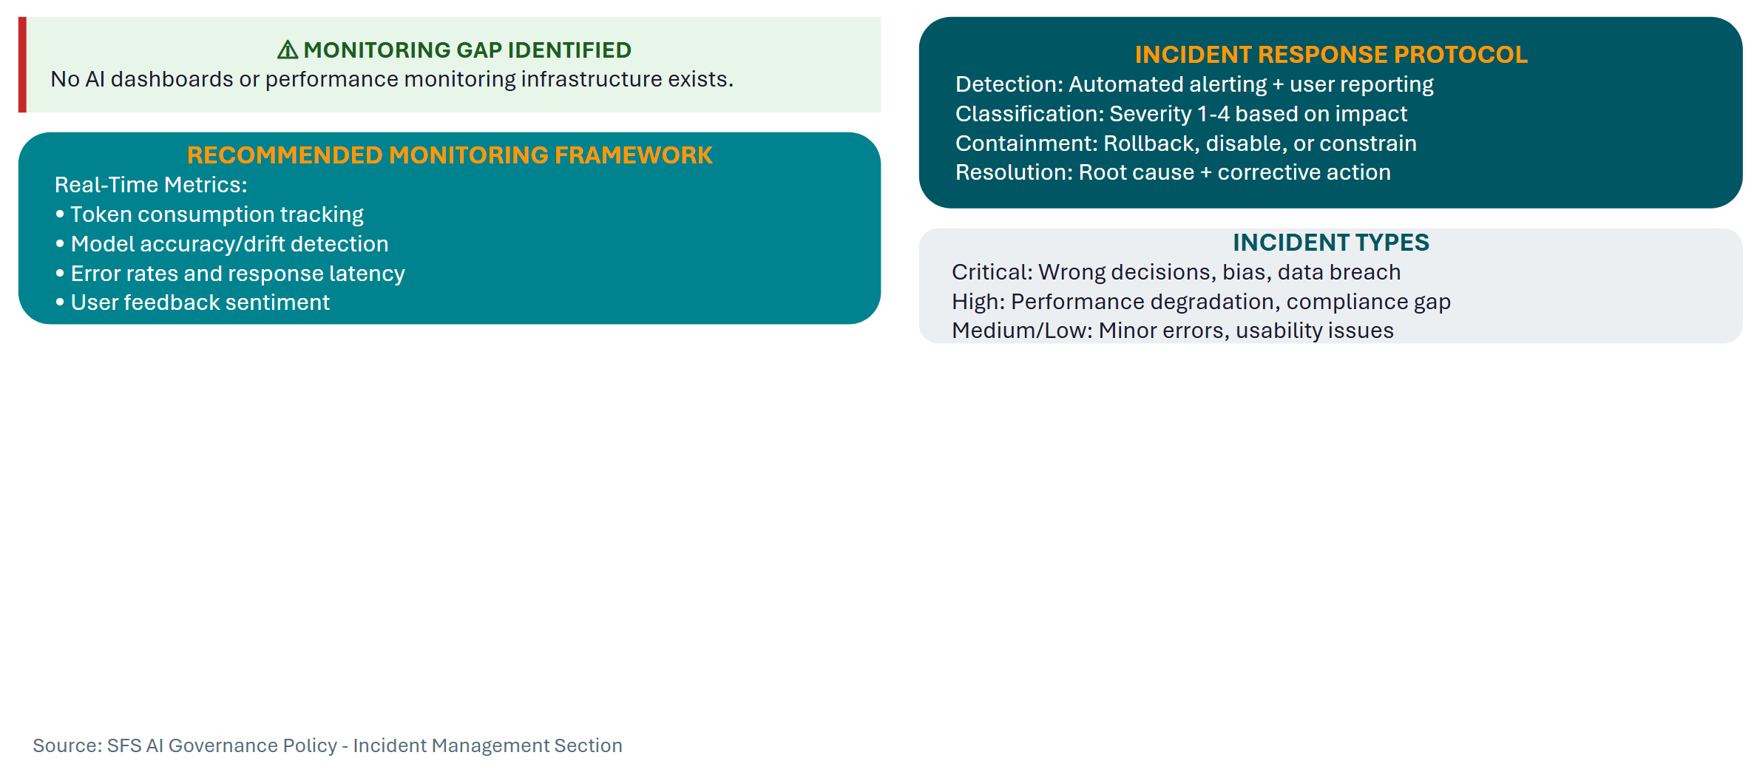

Regulatory Compliance & Change Management
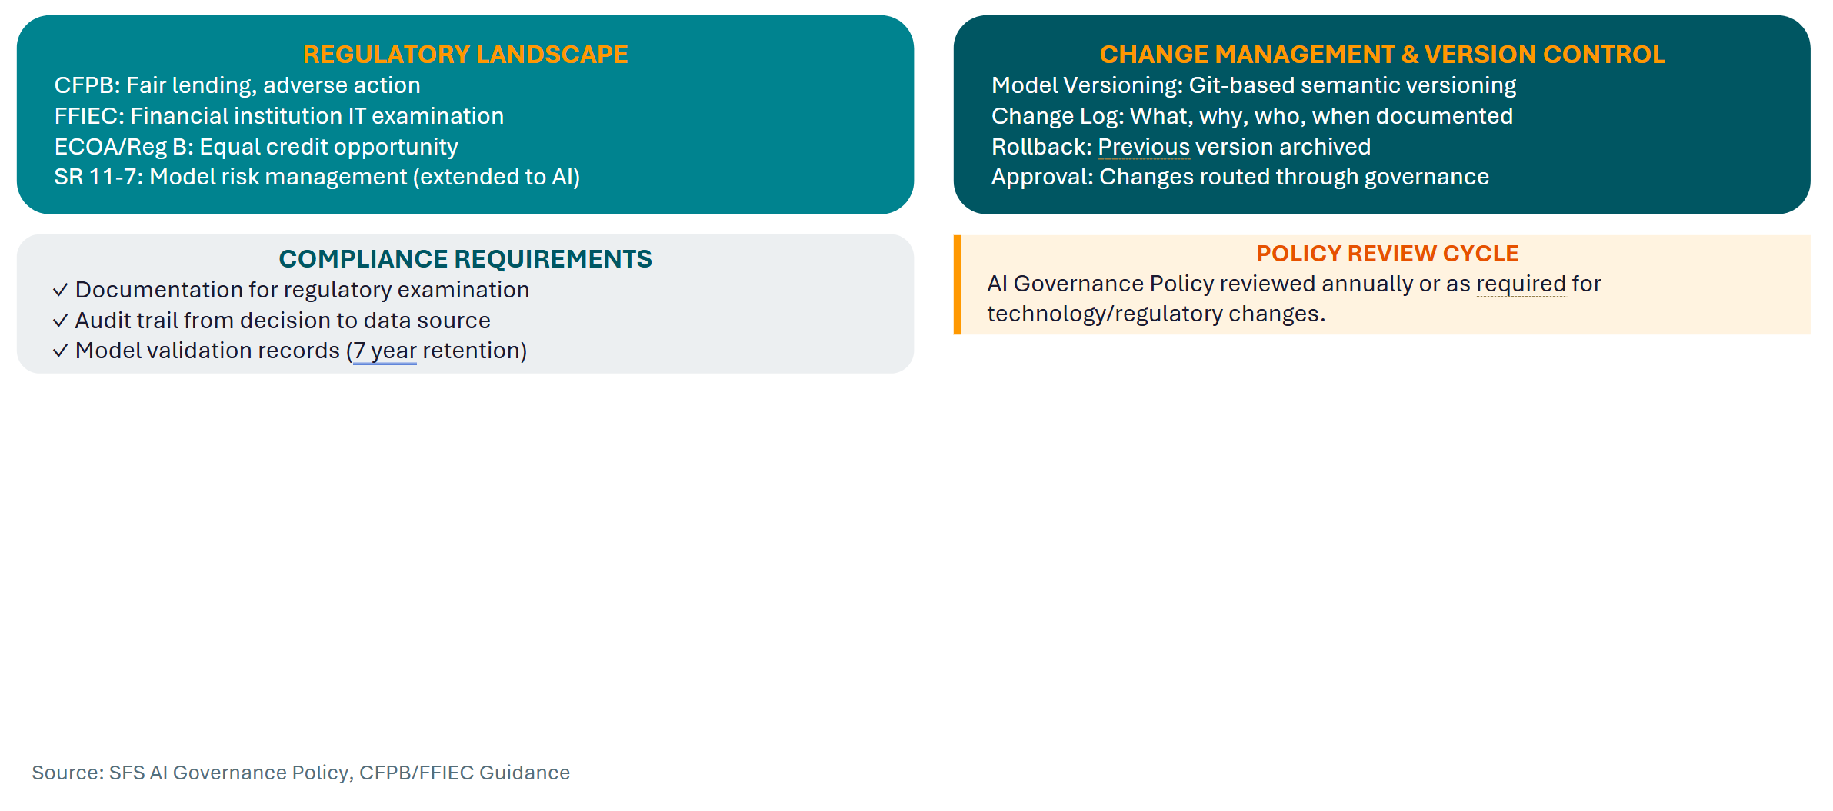

Training, Awareness & Audit
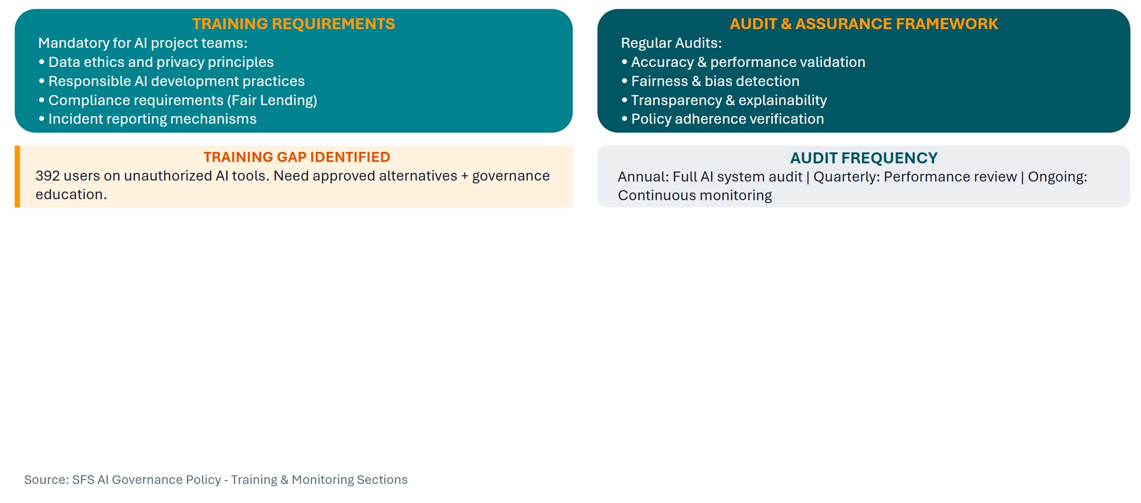

Sustainability, Human Oversight & IP
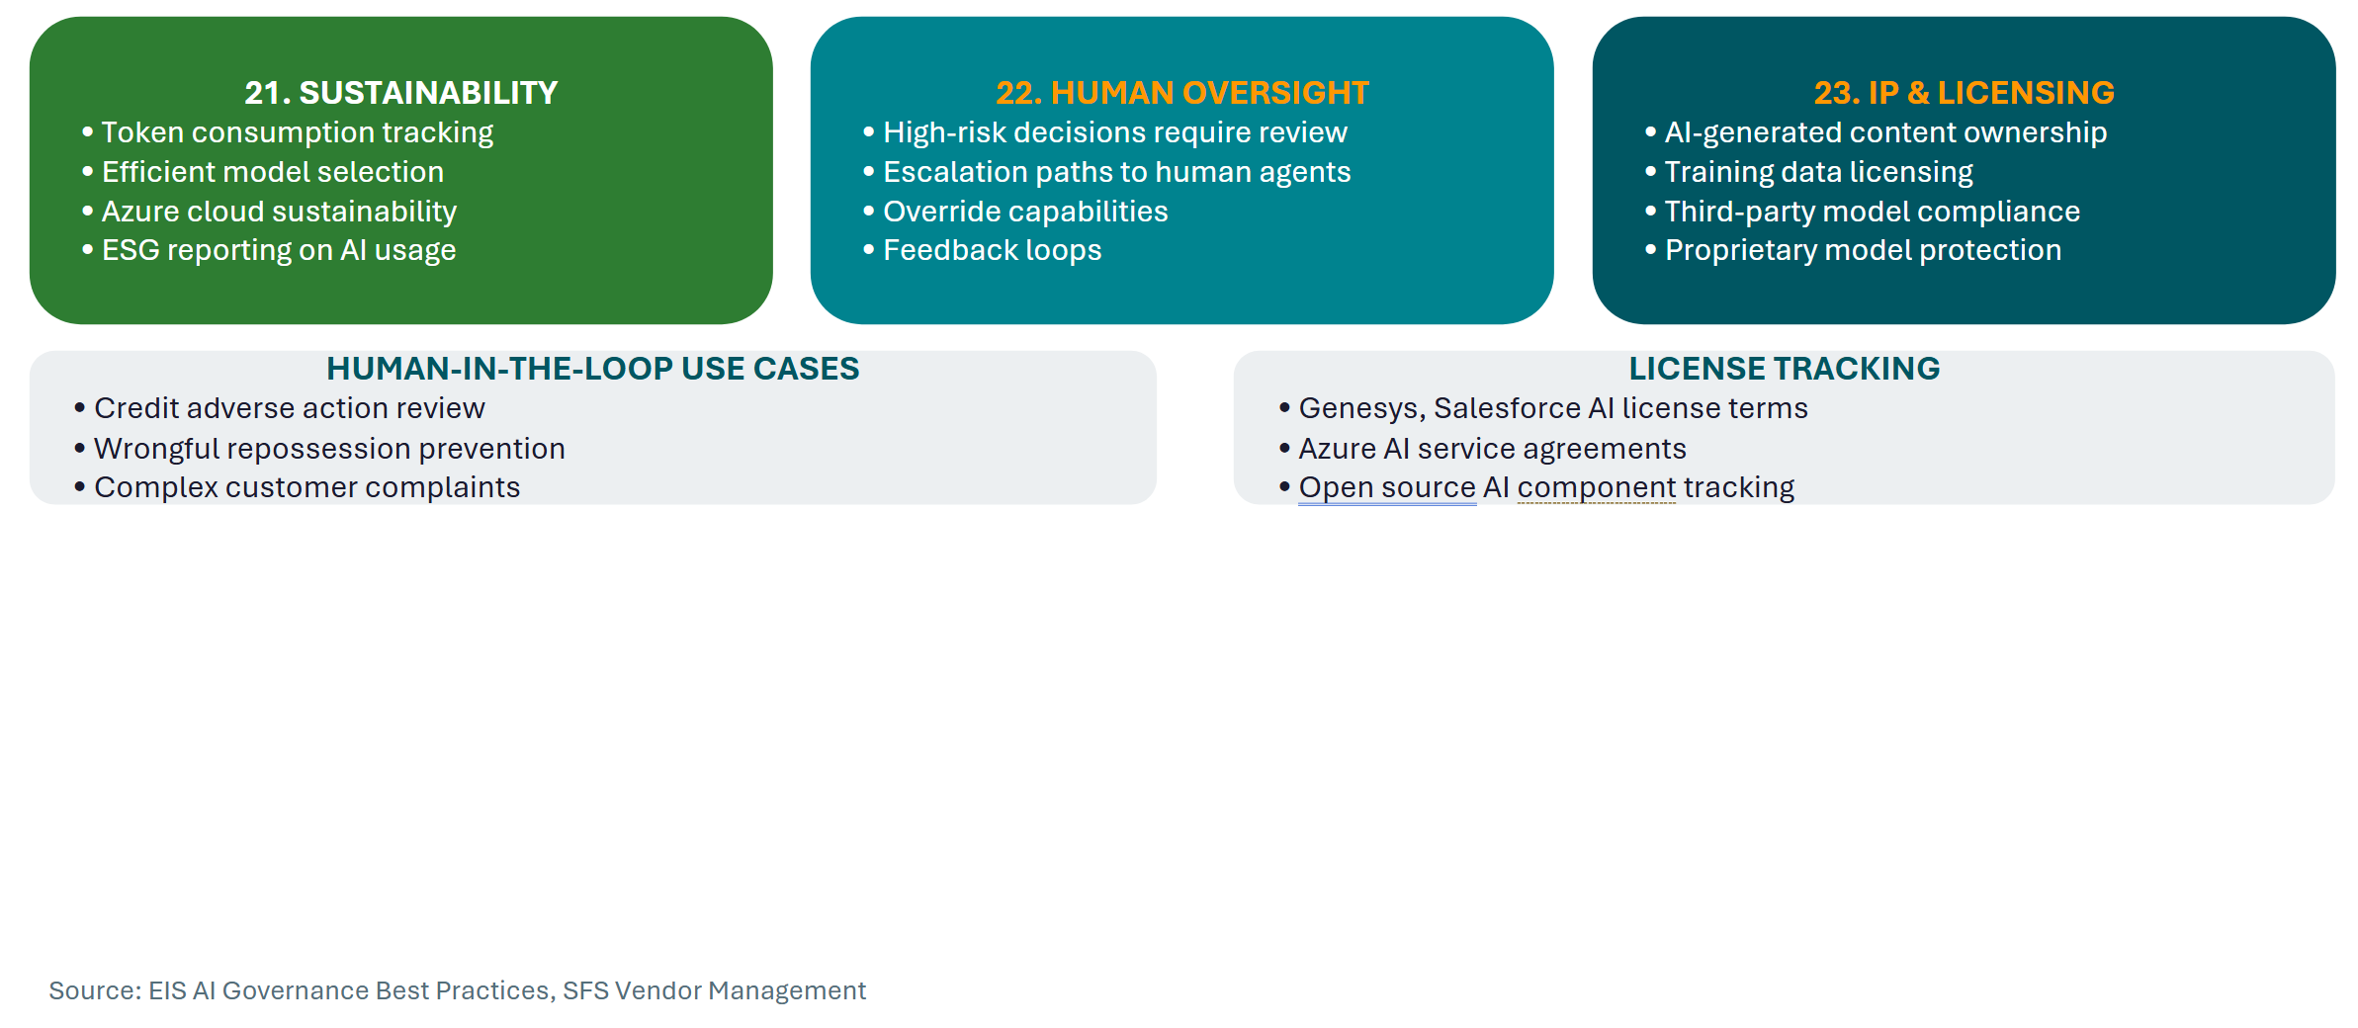

System Retirement & Continuous Improvement
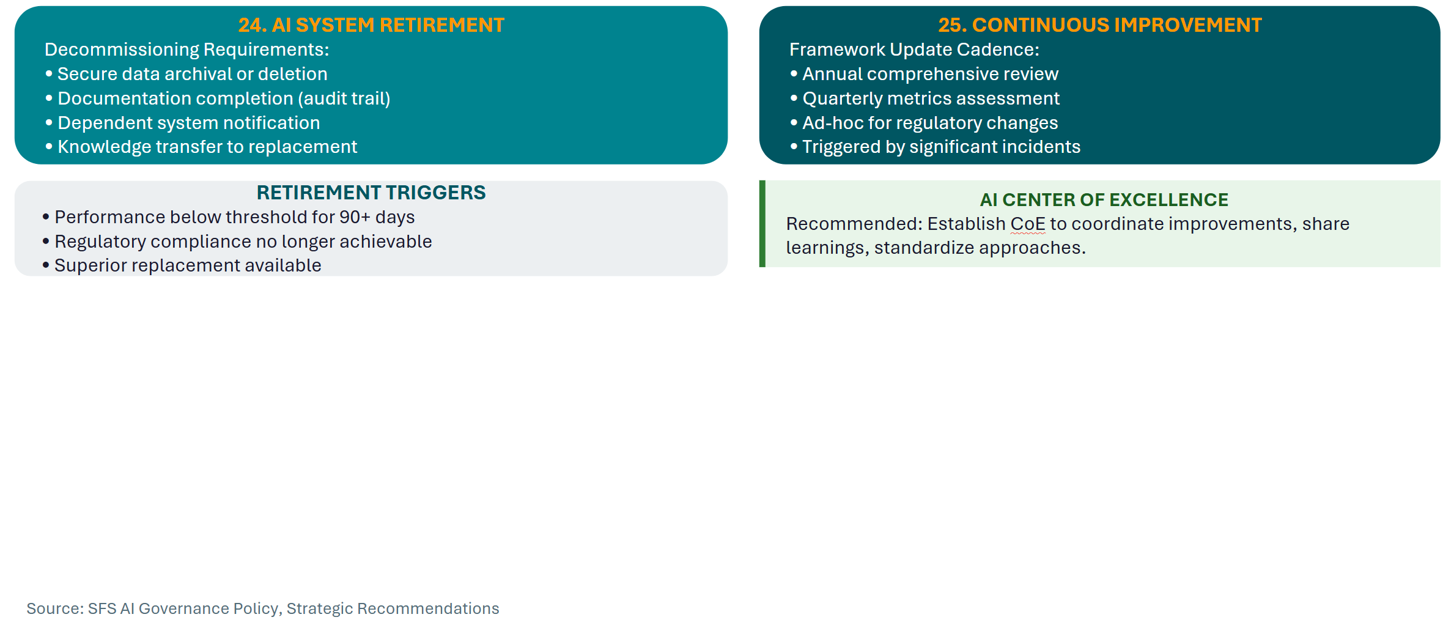

Implementation Roadmap
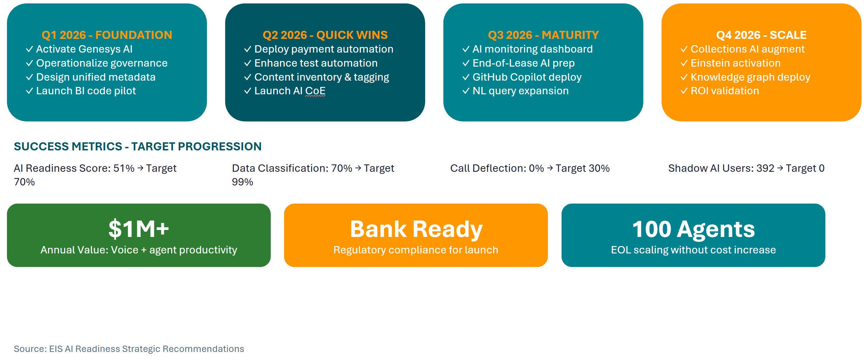

Technical Architecture

API Orchestration Strategy

Executive Summary

Strategic Context
- 18-month migration window (MuleSoft → Azure APIM)
- 65 APIs, hundreds of endpoints to migrate
- Emerging AI/agentic capabilities require governance framework
- Cost attribution critical for sustainable AI adoption

Key Recommendations
- Align orchestration strategy with Azure migration to embed governance and observability from day one
- Implement cost tracking infrastructure for both traditional APIs and AI/token consumption
- Establish patterns for agentic system management before proliferation occurs
- Position MCP as future integration layer for AI agent interoperability

Orchestration Pattern Overview

Available Patterns
- API Gateway: Centralized control plane, policy enforcement, single entry point
- Event-Driven/Pub-Sub: Async communication, decoupling, batch friendly
- Service Mesh: Sidecar pattern for microservices (awareness only)
- Choreography vs. Orchestration: Distributed vs. centralized coordination
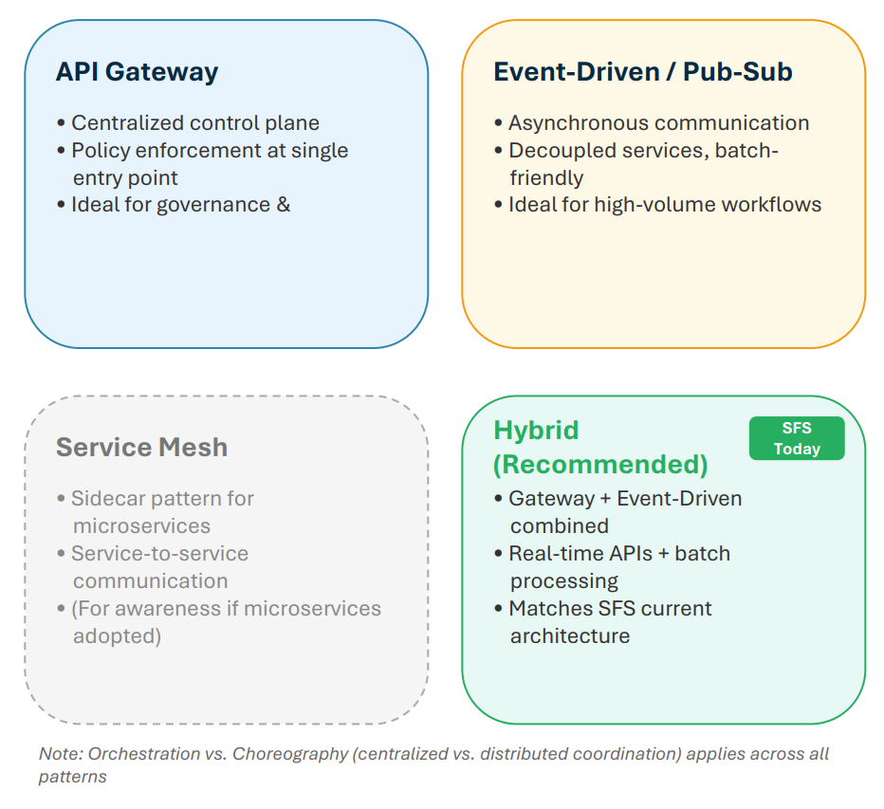

Decision Rubric: Choosing the Right Pattern
SFS Recommendation
- Hybrid (Gateway + Event-Driven) aligns with current architecture and future needs
- Gateway for real-time API management and governance
- Event-Driven for batch processes and Salesforce Platform Events
- Service Mesh: Monitor if microservices adoption increases
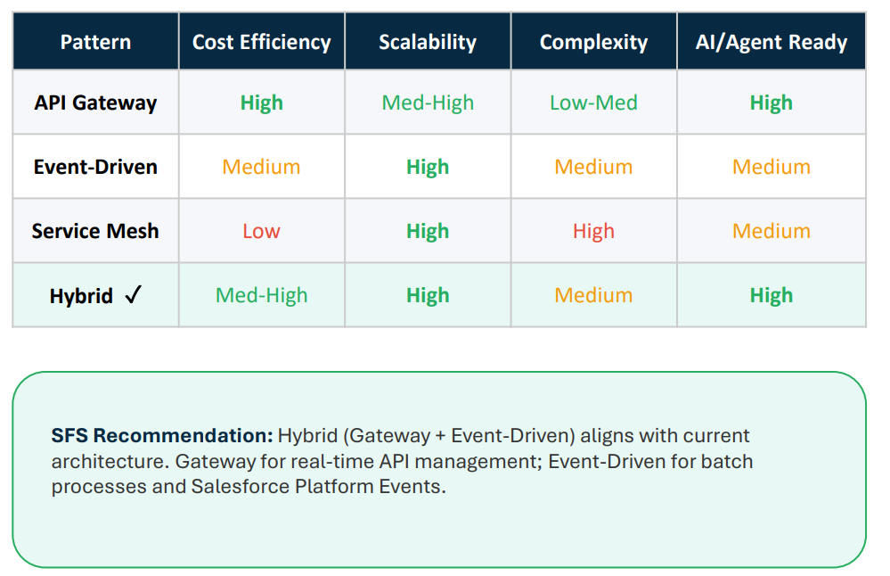

Cost & Scalability Fundamentals
Cost Drivers
- Compute: Request processing, transformation
- Data Transfer: Egress, cross-region movement
- Third-Party APIs: Pass-through costs (FICO, RDN, Datascan, etc.)
- Token/AI Consumption: Emerging and growing cost center
- Storage: Logs, cache, audit trails

Scalability Levers
- Stateless Design: Enable horizontal scaling
- Caching Strategies: Reduce redundant API calls
- Rate Limiting & Throttling: Protect backends, manage costs
- Async/Queue-Based: Absorb batch processing spikes

Azure APIM Capabilities Mapped to SFS Needs
Additional Capabilities
- Developer Portal → API discovery, future agent registry
- Products & Subscriptions → Segment by business unit
- Policy Expressions → Request/response transformation
- Named Values & Backends → Centralized configuration

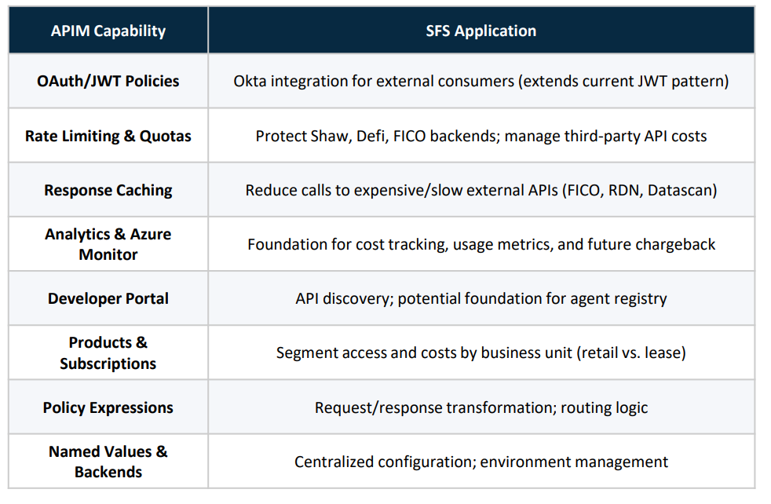

MuleSoft to Azure APIM: Key Considerations
Migration Mapping
- Policies: MuleSoft policies → APIM policy expressions (similar concepts, different syntax)
- API Layers: Experience/Process/System → APIM Products/APIs/Backends
- Authentication: Both support OAuth/JWT; APIM adds native Azure AD
- Monitoring: Anypoint Monitoring → Azure Monitor + App Insights
Lessons from Pilot
- Early investment in Azure platform configuration pays dividends
- DNS, certificates, RBAC setup require upfront planning
- Establish patterns before bulk migration
- Detailed comparison available in Appendix

Process Layer Compute Options

Azure Compute Options for Orchestration Logic
- Azure Functions: Stateless, event-driven, pay-per execution; good for simple transforms
- Durable Functions: Long-running workflows, stateful orchestration, fan-out/fan-in
- Logic Apps: Visual designer, 400+ connectors; per-action pricing can add up
- .NET APIs: Full control, team expertise; you manage hosting
- Container Apps: Containerized workloads, auto-scaling; more infra to manage
Decision Framework
Stateless → Functions | Stateful → Durable Functions | Visual/Connectors → Logic Apps | Full control → .NET

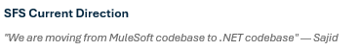
- Process layer logic → .NET APIs hosted in Azure
- APIM as gateway layer (auth, rate limiting, caching)
- Business logic and transforms in .NET code
- Azure Service Bus for reliability patterns
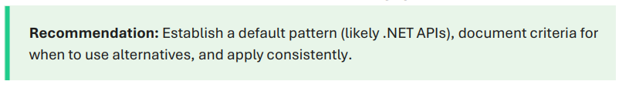

Process Layer Compute Options
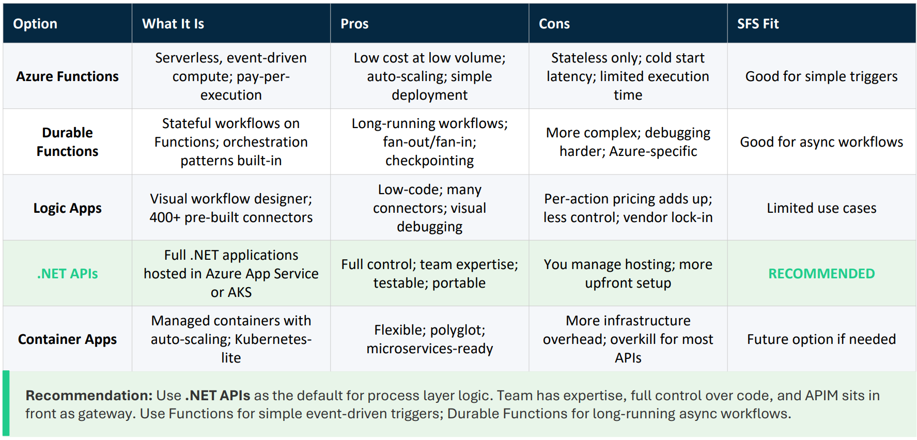

Cost Monitoring

Cost Monitoring Architecture
Monitoring Touchpoints by Layer
- Experience Layer: Consumer attribution (who's calling), use case tagging, business unit mapping
- Process Layer: Orchestration metrics, transformation costs, caching effectiveness
- System Layer: Backend call counts, third-party API costs (FICO, RDN, Datascan), response times
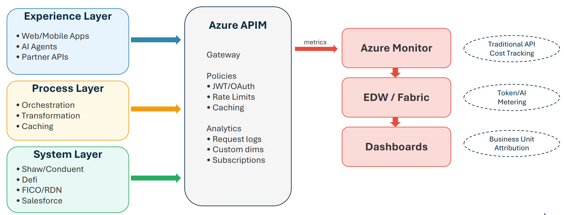

Traditional API Cost Tracking
Key Metrics to Capture
- Request counts by consumer, endpoint, time period
- Response times and latency percentiles (p50, p95, p99)
- Error rates and failure patterns
- Data transfer volumes (egress costs)
- Third-party API call counts and costs
Implementation Approach
- APIM Analytics: Built-in metrics, request logging, subscription tracking
- Azure Monitor: Custom dimensions for business attribution
- Custom Tags: Business unit, cost center, backend system
- Critical: Tag during migration to avoid costly backfill later

AI/Token Tracking Patterns
Three Metering Patterns
- Pattern 1: Gateway Proxy: Route all AI requests through APIM; captures model, tokens, caller, use case; enables rate limiting and cost caps
- Pattern 2: SDK Wrapper: Lightweight wrapper at application level; works for embedded AI like Einstein; less centralized visibility
- Pattern 3: Async Metering: Fire-and-forget to event hub; aggregation in data warehouse; enables near-real-time dashboards
SFS Recommendation
- Primary: Pattern 1 (Gateway Proxy) for centralized AI requests
- Aggregation: Pattern 3 for warehouse-level analytics
- Fallback: Pattern 2 where gateway not feasible (Einstein)
- Note: Genesys uses token-based consumption model - align tracking

AI/Token Tracking Patterns
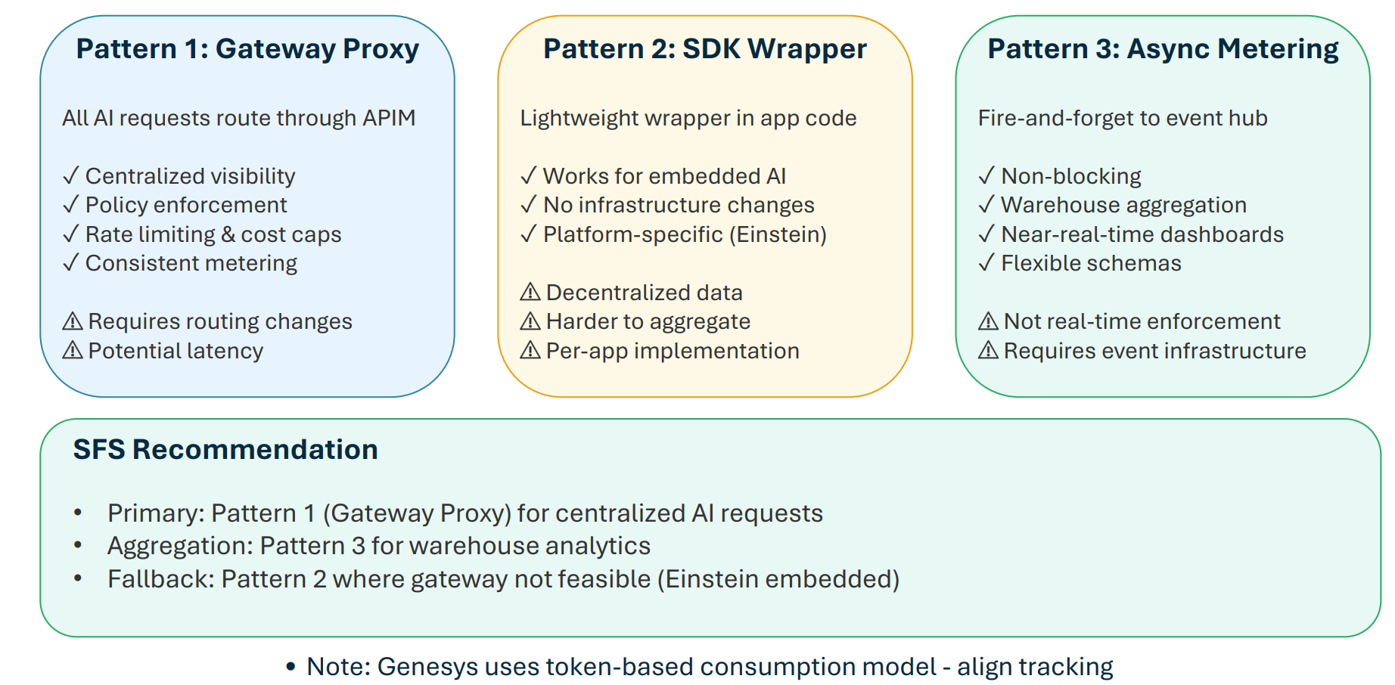

Chargeback Foundation
Building Blocks for Cost Allocation
- Consumer Identification: Map requests to business units (retail vs. lease), cost centers, applications
- Service Categorization: Distinguish AI/token costs from traditional API costs
- Usage Aggregation: Roll up to meaningful reporting periods and dimensions
- Cost Allocation Model: Direct attribution vs. shared services allocation
Design Principle
- Capture granular data now, decide allocation model later
- SF already segments costs by call center and tracks third-party APIs (Google services)
- Token costs may double or triple as AI subsidies end - track for ROI validation
- Business units should demonstrate ROI to fund AI capabilities

Agentic Management

The Agentic AI Management Challenge
Emerging Requirements
- Discovery: How do consumers find available AI agents and capabilities?
- Registration: How are new agents onboarded with appropriate metadata?
- Authorization: Who can invoke which agents with what data access?
- Observability: How do we monitor agent behavior, costs, and outcomes?
- Governance: How do we ensure compliance and audit trail?
Parallels to API Management Evolution
- API management matured from ad-hoc to governed over 10+ years
- Agentic systems face similar lifecycle: discovery → registration → governance
- Opportunity: Apply API lessons proactively before proliferation
- Scope: Primarily AI agents, but patterns apply to RPA (UiPath) and business rules engines

Decision Engines in the Agentic Landscape
SFS Decision Engines
- FICO Decision Modeler: Credit decisioning, collections strategies
- Remarketing Decision Engine: Pricing optimization, channel routing, business rules (FICO platform)
- Future: Pricing optimization, termination models, reconditioning decisions
Special Considerations
- Not quite APIs, not quite AI agents - deterministic rule/model-based systems
- May need special treatment: latency-sensitive, highstakes, strict versioning/audit
- Can be 'tools' that AI agents invoke via API layer

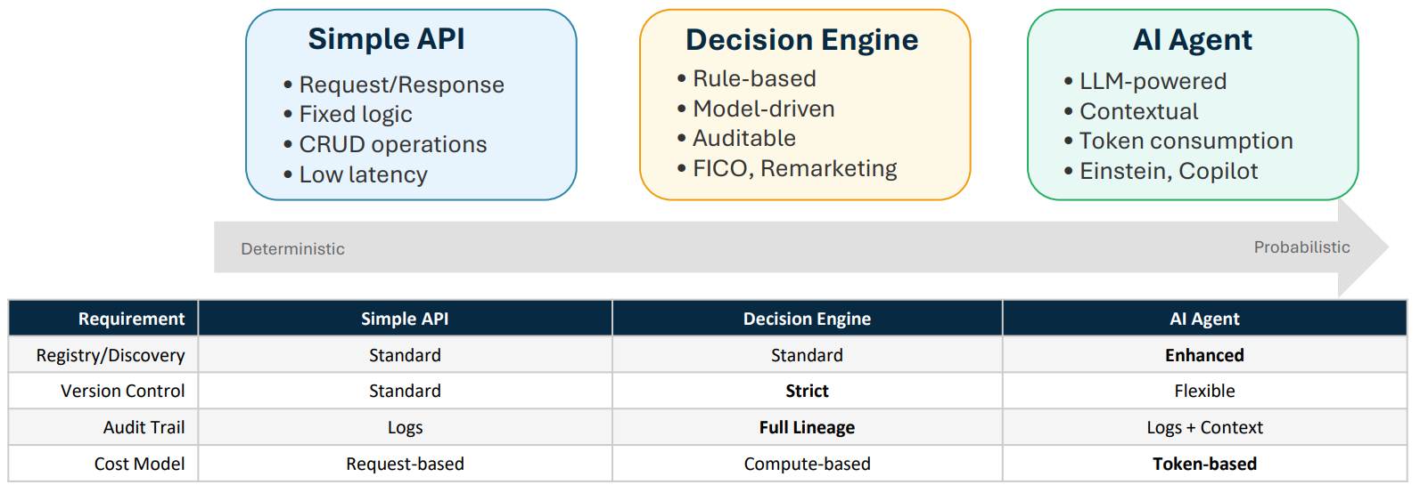

Agent Registry Patterns
Registry Metadata
- Identity: Name, description, owner, version
- Capabilities: What can this agent do? Input/output schemas
- Cost Profile: Expected token consumption, compute costs
- Compliance: Data access classification, PII handling, audit requirements
- Status: Active, deprecated, testing, approved platforms

Implementation Options
- Option 1: Extend APIM Developer Portal catalog (low effort, near-term)
- Option 2: Dedicated registry service (richer features, medium-term)
- Option 3: MCP-native discovery (if MCP adopted)
- Recommendation: Start manual/extended APIM during pilots; evaluate dedicated registry as scale grows

Agent Orchestration Patterns
Three Orchestration Models
- Centralized Orchestrator: Single conductor coordinates all agents; easier monitoring/audit; potential bottleneck
- Federated/Peer-to-Peer: Agents communicate directly; flexible and scalable; harder to govern
- Domain Orchestrators + Light Coordination: Domainspecific orchestrators with thin cross-domain layer
SFS Recommendation
- Pattern 3 (Domain Orchestrators) aligns with SFS direction
- Domain examples: Compliance, Customer Service, Remarketing, Collections
- Supports “specialized bots for compliance” approach already discussed
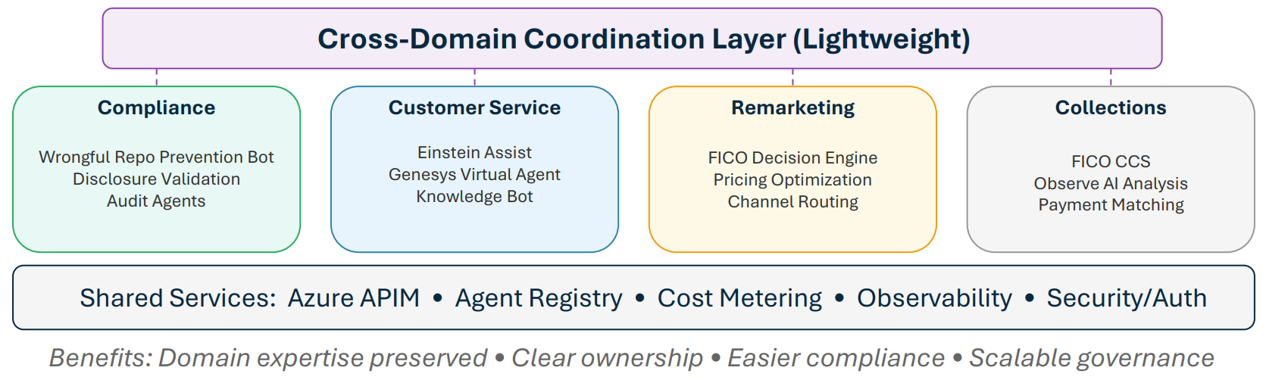

Architecture: Without MCP
Key Components
- AI Platforms: Einstein, Azure AI, Genesys
- Gateway: Azure APIM with policies, analytics, developer portal
- Backends: Shaw, Defi, FICO, Salesforce, EDW
- Observability: Azure Monitor → Fabric/EDW → Dashboards

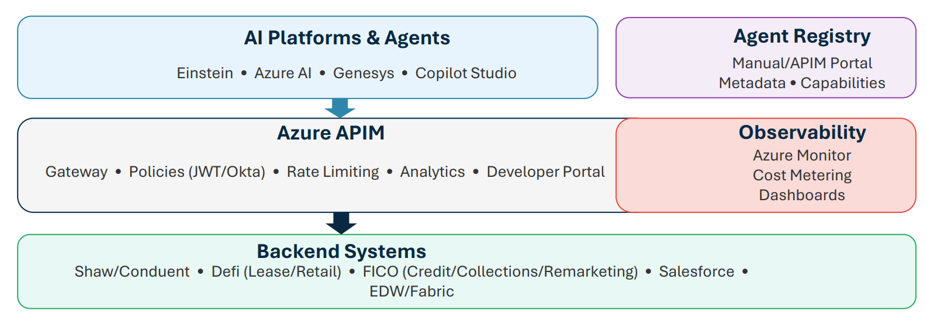

Architecture: With MCP
MCP Value Proposition
- Multiple AI platforms (Einstein, Azure AI, Genesys) → fragmentation risk
- MCP provides common protocol layer for tool discovery and invocation
- Incremental deployment possible - doesn't require big-bang adoption
- Detailed MCP coverage in Section 5

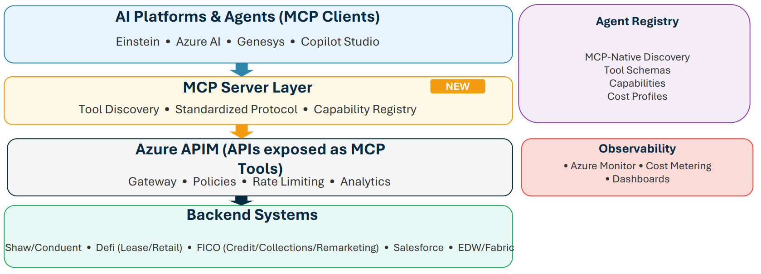

SFS Recommendations
Phased Implementation Roadmap

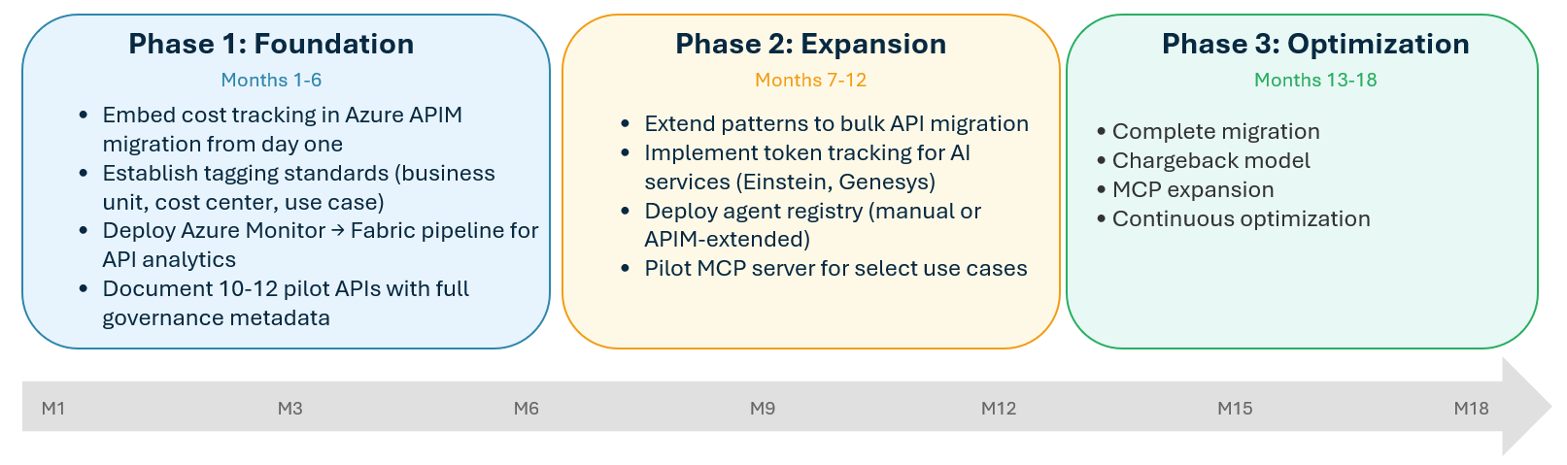
Key Milestones
- M3: Pilot APIs complete
- M6: Patterns documented
- M12: 50% APIs migrated
- M18: Migration complete (before MuleSoft license expiry )

Integration with Azure Migration
Leverage Migration Momentum
- MuleSoft → Azure APIM migration is the forcing function for governance
- Each migrated API is an opportunity to add: cost tags, policies, observability hooks
- Establish patterns with pilot 10-12 APIs, then scale
- Target: 18-month completion (buffer before MuleSoft license expiry)

Avoid Retrofit Costs
- Retrofit cost tracking after migration = 3-5x more expensive
- Lessons from pilot: DNS, certificates, RBAC require upfront investment
- Build governance into migration checklist, not as afterthought
- Document patterns for EA team to validate and replicate

Platform Readiness Checklist

Prerequisites (from Pilot Lessons)
- DNS: Routes configured; coordination with Stellantis/Europe complete
- Certificates: Automated renewal in place for all environments
- RBAC: Roles defined for API developers, DevOps, service accounts
- Network: Connectivity verified to all backends (Shaw, Defi, FICO, SF)
- CI/CD: Pipeline templates tested with initial APIs
- Monitoring: Azure Monitor → Fabric pipeline operational
- Environments: Dev/QA/UAT/Prod APIM instances provisioned Note: Pilot revealed DNS (3-4 week delay), RBAC, and certificate automation as key infrastructure gaps to address upfront.
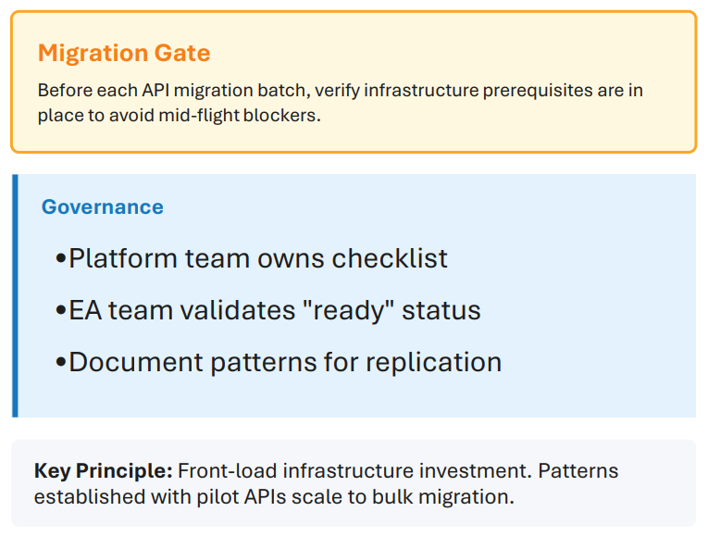
Quick Win Opportunities
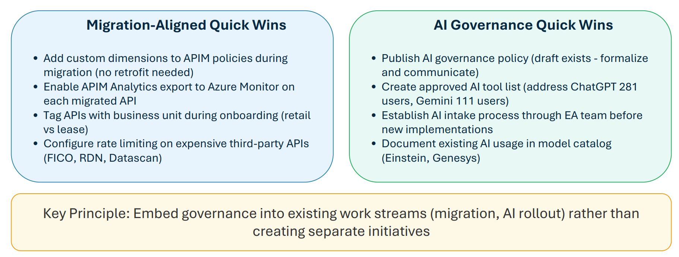

Governance Framework Principles
Governance Model
- EA team as approval gate for new AI implementations (Vik, Larry, Puru)
- Domain-specific AI/agents owned by business but governed centrally
- Specialized bots for compliance-critical operations (e.g., wrongful repo prevention)
- All new AI deployments require: cost projection, ROI case, data access review
Key Stakeholders
- Larry Burgess: Infrastructure, Genesys SOW, platform decisions
- Vik Chopra: Enterprise Architecture, AI governance,
- Puru Naktode: AI architecture, reference patterns
- Nader Afshar: AI Product Owner (new role - needs EA integration)

MCP Deep Dive

What is MCP?
Model Context Protocol Overview
- Open standard for connecting AI models to external data and tools
- Developed by Anthropic, adopted by growing ecosystem
- Standardizes how AI agents discover and invoke capabilities
- Analogous to how USB standardized peripheral connections
Why It Matters for SFS
- Multiple AI platforms (Einstein, Azure AI, Genesys) = fragmentation risk
- Without standard: each platform requires custom integration
- With MCP: unified protocol for tool discovery and invocation
- Future-proofs against AI platform changes

MCP Architecture Concepts
Core Components
- MCP Server: Exposes capabilities (tools, resources, prompts) via standard protocol
- MCP Client: AI application that discovers and invokes server capabilities
- Tools: Functions the AI can call (e.g., 'get_customer_info', 'submit_payment')
- Resources: Data the AI can access (documents, databases, APIs)

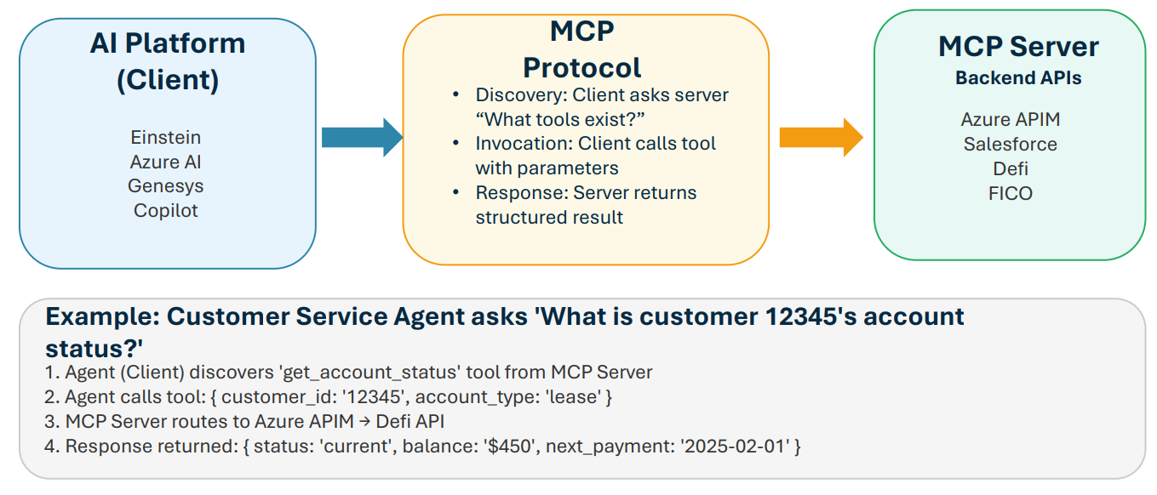

MCP Server Implementation Options
Option A: Gateway-Level MCP
- MCP Server sits in front of Azure APIM
- Automatically exposes all APIM APIs as MCP tools
- Centralized: one MCP server, many tools
- Pro: Single point of governance
- Con: May be bottleneck
Option B: Domain-Level MCP
- Multiple MCP servers per domain (Compliance, Collections, etc.)
- Each domain team owns their MCP server
- Pro: Distributed ownership, domain expertise; Con: Coordination overhead
- Aligns with Domain Orchestrator pattern recommended for SFS

Mapping SFS APIs to MCP Tools
High-Value MCP Tool Candidates
- Customer lookup (Salesforce customer master)
- Account status check (Defi lease/retail)
- Payment processing (Shaw/Conduent)
- Credit decision (FICO Decision Modeler)
- Vehicle valuation (remarketing decision engine)

Tool Schema Example
- Name: 'get_customer_account_status'
- Description: 'Retrieve current status of customer account'
- Input: { customer_id: string, account_type: 'lease' | 'retail' }
- Output: { status, balance, next_payment_date, ... }

MCP Implementation Considerations
Adoption Considerations
- MCP is emerging - not yet universally supported by all AI platforms
- Einstein, Azure AI have native tool-calling; MCP adds interop layer
- Start with pilot: one domain, one MCP server, evaluate friction
- MCP doesn't replace API - still need APIM policies, auth
SFS Recommendation
- Position MCP as strategic direction, not immediate requirement
- Design APIs to be 'MCP-ready' (clear schemas, consistent patterns)
- Pilot in 2025 with single domain (e.g., Customer Service)
- Re-evaluate as ecosystem matures and AI platform support grows

Non-MCP Alternatives
Platform-Native Tool Calling
- Azure AI: Function calling with JSON schemas
- Einstein: Apex actions, Flow invocations
- Genesys: Bot flows, data actions
- Pro: Native, supported; Con: Platformspecific, no interop

API-First Without MCP
- Well-documented APIs in APIM Developer Portal
- OpenAPI/Swagger specs as tool definitions
- Manual integration per AI platform
- Viable near-term; MCP becomes value-add if multi-platform AI grows

MCP Security
MCP: Increases Audit Surface, Not Attack Surface
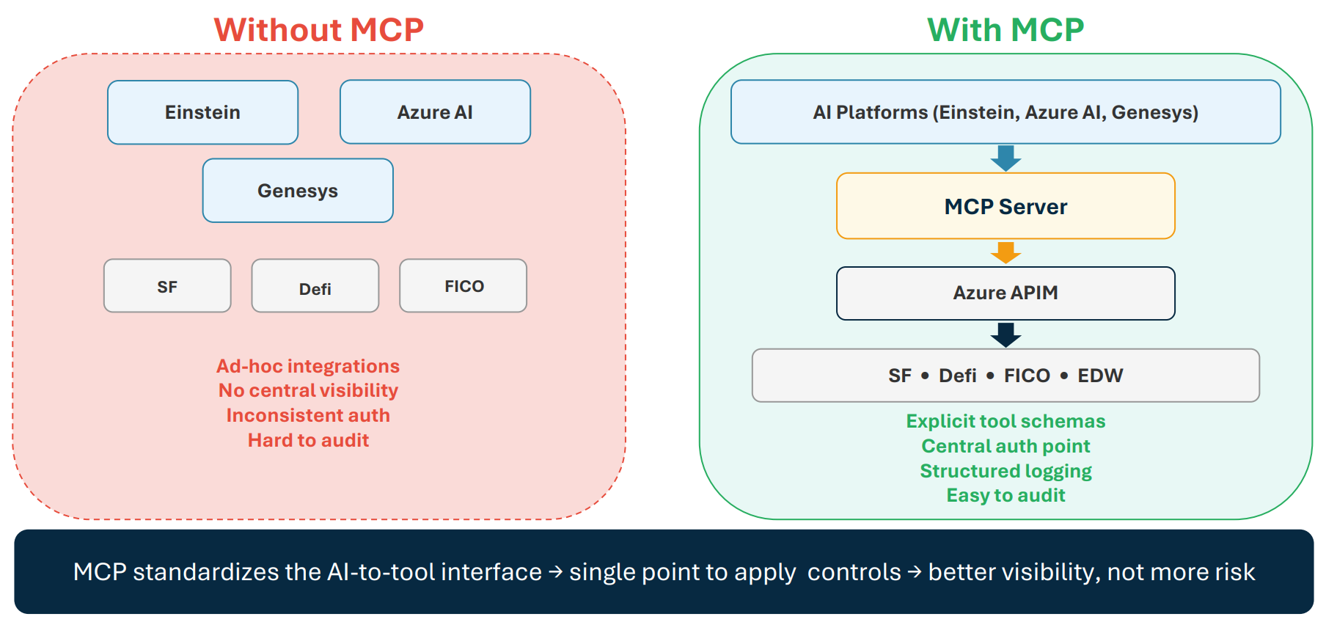

MCP Security Considerations

Risk Categories
- Over-permissioned tools: AI granted excessive backend access
- Authorization gaps: Inconsistent auth across AI-to-API calls
- Prompt injection via tools: Malicious content manipulates AI behavior
- Audit trail complexity: Multi-hop calls harder to trace
- Cost/rate runaway: AI makes excessive calls quickly

Why MCP Helps (Not Hurts)
- Permissions become explicit via tool schemas - easier to audit than ad-hoc integrations
- Centralizes integration point - apply auth once at MCP server, not per-integration
- Same risk exists in any AI tool-calling; MCP standardizes where to apply validation
- Structured tool invocations with defined schemas - more auditable than unstructured calls
- Single place to enforce rate limits and quotas Thesis: MCP increases audit surface, not attack surface

Thesis: MCP increases audit surface, not attack surface

SFS Security Mitigation Approach
Leverage Existing Controls
- Azure APIM policies still apply - MCP sits behind gateway
- Okta/JWT auth unchanged - MCP inherits API authentication
- Azure Monitor captures all calls - add MCPlayer context
- Rate limiting at gateway - apply AI-specific tiers
- RBAC in Azure - extend to MCP server deployments

Add MCP-Specific Guardrails
- Tool allowlists per AI agent (principle of least privilege)
- Human-in-the-loop for sensitive operations (payments, repo actions)
- Version pinning for MCP server dependencies
- Internal-only MCP servers (no third-party MCP)
- Explicit tool schema review before deployment Key principle: MCP is an additional visibility layer that plugs into existing controls

Key principle: MCP is an additional visibility layer that plugs into existing controls

SFS Security Controls: MCP Fits Your Existing Model
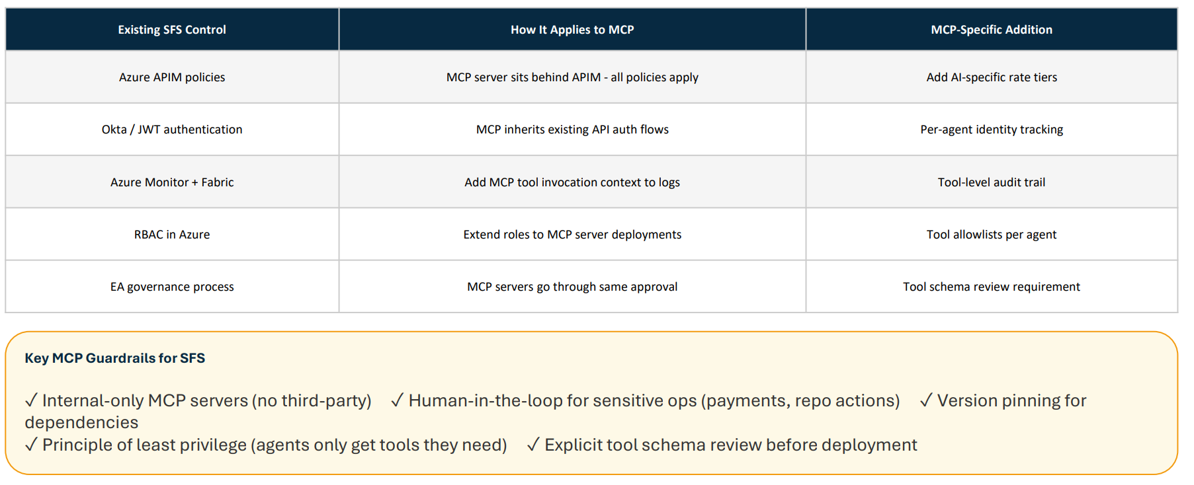

Appendix

Appendix A: Glossary
Orchestration Terms
- API Gateway: Centralized entry point for API traffic with policy enforcement
- APIM: Azure API Management - Microsoft's API gateway and management platform
- MCP: Model Context Protocol - standard for AI-to-tool communication
- Orchestration: Centralized coordination of service interactions
- Choreography: Distributed coordination where services react to events
AI/Agent Terms
- Agentic AI: AI systems that can take autonomous actions toward goals
- Token: Unit of text processed by LLMs (roughly 4 characters)
- Decision Engine: Rule/model-based system for automated decisions (e.g., FICO)
- RAG: Retrieval-Augmented Generation - combining search with LLMs

Appendix B: MuleSoft to Azure APIM Comparison
Migration Lessons
- DNS configuration required European coordination (3-4 week delay)
- Certificate management: automated renewal added during fix
- RBAC roles needed to be created before migration could proceed
- 7-8 endpoints migrated in 7-8 months; patterns now established

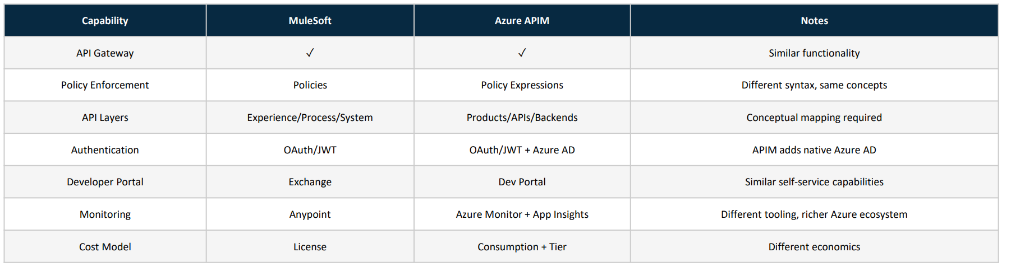

Agent Lifecycle Management Approach

Executive Summary

Purpose
Provide SFS with a comprehensive framework for managing AI agents from ideation through decommissioning — across Azure, Genesys, and Salesforce platforms.
Key Recommendation
Adopt a platform-agnostic lifecycle approach with unified governance principles, while leveraging MCP/A2A as the emerging interoperability standard.
Why Now
Industry data shows 80% of organizations have encountered risky AI agent behaviors, and 40%+ of agentic AI projects are predicted to fail by 2027.
Foundation
This framework builds on SFS's existing AI Governance Policy v1.0, addressing operational gaps while preserving established accountability structures.

Why Agent Lifecycle Management Matters
Industry Statistics
- 80% of organizations have encountered risky behaviors from AI agents Source: McKinsey, Oct 2025
- 40%+ of agentic AI projects will be canceled by 2027 Source: Gartner, June 2025
- Only 25-36% of organizations have formal AI governance frameworks Source: AuditBoard/Pacific AI, 2025
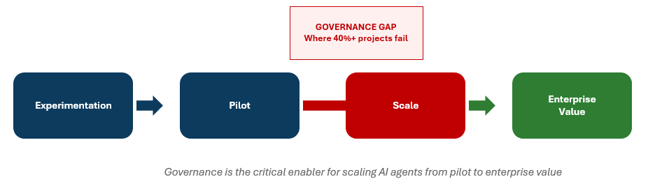

What is an "Agent" at SFS?
Scope Definition
For lifecycle purposes, an "agent" includes any AI-powered system that:
- Interacts with users (customers or employees)
- Makes or supports decisions
- Operates with some degree of autonomy
- Consumes tokens, compute, or API calls
This includes systems built in-house AND configured within vendor platforms.
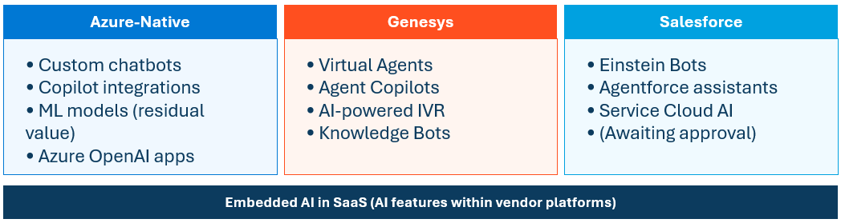

Why a Unified Framework?
Proliferation Risk
Platform-native agents (Genesys bots, Einstein assistants) are easier to deploy than custom-built systems. Without unified governance, they may bypass oversight.
Compliance Consistency
The same customer data, the same regulatory requirements (CFPB, fair lending, privacy) apply regardless of which platform hosts the agent.
Cost Visibility
Token consumption and compute costs span multiple platforms. Without unified tracking, SFS cannot attribute costs by business unit or demonstrate ROI.
Interoperability Readiness
The industry is converging on MCP/A2A standards. A unified framework positions SFS to orchestrate agents across platforms.

SFS AI Governance Policy v1.0 — Current Foundation
Lifecycle Stages Defined
- Design & Development
- Testing & Validation
- Deployment & Monitoring
- Decommissioning
Accountability Structure
- CDO ultimately responsible for all AI
- AI Steering Committee approval required

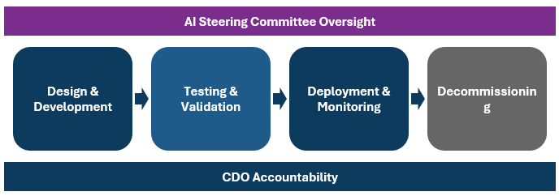

Governance Reality — How It Works Today
AI Steering Committee
- Meets every 6-10 weeks
- Includes key executives, architects, interested parties
- Ryan Miller coordinates
Maturity Level
- Process "hasn't been pressure tested yet" — team expects edge cases as agent deployments scale.
Procurement Integration
- Allison not formally in committee, but "nothing gets signed without her" — practical stopgap for tool acquisition governance
Existing Practices Worth Formalizing
- Rene's champion-challenger validation
- Mark Segarra's model governance team
- ARB reviews in EPMO discovery
Source: EPMO Interview, Dec 2025

Gaps in Current Policy
What's Missing
- Agent/Model Registry — No visibility into what exists
- Version Control & Rollback — No standards
- Champion-Challenger — Ad hoc (Rene's team only)
- Drift Detection — No thresholds or automation
- Performance SLAs — "Monitored" undefined
Additional Gaps
- Cost Attribution — No token/compute tracking
- Human-in-the-Loop — No risk-tiered requirements
- Incident Response — No AI-specific playbook
- Vendor AI Coverage — Genesys, Einstein unclear
- Interoperability — No MCP/A2A preparation

Recommended Lifecycle Framework
Key Principles
- Agent Registry as system of record throughout
- Risk tier determines governance requirements
- Defined gates, artifacts, and accountability at each stage
- AI Steering Committee touchpoints at key stages
- CDO accountability spans all stages

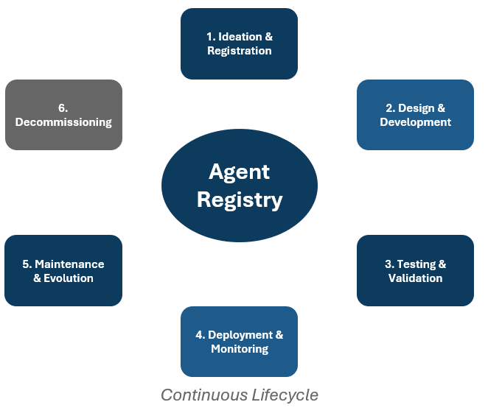

Stage 1: Ideation & Registration

Register in Agent Catalog
- Agent name and description
- Business owner and technical owner
- Platform (Azure, Genesys, Salesforce)
- Planned data sources
- Target users (customer-facing vs. internal)
Document Business Case
- Problem, expected outcomes, alternatives

Governance Touchpoints
- AI Steering Committee: Notify for Tier 1-2
- EPMO: Initiate intake process
- Procurement: Engage if vendor tool required
Artifacts Produced
- Agent registration form
- Business case document
- Risk tier assignment

Stage 2: Design & Development
Environment Standards
- Lower environments: Contributor access, no prod data
- Higher environments: Restricted access, audit logging
Documentation Requirements
- Purpose, scope, data inputs, decision logic
- Expected behaviors and known limitations
- Guardrails and constraints
Technical Standards
- Version control for code, prompts, configs
- Experiment tracking (Azure ML or equivalent)
- Reproducibility requirements
Platform-Specific
- Genesys: AI Studio, AI Guides configs
- Salesforce: AgentBuilder, MCP connections
- Azure: ML workspace for versioning

Stage 3: Testing & Validation
Champion-Challenger Methodology
- Test multiple approaches where applicable
- Document selection rationale
- Formalize Rene's team practice as standard
Validation Team Review
- Model governance team involvement
- Independent validation for Tier 1 agents
What to Test
- Functional: Does it do what it should?
- Performance: Response time, throughput
- Fairness/Bias: Per policy requirements
- Edge Cases: Unexpected inputs, adversarial prompts
- Integration: Works with connected systems
Sign-offs: Business UAT, Compliance (Tier 1-2)

Stage 4: Deployment & Monitoring

Deployment Requirements
- ARB review (significant agents)
- AI Steering Committee sign-off (Tier 1-2)
- Rollback procedures documented and tested
- Human-in-the-loop defined by risk tier

Monitoring Requirements
- Performance metrics & SLAs defined
- Drift detection: model, data, concept drift
- Cost tracking: Tokens by agent/BU
- Incident alerting with escalation paths
Artifacts: Deployment checklist, monitoring dashboard, rollback runbook

Stage 5: Maintenance & Evolution
Recalibration Triggers & Cadence
- Monthly reviews (Tier 1)
- Quarterly reviews (Tier 2)
- Semi-annual reviews (Tier 3-4)
- Performance degradation triggers
- Business/regulatory change triggers

Change Management
- All changes tracked in agent registry
- Approval proportional to risk tier
- Audit trail maintained
A/B Testing & Retraining
- Controlled rollout of updates
- Automated retraining pipelines where applicable

Stage 6: Decommissioning
Retirement Criteria
- Business need no longer exists
- Replaced by newer capability
- Performance no longer acceptable
- Compliance or regulatory concerns

Data Handling (per policy)
- Archive data per retention requirements
- Delete data not subject to retention
- Document disposition decisions
Knowledge Transfer
- Document lessons learned
- Notify users and dependent systems
- Update registry with retirement date

Risk Tiering Framework
Tier 1: Critical
- Customer-facing decisions (credit, collections)
- Full committee review, independent validation
- Human-in-the-loop required, monthly reviews
Tier 2: High
- Customer-facing informational, accesses PII
- Committee notification, validation review
- Quarterly reviews
Tier 3: Moderate
- Internal productivity, limited data access
- Streamlined registration, peer review
- Semi-annual reviews
Tier 4: Low
- Experimental/POC, sandbox only
- Registration only, documented constraints

The Interoperability Landscape
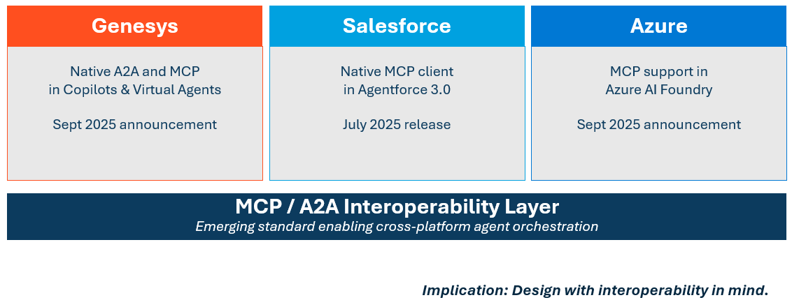

Platform-Specific Implementation
Azure
- Registry: Azure ML model registry
- Development: ML workspace, managed identity
- Monitoring: Azure Monitor, App Insights
- Cost: Azure cost management
Genesys
- Registry: AI Studio catalog
- Monitoring: Event Data Platform (EDP)
- Cost: AI Experience tokens

Salesforce
- Registry: AgentBuilder inventory
- Development: AgentBuilder (no-code)
- Monitoring: Native SF analytics
- Cost: Einstein usage metrics
Cross-Platform
- Unified agent registry (start with spreadsheet)
- Aggregate cost reporting
- Consistent governance gates

Governance Integration — Touchpoints
By Lifecycle Stage
- Ideation: Committee notify (T1-2), EPMO intake
- Design: ARB review if significant
- Testing: Committee review (T1)
- Deployment: Committee approve (T1-2), ARB final
- Maintenance: Notify on major changes
- Decommission: Notify committee
Recommendation
Consider increasing AI Steering Committee cadence from 6-10 weeks to monthly during initial agent deployment phase.
Procurement Integration
- Engage at Ideation if vendor tool required
- Contract review at Decommissioning

RACI for Agent Lifecycle
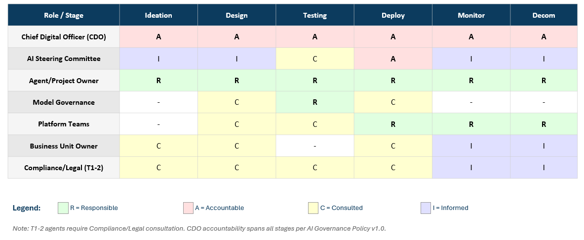
Accountable (A)
- CDO: Accountable across ALL stages
- AI Steering Committee: Accountable at Deploy
Responsible (R)
- Agent/Project Owner: R across all stages
- Model Governance: R at Testing
- Platform Teams: R at Deploy, Monitor, Decom
Consulted (C)
- Business Unit Owner: C at Design, Deploy
- Compliance/Legal: C throughout (T1-2)
- Platform Teams: C at Design, Testing
Informed (I)
- AI Steering Committee: I at Design, Monitor, Decom
- Business Unit Owner: I at Monitor

Alternatives & Tradeoffs

Azure-Native vs. Third-Party MLOps
- Options: MLflow, Weights & Biases, ModelOp
- Recommendation: Start Azure-native given existing investment
- Revisit as requirements clarify

Build vs. Buy for Lifecycle Tooling
- Current: Start lightweight (spreadsheet registry)
- Future: Consider dedicated platforms as volume grows
Platform-Specific vs. Unified Approach
- Recommendation: Platform-agnostic principles, platform-specific implementation
- MCP/A2A emergence suggests future convergence

Recommended Next Steps — Immediate (0-3 Months)
1. Establish Agent Registry
- Create initial inventory of existing/planned agents
- Assign risk tiers to each
- Start simple (spreadsheet acceptable)
2. Document Existing Practices
- Formalize Rene's champion-challenger as template
Document ARB review criteria3. Pilot Lifecycle Process
- Select one upcoming agent deployment (Tier 2-3)
- Apply full framework from ideation through monitoring
- Document lessons learned, refine process
4. Define Incident Response Playbook
- Create AI-specific runbook for agent failures
- Include escalation paths, rollback triggers

Recommended Next Steps — Short/Medium Term
Short-Term (3-6 Months)
- Formalize lifecycle stages with required artifacts
- Implement monitoring standards
- Enhance AI Steering Committee with lifecycle checkpoints
- Increase committee cadence to monthly
- Train project teams on requirements

Medium-Term (6-12 Months)
- Deploy Azure-native lifecycle tooling
- Integrate lifecycle tracking across platforms
- Establish cost attribution and chargeback
- Evaluate interoperability readiness (MCP)
- Assess need for dedicated AI governance platform

Recommended Next Steps — Short/Medium Term
Short-Term (3-6 Months)
- Formalize lifecycle stages with required artifacts
- Implement monitoring standards
- Enhance AI Steering Committee with lifecycle checkpoints
- Increase committee cadence to monthly
- Train project teams on requirements

Medium-Term (6-12 Months)
- Deploy Azure-native lifecycle tooling
- Integrate lifecycle tracking across platforms
- Establish cost attribution and chargeback
- Evaluate interoperability readiness (MCP)
- Assess need for dedicated AI governance platform

Summary

Key Takeaways
- Agent lifecycle management is essential — 80% of orgs encountered risky behaviors, 40%+ projects predicted to fail
- SFS has a solid foundation — AI Governance Policy v1.0 establishes principles; this framework operationalizes them
- Platform-agnostic principles, platform-specific implementation — unified governance across Azure, Genesys, Salesforce
Key Takeaways (continued)
- Risk tiering enables proportional controls — Tier 1-4 framework balances governance rigor with deployment velocity
- Start simple, formalize over time — begin with spreadsheet registry and manual checklists; invest in tooling as volume increases

Appendix: Sources
Industry Statistics
- 80% risky agent behaviors: McKinsey, Oct 2025
- 40%+ projects canceled: Gartner, June 2025
- 25-36% have governance: AllAboutAI/AuditBoard, 2025
- 51% negative incidents: McKinsey State of AI, Nov 2025

Platform Announcements
- Genesys MCP/A2A: BusinessWire, Sept 2025
- Salesforce Agentforce MCP: SF Dev Blog, June 2025
- Azure MCP/A2A: Microsoft Azure Blog, Sept 2025
Internal Sources
- EPMO Interview, December 2025
- SFS AI Governance Policy v1.0

Appendix: Glossary
Key Terms
- Agent: AI system that interacts, decides, operates autonomously
- MCP: Model Context Protocol — standard for agent-tool connections
- A2A: Agent-to-Agent — protocol for cross-agent collaboration
- MLOps: Practices for deploying/maintaining ML in production
- Drift: Performance degradation over time

Additional Terms
- Champion-Challenger: Testing new vs. current model
- Human-in-the-Loop: Required human review at decision points
- Risk Tier: Classification determining governance level
- Agent Registry: Central catalog of all agents
- Rollback: Reverting to previous version on failure

KM Framework

Executive Summary
This Knowledge Management (KM) Framework establishes the foundational standards, capabilities, and governance structures required to transform SFS's fragmented knowledge ecosystem into an AI-ready infrastructure. The framework addresses current data challenges identified through stakeholder interviews without prescribing specific implementation approaches, which are detailed in the Strategic Recommendations document.
The framework provides:
- A standardized KM maturity model for measuring progress across 7 categories.
- Gap analysis comparing current state to target capabilities.
- Capability definitions for each KM domain.
- Principles and standards governing knowledge operations.
- Roles and responsibilities for KM governance.
- Success metrics and measurement methodology.
Current State: SFS operates at KM Maturity Level 2 (Aware) overall, with one critical category (Expertise Location) at Level 1 (Unpredictable). This creates significant risk as the organization scales, particularly for the End-of-Lease growth from 14 to 100+ agents.

Overview
Category | Current Rating | Current Level | Target Level | Gap Priority
Core Collaboration | 2 | Aware | 4 - Managed | High
Expertise Location | 1 | Unpredictable | 3 - Defined | Critical
Content Curation | 2 | Aware | 4 - Managed | High
Information Architecture | 2 | Aware | 4 - Managed | High
Infrastructure | 2 | Aware | 3 - Defined | Medium
Search Integration | 2 | Aware | 4 - Managed | High
Governance | 2 | Aware | 4 - Managed | High
Figure 1: Knowledge Management Maturity Model

Stellantis Financial Services (SFS) operates at Knowledge Management Maturity Level 2 (Aware) across most dimensions, with critical expertise location capabilities at Level 1 (Unpredictable). This assessment, conducted through comprehensive stakeholder interviews across Customer Service, Business Intelligence, Data Management, Testing, and Enterprise Architecture teams, reveals an organization in transition, aware of knowledge management deficiencies and actively investing in solutions, yet facing significant structural barriers to enterprise-scale knowledge effectiveness.
The organization manages a complex technology landscape of 35+ platforms processing 50,000+ monthly customer interactions, with only 30-40% of enterprise integrations properly documented. Critical business knowledge resides in isolated pockets, with single individuals serving as irreplaceable knowledge bottlenecks across multiple mission-critical systems.
Core Challenges
Stellantis Financial Services operates at Knowledge Management Maturity Level 2 (Aware), with critical tribal knowledge concentrated on single individuals. Only 30-40% of enterprise integrations are properly documented across 35+ platforms, while data classification sits at 70% versus a 99% regulatory target. The organization lacks enterprise search capabilities, forcing employees to rely on email requests and personal networks to locate information, resulting in 10-day BI report turnaround times and 50% of testing engineer time consumed by maintenance rather than development. A single OpEx specialist manages knowledge for 400-500 employees while the organization simultaneously executes multiple technology migrations (SharePoint→Salesforce, MuleSoft→Azure, Legacy→Fabric) without a unified knowledge management strategy, creating scalability constraints as Collections teams prepare to expand from small operations to 200+ agents by 2026.
Strategic Opportunities
SFS's current KM challenges represent significant opportunities for AI-powered transformation that directly align with business priorities. The organization’s modern Microsoft Azure/Fabric infrastructure established AI Governance Policy (v1.0), and active Salesforce Knowledge Management implementation provide a strong technical foundation for rapid advancement. Immediate quick wins include deploying Genesys Cloud AI capabilities for the 50,000+ monthly customer calls, implementing AI-powered SQL generation to reduce BI's 10-day report turnaround, and enabling self-healing test automation to reclaim engineer capacity currently lost to maintenance. The organization can leverage large language models to surface 200+ legacy data sources, implement federated search across fragmented systems, and deploy chatbots targeting 20-30% call deflection, generating $1M+ in annual savings while enabling the planned Collections scaling to 200+ agents. Advanced capabilities including knowledge graphs for relationship discovery, automated data lineage visualization, and natural language query interfaces to the EDW position SFS to achieve competitive differentiation while meeting the 99% data classification compliance target and reducing single-point-of-failure operational risk.

KM Maturity Assessment

Assessment Findings Overview
The KM Maturity Assessment evaluated SFS across seven domains: Core Collaboration, Expertise Location, Content Curation, Information Architecture, Infrastructure, Search Integration, and Governance. The scoring methodology assessed 27 interviews and documents across these domains, with scores reflecting the maturity of current capabilities against industry best practices.

 | 1  Unpredictable | 2  Aware | 3  Competent | 4  Synchronized | 5  Choreographed
Core Collaboration | Rudimentary, random, haphazard | Intentional, ineffective knowledge capture and codification | Practices identified, formal harvesting and promotion of output | Integrated into processes with creation, access, and reuse mapped | Seamless and habitual with collaboration processes integrated with business needs and downstream uses
Expertise Location | Who you know | Word of mouth | Key skills identified and captured | Formal expertise directories leveraged | Expertise derivation through text analytics, community participation, and group interactions
Content Curation | Haphazard and application-limited | Pockets of curated content, sub-optimized across processes | Content aligned with platform and process, governance-driven information concierge | Workflow-driven integration with hybrid tagging and entity extraction processes | Value added at each touch point, core metadata flows with content, lifecycles managed, retention enforced
Information Architecture | IA is Navigation, inconsistent metadata, few standards, and poor usability | Application and department localized taxonomies | Classification structures applied to support dynamic knowledge | Multi-channel, device and format-independent cross-application architecture | Upstream supply chain and downstream syndication w/ partner & customer processes
Infrastructure | Foundational, little to no collaborative tools, CM is rudimentary | Foundational tools in place, but without out-of-the-box deployment | Knowledge harvesting integrated with collaboration and reuse | Expertise in location, community management, and intentional knowledge optimization | Multiple tools mapped to detailed requirements and use cases with ongoing tuning and enhancement
Search Integration | Search as “Random Document Generator “ | Some tuning of the search ranking algorithm with content tagging | Integration across structured and unstructured systems for content in context | Expertise mapped to search domains and terms, reduced e-discovery risk | Search-driven integration across platforms, knowledge in the task and process context
Governance | Nonexistent | Initial attempts led to fiefdoms | Repeatable, defined KM governance | Integrated, cross-functional managed processes | Business value-driven, enterprise-wide deployment
Figure 2: Full KM Maturity Model (Pink indicates current state; green indicates target state)

Core Collaboration
Rating: 2 - Aware
Evidence: Intentional but ineffective knowledge capture:
- Customer Service has dedicated OpEx specialist managing knowledge base maintenance, but this creates bottlenecks against 400-500 employees (Source: EIS-SFS-Interview-Customer-Service-Team-Tanya-2025-12-08.docx.)
- SharePoint-based knowledge management "wasn't very good. It wasn't very searchable" and lacked version control (Source: EIS-SFS-Interview-Customer-Service-Team-Tanya-2025-12-08.docx.)
- Manual tracking and updating processes despite dedicated resources (Source: EIS-SFS-Interview-Customer-Service-Team-Tanya-2025-12-08.docx.)
Minimal alignment across systems:
- "Information was not one in the same and it wasn't equal across one department to the next" (Source: EIS-SFS-Interview-Customer-Service-Team-Tanya-2025-12-08.docx.)
- Different departments maintained varying versions of same procedures (Source: EIS-SFS-Interview-Customer-Service-Team-Tanya-2025-12-08.docx.)
- Collections team uses Excel-based knowledge tool with search functionality but operates outside main systems (Source: EIS-SFS-Interview-Lease-Opportunities-Danny-Rodriguez-2025-12-10.docx.)
Transition in progress:
- Migrating from SharePoint to Salesforce Knowledge Management (December 13, 2025, implementation) (Source: EIS-SFS-Interview-Customer-Service-Team-Tanya-2025-12-08.docx.)
- Planning "Knowledge Management 2.0" with AI-powered contextual delivery (Source: EIS-SFS-Interview-Customer-Service-Team-Tanya-2025-12-08.docx.)

Expertise Location
Rating: 1 - Unpredictable
Evidence: Heavy tribal knowledge concentration:
- Key contributors can become knowledge bottlenecks (Source: EIS-SFS-Interview-Data-Part-II-Bobby-Goodwin-2025-12-11.docx.)
- BI team relies on "significant tribal knowledge and person-to-person consultation to locate fields" (Source: EIS-SFS-Interview-BI-Shandria-2025-12-15.docx.)
- Data dictionaries from vendors "often incomplete, requiring significant tribal knowledge" (Source: EIS-SFS-Interview-BI-Shandria-2025-12-15.docx.)
No systematic expertise tracking:
- Team members "reach out via email when seeking similar work" rather than using formal discovery systems (Source: EIS-SFS-Interview-BI-Shandria-2025-12-15.docx.)
- Documentation coverage "uneven, some areas well-documented while others rely on tribal knowledge" (Source: EIS-SFS-Interview-Data-Science-N-Fabric-Adam-2025-12-22.docx.)
- Testing team notes need to "capture tribal knowledge from experienced team members into AI-accessible formats" (Source: EIS-SFS-Interview-Testing-Swarupa-2025-12-17.docx.)
Cultural challenge:
- Company culture reflects "small, acquired company now scaling rapidly. Many team members haven't experienced enterprise-scale operations and 'don't know what they don't know'" (Source: EIS-SFS-Interview-BI-Tricia-2025-12-17.docx.)

Content Curation
Rating: 2 - Aware
Evidence: Pockets of specialized curation:
- BI team maintains "self-created onboarding documentation that evolves with each new hire" including data dictionaries, helpful hints, acronym definitions (Source: EIS-SFS-Interview-BI-Shandria-2025-12-15.docx.)
- Customer Service has OpEx specialist dedicated to content maintenance (Source: EIS-SFS-Interview-Customer-Service-Team-Tanya-2025-12-08.docx.)
- Website FAQ can be "updated real time" by section owners, while main website requires development releases (Source: EIS-SFS-Interview-PO-Website-Sana-2025-12-18.docx.)
Minimal alignment:
- Content age varies significantly, "some materials potentially two years old requiring validation before migration" (Source: EIS-SFS-Interview-Customer-Service-Team-Tanya-2025-12-08.docx.)
- No KCS (Knowledge-Centered Service) methodology - using "hybrid model" with manual processes (Source: EIS-SFS-Interview-Customer-Service-Team-Tanya-2025-12-08.docx.)
- SharePoint documentation maintained by each department independently with "organic growth" (Source: EIS-SFS-Interview-UX-UI-Team-Matt-2025-12-05.docx.)
Quality inconsistency:
- Data team "intentionally don't publish detailed data lineage documentation to force cultural change" (Source: EIS-SFS-Interview-Data-Part-II-Bobby-Goodwin-2025-12-11.docx.)
- Testing documentation needs vary - some areas require detailed process documents while others are undocumented (Source: EISSFSInterviewAutomatedTestingIStephen20260107.pdf.)

Information Architecture
Rating: 2 - Aware
Evidence: Metadata use defined locally:
- Data classification system exists (five-tier: public, internal, confidential, restricted, highly restricted) but only ~70% of unstructured data properly tagged, targeting 99% (Source: EIS-SFS-Interview-Security-N-Data-Governance-Tony-Vik-2025-12-05.docx.)
- Microsoft Copilot restricted to "non-sensitive information" (public/internal only) due to data classification concerns (Source: EIS-SFS-Interview-Security-N-Data-Governance-Mike-2025-12-05.docx.)
Inconsistent metadata standards:
- BI reports organized "in Tableau folders by department, with SharePoint landing pages providing links across platforms" but no systematic discovery (Source: EIS-SFS-Interview-BI-Shandria-2025-12-15.docx.)
- "No systematic way to discover similar existing reports or reuse query logic" (Source: EIS-SFS-Interview-BI-Shandria-2025-12-15.docx.)
Standards deficit:
- Detailed data lineage documents are not published creating opacity (Source: EIS-SFS-Interview-Data-Part-II-Bobby-Goodwin-2025-12-11.docx.)
- Enterprise integration documentation gap: only "30-40% of enterprise integrations properly documented" (Source: EIS_SFS_Interview-Architecture_Walkthrough_Tony_Vik_2025_11_26.docx.)
Poor usability:
- SharePoint knowledge base described as "not very searchable" and lacking version control (Source: EIS-SFS-Interview-Customer-Service-Team-Tanya-2025-12-08.docx.)
- "Memorized navigation" evident in Collections team's Excel-based tool despite having search functionality (Source: EIS-SFS-Interview-Lease-Opportunities-Danny-Rodriguez-2025-12-10.docx.)

INFRASTRUCTURE
Rating: 2 - Aware
Evidence: Some KM tools in place:
- Salesforce Knowledge Management being implemented (Source: EIS-SFS-Interview-Customer-Service-Team-Tanya-2025-12-08.docx.)
- SharePoint as primary document storage (Source: EIS-SFS-Interview-Data-Part-II-Bobby-Goodwin-2025-12-11.docx.)
- Genesys Cloud CX platform for telephony with one-year operational history (Source: EIS-SFS-Interview-Customer-Service-Team-Tanya-2025-12-08.docx.)
- Microsoft Teams as "primary collaboration platform" (Source: EIS-SFS-Interview-Data-Science-N-Fabric-Adam-2025-12-22.docx.)
Out-of-box deployment:
- Salesforce KM implementation described as "not a full standalone product" using "basic approval and versioning" (Source: EIS-SFS-Interview-Customer-Service-Team-Tanya-2025-12-08.docx.)
- Enterprise Document Management System "in development" but not yet operational (Source: EIS-SFS-Interview-Data-Part-II-Bobby-Goodwin-2025-12-11.docx.)
Effortful alignment:
- 35+ platforms with fragmented knowledge ecosystem (Source: Strategic Assessment implied from multiple interviews.)
- MuleSoft to Azure API Management migration in progress - only 6 of planned integrations migrated (Source: EISSFSInterviewAutomatedTestingIStephen20260107.pdf.)
- "Data is not yet ported out into a usable format for the tools without it being a manual export" from Salesforce (Source: EIS-SFS-Interview-BI-Tricia-2025-12-17.docx.)
No specialized collaboration tools:
- Learning Management System is not integrated into applications, which would help with scaling from small teams to 200+ agents planned (Source: Strategic context from multiple interviews.)
- Limited AI tooling: Azure AI Foundry "access currently restricted to Mike and two others running POCs" (Source: EIS-SFS-Interview-Security-N-Data-Governance-Tony-Vik-2025-12-05.docx.)

Search Integration
Rating: 2 - Aware
Evidence: Multiple shared spaces with rudimentary management:
- SharePoint with "no centralized intranet search beyond SharePoint's native capabilities" (Source: EIS-SFS-Interview-UX-UI-Team-Matt-2025-12-05.docx.)
- BI reports require team members to "reach out via email when seeking similar work" (Source: EIS-SFS-Interview-BI-Shandria-2025-12-15.docx.)
- Collections use Excel tool with federated search tabs, but require users to leave primary systems (Source: EIS-SFS-Interview-Lease-Opportunities-Danny-Rodriguez-2025-12-10.docx.)
No holistic understanding of user needs:
- Website Learning Center has "not a ton of content" and FAQ is more developed but siloed (Source: EIS-SFS-Interview-PO-Website-Sana-2025-12-18.docx.)
- Customer-facing content includes "basic articles and FAQs" but over 200 data sources have not yet surfaced (Source: EIS-SFS-Interview-UX-UI-Team-Matt-2025-12-05.docx.)
- "Legacy documentation not yet surfaced to end users" (Source: EIS-SFS-Interview-UX-UI-Team-Matt-2025-12-05.docx.)
Limited cross-system integration:
- Salesforce KM 2.0 planning to "push relevant articles to agents based on case context, keywords" but not yet implemented (Source: EIS-SFS-Interview-Customer-Service-Team-Tanya-2025-12-08.docx.)
- No integration between structured EDW data and unstructured documentation repositories (Source: EIS-SFS-Interview-Data-Part-II-Bobby-Goodwin-2025-12-11.docx.)

Governance
Rating: 2 - Aware
Evidence: Isolated attempts and fiefdoms:
- AI Governance Policy established (v1.0 dated March 31, 2025) with governance committee structure (Source: EISSFSDocumentStellantisFinancialServicesAIGovernancePolicyv120251121.pdf.)
- Data classification framework exists but implementation is incomplete (70% vs 99% target) (Source: EIS-SFS-Interview-Security-N-Data-Governance-Tony-Vik-2025-12-05.docx.)
- "Different IAs in each system" - Customer Service, BI, Collections all maintain separate knowledge systems (Source: Multiple interview files.)
Documented but wholly manual:
- Content governance "using hybrid model with centralized content management through Antonio's team" - one person bottleneck (Source: EIS-SFS-Interview-Customer-Service-Team-Tanya-2025-12-08.docx.)
- "Manual tracking and updating processes create maintenance bottlenecks" (Source: EIS-SFS-Interview-Customer-Service-Team-Tanya-2025-12-08.docx.)
- Data quality management defined in AI Governance Policy, but implementation gaps exist (Source: EISSFSDocumentStellantisFinancialServicesAIGovernancePolicyv120251121.pdf.)
Compliance framework exists:
- Four regulatory frameworks (FTC, GLBA, FDIC, PCI DSS) plus SOC 2 voluntary compliance (Source: EIS-SFS-Interview-Security-N-Data-Governance-Tony-Vik-2025-12-05.docx.)
- "Privacy function being established to conduct privacy impact assessments" (Source: EIS-SFS-Interview-Security-N-Data-Governance-Tony-Vik-2025-12-05.docx.)
- Vendor management requires "SOC 2 Type 2 certification minimum" (Source: EIS-SFS-Interview-Security-N-Data-Governance-Tony-Vik-2025-12-05.docx.)
No enterprise-wide deployment:
- Detailed data lineage documentation access is control rather than democratized (Source: EIS-SFS-Interview-Data-Part-II-Bobby-Goodwin-2025-12-11.docx.)
- Shadow IT enforcement "approximately 75% effectiveness" (Source: Strategic Assessment context.)
- No integrated KPIs or metrics system for knowledge management effectiveness.

Gap Analysis
Knowledge Management Gap Analysis Clustered by Priority & Business Impact
Priority 1: Critical Business Risk

Gap: Enterprise Integration Documentation Void
Summary of Findings:
Only 30-40% of enterprise integrations are properly documented across the 35+ platform technology landscape. The organization acknowledges approximately 70% of unstructured data is properly tagged versus a 99% regulatory target for data classification. Bobby's data team "intentionally don't publish detailed data lineage documentation to force cultural change, if analysts see exact calculation methods, they'll reproduce them in their own code rather than adopting the EDW." Content age varies significantly, with "some materials potentially two years old requiring validation before migration." The Enterprise Document Management System is "in development" but not yet operational, leaving SharePoint as the primary, and inadequate, document repository.
Business Impact:
- 30-40% documentation gap creates regulatory compliance exposure under FTC, GLBA, FDIC, PCI DSS frameworks.
- Unknown integration dependencies increase change management risk and system failure probability.
- Inability to perform comprehensive impact analysis for system changes.
- Audit preparation requires excessive manual effort to reconstruct undocumented processes.
- New team members cannot independently understand system architecture.
Sources:
- EIS_SFS_Interview-Architecture_Walkthrough_Tony_Vik_2025_11_26.docx
- EIS-SFS-Interview-Security-N-Data-Governance-Tony-Vik-2025-12-05.docx
- EIS-SFS-Interview-Data-Part-II-Bobby-Goodwin-2025-12-11.docx
- EIS-SFS-Interview-Customer-Service-Team-Tanya-2025-12-08.docx
Priority 2: High Operational Impact

Gap: Absent Enterprise Search & Discovery
Summary of Findings:
SFS has "no centralized intranet search beyond SharePoint's native capabilities." The BI team reports "no systematic way to discover similar existing reports or reuse query logic," forcing "team members to reach out via email when seeking similar work." Reports are organized "in Tableau folders by department, with SharePoint landing pages providing links across platforms" but without cross-platform search functionality. Customer Service's SharePoint knowledge base "wasn't very good. It wasn't very searchable" and lacked version control. The Collections team uses an Excel-based knowledge tool that requires agents to "go outside of the system to use it" despite having search functionality. Over 200 legacy data sources exist with "substantial legacy documentation not yet surfaced to end users." The website Learning Center has "not a ton of content" limiting customer self-service capabilities.
Business Impact:
- 10-day average turnaround for BI report requests with most time spent on data discovery.
- Duplicated effort creating redundant reports and queries.
- Customer service agents require 1.2-2 calls per issue resolution due to knowledge access limitations.
- 50,000+ monthly customer calls could be deflected with better self-service search.
- Estimated $500K+ annual productivity loss from search inefficiency.
Sources:
- EIS-SFS-Interview-UX-UI-Team-Matt-2025-12-05.docx
- EIS-SFS-Interview-BI-Shandria-2025-12-15.docx
- EIS-SFS-Interview-Customer-Service-Team-Tanya-2025-12-08.docx
- EIS-SFS-Interview-Lease-Opportunities-Danny-Rodriguez-2025-12-10.docx
- EIS-SFS-Interview-PO-Website-Sana-2025-12-18.docx

Gap: Fragmented Departmental Knowledge Silos
Summary of Findings:
Customer Service reports that "information was not one in the same and it wasn't equal across one department to the next" with different departments maintaining "varying versions of the same procedures." SharePoint documentation is maintained by each department independently with "organic growth" and decentralized control. BI reports are organized by departments with no cross-functional visibility. Collections operate a separate Excel-based knowledge system. Customer Service uses SharePoint transitioning to Salesforce KM. The UX team maintains process documents in their own SharePoint section. Tricia Reed's BI team noted the challenge of cross-system data integration: "Salesforce data is not yet ported out into a usable format for the tools without it being a manual export." There is no systematic way to share knowledge discoveries across departmental boundaries.
Business Impact:
- Inconsistent customer experience is due to different departments having different procedure versions.
- Duplicated knowledge maintenance effort across departments.
- Cross-functional collaboration hindered by inability to access relevant knowledge from other teams.
- Onboarding complexity as new employees must learn multiple disconnected systems.
- Strategic initiatives delayed by inability to aggregate cross-departmental insights.
Sources:
- EIS-SFS-Interview-Customer-Service-Team-Tanya-2025-12-08.docx
- EIS-SFS-Interview-UX-UI-Team-Matt-2025-12-05.docx
- EIS-SFS-Interview-BI-Shandria-2025-12-15.docx
- EIS-SFS-Interview-BI-Tricia-2025-12-17.docx
- EIS-SFS-Interview-Lease-Opportunities-Danny-Rodriguez-2025-12-10.docx

Gap: Manual Governance Bottlenecks Preventing Scale
Summary of Findings:
A single OpEx specialist manages knowledge base maintenance for 400-500 employees in Customer Service, creating an obvious bottleneck. The organization uses a "hybrid model with centralized content management through Antonio's team" which concentrates control. "Manual tracking and updating processes create maintenance bottlenecks despite having a dedicated OpEx specialist managing content." Salesforce KM is described as "not a full standalone product" requiring significant manual workarounds for basic features like approval and versioning. There is no Knowledge-Centered Service (KCS) methodology in place to distribute content creation responsibility. Content governance decisions flow through one person, creating delays in updating critical customer-facing and agent-facing content. The organization acknowledges this model cannot scale to support the planned Collections expansion to 200+ agents by 2026.
Business Impact:
- Content updates delayed by single person bottleneck.
- Cannot scale knowledge management proportionally to business growth.
- OpEx specialist represents single point of failure for all Customer Service knowledge.
- Quality inconsistency as one person cannot maintain expertise across all domains.
- Collections expansion to 200+ agents blocked by governance capacity constraints.
Sources:
- EIS-SFS-Interview-Customer-Service-Team-Tanya-2025-12-08.docx
Priority 3: Medium Strategic Impact

Gap: Concurrent Technology Migrations Without Integration Strategy
Summary of Findings:
The organization is executing multiple major technology migrations simultaneously without a unified integration approach: (1) SharePoint to Salesforce Knowledge Management (launched December 13, 2025), (2) MuleSoft to Azure API Management (only 6 APIs migrated of complete replacement scope), (3) Legacy systems to Microsoft Fabric EDW, and (4) Enterprise Document Management System "in development." Tricia Reed's BI team noted that "Salesforce data is not yet ported out into a usable format for the tools without it being a manual export," indicating integration gaps between migrations. Testing automation team reports "50% of automation engineer time spent on test maintenance" rather than supporting new development, suggesting migration overhead. The strategic assessment indicates these migrations are proceeding on different timelines with different teams and insufficient coordination.
Business Impact:
- Integration gaps between migrated systems create manual workarounds.
- Testing burden increases exponentially with each additional platform.
- Data accessibility issues as systems migrate on different schedules.
- Technical debt accumulation as interim solutions become permanent.
- Team capacity stretched across too many concurrent initiatives.
Sources:
- EIS-SFS-Interview-Customer-Service-Team-Tanya-2025-12-08.docx
- EIS-SFS-Interview-BI-Tricia-2025-12-17.docx
- EIS-SFS-Interview-Testing-Swarupa-2025-12-17.docx
- EISSFSInterviewAutomatedTestingIStephen20260107.pdf
- EIS-SFS-Interview-Data-Part-II-Bobby-Goodwin-2025-12-11.docx

Gap: Insufficient AI Readiness & Tooling Access
Summary of Findings:
Azure AI Foundry "access currently restricted to Mike and two others running POCs," limiting AI experimentation to a tiny group. The BI team has "no access to GitHub Copilot or code generation tools" despite these being standard productivity aids in modern development. The team "wasn't aware" Microsoft 365 Copilot had code generation capabilities, indicating insufficient training and awareness. Microsoft Copilot usage is restricted to "non-sensitive information" (public/internal only) with confidential, restricted, or highly restricted data prohibited, significantly limiting AI utility. Testing team notes that vendors like PWC "appear to use Enterprise ChatGPT for test case generation" while SFS lacks similar capabilities internally. Heavy workload "prevents exploration of new tools" creating a capability gap versus competitors. The organization has established an AI Governance Policy (v1.0) but implementation and tooling rollout lag significantly behind policy creation.
Business Impact:
- Competitive disadvantage as other organizations leverage AI productivity tools.
- BI team's 10-day report turnaround could be reduced with AI-assisted SQL generation.
- Testing team's 50% maintenance burden addressable with AI self-healing capabilities.
- Developer productivity 20-30% below industry benchmarks lacking AI coding assistants.
- Strategic AI initiatives delayed by insufficient foundational AI tooling and skills.
Sources:
- EIS-SFS-Interview-Security-N-Data-Governance-Tony-Vik-2025-12-05.docx
- EIS-SFS-Interview-BI-Shandria-2025-12-15.docx
- EIS-SFS-Interview-Testing-Swarupa-2025-12-17.docx
- EIS-SFS-Interview-Security-N-Data-Governance-Mike-2025-12-05.docx
- EISSFSDocumentStellantisFinancialServicesAIGovernancePolicyv120251121.pdf

Gap: Inadequate Data Quality & Metadata Management
Summary of Findings:
Data classification sits at 70% actual versus 99% regulatory target for unstructured data tagging, creating compliance gaps under FTC, GLBA, FDIC, and PCI DSS requirements. Vendor-provided data dictionaries are "often incomplete, requiring significant tribal knowledge and person-to-person consultation to locate fields." Bobby's team "intentionally don't publish detailed data lineage documentation" creating information opacity rather than transparency. The BI team must "trace lineage of priority Tableau reports back to source systems" manually during migration, indicating absence of automated lineage tracking. The AI Governance Policy defines data quality requirements (accuracy, completeness, consistency, timeliness) but implementation gaps exist between policy and practice. Approximately 50-100 third-party data sources feed the EDW beyond core operational systems, but metadata management for these sources is inconsistent.
Business Impact:
- Regulatory compliance exposure with 29% gap from data classification target.
- Report accuracy concerns due to unknown data lineage and transformation logic.
- New analyst productivity severely hampered by incomplete metadata.
- Inability to perform comprehensive impact analysis for system changes.
- AI/ML model reliability compromised by poor data quality and unknown provenance.
Sources:
- EIS-SFS-Interview-Security-N-Data-Governance-Tony-Vik-2025-12-05.docx
- EIS-SFS-Interview-BI-Shandria-2025-12-15.docx
- EIS-SFS-Interview-Data-Part-II-Bobby-Goodwin-2025-12-11.docx
- EISSFSDocumentStellantisFinancialServicesAIGovernancePolicyv120251121.pdf

Gap: Limited Customer Self-Service Knowledge
Summary of Findings:
The website Learning Center has "not a ton of content" limiting customer self-service options. Customer Service processes 50,000+ monthly calls with 60-65% payment-related, many of which could be deflected with better self-service knowledge. The FAQ is "more developed" than the Learning Center and can be "updated real time" by section owners but lacks integration with other customer touchpoints. Secured messaging and chat functionality have been "built but not yet released" because the organization needs to "allow non-functional activities in order to support it" and establish proper knowledge base foundation first. There is no chatbot currently deployed despite this being "on the roadmap" with the priority being "ensuring sustainability before rollout." Customer-facing knowledge articles exist but do not proactively surface based on customer context or journey. The organization acknowledges that "traditionally this would require a consolidated knowledge base, but with AI and large language models, there's potential for more sophisticated approaches."
Business Impact:
- 50,000+ monthly calls with potential 20-30% deflection opportunity = $1M+ annual savings.
- Customer frustration with inability to self-serve basic inquiries.
- Agent capacity consumed by repetitive questions preventable through knowledge access.
- Collections expansion to 200+ agents require proportional knowledge investment without self-service.
- Competitive disadvantages versus financial services firms offering AI-powered customer assistance.
Sources:
- EIS-SFS-Interview-PO-Website-Sana-2025-12-18.docx
- EIS-SFS-Interview-Customer-Service-Team-Tanya-2025-12-08.docx
- EIS-SFS-Interview-UX-UI-Team-Matt-2025-12-05.docx
Based on SFS's specific operational context, technology landscape, and knowledge management challenges, here's a comprehensive KM Capability Framework section:

Gap: Tribal Knowledge Concentration & Succession Risk
Summary of Findings:
Core individuals are/can become irreplaceable single point of failure. The BI team relies heavily on "significant tribal knowledge and person-to-person consultation to locate fields" because vendor-provided data dictionaries are incomplete. Documentation coverage is described as "uneven, some areas well-documented while others rely on tribal knowledge." The organization's culture reflects its origin as "a small, acquired company now scaling rapidly" where "many team members haven't experienced enterprise-scale operations and 'don't know what they don't know.'" Testing teams have identified the critical need to "capture tribal knowledge from experienced team members into AI-accessible formats."
Business Impact:
- Loss of key personal would severely disrupt operations across critical business systems.
- New analysts take months to become productive due to knowledge gaps.
- Operational continuity at extreme risk with no documented succession plans.
- Scaling from current operations to 200+ Collections agents by 2026 impossible without knowledge transfer.
Sources:
- EIS-SFS-Interview-Data-Part-II-Bobby-Goodwin-2025-12-11.docx
- EIS-SFS-Interview-BI-Shandria-2025-12-15.docx
- EIS-SFS-Interview-Data-Science-N-Fabric-Adam-2025-12-22.docx
- EIS-SFS-Interview-BI-Tricia-2025-12-17.docx
- EIS-SFS-Interview-Testing-Swarupa-2025-12-17.docx

KM Capability definitions
The capability framework defines what effective knowledge management looks like across six core capability areas (Knowledge Capture & Creation, Content Organization & Structure, Expertise Location & Access, Search & Discovery, Content Lifecycle Management, and Governance & Quality), tailored to SFS's operational reality as a rapidly scaling financial services organization with significant tribal knowledge concentration and fragmented system landscape.
Cross-Capability Integration Note: These six capabilities function as an integrated system. For example, strong Content Organization & Structure enables effective Search & Discovery, while Expertise Location & Access informs Content Ownership Assignment under Governance & Quality. Implementation should prioritize establishing foundational capabilities (governance, taxonomy, capture processes) before advancing to sophisticated capabilities (AI-powered search, predictive analytics).

Knowledge Capture & Creation
Current State Context: SFS faces critical knowledge concentration in key individuals, with only 30-40% of enterprise integrations documented. Rapid scaling (Collections growing from 400 to 600 FTE by end of 2026) creates urgent need for systematic knowledge capture before institutional knowledge walks out the door.
Capability Components

SME Interview and Knowledge Extraction
- Structured interview protocols for capturing tribal knowledge from single points of failure (system integrations, legacy data structures, undocumented business rules.)
- Video/audio recording with automatic transcription for technical knowledge transfer sessions.
- Knowledge elicitation workshops during vendor implementations to capture configuration decisions and customizations.
- Exit interview protocols for departing personnel with critical system knowledge.
- Peer knowledge transfer sessions documented before role transitions or retirements.

Meeting Transcript and Call Recording Insight Capture
- Observe AI call transcription and sentiment analysis currently deployed in Collections (5-6 years of accumulated data.)
- Genesys Cloud Telephony Platform Transcription Capabilities for Customer Service (46,000-50,000 monthly calls.)
- Managed file transfer process currently moves voice recordings from Genesys to Observe AI nightly for processing.
- Extract actionable insights from transcripts: common customer pain points, policy clarifications needed, agent knowledge gaps.
- Compliance-focused capture for wrongful repossession prevention protocols and disclosure requirements.
- Integration of transcript data into data warehouse (Snowflake/Fabric) for advanced analytics.

Process Documentation from Workflow Observation
- Shadow experienced agents during collections calls to document decision-making heuristics.
- Screen recording for complex system workflows across Genesys, DeFy, Salesforce, and NSF applications.
- Capture implicit knowledge: "We always check System X before System Y because..." rationale documentation.
- Document workaround procedures that emerge from system limitations or integration gaps.
- RPA bot failure analysis to capture manual intervention knowledge when automation breaks.

Tribal Knowledge Conversion to Structured Formats
- Priority focus on undocumented legacy data marts where "nobody knows who wrote the stored procedures."
- Systematize data lineage knowledge before it represents single point of failure.
- Convert 20+ years of legacy database tribal knowledge into documented data dictionaries.
- Extract business rules embedded in Risk analysts' SQL scripts (currently requiring IT rewrite for performance.)
- Document the "fuzzy logic" in case type reporting before Salesforce case management clarifies it.

Continuous Learning Capture from AI System Feedback
- Monitor Copilot interactions to identify frequently asked questions requiring better documentation.
- Track Observe AI's "next best action" recommendations that agents override to understand when AI guidance is insufficient.
- Analyze Genesys AI Knowledge feature queries to identify content gaps.
- Capture successful problem resolutions from AI-assisted workflows to formalize best practices.
- Feed AI-generated call summaries back into knowledge base as candidate articles.

Content Organization & Structure
Current State Context: Multiple SharePoint sites with inconsistent organization; Customer Service transitioning from SharePoint to Salesforce Knowledge Management (December 13, 2025, go-live); no enterprise-wide taxonomy; each department maintains separate documentation repositories.
Capability Components:

Enterprise Taxonomy and Controlled Vocabulary
- Align with the EDW naming conventions: business-friendly column names that "analysts should understand on first day.”
- Avoid technical jargon in taxonomy (no "vendor-specific abbreviations like CUSLN".)
- Product hierarchy: Retail/Lease/Insurance/Floor Plan as top-level categories.
- System taxonomy: Genesys, Salesforce, DeFy, RePay, NSF applications, Azure Integration Hub, etc.
- Process taxonomy: Collections, Customer Service, Testing, Risk Management, Residual Management, etc.
- Data classification taxonomy: Public, Internal, Confidential, Restricted, Highly Restricted (aligned with Mike Calaway's security framework.)
- Regulatory taxonomy: FTC, GLBA, FDIC, PCI DSS, SOC 2 compliance tags.

Metadata Schema with Applicability Indicators
- System applicability: Which platforms (Genesys vs. Salesforce, DeFy vs. Shaw for servicing.)
- Product applicability: Retail vs. Lease distinctions critical for operational procedures.
- Role applicability: Agent-facing vs. back-office vs. analytical procedures.
- Lifecycle stage: Origination, Servicing, Collections, End-of-Lease, Remarketing.
- Data vintage: Which EDW migration wave (Lease completed, Retail in progress, Insurance pending.)
- Version specifically: "Valid for Salesforce Winter '25 release" or "Genesys Cloud R3."

Content Component Model for Reusability
- Modular content architecture: step-by-step procedures, policy explanations, decision trees, troubleshooting flows stored as reusable components.
- Single-source authoring for content used across channels (agent desktop, MySFS portal, IVR scripts.)
- Template library: How-to guides, system integrations, API documentation, data dictionary entries, test case documentation.
- Consistent formatting: Salesforce Knowledge Management templates for Customer Service; SharePoint templates for technical documentation.

Cross-System Classification Alignment
- Map SharePoint folder structures to Salesforce Knowledge categories during Customer Service migration.
- Align Testing documentation (Spira Test, manual test repository) with enterprise taxonomy.
- Connect BI report metadata (Tableau, Power BI, SAS) to business domain taxonomy.
- Bridge EDW data dictionary to operational process documentation.
- Link Observe AI call categories to knowledge article taxonomy.

Version Control and Change Tracking
- Salesforce Knowledge native versioning for Customer Service content (going live December 13, 2025.)
- Git/GitHub for technical documentation, API specifications, infrastructure as code.
- Change notifications when procedures updated mid-quarter (particularly critical for regulatory compliance content.)
- Archive previous versions for audit trail (required by financial services regulators.)
- Track "last reviewed date" vs. "last modified date" to identify stale content requiring SME re-validation.

Expertise Location & Access
Current State Context: Organizational knowledge concentrated in core individuals like Bobby Goodwin (data/systems), Cassidy Hodge/Sajid Chida (Salesforce), Chandria Burden (legacy BI systems). No formal skills directory. Rapid growth creates urgent succession planning needs.
Capability Components:

Skills and Expertise Directory
- Catalog technical expertise: Salesforce developers, data engineers, automation testers, BI analysts, risk modelers.
- Document system expertise: Who knows Genesys configuration? DeFy integrations? Legacy data marts? Azure Integration Hub?
- Track domain expertise: Collections procedures, wrongful repossession prevention, residual valuation, end-of-lease workflows.
- Identify "go-to" people for: MuleSoft replacements, Fabric migration, SOC 2 compliance, PCI DSS controls.
- Maintain contact routing information: Manager on Duty (MOD) support line, escalation paths, after-hours contacts.

SME Identification and Contact Routing
- Embedded in knowledge articles: "For questions on this topic, contact [Name/Team]."
- Automated routing in Salesforce case management based on issue categorization.
- Manager on Duty chat support for Customer Service agents needing real-time assistance.
- Testing team structure: Manual testing lead (Corinne Anderson), automation lead (Stephen Kinnison), Geetha Gajavally for technical implementation.
- Enterprise Architecture contacts: Larry Burgess (infrastructure), Tony Grogan (operations), Vik Chopra, Puru Naktode.

Knowledge Graph of Expertise Relationships
- Map dependencies: For example: Bobby Goodwin → 33 direct reports including Tobin Page (data management), Chris Rodriguez, Adam Ruthford (Fabric/data science.)
- Document collaboration patterns: Risk teams working with Data teams on Observe AI transcript analysis.
- Identify knowledge bottlenecks: single points of failure requiring immediate succession planning.
- Track mentor relationships: experienced manual testers transitioning to automation roles.
- Visualize organizational knowledge flows: who trains whom, who reviews whose work, who escalates to whom.

Succession Planning for Critical Knowledge
- Priority 1: Bobby Goodwin's integration and data lineage knowledge (30-40% documented → target 80%+.)
- Priority 2: Collections scaling knowledge before 200-person growth event.
- Priority 3: Legacy BI system knowledge (Chandria Burden's expertise) during Power BI migration.
- Document "bus factor" risks: what happens if key personnel are unavailable during critical incidents?
- Cross training programs: ensure at least two people can perform critical technical procedures.

Expertise Contribution Recognition
- Track knowledge article authorship and maintenance contributions.
- Recognize subject matter experts who respond to knowledge base feedback.
- Gamification elements in Salesforce Knowledge: top contributors, most helpful articles.
- Performance review criteria: knowledge sharing and documentation contributions.
- Incentivize tribal knowledge conversion: reward individuals who document previously undocumented procedures.

Search & Discovery
Current State Context: No unified enterprise search; SharePoint search limited to individual sites; each team maintains separate repositories; Customer Service transitioning to Salesforce Knowledge search; approximately 70% of unstructured data tagged for discovery (target: 99%).
Capability Components:
Unified Enterprise Search Across Repositories
- Current fragmentation: SharePoint documentation, Salesforce Knowledge, Spira Test cases, Tableau/Power BI reports, EDW data dictionary, email archives.
- Target state: Single search interface spanning all knowledge repositories with role-based access controls.
- Microsoft 365 Copilot integration for Public and Internal classified content (current AI governance allows these tiers only.)
- Search result ranking based on content recency, user role, previous search patterns, content quality ratings.
- Federated search respecting data classification boundaries (Confidential/Restricted/Highly Restricted access controls.)

Natural Language Query Interfaces
- "What's the procedure for wrongful repossession prevention?" maps to Collections documentation.
- "Show me DeFy integration error codes" surfaces technical troubleshooting guides.
- "How do I calculate residual value for early lease terminations?" retrieves analytical procedures.
- Conversational AI over Fabric data warehouse (Adam Ruthford's Treasury pilot with 25-table subset.)
- Natural language test querying: "Show me all tests that failed related to payment processing in the last month" (Swarupa's team vision.)

Similar Content/Report Discovery
- BI report similarity matching to prevent duplicate development (Shandria Burden's team need.)
- "Others who viewed this also found helpful..." recommendations.
- Related knowledge articles automatically surfaced based on semantic similarity.
- Find existing SQL queries similar to analyst's requirements before writing from scratch.
- Discover reusable test cases when creating new Salesforce automation scenarios.

Contextual Search Within Applications
- Salesforce Knowledge embedded within agent console: search while on call without leaving screen.
- Genesys AI Knowledge feature: ChatGPT-like interface for policy lookup within Collections data universe.
- IDE-integrated search for automation engineers: find test patterns while coding.
- Power BI report search within Fabric workspace.
- Context-aware results: searching from Collections context prioritizes Collections-relevant content.

AI-Powered Semantic Retrieval
- Understand intent beyond keywords: "charge-off" and "120-day delinquency" recognized as related concepts.
- Retrieval Augmented Generation (RAG) architectures for LLM-powered knowledge access.
- Semantic search over call transcripts: find conversations discussing specific customer scenarios even without exact keyword matches.
- Vector embeddings for technical documentation: retrieve conceptually similar integration patterns.
- Multi-modal search: find information across text, diagrams, screenshots, video transcripts.

Content Lifecycle Management
Current State Context: Salesforce Knowledge implementing approval workflows December 13; SharePoint lacks formal governance; Customer Service has OpEx specialist (Antonio Martir's team) manually maintaining knowledge; Testing documentation inconsistently updated; no enterprise-wide lifecycle management.
Capability Components:

Content Creation and Approval Workflows
- Salesforce Knowledge native workflows: draft → SME review → approval → publication.
- Multi-tier approval for regulatory-sensitive content: SME → Compliance → Legal sign-off before publication.
- Emergency update process: expedited approvals for critical procedure changes (e.g., system outages, regulatory alerts.)
- Collaborative authoring: multiple SMEs contributing expertise to comprehensive guides.
- Template enforcement: new content must use approved formats for consistency.

Scheduled Review and Refresh Cycles
- Tier 0 systems (Genesys, Salesforce, DeFy servicing): Quarterly review.
- Compliance/regulatory content: Semi-annual or triggered by regulatory changes.
- General operational procedures: Annual review.
- Legacy system documentation (data marts, old integrations): Review during migration/replacement projects.
- Automated review reminders sent to content owners 30 days before due date.
- Escalation to manager if review deadline missed.

Archival and Retention Policies
- Financial services retention requirements: 7 years for compliance-related documentation.
- System decommissioning: archive but retain documentation for audit/reference (e.g., MuleSoft to Azure Integration Hub migration.)
- Version history retention: maintain change trail for regulatory examiner requests.
- Sunset obsolete content: clearly mark deprecated procedures to prevent confusion.
- Migration support: maintain "legacy system" documentation during transition periods.

Quality Validation and Compliance Checks
- Peer review for technical accuracy before publication.
- Compliance team review for FTC, GLBA, FDIC, PCI DSS, SOC 2 sensitive content.
- Readability scoring: ensure content appropriate for target audience (agent-facing vs. technical teams.)
- Link validation: automated checks for broken references to other knowledge articles.
- Screenshot currency: flag outdated UI images when systems upgraded.
- Consistency checks: ensure procedure alignment across related articles.

Usage Analytics for Content Optimization
- Track search queries leading to each article: understand how users find content.
- Monitor "helpful"/"not helpful" ratings: identify low-quality content requiring improvement.
- Analyze time spent on article: noticeably short durations suggest content not relevant or poorly structured.
- Zero-hit searches: identify content gaps where users search but nothing found.
- Case creation patterns: high case volumes for topics with existing knowledge articles suggest articles ineffective.
- A/B testing: compare different article formats/structures to optimize for user engagement.

Governance & Quality
Current State Context: AI Governance Committee established (CDO-led, cross-functional); early maturity (A1 level) with policies written 3 months ago; no enterprise KM governance framework; department-specific approaches (Customer Service OpEx specialist, Testing documentation standards, Data Management conventions).
Capability Components:

Content Ownership Assignment
- Named individual owners (not "teams" or "departments") for each knowledge domain.
- Backup owners designated for continuity during vacations/transitions.
- Clear escalation paths: content owner → domain lead → executive sponsor.
- Ownership model examples:
- Collections procedures: Greg Shreve's organization with designated SME owners.
- Customer Service knowledge: Tanya Messmer's organization, Antonio Martir's OpEx specialist coordinate.
- Testing standards: Swarupa Kota's team, with Corinne Anderson (manual) and Stephen Kinnison (automation) as co-owners.
- Data dictionary: The EDM team with domain-specific stewards.
- Integration documentation: Herb Williams' development organization, Tony Grogan's infrastructure team.

Quality Standards and Validation Criteria
- Accuracy: SME verification required before publication; technical content must be tested in appropriate environment.
- Completeness: addresses full scope including prerequisites, step-by-step procedures, expected outcomes, troubleshooting.
- Clarity: written for target audience technical level; uses enterprise vocabulary (EDW naming conventions, not vendor abbreviations.)
- Currency: reviewed within defined cycle; flagged as outdated if review date missed
- Regulatory alignment: compliance tags for FTC, GLBA, FDIC, PCI DSS, SOC 2 content; Legal/Compliance approval where required.
- Cross-reference integrity: links to related content validated; no broken references.

Audit Trails for Compliance
- Complete change history: who created, who modified, who approved, when published.
- Regulatory examiner access: ability to produce documentation showing knowledge accuracy at specific historical dates.
- SOC 2 control evidence: demonstrate documented procedures exist and are current.
- PCI DSS compliance: show cardholder data handling procedures documented and reviewed.
- Banking operations requirements (FDIC): demonstrate loan servicing procedures documented appropriately.
- User access logs: who accessed what information when (particularly for Restricted/Highly Restricted content.)

Performance Metrics and KPIs
Knowledge Base Health Metrics:
- Content coverage: % of critical procedures documented (current: 30-40% integrations → target: 80%+.)
- Content currency: % of content reviewed within scheduled cycle (target: 95%+.)
- Content quality: average user rating (target: 4.0+ out of 5.0.)
- Tribal knowledge conversion: # of single-point-of-failure knowledge areas documented per quarter.
Usage and Impact Metrics:
- Search success rate: % of searches resulting in article view (target: 70%+.)
- Self-service resolution rate: % of issues resolved without escalation (Customer Service target: reduce 46,000-50,000 monthly calls by 20%.)
- Time to competency: new agent onboarding time reduction (Collections: prepare for 200-person scaling.)
- First call resolution: improvement in FCR rate for Customer Service (current: 1.2-2 calls per issue → target: 1.1 or better.)
- Zero-hit searches: monthly count of searches finding no results (target: declining trend.)
Operational Efficiency Metrics:
- Knowledge contribution rate: articles created/updated per month per organization.
- SME time investment: hours per month spent on knowledge creation vs. reactive support.
- Testing efficiency: % reduction in "How do I..." Slack questions after documentation improvement (Swarupa's team.)
- BI report duplication prevention: # of duplicate reports avoided through discovery (Shandria's team.)
- Data lineage documentation: % of EDW tables with complete source-to-target lineage.
AI Enhancement Metrics (when AI access expands beyond Public/Internal):
- AI-assisted resolution rate: % of questions answered by AI without human intervention.
- AI recommendation acceptance: % of Observe AI or Genesys AI Knowledge suggestions accepted by agents.
- Copilot usage adoption: % of eligible users actively use Microsoft Copilot for knowledge tasks.
- AI-generated content quality: human rating of AI-suggested knowledge article drafts.

Principles and Standards

Guiding Principles
Effective knowledge management at SFS requires a comprehensive framework built on four foundational pillars: guiding principles, content quality standards, metadata requirements, and data classification standards. These interconnected elements work together to transform fragmented knowledge into strategic advantage while maintaining regulatory compliance and operational integrity.
Implementation Note: This framework leverages SFS's existing five-tier classification system established by Mike Calaway (CISO) and integrates with current security infrastructure (Purview, Zscaler, CrowdStrike, Microsoft Defender). The enhanced tribal knowledge and legacy system focus directly addresses operational risks identified in stakeholder interviews.

Knowledge as Strategic Asset
- Knowledge is an organizational asset requiring proactive investment, stewardship, and protection against loss through attrition, particularly given SFS's rapid growth and reliance on tribal knowledge holders.
- Single points of failure in critical knowledge areas (e.g., system integrations, data lineage, business rules) must be systematically identified and mitigated through documentation and cross-training.

Point-of-Creation Capture
- Knowledge should be captured at the point of creation or discovery, embedded within operational workflows rather than as post-hoc documentation activities.
- Issue resolution, system changes, and analytical discoveries trigger documentation requirements before being marked complete.
- Vendor implementations must include knowledge transfer and documentation as contractual deliverables.

Regulatory-Aligned Access Control
- Knowledge accessibility must align with SFS's five-tier data classification system (Public, Internal, Confidential, Restricted, Highly Restricted) and regulatory requirements (FTC, GLBA, FDIC, PCI DSS, SOC 2.)
- Access controls balance knowledge sharing with compliance obligations, protecting customer PII, financial data, and other regulated information.
- Knowledge systems must support audit trails demonstrating who accessed what information and when.

AI as Knowledge Amplifier
- AI systems enhance but do not replace human expertise, subject matter knowledge, and professional judgment.
- AI-accessible knowledge must be limited to Public and Internal classifications until enhanced governance controls are validated and approved.
- Human oversight and validation remain mandatory for AI-generated content before publication or use in business decisions.

Data-Driven Continuous Improvement
- Knowledge management effectiveness is measured through usage analytics, search success rates, time-to-resolution metrics, and user feedback.
- Regular review cycles ensure content accuracy, relevance, and alignment with current operational practices.
- Sunset processes remove outdated content that could mislead users or perpetuate obsolete procedures.

Tribal Knowledge Systematization
- Expertise concentrated in key individuals (particularly regarding system integrations, legacy data structures, and undocumented business rules) must be systematically extracted and formalized.
- Subject matter experts dedicate time for knowledge documentation as a core job responsibility, not optional activity.
- Succession planning requires validated knowledge transfer before critical personnel transitions.

Content Quality Standards

Accuracy
- Content must be factually correct and verified by designated SME or content owner.
- For technical content: tested and validated in appropriate environment before publication.
- For regulatory/compliance content: reviewed and approved by Compliance or Legal as required.
- Sources must be attributed, particularly when referencing vendor documentation, regulatory guidance, or external standards.
- Review date must be current within defined review cycle (quarterly for Tier 0 systems, semi-annually for other critical content, annually for general knowledge.)
- Conflicting information across multiple sources must be reconciled and consolidated into single authoritative version.

Completeness
- Content must address the full scope of the topic, including prerequisites, step-by-step procedures, expected outcomes, and troubleshooting guidance.
- System integration documentation must include data flows, dependent systems, failure modes, rollback procedures, and contact information for support escalation.
- Related content must be linked (e.g., linking API documentation to system architecture overviews, linking collections procedures to wrongful repossession prevention protocols.)
- Applicability context must be specified: which products (retail/lease/insurance), processes, roles, departments, or business scenarios does this content apply to?
- Known limitations, exceptions, or edge cases must be explicitly documented.

Clarity & Usability
- Content must be written for the target audience's technical proficiency level and role-specific needs (executive summary vs. technical implementation details.)
- Terminology must align with SFS enterprise vocabulary and data dictionary conventions (e.g., using consistent field names that match EDW column names rather than source system abbreviations.)
- Structure must follow approved templates appropriate to content type (how-to guides, system overviews, troubleshooting runbooks, decision trees, etc.)
- Visual aids (diagrams, screenshots, flowcharts, decision matrices) should supplement text where they improve comprehension.
- Step-by-step procedures must be testable and reproducible by someone unfamiliar with the process.

Versioning & Change History
- Major content revisions must be versioned with change history documenting what changed and why.
- Previous versions retained according to retention policy for audit and rollback purposes.
- System documentation must clearly indicate which software/platform version it applies to.

Metadata Requirements
All knowledge assets must include the following metadata to enable discovery, governance, and lifecycle management:
Core Identification
- Title: Descriptive, searchable title using business terminology (avoid technical jargon in titles.)
- Content Type: Classification by type (procedure, reference guide, troubleshooting, architecture diagram, decision support, FAQ, etc.)
- Owner: Named individual (not role or department) responsible for accuracy and currency
- Backup Owner: Designated alternate for owner absence or role transition.
- Created/Modified Dates: Automated date stamps for lifecycle tracking and staleness detection.

Classification & Security
- Data Classification: Sensitivity level aligned with SFS standards (Public, Internal, Confidential, Restricted, Highly Restricted.)
- Regulatory Tags: Applicable regulatory frameworks (FTC, GLBA, FDIC, PCI DSS, SOC 2) if content relates to compliance obligations.
- Access Restrictions: Role-based access requirements if content contains sensitive information beyond classification level.

Contextual Metadata
- Applicability: Products (retail/lease/insurance/floor plan), processes, roles, departments, or systems where content applies.
- Business Domain: Risk Management, Collections, Customer Service, Data Management, Testing, etc.
- System Dependencies: Specific systems/platforms documented (Genesys, Salesforce, DeFy, Fabric, etc.)
- Version/Release: Software or platform version if content is version specific.

Lifecycle Management
- Review Frequency: Scheduled review cycle (quarterly/semi-annually/annually) based on criticality.
- Next Review Date: Calculated date for next mandatory review.
- Retirement Date: Scheduled sunset date for time-limited content (project documentation, deprecated procedures.)

Source & Relationships
- Source: Origin of information (SME interview, vendor documentation, internal analysis, regulatory guidance, etc.)
- Related Content: Links to associated materials, prerequisite knowledge, dependent procedures.
- Supersedes: Links to prior versions or deprecated content this replaces.

Usage & Feedback
- View Count: Usage analytics for prioritizing updates and identifying valuable content.
- User Ratings: Quality feedback mechanism.
- Last Accessed: Staleness indicator for low-usage content review.

Data Classification Standards & AI Access Controls
SFS employs a five-tier classification system aligned with regulatory obligations and operational security requirements. AI system access is progressively restricted based on classification level and demonstrated governance controls.
Classification | Description | Examples | AI Access | Regulatory Controls
Public | Externally shareable information with no business risk if disclosed | Marketing materials, public website content, published reports | Full access (Copilot enabled) | None required
Internal | General internal use; limited business impact if disclosed | Internal communications, non-sensitive operational procedures, training materials | Full access (Copilot enabled) | Basic access controls, SSO authentication
Confidential | Business-sensitive information; moderate impact if disclosed | Business strategies, financial analysis, vendor contracts, employee directories, system architecture diagrams | Restricted - governance required; case-by-case approval with enhanced controls | Enhanced access logging, need-to-know basis, NDA requirements
Restricted | Regulated data or contractual limits; significant impact if disclosed | Credit bureau data (1,700+ attributes), dealer business information, OEM proprietary data, risk model parameters | Prohibited without explicit AI Governance Committee approval | Regulatory compliance validation (FTC, GLBA, SOC 2), enhanced monitoring, DLP controls
Highly Restricted | PII, financial data, payment information, legal holds; severe impact if disclosed | SSN, account numbers, payment card data (PCI), personal financial information, legal matter files | Prohibited from AI systems | Full regulatory compliance (GLBA, FDIC, PCI DSS), encryption at rest and in transit, comprehensive audit trails

Pseudo-Classifications for Data Quality Context
Within Confidential, Restricted, and Highly Restricted tiers, content may carry additional context tags:
- Financial: Budget data, P&L information, pricing strategies
- IT Secrets: Credentials, API keys, infrastructure configurations
- PII/NPI: Personally identifiable or non-public personal information
- Legal: Attorney-client privileged, litigation hold materials
- Regulatory: Materials subject to examiner review or regulatory reporting

Special Handling Requirements
- Legacy Data Systems: Content documenting undocumented legacy databases ("marks") or tribal knowledge systems must be tagged for priority documentation and data lineage mapping initiatives.
- Vendor-Specific: Content derived from vendor systems must attribute source and note any vendor-specific terminology or data structures.
- VIN Numbers: Following Stellantis parent organization standards, VIN numbers are classified as Internal at SFS (not PII) as the attribute alone does not constitute personal information.
- Compliance Documentation: All content supporting regulatory examinations or audit processes must be tagged for retention and preservation.

AI Access Expansion Roadmap
Current state restricts AI to Public and Internal classifications. Future expansion to Confidential, Restricted, or Highly Restricted data requires:
- Proven governance controls and monitoring capabilities
- AI Governance Committee review and approval
- Compliance and Legal validation for regulated data
- Enhanced audit logging and DLP integration
- Demonstrated value justification with risk mitigation.

Classification Enforcement
- Microsoft Purview provides automated classification and DLP monitoring.
- Approximately 70% of unstructured data currently tagged; target: 99% identification.
- Zscaler and SSL decryption monitor data uploads to unauthorized AI services.
- CrowdStrike endpoint protection detects anomalous AI tool usage patterns.

Roles & Responsibilities
Successful knowledge management requires clear ownership and accountability across the organization, but this doesn't necessarily mean creating an entirely new organizational structure. The roles and responsibilities outlined in this chapter are designed to serve as a framework for thinking comprehensively about knowledge management governance, highlighting critical functions that must be performed, decisions that need owners, and accountability structures that ensure sustained success. However, the most practical and effective approach for SFS will likely involve augmenting existing roles with knowledge management responsibilities rather than creating parallel structures.

Knowledge Management Governance Committee
Composition (recommended):
- Chuck Berend (Risk) - Data quality and compliance perspective
- Mike Calaway (Security) - Security and access control
- Tony Grogan (IT Governance) - Technology standards
- Bobby Goodwin (Data) - Enterprise data management
- Business unit representatives (rotating)
Responsibilities:
- Approve KM policies and standards.
- Resolve cross-functional governance issues.
- Review KM metrics and progress quarterly.
- Allocate resources for KM initiatives.

Executive Sponsorship & Strategic Direction
Chief Information Officer (Phil Maternowski)
- Provides executive sponsorship for enterprise knowledge management initiatives.
- Allocates resources and budget for KM implementation.
- Champions knowledge sharing culture across IT and Digital organizations.
- Reviews KM program performance against strategic objectives quarterly.
- Approves major KM technology investments and architectural decisions.
Chief Risk Officer (Chuck Berend)
- Ensures KM practices support regulatory compliance and risk management requirements.
- Sponsors knowledge capture initiatives within Risk, BI, and Analytics organizations.
- Validates that knowledge assets adequately document risk models, pricing algorithms, and analytical methodologies.
- Approves knowledge governance policies affecting risk-sensitive information.
AI Governance Committee (CDO-led, cross-functional)
- Establishes policies and standards for AI-enhanced knowledge management.
- Reviews and approves KM initiatives involving AI/ML capabilities.
- Ensures knowledge assets support responsible AI development and deployment.
- Monitors compliance with data governance requirements for knowledge repositories.
Enterprise Architecture Team (Larry Burgess/Tony Grogan/Vik Chopra)
- Defines technical architecture standards for knowledge management platforms.
- Ensures integration between knowledge repositories and enterprise systems.
- Establishes reference architectures for knowledge capture, storage, and retrieval.
- Reviews and approves KM technology selections for architectural alignment.
- Provides governance oversight for knowledge infrastructure.

Operational Leadership
Senior Managing Director, Enterprise Data Management (Bobby Goodwin)
- Accountable for enterprise data lineage documentation and system integration knowledge.
- Owns data dictionary and metadata management as foundational knowledge assets.
- Ensures data pipeline documentation supports knowledge transfer and continuity.
- Coordinates knowledge capture for EDW/Fabric migration activities.
Chief Digital Officer (Ryan Miller)
- Sponsors digital knowledge initiatives including customer-facing knowledge bases.
- Ensures product documentation and digital asset knowledge are maintained.
- Coordinates AI Product Owner (Nader Afshar) engagement with KM initiatives.
- Approves knowledge sharing tools and platforms for digital organization.
Managing Director, Infrastructure & Enterprise Architecture (Larry Burgess)
- Owns infrastructure and operations documentation standards.
- Ensures IT service desk knowledge base supports efficient incident resolution.
- Maintains architectural decision records and technical design documentation.
- Coordinates knowledge capture for infrastructure modernization projects.
Managing Director, Solutions Testing (Swarupa Kota)
- Accountable for test automation knowledge base and regression test documentation.
- Ensures tribal knowledge from manual testers is captured as they transition roles.
- Maintains knowledge assets supporting QA processes across Genesys, Salesforce, and NSF applications.
- Documents testing standards and methodologies for organizational consistency.
Managing Director, Business Intelligence (Tricia Reed)
- Owns BI report documentation and data visualization knowledge assets.
- Ensures analytical methodologies and business logic are documented.
- Maintains knowledge repository for Tableau reports, Power BI dashboards, and forecasting models.
- Coordinates knowledge sharing across BI, Risk Analytics, and Residual Management teams.

Domain Knowledge Stewards
Domain Subject Matter Experts (by functional area)
- Collections (Greg Shreve): Call handling procedures, collections workflows, wrongful repossession prevention protocols.
- Customer Service (Tanya Messmer): Agent scripts, issue resolution procedures, Genesys platform knowledge.
- Testing (Corinne Anderson, Stephen Kinnison): Manual test procedures, automation frameworks, quality standards
- Risk & Analytics (Chuck Berend's organization): Model documentation, statistical methodologies, analytical techniques.
- Economics & Residual (Rene Abdalah-Herrera): Forecasting methodologies, market research practices, valuation approaches.
- Product Management (Joe Tominna): Product requirements, feature documentation, roadmap planning.
Responsibilities:
- Identify critical knowledge assets within their domain requiring formal capture.
- Validate accuracy and relevance of documented knowledge.
- Participate in knowledge capture sessions and documentation reviews.
- Flag knowledge gaps that create operational or compliance risks.
- Mentor team members and facilitate knowledge transfer activities.

Knowledge Practitioners
Technical Writers & Documentation Specialists (to be established)
- Create and maintain formal documentation following established templates and standards.
- Convert tribal knowledge from SMEs into structured, searchable knowledge assets.
- Ensure documentation quality, consistency, and adherence to governance standards.
- Maintain version control and change history for knowledge assets.
Knowledge Management System Administrators (IT Operations)
- Administer knowledge management platforms (SharePoint, Confluence, ServiceNow Knowledge, or selected enterprise KB.)
- Configure security, permissions, and access controls.
- Monitor system performance and user adoption metrics.
- Provide technical support for knowledge contributors and consumers.
- Execute regular backups and maintain system availability.
Content Curators (departmental assignments)
- Review knowledge assets quarterly for accuracy and relevance.
- Archive or sunset outdated content.
- Identify content gaps based on support tickets, incident patterns, or frequently asked questions.
- Tag and categorize content to improve discoverability.
- Promote valuable knowledge assets to appropriate audiences.

All Employees
Knowledge Contributors
- Document solutions to non-routine problems when resolved.
- Share lessons learned from projects and initiatives.
- Contribute to departmental wikis, knowledge bases, and documentation repositories.
- Tag tribal knowledge holders when documenting processes they originated.
- Flag outdated or inaccurate knowledge when encountered.
Knowledge Consumers
- Search knowledge repositories before escalating questions or issues.
- Provide feedback on knowledge asset usefulness (ratings, comments.)
- Suggest improvements or corrections to existing documentation.
- Report broken links, outdated procedures, or knowledge gaps.
Success Metrics & Accountability
Each role should be measured against appropriate KPIs:
- Executive Sponsors: KM program funding stability, organizational KM maturity advancement.
- Governance Bodies: Policy compliance rates, risk mitigation effectiveness.
- Operational Leaders: Documentation coverage in their domains, knowledge transfer success during scaling events.
- Domain Stewards: Knowledge asset quality scores, currency of critical documentation.
- Knowledge Practitioners: Content creation velocity, user satisfaction scores.
- All Employees: Knowledge contribution rates, time-to-resolution improvements.

Success Metrics
Success metrics align with assessment factors, industry benchmarks, and business outcomes. Regular measurement enables course correction and demonstrates value to stakeholders.
Continuous Improvement Processes
- Quarterly KM metrics review with executive sponsors.
- Monthly content quality audits sampling knowledge base randomly.
- User feedback loops: systematic follow-up on "not helpful" ratings.
- A/B testing for content structure and formatting.
- Regular review of zero-hit searches to identify content gaps.
- Benchmarking against industry best practices for financial services knowledge management.
- Post-implementation reviews: lessons learned from major knowledge initiatives (e.g., Salesforce Knowledge deployment.)
Executive Dashboard: Overall Program Health
Metric | Baseline | 6 Months | 12 Months | 18 Months | Source
KM Maturity Level | 2.0 (Aware) | 2.5 (Aware+) | 3.0 (Repeatable) | 3.5-4.0 (Synchronized) | Assessment Framework
Integration Documentation Coverage | 30-40% | 70% | 90% | 95%+ | Enterprise Architecture
Data Classification Compliance | 70% | 85% | 95% | 99% | Security & Governance

Priority 1 Metrics: Foundation Stabilization
Tribal Knowledge Capture: Knowledge Transfer Completeness
KPI | Target | Measurement Method | Frequency | Owner
Knowledge Succession Sessions Completed | 40+ hours | Video recordings + documentation review | Weekly | Data Team Lead
Critical Systems Documented | 4/4 systems (Salesforce, DeFi, Fabric, Shaw) | Documentation completeness audit | Bi-weekly | Enterprise Architecture
Backup Personnel Certified | 2 per system | Competency assessment + hands-on validation | Monthly | Data Team + HR
Decision Trees Documented | 20+ critical decision points | Process documentation review | Bi-weekly | Data Team
Exception Scenarios Captured | 50+ exception cases | Documentation + test case validation | Monthly | Data Team + Testing

Integration Documentation Coverage & Quality
KPI | Target | Measurement Method | Frequency | Owner
Integrations Documented | 90% (from 30-40% baseline) | Architecture repository audit | Weekly | Enterprise Architecture
Top 20 High-Risk Integrations Complete | 100% by Month 2 | Documentation review + stakeholder signoff | Bi-weekly | Architecture
Data Lineage Coverage (EDW) | 100% of EDW pipelines | Automated lineage tracking validation | Weekly | Data Team
Documentation Quality Score | 4.0/5.0 average | Peer review + stakeholder feedback | Monthly | Architecture + Quality
Time to Find Integration Info | <5 minutes (from 30+ minutes) | User survey + search analytics | Monthly | All Technical Teams

Enterprise Search Deployment: Effectiveness & Adoption
KPI | Target | Measurement Method | Frequency | Owner
Search System Uptime | 99.9% | System monitoring | Real-time | IT Operations
Average Time to Find Information | <2 minutes (from 30+ minutes) | User survey + search analytics | Monthly | All Staff
Findability Score | >90% | User survey + search analytics | Monthly | All Staff
Search Adoption Rate | 80%+ daily active users
First Query Success Rate | 70%+ | Search analytics + user feedback | Weekly | IT + BI
Email Requests for Information | -50% reduction | Email analysis + survey | Monthly | All Teams
Data Sources Indexed | 200+ sources | Search index audit | Weekly | IT + Data

Data Classification Progress: Compliance Readiness
KPI | Target | Measurement Method | Frequency | Owner
Data Classification Coverage | 85% (from 70%, targeting 99%) | Automated scanning + manual audit | Weekly | Security + Governance
PII/Financial Data Properly Tagged | 100% of known PII/financial | Data discovery tool reports | Weekly | Security
AI-Assisted Tagging Accuracy | 95%+ | Manual validation sampling | Monthly | Security + Data
Microsoft Copilot Data Scope Expansion | Confidential tier approved | Security review + pilot | Monthly | Security + CIO
Regulatory Audit Readiness Score | 3.5/5.0 (from 2.0/5.0) | Internal audit assessment | Quarterly | Risk + Compliance

Governance Model Transformation: Scalability
KPI | Target | Measurement Method | Frequency | Owner
Content Owners Activated | 50+ SMEs (from 1 OpEx specialist) | Content ownership registry | Monthly | Customer Service + HR
Content Update Cycle Time | <3 days (from weeks) | Content management system tracking | Weekly | Customer Service
KCS Methodology Adoption | 80%+ of agents documenting | Workflow analytics + training completion | Monthly | Customer Service
Content Quality Score | 4.0/5.0 average | Peer review + customer feedback | Monthly | Customer Service
Governance Bottleneck Score | <10% (from 100% single-person) | Process flow analysis | Monthly | PMO

Priority 2 Metrics: Enterprise Integration
Advanced Search & Discovery Effectiveness
KPI | Target | Measurement  Method | Frequency | Owner
Legacy Data Sources Surfaced | 200+ sources indexed | Search index audit | Weekly | IT + Data
Semantic Search Accuracy | 85%+ user satisfaction | User feedback + search analytics | Monthly | IT + BI
Natural Language Query Success | 75%+ successful queries | Query analytics + user feedback | Weekly | BI + Data
Knowledge Graph Queries | 50+ cross-system queries/week | Usage analytics | Weekly | Data + BI
Report Discovery Time | <5 minutes (from 30+ minutes) | User survey + analytics | Monthly | BI Team
Duplicate Report Creation | -80% reduction | Report creation tracking | Monthly | BI Team

Cross Departmental Integration: Knowledge Sharing & Collaboration
KPI | Target | Measurement Method | Frequency | Owner
Departments Using Unified Platform | 100% (all 8+ departments) | Platform usage analytics | Monthly | All Department Leads
Cross-Department Knowledge Reuse | 40%+ of content accessed cross-functionally | Usage analytics | Monthly | PMO
Communities of Practice Active | 5+ active CoPs | Meeting attendance + engagement | Monthly | HR + Department Leads
Duplicate Content Eliminated | -70% reduction | AI-powered duplicate detection | Monthly | Knowledge Team
Cross-Functional Collaboration Score | 4.0/5.0+ | Employee survey | Quarterly | HR
Knowledge Contribution Rate | 60%+ employees contributing | Content management analytics | Monthly | All Departments

Data Quality & Linage: Data Trust & Traceability
KPI | Target | Measurement Method | Frequency | Owner
Data Lineage Coverage | 100% of EDW pipelines | Automated lineage tracking | Weekly | Data Team
Data Quality Score | 4.5/5.0+ | Automated quality monitoring | Daily | Data + Risk
Data Classification Progress | 95% (toward 99% target) | Automated scanning + audit | Weekly | Security + Governance
Metadata Completeness | 90%+ of data assets | Metadata repository audit | Monthly | Data Team
Impact Analysis Capability | <1 hour for any change | Impact analysis tool testing | Monthly | Data + Architecture
Data-Related Incidents | -50% reduction | Incident management tracking | Monthly | IT Operations

Phase 3 Metrics: Enhanced Operations
Customer Self-Service: Call Deflection & Customer Satisfaction
KPI | Target | Measurement Method | Frequency | Owner
Call Deflection Rate | 20-30% of 50K monthly calls | Call volume tracking + chatbot analytics | Daily | Customer Service
Chatbot Containment Rate | 70%+ (resolved without human) | Conversation analytics | Daily | Customer Service
Customer Satisfaction (CSAT) | 4.0/5.0+ for chatbot interactions | Post-interaction survey | Daily | Customer Service
Average Handle Time (AHT) | -20% reduction for human agents | Call center analytics | Daily | Customer Service
First Contact Resolution | 85%+ (from 50-100% baseline) | Case management tracking | Daily | Customer Service
Self-Service Adoption Rate | 40%+ customers attempt self-service first | Channel analytics | Weekly | Digital + Customer Service

Regulatory Compliance Achievement: Readiness & Audit Performance
KPI | Target | Measurement Method | Frequency | Owner
Data Classification Compliance | 99%+ (from 70% baseline) | Automated scanning + audit | Weekly | Security + Governance
Integration Documentation | 95%+ (from 30-40% baseline) | Architecture repository audit | Monthly | Enterprise Architecture
Automated Compliance Monitoring | 100% of AI systems monitored | Monitoring dashboard + alerts | Real-time | Risk + IT Operations
Regulatory Audit Readiness | 4.5/5.0+ (from 2.0/5.0 baseline) | Internal audit assessment | Quarterly | Risk + Compliance
Data Lineage Visualization | 100% of regulated data | Lineage tool coverage audit | Monthly | Data + Risk
Policy Compliance Score | 95%+ adherence | Automated policy checks | Daily | Risk + Compliance

Collections Scaling Support/Success
KPI | Target | Measurement Method | Frequency | Owner
Collections Agent Count | 200+ agents supported (from small team) | Headcount tracking | Monthly | Collections + HR
New Agent Ramp-Up Time | <12 weeks (from 6-9 months) | Training completion + competency | Monthly | Collections + HR
Agent Knowledge Access Time | <1 minute (from 15+ minutes) | User survey + search analytics | Monthly | Collections
Collections Agent Productivity | 90%+ of target within 3 months | Performance tracking | Monthly | Collections
Knowledge Base Coverage | 100% of Collections procedures | Documentation audit | Monthly | Collections + Knowledge
Agent Satisfaction with KM | 4.0/5.0+ | Agent survey | Monthly | Collections + HR

Other Metrics
Employee Experience & Adoption
KPI | Target | Measurement Method | Frequency
Overall Employee Satisfaction with KM | 4.0/5.0+ | Quarterly employee survey | Quarterly
Knowledge System Daily Active Users | 80%+ of employees | Usage analytics | Weekly
Average Time Saved Per Employee | 30+ min/day | Time tracking + survey | Monthly
AI Tool Adoption Rate | 85%+ eligible staff | License usage analytics | Monthly
Training Completion Rate | 90%+ | Learning management system | Monthly
Knowledge Contribution Rate | 60%+ employees | Content management analytics | Monthly
Change Resistance Index | <15% | Change management survey | Quarterly

Executive Reporting Cadence
Executive reporting should occur on a monthly basis to maintain omentum, ensure continued stakeholder engagement, and enable timely course corrections based on performance metrics and evolving business priorities.
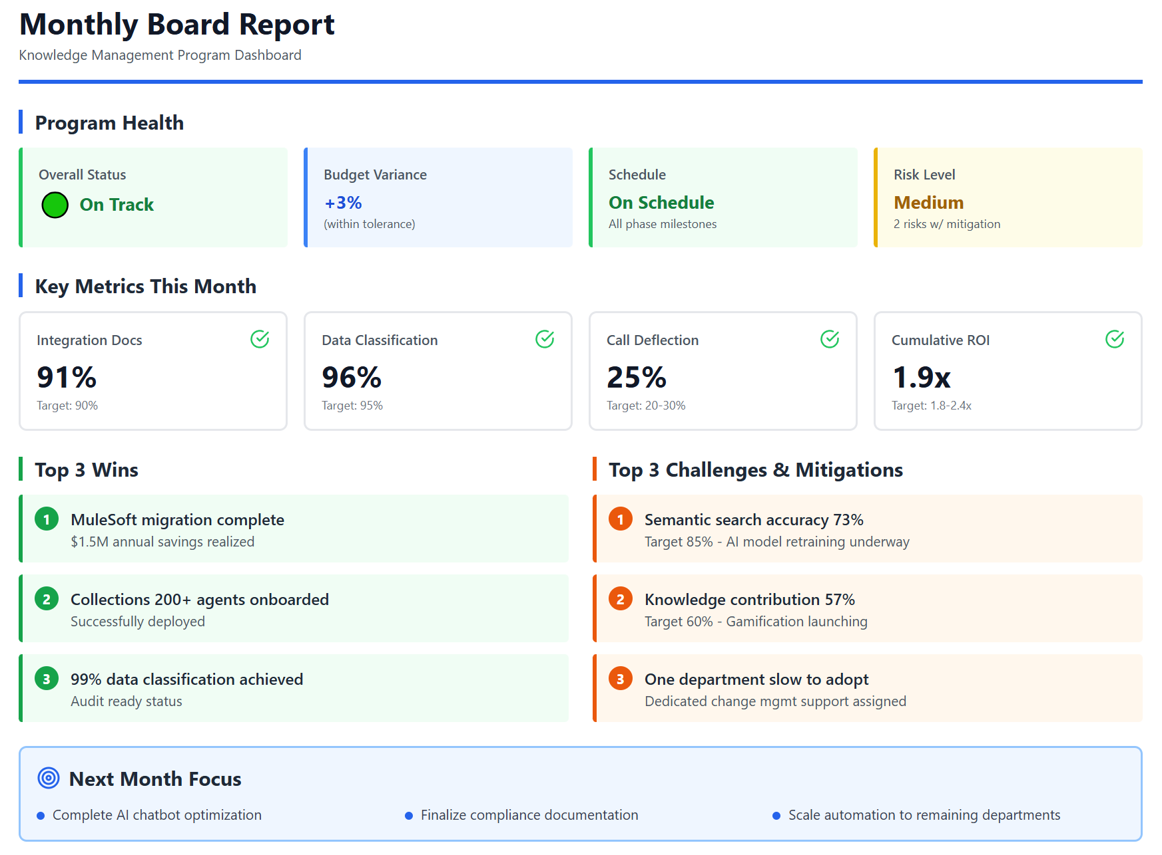

Conclusion: The Path Forward
The Knowledge Management Framework serves as an Integration Layer:
- Knowledge Management infrastructure serves as connective tissue across migrations.
- Federated search provides unified access regardless of underlying platform.
- Metadata and classification standards enable cross-platform AI applications.
- Data lineage tracking ensures visibility through migration transitions.
Stellantis Financial Services stands at a critical decision point. The organization's knowledge management challenges are not just operational inefficiencies; they represent fundamental threats to business continuity, regulatory compliance, and competitive viability. Six converging crises demand immediate action: Only 30-40% of enterprise integrations are documented; data classification sits at 70% versus a 99% regulatory requirement; key knowledge holders serve as irreplaceable bottlenecks; the planned expansion to 200+ Collections agents by 2026 cannot succeed without proper knowledge infrastructure.
The path forward requires a phased investment across three stages: Foundation Stabilization to capture critical tribal knowledge and deploy essential tools, Enterprise Integration to connect fragmented systems and scale capabilities, and Enhanced Operations to automate processes and achieve regulatory compliance.
Success means more than financial returns. Within 18 months, SFS will eliminate single points of failure that threaten operations, achieve 99% data classification compliance to satisfy regulators, successfully scale Collections operations by 10x, pass regulatory examinations without findings, and establish competitive parity with AI-enabled financial services firms. The organization will transform from fragmented, tribal knowledge dependence into an integrated, scalable, AI-enhanced enterprise capable of sustainable growth.
The window for proactive action is now, Q1 to Q2 2026. Every quarter of delay costs $600K-970K in lost productivity, increases risk exposure across all six crisis dimensions, and compounds the competitive disadvantage. Waiting six months puts Collections scaling at risk; waiting twelve months means dealing with regulatory findings, and a competitive gap requiring 2-3x the investment to close. This is not a choice between investing or not investing, it's a choice between proactive investment with positive returns or a reactive crisis spending under regulatory pressure with negative returns.
SFS possesses the organizational strengths required for success: committed executive leadership under CIO Phil Maternowski and CEO Tommy Moore, modern Azure/Fabric/Salesforce infrastructure already in place, established AI Governance Policy and compliance frameworks, deep subject matter expertise across the organization, and clear, quantifiable business drivers. The primary execution risks involve scaling limitations and coordination challenges, not fundamental capability gaps. With proper program management and the phased approach outlined here, SFS demonstrates high likelihood of successful execution.

Phase 2

Business Intelligence

Executive Summary
This assessment evaluates Stellantis Financial Services' Business Intelligence function for AI readiness, identifying immediate opportunities to enhance productivity through LLM-powered tools. Based on comprehensive interviews with BI leadership (Shandria Burden, Tricia Reed), Risk BI (Chuck), Data Management (Bobby Tobin), and supporting teams, we have identified significant opportunities in three primary areas: SQL code generation and optimization, report discovery and reuse, and conversational analytics.
Key Finding: The BI team spends the majority of report development time writing, evaluating, and optimizing SQL queries. AI-assisted code generation represents the highest-impact opportunity, with potential to reduce the current 10-day report turnaround target by 40-60%.
- Overall BI AI Maturity Rating
Dimension | Maturity | Assessment
AI Tool Adoption | Level 1 | Minimal exposure; no code generation tools deployed
Data Infrastructure | Level 2 | Fabric EDW in progress; still querying legacy sources
Knowledge Management | Level 2 | Self-created docs exist; no systematic discovery
Data Governance | Level 3 | Strong PII avoidance; aggregated metrics focus
Organizational Readiness | Level 3 | Team enthusiastic; leadership aligned on AI vision

Current State Analysis

Team Structure & Scope
Shandria Burden leads an 8-person centralized BI team that has been with SFS since its inception 4-5 years ago. The team serves as the primary reporting function for nearly all departments, handling both ad-hoc requests and scheduled production reports. Tricia Reed recently assumed a dual Managing Director role overseeing both BI and Forecasting, with responsibility for developing enterprise-wide KPI frameworks.

Technical Environment
- Primary Platforms: Tableau for visualizations, SAS for complex analytics, SSRS for scheduled distribution, SQL/Excel for ad-hoc requests
- Data Sources: Primarily querying source systems (D5 servicing with ~100 tables, Shaw, others) rather than the emerging Fabric EDW
- Development Environment: SQL Management Studio for most queries; Tableau custom SQL for embedded queries
- Future Direction: Power BI migration explored but stalled due to licensing costs; Fabric EDW adoption planned but timeline unclear

Key Pain Points Identified
- SQL Development Bottleneck
SQL development consumes the majority of report creation time. The team must understand complex business scenarios, navigate incomplete data dictionaries, handle duplicate prevention, and optimize performance. When asked what percentage of time is spent on SQL coding versus other tasks (aesthetics, requirements gathering), Shandria confirmed: "Most of the time it's been writing."
- Query Performance Issues
Long-running queries (30-40+ minutes) trigger IT alerts and block other processes. The team must carefully schedule report refreshes to avoid overwhelming infrastructure. They lack tools for pre-execution performance analysis or quality assurance beyond manual validation.
- Knowledge Fragmentation
No systematic way to discover similar existing reports or reuse query logic. Team members reach out via email when seeking similar work. The decision science team often requests queries to use as starting points. Data dictionaries from vendors are often incomplete, requiring significant tribal knowledge.
- EDW Migration Challenge
Q1 2026 target for EDW migration will require massive effort to migrate every report, code, and query to new data sources. Tricia noted this is "unglamorous but essential work where AI could potentially provide significant assistance."

AI Opportunity Assessment
Opportunity 1: AI-Assisted SQL Generation
Impact | HIGH - Addresses primary time consumer; potential 40-60% productivity gain
Complexity | MEDIUM - Requires schema integration, data dictionary enrichment, business logic encoding
Description | Schema-aware LLM that generates SQL from natural language descriptions, understanding table relationships, business logic, and common patterns. Includes query explanation, optimization suggestions, and error correction capabilities.
Key Components | (1) Natural language to SQL translation, (2) Query optimization recommendations, (3) Problematic query diagnosis and fixing, (4) Code documentation generation

Opportunity 2: Query Performance Analyzer
Impact | MEDIUM-HIGH - Reduces IT alerts, infrastructure strain, and analyst troubleshooting time
Complexity | MEDIUM - Requires access to execution plans, historical performance data, infrastructure metrics
Description | Pre-execution performance prediction tool that analyzes query structure, identifies potential bottlenecks, suggests optimizations, and estimates runtime. Helps less experienced team members write efficient code.

Opportunity 3: Conversational Analytics Interface
Impact | HIGH - Democratizes data access; reduces simple query requests to BI team
Complexity | HIGH - Requires robust EDW, semantic layer, governance guardrails, user training
Description | Natural language query interface allowing business users to ask questions about data without SQL expertise. Builds on existing Fabric agent PoC. Leverages data dictionary and metadata investments.

Opportunity 4: Report Discovery & Reuse Engine
Impact | MEDIUM - Eliminates duplicate work; accelerates new report development
Complexity | LOW-MEDIUM - Semantic indexing of existing reports and queries; similarity matching
Description | AI-powered semantic search across existing reports, queries, and documentation. Recommends similar reports when new requests arrive. Enables query logic reuse and promotes consistency.

Phase 1: Quick Wins (Weeks 4-9)
- Deploy GitHub Copilot for SQL development in SQL Management Studio. Investigate licensing with Nader/IT. Low barrier, immediate productivity boost.
- Build Schema-Aware SQL Assistant PoC using existing data dictionary and Fabric metadata. Start with EDW tables where documentation is strongest.
- Index Existing Reports for semantic search. Low complexity, enables discovery and reduces duplicate development.

Phase 2: Foundation Building (Q1-Q2 2026)
- Enrich Data Dictionary with business context, common query patterns, and relationship documentation. Critical foundation for all AI capabilities.
- Deploy Query Performance Analyzer integrated with BI development workflow. Pre-execution analysis, optimization recommendations.
- Support EDW Migration with AI-assisted code translation from legacy queries to new data sources.

Phase 3: Strategic Capabilities (Q3-Q4 2026)
- Productionize Conversational Analytics building on Fabric agent PoC. Start with well-governed EDW domains, expand gradually.
- Implement Automated Quality Assurance for report validation, anomaly detection, and consistency checking across platforms.

Appendix: Interview Sources
This assessment synthesizes findings from the following interviews:
- Shandria Burden - BI Team Lead (December 15, 2025)
- Tricia Reed - MD, BI & Forecasting (December 17, 2025)
- Chuck - Risk BI (December 12, 2025)
- Yu - BI Analyst (December 16, 2025)
- TJ Singh - PO AI Initiatives / Remarketing (December 23, 2025)
- Bobby Tobin - Data Discovery & Data Part II (December 3 & 11, 2025)
- Tony/Vik - Architecture Walkthrough (November 26, 2025)

Automated Testing

Executive Summary
Purpose
This report presents findings from the AI optimization assessment of SFS's Solutions Testing organization, conducted by Earley Information Science (EIS) during December 2025 through January 2026. The assessment examined current testing processes, pain points, existing AI tool usage, and opportunities for AI-enhanced automation.
Key Findings
Area | Finding
Team Structure | 49 total staff (40 manual, 9 automation); 75% contractors, 25% FTEs
Primary Challenge | Two-week sprint cycles with immediate production deployment create severe pressure on testing capacity
Current AI Maturity | Team has proactively adopted Microsoft Copilot for Gherkin test case generation with custom prompt template
Highest-ROI Opportunity | AI-driven test impact analysis to enable risk-based regression testing
Critical Bottleneck | 50% of automation engineer time spent on locator maintenance due to lack of standardized data-test-id attributes

Top Recommendations
- Mandate data-test-id attributes in UI development to reduce maintenance overhead
- Implement AI-driven test impact analysis as highest-priority initiative
- Enhance existing Copilot prompt with structured formatting and examples
- Shift automation left to QA environment for earlier defect detection
- Deploy AI-assisted user story validation for upstream quality improvement
Expected Outcomes
- 50% reduction in test locator maintenance time
- 30% faster test case generation through improved prompts
- 40% reduction in regression scope through intelligent test selection
- 25% fewer production defects through risk-based testing

Assessment Overview
Methodology
EIS conducted multiple discovery sessions with SFS testing leadership and practitioners:
Date | Session | Participants
Dec 17, 2025 | Testing Team Overview | Swarupa Kota, Stephen Kinnison, Geetha Gajavally
Dec 18, 2025 | Manual Testing Optimization | Corinne Anderson, Swarupa Kota
Jan 7, 2026 | Automated Testing Deep-Dive | Stephen Kinnison, Geetha Gajavally, Tyler Jones
Jan 28, 2026 | SDLC AI Opportunities | Deepak Khemchandani

Scope
The assessment covered:
- Manual and automated testing processes
- Current AI tool usage and workflows
- Testing tools and technical architecture
- Pain points and optimization opportunities
- Integration with development lifecycle
Stakeholders Interviewed
Name | Role
Swarupa Kota | Director, Solutions Testing
Stephen Kinnison | Manager, Automation Team (joined Oct 2025)
Corinne Anderson | Manager, Manual Testing
Geetha Gajavally | Senior Test Automation Engineer
Tyler Jones | Automation Engineer
Deepak Khemchandani | Lead, EPMO

Current State Analysis

3.1 Organizational Structure
The Solutions Testing organization sits under QA Lead Swarupa Kota and encompasses both manual and automation teams.
Manual Testing Team
- 40 personnel (including managers)
- Embedded within development scrum teams at 2:1 ratio with developers
- Led by Corinne Anderson
Automation Team
- 9 engineers
- Recently expanded from 3-person team
- Led by Stephen Kinnison (hired October 2025)
- Key technical lead: Geetha Gajavally
Staffing Model
- 25% full-time employees
- 75% offshore contractors
- Provides organizational flexibility but creates knowledge continuity challenges

Testing Scope and Responsibilities
Solutions Testing handles all in-house developed applications including:
Application Type | Examples
Salesforce-based | Agent Console (SF3), MySFS Customer Portal
Legacy (NSF) | Non-Salesforce applications
Data/BI | SQL work, Enterprise Data Warehouse
Integrations | APIs, Azure Integration Hub

Current Product Lines Under Test:
- Titles
- Agent Console (SF3)
- MySFS Customer Portal
- Remarketing
- Dealer Dash
- Commercial Lending
- Insurance (legacy, planning Salesforce migration)
- DOC Project (used vehicle remarketing)
- Lease Maturity Project (PWC-led, 7,000 test cases)

Excluded from Scope:
- AI evaluation frameworks for Genesis and back-office tools (owned by individual product teams)
- Third-party vendor sprint-level testing (vendors handle their own)

Technical Architecture and Tools
Category | Tools
UI Automation | Behave (BDD framework), Playwright
API Testing | Pytest, Requests
CI/CD | Jenkins
Reporting | Allure
Test Management | Spira Test
Version Control | Azure DevOps, Git
IDE | VS Code with Python
AI Tools | Microsoft Copilot (Office integration only)

Environments:
Dev → QA → Full Copy/Staging → UAT → Pre-Prod → Production

Current Automation Focus:
The automation team currently runs tests in Full Copy/Staging environment to avoid daily QA changes while building regression coverage. Future goal is running automation in QA environment concurrent with development.

Coverage Metrics
Application | Automation Coverage
MySFS | 41% of manual test cases automated
Overall (where automation exists) | 25-30%
Testing Focus | 80-85% UI, emerging API coverage

Salesforce enforces 70% unit test coverage before code exits Dev environment.

Critical Pain Points

Locator Management and Flaky Tests
Severity: Critical
This is the most significant daily challenge facing the automation team. Engineers spend approximately 50% of their time on test maintenance rather than new test development.
Root Cause: Development teams do not consistently implement standardized data-test-id attributes on UI elements, forcing automation engineers to rely on fragile CSS selectors, class names, element positions, or complex XPath expressions.
"Features change without adequate advance notice of new locators. Sometimes no unique identifiers exist, forcing brittle XPath usage."
— Swarupa Kota
Impact:
- Each morning begins with reviewing overnight Jenkins failures
- Significant effort to identify root cause (environment issue vs. locator change vs. actual defect)
- Framework updates cannot keep pace with UI changes before regression execution needed
Recommendation: Establish governance requiring developers to implement stable data-test-id attributes on all interactive UI elements before code can exit development.

Compressed Testing Timeline
Severity: Critical
The organization's transition to two-week sprint cycles with immediate production deployment creates severe pressure on testing capacity.
Current Workflow:
1. Test cases written during sprint
2. Execute in QA environment
3. Pass to UAT for business validation
4. Rerun in staging
5. Deploy to production
Problem: The team cannot perform comprehensive pass-two regression in QA due to bandwidth constraints, effectively using staging as their second test pass.
"This compressed timeline means fixes cannot be fully validated before promotion. The team must 'pray' that bug fixes don't introduce new issues, as there's no time for additional regression cycles."
— Testing Optimization Interview
Impact:
- Production becomes the ultimate validation environment
- Customer-reported issues drive hot fix cycles
- Hot fixes further strain testing resources

Test Execution Effort Imbalance
Severity: High
Metric | Current State | Target State
Test Planning | 40% | 60-70%
Test Execution | 60% | 30%

The imbalance is primarily driven by extensive bug retesting cycles and insufficient automation coverage.
"Test execution consumes 60% of effort versus the ideal 30%, primarily due to extensive bug retesting cycles."
— Testing Optimization Interview

Lack of Test Impact Analysis
Severity: High
The team lacks systematic tools to identify which test cases should execute based on code changes. Current process is entirely manual:
1. Developers or architects communicate change scope
2. QA leads interpret implications
3. Testers manually identify relevant test scenarios
Impact:
- Cannot implement true risk-based regression testing
- Either over-test (wasting resources) or under-test (missing defects)
- Cross-team coordination doesn't scale

Vague User Stories
Severity: High
User stories frequently lack sufficient detail and clarity, requiring extensive questioning and assumptions that propagate through test case generation.
"They're not as defined as we need them to be. Sometimes they don't contain all the information we need, and sometimes, many times they're very vague. We have to dig a lot deeper and ask a ton of questions."
— Corinne Anderson
Impact:
- AI-assisted test case generation outputs reflect input quality
- Development team design documents rarely attached to stories
- Extensive back-and-forth delays test case creation

Test Data Management
Severity: Medium
The team lacks dedicated test data management, leading to conflicts when multiple testing activities use the same accounts or data sets.
Impact:
- Shared user accounts modified by manual testers cause automation failures
- Cannot execute comprehensive validation in production due to PII restrictions
- Test data conflicts create false failures

Automation Handoff Timing
Severity: Medium
Automation handoff occurs only after functionality is live in production and business requirements are stable. The automation team cannot create automated tests within two-week sprint windows.
"Ideally, we want to be more involved in that process... we have initiatives or goals in 2026 to get to a place where code is developed in a Sprint. And then the very subsequent sprint, we would have automated the test that surrounds that."
— Stephen Kinnison

Current AI Usage Assessment

Microsoft Copilot for Test Case Generation
The manual testing team has proactively adopted Microsoft Copilot for Gherkin test case generation, demonstrating AI maturity and initiative.
Current Workflow:
1. Copy user story from Jira
2. Paste to Microsoft Copilot
3. Run custom prompt template
4. Receive Excel output
5. Manual cleanup and data addition
6. Import to Spira Test

What's Working:
- Standardized Gherkin format output
- Excel export matches approximately 80% of Spira import template
- Generates positive, negative, and alternate scenarios
- Team-wide adoption across manual testers
- Custom prompt template ensures consistency

Limitations:
- No integration with Jira or Spira (manual copy/paste required)
- Cannot access test data, account numbers, or environment details
- Output quality directly depends on user story quality
- Microsoft Copilot not available in development IDEs (only Office tools)
- Spira's built-in AI cannot be used (doesn't integrate with approved Copilot)
"We only have access to Microsoft Copilot, not GitHub Copilot... it's really hanging off of our office tool sets. So you can use it for some of the scaffolding, but it's a really poor fit for that world."
— Stephen Kinnison

AI Tool Constraints
Tool | Status | Limitation
Microsoft Copilot | Approved | Office integration only, not IDE
GitHub Copilot | Not Approved | Per SFS policy
Spira Built-in AI | Cannot Use | Doesn't integrate with Copilot
Claude | Under Consideration | Licensing pending

Copilot Prompt Analysis

Current Prompt (Provided by Corinne Anderson)
The current prompt used by the manual testing team is a single-block instruction that specifies persona, output format, testing types, priority definitions, and Excel column structure. While functional, analysis revealed several opportunities for improvement.

Strengths Identified
Strength | Benefit
Persona specification ("I" persona) | Ensures consistent voice across test cases
Explicit column ordering | Reduces manual reformatting for Spira import
Priority definitions included | Provides clear decision criteria for categorization
Testing type categorization | Ensures comprehensive coverage across test categories
Step 0 pattern for metadata | Smart workaround for Spira's import structure
"Validate" prefix requirement | Standardizes naming convention
User story # inclusion | Enables traceability

Issues Identified
- Issue 1: Prompt Overload (Cognitive Load Problem)
Problem: The prompt attempts too much in one pass, causing LLMs to deprioritize instructions buried in the middle.
Solution: Use structured, categorized formatting with clear hierarchy.
- Issue 2: Missing Application Context
Problem: The prompt assumes Copilot understands SFS's domain (auto finance, Salesforce, customer portals). Without context, generated scenarios are generic.
Solution: Add a context block specifying application, domain, platform, user types, and key data entities.
- Issue 3: No Examples Provided (Few-Shot Gap)
Problem: LLMs perform dramatically better with examples. The prompt provides no reference for what 'good' output looks like.
Solution: Include 1-2 complete scenario examples matching the exact Spira format.
- Issue 4: Ambiguous Expected Results Instruction
Problem: The instruction "add a - for any expected result that does not have a test step description" is confusing and causes inconsistent output.
Solution: Clarify with explicit rules: every step must have both description and expected result.
- Issue 5: Trailing Question Weakens Output
Problem: The prompt ends with "Are there more scenarios we can add to the excel sheet" which causes the model to either generate endless scenarios or add conversational responses.
Solution: Replace with explicit completion criteria (minimum scenarios, stop conditions).
- Issue 6: No Acceptance Criteria Extraction Step
Problem: The prompt jumps to scenario generation without first parsing the user story's acceptance criteria, leading to missed coverage.
Solution: Add multi-step process: extract AC, map to test types, generate scenarios.

Recommended Improved Prompt
A restructured prompt template has been developed that addresses all identified issues. The improved prompt uses a multi-step process (extract requirements, generate scenarios, format output), includes application context blocks, provides example output in the exact Spira format, defines data placeholders for test data, and specifies explicit completion criteria. The full prompt template is provided as a separate deliverable.
Expected Impact of Prompt Improvements
Metric | Expected Improvement
Output Consistency | 30-50% improvement
Manual Cleanup Time | 20-40% reduction
Test Coverage Completeness | 25% improvement
Rework/Regeneration Rate | 50% reduction

AI Opportunities Roadmap
Immediate Quick Wins (2-3 Months)
Initiative | Description | Impact | Effort
Enhanced Copilot Prompt | Deploy improved prompt with examples and structure | High | Low
Test Impact Analysis Pilot | Correlate code changes with required test execution using 20 sample stories | High | Medium
User Story Quality Validation | AI-assisted identification of vague or incomplete requirements | Medium | Low
Bug Pattern Analysis | Identify high-risk code areas requiring focused testing | Medium | Low
Root Cause Analysis Framework | AI-powered analysis for critical production defects | Medium | Medium

Medium-Term Initiatives (3-6 Months)
Initiative | Description | Impact | Effort
Jira to AI to Spira Pipeline | Integrated solution for automated test case generation | High | High
Pre-Deployment Merge Validation | Prevent production code overwrites through AI analysis | High | Medium
AI-Enhanced Test Case Review | Automated identification of coverage gaps | Medium | Medium
Regression Suite Recommendation | Risk-based test selection based on code changes | High | High
Automated Test Data Generation | AI-driven comprehensive scenario coverage | Medium | Medium

Strategic Transformation (6-12+ Months)
Initiative | Description | Impact | Effort
Self-Healing Locator Framework | AI-powered automatic locator updates when UI changes | Very High | Very High
Predictive Defect Analysis | Identify likely defect areas before testing begins | High | High
Autonomous Regression Selection | Fully automated risk-based test suite selection | Very High | Very High
AI-Powered Root Cause Analysis | Automated defect diagnosis and fix recommendations | High | High
Continuous Testing Intelligence | Real-time quality dashboards with AI insights | High | High

Recommendations
- Recommendation 1: Mandate data-test-id Attributes
Priority: Critical | Timeline: Immediate
Establish governance requiring developers to implement standardized data-test-id attributes on all interactive UI elements before code can exit development.
Rationale: This single change would reduce automation maintenance overhead by approximately 50%, freeing engineers to focus on new test development.
Implementation:
• Add to Definition of Done for all user stories
• Include in code review checklist
• Create automated linting rule to flag missing attributes
• Provide naming convention documentation
- Recommendation 2: Implement AI-Driven Test Impact Analysis
Priority: Critical | Timeline: 2-3 Months
Deploy AI-powered mapping between code changes and affected test cases to enable true risk-based regression testing.
Rationale: This is the highest-ROI opportunity identified. The five-day regression window was specifically called out by EPMO leadership as the top improvement target.
"The five-day regression testing window represents the highest opportunity for improvement through AI-driven automation."
— Deepak Khemchandani
Implementation:
• Pilot with 20 sample user stories and corresponding PRs
• Map code file changes to Spira test case coverage
• Build recommendation engine for regression scope
• Integrate with Jenkins for automated triggering
- Recommendation 3: Enhance Copilot Prompt Template
Priority: High | Timeline: Immediate
Deploy improved prompt with structured formatting, examples, and application context.
Rationale: Low-effort, high-impact improvement that can be implemented immediately with no tool procurement or integration required.
Implementation:
• Deploy recommended prompt structure
• Create application-specific context blocks for each product
• Build prompt library with variants for different testing types
• Measure output quality improvement over 2-week period
- Recommendation 4: Shift Automation Left
Priority: High | Timeline: 3-6 Months
Move automated testing from Full Copy/Staging environment to QA environment to run concurrent with development.
Rationale: Earlier defect detection reduces cost of fixes and prevents issues from reaching staging/production.
Implementation:
• Establish stable automation data sets in QA
• Implement environment state management
• Create notification system for environment changes
• Build sprint N+1 automation development process
- Recommendation 5: AI-Assisted User Story Validation
Priority: High | Timeline: 2-3 Months
Implement AI-powered analysis of incoming Jira stories to identify vague or incomplete requirements before test case generation begins.
Rationale: Upstream quality improvement cascades benefits through the entire testing process. Better inputs yield better AI-generated test cases.
Implementation:
• Create validation prompt for user story completeness
• Generate clarifying questions for product owners
• Establish quality score threshold for test case generation
• Integrate with Jira workflow
- Recommendation 6: Establish Dedicated Test Data Management
Priority: Medium | Timeline: 3-6 Months
Implement dedicated test data management to prevent conflicts across testing activities.
Rationale: Shared data causes false failures and wastes debugging time.
Implementation:
• Create isolated data sets per testing activity
• Implement data refresh automation
• Establish data ownership and reservation system
• Build synthetic data generation for sensitive scenarios

Implementation Roadmap
Phase 1: Foundation (Weeks 1-4)
Week | Activities
1-2 | Deploy enhanced Copilot prompt template
1-2 | Gather 20 sample user stories for test impact analysis pilot
1-2 | Document current test impact identification process
1-2 | Identify pilot application scope (recommend MySFS)
3-4 | Design test impact analysis POC architecture
3-4 | Measure prompt improvement results
3-4 | Initiate dev team alignment on data-test-id governance
3-4 | Define success metrics and baseline measurements

Phase 2: Pilot (Weeks 5-8)
Week | Activities
5-6 | Execute test impact analysis pilot with sample data
5-6 | Build Jira to Spira integration prototype
5-6 | Implement user story validation prompts
7-8 | Measure time savings and quality impact
7-8 | Document lessons learned and refinements
7-8 | Present findings and scale recommendations

Phase 3: Scale (Weeks 9-16)
Week | Activities
9-12 | Roll out test impact analysis to additional products
9-12 | Implement data-test-id governance
9-12 | Deploy Jira to AI to Spira pipeline
13-16 | Begin shift-left automation initiative
13-16 | Implement test data management
13-16 | Measure ROI and plan strategic initiatives

Success Metrics
Metric | Baseline | Target | Measurement Method
Locator maintenance time | 50% of automation effort | 25% of automation effort | Time tracking analysis
Test case generation time | Current average | 30% reduction | Spira timestamp analysis
Regression scope | Full regression | 40% reduction through risk-based selection | Test execution reports
Production defects | Current rate | 25% reduction | Defect tracking system
Automation coverage | 25-30% | 50% | Spira automation metrics

Appendix
Interview Participants
Name | Title | Sessions
Swarupa Kota | Director, Solutions Testing | Dec 17, Dec 18
Stephen Kinnison | Manager, Automation Team | Dec 17, Jan 7
Corinne Anderson | Manager, Manual Testing | Dec 18
Geetha Gajavally | Senior Test Automation Engineer | Dec 17, Jan 7
Tyler Jones | Automation Engineer | Jan 7
Nader Afshar | Product Owner, AI | Dec 17
Deepak Khemchandani | Lead, EPMO | Jan 28

Tools Inventory
Category | Tool | Purpose
Test Management | Spira Test | Test case management, traceability
Project Management | Jira | User stories, defect tracking
UI Automation | Playwright | Browser automation
BDD Framework | Behave | Gherkin test execution
API Testing | Pytest, Requests | API validation
CI/CD | Jenkins | Test orchestration
Reporting | Allure | Test results visualization
Version Control | Azure DevOps, Git | Code management
AI | Microsoft Copilot | Test case generation

- Environment Architecture
The testing environment pipeline flows through six stages: Development (unit testing, 70% coverage required for Salesforce), QA (manual testing, future automation target), Full Copy/Staging (current automation target), UAT (business validation), Pre-Prod (DevOps validation), and Production.
- Key Quotes from Interviews
"Most significant challenge is self-healing locators. Automation engineers spend considerable daily effort identifying failed tests, finding new working locators for changed elements, and updating framework."
— Swarupa Kota, Director, Solutions Testing
"The team must 'pray' that bug fixes don't introduce new issues, as there's no time for additional regression cycles."
— Testing Optimization Session
"The five-day regression testing window represents the highest opportunity for improvement through AI-driven automation."
— Deepak Khemchandani, EPMO Lead
"I just spent hours and hours and hours in Copilot, just going through running different scenarios and say, OK, this scenario looks good. Let me take this little piece and I kept taking little pieces and building them together."
— Corinne Anderson, on developing the prompt template
"Ideally, we want to be more involved in that process... we have initiatives or goals in 2026 to get to a place where code is developed in a Sprint. And then the very subsequent sprint, we would have automated the test that surrounds that."
— Stephen Kinnison, Manager, Automation Team

SDLC Recommendations

SDLC Workflow Engine

The Vision

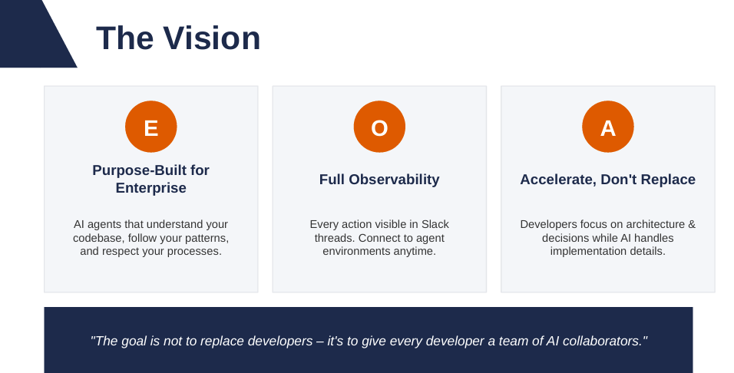

System Architecture
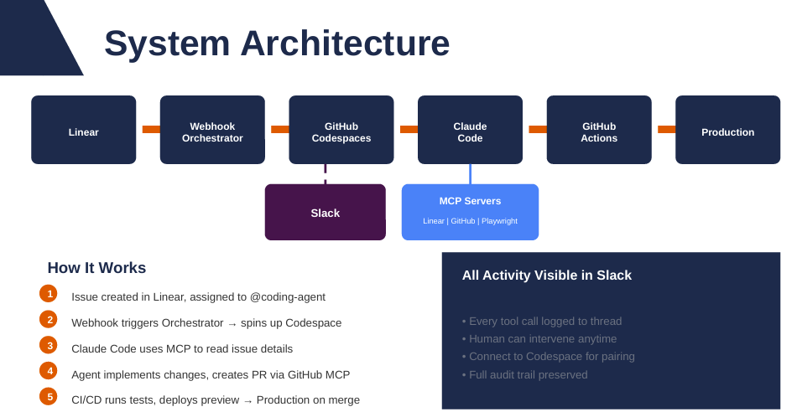

Scalable Infrastructure
Deterministic CI/CD + Dynamic Environments = Unlimited Scale

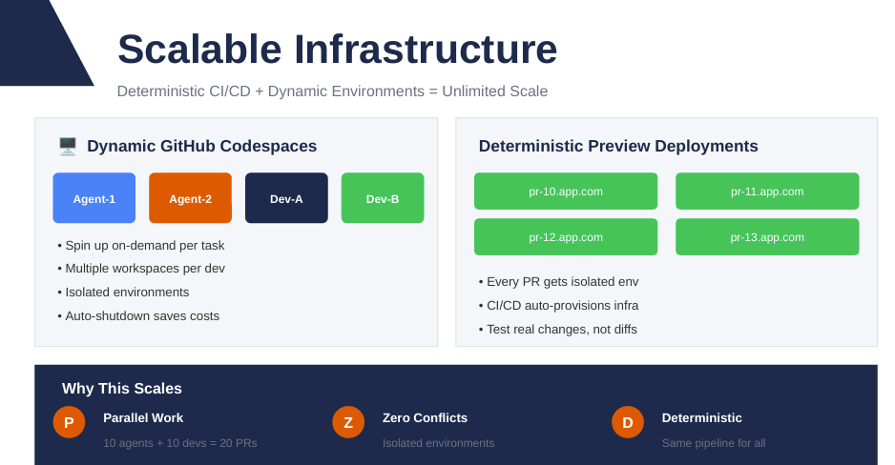

Workflow Flexibility
Three paths to production, choose based on task complexity

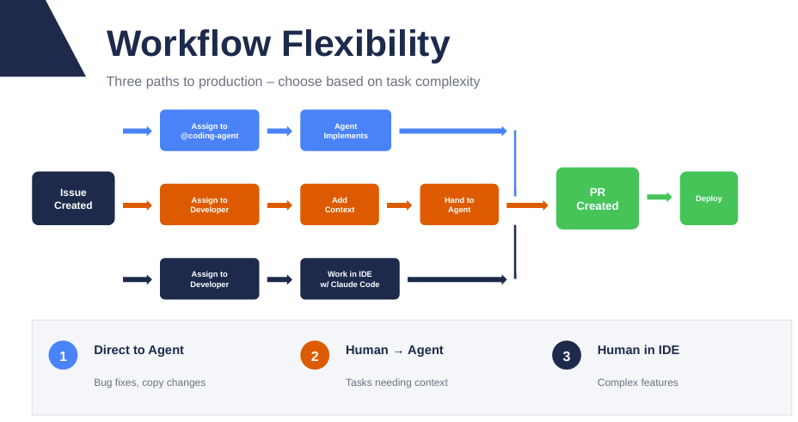

Demo 1: Bug Fix – Linear Issue
PM creates issues, assigns to @coding-agent

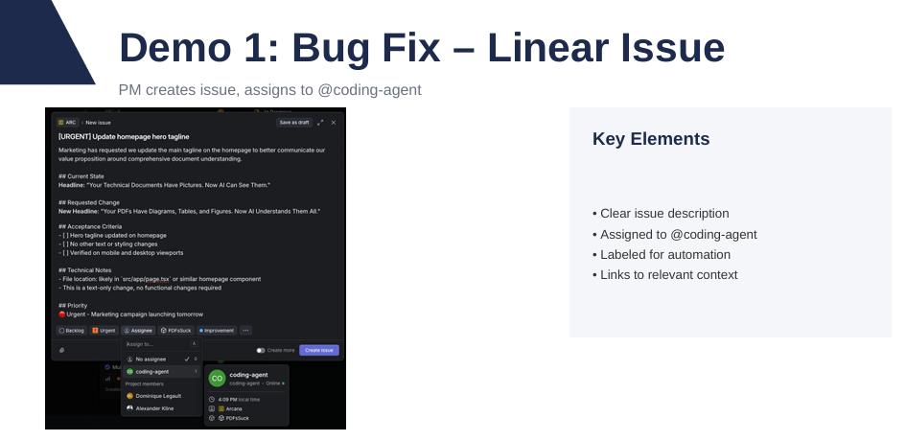

Step 2: Automatic Slack Thread
Linear integration posts to Slack – single thread for all activity
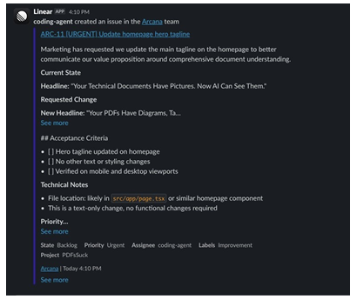

Step 3: Agent Reads & Plans
Claude Code analyzes the issue and plans the fix
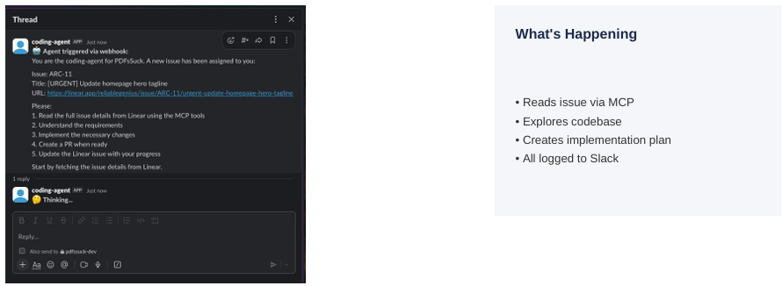

Step 4: Implementation
Agent writes code following existing patterns
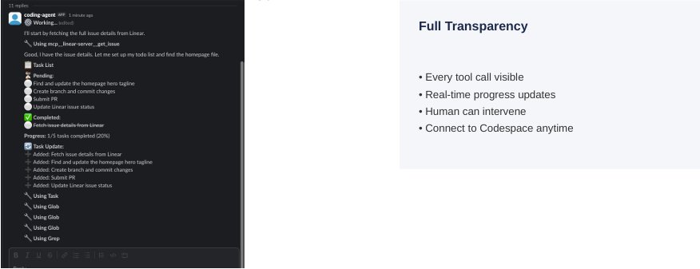

Step 5: Pull Request Created
Agent creates PR with detailed description
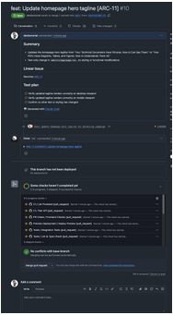

Step 6: CI/CD & Preview
Automated tests run, preview deployment created

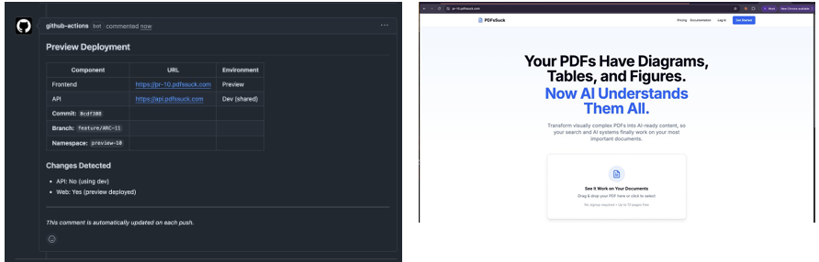

Step 7: Review & Merge
Human reviews, approves, and merges

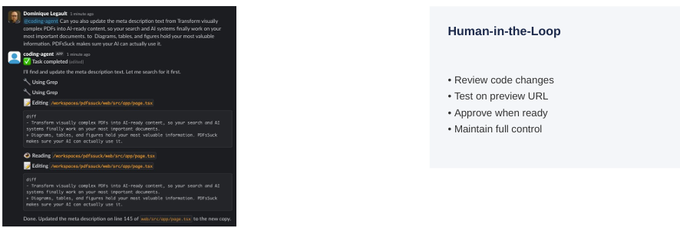

Step 8: Production Deploy
Changes automatically deployed to production

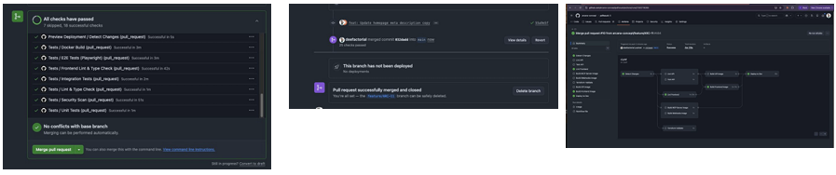

Bug Fix: 12 Minutes Total
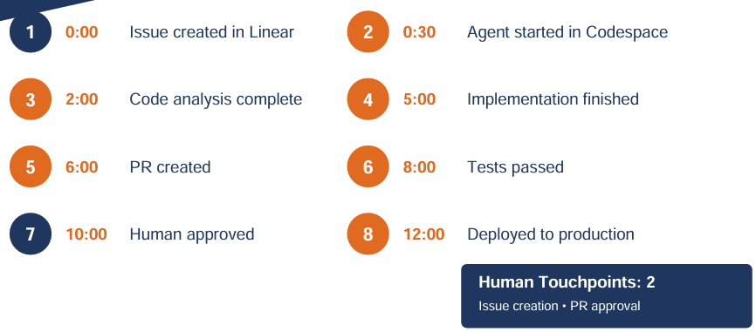

Feature Development
Activity Timeline Component

Step 1: Feature Issue in Linear
Developer creates detailed feature request
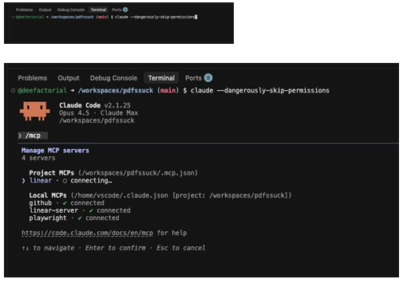

Step 2: Agent Session Starts
Claude Code begins feature implementation
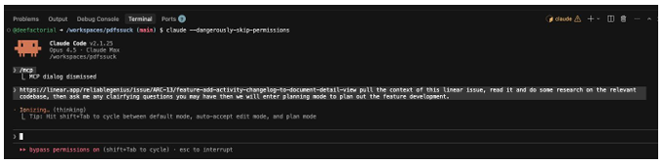

Step 3: Component Implementation
Building the Activity Timeline component
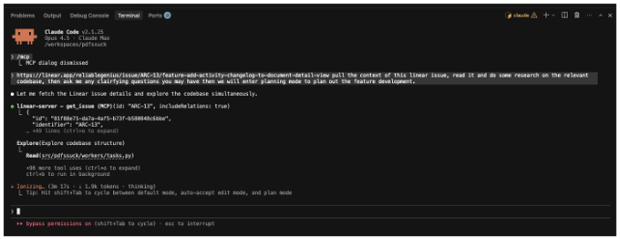

Step 4: Human Clarification
AI asks questions, human provides guidance
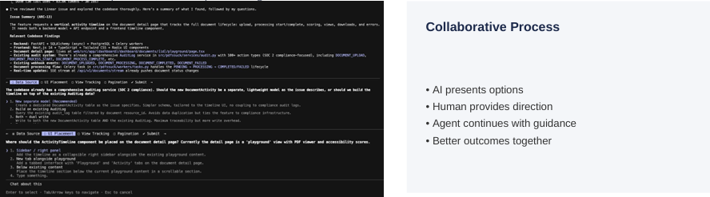

Step 5: Full Implementation
Agent implements all 7 phases of the feature
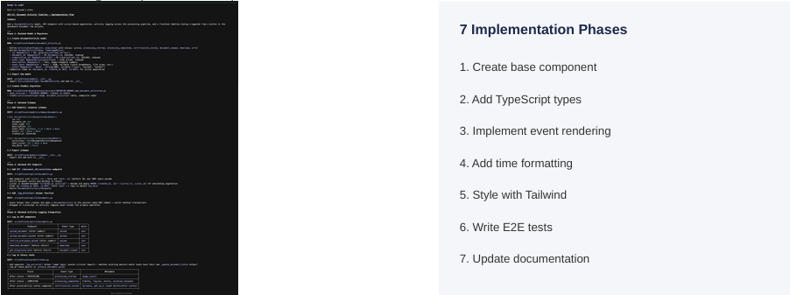

Step 6: Code Review Request
PR ready for human review
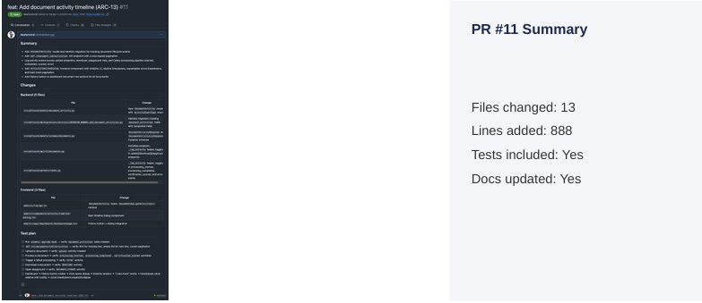

Step 7: Manual Testing – Empty State
Timeline show no activity initially

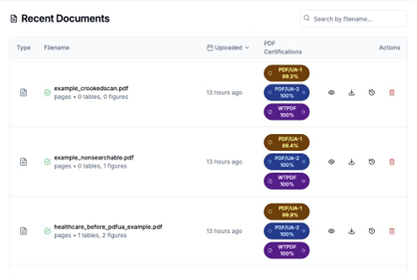

Step 7.1: Upload & Processing
Events appear as document processes
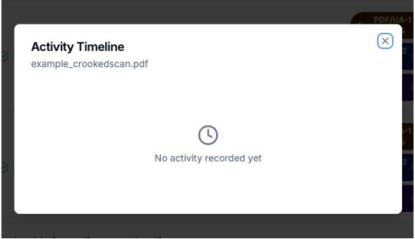

Step 7.2: Scoring Complete
Certification score displayed
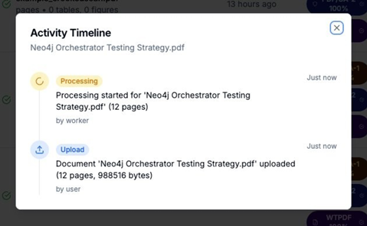

Step 7.3: Score Details Expanded
Full scoring breakdown visible
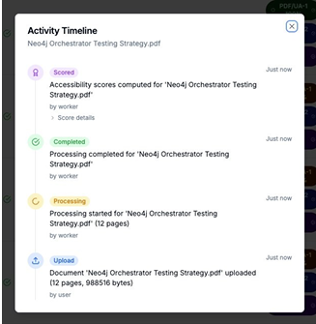

Step 8: All Checks Pass
CI/CD complete, ready to merge
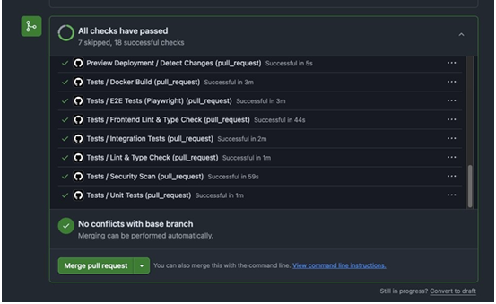

Feature: ~30 Minutes
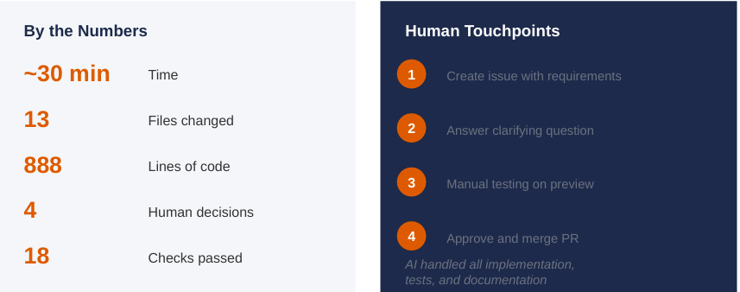

Extending Across the SDLC
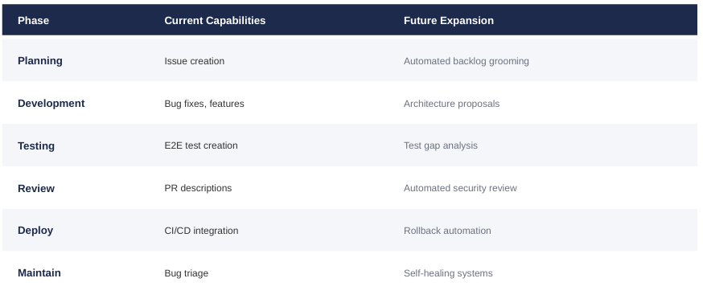

What this means for SFS
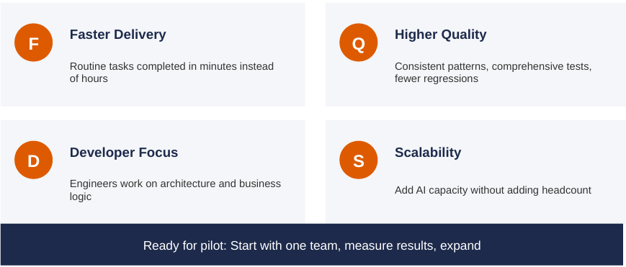

SDLC Report (Phil)
Proposed structure, please adjust as necessary
1. Introduction & Scope
Purpose and Objectives
Document Conventions
Stakeholders and Roles (including Salesforce Admins, Architects, Data Engineers, Integration Developers)
Governing Standards and Compliance Requirements

2. Salesforce Development Lifecycle
Org Strategy & Environment Management — Sandbox hierarchy (Dev, QA, UAT, Prod), scratch orgs, org shapes
Configuration vs. Customization Standards — When to use declarative tools vs. Apex/LWC
Release & Deployment Management — Change Sets vs. CI/CD pipelines (Salesforce DX, Copado, Gearset)
Metadata Management — Version control strategy, metadata types, package-based development
Apex & LWC Development Standards — Coding guidelines, governor limits, trigger frameworks
Testing Standards — Unit test coverage requirements, test data strategy, regression testing
Salesforce Security Review — Profiles, permission sets, field-level security, sharing rules

3. Integration Lifecycle
Integration Architecture & Patterns — Event-driven, request/reply, batch; ESB vs. iPaaS vs. point-to-point
API Design & Governance — REST/SOAP/GraphQL standards, versioning, naming conventions
Middleware & Platform Management — MuleSoft, Boomi, Azure Integration Services, etc.
Authentication & Security — OAuth, JWT, API keys, certificate management
Error Handling & Retry Logic — Dead-letter queues, alerting, fault tolerance patterns
Integration Testing — Contract testing, mock services, end-to-end testing protocols
Monitoring & Observability — Logging standards, dashboards, SLA/SLO definitions

4. Data Lifecycle
Data Architecture & Modeling — Conceptual, logical, and physical data models; entity relationships
Data Governance — Ownership, stewardship, data quality standards, lineage tracking
Data Ingestion & ETL/ELT Pipelines — Batch vs. streaming, pipeline design, tooling standards
Master Data Management (MDM) — Golden record strategy, deduplication, matching rules
Data Quality & Validation — Profiling, cleansing rules, acceptance criteria
Data Security & Privacy — PII handling, masking, encryption, GDPR/CCPA compliance
Data Testing & Reconciliation — Row counts, checksums, business rule validation
Data Migration Standards — Source-to-target mapping, cutover planning, rollback procedures

5. Cross-Cutting Concerns
Requirements & Traceability — User stories, acceptance criteria, RTM (Requirements Traceability Matrix)
Change Management & Version Control — Git branching strategy, PR/review process, change control board
DevOps & CI/CD Pipeline — Build, test, and deploy automation across all three domains
Documentation Standards — Technical specs, runbooks, data dictionaries, API catalogs
Incident & Defect Management — Severity classification, SLA for resolution, post-mortems
Performance & Scalability Testing — Load testing, governor limit analysis, data volume benchmarks

6. Governance & Compliance
Audit Trails & Logging — Field history tracking (Salesforce), integration logs, data audit tables
Regulatory Compliance — SOX, GDPR, CCPA, industry-specific requirements
Review Gates & Approvals — Phase gate criteria, sign-off matrix

Phase 3

Results Synthesis
Results Synthesis | Pilot results analysis  ROI calculations  Lessons learned documentation  Success story compilation | Week 10 | Quantified benefits  Clear success metrics  Documented learnings
There was no pilot, there are no ROI, lessons learned, nor success stories for the pilot. Thomas recommends to remove this section and include the ROI for the proposed future projects into the roadmap.

Technology Recommendations (Sanjay)
Technology Recommendations | Best-in-class tool recommendations  "What you're not thinking about" analysis  Budget and resource requirements  Risk mitigation strategies | Week 10-11 | Technology selection criteria  Vendor recommendations  Implementation priorities

Proposed framework (change as needed)

Best-in-Class Tool Recommendations
Organized by capability domain rather than a flat list, so the reader understands why each tool is recommended in context. Suggested sub-groupings:
- AI/ML Platforms — Model development, training, and deployment
- Data & Analytics Infrastructure — Data platforms, pipelines, and governance tools
- Knowledge Management & Search — Enterprise search, RAG frameworks, knowledge graphs
- Integration & Orchestration — API management, workflow automation, agent frameworks
- Productivity & Copilot Tools — End-user AI assistants and embedded AI in existing systems
Each tool entry should include a brief rationale, fit score against the client's context, and any notable trade-offs vs. alternatives.

"What You're Not Thinking About" Analysis
This is the high-value differentiator section — EIS's perspective on overlooked or underestimated factors. Structured as a set of insight statements, such as:
- Data Readiness as a Prerequisite — Most organizations underestimate how much data remediation is required before AI delivers value
- Knowledge Architecture Debt — Unstructured content and poor taxonomy slow AI performance significantly
- Shadow AI Risk — Employees are already using AI tools outside of sanctioned platforms
- Model Governance & Drift — Production models degrade over time without active monitoring
- Vendor Lock-in Exposure — Over-reliance on a single hyperscaler limits optionality as the market evolves
- Change Fatigue — Technology deployment outpacing organizational absorption capacity

Budget & Resource Requirements
Broken into three views:
- Total Cost of Ownership (TCO) — Licensing, infrastructure, implementation, and ongoing maintenance
- Resource Requirements — Internal FTEs, skill gaps requiring hiring or upskilling, and vendor/partner support
- Phased Investment Model — Aligned to the 12-month roadmap phases (Foundation → Pilot → Scale), showing where spend is concentrated and when ROI begins to materialize
A simple table or tiered view (Low / Medium / High investment scenarios) works well here for executive audiences.

Risk Mitigation Strategies
Structured as a risk register with mitigation actions, covering:
- Technology Risk — Vendor viability, integration complexity, platform immaturity
- Data Risk — Quality, privacy, regulatory compliance (GDPR, CCPA, industry-specific)
- People Risk — Skills gaps, adoption resistance, dependency on key individuals
- Operational Risk — Model failure, hallucination, unintended automation outcomes
- Strategic Risk — Misalignment between AI investments and business priorities
Each risk entry should have a likelihood/impact rating and a corresponding mitigation or contingency action.

12-Month Roadmap (Phil/Sanjay)
(Proposed Structure, adjust as needed)
This section needs coordination
Roadmap Development | 12-month AI transformation roadmap  Document processing strategy  Scaling recommendations Phase 2 project definition | Week 11-12 | Approved roadmap  Clear next steps  Budget estimates

Executive Summary (Phil)

Current State Assessment (People, Process, Technology baseline) (Phil)
(Quick summary of current document to algin to People, Process, Technology)

AI Vision & Strategic Objectives (Phil)

People & Organizational Readiness (Roles, skills, governance, change management) (Phil)

Process Transformation (AI-enabled workflows, process redesign priorities) (Phil)

Technology Architecture & Enablers (Platforms, infrastructure, data readiness) (Phil)

Proposed AI Projects & Use Cases (Prioritized initiative portfolio with owners and outcomes) (Sanjay’s list)

12-Month Implementation Roadmap (Phased timeline, milestones, dependencies) (Phil/Sanjay)

Scaling Strategy & Governance (CoE model, scaling criteria, risk & compliance) (Sanjay)

Investment, Success Metrics & ROI (Phil)

