STELLANTIS FINANCIAL SERVICES

API-Orchestration-Strategy

From Assessment to Action: Transforming SFS into an AI-Ready Organization

February 2026
Prepared by Earley Information Science


Contents
1 Phase 1 3
1.4 Technical Architecture 3
1.4.1 API Orchestration Strategy 3

Phase 1

Technical Architecture

API Orchestration Strategy

Executive Summary

Strategic Context
- 18-month migration window (MuleSoft → Azure APIM)
- 65 APIs, hundreds of endpoints to migrate
- Emerging AI/agentic capabilities require governance framework
- Cost attribution critical for sustainable AI adoption

Key Recommendations
- Align orchestration strategy with Azure migration to embed governance and observability from day one
- Implement cost tracking infrastructure for both traditional APIs and AI/token consumption
- Establish patterns for agentic system management before proliferation occurs
- Position MCP as future integration layer for AI agent interoperability

Orchestration Pattern Overview

Available Patterns
- API Gateway: Centralized control plane, policy enforcement, single entry point
- Event-Driven/Pub-Sub: Async communication, decoupling, batch friendly
- Service Mesh: Sidecar pattern for microservices (awareness only)
- Choreography vs. Orchestration: Distributed vs. centralized coordination
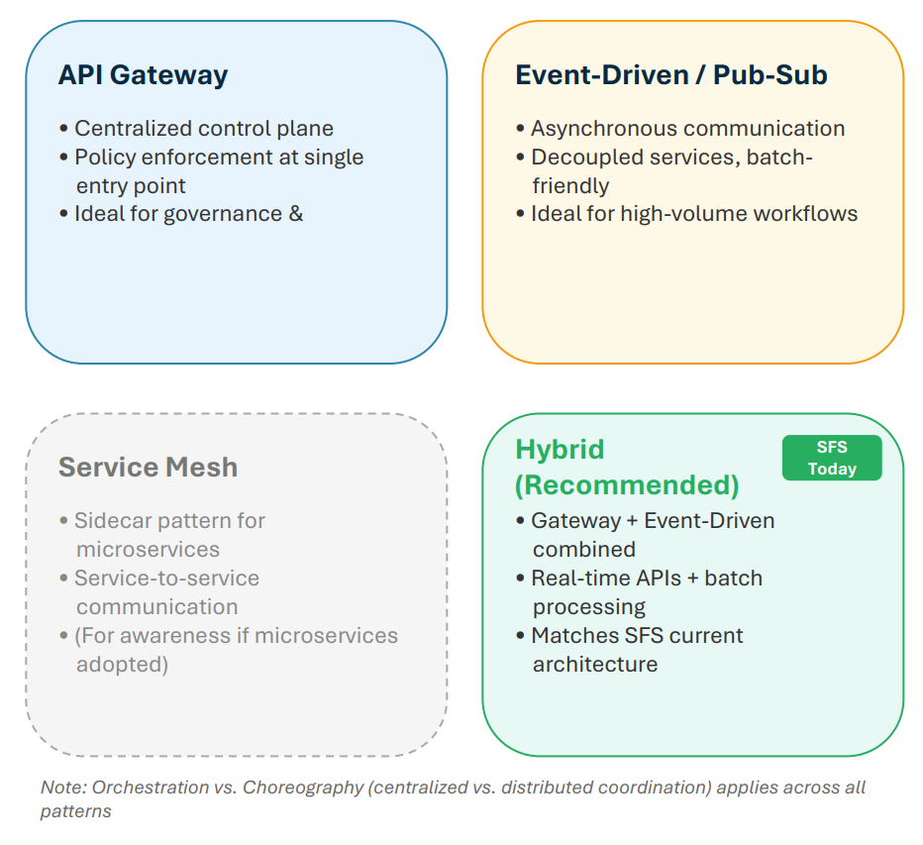

Decision Rubric: Choosing the Right Pattern
SFS Recommendation
- Hybrid (Gateway + Event-Driven) aligns with current architecture and future needs
- Gateway for real-time API management and governance
- Event-Driven for batch processes and Salesforce Platform Events
- Service Mesh: Monitor if microservices adoption increases
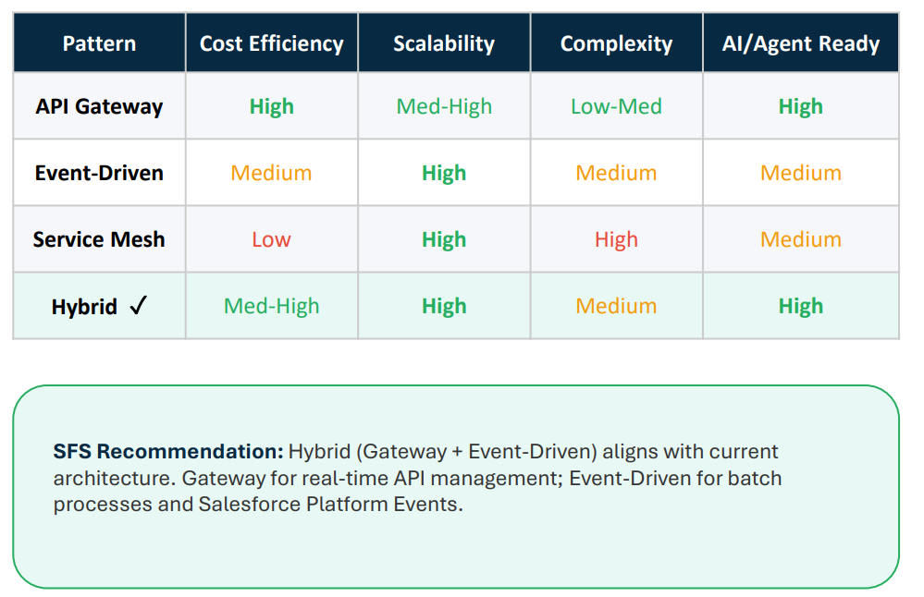

Cost & Scalability Fundamentals
Cost Drivers
- Compute: Request processing, transformation
- Data Transfer: Egress, cross-region movement
- Third-Party APIs: Pass-through costs (FICO, RDN, Datascan, etc.)
- Token/AI Consumption: Emerging and growing cost center
- Storage: Logs, cache, audit trails

Scalability Levers
- Stateless Design: Enable horizontal scaling
- Caching Strategies: Reduce redundant API calls
- Rate Limiting & Throttling: Protect backends, manage costs
- Async/Queue-Based: Absorb batch processing spikes

Azure APIM Capabilities Mapped to SFS Needs
Additional Capabilities
- Developer Portal → API discovery, future agent registry
- Products & Subscriptions → Segment by business unit
- Policy Expressions → Request/response transformation
- Named Values & Backends → Centralized configuration

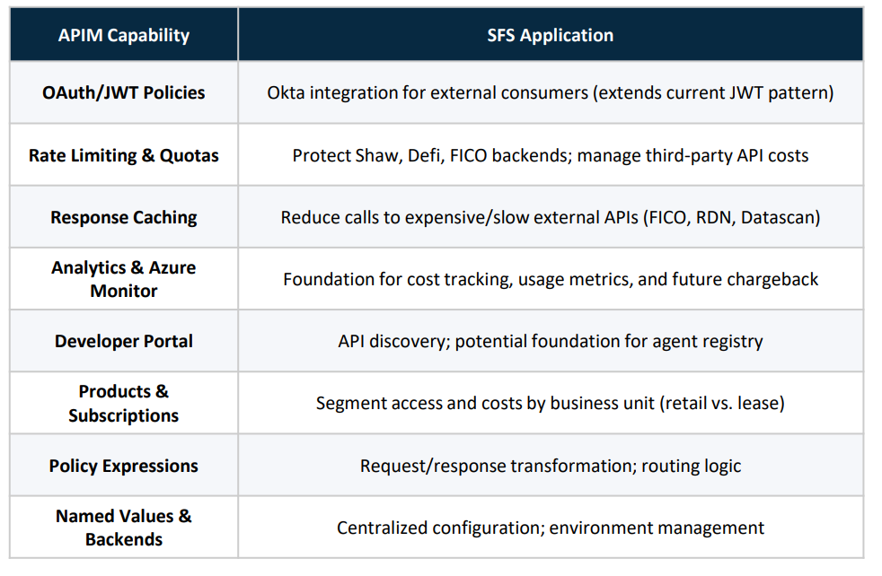

MuleSoft to Azure APIM: Key Considerations
Migration Mapping
- Policies: MuleSoft policies → APIM policy expressions (similar concepts, different syntax)
- API Layers: Experience/Process/System → APIM Products/APIs/Backends
- Authentication: Both support OAuth/JWT; APIM adds native Azure AD
- Monitoring: Anypoint Monitoring → Azure Monitor + App Insights
Lessons from Pilot
- Early investment in Azure platform configuration pays dividends
- DNS, certificates, RBAC setup require upfront planning
- Establish patterns before bulk migration
- Detailed comparison available in Appendix

Process Layer Compute Options

Azure Compute Options for Orchestration Logic
- Azure Functions: Stateless, event-driven, pay-per execution; good for simple transforms
- Durable Functions: Long-running workflows, stateful orchestration, fan-out/fan-in
- Logic Apps: Visual designer, 400+ connectors; per-action pricing can add up
- .NET APIs: Full control, team expertise; you manage hosting
- Container Apps: Containerized workloads, auto-scaling; more infra to manage
Decision Framework
Stateless → Functions | Stateful → Durable Functions | Visual/Connectors → Logic Apps | Full control → .NET


- Process layer logic → .NET APIs hosted in Azure
- APIM as gateway layer (auth, rate limiting, caching)
- Business logic and transforms in .NET code
- Azure Service Bus for reliability patterns
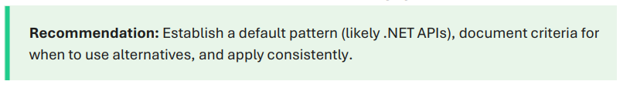

Process Layer Compute Options
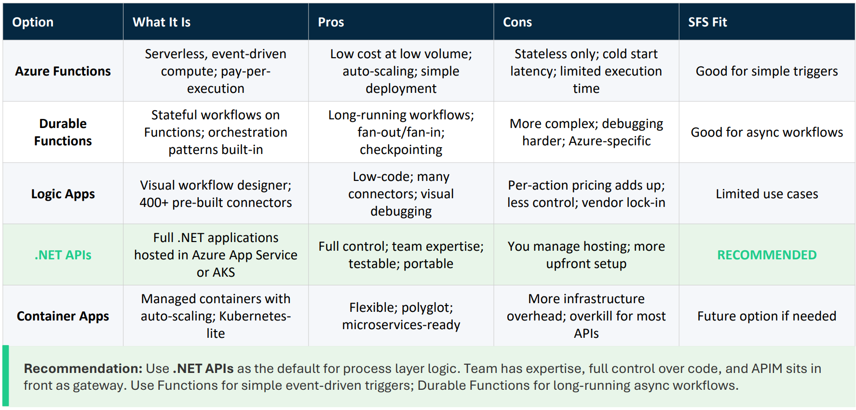

Cost Monitoring

Cost Monitoring Architecture
Monitoring Touchpoints by Layer
- Experience Layer: Consumer attribution (who's calling), use case tagging, business unit mapping
- Process Layer: Orchestration metrics, transformation costs, caching effectiveness
- System Layer: Backend call counts, third-party API costs (FICO, RDN, Datascan), response times
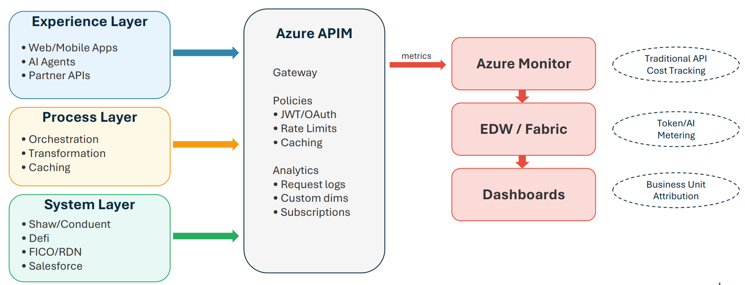

Traditional API Cost Tracking
Key Metrics to Capture
- Request counts by consumer, endpoint, time period
- Response times and latency percentiles (p50, p95, p99)
- Error rates and failure patterns
- Data transfer volumes (egress costs)
- Third-party API call counts and costs
Implementation Approach
- APIM Analytics: Built-in metrics, request logging, subscription tracking
- Azure Monitor: Custom dimensions for business attribution
- Custom Tags: Business unit, cost center, backend system
- Critical: Tag during migration to avoid costly backfill later

AI/Token Tracking Patterns
Three Metering Patterns
- Pattern 1: Gateway Proxy: Route all AI requests through APIM; captures model, tokens, caller, use case; enables rate limiting and cost caps
- Pattern 2: SDK Wrapper: Lightweight wrapper at application level; works for embedded AI like Einstein; less centralized visibility
- Pattern 3: Async Metering: Fire-and-forget to event hub; aggregation in data warehouse; enables near-real-time dashboards
SFS Recommendation
- Primary: Pattern 1 (Gateway Proxy) for centralized AI requests
- Aggregation: Pattern 3 for warehouse-level analytics
- Fallback: Pattern 2 where gateway not feasible (Einstein)
- Note: Genesys uses token-based consumption model - align tracking

AI/Token Tracking Patterns
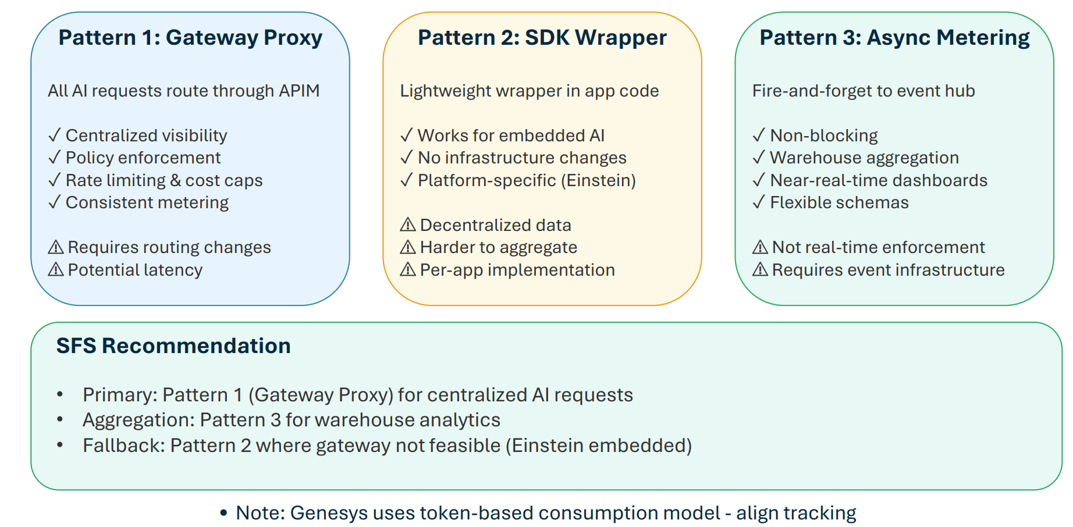

Chargeback Foundation
Building Blocks for Cost Allocation
- Consumer Identification: Map requests to business units (retail vs. lease), cost centers, applications
- Service Categorization: Distinguish AI/token costs from traditional API costs
- Usage Aggregation: Roll up to meaningful reporting periods and dimensions
- Cost Allocation Model: Direct attribution vs. shared services allocation
Design Principle
- Capture granular data now, decide allocation model later
- SF already segments costs by call center and tracks third-party APIs (Google services)
- Token costs may double or triple as AI subsidies end - track for ROI validation
- Business units should demonstrate ROI to fund AI capabilities

Agentic Management

The Agentic AI Management Challenge
Emerging Requirements
- Discovery: How do consumers find available AI agents and capabilities?
- Registration: How are new agents onboarded with appropriate metadata?
- Authorization: Who can invoke which agents with what data access?
- Observability: How do we monitor agent behavior, costs, and outcomes?
- Governance: How do we ensure compliance and audit trail?
Parallels to API Management Evolution
- API management matured from ad-hoc to governed over 10+ years
- Agentic systems face similar lifecycle: discovery → registration → governance
- Opportunity: Apply API lessons proactively before proliferation
- Scope: Primarily AI agents, but patterns apply to RPA (UiPath) and business rules engines

Decision Engines in the Agentic Landscape
SFS Decision Engines
- FICO Decision Modeler: Credit decisioning, collections strategies
- Remarketing Decision Engine: Pricing optimization, channel routing, business rules (FICO platform)
- Future: Pricing optimization, termination models, reconditioning decisions
Special Considerations
- Not quite APIs, not quite AI agents - deterministic rule/model-based systems
- May need special treatment: latency-sensitive, highstakes, strict versioning/audit
- Can be 'tools' that AI agents invoke via API layer

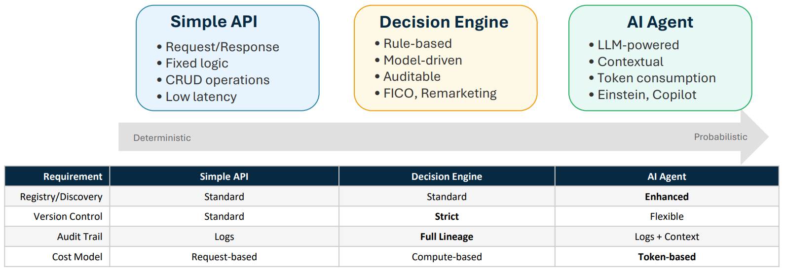

Agent Registry Patterns
Registry Metadata
- Identity: Name, description, owner, version
- Capabilities: What can this agent do? Input/output schemas
- Cost Profile: Expected token consumption, compute costs
- Compliance: Data access classification, PII handling, audit requirements
- Status: Active, deprecated, testing, approved platforms

Implementation Options
- Option 1: Extend APIM Developer Portal catalog (low effort, near-term)
- Option 2: Dedicated registry service (richer features, medium-term)
- Option 3: MCP-native discovery (if MCP adopted)
- Recommendation: Start manual/extended APIM during pilots; evaluate dedicated registry as scale grows

Agent Orchestration Patterns
Three Orchestration Models
- Centralized Orchestrator: Single conductor coordinates all agents; easier monitoring/audit; potential bottleneck
- Federated/Peer-to-Peer: Agents communicate directly; flexible and scalable; harder to govern
- Domain Orchestrators + Light Coordination: Domainspecific orchestrators with thin cross-domain layer
SFS Recommendation
- Pattern 3 (Domain Orchestrators) aligns with SFS direction
- Domain examples: Compliance, Customer Service, Remarketing, Collections
- Supports “specialized bots for compliance” approach already discussed
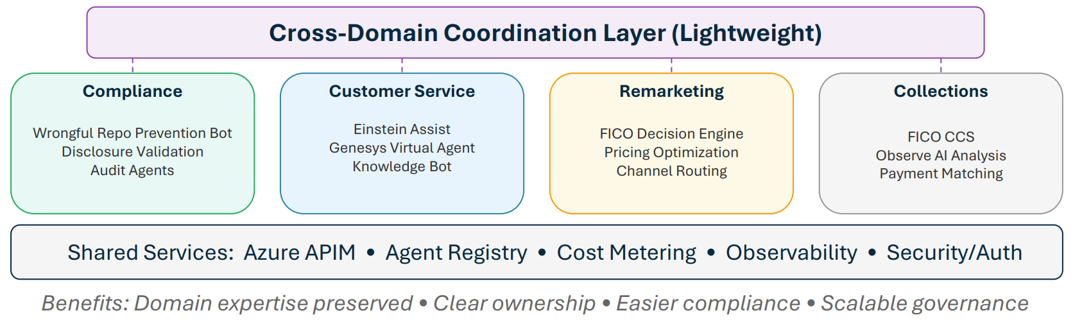

Architecture: Without MCP
Key Components
- AI Platforms: Einstein, Azure AI, Genesys
- Gateway: Azure APIM with policies, analytics, developer portal
- Backends: Shaw, Defi, FICO, Salesforce, EDW
- Observability: Azure Monitor → Fabric/EDW → Dashboards

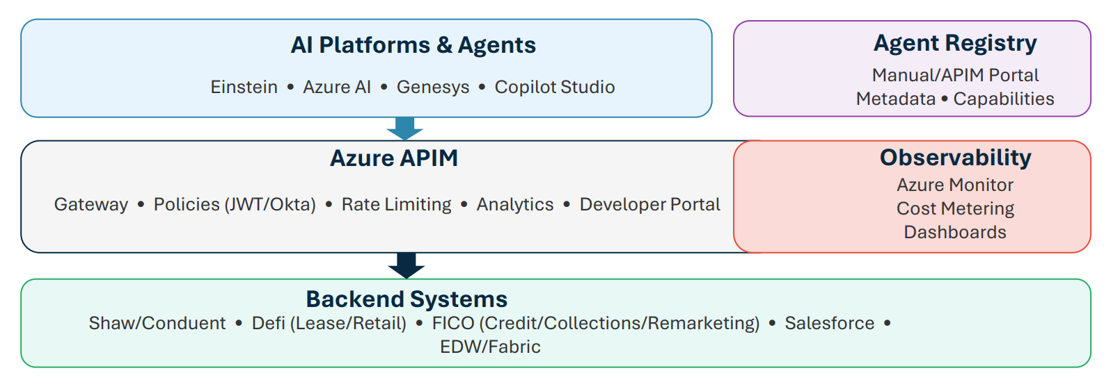

Architecture: With MCP
MCP Value Proposition
- Multiple AI platforms (Einstein, Azure AI, Genesys) → fragmentation risk
- MCP provides common protocol layer for tool discovery and invocation
- Incremental deployment possible - doesn't require big-bang adoption
- Detailed MCP coverage in Section 5

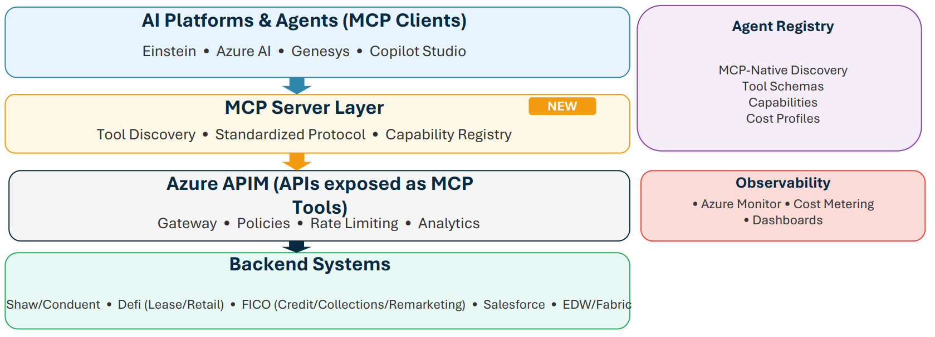

SFS Recommendations
Phased Implementation Roadmap

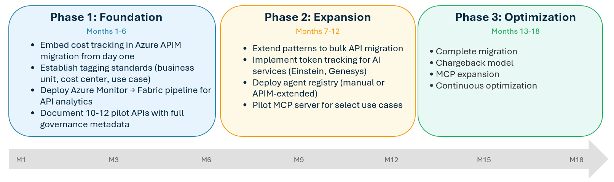
Key Milestones
- M3: Pilot APIs complete
- M6: Patterns documented
- M12: 50% APIs migrated
- M18: Migration complete (before MuleSoft license expiry )

Integration with Azure Migration
Leverage Migration Momentum
- MuleSoft → Azure APIM migration is the forcing function for governance
- Each migrated API is an opportunity to add: cost tags, policies, observability hooks
- Establish patterns with pilot 10-12 APIs, then scale
- Target: 18-month completion (buffer before MuleSoft license expiry)

Avoid Retrofit Costs
- Retrofit cost tracking after migration = 3-5x more expensive
- Lessons from pilot: DNS, certificates, RBAC require upfront investment
- Build governance into migration checklist, not as afterthought
- Document patterns for EA team to validate and replicate

Platform Readiness Checklist

Prerequisites (from Pilot Lessons)
- DNS: Routes configured; coordination with Stellantis/Europe complete
- Certificates: Automated renewal in place for all environments
- RBAC: Roles defined for API developers, DevOps, service accounts
- Network: Connectivity verified to all backends (Shaw, Defi, FICO, SF)
- CI/CD: Pipeline templates tested with initial APIs
- Monitoring: Azure Monitor → Fabric pipeline operational
- Environments: Dev/QA/UAT/Prod APIM instances provisioned Note: Pilot revealed DNS (3-4 week delay), RBAC, and certificate automation as key infrastructure gaps to address upfront.
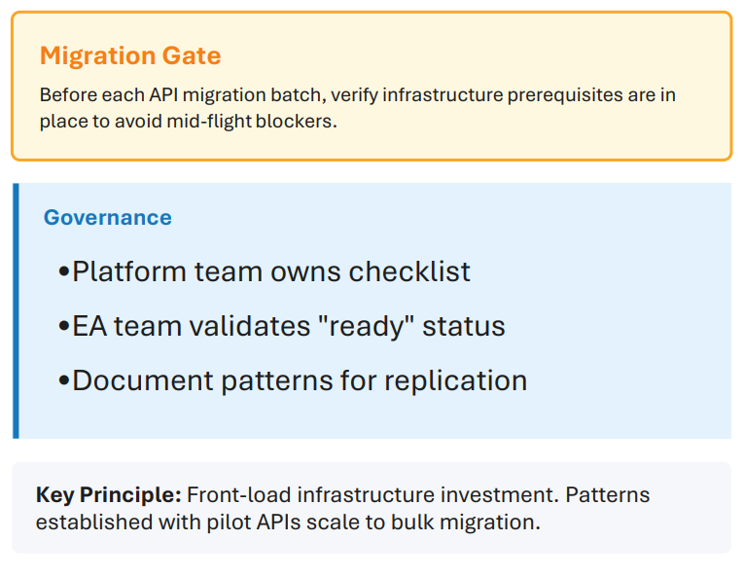
Quick Win Opportunities
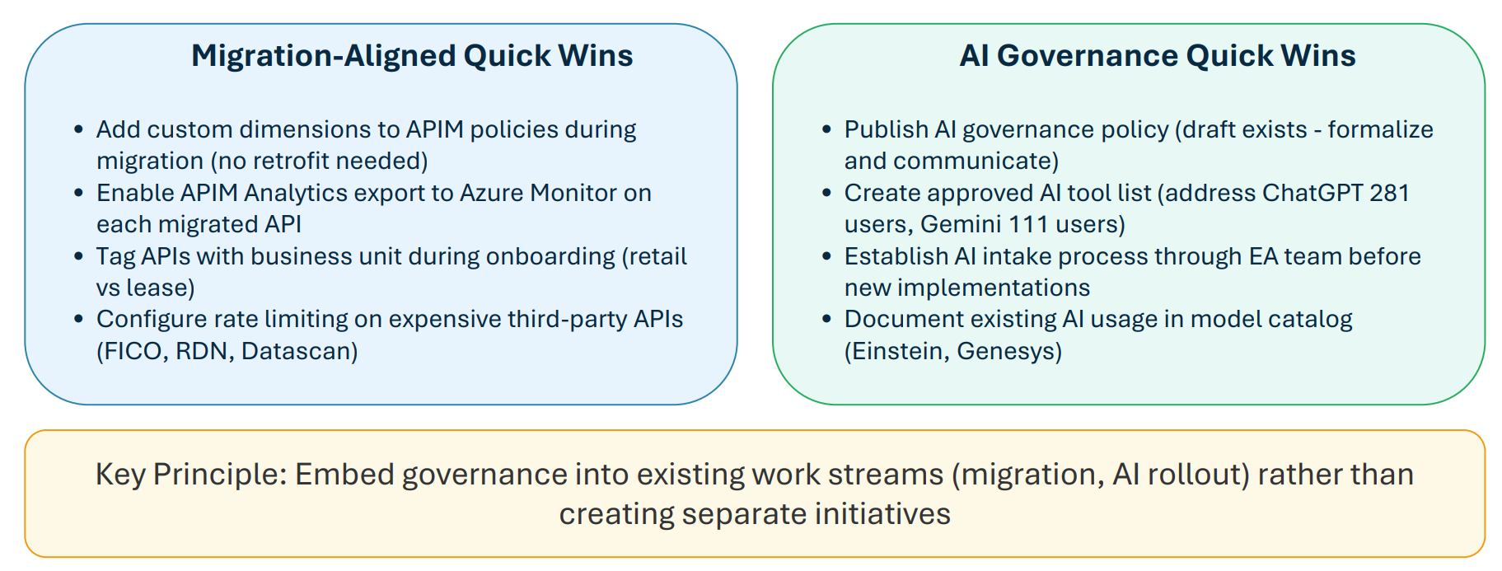

Governance Framework Principles
Governance Model
- EA team as approval gate for new AI implementations (Vik, Larry, Puru)
- Domain-specific AI/agents owned by business but governed centrally
- Specialized bots for compliance-critical operations (e.g., wrongful repo prevention)
- All new AI deployments require: cost projection, ROI case, data access review
Key Stakeholders
- Larry Burgess: Infrastructure, Genesys SOW, platform decisions
- Vik Chopra: Enterprise Architecture, AI governance,
- Puru Naktode: AI architecture, reference patterns
- Nader Afshar: AI Product Owner (new role - needs EA integration)

Appendix: Sources
Industry Statistics
- 80% risky agent behaviors: McKinsey, Oct 2025
- 40%+ projects canceled: Gartner, June 2025
- 25-36% have governance: AllAboutAI/AuditBoard, 2025
- 51% negative incidents: McKinsey State of AI, Nov 2025

Platform Announcements
- Genesys MCP/A2A: BusinessWire, Sept 2025
- Salesforce Agentforce MCP: SF Dev Blog, June 2025
- Azure MCP/A2A: Microsoft Azure Blog, Sept 2025
Internal Sources
- EPMO Interview, December 2025
- SFS AI Governance Policy v1.0

Appendix: Glossary
- Orchestration Terms
- API Gateway: Centralized entry point for API traffic with policy enforcement
- APIM: Azure API Management - Microsoft's API gateway and management platform
- MCP: Model Context Protocol - standard for AI-to-tool communication
- Orchestration: Centralized coordination of service interactions
- Choreography: Distributed coordination where services react to events
- AI/Agent Terms
- Agentic AI: AI systems that can take autonomous actions toward goals
- Token: Unit of text processed by LLMs (roughly 4 characters)
- Decision Engine: Rule/model-based system for automated decisions (e.g., FICO)
- RAG: Retrieval-Augmented Generation - combining search with LLMs

Appendix B: MuleSoft to Azure APIM Comparison
- Migration Lessons
- DNS configuration required European coordination (3-4 week delay)
- Certificate management: automated renewal added during fix
- RBAC roles needed to be created before migration could proceed
- 7-8 endpoints migrated in 7-8 months; patterns now established

