STELLANTIS FINANCIAL SERVICES

MCP OPPORTUNITIES

From Assessment to Action: Transforming SFS into an AI-Ready Organization

February 2026
Prepared by Earley Information Science


Contents
1 Phase 1 3
1.4 Technical Architecture 3
1.4.2 MCP Opportunities 3

Phase 1

Technical Architecture

MCP Opportunities

MCP Deep Dive

What is MCP?
Model Context Protocol Overview
- Open standard for connecting AI models to external data and tools
- Developed by Anthropic, adopted by growing ecosystem
- Standardizes how AI agents discover and invoke capabilities
- Analogous to how USB standardized peripheral connections
Why It Matters for SFS
- Multiple AI platforms (Einstein, Azure AI, Genesys) = fragmentation risk
- Without standard: each platform requires custom integration
- With MCP: unified protocol for tool discovery and invocation
- Future-proofs against AI platform changes

MCP Architecture Concepts
Core Components
- MCP Server: Exposes capabilities (tools, resources, prompts) via standard protocol
- MCP Client: AI application that discovers and invokes server capabilities
- Tools: Functions the AI can call (e.g., 'get_customer_info', 'submit_payment')
- Resources: Data the AI can access (documents, databases, APIs)

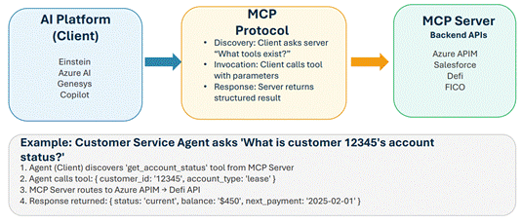

MCP Server Implementation Options
Option A: Gateway-Level MCP
- MCP Server sits in front of Azure APIM
- Automatically exposes all APIM APIs as MCP tools
- Centralized: one MCP server, many tools
- Pro: Single point of governance
- Con: May be bottleneck
Option B: Domain-Level MCP
- Multiple MCP servers per domain (Compliance, Collections, etc.)
- Each domain team owns their MCP server
- Pro: Distributed ownership, domain expertise; Con: Coordination overhead
- Aligns with Domain Orchestrator pattern recommended for SFS

Mapping SFS APIs to MCP Tools
High-Value MCP Tool Candidates
- Customer lookup (Salesforce customer master)
- Account status check (Defi lease/retail)
- Payment processing (Shaw/Conduent)
- Credit decision (FICO Decision Modeler)
- Vehicle valuation (remarketing decision engine)

Tool Schema Example
- Name: 'get_customer_account_status'
- Description: 'Retrieve current status of customer account'
- Input: { customer_id: string, account_type: 'lease' | 'retail' }
- Output: { status, balance, next_payment_date, ... }

MCP Implementation Considerations
Adoption Considerations
- MCP is emerging - not yet universally supported by all AI platforms
- Einstein, Azure AI have native tool-calling; MCP adds interop layer
- Start with pilot: one domain, one MCP server, evaluate friction
- MCP doesn't replace API - still need APIM policies, auth
SFS Recommendation
- Position MCP as strategic direction, not immediate requirement
- Design APIs to be 'MCP-ready' (clear schemas, consistent patterns)
- Pilot in 2025 with single domain (e.g., Customer Service)
- Re-evaluate as ecosystem matures and AI platform support grows

Non-MCP Alternatives
Platform-Native Tool Calling
- Azure AI: Function calling with JSON schemas
- Einstein: Apex actions, Flow invocations
- Genesys: Bot flows, data actions
- Pro: Native, supported; Con: Platformspecific, no interop

API-First Without MCP
- Well-documented APIs in APIM Developer Portal
- OpenAPI/Swagger specs as tool definitions
- Manual integration per AI platform
- Viable near-term; MCP becomes value-add if multi-platform AI grows

MCP Security
MCP: Increases Audit Surface, Not Attack Surface
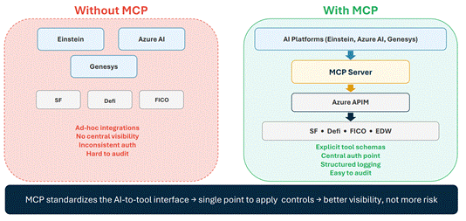

MCP Security Considerations

Risk Categories
- Over-permissioned tools: AI granted excessive backend access
- Authorization gaps: Inconsistent auth across AI-to-API calls
- Prompt injection via tools: Malicious content manipulates AI behavior
- Audit trail complexity: Multi-hop calls harder to trace
- Cost/rate runaway: AI makes excessive calls quickly

Why MCP Helps (Not Hurts)
- Permissions become explicit via tool schemas - easier to audit than ad-hoc integrations
- Centralizes integration point - apply auth once at MCP server, not per-integration
- Same risk exists in any AI tool-calling; MCP standardizes where to apply validation
- Structured tool invocations with defined schemas - more auditable than unstructured calls
- Single place to enforce rate limits and quotas Thesis: MCP increases audit surface, not attack surface

Thesis: MCP increases audit surface, not attack surface

SFS Security Mitigation Approach
Leverage Existing Controls
- Azure APIM policies still apply - MCP sits behind gateway
- Okta/JWT auth unchanged - MCP inherits API authentication
- Azure Monitor captures all calls - add MCPlayer context
- Rate limiting at gateway - apply AI-specific tiers
- RBAC in Azure - extend to MCP server deployments

Add MCP-Specific Guardrails
- Tool allowlists per AI agent (principle of least privilege)
- Human-in-the-loop for sensitive operations (payments, repo actions)
- Version pinning for MCP server dependencies
- Internal-only MCP servers (no third-party MCP)
- Explicit tool schema review before deployment Key principle: MCP is an additional visibility layer that plugs into existing controls

Key principle: MCP is an additional visibility layer that plugs into existing controls

SFS Security Controls: MCP Fits Your Existing Model
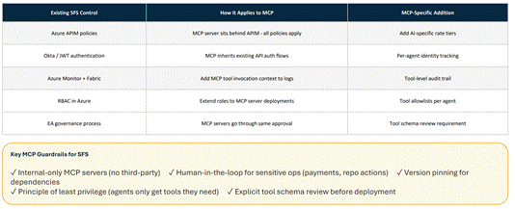

Appendix

Appendix A: Glossary
Orchestration Terms
- API Gateway: Centralized entry point for API traffic with policy enforcement
- APIM: Azure API Management - Microsoft's API gateway and management platform
- MCP: Model Context Protocol - standard for AI-to-tool communication
- Orchestration: Centralized coordination of service interactions
- Choreography: Distributed coordination where services react to events
AI/Agent Terms
- Agentic AI: AI systems that can take autonomous actions toward goals
- Token: Unit of text processed by LLMs (roughly 4 characters)
- Decision Engine: Rule/model-based system for automated decisions (e.g., FICO)
- RAG: Retrieval-Augmented Generation - combining search with LLMs

Appendix B: MuleSoft to Azure APIM Comparison
Migration Lessons
- DNS configuration required European coordination (3-4 week delay)
- Certificate management: automated renewal added during fix
- RBAC roles needed to be created before migration could proceed
- 7-8 endpoints migrated in 7-8 months; patterns now established

