STELLANTIS FINANCIAL SERVICES

AGENT-LIFECYCLE-MANAGEMENT-APPROACH

From Assessment to Action: Transforming SFS into an AI-Ready Organization

February 2026
Prepared by Earley Information Science


Contents
1 Phase 1 3
1.4 Technical Architecture 3
1.4.3 Agent Lifecycle Management Approach 3

Phase 1

Technical Architecture

Agent Lifecycle Management Approach

Executive Summary

Purpose
Provide SFS with a comprehensive framework for managing AI agents from ideation through decommissioning — across Azure, Genesys, and Salesforce platforms.
Key Recommendation
Adopt a platform-agnostic lifecycle approach with unified governance principles, while leveraging MCP/A2A as the emerging interoperability standard.
Why Now
Industry data shows 80% of organizations have encountered risky AI agent behaviors, and 40%+ of agentic AI projects are predicted to fail by 2027.
Foundation
This framework builds on SFS's existing AI Governance Policy v1.0, addressing operational gaps while preserving established accountability structures.

Why Agent Lifecycle Management Matters
Industry Statistics
- 80% of organizations have encountered risky behaviors from AI agents Source: McKinsey, Oct 2025
- 40%+ of agentic AI projects will be canceled by 2027 Source: Gartner, June 2025
- Only 25-36% of organizations have formal AI governance frameworks Source: AuditBoard/Pacific AI, 2025
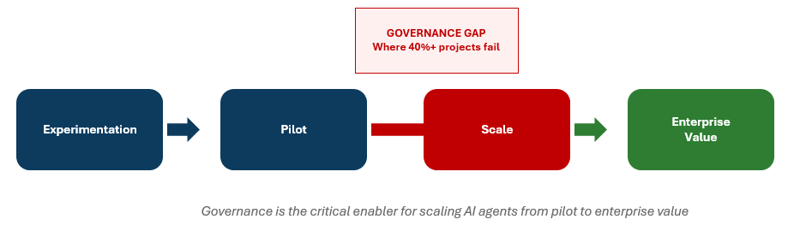

What is an "Agent" at SFS?
Scope Definition
For lifecycle purposes, an "agent" includes any AI-powered system that:
- Interacts with users (customers or employees)
- Makes or supports decisions
- Operates with some degree of autonomy
- Consumes tokens, compute, or API calls
This includes systems built in-house AND configured within vendor platforms.
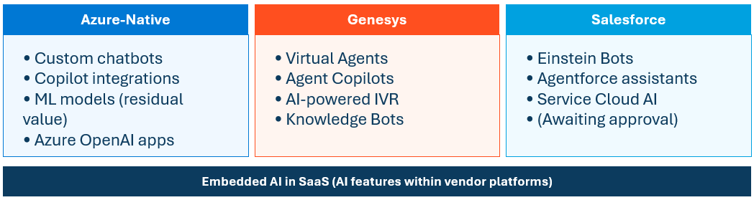

Why a Unified Framework?
Proliferation Risk
Platform-native agents (Genesys bots, Einstein assistants) are easier to deploy than custom-built systems. Without unified governance, they may bypass oversight.
Compliance Consistency
The same customer data, the same regulatory requirements (CFPB, fair lending, privacy) apply regardless of which platform hosts the agent.
Cost Visibility
Token consumption and compute costs span multiple platforms. Without unified tracking, SFS cannot attribute costs by business unit or demonstrate ROI.
Interoperability Readiness
The industry is converging on MCP/A2A standards. A unified framework positions SFS to orchestrate agents across platforms.

SFS AI Governance Policy v1.0 — Current Foundation
Lifecycle Stages Defined
- Design & Development
- Testing & Validation
- Deployment & Monitoring
- Decommissioning
Accountability Structure
- CDO ultimately responsible for all AI
- AI Steering Committee approval required

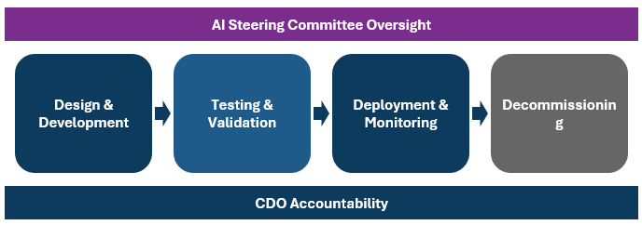

Governance Reality — How It Works Today
AI Steering Committee
- Meets every 6-10 weeks
- Includes key executives, architects, interested parties
- Ryan Miller coordinates
Maturity Level
- Process "hasn't been pressure tested yet" — team expects edge cases as agent deployments scale.
Procurement Integration
- Allison not formally in committee, but "nothing gets signed without her" — practical stopgap for tool acquisition governance
Existing Practices Worth Formalizing
- Rene's champion-challenger validation
- Mark Segarra's model governance team
- ARB reviews in EPMO discovery
Source: EPMO Interview, Dec 2025

Gaps in Current Policy
What's Missing
- Agent/Model Registry — No visibility into what exists
- Version Control & Rollback — No standards
- Champion-Challenger — Ad hoc (Rene's team only)
- Drift Detection — No thresholds or automation
- Performance SLAs — "Monitored" undefined
Additional Gaps
- Cost Attribution — No token/compute tracking
- Human-in-the-Loop — No risk-tiered requirements
- Incident Response — No AI-specific playbook
- Vendor AI Coverage — Genesys, Einstein unclear
- Interoperability — No MCP/A2A preparation

Recommended Lifecycle Framework
Key Principles
- Agent Registry as system of record throughout
- Risk tier determines governance requirements
- Defined gates, artifacts, and accountability at each stage
- AI Steering Committee touchpoints at key stages
- CDO accountability spans all stages

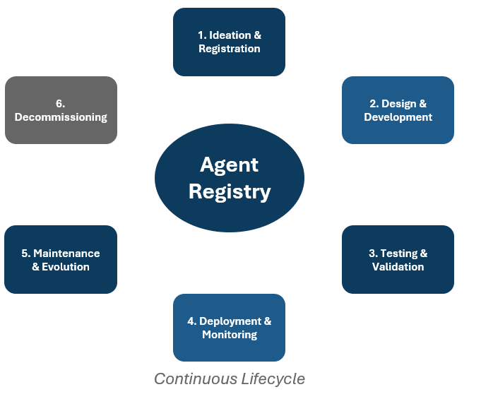

Stage 1: Ideation & Registration

Register in Agent Catalog
- Agent name and description
- Business owner and technical owner
- Platform (Azure, Genesys, Salesforce)
- Planned data sources
- Target users (customer-facing vs. internal)
Document Business Case
- Problem, expected outcomes, alternatives

Governance Touchpoints
- AI Steering Committee: Notify for Tier 1-2
- EPMO: Initiate intake process
- Procurement: Engage if vendor tool required
Artifacts Produced
- Agent registration form
- Business case document
- Risk tier assignment

Stage 2: Design & Development
Environment Standards
- Lower environments: Contributor access, no prod data
- Higher environments: Restricted access, audit logging
Documentation Requirements
- Purpose, scope, data inputs, decision logic
- Expected behaviors and known limitations
- Guardrails and constraints
Technical Standards
- Version control for code, prompts, configs
- Experiment tracking (Azure ML or equivalent)
- Reproducibility requirements
Platform-Specific
- Genesys: AI Studio, AI Guides configs
- Salesforce: AgentBuilder, MCP connections
- Azure: ML workspace for versioning

Stage 3: Testing & Validation
Champion-Challenger Methodology
- Test multiple approaches where applicable
- Document selection rationale
- Formalize Rene's team practice as standard
Validation Team Review
- Model governance team involvement
- Independent validation for Tier 1 agents
What to Test
- Functional: Does it do what it should?
- Performance: Response time, throughput
- Fairness/Bias: Per policy requirements
- Edge Cases: Unexpected inputs, adversarial prompts
- Integration: Works with connected systems
Sign-offs: Business UAT, Compliance (Tier 1-2)

Stage 4: Deployment & Monitoring

Deployment Requirements
- ARB review (significant agents)
- AI Steering Committee sign-off (Tier 1-2)
- Rollback procedures documented and tested
- Human-in-the-loop defined by risk tier

Monitoring Requirements
- Performance metrics & SLAs defined
- Drift detection: model, data, concept drift
- Cost tracking: Tokens by agent/BU
- Incident alerting with escalation paths
Artifacts: Deployment checklist, monitoring dashboard, rollback runbook

Stage 5: Maintenance & Evolution
Recalibration Triggers & Cadence
- Monthly reviews (Tier 1)
- Quarterly reviews (Tier 2)
- Semi-annual reviews (Tier 3-4)
- Performance degradation triggers
- Business/regulatory change triggers

Change Management
- All changes tracked in agent registry
- Approval proportional to risk tier
- Audit trail maintained
A/B Testing & Retraining
- Controlled rollout of updates
- Automated retraining pipelines where applicable

Stage 6: Decommissioning
Retirement Criteria
- Business need no longer exists
- Replaced by newer capability
- Performance no longer acceptable
- Compliance or regulatory concerns

Data Handling (per policy)
- Archive data per retention requirements
- Delete data not subject to retention
- Document disposition decisions
Knowledge Transfer
- Document lessons learned
- Notify users and dependent systems
- Update registry with retirement date

Risk Tiering Framework
Tier 1: Critical
- Customer-facing decisions (credit, collections)
- Full committee review, independent validation
- Human-in-the-loop required, monthly reviews
Tier 2: High
- Customer-facing informational, accesses PII
- Committee notification, validation review
- Quarterly reviews
Tier 3: Moderate
- Internal productivity, limited data access
- Streamlined registration, peer review
- Semi-annual reviews
Tier 4: Low
- Experimental/POC, sandbox only
- Registration only, documented constraints

The Interoperability Landscape
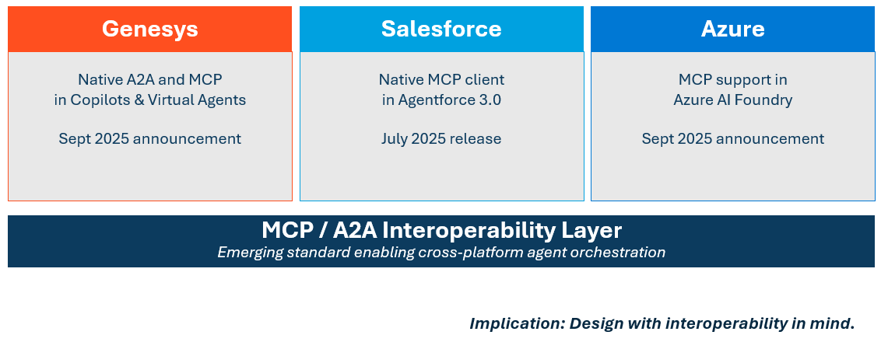

Platform-Specific Implementation
Azure
- Registry: Azure ML model registry
- Development: ML workspace, managed identity
- Monitoring: Azure Monitor, App Insights
- Cost: Azure cost management
Genesys
- Registry: AI Studio catalog
- Monitoring: Event Data Platform (EDP)
- Cost: AI Experience tokens

Salesforce
- Registry: AgentBuilder inventory
- Development: AgentBuilder (no-code)
- Monitoring: Native SF analytics
- Cost: Einstein usage metrics
Cross-Platform
- Unified agent registry (start with spreadsheet)
- Aggregate cost reporting
- Consistent governance gates

Governance Integration — Touchpoints
By Lifecycle Stage
- Ideation: Committee notify (T1-2), EPMO intake
- Design: ARB review if significant
- Testing: Committee review (T1)
- Deployment: Committee approve (T1-2), ARB final
- Maintenance: Notify on major changes
- Decommission: Notify committee
Recommendation
Consider increasing AI Steering Committee cadence from 6-10 weeks to monthly during initial agent deployment phase.
Procurement Integration
- Engage at Ideation if vendor tool required
- Contract review at Decommissioning

RACI for Agent Lifecycle
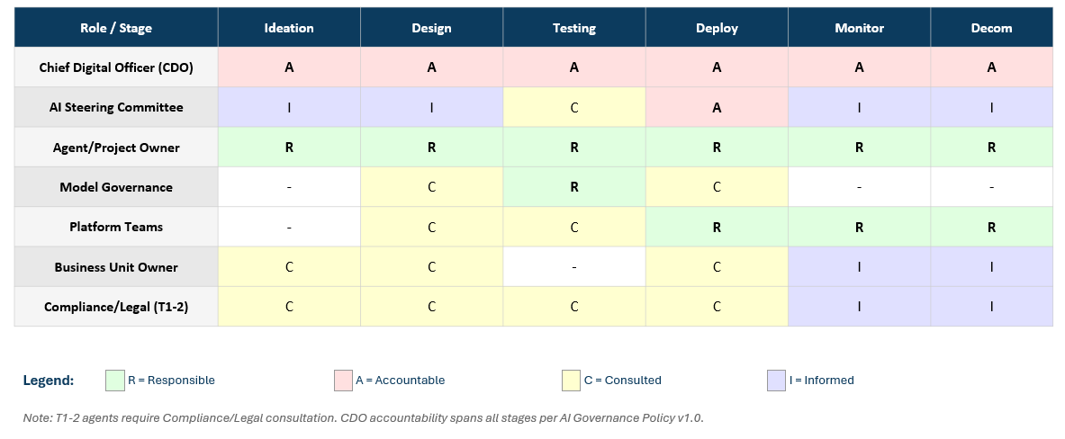
Accountable (A)
- CDO: Accountable across ALL stages
- AI Steering Committee: Accountable at Deploy
Responsible (R)
- Agent/Project Owner: R across all stages
- Model Governance: R at Testing
- Platform Teams: R at Deploy, Monitor, Decom
Consulted (C)
- Business Unit Owner: C at Design, Deploy
- Compliance/Legal: C throughout (T1-2)
- Platform Teams: C at Design, Testing
Informed (I)
- AI Steering Committee: I at Design, Monitor, Decom
- Business Unit Owner: I at Monitor

Alternatives & Tradeoffs

Azure-Native vs. Third-Party MLOps
- Options: MLflow, Weights & Biases, ModelOp
- Recommendation: Start Azure-native given existing investment
- Revisit as requirements clarify

Build vs. Buy for Lifecycle Tooling
- Current: Start lightweight (spreadsheet registry)
- Future: Consider dedicated platforms as volume grows
Platform-Specific vs. Unified Approach
- Recommendation: Platform-agnostic principles, platform-specific implementation
- MCP/A2A emergence suggests future convergence

Recommended Next Steps — Immediate (0-3 Months)
1. Establish Agent Registry
- Create initial inventory of existing/planned agents
- Assign risk tiers to each
- Start simple (spreadsheet acceptable)
2. Document Existing Practices
- Formalize Rene's champion-challenger as template
Document ARB review criteria3. Pilot Lifecycle Process
- Select one upcoming agent deployment (Tier 2-3)
- Apply full framework from ideation through monitoring
- Document lessons learned, refine process
4. Define Incident Response Playbook
- Create AI-specific runbook for agent failures
- Include escalation paths, rollback triggers

Recommended Next Steps — Short/Medium Term
Short-Term (3-6 Months)
- Formalize lifecycle stages with required artifacts
- Implement monitoring standards
- Enhance AI Steering Committee with lifecycle checkpoints
- Increase committee cadence to monthly
- Train project teams on requirements

Medium-Term (6-12 Months)
- Deploy Azure-native lifecycle tooling
- Integrate lifecycle tracking across platforms
- Establish cost attribution and chargeback
- Evaluate interoperability readiness (MCP)
- Assess need for dedicated AI governance platform

Recommended Next Steps — Short/Medium Term
Short-Term (3-6 Months)
- Formalize lifecycle stages with required artifacts
- Implement monitoring standards
- Enhance AI Steering Committee with lifecycle checkpoints
- Increase committee cadence to monthly
- Train project teams on requirements

Medium-Term (6-12 Months)
- Deploy Azure-native lifecycle tooling
- Integrate lifecycle tracking across platforms
- Establish cost attribution and chargeback
- Evaluate interoperability readiness (MCP)
- Assess need for dedicated AI governance platform

Summary

Key Takeaways
- Agent lifecycle management is essential — 80% of orgs encountered risky behaviors, 40%+ projects predicted to fail
- SFS has a solid foundation — AI Governance Policy v1.0 establishes principles; this framework operationalizes them
- Platform-agnostic principles, platform-specific implementation — unified governance across Azure, Genesys, Salesforce
Key Takeaways (continued)
- Risk tiering enables proportional controls — Tier 1-4 framework balances governance rigor with deployment velocity
- Start simple, formalize over time — begin with spreadsheet registry and manual checklists; invest in tooling as volume increases

Appendix: Sources
Industry Statistics
- 80% risky agent behaviors: McKinsey, Oct 2025
- 40%+ projects canceled: Gartner, June 2025
- 25-36% have governance: AllAboutAI/AuditBoard, 2025
- 51% negative incidents: McKinsey State of AI, Nov 2025

Platform Announcements
- Genesys MCP/A2A: BusinessWire, Sept 2025
- Salesforce Agentforce MCP: SF Dev Blog, June 2025
- Azure MCP/A2A: Microsoft Azure Blog, Sept 2025
Internal Sources
- EPMO Interview, December 2025
- SFS AI Governance Policy v1.0

Appendix: Glossary
Key Terms
- Agent: AI system that interacts, decides, operates autonomously
- MCP: Model Context Protocol — standard for agent-tool connections
- A2A: Agent-to-Agent — protocol for cross-agent collaboration
- MLOps: Practices for deploying/maintaining ML in production
- Drift: Performance degradation over time

Additional Terms
- Champion-Challenger: Testing new vs. current model
- Human-in-the-Loop: Required human review at decision points
- Risk Tier: Classification determining governance level
- Agent Registry: Central catalog of all agents
- Rollback: Reverting to previous version on failure

