Task 1: JSON API Route
- Create a Flask application with an /api route. When this route is accessed, it should return a JSON list. The data should be stored in a backend file, read from it, and sent as a response.
Screenshot 1: /api route displaying JSON data read from data.json.
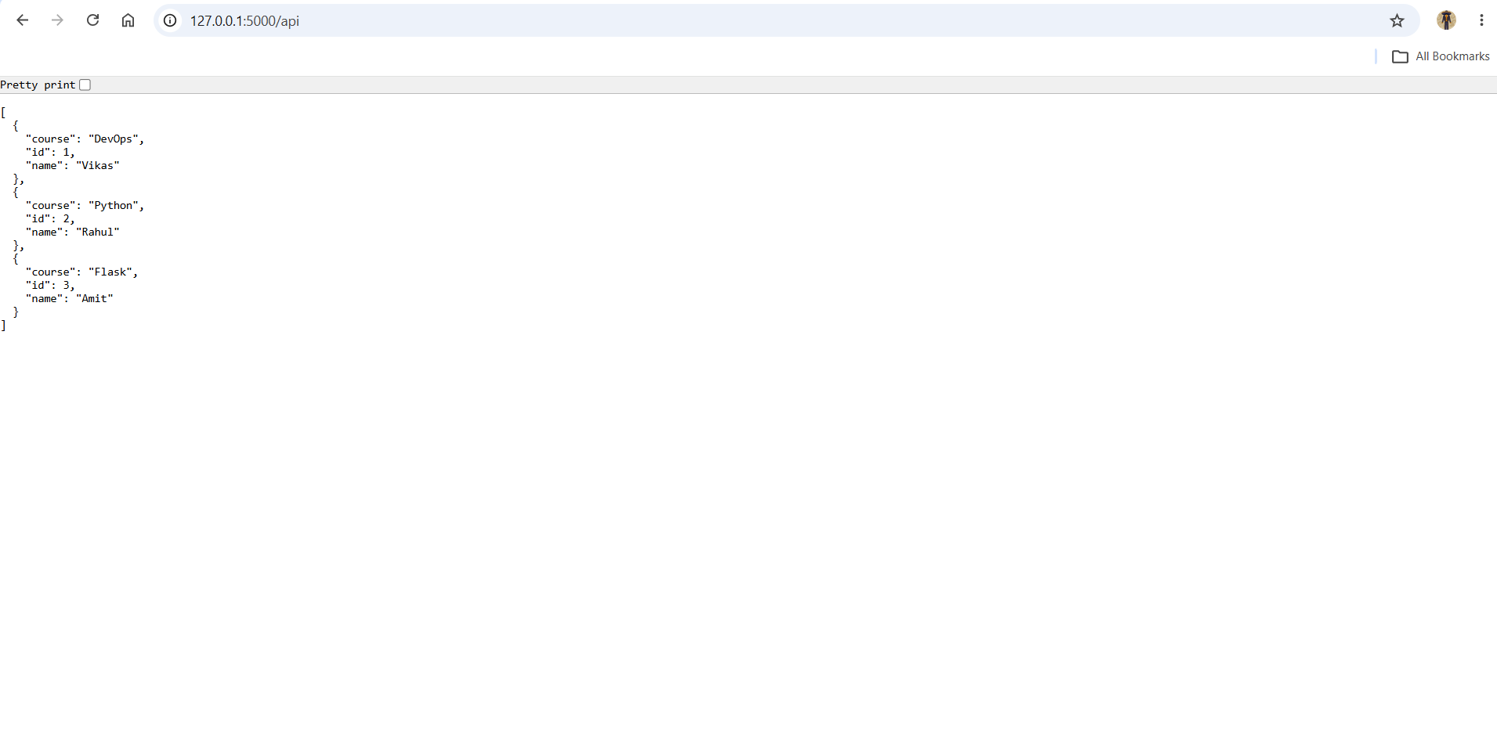
Task 2: Frontend Form with MongoDB Atlas
- Create a form on the frontend that, when submitted, inserts data into MongoDB Atlas.
- On success: the user should be redirected to another page displaying the message “Data submitted successfully”.
- On error: display the error on the same page without redirection.

- Screenshot: MongoDB Atlas connection successfully established with the Flask application.
- Screenshot: Student Registration Form displayed through the Flask frontend.
- Screenshot: Form data submitted successfully and success message displayed.
- Screenshot: Submitted student data successfully stored in MongoDB Atlas.
- Screenshot: Error message displayed on the same form page when required fields are empty.
