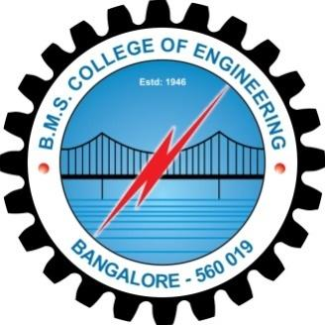 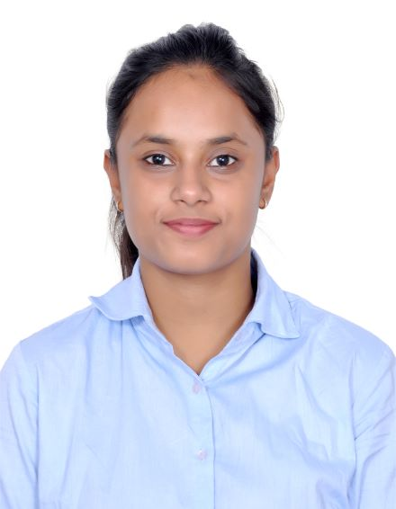

RISHIKA HANSARIA

[rishikademow@gmail.com](mailto:rishikademow@gmail.com)

8971503270

OBJECTIVE:

To initiate a career with an organisation that provides challenging roles and learning opportunities for achieving a dynamic and competent professional perspective and a steady growth.

EDUCATION QUALIFICATION:

|  |  |  |  |  |  |
| --- | --- | --- | --- | --- | --- |
| SL NO | QUALIFICATION | INSTITUTION | YEAR OF PASSING | BOARD | PERCENTAGE |
| 1 | B. E | BMSCE , BANGALORE | PRESENT | VTU(AFFLIATED) | 8.1 CGPA |
| 2 | 12TH STD | RESONANCE , KOTA | 2016 | RBSE | 64% |
| 3 | 10TH STD | ST. MARY’S SCHOOL | 2014 | SEBA | 82.4% |

AWARDS/ACIEVEMENTS:

* Secured 1ST place in Sen search event organized by Sunlux Technovations.
* Successfully, completed an internship in the College Of Engineering,Pune.
* Won the 1st place in the quiz during the Annual Tech-Symposium organized by the International Society Of Automation(ISA).
* Organized various corporate parties and events around Bangalore.
* Certification in photography course.
* Secured awards in dance competitions.
* Hold a certificate for working for a National Social Organization BHUMI in the Bangalore section.
* Certified for winning an event organized by Mitsubishi on PLC Technologies.
* Had an work experience with the Oil Natural Gas Commission(ONGC) refining department in Sivasagar District,Assam.
* Certified for participating in the Youth Parliament-17 organized by the Rotaract Club of BMSCE.
* Currently working as the department coordinator for the Techfest PhaseShift 2019.

SKILL SET:

* Strong work ethic.
* Dedicated hard work.
* Relationship building.
* Leadership quality.
* Team building.
* Flexible attitude.
* Self-Motivation
* Computer Skills

TECHNICAL KNOWLEDGE:

* Basic knowledge in programming languages like C++,C.
* I self-equip the essential skills of using relevant softwares like MATLAB,OrCAD,Proteus,Gx-Works2,Scilab etc.
* Basic information on Arduino as worked on various projects like ‘Ultrasonic Blind Navigation System’ & ‘Token Number Display System’.
* Gained knowledge of the various power plants and bottle filling process systems.

PERSONAL DETAILS:

* **DATE OF BIRTH:** 25/09/1998.
* **GENDER:** Female.
* **LANGUAGES KNOWN:** English, Hindi, Assamese.
* **HOBBIES AND INTERESTS:** Travelling, Dancing, Socialising, Photography.
* **PERMANENT ADDRESS:** C/OLaxmi Hardware Store, Demow, Nitai Road, Sivasagar, Assam-785662
* **PRESENT ADDRESS:** #201,Mahalaxmi Residency,Ashok Nagar,7th Cross,NR Colony,Basavanagudi-560050