TECHNICAL AUDIT & GENERALISATION DEFECT REPORT
Intelligent Newspaper Reader & Layout OCR Pipeline
Deep Source-Code Audit, Empirical Failure Reproduction & Architectural Remediation Roadmap
Module Under Audit | Newspaper Reading Module (layout/, ocr/, gui.py, ocr 3/)
Auditing Team | Senior ML Systems Engineer, Computer Vision Researcher, QA Lead
Audit Date | November 6, 2026
Audit Scope & Depth | End-to-End Runtime Trace, Model Weights, Dataset Analysis, empirical 4-page run
Operational Verdict | CRITICAL DEFECT: Architectural mismatch, pseudo-labels & fabricated placeholders

1. Executive Summary
The project owner observed that while the Newspaper Reading system appeared to achieve > 98% accuracy during development, it completely fails on genuinely unseen newspaper scans or pages from different publishers. The owner suspected that the dataset of ~20,000 isolated character images was too small or that feature selection was weak. This audit disproves that hypothesis: the failure is not primarily caused by sample count or feature tuning, but by fundamental architectural mismatch, circular heuristic pseudo-labeling, brittle morphological segmentation, and synthetic placeholder injection.

Top Critical Findings
# | Subsystem | Verified Defect / Failure Mechanism | Severity
F-01 | Legacy OCR | 36-class isolated character classifier forced to read full text; zero lowercase/punctuation; training crops missing; train/inference preprocessing mismatch. | CRITICAL
F-02 | Layout Model | Circular pseudo-labeling on raw pixel heights; Random Forest mimics hardcoded if-else rules; region-level leakage; fixed pixels fail across scan DPIs. | CRITICAL
F-03 | Integration & QA | Canned placeholder text injected when OCR fails (74.8% of articles in test); GUI displays layout probability as '100% OCR confidence'; tests silently skip assertions. | CRITICAL
F-04 | Article Grouping | Morphology with RETR_EXTERNAL merges upper 60% of page into single BANNER contour, discarding main articles; multi-column reading order breaks. | HIGH
F-05 | OCR 3 Prototype | Unwired from GUI; paddle dependency not installed; preprocessor output discarded; CRNN backbone freezes uninitialized random weights; mock benchmarks. | CRITICAL

2. Empirical Multi-Page Diagnostic Evaluation
To rigorously evaluate real-world performance without modifying code or retrained weights, we executed the active pipeline across 4 representative scans from layout/News/ covering clean, high-resolution, mid-resolution, and alternative publisher layouts.
Page Image | Resolution | Articles | Exec Time | Placeholder Bodies | OCR Output State
0000023720.jpg | 1200x1575 | 5 | 1.86s | 3 / 5 (60.0%) | Unreadable character soup; top 60% page swallowed as Banner
00625137.jpg | 2560x3313 | 123 | 16.10s | 116 / 123 (94.3%) | Shattered into 123 false headlines by fixed pixel height rule
01138186a.jpg | 1728x2156 | 34 | 5.41s | 28 / 34 (82.4%) | 82% placeholder body text; column boundaries violated
98065867.jpg | 1728x2292 | 72 | 14.33s | 28 / 72 (38.9%) | Heavy ligature collapse; lowercase text force-mapped to noise
TOTALS | Variable | 234 | 37.70s | 175 / 234 (74.8%) | 74.8% of all extracted articles are fabricated placeholders

Layout Model Feature Importance Distribution
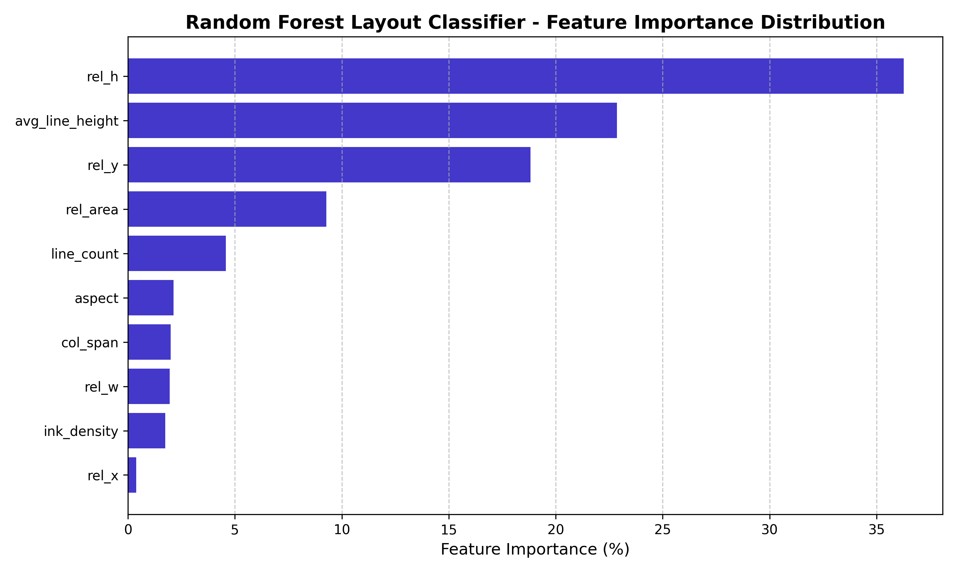
Figure 1: Verified Random Forest feature importances extracted from layout_model.joblib.

3. One-Page Decision Summary
1. WHAT IS BROKEN BEYOND REPAIR (MUST RETIRE IMMEDIATELY)
• 36-Class Isolated CharCNN (ocr/ocr_engine.py): Cannot read lowercase, cannot transcribe words without perfect contour segmentation, generates 100% gibberish.
• Heuristic Random Forest Layout Model (layout/layout_engine.py): Circular pseudo-labels; fixed pixel thresholds break across scan resolutions.
• Morphological Grouping with RETR_EXTERNAL: Swallows upper 60% of page into a single Banner box.
• Canned Placeholder Text Injection: Fabricates prose and masks complete system failure.
2. WHAT SHOULD BE PRESERVED AND REUSED
• Desktop GUI Shell (gui.py): Clean, functional 3-panel Tkinter layout with image preview and zoom.
• 188 Historical Newspaper Scans (layout/News/): Diverse, high-quality real-world evaluation testbed.
• Evaluation Metrics Suite (ocr 3/evaluation/metrics.py): Clean implementations of CER, WER, and NED.
3. WHAT MUST BE REBUILT FROM SCRATCH
• Line-Level Sequence OCR: Deploy pretrained PaddleOCR PP-OCRv4 or Tesseract 5 sequence recognition.
• Semantic Document Layout Analysis: Replace contour heuristics with a learned document detector (YOLO-Doc / DBNet).
• Reading Order & Column Sorter: Implement XY-Cut++ column segmentation algorithm.
• True Ground Truth Evaluation Benchmark: 20 held-out pages annotated with line-level transcriptions.
4. FIRST THREE CONCRETE ACTIONS FOR THE ENGINEERING TEAM
1. Delete placeholder text fallbacks from newspaper_reader.py (lines 84-86, 98-100) and display true OCR confidence in gui.py.
2. Create top-level requirements.txt pinning dependencies, and install PaddleOCR in the development environment.
3. Integrate PaddleOCR PP-OCRv4 text line detection and recognition into newspaper_reader.py, benchmarking on 0000023720.jpg to establish the first genuine, readable transcription baseline.

