**Use Case Diagrams**

**for**

**VideoCo Management System**

**Version 1.0 approved**

**Prepared by Linwei Wang, Taariq McDonald, Randal Alexander, Haoran Zhou, Lan Zhang, and Yucheng Zhou**

**Lassonde School of Engineering, York University**

**2020-11-08**

# **Customer and Member Use Case Diagram**

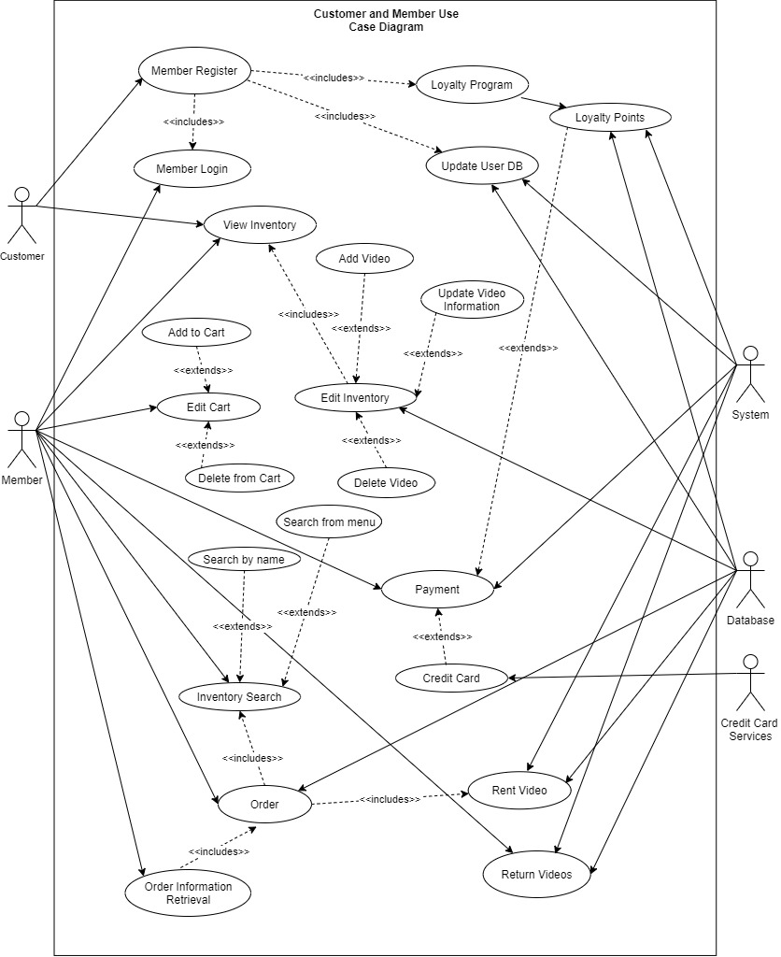

1. Customers create accounts to become members. Database update information.
2. Members search videos either by name or from the menu.
3. Members edit their carts and make orders.
4. Members pay their orders by credit card and use loyalty points to apply discounts.
5. Members retrieve their orders to review orders.
6. Members return video, then the system and database updates the information.

# **Manager Use Case Diagram**

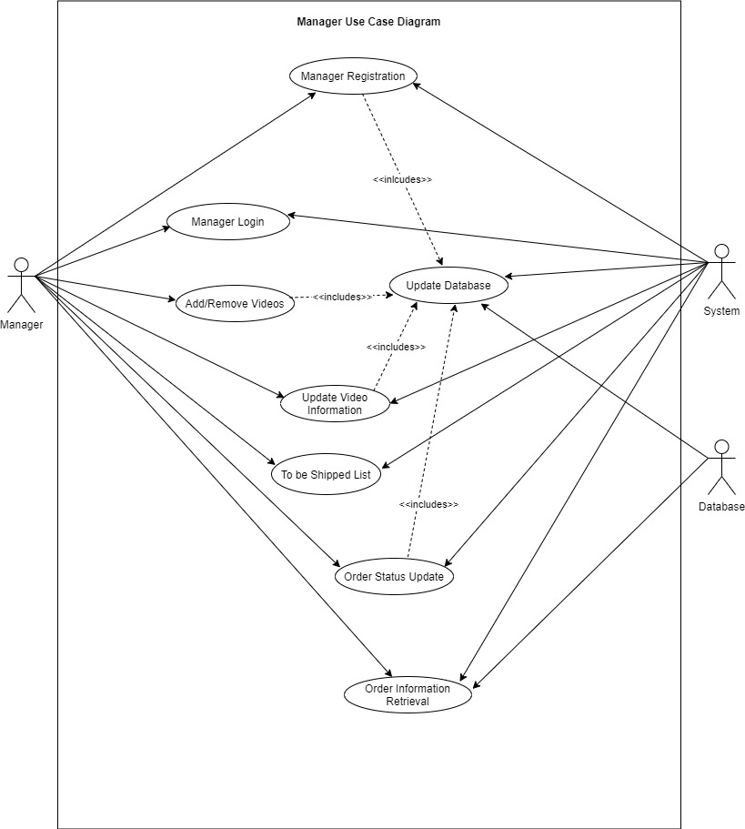

1. Managers create accounts to access the system. Database update information.
2. Managers add/remove videos and update video information. Database update information.
3. Managers retrieve orders and update order status.
4. Managers get the to-be-shipped list and prepare orders.

# **System Use Case Diagram**

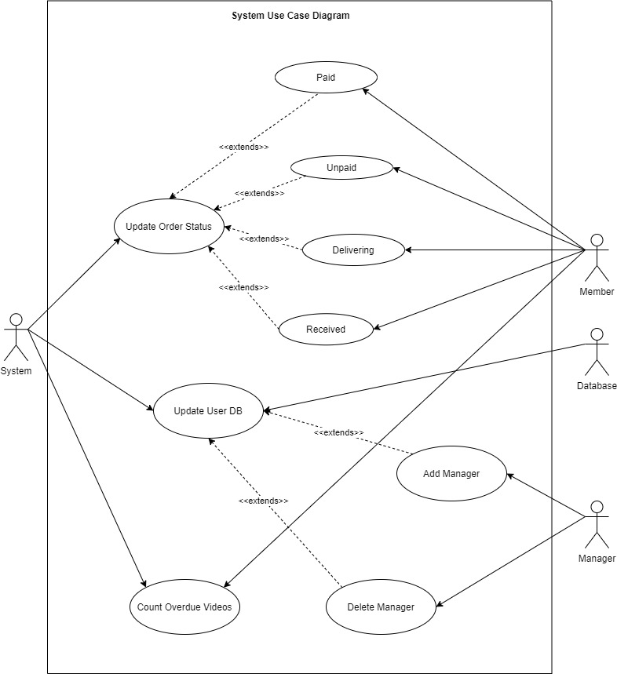

1. The System can update the status of an order from ‘unpaid’ to ‘paid’ and from ‘delivering’ to ‘received’.
2. The System can update the user database by either adding or deleting a manager from the database. The database will then be updated.
3. The System can keep track of the amount of overdue videos. The member will be notified when they have an overdue video.

**Legends**

