GENERATIVE INPAINTING

Training the DCGAN

The DCGAN trained on the celebA dataset.

Corrupted Result

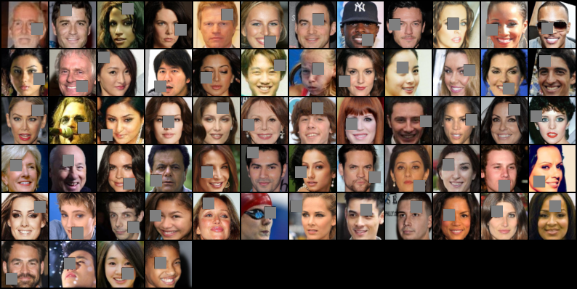

Completed Result

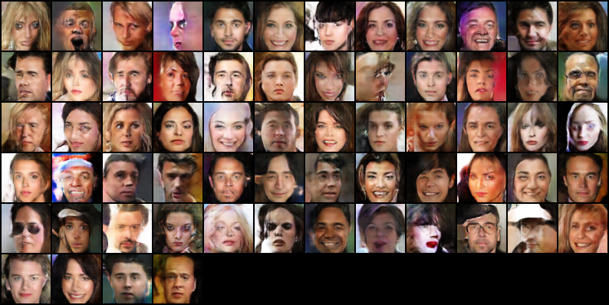

Blended Result

Although the blending was not perfect for few of the image, however I have attempted to perform
few of the experiments to see how the blending can be improved.

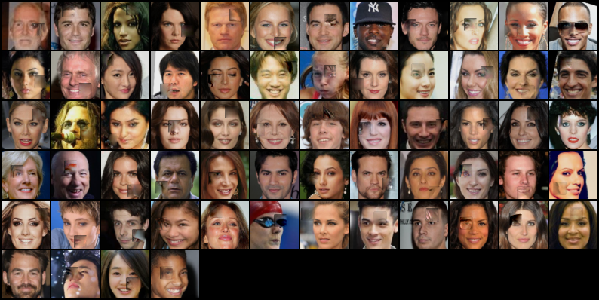

Experiment 1) May be the images quality is detoriated because the image been reduced to a size of 64*64.?.
The answer was no. I attempted to send the original image, still the results were same.
Changing the quality of the image (however the loss of the image due to the compression)doesnt improve the result anyway.

Blended Image Corrupted Image



Experiment 2) Changing the batch normalization detoriated the output results.

The aim of this experiment is to find out how batch normalisations stabilises the training of the GAN.

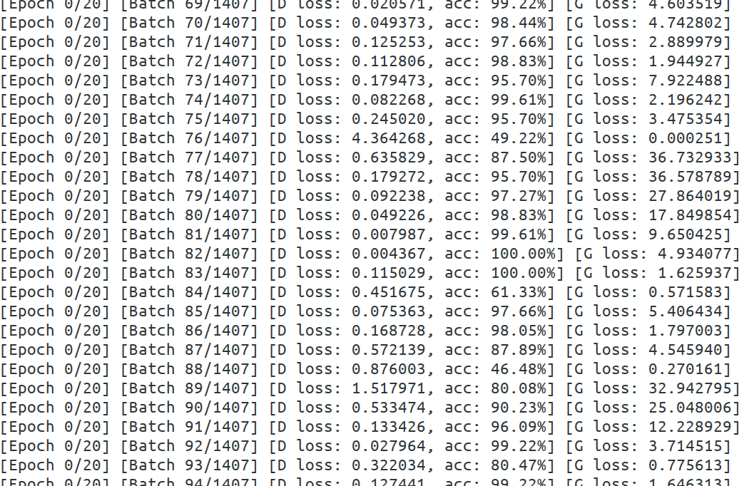
As we could see that the G loss generates a huge loss as Batch Normalization was not performed. This clearly indicates why DCGAN is recommended to do Batch Normalization.

As the training approaches we could see that the Generated Loss turns to be 0.

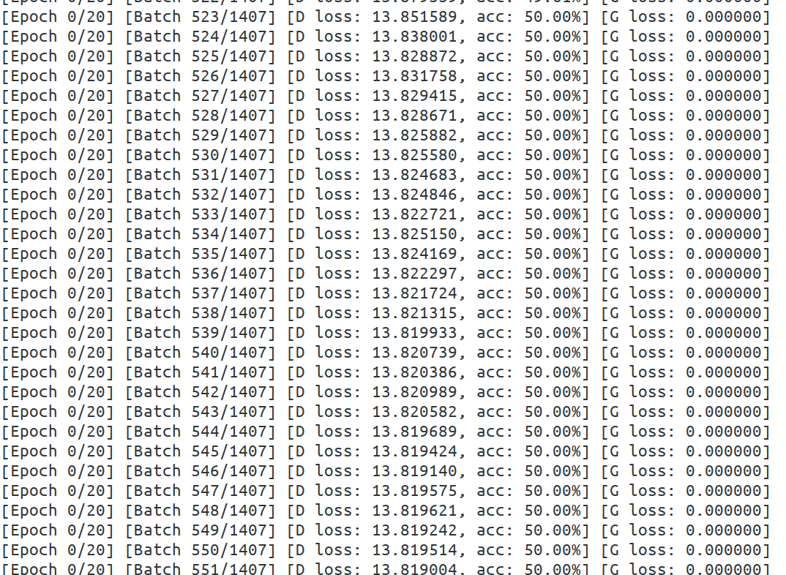

Experiment 3) May be a change the loss function do the trick?.

This is a subject that needs to be explored more with more amount of time and can find out which loss results better.

Selfie

For the selfie I created a corrupted image and then created .npy file that contains the mask.
I import both the image and the mask file under inpaint.py file and then perform the inpainting operation.

Experiments

Experiment 1 - Results with batch size 1

This experimentation was based on the number of batches the selfie images are obtained and see for the results as such.

The results are as below

Single batch of images inpaint

Blended | Corrupted | Comments
 |  | Increased the mask size and tried inpainting, where the blending was imperfect.
 |  | Changing the mask size gave me better results as we could tha the blending is fine.
 |  | Blended correctly.

Multiple batch size of 4 images

Blended | Corrupted
 | 
 | 

The corrupted image has been created and fed to the best trained model. We could recoved the corrupted image via inpainting.
The GAN model tries to find the best fitted inpainting for the corrupted image.
Few of the batched images above shows that the blending goes smooth to the corrupted area and gives us a recovered image.
The quality of the recovered image looks fine for a 64*64 patched image.

Advantages:-

The usage of latent vectors is easier in GAN. We randomly create a latent vector and introduce it to the GAN for training.

Disadvantages :-

GAN’s are very hard to train. We could see the training for the dataset provided a lot of time to train.

There is always a unstable state between the generator and the discriminator.

Future Work:-

GAN’s are very useful for semi-supervised training. But only because of the training, we find it harder enough to use GAN’s. Identifying the way on how the training between the discriminator and the generator be made simple can be identified.
Since the discriminator has no purpose after the training, we could find ways to identify and make the discriminator more useful.

3DGAN

Experiment 1

Changing the learning rate improved the 3DGAN results

Experiment 1 ) Learning Rate did the trick - learning rate – 0.0004 gave better results than 0.00002

Results for Learning Rate 0.00002
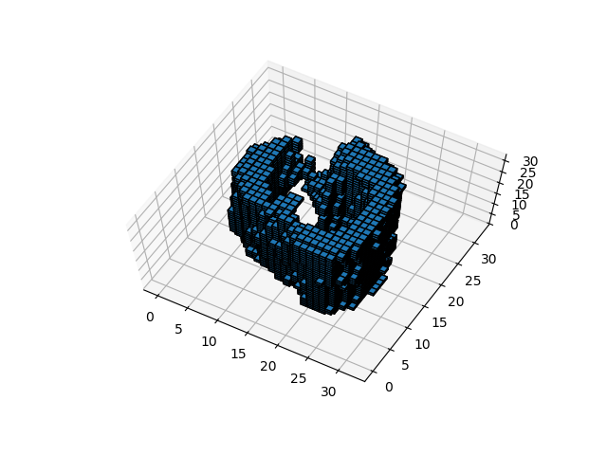
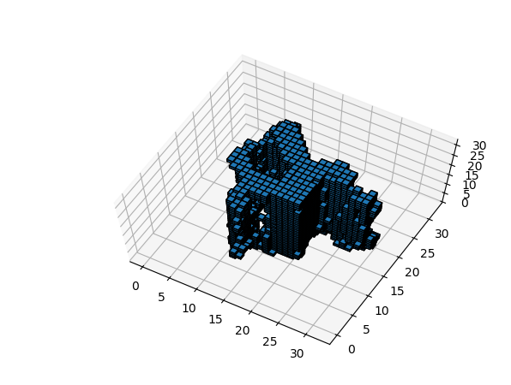
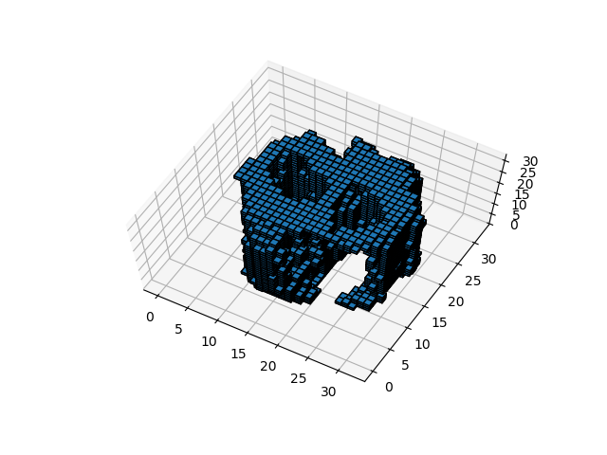

Training Loss:
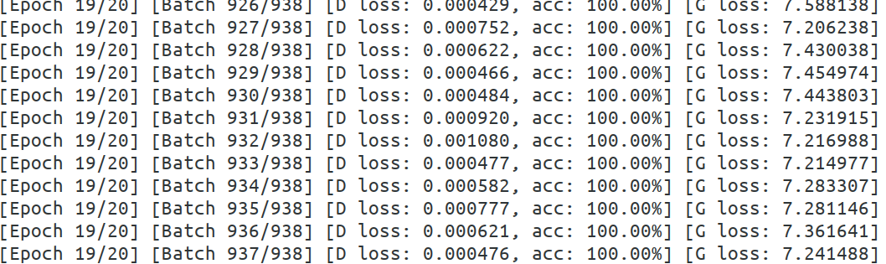

Experiment 2) Plotted only the points with the threshold value > 0.5 in the latent vector

Results for Learning rate 0.00004

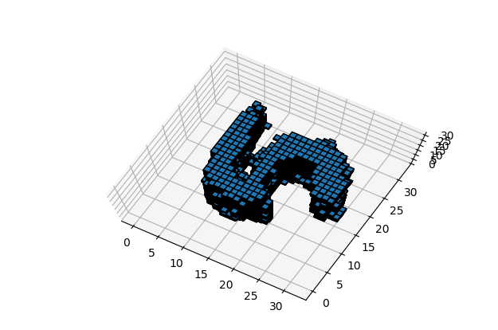
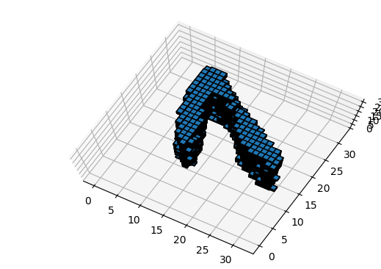
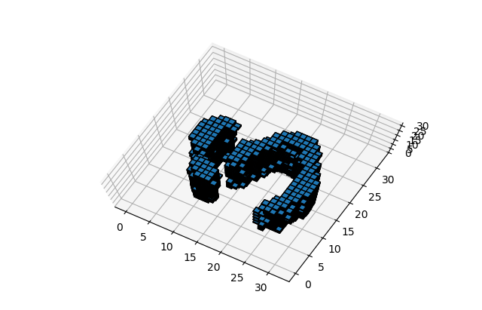

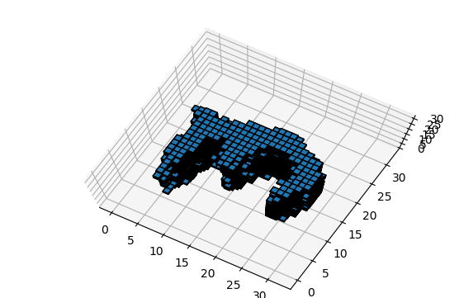
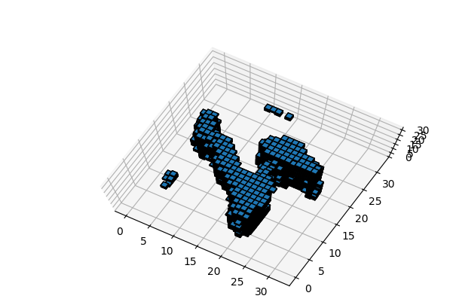
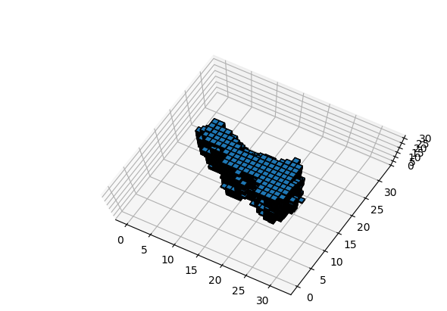

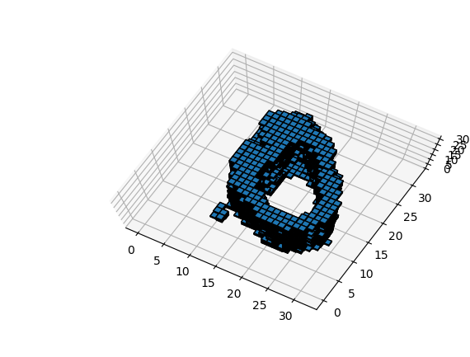
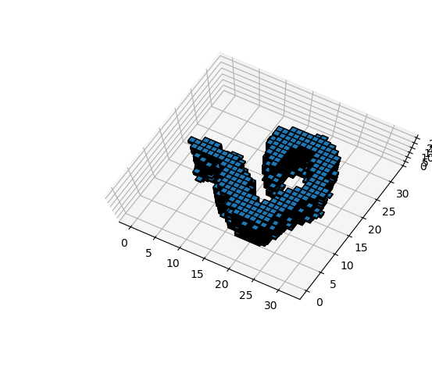
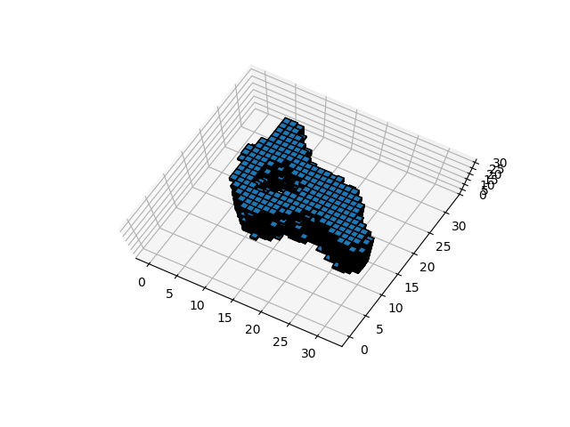

Tough Decisions (Eg’s digit 2, 8, digit 6)
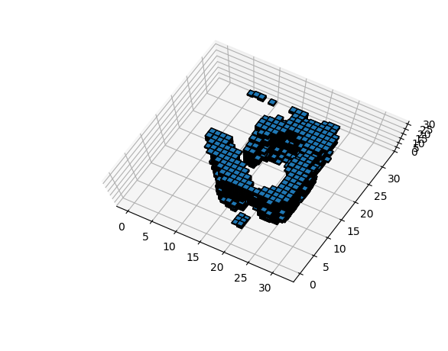
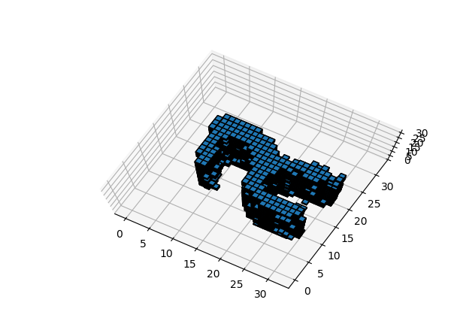

Training Loss

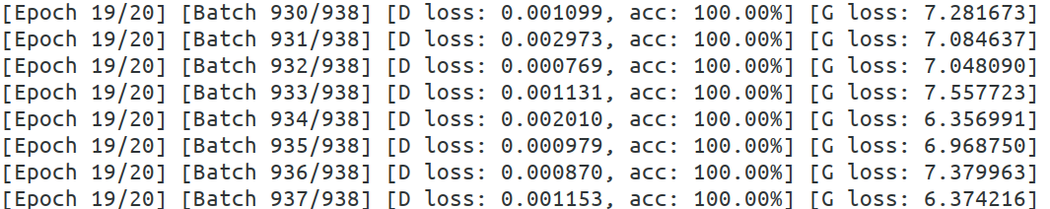

Interpolation Results

The Interpolation is shown from the digit 4 to 6
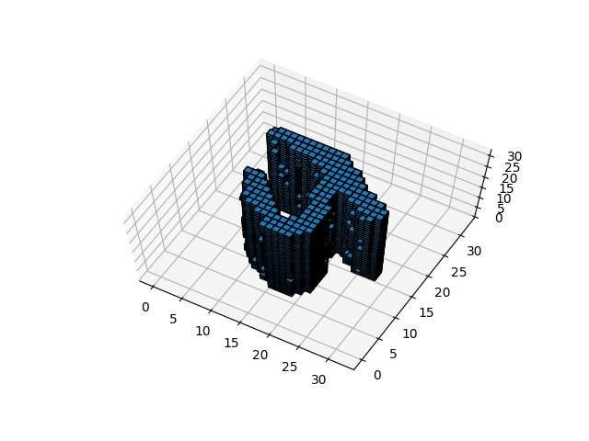
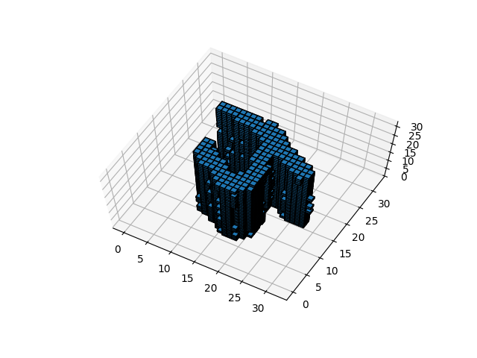
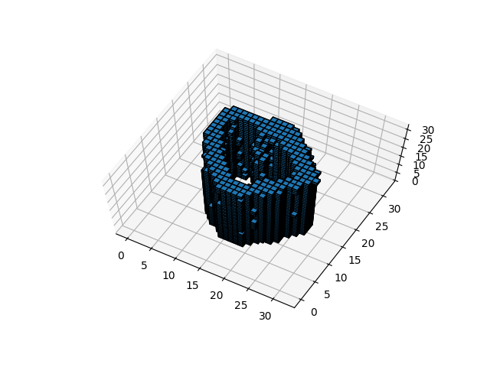
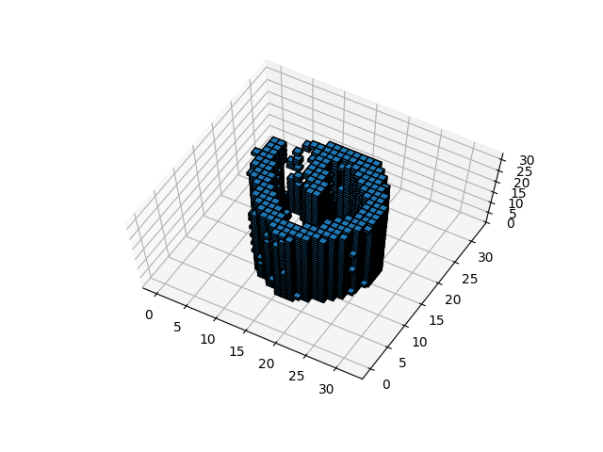
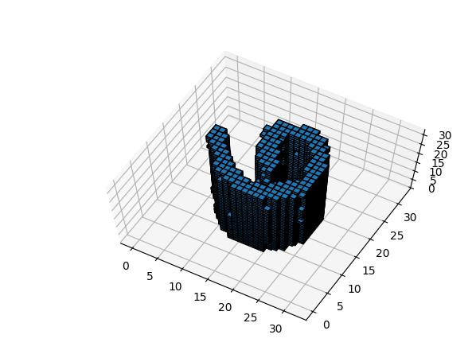
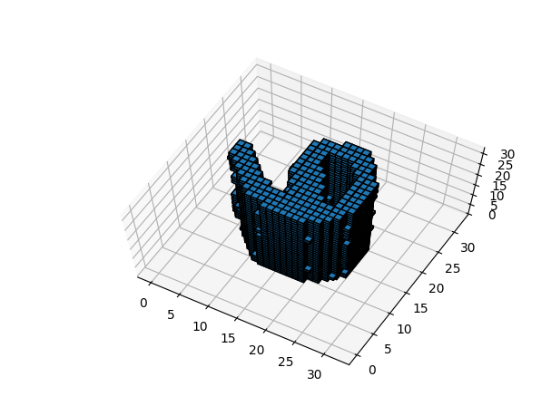

VOXELISED GAN

Advantages:

The Voxelised GAN captures very realistic images of any object in 3D such as numbers, cars, chairs, etc enabling the user to view it in 3D. This would particularly be very useful in the current world, because everywhere everything is turned into 3 dimensional space nowadays which would be the future.

The trained generator can identify any 3D voxels and it’s easy to interpolate from any latent space to the others. This gives the independence of viewing any object in the latent space.

Disadvantages

Training a GAN was hard. To train a higher dataset, we may require much more pulling capacity of GPU’s to train it in 3D.

Viewing the 3 dimensional or more would be a problem.
Training the network would be very time consuming.
It was very had enough to view the objects in 3D. For example, in our assignment the MNIST datasets with anything more than 32*32*32 dimension was be a problem. So the dimensional constraint is still a concern.

Future Works

Even though the Generator loss decreases over the training , still the amount of loss is not acceptable. So we can identify how to decrease the Generator loss and achieve a minimal loss all the time.

The 3D GAN can be implemented to various objects and it will be very useful for any industry who wants to synthesize the object as a whole. So learning to synthesize any objects in a 3D would be great.

