MLOps for Retention Analytics using Databricks
Research Documentation for Customer Churn Prediction
Prepared for Mercer Superannuation Use Case
Model versioning | Performance validation | Fairness assessment | Unity Catalog governance | Model serving | Monitoring
1. Introduction
Retention analytics identifies members who may be likely to transfer funds, become disengaged or discontinue their relationship with a superannuation product. A churn prediction model supports earlier and better prioritised retention conversations, provided that its use is governed by approved business and responsible-use controls.
A successful machine learning proof of concept is not automatically ready for operational use. The data used for training must be traceable, model experiments must be reproducible, candidate versions must be evaluated consistently, deployment decisions must be evidence based and post-deployment performance must be monitored. MLOps provides this controlled lifecycle.
1.1 Purpose of this document
This document describes a Databricks-based MLOps approach for a retention analytics solution. It explains what each model lifecycle activity accomplishes, how the implemented baseline and candidate models differ, how model quality and fairness are assessed, how Unity Catalog supports governance, and how the approved model can be deployed and monitored.
1.2 Scope and interpretation
The implementation is based on an illustrative churn dataset and the recorded example results from the analysis exercise. It is suitable for demonstrating the lifecycle and informing enterprise implementation design. Before production adoption, feature definitions, decision thresholds, privacy controls, monitoring thresholds and approval authorities must be agreed with business, risk and compliance stakeholders.
1.3 Business outcomes supported
- Prioritise members who may require proactive retention engagement.
- Compare model versions using a repeatable and governed evaluation dataset.
- Prevent uncontrolled deployment by using documented validation and promotion decisions.
- Monitor operational health, model quality and fairness indicators after deployment.
- Maintain an auditable record of data, experiments, model versions and approvals.
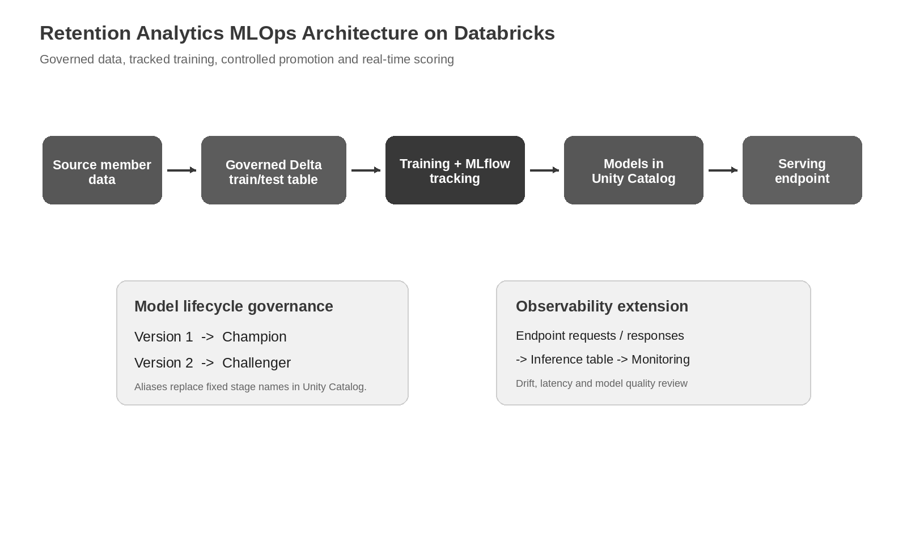
Figure 1. End-to-end MLOps architecture for the retention analytics solution.
2. MLOps Lifecycle for Retention Analytics
MLOps is the collection of processes, technology and governance controls that move a model from experimentation into reliable operational use. In this retention analytics solution, the lifecycle is designed to make every deployed prediction traceable back to its training data, experiment run, validation evidence and approval decision.
Lifecycle activity | Purpose in this solution | Resulting evidence
Data preparation | Create an approved dataset and fixed evaluation split. | Governed Delta train/test table.
Model development | Train a baseline and improved candidate model. | Tracked MLflow runs and model artifacts.
Model versioning | Register immutable versions for controlled comparison. | Version 1 and Version 2 in Unity Catalog.
Validation | Compare performance and fairness on identical test rows. | Metric and fairness review tables.
Promotion | Identify the model approved for deployment. | Champion and Challenger aliases.
Serving | Expose approved predictions for downstream use. | Ready serving endpoint and test response.
Monitoring | Observe health, drift and outcome-based quality. | Inference records, dashboards and review actions.

2.1 Why model governance matters for a retention decision
A churn model can influence which members are contacted and how retention teams allocate attention. A model that has high overall accuracy but misses too many genuine churners may fail the business objective. A model that behaves differently across approved review groups may also require investigation. Governance therefore combines predictive quality, responsible-use diagnostics, controlled access and auditable promotion decisions.
3. Technology Stack and Dependencies
The following components support the implemented lifecycle. The example implementation uses GridSearchCV from scikit-learn for parameter tuning. Hyperopt is included as an optional extension for larger or more scalable search strategies; it is not required to reproduce the recorded Version 2 example results.
Technology / library | Use in the solution | Why it is important
Azure Databricks | Managed workspace for notebooks, registry, serving and monitoring. | Provides an integrated analytics and ML operating environment.
Python | Implementation language for training and validation logic. | Widely supported across ML libraries and Databricks workloads.
pandas | In-memory analysis of the example dataset and evaluation output. | Efficient manipulation of tabular data.
NumPy | Numerical array operations used during analysis. | Supports efficient numerical calculations.
scikit-learn | Preprocessing pipeline, Logistic Regression, metrics and GridSearchCV. | Provides transparent and reproducible predictive modelling.
MLflow | Tracks parameters, metrics, artifacts and registered model versions. | Provides reproducibility and model lifecycle traceability.
Delta Lake | Stores the governed train/test split table. | Ensures reliable and auditable table storage.
Unity Catalog | Governs tables, volumes and registered models. | Centralises access control, lineage and auditability.
Databricks Model Serving | Hosts the approved model as a prediction endpoint. | Supports real-time scoring through a managed API.
PySpark | Writes and reads governed Delta tables in the workspace. | Supports scalable data processing when required.
Hyperopt - optional | Alternative optimisation technique for larger tuning search spaces. | Useful for future experimentation; not used in the recorded example.

Important clarification: The term intended is Hyperopt, not hyperplasia or hyperopia. In the demonstrated model run, Version 2 was tuned using scikit-learn GridSearchCV; Hyperopt can be considered later if the parameter search becomes more complex or computationally intensive.

4. Solution Architecture and Governed Assets
The solution separates governed data, model development, controlled release and operational monitoring. Source member records are stored or accessed through approved data objects. A fixed split table allows model comparisons on the same rows. Training runs are tracked in MLflow, and approved model assets are registered in Unity Catalog before serving.
4.1 Implementation assets
Asset type | Example asset | Role in the lifecycle
Workspace folder | Retention_Analytics_MLOps | Organises model lifecycle assets.
Input volume | <catalog>.<schema>.<volume> | Stores the controlled CSV input used for analysis.
Delta table | <catalog>.<schema>.churn_dataset_split | Preserves train/test assignments for repeatable evaluation.
Registered model | <catalog>.<schema>.superannuation_churn_logistic_reg_model | Contains immutable model versions and aliases.
Serving endpoint | retention-churn-champion-endpoint | Serves approved predictions.
Inference table | Generated after logging is enabled | Captures requests/responses for monitoring.

4.2 Logical separation of responsibilities
- Data layer: controls source data quality, permitted feature use and repeatable train/test partitions.
- Experiment layer: records training parameters, metrics and model artifacts in MLflow.
- Governance layer: stores approved model versions, aliases, access rules and audit history in Unity Catalog.
- Serving layer: makes the approved model available for real-time prediction.
- Monitoring layer: observes requests, predictions, drift, model quality and approved fairness indicators.
5. Dataset Preparation Strategy
The illustrative dataset represents member attributes and engagement behaviours that may be informative for churn prediction. For a production solution, each field must be approved for use, sourced from governed systems and documented with its meaning, expected range and quality rules.
5.1 Example features used in endpoint scoring
Feature group | Illustrative fields | Possible retention signal
Member profile | member_age, membership_tenure_years | Life stage and duration of relationship.
Financial activity | annual_contribution_amount, super_balance, investment_return_percent | Value and recent investment experience.
Engagement | portal_login_frequency, mobile_app_usage, financial_adviser_interaction | Level of digital or adviser engagement.
Service interaction | customer_support_calls, withdrawal_frequency_per_year | Potential friction or liquidity needs.
Product choice | investment_plan_type, insurance_opt_in, risk_profile, employer_category | Product preferences and membership context.

5.2 Target variable and data partitioning
The binary target variable churn represents whether a member belongs to the churn outcome class. A fixed 80 percent training and 20 percent testing split is produced using stratification so that the churn proportion is represented in both partitions. Saving the split assignment to a governed Delta table prevents later versions from appearing better merely because they were tested on different rows.
Code excerpt - governed and repeatable train/test split
train_index, test_index = train_test_split(
data.index, test_size=0.20, random_state=42,
stratify=data["churn"]
)
data["dataset_split"] = "train"
data.loc[test_index, "dataset_split"] = "test"
spark.createDataFrame(data).write.format("delta") \
.mode("overwrite").saveAsTable(SPLIT_TABLE_NAME)

5.3 Feature preparation approach
Identifier columns are excluded from model inputs because they uniquely identify records rather than explaining behaviour. Numeric fields are standardised so their scale does not dominate the optimisation process. Categorical values are converted to machine-readable indicators through one-hot encoding, with previously unseen categories ignored at scoring time rather than causing failure.
Preparation activity | Purpose | Control consideration
Remove identifier fields | Prevent member identifiers from acting as predictors. | Retain identifiers only for approved traceability outside the model input.
Handle null target rows | Ensure training records have known outcomes. | Record excluded-row counts for audit.
Scale numeric features | Support stable Logistic Regression optimisation. | Fit transformations only using training data.
Encode categorical features | Convert text categories into model features. | Monitor new categories after deployment.

6. Baseline Model Development - Version 1
Version 1 establishes the performance benchmark. It is not assumed to be the best possible model; rather, it creates a reliable reference point for deciding whether later modelling changes deliver sufficient benefit without unacceptable trade-offs.
6.1 Purpose of the baseline development asset
The baseline development notebook is used to load the governed dataset, apply the approved feature-preparation pipeline, train a standard Logistic Regression classifier, calculate evaluation metrics and register the resulting model artifact as Version 1. Its most important contribution is establishing a controlled starting point for model comparison.
6.2 Why Logistic Regression is appropriate for a baseline
- It produces a probability of churn and supports threshold-based classification.
- It is computationally efficient and easy to reproduce.
- Its behaviour and coefficient-based directionality are relatively explainable compared with more complex algorithms.
- It provides an interpretable benchmark before considering more complex models.
6.3 Preprocessing and baseline configuration
Component | Baseline configuration | Explanation
Algorithm | Logistic Regression | Binary classifier for churn probability.
Regularisation strength (C) | 1.0 | Standard baseline regularisation setting.
Class weighting | None | No rebalancing applied in Version 1.
Maximum iterations | 2000 | Allows optimisation to converge.
Evaluation split | Fixed governed test partition | Maintains a fair basis for comparison.

Code excerpt - baseline model pipeline
baseline_model = Pipeline(steps=[
("preprocessor", preprocessor),
("classifier", LogisticRegression(
C=1.0, class_weight=None, max_iter=2000, random_state=42
))
])
baseline_model.fit(X_train, y_train)

6.4 MLflow experiment tracking and model registration
MLflow records how a model was produced. For Version 1, the run contains the algorithm configuration, common split table reference, measured quality indicators and the fitted model artifact. Registering the model creates an immutable version that can later be validated, promoted or retained for rollback.
Code excerpt - track metrics and register Version 1 in MLflow
with mlflow.start_run(run_name="Version_1_Baseline"):
mlflow.log_params({"model_role": "Baseline", "C": 1.0})
mlflow.log_metrics(baseline_metrics)
mlflow.sklearn.log_model(
baseline_model, "model", registered_model_name=MODEL_NAME,
signature=signature, input_example=X_train.head(5)
)

6.5 Recorded baseline result
Version | Role | Accuracy | Precision | Recall | F1 Score | ROC AUC
1 | Baseline | 0.9313 | 0.7222 | 0.4937 | 0.5865 | 0.9509

Version 1 correctly ranks churn risk strongly according to its ROC AUC and captures approximately 49 percent of actual churners in the example test sample. These measures become the reference values used when evaluating Version 2.

7. Candidate Model Development and Hyperparameter Optimisation - Version 2
Version 2 evaluates whether a tuned Logistic Regression model can improve the retention prediction outcome without changing the underlying algorithm or the evaluation dataset. This isolates the impact of tuning decisions and maintains a clear comparison with the baseline.
7.1 What changed from Version 1 to Version 2
The model family remains Logistic Regression. The change is that Version 2 searches across combinations of regularisation strength and class weighting using cross-validation. This is called hyperparameter optimisation: selecting configuration values that are determined before final fitting rather than learned as model coefficients during training.
Hyperparameter | Version 1 | Version 2 search values | Why it matters
C - inverse regularisation strength | 1.0 only | 0.01, 0.1, 1.0, 10.0 | Controls the balance between fitting the training data and keeping model coefficients constrained.
class_weight | None only | None, balanced | Balanced weighting gives additional influence to the less frequent target class where churn is imbalanced.
Selection method | No search | GridSearchCV with 3-fold cross-validation | Compares parameter combinations systematically.
Optimisation metric | Not applicable | ROC AUC | Selects a model that ranks churners above non-churners across thresholds.

7.2 Regularisation strength (C) explained
For scikit-learn Logistic Regression, C is the inverse of regularisation strength. Lower C values impose stronger regularisation and can reduce overfitting by constraining coefficients more heavily. Higher C values permit a closer fit to the training data, which can increase variance. Testing multiple values identifies the trade-off that best supports predictive ranking on validation folds.
7.3 Class weighting explained
Churn datasets often contain substantially fewer churned members than retained members. When class_weight is set to balanced, the fitting process automatically gives greater importance to the minority class relative to its frequency. This can improve detection of churners, but it can also increase false positives. The effect must therefore be verified through metrics and business judgement rather than assumed to be beneficial.
Code excerpt - Version 2 hyperparameter search
parameter_grid = {
"classifier__C": [0.01, 0.1, 1.0, 10.0],
"classifier__class_weight": [None, "balanced"]
}
grid_search = GridSearchCV(
candidate_pipeline, parameter_grid, scoring="roc_auc", cv=3, refit=True
)
grid_search.fit(X_train, y_train)

7.4 Role of Hyperopt in an enterprise extension
Hyperopt is an optimisation library that can be considered when the search space grows beyond a small number of discrete combinations or when distributed tuning is required. In this documented proof of concept, it should not be presented as an executed dependency because the recorded Version 2 result was produced by GridSearchCV. A future experimentation plan may compare GridSearchCV, RandomizedSearchCV and Hyperopt under agreed cost and performance criteria.
7.5 Candidate registration and recorded result
Once the selected candidate configuration is fitted using the governed training partition, it is logged through MLflow and registered under the same model name as Version 1. MLflow creates Version 2 rather than replacing the baseline, enabling side-by-side evidence review and controlled promotion.
Version | Role | Accuracy | Precision | Recall | F1 Score | ROC AUC
1 | Baseline | 0.9313 | 0.7222 | 0.4937 | 0.5865 | 0.9509
2 | Candidate | 0.9337 | 0.7955 | 0.4430 | 0.5691 | 0.9505

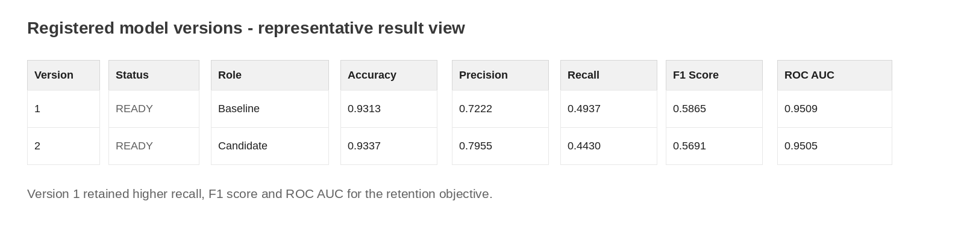
Figure 2. Recorded model-version result view used for performance validation.

8. MLflow Model Tracking and Versioning
Experiment tracking and version management are separate but complementary capabilities. A run stores evidence about an individual training attempt; a registered model version stores the deployable model artifact associated with an approved or reviewable training result.
8.1 MLflow evidence captured for each version
Evidence category | Example recorded values | Review purpose
Parameters | Algorithm, C, class_weight, split_table, tuning method | Understand how the model was produced.
Metrics | Accuracy, precision, recall, F1 Score, ROC AUC | Compare predictive quality.
Confusion outcomes | True positives, false positives, true negatives, false negatives | Assess operational trade-offs.
Artifacts | Fitted preprocessing and classification pipeline | Enable repeatable deployment.
Signature and input example | Input column structure and representative values | Validate serving contract.

8.2 Model version history
Version | Description | Lifecycle position | Decision
Version 1 | Baseline Logistic Regression using fixed governed split. | Validated model. | Selected as Champion in example.
Version 2 | Tuned Logistic Regression candidate using parameter search. | Validated candidate. | Retained as Challenger in example.

8.3 Why models are registered in Unity Catalog
A model used in an enterprise analytics process needs controlled visibility, approved ownership, consistent naming and an audit trail. Models in Unity Catalog provide a governed registered-model location with model versions and alias-based lifecycle management. This makes the deployed model identifiable and supports controlled change or rollback.

9. Performance Validation and Champion Selection
A model should not be promoted only because one metric improves. Retention analytics involves business trade-offs: a false positive may result in unnecessary outreach, while a false negative means a genuine churner is not prioritised for intervention. The right model is selected by reviewing metrics in relation to the stated objective.
9.1 Evaluation metrics and interpretation
Metric | Meaning for this use case | Decision relevance
Accuracy | Percentage of all members correctly classified. | Useful overview, but can hide weak churn detection when the class is imbalanced.
Precision | Percentage of predicted churners who actually churned. | Higher precision targets interventions more narrowly.
Recall | Percentage of actual churners detected by the model. | Higher recall avoids missing retention opportunities.
F1 Score | Balance between precision and recall. | Useful when both unnecessary contact and missed churners matter.
ROC AUC | Ability to rank churners ahead of non-churners across thresholds. | Supports overall risk-ranking assessment.

9.2 Version comparison
Metric | Version 1 - Baseline | Version 2 - Candidate | Observation
Accuracy | 0.9313 | 0.9337 | Candidate improves very slightly.
Precision | 0.7222 | 0.7955 | Candidate flags fewer non-churners as likely churn.
Recall | 0.4937 | 0.4430 | Baseline captures more actual churners.
F1 Score | 0.5865 | 0.5691 | Baseline has better precision/recall balance.
ROC AUC | 0.9509 | 0.9505 | Baseline ranks risk slightly better.

9.3 Business interpretation of the decision
Version 2 increases precision, which means retention outreach could be more targeted. However, it reduces recall, meaning that more members who genuinely churn are not detected by the model. Because the stated retention objective is to identify members requiring proactive intervention, the example review gives greater weight to churn capture and balanced performance. Version 1 therefore remains the preferred deployment candidate.
Decision outcome: Version 1 is selected as Champion for the example deployment. Version 2 is retained as Challenger because its higher precision may be useful in future analysis, but its lower recall does not support the selected retention objective as strongly as Version 1.

10. Bias Detection and Fairness Assessment
Predictive performance alone does not demonstrate responsible model behaviour. A retention model can exhibit different selection or error rates across approved groups. This analysis evaluates model behaviour across member age groups as a diagnostic example, not as a final organisational fairness policy.
10.1 Why fairness diagnostics are included
- To detect whether one reviewed group is systematically flagged more or less frequently.
- To understand whether true churners in one group are missed more frequently.
- To check whether unnecessary outreach risk is materially different between groups.
- To provide evidence for risk, compliance and business review before promotion.
10.2 Reviewed age segments and indicators
Indicator | Definition | Review purpose
Selection rate | Proportion predicted as likely to churn within a group. | Detect significant differences in flagged volumes.
Recall / true positive rate | Proportion of actual churners correctly identified in a group. | Check for uneven missed churn risk.
False positive rate | Proportion of non-churners incorrectly flagged in a group. | Check for uneven unnecessary intervention risk.
Disparate impact ratio | Lowest group selection rate divided by highest group selection rate. | Diagnostic parity measure requiring policy-approved thresholds.
Recall gap | Highest group recall minus lowest group recall. | Highlights unequal churn capture.

10.3 Recorded fairness diagnostic result
V | Role | Age group | Rows | Selection rate | Precision | Recall | FP rate
1 | Baseline | Under 35 | 82 | 0.0732 | 0.6667 | 0.5714 | 0.0267
1 | Baseline | 35-49 | 268 | 0.0672 | 0.6111 | 0.4074 | 0.0290
1 | Baseline | 50-64 | 281 | 0.0676 | 0.8421 | 0.5161 | 0.0120
1 | Baseline | 65+ | 169 | 0.0651 | 0.7273 | 0.5714 | 0.0194
2 | Candidate | Under 35 | 82 | 0.0610 | 0.8000 | 0.5714 | 0.0133
2 | Candidate | 35-49 | 268 | 0.0485 | 0.6154 | 0.2963 | 0.0207
2 | Candidate | 50-64 | 281 | 0.0569 | 0.9375 | 0.4839 | 0.0040
2 | Candidate | 65+ | 169 | 0.0592 | 0.8000 | 0.5714 | 0.0129

Version | Role | Disparate impact ratio | Recall gap | False positive rate gap
1 | Baseline | 0.8895 | 0.1640 | 0.0170
2 | Candidate | 0.7955 | 0.2751 | 0.0167

10.4 Fairness interpretation
In this example, Version 1 has a smaller recall gap than Version 2, which means its ability to detect actual churners is more consistent across the assessed age bands. Version 2 has a lower disparate impact ratio and a wider recall gap. These results reinforce the decision to keep Version 1 as Champion for the documented retention objective.
Responsible-use condition: Age-band diagnostics in this document illustrate a review method. Production protected or sensitive attribute review, acceptable thresholds, member-impact controls and approval responsibilities must be defined by authorised stakeholders before use in a live process.

11. Champion-Challenger Promotion Strategy
The Champion-Challenger approach separates approval from experimentation. The Champion is the model selected for approved deployment. The Challenger is a viable alternative that remains available for further testing or future promotion after new evidence is obtained.
Alias | Assigned version | Rationale in this example
Champion | Version 1 - Baseline | Higher recall, F1 Score and ROC AUC with a smaller age-group recall gap.
Challenger | Version 2 - Candidate | Higher precision, but lower churn capture and a wider recall gap.

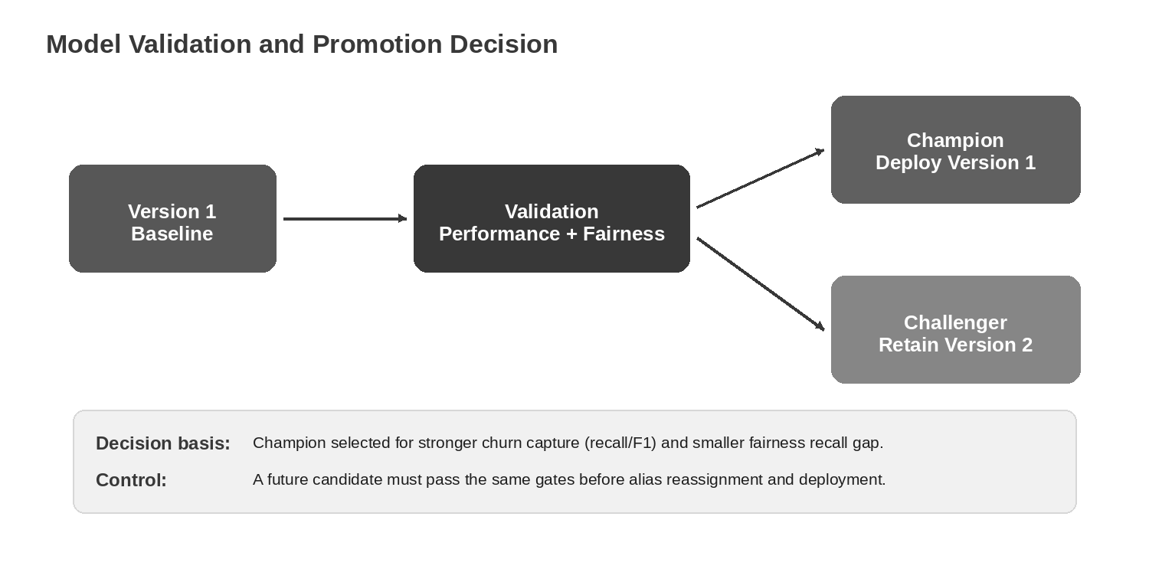
Figure 3. Example validation and promotion decision using the Champion-Challenger pattern.
11.1 Alias assignment
Aliases communicate the approved lifecycle role of a registered version without deleting earlier versions. Applying the aliases after documented review creates a transparent link between validation evidence and the deployment decision.
Code excerpt - assign Champion and Challenger aliases
client = MlflowClient()
client.set_registered_model_alias(MODEL_NAME, "Champion", "1")
client.set_registered_model_alias(MODEL_NAME, "Challenger", "2")
champion_model = mlflow.sklearn.load_model(
f"models:/{MODEL_NAME}@Champion"
)

11.2 Controlled promotion criteria
- Candidate is evaluated on the approved test dataset and the same metrics as the current Champion.
- Performance and approved fairness diagnostics are recorded and reviewed.
- A model owner records the decision rationale and approval outcome.
- The endpoint is changed only through a controlled deployment activity.
- Rollback remains possible using a previously approved version.
12. Unity Catalog Governance
Unity Catalog provides the governance layer for data and AI assets in this solution. The implementation uses catalog and schema organisation for stored datasets, governed Delta tables and registered models. This supports traceability from a model version back to the data and review process that produced it.
12.1 Governance areas
Governance area | Recommended implementation | Benefit
Access control | Grant least-privilege access to volumes, tables, models and inference records. | Limits unauthorised data or model use.
Data lineage | Track approved data transformations and model inputs. | Explains how data contributes to model output.
Model governance | Register models with versions, aliases, metrics and review evidence. | Creates controlled deployment history.
Auditability | Retain experiment evidence, approvals and deployment actions. | Supports review and compliance requirements.
Privacy | Remove or restrict identifiers and sensitive payload fields where not required. | Reduces member data exposure.

12.2 Recommended registered-model naming convention
A three-level Unity Catalog name clearly indicates the governance scope and asset purpose. The model used in the example follows the pattern:
Registered model naming pattern
<catalog_name>.<schema_name>.superannuation_churn_logistic_reg_model

The catalog identifies the top-level governance boundary, the schema groups related assets, and the model name states its business purpose and algorithm family.
12.3 Data and model ownership
Role | Primary responsibility
Data owner | Approve source data, permitted feature use, quality rules and retention policies.
Model developer | Train, track and document model versions using approved data.
Model reviewer / validator | Evaluate quality, fairness evidence and deployment readiness.
Platform owner | Operate permissions, endpoint configuration, monitoring and technical controls.
Business owner | Approve use of predictions in retention processes and outcome measurement.

13. Deployment through Databricks Model Serving
After validation and approval, the Champion model is deployed as a real-time prediction endpoint. Model Serving provides an API contract through which approved feature values are submitted and a model prediction is returned. This allows a downstream retention workflow or application to consume the prediction in a controlled manner.
13.1 Deployment readiness requirements
- The selected model version has completed performance and responsible-use review.
- The model signature and required input fields have been validated.
- Endpoint access is restricted to approved principals or applications.
- Operational owner, monitoring responsibilities and rollback procedure are defined.
- The endpoint is tested with representative and edge-case payloads before release.
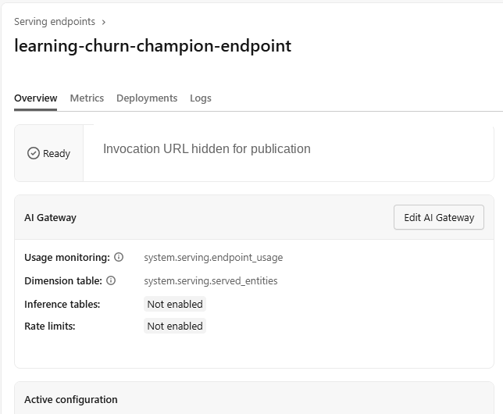
Figure 4. Example model-serving endpoint in Ready status; invocation URL removed for publication.

13.2 Serving request contract
The deployed model expects a JSON structure matching the MLflow model signature. The following compact example shows the dataframe_records pattern used by the endpoint. In a production integration, required fields and acceptable value ranges should be validated before a request is submitted.
Code excerpt - representative JSON scoring request
payload = {
"dataframe_records": [{
"member_age": 63,
"membership_tenure_years": 4,
"annual_contribution_amount": 20019.90,
"super_balance": 1666363.52,
"investment_plan_type": "High Growth",
"risk_profile": "Medium Risk"
}]
}

13.3 Example endpoint outcome
The documented endpoint test returned a prediction value of 0. In the example binary interpretation, 0 means that the member was not classified as likely to churn by the deployed model, whereas 1 indicates a likely-churn classification for possible retention workflow consideration.
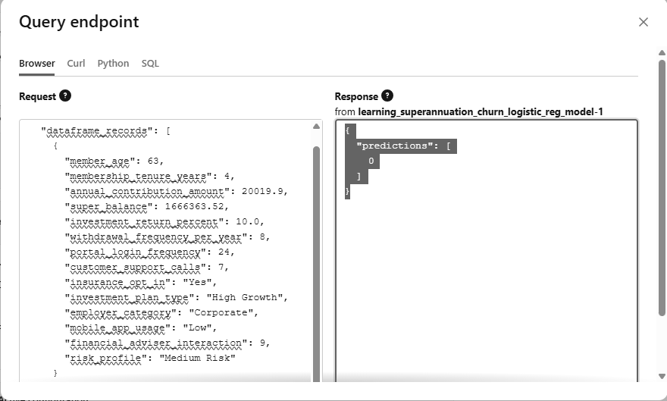
Figure 5. Recorded test query and response from the deployed endpoint.

14. Monitoring and Observability Strategy
Deployment begins the operational phase of the model lifecycle. Model behaviour can change when input distributions, member activity, product conditions or process usage changes. Monitoring must therefore cover system health, input quality, prediction patterns, measured model quality and responsible-use indicators.
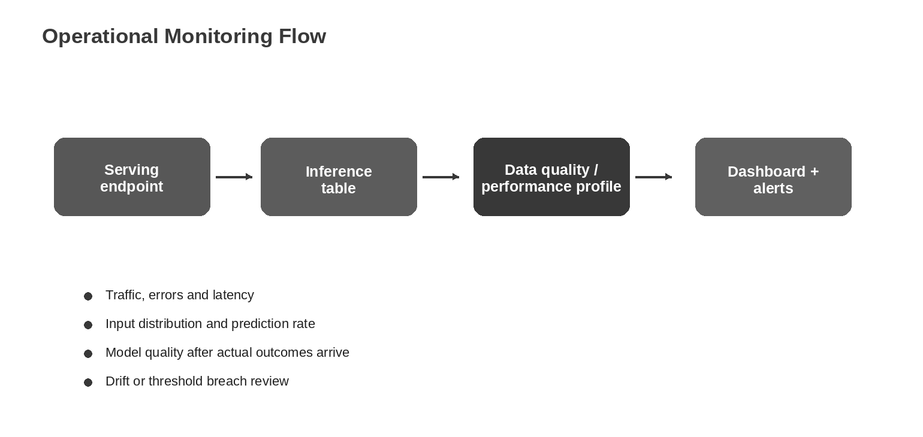
Figure 6. Monitoring flow from serving endpoint through inference records to review and alerting.
14.1 Monitoring categories
Monitoring category | Examples of observation | Action if concern is detected
Endpoint health | Traffic, latency, error rate and availability. | Investigate serving capacity, payload failure or configuration issue.
Input quality and drift | Missing values, schema change or feature distribution movement. | Validate upstream process and assess retraining need.
Prediction drift | Change in prediction rate or churn probability distribution. | Review portfolio change, threshold suitability or model degradation.
Outcome-based quality | Accuracy, precision, recall, F1 Score and ROC AUC after actual outcomes arrive. | Compare against thresholds and consider retraining or rollback.
Fairness diagnostics | Selection rate, recall gap and false positive rate gap by approved groups. | Escalate for responsible-use review and remediation.

14.2 Inference request and response logging
Where enabled and permitted by policy, inference logging captures request and response records in a governed Delta table for monitoring, debugging and quality analysis. The endpoint configuration, fields captured and access privileges must be verified in the target Databricks environment before production use.
SQL excerpt - initial operational inspection of inference records
SELECT *
FROM <catalog_name>.<schema_name>.<inference_table_name>
ORDER BY timestamp_ms DESC
LIMIT 20;
SELECT date_trunc('DAY', timestamp_ms) AS scoring_day,
COUNT(*) AS request_count
FROM <catalog_name>.<schema_name>.<inference_table_name>
GROUP BY date_trunc('DAY', timestamp_ms)
ORDER BY scoring_day DESC;

14.3 Outcome-based quality monitoring loop
- Store a permitted prediction reference that can later be matched with observed churn outcome.
- After an agreed observation period, join predictions with actual outcomes using a governed data process.
- Calculate precision, recall, F1 Score and ROC AUC against labelled outcomes.
- Recalculate approved fairness diagnostics and review material differences.
- Apply defined thresholds for alerting, retraining, model revalidation or rollback.
14.4 Suggested operational thresholds and ownership design
Area | Threshold design approach | Proposed owner
Endpoint reliability | Set service-specific latency and error-rate alert limits. | Platform operations.
Data drift | Establish feature distribution tolerance from baseline data. | Data and model owners.
Recall decline | Define minimum acceptable churn-capture threshold. | Business and model validator.
Fairness gap | Use policy-approved thresholds and escalation rules. | Risk / compliance and business owner.
Retraining cadence | Review periodically or following material drift. | Model owner.

15. Operational Governance and Rollback Strategy
A model release is controlled only when it can be traced, reviewed and reversed. Governance is therefore required across training evidence, validation results, endpoint configuration changes, monitoring outcomes and rollback activities.
15.1 Operational governance controls
Control | Required practice | Evidence retained
Data access | Apply least-privilege permissions to tables, volumes and inference records. | Permission configuration and audit history.
Version registration | Register every deployment candidate with signature and metrics. | MLflow run and model version.
Promotion approval | Approve Champion only after model quality and fairness review. | Recorded decision and reviewer sign-off.
Deployment release | Update serving endpoints through controlled change. | Endpoint deployment record.
Monitoring review | Review monitored results and remediation decisions. | Dashboards, alerts and review notes.
Privacy and retention | Store only permitted fields for approved duration. | Data retention and access rules.

15.2 Rollback procedure
- Confirm the issue using endpoint, monitoring and business-impact evidence.
- Identify the previously approved stable model version in Unity Catalog.
- Record rollback authorisation and reason for change.
- Reassign the Champion alias if required by the lifecycle decision.
- Update the serving endpoint to the approved rollback version and validate scoring.
- Monitor post-rollback results and document resolution or follow-up analysis.
Rollback principle: Rollback restores an approved model version; it does not remove the need to investigate data drift, process issues or model limitations that caused the concern.

16. Enterprise Implementation Recommendations
The proof-of-concept lifecycle provides a foundation for an enterprise retention analytics capability. The following recommendations extend the implementation from a successful demonstration into a sustainable operating model.
Recommendation | Enterprise implementation approach | Expected benefit
Approval framework | Create formal promotion criteria, reviewer roles and documented sign-off. | Consistent release decisions.
Feature governance | Maintain approved feature definitions, lineage and privacy assessment. | Trustworthy and compliant data use.
Automated pipeline | Schedule training, validation, registration and reporting through controlled jobs. | Repeatable and efficient model lifecycle.
Monitoring dashboards | Implement operational, data-drift, quality and fairness reporting. | Earlier detection of degradation.
Threshold management | Define business-approved intervention thresholds separately from model ranking. | Aligns outreach capacity with risk ranking.
Retraining policy | Retrain on schedule or when drift/performance triggers are met. | Maintains relevance over time.
Model comparison expansion | Evaluate alternative algorithms after baseline governance is stable. | Potential quality improvement with controlled complexity.

16.1 Future model experimentation opportunities
After baseline governance and monitoring are operational, subsequent analysis may explore tree-based algorithms, calibrated probability thresholds, cost-sensitive decision rules or additional engagement signals. Any new candidate must be compared on the same governed test basis or an approved revised evaluation design, and it must satisfy the same promotion controls.
16.2 Documentation deliverables for production readiness
- Approved feature catalogue and data-quality rules.
- Model card describing intended use, limitations and responsible-use controls.
- Validation report containing model comparison and fairness evidence.
- Deployment runbook, endpoint access controls and incident response process.
- Monitoring dashboard definitions, thresholds and ownership matrix.
- Retraining, promotion and rollback policy.
17. Conclusion
This document presents a governed MLOps lifecycle for a Databricks-based retention analytics solution. The implementation creates a fixed evaluation foundation, trains and registers a baseline model and tuned candidate, compares predictive quality and fairness diagnostics, selects a Champion using documented evidence, demonstrates real-time serving and defines the monitoring and rollback controls required for operational use.
The example result selects Version 1 as Champion because it provides stronger churn capture and a smaller recall gap across evaluated age bands, despite Version 2 delivering higher precision. This decision illustrates the central purpose of MLOps: deployment should be based on transparent business-aligned evidence, not only on whether a newly trained model produces a single improved metric.
For enterprise adoption, the next priority is to formalise approved feature use, review thresholds, access controls, monitoring ownership and retraining/rollback procedures within organisational governance standards.

Appendix A. Model Lifecycle Asset Organisation
The following workspace arrangement shows how development assets can be separated by lifecycle responsibility. It is included as a reference organisation, not as a step-by-step execution guide.
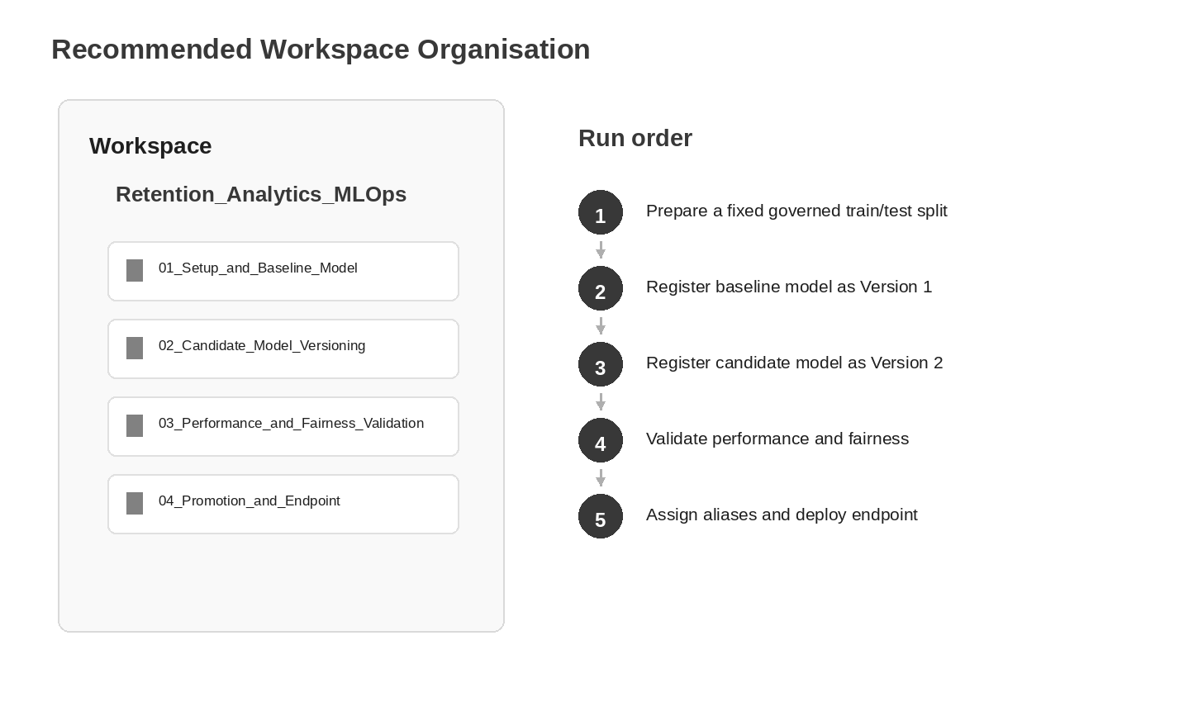
Figure 7. Recommended organisation of governed model lifecycle assets.
Lifecycle asset | Primary purpose
Baseline model development asset | Creates governed split and records Version 1 evidence.
Candidate model development asset | Evaluates tuned configuration and records Version 2 evidence.
Performance and fairness validation asset | Produces promotion evidence on identical test records.
Promotion and endpoint asset | Applies lifecycle aliases and validates deployment contract.

Appendix B. Important Code Snippets Reference
These extracts illustrate the most important implementation concepts without duplicating complete notebooks. Actual deployment code should be reviewed, tested and stored in the approved source repository.
B.1 Set Unity Catalog as the MLflow registry
import mlflow
from mlflow.tracking import MlflowClient
mlflow.set_registry_uri("databricks-uc")
client = MlflowClient()

B.2 Load an approved model alias
champion_model = mlflow.sklearn.load_model(
f"models:/{MODEL_NAME}@Champion"
)

B.3 Generate a real-time serving request
import json
payload = {
"dataframe_records": json.loads(sample_input.to_json(orient="records"))
}

B.4 Fairness gap indicator calculation
disparate_impact_ratio = min(selection_rate) / max(selection_rate)
recall_gap = max(recall_by_group) - min(recall_by_group)
false_positive_rate_gap = max(fp_rate_by_group) - min(fp_rate_by_group)

Appendix C. References
The following official resources should be reviewed against the target cloud and workspace configuration before production implementation. Titles and URLs are written in full for client readability.
- Databricks. Manage model lifecycle in Unity Catalog. https://docs.databricks.com/aws/en/machine-learning/manage-model-lifecycle/
- Databricks. What is Unity Catalog? https://docs.databricks.com/aws/en/data-governance/unity-catalog/
- Databricks. Deploy models using Model Serving. https://docs.databricks.com/aws/en/machine-learning/model-serving/
- Databricks. Monitor served models using Unity AI Gateway-enabled inference tables. https://docs.databricks.com/aws/en/ai-gateway/inference-tables
- scikit-learn. LogisticRegression documentation. https://scikit-learn.org/stable/modules/generated/sklearn.linear_model.LogisticRegression.html
- scikit-learn. GridSearchCV documentation. https://scikit-learn.org/stable/modules/generated/sklearn.model_selection.GridSearchCV.html

