MLOps for Retention Analytics
using Databricks
Step-by-Step Hands-On Implementation Guide
Model versioning | Performance validation | Fairness assessment
Unity Catalog governance | Champion/Challenger promotion | Model Serving | Monitoring
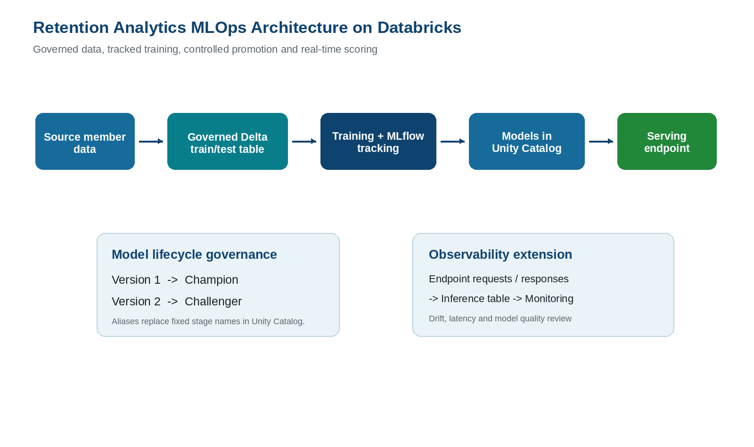
Figure 1. End-to-end architecture implemented in this guide.
Outcome: A practitioner can follow this document from workspace setup through a tested real-time prediction endpoint, then configure operational monitoring.

Section | Topic
1 | Purpose and business context
2 | Core concepts in plain language
3 | Architecture and implementation objects
4 | Prerequisites and workspace setup
5 | Notebook 01 - fixed dataset split and Version 1 baseline
6 | Notebook 02 - Version 2 candidate model
7 | Notebook 03 - performance and fairness validation
8 | Notebook 04 - promotion and serving endpoint
9 | Real-time endpoint testing
10 | Model performance monitoring implementation
11 | Operational governance and rollback
12 | Troubleshooting checklist
13 | References
Terminology: This guide uses the aliases Champion for the approved deployment candidate and Challenger for the alternate model under evaluation. Models in Unity Catalog use aliases and tags instead of legacy fixed model stages.
Dependencies and Libraries
The implementation uses the following libraries and frameworks:
• MLflow – experiment tracking, model registry and model lifecycle management.
• scikit-learn (sklearn) – model training, preprocessing and evaluation.
• Hyperopt – hyperparameter optimization for candidate model selection.
• Pandas – data manipulation and analysis.
• NumPy – numerical computation.
• Databricks Runtime – notebook execution environment.
• Unity Catalog – governance, lineage and access control.
• Delta Lake – governed storage and versioned datasets.
• Databricks Model Serving – real-time prediction endpoints.
• PySpark – distributed data processing where required.

1. Purpose and Business Context
Retention analytics estimates which members may discontinue or reduce their relationship with a superannuation product. The prediction can be used to prioritise timely retention interventions, subject to agreed business policy and responsible-use controls.
A machine learning model alone is not sufficient for an operational solution. The model must be versioned, evaluated consistently, approved using transparent evidence, deployed in a controlled manner and monitored after release. This operational discipline is commonly referred to as MLOps.

1.1 What this implementation builds
Capability | Implementation outcome
Governed data split | A fixed train/test split saved as a Unity Catalog Delta table so that model versions are evaluated on identical records.
Model versioning | A baseline Logistic Regression model registered as Version 1 and a tuned Logistic Regression candidate registered as Version 2.
Validation | A performance comparison and age-group fairness diagnostic prior to promotion.
Promotion | Champion and Challenger aliases applied to approved and alternate registered versions.
Deployment | A Databricks Model Serving endpoint configured for the approved version and queried with JSON input.
Monitoring | A practical operationalisation path using endpoint usage metrics, inference logging and data-quality/performance profiling.

2. Core Concepts in Plain Language
Term | Practical meaning
MLflow Tracking | Records parameters, metrics and model artefacts for each training run. It answers: what was trained, with which settings, and how did it perform?
Registered Model | A governed model asset whose versions can be reviewed and deployed.
Model Version | An immutable numbered snapshot created when a newly logged model is registered under the same registered model name.
Unity Catalog | The governance layer for tables, volumes and models, including access control, discovery, lineage and auditing.
Champion | An alias used here for the validated model chosen for deployment.
Challenger | An alias used here for a candidate model retained for further comparison or improvement.
Serving Endpoint | A managed API endpoint that receives new feature values and returns model predictions in real time.
Inference Table | A Unity Catalog Delta table that can capture model-serving requests and responses after inference logging is configured.
Fairness Diagnostic | A comparison of prediction behaviour across groups, used to identify material gaps that require review before approval.

2.1 Performance metrics used for churn models
Metric | Business interpretation
Accuracy | Overall percentage of correct classifications. Useful, but can conceal weak detection of a smaller churn class.
Precision | Among members predicted as likely to churn, the percentage who actually churn. Higher precision reduces unnecessary outreach.
Recall | Among members who actually churn, the percentage identified by the model. Higher recall reduces missed retention opportunities.
F1 Score | Balance between precision and recall; useful when both false positives and false negatives matter.
ROC AUC | Ability to rank churn-risk members ahead of non-churn members across different probability thresholds.

3. Architecture and Implementation Objects

Figure 2. Governed MLOps workflow for retention analytics.

3.1 Objects to create
Object type | Example object | Purpose
Workspace folder | Retention_Analytics_MLOps | Organises runnable notebooks.
Unity Catalog volume | <catalog>.<schema>.<volume> | Stores the CSV input file.
Delta table | <catalog>.<schema>.churn_dataset_split | Preserves the fixed train/test assignment.
Registered model | <catalog>.<schema>.superannuation_churn_logistic_reg_model | Contains model versions and aliases.
Serving endpoint | retention-churn-champion-endpoint | Serves the approved model prediction API.
Inference table | Configured during monitoring setup | Stores requests/responses for operational review.

4. Prerequisites and Workspace Setup

4.1 Required access and components
- Azure Databricks workspace with Unity Catalog enabled.
- Permission to use a catalog and schema, create a Delta table, register models and create or manage a serving endpoint.
- Compute or serverless notebook execution environment with Python, scikit-learn, pandas and MLflow available.
- A source dataset accessible from a Unity Catalog volume. The sample implementation expects a CSV file.
- A binary target column named churn, and optionally an identifier column named member_id.

4.2 Create the notebook folder and notebooks
In the Databricks workspace, create one solution folder and four Python notebooks. Keeping the notebooks separated makes the lifecycle auditable and helps reviewers rerun only the intended phase.
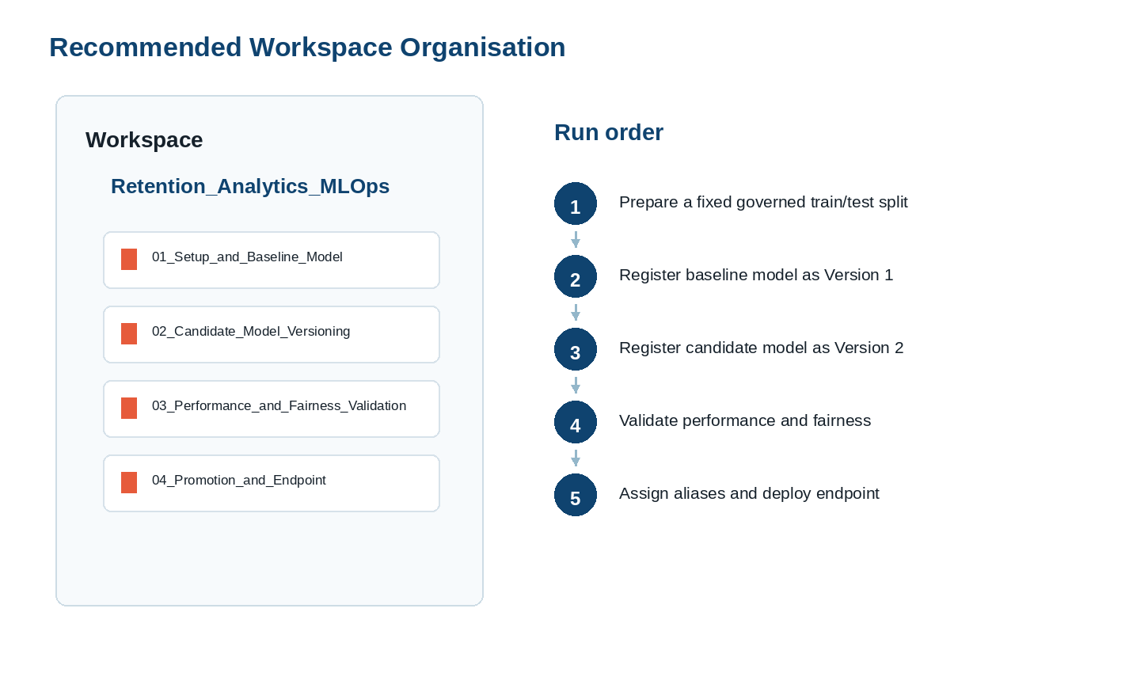
Figure 3. Notebook structure and execution order.
Notebook | Purpose | Expected output
01_Setup_and_Baseline_Model | Prepare governed split and baseline model | Registered model Version 1
02_Candidate_Model_Versioning | Tune and register candidate | Registered model Version 2
03_Performance_and_Fairness_Validation | Review model quality and prediction behaviour | Promotion recommendation
04_Promotion_and_Endpoint | Apply aliases and test the endpoint | Real-time prediction service

Execution control: When a cell registers a model, running the cell again creates an additional version. Before each registration, verify the current model versions and execute the registration cell once only.

5. Notebook 01 - Fixed Dataset Split and Version 1 Baseline
The first notebook creates the common evaluation foundation and the baseline model. A fixed test split is stored in a governed Delta table so that future candidates are measured against the same test records.

5.1 Step-by-step actions
Step | Action | Expected confirmation
1 | Create a Python notebook named 01_Setup_and_Baseline_Model. | Notebook is attached to compute.
2 | Paste and run Cell 1 after substituting target catalog, schema and volume names. | Configuration values are printed.
3 | Run Cell 2 to create the fixed train/test split and Delta table. | Training and testing row counts are displayed.
4 | Run Cell 3 to prepare features and exclude identifier fields. | Numeric and categorical columns are listed.
5 | Run Cell 4 to train and evaluate the baseline. | Five metrics are printed.
6 | Run Cell 5 once to register the baseline model. | Registered Version 1 is created.

5.2 Notebook code
Cell 1 - Common configuration
# Cell 1 - Common configuration (update these values for the target workspace)
import mlflow
import mlflow.sklearn
import pandas as pd
import numpy as np
from mlflow.models import infer_signature
from mlflow.tracking import MlflowClient
CATALOG = "<catalog_name>"
SCHEMA = "<schema_name>"
VOLUME = "<volume_name>"
DATA_FILE = "superannuation_churn_dataset.csv"
MODEL_NAME = f"{CATALOG}.{SCHEMA}.superannuation_churn_logistic_reg_model"
SPLIT_TABLE_NAME = f"{CATALOG}.{SCHEMA}.churn_dataset_split"
DATA_PATH = f"/Volumes/{CATALOG}/{SCHEMA}/{VOLUME}/{DATA_FILE}"
TARGET_COLUMN = "churn"
ID_COLUMN = "member_id"
mlflow.set_registry_uri("databricks-uc")
client = MlflowClient()
print("Registered Model:", MODEL_NAME)
print("Split Table :", SPLIT_TABLE_NAME)
print("Data Path :", DATA_PATH)

Cell 2 - Governed fixed split
# Cell 2 - Load data and create a fixed governed split
from sklearn.model_selection import train_test_split
data = pd.read_csv(DATA_PATH)
if TARGET_COLUMN not in data.columns:
raise ValueError(f"Target column '{TARGET_COLUMN}' is not present")
demo_data = data.dropna(subset=[TARGET_COLUMN]).copy()
demo_data[TARGET_COLUMN] = demo_data[TARGET_COLUMN].astype(int)
train_index, test_index = train_test_split(
demo_data.index, test_size=0.20, random_state=42,
stratify=demo_data[TARGET_COLUMN]
)
demo_data["dataset_split"] = "train"
demo_data.loc[test_index, "dataset_split"] = "test"
spark.createDataFrame(demo_data).write.format("delta") \
.mode("overwrite").option("overwriteSchema", "true") \
.saveAsTable(SPLIT_TABLE_NAME)
print("Training rows:", (demo_data.dataset_split == "train").sum())
print("Testing rows :", (demo_data.dataset_split == "test").sum())
print("Saved table :", SPLIT_TABLE_NAME)

Cell 3 - Feature preparation
# Cell 3 - Reload the governed split and prepare features
saved_data = spark.table(SPLIT_TABLE_NAME).toPandas()
train_data = saved_data[saved_data["dataset_split"] == "train"].copy()
test_data = saved_data[saved_data["dataset_split"] == "test"].copy()
columns_to_exclude = [TARGET_COLUMN, "dataset_split"]
if ID_COLUMN in saved_data.columns:
columns_to_exclude.append(ID_COLUMN)
X_train = train_data.drop(columns=columns_to_exclude)
y_train = train_data[TARGET_COLUMN].astype(int)
X_test = test_data.drop(columns=columns_to_exclude)
y_test = test_data[TARGET_COLUMN].astype(int)
numeric_columns = X_train.select_dtypes(
include=["int64", "float64", "int32", "float32"]
).columns.tolist()
categorical_columns = X_train.select_dtypes(
include=["object", "category", "bool"]
).columns.tolist()
print("Numeric columns :", numeric_columns)
print("Categorical columns:", categorical_columns)

Cell 4 - Baseline model training and evaluation
# Cell 4 - Train the Version 1 baseline model
from sklearn.compose import ColumnTransformer
from sklearn.pipeline import Pipeline
from sklearn.preprocessing import StandardScaler, OneHotEncoder
from sklearn.linear_model import LogisticRegression
from sklearn.metrics import (accuracy_score, precision_score, recall_score,
f1_score, roc_auc_score, confusion_matrix)
preprocessor = ColumnTransformer(
transformers=[
("numeric", StandardScaler(), numeric_columns),
("categorical", OneHotEncoder(handle_unknown="ignore"), categorical_columns)
], remainder="drop"
)
baseline_model = Pipeline(steps=[
("preprocessor", preprocessor),
("classifier", LogisticRegression(
C=1.0, class_weight=None, max_iter=2000, random_state=42
))
])
baseline_model.fit(X_train, y_train)
baseline_predictions = baseline_model.predict(X_test)
baseline_probabilities = baseline_model.predict_proba(X_test)[:, 1]
baseline_metrics = {
"accuracy": accuracy_score(y_test, baseline_predictions),
"precision": precision_score(y_test, baseline_predictions, zero_division=0),
"recall": recall_score(y_test, baseline_predictions, zero_division=0),
"f1_score": f1_score(y_test, baseline_predictions, zero_division=0),
"roc_auc": roc_auc_score(y_test, baseline_probabilities)
}
baseline_cm = confusion_matrix(y_test, baseline_predictions)
print(baseline_metrics)

Cell 5 - MLflow logging and registration
# Cell 5 - Track and register Version 1 in Models in Unity Catalog
input_example = X_train.head(5)
signature = infer_signature(X_train, baseline_model.predict(X_train))
with mlflow.start_run(run_name="Version_1_Baseline_Logistic_Regression") as run:
mlflow.log_param("model_role", "Baseline")
mlflow.log_param("algorithm", "Logistic Regression")
mlflow.log_param("C", 1.0)
mlflow.log_param("class_weight", "None")
mlflow.log_param("split_table", SPLIT_TABLE_NAME)
for metric_name, metric_value in baseline_metrics.items():
mlflow.log_metric(metric_name, float(metric_value))
mlflow.log_metric("true_negative", int(baseline_cm[0][0]))
mlflow.log_metric("false_positive", int(baseline_cm[0][1]))
mlflow.log_metric("false_negative", int(baseline_cm[1][0]))
mlflow.log_metric("true_positive", int(baseline_cm[1][1]))
mlflow.sklearn.log_model(
sk_model=baseline_model, artifact_path="model",
registered_model_name=MODEL_NAME, signature=signature,
input_example=input_example
)
baseline_run_id = run.info.run_id
print("Version 1 registered. Run ID:", baseline_run_id)

5.3 Implementation output example
Version | Role | Accuracy | Precision | Recall | F1 Score | ROC AUC
1 | Baseline | 0.9313 | 0.7222 | 0.4937 | 0.5865 | 0.9509

Interpretation: Version 1 establishes the benchmark against which a later candidate is reviewed. It is not deployed until validation and promotion steps are completed.

6. Notebook 02 - Version 2 Candidate Model
The second notebook reads the identical governed split table and produces a candidate model. The algorithm remains Logistic Regression, while hyperparameter search evaluates regularisation and class-weight options using ROC AUC during cross-validation.

6.1 Step-by-step actions
Step | Action | Why it matters
1 | Create the notebook 02_Candidate_Model_Versioning. | Separates baseline and candidate lifecycle events.
2 | Run Cell 1 to load the same governed split. | Prevents inconsistent test-set comparison.
3 | Run Cell 2 to tune and evaluate candidate options. | Selects the best cross-validated setting.
4 | Review metrics, then run Cell 3 once. | Creates Version 2 without overwriting Version 1.
5 | Run Cell 4 to display both versions. | Provides traceable comparison evidence.

6.2 Notebook code
Cell 1 - Load governed split
# Cell 1 - Load the same governed split for Version 2
import mlflow
import mlflow.sklearn
import pandas as pd
import numpy as np
from mlflow.models import infer_signature
from mlflow.tracking import MlflowClient
from sklearn.compose import ColumnTransformer
from sklearn.pipeline import Pipeline
from sklearn.preprocessing import StandardScaler, OneHotEncoder
from sklearn.linear_model import LogisticRegression
from sklearn.model_selection import GridSearchCV
from sklearn.metrics import (accuracy_score, precision_score, recall_score,
f1_score, roc_auc_score, confusion_matrix)
CATALOG = "<catalog_name>"
SCHEMA = "<schema_name>"
MODEL_NAME = f"{CATALOG}.{SCHEMA}.superannuation_churn_logistic_reg_model"
SPLIT_TABLE_NAME = f"{CATALOG}.{SCHEMA}.churn_dataset_split"
TARGET_COLUMN = "churn"
ID_COLUMN = "member_id"
mlflow.set_registry_uri("databricks-uc")
client = MlflowClient()
saved_data = spark.table(SPLIT_TABLE_NAME).toPandas()
train_data = saved_data[saved_data.dataset_split == "train"].copy()
test_data = saved_data[saved_data.dataset_split == "test"].copy()
exclude = [TARGET_COLUMN, "dataset_split"] + ([ID_COLUMN] if ID_COLUMN in saved_data.columns else [])
X_train, y_train = train_data.drop(columns=exclude), train_data[TARGET_COLUMN].astype(int)
X_test, y_test = test_data.drop(columns=exclude), test_data[TARGET_COLUMN].astype(int)
numeric_columns = X_train.select_dtypes(include=["int64","float64","int32","float32"]).columns.tolist()
categorical_columns = X_train.select_dtypes(include=["object","category","bool"]).columns.tolist()

Cell 2 - Candidate training and test evaluation
# Cell 2 - Tune the Version 2 candidate model
preprocessor = ColumnTransformer(transformers=[
("numeric", StandardScaler(), numeric_columns),
("categorical", OneHotEncoder(handle_unknown="ignore"), categorical_columns)
], remainder="drop")
candidate_pipeline = Pipeline(steps=[
("preprocessor", preprocessor),
("classifier", LogisticRegression(max_iter=2000, random_state=42))
])
parameter_grid = {
"classifier__C": [0.01, 0.1, 1.0, 10.0],
"classifier__class_weight": [None, "balanced"]
}
grid_search = GridSearchCV(
estimator=candidate_pipeline, param_grid=parameter_grid,
scoring="roc_auc", cv=3, n_jobs=-1, refit=True
)
grid_search.fit(X_train, y_train)
candidate_model = grid_search.best_estimator_
candidate_predictions = candidate_model.predict(X_test)
candidate_probabilities = candidate_model.predict_proba(X_test)[:, 1]
candidate_metrics = {
"accuracy": accuracy_score(y_test, candidate_predictions),
"precision": precision_score(y_test, candidate_predictions, zero_division=0),
"recall": recall_score(y_test, candidate_predictions, zero_division=0),
"f1_score": f1_score(y_test, candidate_predictions, zero_division=0),
"roc_auc": roc_auc_score(y_test, candidate_probabilities)
}
candidate_cm = confusion_matrix(y_test, candidate_predictions)
print("Best parameters:", grid_search.best_params_)
print(candidate_metrics)

Cell 3 - Candidate registration
# Cell 3 - Track and register Version 2
input_example = X_train.head(5)
signature = infer_signature(X_train, candidate_model.predict(X_train))
with mlflow.start_run(run_name="Version_2_Candidate_Logistic_Regression") as run:
mlflow.log_param("model_role", "Candidate")
mlflow.log_param("algorithm", "Logistic Regression")
mlflow.log_param("tuning_method", "GridSearchCV")
mlflow.log_param("selection_metric", "roc_auc")
mlflow.log_param("best_C", grid_search.best_params_["classifier__C"])
mlflow.log_param("best_class_weight", str(grid_search.best_params_["classifier__class_weight"]))
mlflow.log_param("split_table", SPLIT_TABLE_NAME)
for metric_name, metric_value in candidate_metrics.items():
mlflow.log_metric(metric_name, float(metric_value))
mlflow.log_metric("true_negative", int(candidate_cm[0][0]))
mlflow.log_metric("false_positive", int(candidate_cm[0][1]))
mlflow.log_metric("false_negative", int(candidate_cm[1][0]))
mlflow.log_metric("true_positive", int(candidate_cm[1][1]))
mlflow.sklearn.log_model(
sk_model=candidate_model, artifact_path="model",
registered_model_name=MODEL_NAME, signature=signature,
input_example=input_example
)
candidate_run_id = run.info.run_id
print("Version 2 registered. Run ID:", candidate_run_id)

Cell 4 - Version verification
# Cell 4 - Verify Version 1 and Version 2
version_rows = []
for version in client.search_model_versions(f"name='{MODEL_NAME}'"):
run = client.get_run(version.run_id)
version_rows.append({
"version": int(version.version), "status": version.status,
"model_role": run.data.params.get("model_role"),
"accuracy": run.data.metrics.get("accuracy"),
"precision": run.data.metrics.get("precision"),
"recall": run.data.metrics.get("recall"),
"f1_score": run.data.metrics.get("f1_score"),
"roc_auc": run.data.metrics.get("roc_auc")
})
versions_df = pd.DataFrame(version_rows).sort_values("version")
display(versions_df)

6.3 Registered model version result
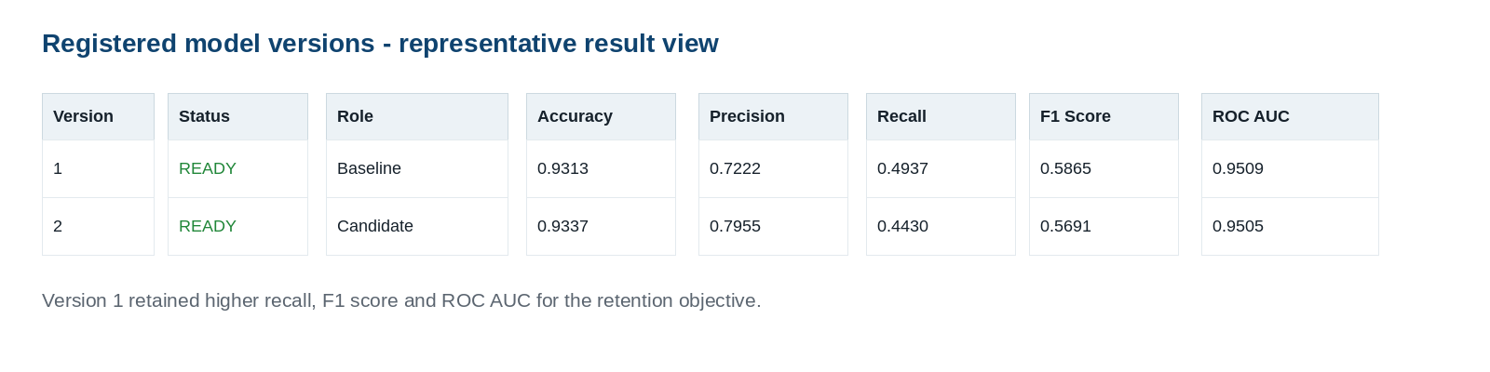
Figure 4. Representative output generated from registered version validation results.

7. Notebook 03 - Performance and Fairness Validation
Model promotion should be evidence based. This notebook loads both model versions from Unity Catalog, re-evaluates them using the identical test records and calculates fairness diagnostics across member age groups.
Responsible-use note: The age grouping in this walkthrough is a diagnostic example. Production fairness dimensions, thresholds and approval decisions must be agreed with business, risk and compliance stakeholders.

7.1 Step-by-step actions
Step | Action | Review outcome
1 | Load Version 1, Version 2 and the governed test rows. | Both models receive identical features.
2 | Calculate common performance metrics. | Compare churn-capture trade-offs.
3 | Create age groups and calculate group metrics. | Observe selection, recall and false-positive behaviour.
4 | Calculate fairness-gap indicators. | Identify material differences requiring review.
5 | Document the promotion decision. | Promotion is traceable and explainable.

7.2 Notebook code
Cell 1 - Load common test dataset and registered versions
# Cell 1 - Load registered models and the common test data
import mlflow
import mlflow.sklearn
import pandas as pd
import numpy as np
from sklearn.metrics import (accuracy_score, precision_score, recall_score,
f1_score, roc_auc_score, confusion_matrix)
CATALOG = "<catalog_name>"
SCHEMA = "<schema_name>"
MODEL_NAME = f"{CATALOG}.{SCHEMA}.superannuation_churn_logistic_reg_model"
SPLIT_TABLE_NAME = f"{CATALOG}.{SCHEMA}.churn_dataset_split"
TARGET_COLUMN = "churn"
ID_COLUMN = "member_id"
SENSITIVE_ATTRIBUTE = "member_age"
mlflow.set_registry_uri("databricks-uc")
test_data = spark.table(SPLIT_TABLE_NAME).toPandas()
test_data = test_data[test_data.dataset_split == "test"].copy()
exclude = [TARGET_COLUMN, "dataset_split"] + ([ID_COLUMN] if ID_COLUMN in test_data.columns else [])
X_test = test_data.drop(columns=exclude)
y_test = test_data[TARGET_COLUMN].astype(int)
baseline_model = mlflow.sklearn.load_model(f"models:/{MODEL_NAME}/1")
candidate_model = mlflow.sklearn.load_model(f"models:/{MODEL_NAME}/2")

Cell 2 - Common performance evaluation
# Cell 2 - Re-evaluate both versions with identical test data and metrics
def evaluate_model(model, version, role, X_eval, y_eval):
prediction = model.predict(X_eval)
probability = model.predict_proba(X_eval)[:, 1]
cm = confusion_matrix(y_eval, prediction, labels=[0, 1])
return {
"version": version, "role": role,
"accuracy": accuracy_score(y_eval, prediction),
"precision": precision_score(y_eval, prediction, zero_division=0),
"recall": recall_score(y_eval, prediction, zero_division=0),
"f1_score": f1_score(y_eval, prediction, zero_division=0),
"roc_auc": roc_auc_score(y_eval, probability),
"tn": int(cm[0,0]), "fp": int(cm[0,1]),
"fn": int(cm[1,0]), "tp": int(cm[1,1])
}, prediction, probability
baseline_result, baseline_pred, baseline_prob = evaluate_model(
baseline_model, 1, "Baseline", X_test, y_test)
candidate_result, candidate_pred, candidate_prob = evaluate_model(
candidate_model, 2, "Candidate", X_test, y_test)
performance_df = pd.DataFrame([baseline_result, candidate_result])
display(performance_df.round(4))

Cell 3 - Fairness analysis by age group
# Cell 3 - Evaluate prediction behaviour across member age groups
fairness_data = test_data.copy()
fairness_data["age_group"] = pd.cut(
fairness_data[SENSITIVE_ATTRIBUTE], bins=[0, 34, 49, 64, np.inf],
labels=["Under 35", "35-49", "50-64", "65+"], include_lowest=True
)
def fairness_metrics(data, actual, predicted, probability):
result = []
evaluation = data.copy()
evaluation["actual"] = np.array(actual)
evaluation["predicted"] = np.array(predicted)
evaluation["probability"] = np.array(probability)
for group, df in evaluation.groupby("age_group", observed=False):
if len(df) == 0:
continue
tn, fp, fn, tp = confusion_matrix(
df.actual, df.predicted, labels=[0, 1]
).ravel()
result.append({
"age_group": str(group), "record_count": len(df),
"selection_rate": df.predicted.mean(),
"precision": precision_score(df.actual, df.predicted, zero_division=0),
"recall_true_positive_rate": tp / (tp + fn) if tp + fn else np.nan,
"false_positive_rate": fp / (fp + tn) if fp + tn else np.nan,
"roc_auc": roc_auc_score(df.actual, df.probability)
if df.actual.nunique() == 2 else np.nan
})
return pd.DataFrame(result)
baseline_fairness = fairness_metrics(fairness_data, y_test, baseline_pred, baseline_prob)
candidate_fairness = fairness_metrics(fairness_data, y_test, candidate_pred, candidate_prob)
baseline_fairness.insert(0, "version", 1); baseline_fairness.insert(1, "role", "Baseline")
candidate_fairness.insert(0, "version", 2); candidate_fairness.insert(1, "role", "Candidate")
fairness_comparison_df = pd.concat([baseline_fairness, candidate_fairness], ignore_index=True)
display(fairness_comparison_df.round(4))

Cell 4 - Gap indicators
# Cell 4 - Produce fairness-gap indicators for model review
summary = []
for version, role, df in [(1,"Baseline",baseline_fairness), (2,"Candidate",candidate_fairness)]:
min_sr, max_sr = df.selection_rate.min(), df.selection_rate.max()
summary.append({
"version": version, "role": role,
"disparate_impact_ratio": min_sr / max_sr if max_sr else np.nan,
"recall_gap": df.recall_true_positive_rate.max() - df.recall_true_positive_rate.min(),
"false_positive_rate_gap": df.false_positive_rate.max() - df.false_positive_rate.min()
})
fairness_summary_df = pd.DataFrame(summary)
display(fairness_summary_df.round(4))

7.3 Performance validation example result
Version | Role | Accuracy | Precision | Recall | F1 Score | ROC AUC
1 | Baseline | 0.9313 | 0.7222 | 0.4937 | 0.5865 | 0.9509
2 | Candidate | 0.9337 | 0.7955 | 0.4430 | 0.5691 | 0.9505

The candidate achieves slightly higher accuracy and precision. The baseline achieves higher recall, F1 Score and ROC AUC. For a proactive retention objective, missing true churners can be costly; therefore recall and the overall trade-off must be explicitly reviewed before deployment.

7.4 Fairness definitions
Indicator | Definition | Review purpose
Selection rate | Percentage of members in a group predicted as likely to churn. | Checks whether one group is flagged far more or less frequently.
Recall / true positive rate | Percentage of actual churners detected within a group. | Checks whether the model misses churners more frequently in a group.
False positive rate | Percentage of non-churners incorrectly flagged within a group. | Checks disproportionate unnecessary outreach.
Disparate impact ratio | Lowest group selection rate divided by highest group selection rate. | A diagnostic parity measure; threshold must be policy approved.
Recall gap | Highest group recall minus lowest group recall. | Highlights uneven churn capture.

7.5 Fairness diagnostic example result
V | Role | Age group | Rows | Select rate | Precision | Recall | FP rate
1 | Baseline | Under 35 | 82 | 0.0732 | 0.6667 | 0.5714 | 0.0267
1 | Baseline | 35-49 | 268 | 0.0672 | 0.6111 | 0.4074 | 0.0290
1 | Baseline | 50-64 | 281 | 0.0676 | 0.8421 | 0.5161 | 0.0120
1 | Baseline | 65+ | 169 | 0.0651 | 0.7273 | 0.5714 | 0.0194
2 | Candidate | Under 35 | 82 | 0.0610 | 0.8000 | 0.5714 | 0.0133
2 | Candidate | 35-49 | 268 | 0.0485 | 0.6154 | 0.2963 | 0.0207
2 | Candidate | 50-64 | 281 | 0.0569 | 0.9375 | 0.4839 | 0.0040
2 | Candidate | 65+ | 169 | 0.0592 | 0.8000 | 0.5714 | 0.0129

Version | Role | Disparate Impact Ratio | Recall Gap | False Positive Rate Gap
1 | Baseline | 0.8895 | 0.1640 | 0.0170
2 | Candidate | 0.7955 | 0.2751 | 0.0167

7.6 Promotion recommendation from the example
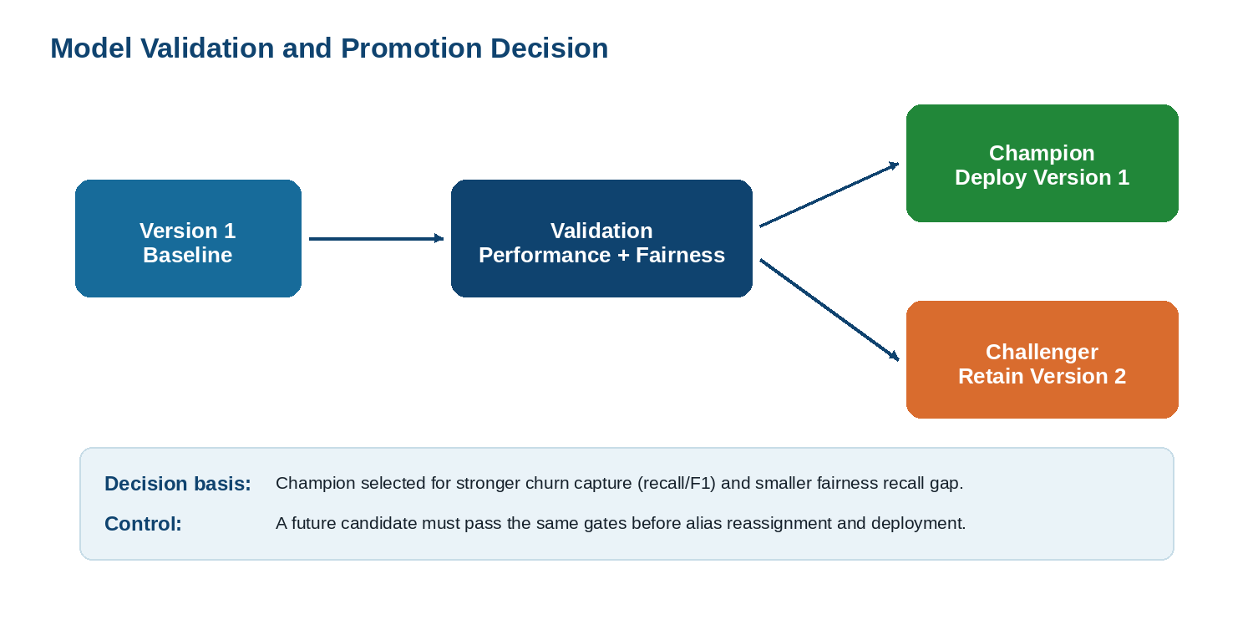
Figure 5. Example decision from performance and fairness review.
Version 1 is selected as Champion in the example because it has higher recall, F1 Score and ROC AUC, and a smaller recall gap across the evaluated age bands. Version 2 is retained as Challenger because it improves precision but detects fewer actual churners and has a wider recall gap.

8. Notebook 04 - Promotion and Serving Endpoint
The fourth notebook applies aliases after validation approval and verifies that the approved model can be loaded through the Champion alias. A serving endpoint is then created in the Databricks user interface for the concrete approved model version.

8.1 Alias promotion code
Cell 1 - Assign and verify Champion / Challenger aliases
# Cell 1 - Assign aliases after validation approval
import mlflow
import mlflow.sklearn
import pandas as pd
from mlflow.tracking import MlflowClient
CATALOG = "<catalog_name>"
SCHEMA = "<schema_name>"
MODEL_NAME = f"{CATALOG}.{SCHEMA}.superannuation_churn_logistic_reg_model"
CHAMPION_VERSION = "1"
CHALLENGER_VERSION = "2"
mlflow.set_registry_uri("databricks-uc")
client = MlflowClient()
client.set_registered_model_alias(MODEL_NAME, "Champion", CHAMPION_VERSION)
client.set_registered_model_alias(MODEL_NAME, "Challenger", CHALLENGER_VERSION)
champion = client.get_model_version_by_alias(MODEL_NAME, "Champion")
challenger = client.get_model_version_by_alias(MODEL_NAME, "Challenger")
display(pd.DataFrame([
{"alias":"Champion", "version":champion.version, "status":champion.status},
{"alias":"Challenger", "version":challenger.version, "status":challenger.status}
]))

Cell 2 - Load and validate the Champion alias
# Cell 2 - Validate model access through the Champion alias
SPLIT_TABLE_NAME = f"{CATALOG}.{SCHEMA}.churn_dataset_split"
TARGET_COLUMN = "churn"
ID_COLUMN = "member_id"
champion_model = mlflow.sklearn.load_model(f"models:/{MODEL_NAME}@Champion")
sample = spark.table(SPLIT_TABLE_NAME).toPandas()
sample = sample[sample.dataset_split == "test"].head(1).copy()
exclude = [TARGET_COLUMN, "dataset_split"] + ([ID_COLUMN] if ID_COLUMN in sample.columns else [])
sample_input = sample.drop(columns=exclude)
prediction = int(champion_model.predict(sample_input)[0])
probability = float(champion_model.predict_proba(sample_input)[0][1])
print("Prediction:", prediction)
print("Churn probability:", round(probability, 4))
display(sample_input)

8.2 Important deployment behaviour
Alias versus deployed version: The alias expresses lifecycle approval. When configuring the serving endpoint in the UI, select the concrete model version currently represented by Champion. When Champion later moves to a new version, update the serving endpoint in a controlled release step.

8.3 Create the endpoint in the Databricks UI
Step | UI action | Value / selection
1 | Open Serving from the left navigation and select Create serving endpoint. | Custom model serving endpoint
2 | Provide an endpoint name. | Example: retention-churn-champion-endpoint
3 | Choose My models - Unity Catalog and select the registered model. | <catalog>.<schema>.superannuation_churn_logistic_reg_model
4 | Select the model version represented by Champion. | Example decision: Version 1
5 | Assign traffic and compute. | 100% traffic; suitable CPU workload size
6 | For non-production testing only, consider scale to zero. | May introduce cold-start latency
7 | Select Create and wait for the endpoint state to become Ready. | Endpoint can now be queried

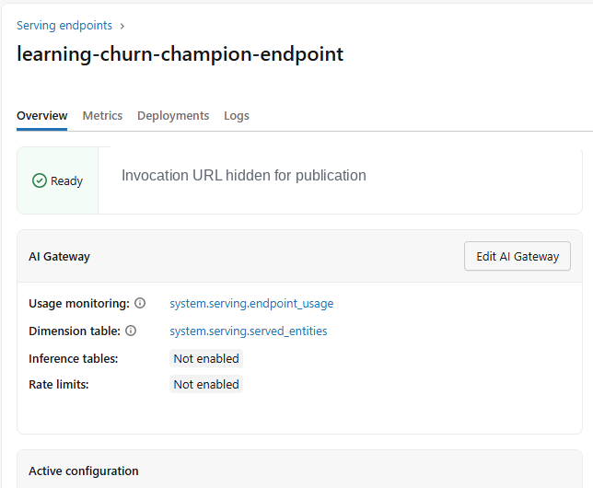
Figure 6. Endpoint readiness screen. The invocation URL is removed from this publication image.

9. Real-Time Endpoint Testing
A serving endpoint receives feature data as JSON and returns a prediction. Use the same feature column names and data types that were recorded in the MLflow model signature.

9.1 Generate request JSON from the notebook
Cell 3 - Generate a valid JSON payload
# Cell 3 - Generate request JSON for the deployed endpoint
import json
payload = {"dataframe_records": json.loads(sample_input.to_json(orient="records"))}
print(json.dumps(payload, indent=2))

9.2 Submit the request in the UI
Step | Action
1 | Open the Ready endpoint, select Use, then select Query endpoint.
2 | Select the Browser query tab.
3 | Paste the JSON returned from Cell 3 using the dataframe_records wrapper.
4 | Select Send request and review the predictions response.

Example request submitted through the endpoint
{
"dataframe_records": [
{
"member_age": 63,
"membership_tenure_years": 4,
"annual_contribution_amount": 20019.9,
"super_balance": 1666363.52,
"investment_return_percent": 10,
"withdrawal_frequency_per_year": 8,
"portal_login_frequency": 24,
"customer_support_calls": 7,
"insurance_opt_in": "Yes",
"investment_plan_type": "High Growth",
"employer_category": "Corporate",
"mobile_app_usage": "Low",
"financial_adviser_interaction": 9,
"risk_profile": "Medium Risk"
}
]
}

Example response
{
"predictions": [
0
]
}

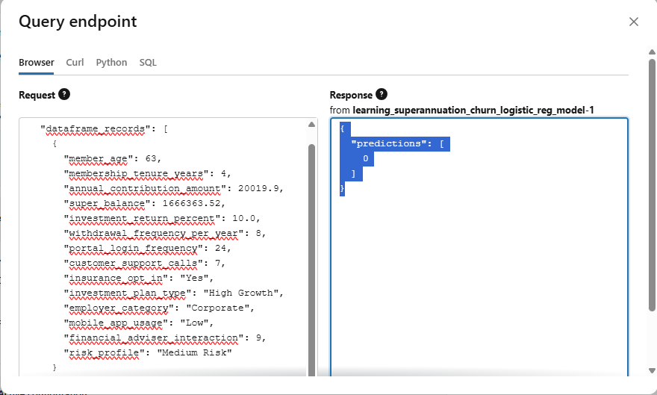
Figure 7. Successful real-time endpoint scoring request and response.
Business interpretation: A prediction of 0 indicates that the member was not classified as likely to churn by the deployed model. A prediction of 1 would indicate a likely-churn classification for downstream retention workflow consideration.

10. Model Performance Monitoring Implementation
Deployment is not the end of the lifecycle. A deployed retention model must be observed for operational health, input changes, prediction changes and outcome-based model performance once actual churn outcomes become available.
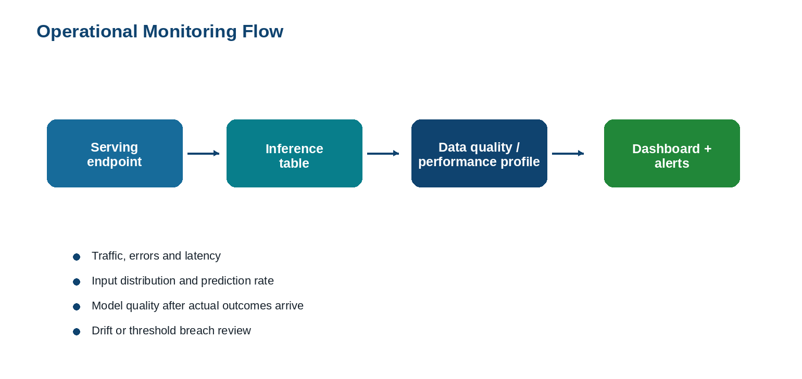
Figure 8. Monitoring flow after endpoint deployment.

10.1 What to monitor
Monitoring area | Examples of observations | Action when concern is identified
Endpoint health | Request volume, error rate, latency, availability | Investigate endpoint configuration, serving capacity or request payload errors.
Input drift | Changes in member age, balance, contribution or categorical distributions | Review data pipeline and retraining need.
Prediction drift | Change in predicted churn-rate distribution | Validate whether portfolio behaviour changed or model is degrading.
Performance | Accuracy, recall, precision, ROC AUC after actual churn labels arrive | Re-evaluate, retrain or re-promote a candidate.
Fairness indicators | Selection rate, recall gap and false-positive gap by approved groups | Escalate for responsible-use review and mitigation.

10.2 Configure request/response logging
Databricks supports Unity AI Gateway-enabled inference tables for served models. After enabled, endpoint request and response payloads are captured into a Unity Catalog Delta table for monitoring and analysis. Field names and availability can vary by workspace feature availability and configuration; validate the feature in the target workspace before production rollout.
Step | UI action
1 | Open the serving endpoint and select Edit AI Gateway or the relevant monitoring configuration option in the endpoint UI.
2 | Enable inference table / request-response logging for the endpoint.
3 | Select the governed catalog and schema where inference records must be stored.
4 | Save the configuration and issue controlled test predictions.
5 | Verify that records are written to the generated inference table before building monitoring queries or profiles.

10.3 Initial SQL inspection
SQL - inspect inference records and request volume
-- After inference logging is configured, inspect the generated inference table.
-- Replace the table name with the one created in the target schema.
SELECT *
FROM <catalog_name>.<schema_name>.<inference_table_name>
ORDER BY timestamp_ms DESC
LIMIT 20;
-- Operational starting point: invocation volume by day.
SELECT date_trunc('DAY', timestamp_ms) AS scoring_day,
COUNT(*) AS request_count
FROM <catalog_name>.<schema_name>.<inference_table_name>
GROUP BY date_trunc('DAY', timestamp_ms)
ORDER BY scoring_day DESC;

10.4 Establish a model quality monitoring loop
- Capture a unique scoring/member reference with each prediction where permitted by privacy and governance controls.
- After the observation window, join predictions to actual churn outcomes using an approved governed process.
- Calculate ongoing recall, precision, F1 Score and ROC AUC on labelled outcomes.
- Recalculate approved fairness diagnostics for relevant groups and investigate material deterioration.
- Define alert thresholds, ownership, review cadence and retraining or rollback triggers before production operation.
Monitoring scope statement: The endpoint prediction test demonstrates deployment and scoring. Inference logging, dashboards, alerts and outcome-based monitoring must be configured and validated in the target production environment as an operationalisation step.

11. Operational Governance and Rollback

11.1 Governance controls
Control | Recommended implementation
Data access | Grant least-privilege access to volumes, split tables and inference tables through Unity Catalog.
Model registration | Require a documented run, signature, common-test metrics and validation output for each new version.
Promotion approval | Assign Champion only after performance and responsible-use review is recorded.
Deployment | Update endpoints through a controlled release with validation and audit trail.
Monitoring | Retain monitoring definitions, review outcomes and remediation decisions.
Privacy | Avoid exposing identifiers and sensitive payload fields beyond approved business need.

11.2 Rollback procedure
Step | Rollback action
1 | Confirm the issue using endpoint and monitoring evidence.
2 | Identify the last approved model version in Unity Catalog.
3 | Reassign the Champion alias to the approved rollback version, if required.
4 | Update the serving endpoint to serve the approved rollback version.
5 | Validate a controlled prediction request and monitor post-rollback endpoint behaviour.
6 | Document cause, corrective action and follow-up validation.

12. Troubleshooting Checklist
Issue | Likely cause | Resolution
Experiment path not found when logging a run | A custom MLflow experiment path refers to a workspace folder that does not exist. | Use the notebook-associated MLflow experiment or first create a valid workspace path.
An extra model version appears | The registration cell was executed more than once. | Use the new version intentionally or recreate a clean model name for a controlled walkthrough.
Endpoint request rejects input | Column name or data type does not match the logged model signature. | Generate the payload from an input DataFrame shaped like training features.
Model comparison is unfair | Versions were tested on different splits or with inconsistent metrics. | Store a fixed governed split and re-evaluate both versions with identical logic.
Stages are unavailable | Models in Unity Catalog do not use legacy stage transitions. | Use reassignable aliases such as Champion and Challenger.
No monitoring records appear | Inference logging has not been enabled or tested. | Configure endpoint inference logging and invoke controlled requests.

13. Official Databricks References
The implementation approach in this guide is aligned to Azure Databricks documentation available at the time of preparation. Review the current documentation and organisational standards before a production deployment.
Reference | Official documentation URL
Models in Unity Catalog and model lifecycle | https://learn.microsoft.com/en-us/azure/databricks/machine-learning/manage-model-lifecycle/
Migrate lifecycle workflows to Unity Catalog aliases | https://learn.microsoft.com/en-us/azure/databricks/machine-learning/manage-model-lifecycle/migrate-to-uc
Create custom model serving endpoints | https://learn.microsoft.com/en-us/azure/databricks/machine-learning/model-serving/create-manage-serving-endpoints
Score custom model endpoints | https://learn.microsoft.com/en-us/azure/databricks/machine-learning/model-serving/score-custom-model-endpoints
Inference tables for served model monitoring | https://learn.microsoft.com/en-us/azure/databricks/ai-gateway/inference-tables
Data profiling and model-serving monitoring | https://learn.microsoft.com/en-us/azure/databricks/data-governance/unity-catalog/data-quality-monitoring/data-profiling/
Unity Catalog overview | https://learn.microsoft.com/en-us/azure/databricks/data-governance/unity-catalog/

