Retention Analytics – Databricks ML Notebook Plan
Updated with inputs and outputs for every step
Source: 15 Databricks input views | Grain: one row per account per AsOfDate for historical modelling and one row per eligible account per scoring date for predictions.
The notebook names, descriptions and job-flow sequences below follow the supplied screenshots. Input/output details are added for implementation planning.

Notebook steps – descriptions, inputs and outputs

01_Validate_Source_Views.ipynb
Checks whether all 15 Databricks input views and required columns/data are available.
Input: The 15 configured Databricks source views; expected view/column list; data-quality and freshness rules.
Output: Validation results for each view (available/missing, row counts, mandatory-column checks, freshness and null issues); pass/fail status that can stop downstream jobs.

02_Build_Base_Historical_Dataset.ipynb
Builds the historical account population, applies eligibility/exclusion rules, and creates the churn target.
Input: Validated historical source views; approved AsOfDate and outcome windows; account eligibility rules; exitDate, internal-transfer and deceased exclusions.
Output: Historical account-level base dataset for candidate AsOfDates, with account/member identifiers, eligibility flags, outcome dates and target_churn (1/0 or null where ineligible).

03A_Build_Training_Features.ipynb
Creates historical ML features such as tenure, behaviour, transactions, rollover, campaign, investment and insurance features.
Input: Historical account population; the 15 historical source views; approved feature definitions; each account’s AsOfDate and lookback window.
Output: Point-in-time-safe account-level feature records, with only data available on/before AsOfDate; no churn outcome leakage.

04_Build_Training_Snapshots.ipynb
Creates multiple historical AsOfDate snapshots and combines them into one training dataset.
Input: Base historical records and historical training features for the agreed AsOfDate list; target labels and snapshot configuration.
Output: Combined multi-snapshot training dataset: one row per account_id per AsOfDate, including target_churn and engineered features.

05_Prepare_Model_Data.ipynb
Handles missing values, feature selection and creates train, validation and final test datasets.
Input: Combined labelled historical snapshot dataset; feature exclusion list; approved chronological splitting and preprocessing settings.
Output: Prepared training, validation and untouched final-test datasets, plus saved preprocessing/feature schema to reuse at scoring time.

06_Train_And_Evaluate_Model.ipynb
Trains different models, compares their performance and selects the best model.
Input: Prepared train and validation datasets; selected features and processing pipeline; evaluation metrics and model candidate configuration.
Output: Trained candidate models, evaluation metrics/comparison, selected model and test-set evaluation after selection; run artifacts recorded in MLflow.

07_Register_Model_MLflow.ipynb
Saves and versions the selected model in MLflow.
Input: Approved selected model and its fitted preprocessing steps; MLflow experiment/run ID; registry name and permissions.
Output: Registered, versioned MLflow model with signature, metadata and version/alias for scoring (subject to approval).

02B_Build_Scoring_Population.ipynb
Prepares the current active/eligible accounts that need a churn prediction.
Input: Latest validated Databricks views; current scoring date; approved active-account and eligibility rules.
Output: Current eligible account population (one row per account for the scoring date), with identifiers and scoring date; excluded accounts logged.

03B_Build_Scoring_Features.ipynb
Builds the same approved features for the latest scoring date.
Input: Eligible scoring population; latest source views; registered model’s approved feature definitions and lookback rules.
Output: Latest account-level feature dataset with the same feature names, types and transformations required by the training model.

08_Score_Accounts.ipynb
Loads the registered model and generates churn probability, risk band and churn drivers.
Input: Current scoring features; chosen registered MLflow model version/alias; preprocessing pipeline and risk-band definitions.
Output: Account-level churn probabilities, risk bands and available driver explanations, with scoring date/model version; output ready for publishing.

09_Write_ML_Output_Table.ipynb
Saves the predictions into a persistent Databricks Delta table for Power BI/downstream use.
Input: Scored account predictions and display columns; approved output Delta table/schema and write strategy.
Output: Persistent Delta predictions table for Power BI/downstream systems, with scoring timestamps and model version; write-quality/row-count checks.

10_Monitor_Model_And_Data.ipynb
Monitors data changes, prediction patterns and model performance over time.
Input: Scoring runs/output tables; source validation history; model/version metadata; actual churn outcomes once their outcome windows mature.
Output: Data-quality/drift and prediction-monitoring metrics, performance evaluation where outcomes exist, alerts/dashboard metrics and retraining recommendations.

Job flow
The following sequences and step descriptions are unchanged from the screenshots.

Training / Model Development Job
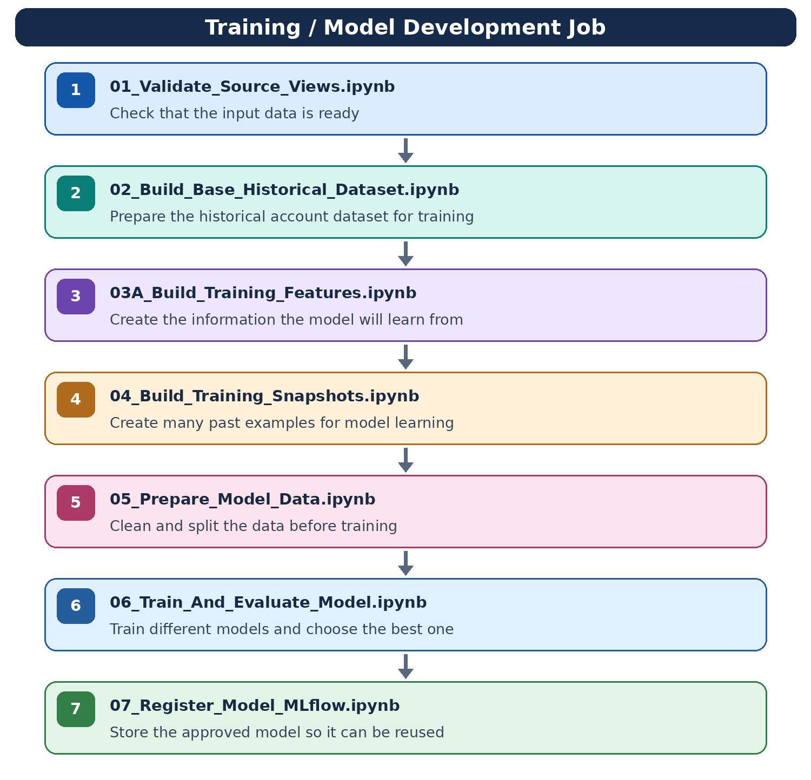

Regular Scoring Job
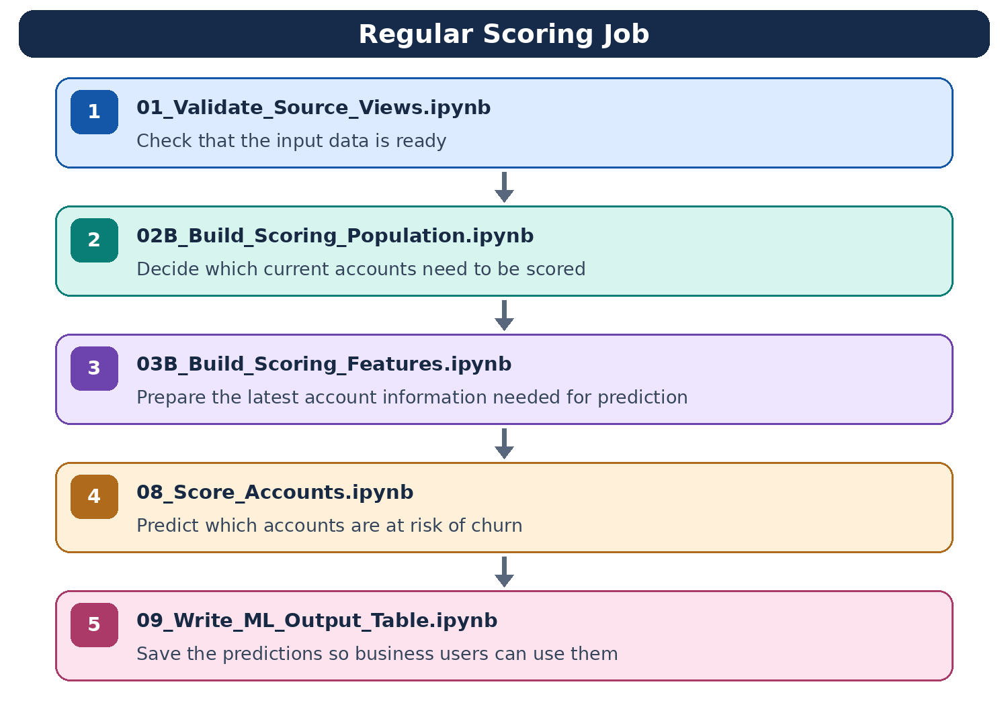

Monitoring Job
