MLOps for Retention Analytics
using Databricks
A Step-by-Step Practical Implementation Guide
Model Versioning | Performance Validation | Bias/Fairness Review |
Unity Catalog Governance | Champion/Challenger Promotion | Model Serving | Monitoring
Use Case: Superannuation Member Churn Prediction for Retention Analytics
Prepared for implementation and knowledge transfer

How to Use This Guide
This document is written for a reader who wants to implement a complete MLOps lifecycle in Databricks without needing prior experience with MLflow Model Registry or Databricks Model Serving. Follow the notebooks in order, execute the cells, compare your outputs with the checkpoints, and complete deployment only after validation is complete.
Implementation result produced by this guide
A governed churn model lifecycle with two model versions, a validated production-choice alias (Champion), a candidate alias (Challenger), and a real-time serving endpoint that returns churn predictions.

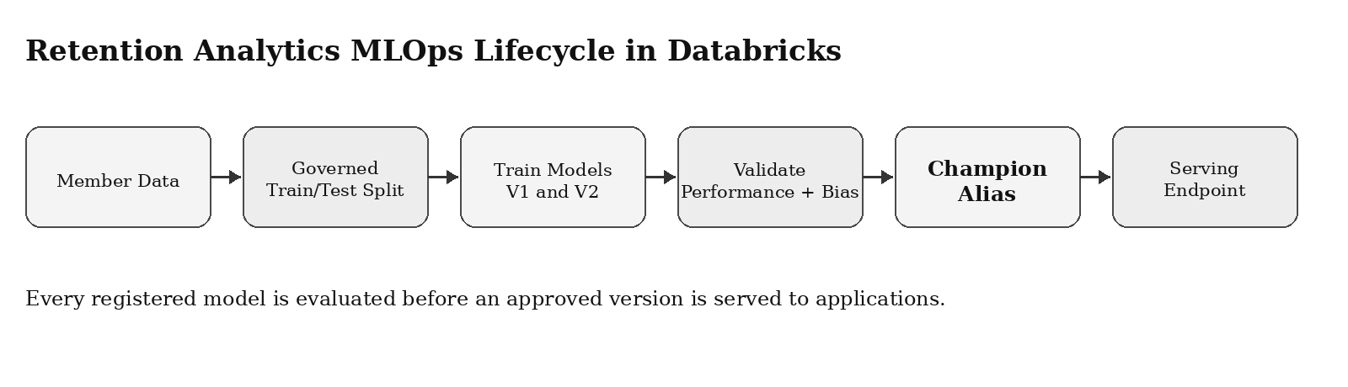
Figure 1. End-to-end lifecycle implemented in this guide.

Reader Journey
Stage | What the reader does | Outcome
1. Prepare | Create a Databricks folder, notebooks and fixed train/test data split | Reusable governed validation dataset
2. Train baseline | Train Logistic Regression and log/register the model | Model Version 1
3. Train candidate | Tune a second Logistic Regression model and register it | Model Version 2
4. Validate | Compare metrics and fairness outputs | Evidence-based selection
5. Promote | Assign Champion and Challenger aliases | Governed lifecycle references
6. Deploy | Create and query a Model Serving endpoint | Real-time churn prediction
7. Monitor | Capture endpoint requests/responses and monitor quality | Operational monitoring design

Important Implementation Principle
Both Version 1 and Version 2 must use the same train/test split. Otherwise, metric differences may be caused by different test records rather than genuine model improvement. In this implementation the common split is saved as a Unity Catalog Delta table and reused by all validation steps.

Contents
1. Understanding MLOps for Retention Analytics
2. Databricks Components and Prerequisites
3. Implementation Objects and Notebook Sequence
4. Notebook 01 - Prepare Data and Create Baseline Version 1
5. Notebook 02 - Create Candidate Version 2
6. Notebook 03 - Compare Performance and Evaluate Bias/Fairness
7. Notebook 04 - Promote Models and Create Serving Endpoint
8. Query the Endpoint and Interpret the Prediction
9. Monitoring Strategy for Deployed Models
10. Governance, Rollback and Operational Controls
11. Troubleshooting Guide
12. Appendix - Results and Reference Documentation

1. Understanding MLOps for Retention Analytics

1.1 Business Problem
Retention Analytics helps identify members who may be at risk of churn. A churn prediction model uses member behaviour and profile indicators, such as contribution amount, balance, portal usage and support contacts, to predict whether a member is likely to leave. The output supports proactive retention engagement.

1.2 What MLOps Means
MLOps is the controlled operating process for machine learning models after development begins. It covers how models are trained, recorded, compared, approved, deployed, monitored and replaced. The goal is not simply to produce a high score; it is to produce a model that is traceable, repeatable, governed and safe to operate.
Term | Easy definition | How it is used here
MLflow Tracking | Stores model run parameters, metrics and artifacts | Logs accuracy, recall, ROC AUC and model files
Model version | A saved iteration of a registered model | Version 1 baseline and Version 2 candidate
Unity Catalog | Governance layer for data and models | Stores governed table and registered model
Champion | Approved model selected for deployment | Assigned to Version 1 after validation
Challenger | Alternative model kept for review/improvement | Assigned to Version 2
Serving endpoint | REST API that returns predictions | Receives member JSON and returns churn class
Bias/fairness evaluation | Checks whether performance differs across groups | Compares age-group outcomes

1.3 Why Performance Alone Is Not Enough
A model can have high overall accuracy while still missing many actual churners or working unevenly across age groups. For retention analytics, recall is important because every missed churner may represent a missed intervention opportunity. The promotion decision therefore considers performance metrics and fairness diagnostics together.

2. Databricks Components and Prerequisites

2.1 Components Used
Component | Purpose in the implementation
Databricks notebooks | Run Python code for preparation, training, validation and promotion
Unity Catalog Delta table | Stores the fixed train/test split used for fair model comparison
MLflow tracking and registry | Records runs and registers model versions
Models in Unity Catalog | Provides governed model versioning, aliases, lineage and access control
Databricks Model Serving | Hosts the approved model as a real-time API endpoint
AI Gateway inference tables (monitoring extension) | Logs endpoint requests and responses for downstream monitoring

2.2 Prerequisites Checklist
- A Databricks workspace with Unity Catalog enabled and permission to create tables and model versions in the required catalog and schema.
- A compute option attached to notebooks, such as serverless compute or a supported cluster.
- A source dataset available in a Unity Catalog Volume or other accessible location.
- Python packages available in the Databricks runtime: pandas, numpy, scikit-learn and mlflow.
- Permission to create or use a Model Serving endpoint when completing deployment.

2.3 Names Used in the Implementation
Object | Value used in examples
Catalog and schema | mlops_dev.ml_schema
Source dataset path | /Volumes/mlops_dev/ml_schema/churn_files/superannuation_churn_dataset.csv
Governed split table | mlops_dev.ml_schema.learning_churn_demo_dataset_split
Registered model | mlops_dev.ml_schema.learning_superannuation_churn_logistic_reg_model
Serving endpoint | learning-churn-champion-endpoint

Adaptation note
Replace catalog, schema, source path and endpoint names with values available in the target Databricks workspace. The implementation flow remains the same.

3. Implementation Objects and Notebook Sequence
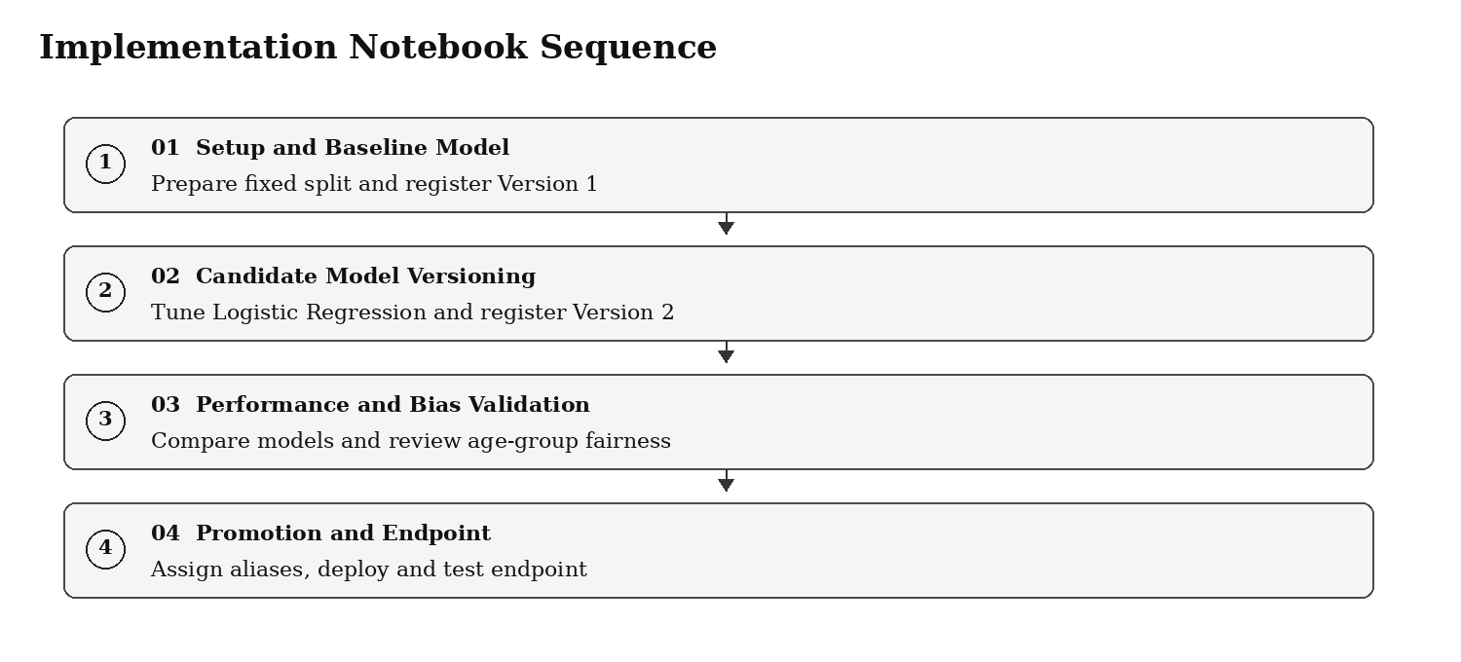
Figure 2. Execute the notebooks in this order.

3.1 Create the Workspace Folder
- In Databricks, select Workspace from the left navigation panel.
- Open the required user or project workspace folder.
- Create a folder named Superannuation_Churn_MLOps_Implementation.
- Create the four Python notebooks shown below inside the folder.
Notebook name | Purpose
01_MLOps_Setup_and_Baseline_Model | Creates the fixed split and registers Version 1
02_MLOps_Candidate_Model_Versioning | Registers Version 2 using tuned Logistic Regression
03_MLOps_Performance_and_Bias_Validation | Compares the two registered models
04_MLOps_Promotion_and_Endpoint | Assigns aliases and deploys approved model

3.2 Output Checkpoints
After notebook | Check that this is visible
01 | Registered model Version 1 is READY and metrics are available
02 | Registered model Version 1 and Version 2 are READY
03 | Performance table and fairness summary support an approval decision
04 | Champion and Challenger aliases exist; endpoint becomes Ready; query returns prediction

4. Notebook 01 - Prepare Data and Create Baseline Version 1
This notebook performs the setup only once. It creates one fixed training/testing split, trains the first Logistic Regression model, stores evaluation metrics and registers the model as Version 1.

4.1 Step 1 - Configure MLflow and Object Names
Create a Python notebook named 01_MLOps_Setup_and_Baseline_Model. Attach compute and run the following first cell. The registry URI tells MLflow to register models in Unity Catalog.
Cell 1 - Imports and object configuration
import mlflow
import mlflow.sklearn
import pandas as pd
import numpy as np
from mlflow.models import infer_signature
from mlflow.tracking import MlflowClient
from sklearn.model_selection import train_test_split
from sklearn.compose import ColumnTransformer
from sklearn.pipeline import Pipeline
from sklearn.preprocessing import StandardScaler, OneHotEncoder
from sklearn.linear_model import LogisticRegression
from sklearn.metrics import accuracy_score, precision_score, recall_score, f1_score, roc_auc_score, confusion_matrix
mlflow.set_registry_uri("databricks-uc")
MODEL_NAME = "mlops_dev.ml_schema.learning_superannuation_churn_logistic_reg_model"
DATA_PATH = "/Volumes/mlops_dev/ml_schema/churn_files/superannuation_churn_dataset.csv"
SPLIT_TABLE_NAME = "mlops_dev.ml_schema.learning_churn_demo_dataset_split"
TARGET_COLUMN = "churn"
ID_COLUMN = "member_id"
client = MlflowClient()
print("Registry URI:", mlflow.get_registry_uri())
print("Registered Model:", MODEL_NAME)
print("Split Table:", SPLIT_TABLE_NAME)

4.2 Step 2 - Check the Model Name Is New
A clean model name is required when the goal is to begin at Version 1. If the model already exists, use a new model name before running any registration cell.
Cell 2 - Verify clean registered model name
try:
existing_model = client.get_registered_model(MODEL_NAME)
raise ValueError("This model name already exists. Use a new clean model name.")
except Exception as exc:
if "already exists" in str(exc):
raise
print("Model name is available. Version 1 will be created at registration.")

4.3 Step 3 - Load the Source Dataset and Create One Fixed Split
The split is saved to a Unity Catalog managed Delta table so Version 1 and Version 2 are validated using exactly the same test records.
Cell 3 - Create governed reusable train/test split
data = pd.read_csv(DATA_PATH)
demo_data = data.dropna(subset=[TARGET_COLUMN]).copy()
demo_data[TARGET_COLUMN] = demo_data[TARGET_COLUMN].astype(int)
train_indexes, test_indexes = train_test_split(
demo_data.index,
test_size=0.20,
random_state=42,
stratify=demo_data[TARGET_COLUMN]
)
demo_data["dataset_split"] = "train"
demo_data.loc[test_indexes, "dataset_split"] = "test"
spark.createDataFrame(demo_data).write .format("delta") .mode("overwrite") .option("overwriteSchema", "true") .saveAsTable(SPLIT_TABLE_NAME)
print("Training records:", (demo_data["dataset_split"] == "train").sum())
print("Testing records :", (demo_data["dataset_split"] == "test").sum())
print("Saved table :", SPLIT_TABLE_NAME)

Expected checkpoint
For a 4,000 row source dataset with a 20% test split, the output shows 3,200 training records and 800 testing records.

4.4 Step 4 - Prepare Model Input Columns
The unique member identifier is retained in the governed table for traceability, but removed from training because it does not describe member behaviour.
Cell 4 - Create training and testing features
saved_demo_data = spark.table(SPLIT_TABLE_NAME).toPandas()
train_data = saved_demo_data[saved_demo_data["dataset_split"] == "train"].copy()
test_data = saved_demo_data[saved_demo_data["dataset_split"] == "test"].copy()
columns_to_exclude = [TARGET_COLUMN, "dataset_split"]
if ID_COLUMN in saved_demo_data.columns:
columns_to_exclude.append(ID_COLUMN)
X_train = train_data.drop(columns=columns_to_exclude)
y_train = train_data[TARGET_COLUMN].astype(int)
X_test = test_data.drop(columns=columns_to_exclude)
y_test = test_data[TARGET_COLUMN].astype(int)
numeric_columns = X_train.select_dtypes(include=["int64", "float64", "int32", "float32"]).columns.tolist()
categorical_columns = X_train.select_dtypes(include=["object", "category", "bool"]).columns.tolist()
print("Numeric columns:", numeric_columns)
print("Categorical columns:", categorical_columns)
print("Excluded columns:", columns_to_exclude)

4.5 Step 5 - Build and Train Baseline Logistic Regression
The preprocessing pipeline is included with the model so that the deployed model can accept business-friendly input values: numeric features are standardised and categorical features are one-hot encoded.
Cell 5 - Train and evaluate Version 1 baseline model
preprocessor = ColumnTransformer(
transformers=[
("numeric", StandardScaler(), numeric_columns),
("categorical", OneHotEncoder(handle_unknown="ignore"), categorical_columns)
],
remainder="drop"
)
baseline_model = Pipeline(
steps=[
("preprocessor", preprocessor),
("classifier", LogisticRegression(
C=1.0,
class_weight=None,
max_iter=2000,
random_state=42
))
]
)
baseline_model.fit(X_train, y_train)
baseline_predictions = baseline_model.predict(X_test)
baseline_probabilities = baseline_model.predict_proba(X_test)[:, 1]
baseline_metrics = {
"accuracy": accuracy_score(y_test, baseline_predictions),
"precision": precision_score(y_test, baseline_predictions, zero_division=0),
"recall": recall_score(y_test, baseline_predictions, zero_division=0),
"f1_score": f1_score(y_test, baseline_predictions, zero_division=0),
"roc_auc": roc_auc_score(y_test, baseline_probabilities)
}
baseline_confusion_matrix = confusion_matrix(y_test, baseline_predictions)
for name, value in baseline_metrics.items():
print(f"{name}: {value:.4f}")

4.6 Step 6 - Log and Register Version 1
Run the following registration cell only once. Each successful registration under the same model name creates a new version.
Cell 6 - MLflow registration code
input_example = X_train.head(5)
signature = infer_signature(X_train, baseline_model.predict(X_train))
with mlflow.start_run(run_name="Version_1_Baseline_Logistic_Regression") as run:
mlflow.log_param("model_role", "Baseline")
mlflow.log_param("algorithm", "Logistic Regression")
mlflow.log_param("C", 1.0)
mlflow.log_param("class_weight", "None")
mlflow.log_param("split_table", SPLIT_TABLE_NAME)
mlflow.log_param("training_rows", X_train.shape[0])
mlflow.log_param("testing_rows", X_test.shape[0])
for name, value in baseline_metrics.items():
mlflow.log_metric(name, float(value))
mlflow.log_metric("true_negative", int(baseline_confusion_matrix[0][0]))
mlflow.log_metric("false_positive", int(baseline_confusion_matrix[0][1]))
mlflow.log_metric("false_negative", int(baseline_confusion_matrix[1][0]))
mlflow.log_metric("true_positive", int(baseline_confusion_matrix[1][1]))
mlflow.sklearn.log_model(
sk_model=baseline_model,
artifact_path="model",
registered_model_name=MODEL_NAME,
signature=signature,
input_example=input_example
)
baseline_run_id = run.info.run_id
print("Baseline model registered. Run ID:", baseline_run_id)

4.7 Step 7 - Verify Version 1
Cell 7 - Verify registered version
registered_versions = client.search_model_versions(f"name='{MODEL_NAME}'")
records = []
for version in registered_versions:
run = client.get_run(version.run_id)
records.append({
"version": int(version.version),
"status": version.status,
"model_role": run.data.params.get("model_role"),
"accuracy": run.data.metrics.get("accuracy"),
"recall": run.data.metrics.get("recall"),
"roc_auc": run.data.metrics.get("roc_auc")
})
version_1_df = pd.DataFrame(records).sort_values("version")
display(version_1_df)

Version | Status | Role | Accuracy | Recall | ROC AUC
1 | READY | Baseline | 0.9313 | 0.4937 | 0.9509

Completion check for Notebook 01
Do not proceed until the registered model page or verification cell displays Version 1 with READY status.

5. Notebook 02 - Create Candidate Version 2
The candidate uses the same algorithm family and exactly the same governed split. The difference is that it evaluates multiple Logistic Regression parameter combinations using GridSearchCV and selects the candidate with the best cross-validation ROC AUC.

5.1 Step 1 - Create the Candidate Notebook and Load Common Data
Cell 1 - Load governed split and confirm baseline exists
import mlflow
import mlflow.sklearn
import pandas as pd
from mlflow.models import infer_signature
from mlflow.tracking import MlflowClient
from sklearn.model_selection import GridSearchCV
from sklearn.compose import ColumnTransformer
from sklearn.pipeline import Pipeline
from sklearn.preprocessing import StandardScaler, OneHotEncoder
from sklearn.linear_model import LogisticRegression
from sklearn.metrics import accuracy_score, precision_score, recall_score, f1_score, roc_auc_score, confusion_matrix
mlflow.set_registry_uri("databricks-uc")
MODEL_NAME = "mlops_dev.ml_schema.learning_superannuation_churn_logistic_reg_model"
SPLIT_TABLE_NAME = "mlops_dev.ml_schema.learning_churn_demo_dataset_split"
TARGET_COLUMN = "churn"
ID_COLUMN = "member_id"
client = MlflowClient()
versions = sorted([int(v.version) for v in client.search_model_versions(f"name='{MODEL_NAME}'")])
assert versions == [1], f"Expected only Version 1; found {versions}"
saved_demo_data = spark.table(SPLIT_TABLE_NAME).toPandas()
train_data = saved_demo_data[saved_demo_data["dataset_split"] == "train"].copy()
test_data = saved_demo_data[saved_demo_data["dataset_split"] == "test"].copy()
exclude = [TARGET_COLUMN, "dataset_split"] + ([ID_COLUMN] if ID_COLUMN in saved_demo_data.columns else [])
X_train = train_data.drop(columns=exclude); y_train = train_data[TARGET_COLUMN].astype(int)
X_test = test_data.drop(columns=exclude); y_test = test_data[TARGET_COLUMN].astype(int)
numeric_columns = X_train.select_dtypes(include=["int64", "float64", "int32", "float32"]).columns.tolist()
categorical_columns = X_train.select_dtypes(include=["object", "category", "bool"]).columns.tolist()

5.2 Step 2 - Tune the Candidate Model
Cell 2 - Hyperparameter selection
preprocessor = ColumnTransformer(
transformers=[
("numeric", StandardScaler(), numeric_columns),
("categorical", OneHotEncoder(handle_unknown="ignore"), categorical_columns)
]
)
candidate_pipeline = Pipeline(
steps=[
("preprocessor", preprocessor),
("classifier", LogisticRegression(max_iter=2000, random_state=42))
]
)
parameter_grid = {
"classifier__C": [0.01, 0.1, 1.0, 10.0],
"classifier__class_weight": [None, "balanced"]
}
grid_search = GridSearchCV(
estimator=candidate_pipeline,
param_grid=parameter_grid,
scoring="roc_auc",
cv=3,
n_jobs=-1,
refit=True
)
grid_search.fit(X_train, y_train)
candidate_model = grid_search.best_estimator_
print("Selected parameters:", grid_search.best_params_)
print("Cross-validation ROC AUC:", round(grid_search.best_score_, 4))

5.3 Step 3 - Evaluate and Register Version 2
Cell 3 - Log and register Version 2 (run only once)
candidate_predictions = candidate_model.predict(X_test)
candidate_probabilities = candidate_model.predict_proba(X_test)[:, 1]
candidate_metrics = {
"accuracy": accuracy_score(y_test, candidate_predictions),
"precision": precision_score(y_test, candidate_predictions, zero_division=0),
"recall": recall_score(y_test, candidate_predictions, zero_division=0),
"f1_score": f1_score(y_test, candidate_predictions, zero_division=0),
"roc_auc": roc_auc_score(y_test, candidate_probabilities)
}
candidate_cm = confusion_matrix(y_test, candidate_predictions)
input_example = X_train.head(5)
signature = infer_signature(X_train, candidate_model.predict(X_train))
with mlflow.start_run(run_name="Version_2_Candidate_Logistic_Regression") as run:
mlflow.log_param("model_role", "Candidate")
mlflow.log_param("algorithm", "Logistic Regression")
mlflow.log_param("tuning_method", "GridSearchCV")
mlflow.log_param("best_C", grid_search.best_params_["classifier__C"])
mlflow.log_param("best_class_weight", str(grid_search.best_params_["classifier__class_weight"]))
mlflow.log_param("split_table", SPLIT_TABLE_NAME)
for name, value in candidate_metrics.items():
mlflow.log_metric(name, float(value))
mlflow.sklearn.log_model(
sk_model=candidate_model,
artifact_path="model",
registered_model_name=MODEL_NAME,
signature=signature,
input_example=input_example
)
print("Candidate model registered as the next version.")

5.4 Step 4 - Verify Both Versions
Cell 4 - Display model versions and metrics
version_records = []
for version in client.search_model_versions(f"name='{MODEL_NAME}'"):
run = client.get_run(version.run_id)
version_records.append({
"version": int(version.version),
"status": version.status,
"model_role": run.data.params.get("model_role"),
"accuracy": run.data.metrics.get("accuracy"),
"precision": run.data.metrics.get("precision"),
"recall": run.data.metrics.get("recall"),
"f1_score": run.data.metrics.get("f1_score"),
"roc_auc": run.data.metrics.get("roc_auc")
})
display(pd.DataFrame(version_records).sort_values("version"))

Version | Role | Accuracy | Precision | Recall | F1 Score | ROC AUC
1 | Baseline | 0.9313 | 0.7222 | 0.4937 | 0.5865 | 0.9509
2 | Candidate | 0.9338 | 0.7955 | 0.4430 | 0.5691 | 0.9505

How to read this output
Version 2 has slightly higher accuracy and precision. Version 1 has higher recall, F1 score and ROC AUC. For proactive retention, Version 1 detects more actual churn cases and is therefore still a strong production candidate.

6. Notebook 03 - Compare Performance and Evaluate Bias/Fairness
Validation is the gate between model registration and deployment. This notebook reloads both registered versions from Unity Catalog, applies identical evaluation logic, evaluates predictions by age group and creates the evidence needed for model promotion.

6.1 Step 1 - Load Both Registered Models and the Common Test Dataset
Cell 1 - Read governed test data and registered models
import mlflow
import mlflow.sklearn
import pandas as pd
import numpy as np
from sklearn.metrics import accuracy_score, precision_score, recall_score, f1_score, roc_auc_score, confusion_matrix
mlflow.set_registry_uri("databricks-uc")
MODEL_NAME = "mlops_dev.ml_schema.learning_superannuation_churn_logistic_reg_model"
SPLIT_TABLE_NAME = "mlops_dev.ml_schema.learning_churn_demo_dataset_split"
TARGET_COLUMN = "churn"
ID_COLUMN = "member_id"
SENSITIVE_ATTRIBUTE = "member_age"
saved_demo_data = spark.table(SPLIT_TABLE_NAME).toPandas()
test_data = saved_demo_data[saved_demo_data["dataset_split"] == "test"].copy()
exclude = [TARGET_COLUMN, "dataset_split"] + ([ID_COLUMN] if ID_COLUMN in test_data.columns else [])
X_test = test_data.drop(columns=exclude)
y_test = test_data[TARGET_COLUMN].astype(int)
baseline_model = mlflow.sklearn.load_model(f"models:/{MODEL_NAME}/1")
candidate_model = mlflow.sklearn.load_model(f"models:/{MODEL_NAME}/2")

6.2 Step 2 - Compare Common Performance Metrics
Cell 2 - Re-evaluate models using identical metrics
def evaluate_model(model, version, role, X_eval, y_eval):
predictions = model.predict(X_eval)
probabilities = model.predict_proba(X_eval)[:, 1]
cm = confusion_matrix(y_eval, predictions)
return {
"version": version,
"role": role,
"accuracy": accuracy_score(y_eval, predictions),
"precision": precision_score(y_eval, predictions, zero_division=0),
"recall": recall_score(y_eval, predictions, zero_division=0),
"f1_score": f1_score(y_eval, predictions, zero_division=0),
"roc_auc": roc_auc_score(y_eval, probabilities),
"false_negative": int(cm[1][0]),
"true_positive": int(cm[1][1])
}, predictions, probabilities
baseline_result, baseline_predictions, baseline_probabilities = evaluate_model(
baseline_model, 1, "Baseline", X_test, y_test)
candidate_result, candidate_predictions, candidate_probabilities = evaluate_model(
candidate_model, 2, "Candidate", X_test, y_test)
performance_df = pd.DataFrame([baseline_result, candidate_result])
display(performance_df.round(4))

6.3 Understanding the Metrics
Metric | Easy definition | Retention analytics interpretation
Accuracy | Percentage of all predictions that were correct | Useful overall measure, but can hide missed churners
Precision | Of predicted churners, how many actually churned | Higher precision reduces unnecessary interventions
Recall | Of actual churners, how many were found | Higher recall captures more at-risk members
F1 Score | Balance between precision and recall | Useful when both intervention quality and capture matter
ROC AUC | How well the model ranks churn risk | Evaluates discrimination across thresholds

6.4 Step 3 - Create Age Groups for Fairness Review
This example uses member age groups as a fairness review dimension. In a production solution, the protected attributes and acceptance thresholds must be defined with compliance, risk and business stakeholders.
Cell 3 - Add age bands for group-level review
fairness_test_data = test_data.copy()
fairness_test_data["age_group"] = pd.cut(
fairness_test_data[SENSITIVE_ATTRIBUTE],
bins=[0, 34, 49, 64, np.inf],
labels=["Under 35", "35-49", "50-64", "65+"],
include_lowest=True
)
display(fairness_test_data["age_group"].value_counts().reset_index())

6.5 Step 4 - Calculate Fairness Metrics by Age Group
Cell 4 - Detailed fairness comparison
def calculate_fairness_metrics(validation_data, actual, predicted, probabilities, group_column):
evaluation = validation_data.copy()
evaluation["actual_churn"] = np.array(actual)
evaluation["predicted_churn"] = np.array(predicted)
evaluation["churn_probability"] = np.array(probabilities)
results = []
for group_name, group_df in evaluation.groupby(group_column, observed=False):
y_true = group_df["actual_churn"]
y_pred = group_df["predicted_churn"]
y_prob = group_df["churn_probability"]
tn, fp, fn, tp = confusion_matrix(y_true, y_pred, labels=[0, 1]).ravel()
results.append({
"age_group": str(group_name),
"record_count": len(group_df),
"selection_rate": y_pred.mean(),
"precision": precision_score(y_true, y_pred, zero_division=0),
"recall_true_positive_rate": tp / (tp + fn) if (tp + fn) else np.nan,
"false_positive_rate": fp / (fp + tn) if (fp + tn) else np.nan,
"roc_auc": roc_auc_score(y_true, y_prob) if y_true.nunique() == 2 else np.nan
})
return pd.DataFrame(results)
baseline_fairness_df = calculate_fairness_metrics(
fairness_test_data, y_test, baseline_predictions, baseline_probabilities, "age_group")
candidate_fairness_df = calculate_fairness_metrics(
fairness_test_data, y_test, candidate_predictions, candidate_probabilities, "age_group")
baseline_fairness_df.insert(0, "version", 1); baseline_fairness_df.insert(1, "role", "Baseline")
candidate_fairness_df.insert(0, "version", 2); candidate_fairness_df.insert(1, "role", "Candidate")
fairness_comparison_df = pd.concat([baseline_fairness_df, candidate_fairness_df], ignore_index=True)
display(fairness_comparison_df.round(4))

6.6 Step 5 - Summarise Fairness Gaps
Cell 5 - Fairness diagnostic summary
summary = []
for version, role, df in [(1, "Baseline", baseline_fairness_df), (2, "Candidate", candidate_fairness_df)]:
max_selection = df["selection_rate"].max()
min_selection = df["selection_rate"].min()
summary.append({
"version": version,
"role": role,
"disparate_impact_ratio": min_selection / max_selection if max_selection else np.nan,
"recall_gap": df["recall_true_positive_rate"].max() - df["recall_true_positive_rate"].min(),
"false_positive_rate_gap": df["false_positive_rate"].max() - df["false_positive_rate"].min()
})
fairness_summary_df = pd.DataFrame(summary)
display(fairness_summary_df.round(4))

6.7 Example Validation Output
Version | Role | Disparate Impact Ratio | Recall Gap | False Positive Rate Gap
1 | Baseline | 0.8895 | 0.1640 | 0.0170
2 | Candidate | 0.7955 | 0.2751 | 0.0167

Decision factor | Observation | Decision impact
Churn capture | Version 1 has higher recall and F1 score | Supports Version 1 for proactive retention
Risk ranking | Version 1 has slightly higher ROC AUC | Supports Version 1
Fairness recall consistency | Version 1 has lower recall gap across age groups | Supports Version 1
Precision | Version 2 has higher precision | Keep as challenger for further analysis

Validation decision
Assign Version 1 as Champion because it provides stronger churn capture and a more consistent fairness outcome in this sample evaluation. Retain Version 2 as Challenger for future improvement.

7. Notebook 04 - Promote Models and Create Serving Endpoint
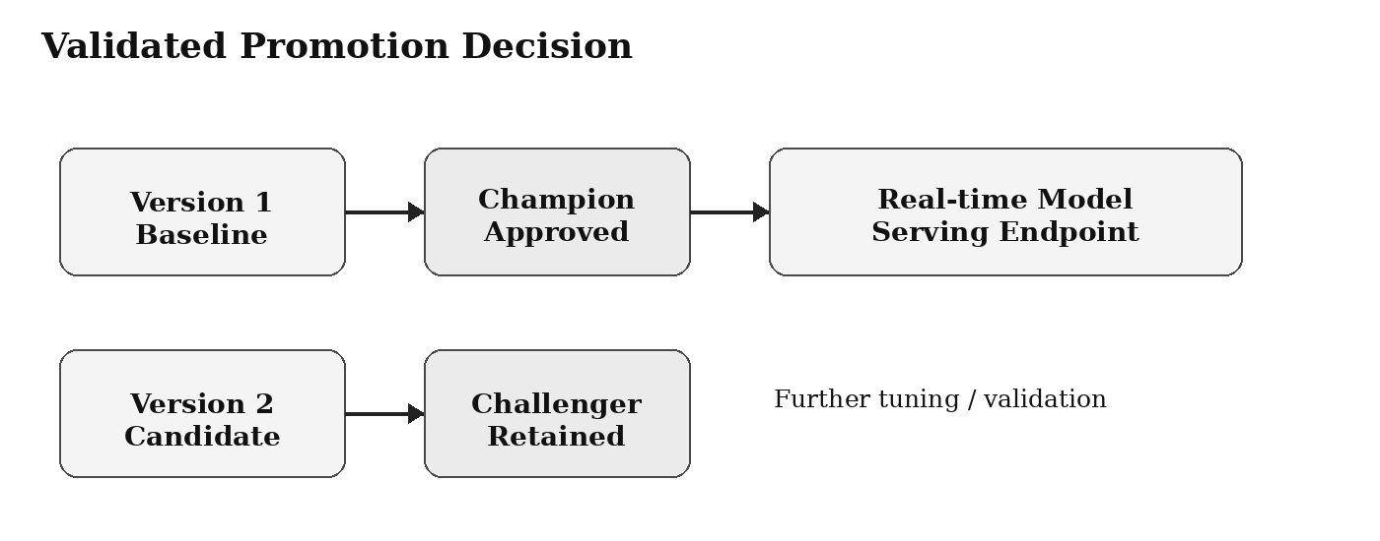
Figure 3. Alias-based promotion and deployment decision.
Models in Unity Catalog use aliases to reference an approved or candidate version. This implementation uses Champion for the approved version and Challenger for the retained candidate. The serving endpoint is then configured to serve the concrete model version corresponding to Champion.

7.1 Step 1 - Assign Champion and Challenger Aliases
Cell 1 - Promote using aliases
import mlflow
import pandas as pd
from mlflow.tracking import MlflowClient
mlflow.set_registry_uri("databricks-uc")
MODEL_NAME = "mlops_dev.ml_schema.learning_superannuation_churn_logistic_reg_model"
client = MlflowClient()
client.set_registered_model_alias(
name=MODEL_NAME,
alias="Champion",
version="1"
)
client.set_registered_model_alias(
name=MODEL_NAME,
alias="Challenger",
version="2"
)
champion = client.get_model_version_by_alias(MODEL_NAME, "Champion")
challenger = client.get_model_version_by_alias(MODEL_NAME, "Challenger")
display(pd.DataFrame([
{"alias": "Champion", "version": champion.version, "status": champion.status},
{"alias": "Challenger", "version": challenger.version, "status": challenger.status}
]))

7.2 Step 2 - Test the Champion Model Locally through Its Alias
Cell 2 - Validate alias loading before deployment
import mlflow.sklearn
SPLIT_TABLE_NAME = "mlops_dev.ml_schema.learning_churn_demo_dataset_split"
TARGET_COLUMN = "churn"
ID_COLUMN = "member_id"
champion_uri = f"models:/{MODEL_NAME}@Champion"
champion_model = mlflow.sklearn.load_model(champion_uri)
sample = spark.table(SPLIT_TABLE_NAME).toPandas().query("dataset_split == 'test'").head(1).copy()
exclude = [TARGET_COLUMN, "dataset_split"] + ([ID_COLUMN] if ID_COLUMN in sample.columns else [])
sample_input = sample.drop(columns=exclude)
predicted_class = int(champion_model.predict(sample_input)[0])
predicted_probability = float(champion_model.predict_proba(sample_input)[0][1])
print("Prediction:", predicted_class)
print("Predicted churn probability:", round(predicted_probability, 4))

Example result
The alias-based local prediction returned class 0 with churn probability 0.1081, confirming that the Champion alias can load and score the approved model.

7.3 Step 3 - Create a Real-Time Model Serving Endpoint in the UI
- Select Serving in the left navigation of the Databricks workspace.
- Select Create serving endpoint.
- Enter endpoint name: learning-churn-champion-endpoint.
- Select My models - Unity Catalog and select the registered model mlops_dev.ml_schema.learning_superannuation_churn_logistic_reg_model.
- Select Model Version 1, which is the model identified by the Champion alias in this validation decision.
- Set traffic to 100%, select a small CPU workload for the initial implementation, and enable scale to zero only when acceptable for non-production or low-usage scenarios.
- Select Create and wait until endpoint status becomes Ready.
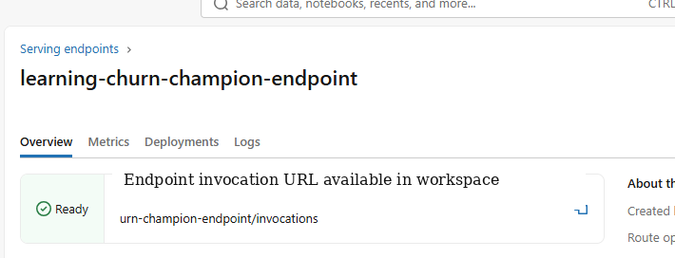
Figure 4. Serving endpoint status displayed as Ready after deployment.

7.4 Why the Endpoint Serves a Version Rather Than an Alias
The alias is used to document which model has been approved in the lifecycle process. When configuring a real-time serving endpoint, the Databricks serving configuration identifies the concrete version to deploy. When a later model becomes Champion, update the endpoint configuration to serve that newly approved version after completing the same validation gates.

8. Query the Endpoint and Interpret the Prediction

8.1 Step 1 - Generate a Valid Request Payload
The request must contain the same feature columns expected by the logged model. The following cell creates a valid request using one record from the governed test split.
Cell 3 - Generate endpoint JSON payload
import json
sample = spark.table(SPLIT_TABLE_NAME).toPandas().query("dataset_split == 'test'").head(1).copy()
exclude = [TARGET_COLUMN, "dataset_split"] + ([ID_COLUMN] if ID_COLUMN in sample.columns else [])
sample_input = sample.drop(columns=exclude)
payload = {
"dataframe_records": json.loads(sample_input.to_json(orient="records"))
}
print(json.dumps(payload, indent=2))

8.2 Step 2 - Query through the Databricks UI
- Open the endpoint page after it has reached Ready status.
- Select Use, then Query endpoint.
- Paste the full dataframe_records payload printed by the notebook cell.
- Select Send request and review the response panel.
Example request
{
"dataframe_records": [
{
"member_age": 63,
"membership_tenure_years": 4,
"annual_contribution_amount": 20019.9,
"super_balance": 1666363.52,
"investment_return_percent": 10.0,
"withdrawal_frequency_per_year": 8,
"portal_login_frequency": 24,
"customer_support_calls": 7,
"insurance_opt_in": "Yes",
"investment_plan_type": "High Growth",
"employer_category": "Corporate",
"mobile_app_usage": "Low",
"financial_adviser_interaction": 9,
"risk_profile": "Medium Risk"
}
]
}

Example endpoint response
{
"predictions": [0]
}

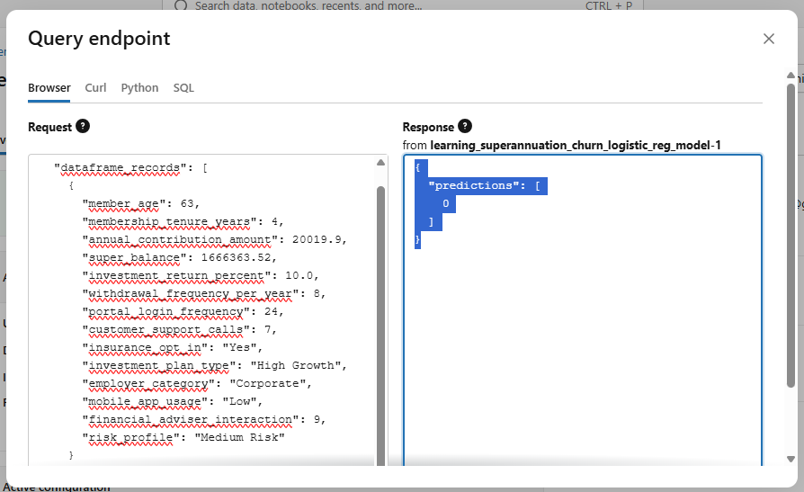
Figure 5. Successful endpoint query returning a churn prediction.

8.3 Interpretation of the Prediction
Prediction value | Business meaning | Possible next action
0 | Member is predicted as not likely to churn | Continue standard engagement; retain score for monitoring
1 | Member is predicted as likely to churn | Consider prioritisation for retention outreach, subject to business rules

A prediction is a decision-support signal and should not be treated as an automatic customer action without agreed business rules, compliance review and monitoring.

9. Monitoring Strategy for Deployed Models
Deployment is not the end of MLOps. Model quality can change when customer behaviour or incoming data changes. Monitoring is designed to detect operational problems, drift, degraded predictive performance and fairness concerns.

9.1 What to Monitor
Monitoring area | What it checks | Example signal
Endpoint operations | Service availability and response behaviour | Error count, latency and volume
Input drift | Whether incoming feature patterns change | Change in age, balance or portal activity distribution
Prediction drift | Whether prediction behaviour changes | Unexpected increase in churn flags
Performance | Whether predictions remain accurate after outcomes arrive | Recall, precision and ROC AUC over recent data
Fairness | Whether group-level behaviour changes | Recall gap by approved fairness dimensions

9.2 Step-by-Step Monitoring Extension in Databricks
Implementation scope note
The endpoint deployment and scoring request have been executed in the illustrated implementation. The following monitoring configuration is the recommended next implementation step and should be enabled in the target environment after confirming governance requirements for request/response logging.

- Open the deployed endpoint and select Edit AI Gateway.
- Enable inference tables for the endpoint and choose an approved catalog and schema location for captured data.
- Send controlled test requests and verify that the generated Unity Catalog Delta table captures request and response records.
- Create Databricks SQL or notebook-based checks for request counts, prediction distributions and errors.
- When actual churn outcomes become available, join predictions with outcomes to calculate ongoing precision, recall and fairness measures.
- Configure alerts and a review process for thresholds agreed by business, risk and compliance stakeholders.

9.3 Example Monitoring Query Pattern
Inference table schemas and available parsed fields depend on endpoint configuration. After enabling inference tables, inspect the generated table before selecting request or response fields. The following pattern shows the intent of operational monitoring.
Illustrative SQL for endpoint request-volume monitoring
-- Replace the generated inference table name and parsed response field
SELECT
date_trunc('day', timestamp_ms) AS scoring_day,
COUNT(*) AS request_count
FROM <catalog>.<schema>.<generated_inference_table>
GROUP BY date_trunc('day', timestamp_ms)
ORDER BY scoring_day DESC;

9.4 Performance Monitoring Requires Ground Truth
A serving endpoint can immediately log inputs and predictions, but true model performance cannot be recalculated until the actual member outcome is known. For example, after an observation window confirms whether the member churned, predictions can be joined to actual outcomes and the same metrics used in model validation can be calculated again.

10. Governance, Rollback and Operational Controls

10.1 Governance Controls Implemented
Control | Implementation in this guide | Why it matters
Governed dataset | Fixed train/test data stored as a Unity Catalog table | Makes model comparisons reproducible
Model versioning | Both Logistic Regression models registered under one UC model | Retains history and lineage
Metric logging | Shared metrics recorded for each model run | Provides promotion evidence
Fairness review | Group-level diagnostics calculated before selection | Reduces unreviewed unequal performance risk
Aliases | Champion and Challenger assigned after validation | Makes approval status explicit
Serving endpoint | Only approved model version deployed | Controls real-time consumption

10.2 Rollback Procedure
When a newly deployed model performs unexpectedly, rollback should be quick and controlled. The previous approved model version remains registered and can be redeployed.
- Review monitoring evidence and confirm rollback is required.
- Reassign the Champion alias to the previous approved model version, when approval governance requires this update.
- Edit the serving endpoint to serve the previous approved concrete model version.
- Wait for endpoint status to return to Ready and execute a controlled scoring request.
- Record the reason for rollback, evidence reviewed and resolution actions.

10.3 Access and Approval Considerations
In a production implementation, privileges to create model versions, apply aliases, edit endpoint configurations and view request/response logs should be restricted according to the organisation's access-control and audit policy. Promotion should occur only after approved performance and fairness reviews.

11. Troubleshooting Guide
Problem | Likely reason | Resolution
New model appears as Version 3 instead of Version 1 | Existing registered model name was reused | Start with a new clean registered model name for a fresh walkthrough
Parent directory does not exist when calling mlflow.set_experiment | Specified workspace experiment path is missing | Use the notebook experiment by omitting mlflow.set_experiment, or create the folder first
Version 1 metrics show null in comparison | Different metric names were logged or metrics were not logged | Evaluate both registered models again using the common test dataset
Endpoint request fails due to schema mismatch | Payload excludes a required feature or uses wrong value type | Generate the payload from the same input DataFrame schema used for training
Endpoint is not immediately ready | Serving compute is provisioning or model is loading | Wait for Ready state; examine deployment logs if it fails
Cannot register model in Unity Catalog | Permissions or signature requirements are unmet | Confirm UC privileges and log the model with an inferred signature

12. Appendix - Results and Reference Documentation

12.1 Recorded Example Results
Metric | Version 1 - Baseline | Version 2 - Candidate | Selected interpretation
Accuracy | 0.9313 | 0.9338 | Version 2 slightly higher
Precision | 0.7222 | 0.7955 | Version 2 identifies flagged churners more precisely
Recall | 0.4937 | 0.4430 | Version 1 captures more actual churners
F1 Score | 0.5865 | 0.5691 | Version 1 better balance in this run
ROC AUC | 0.9509 | 0.9505 | Version 1 marginally higher

12.2 Recorded Fairness Diagnostic Results
Version | Role | Disparate Impact Ratio | Recall Gap | False Positive Rate Gap
1 | Baseline / Champion | 0.8895 | 0.1640 | 0.0170
2 | Candidate / Challenger | 0.7955 | 0.2751 | 0.0167

12.3 Reference Documentation
[1] Microsoft Learn. Manage model lifecycle in Unity Catalog - Azure Databricks. Covers Models in Unity Catalog, access control, lineage and discovery.
[2] Microsoft Learn. Migrate workflows and models to Unity Catalog - Azure Databricks. Describes replacement of fixed stages with custom aliases and tags in Unity Catalog.
[3] Microsoft Learn. Create custom model serving endpoints - Azure Databricks. Describes creating endpoints through the UI, REST API and MLflow Deployments SDK.
[4] Microsoft Learn. Query serving endpoints for custom models - Azure Databricks. Describes accepted scoring request formats such as dataframe_records.
[5] Microsoft Learn. Monitor served models using Unity AI Gateway-enabled inference tables - Azure Databricks. Describes capturing endpoint request and response records in Unity Catalog Delta tables.

12.4 Final Implementation Outcome
Following this guide creates a complete, reproducible MLOps lifecycle for the retention analytics model: governed data preparation, model versioning, performance and fairness validation, alias-based approval, real-time deployment and a monitoring extension for operational use.

