**<https://github.com/vvijaycse97/AngularSpringBootRESTAPIExample>**

Here is the Home Page where the user needs to login

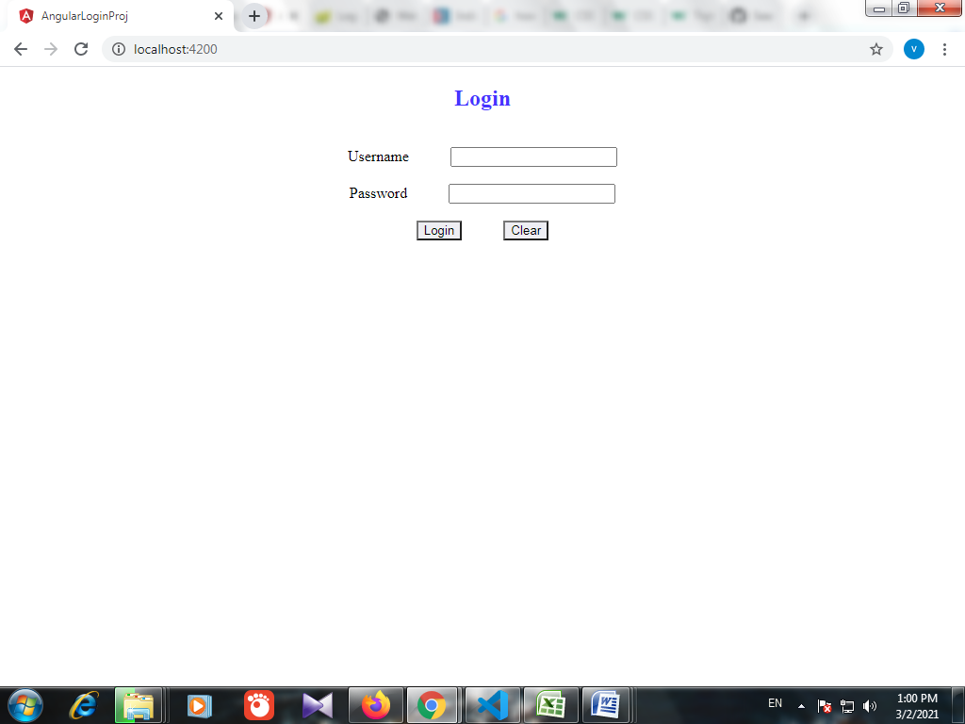

Login User Validations:

a)When username and password are empty.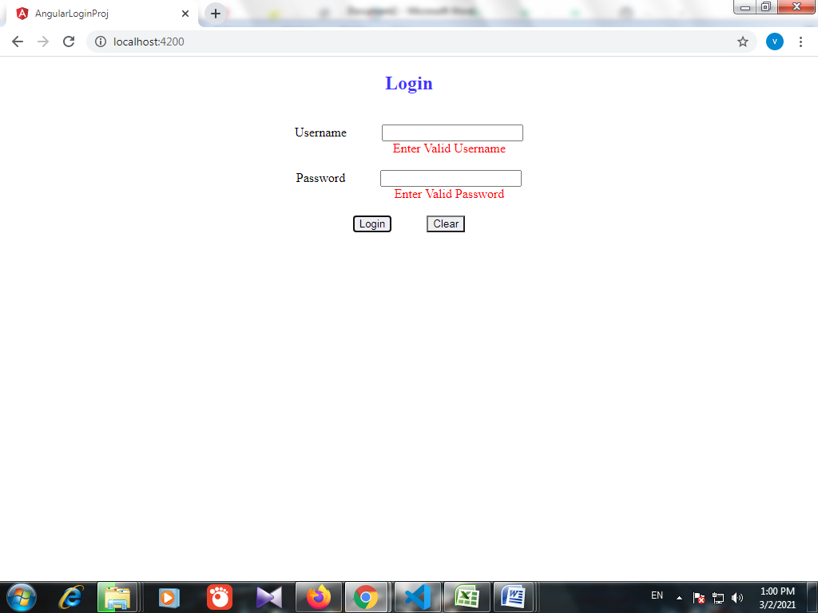

b) When username is correct and password is incorrect

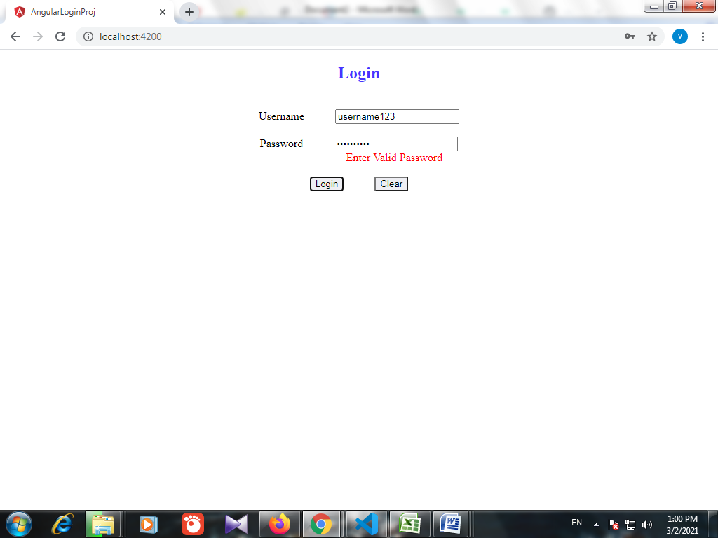

c) When username is incorrect and password is correct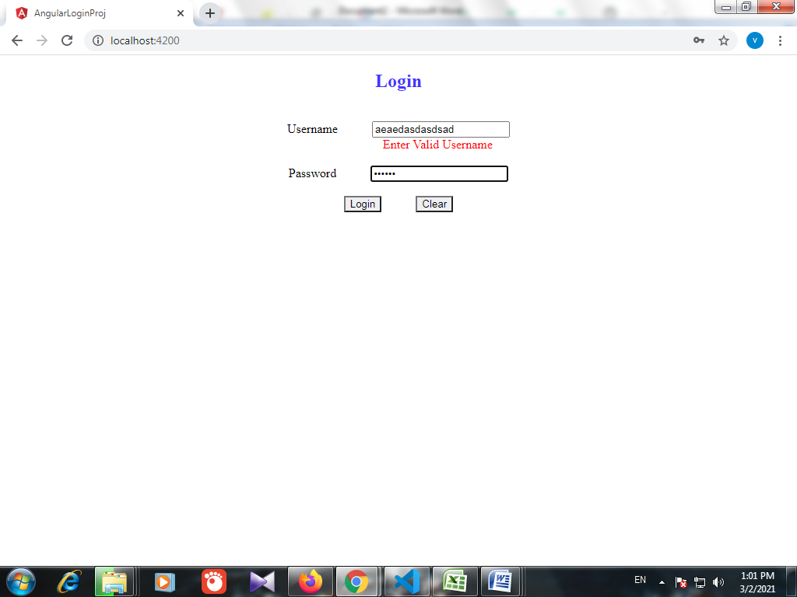

After entering valid username and password and click on Login button, next page appears.

When we try to click submit when Git hub Username is empty, below error message appears.

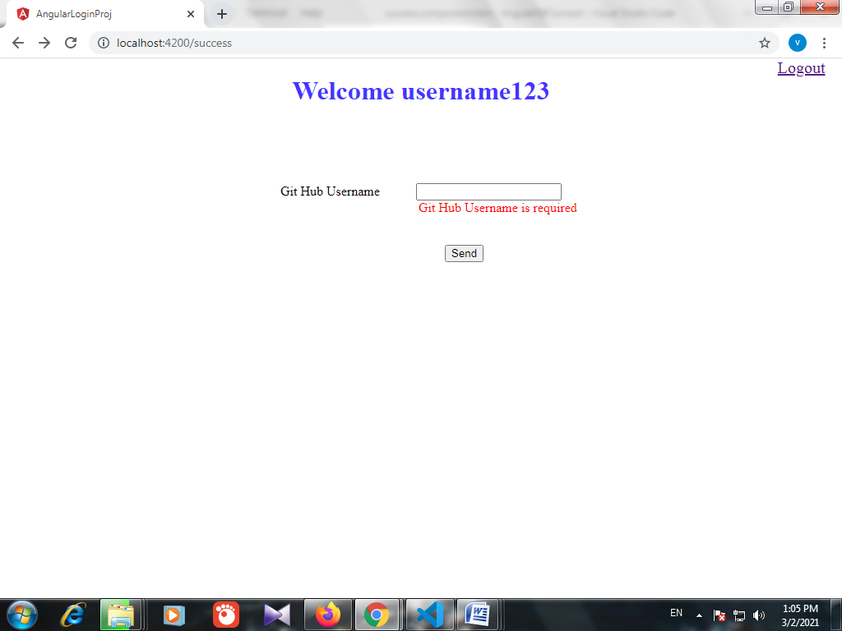

When correct github username is entered (eg:**vvijaycse97**), the user’s git hub details(username, created At, Updated At, Public Repos) details are displayed.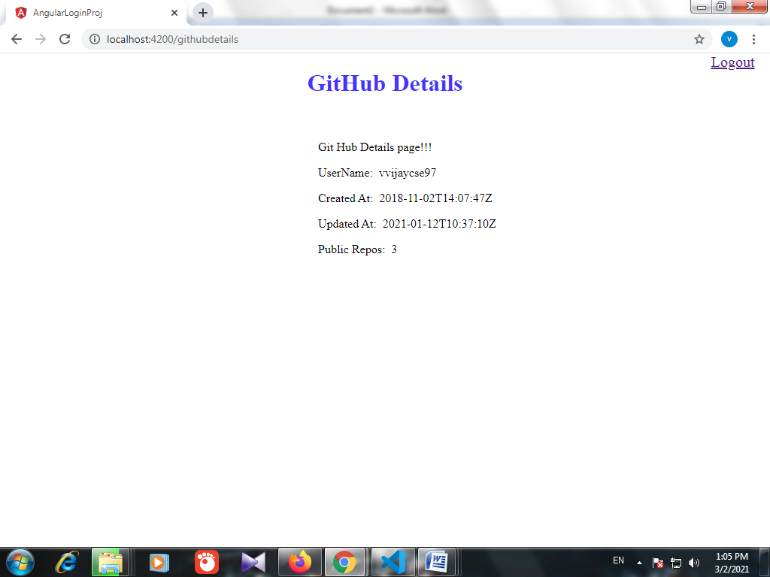

These values are obtained from API

[**https://api.github.com/users/vvijaycse97**](https://api.github.com/users/vvijaycse97)

Here vvijaycse97 is the GitHub User name entered in Screen(Angular).

After Submit button, call goes to SpringBoot Application’s Controller method, which calls the github API and sends those values back to Client(Angular)

Note: public_repos, updated_at values gets updated based on the activities in github account.

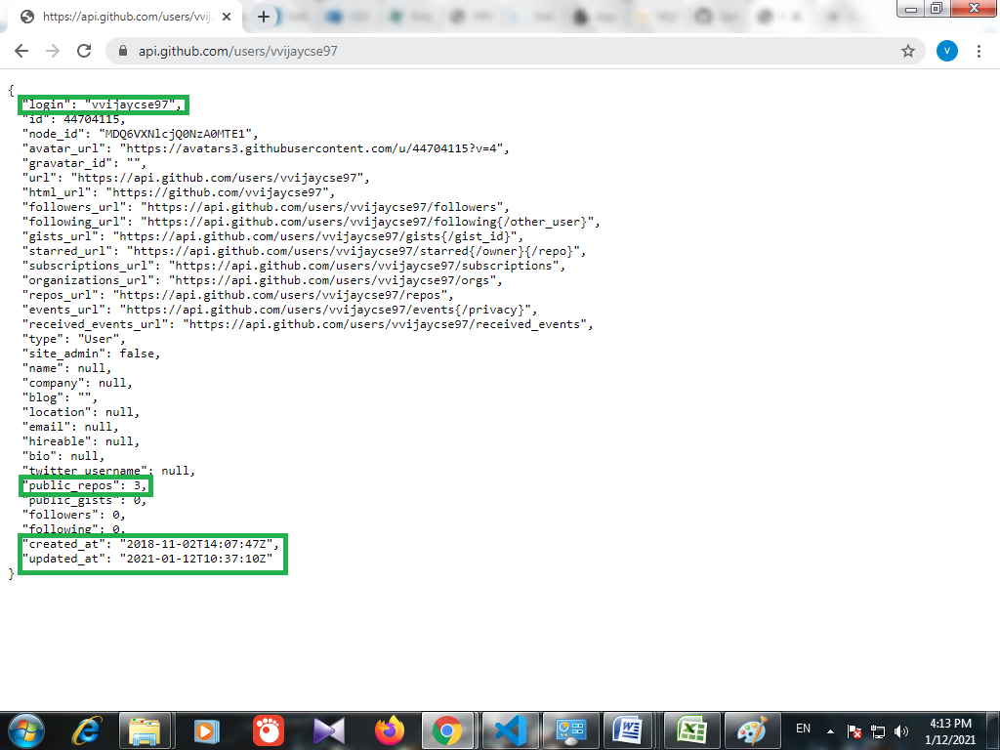

When the user enters an invalid github user:

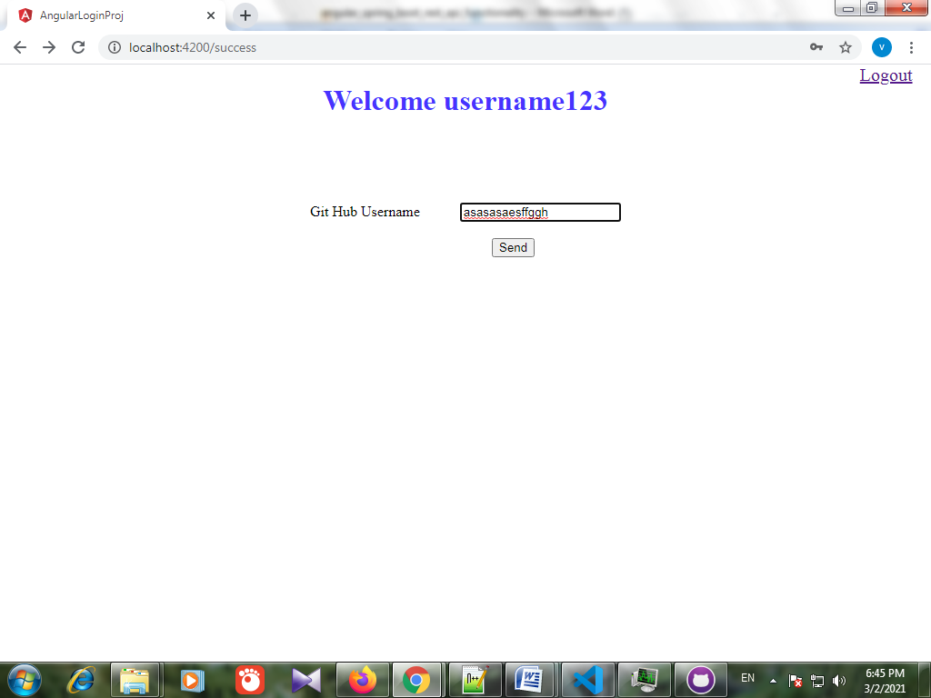

Invalid Github User message is displayed. 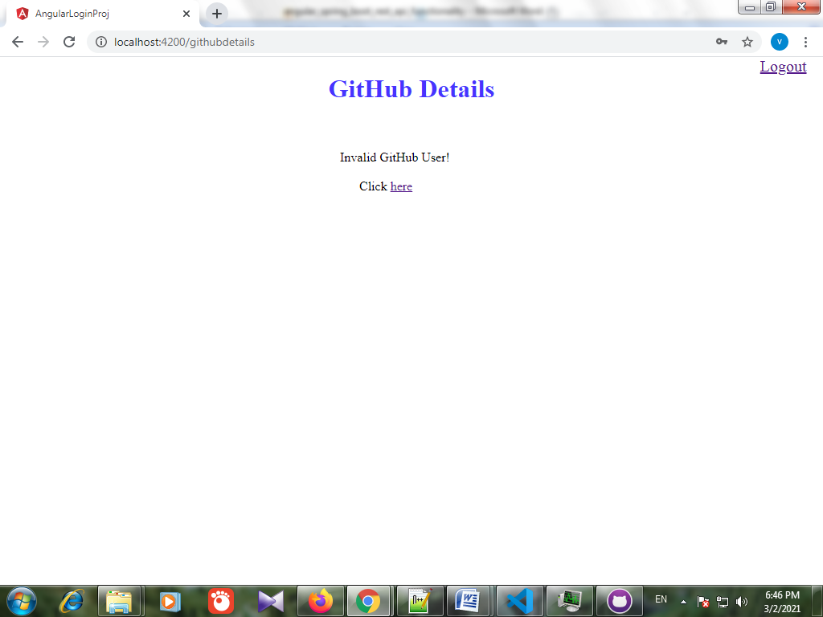

When the user Clicks on **here** hyperlink**,** previous pageappears where the user can enter the Valid Github User.

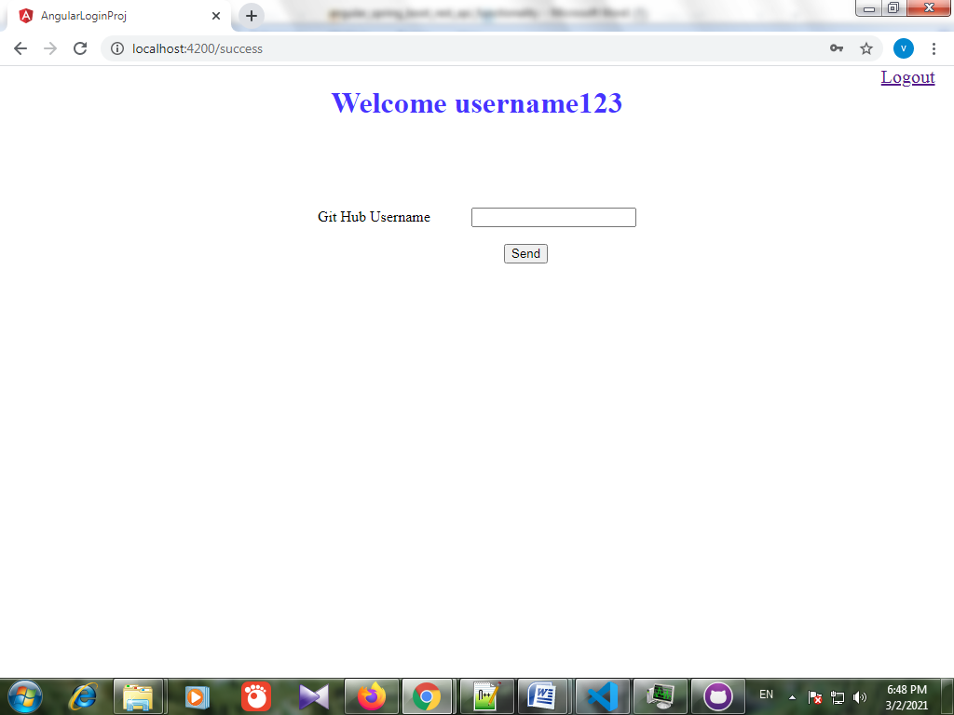

When the user Click Logout Link at the Top right corner, Logout page appears.

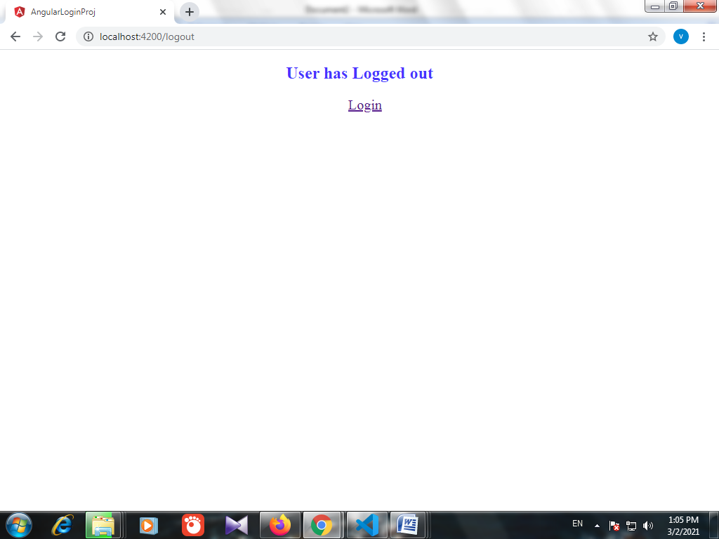

When the user Click on **Login** hyperlink, Login Page appears.

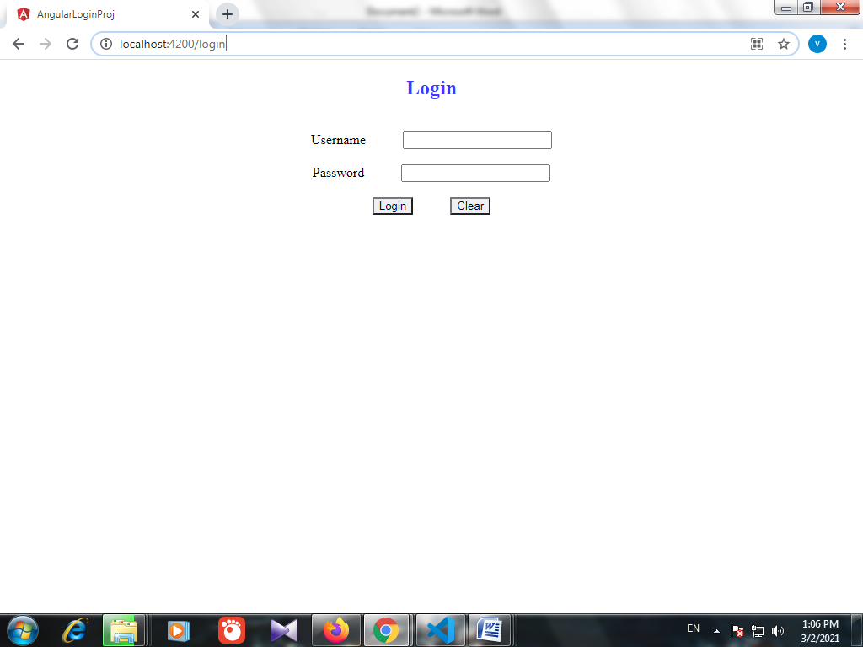

When there is any incorrect url entered, Page Not Found appears.

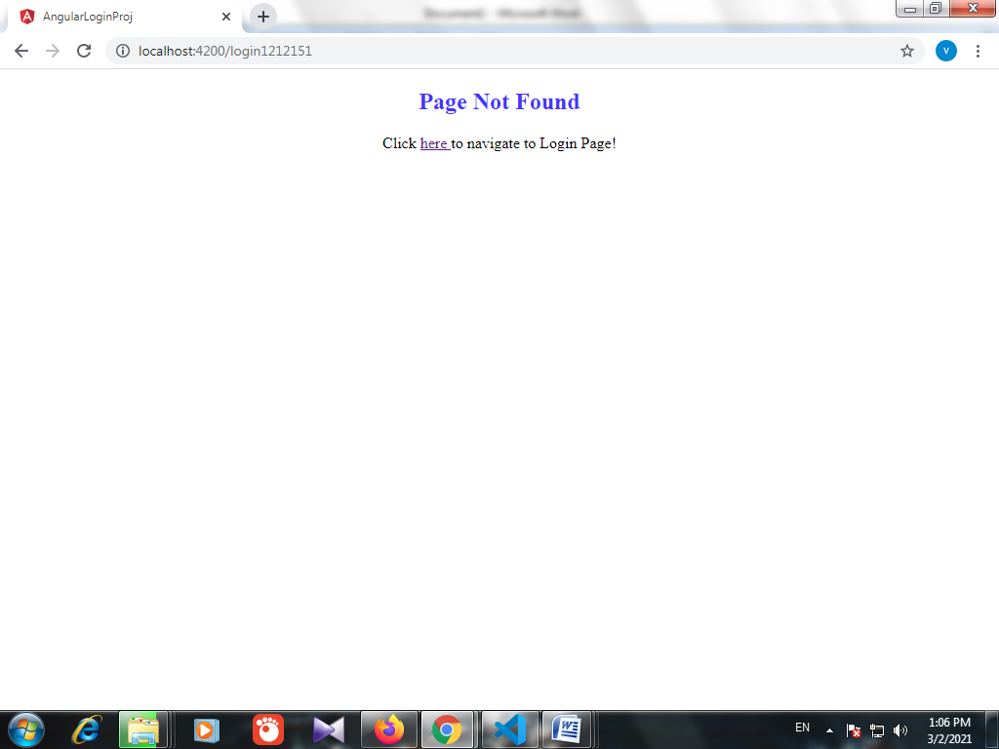

When the user Click on **here** hyperlink, Login page appears.

