To display details about the states which are performing at the top and the bottom along with the country average based on the health indicators.

Login Page:

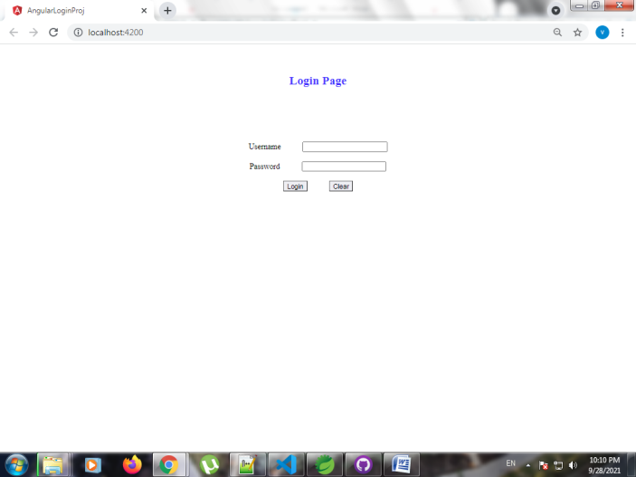

When user name and password is empty

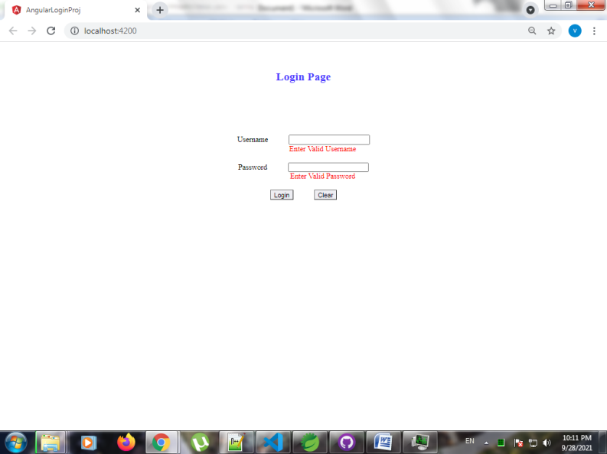

Had set username as **“abc”** password as **“123”** in environment.ts file.

After entering valid credentials success page appears.

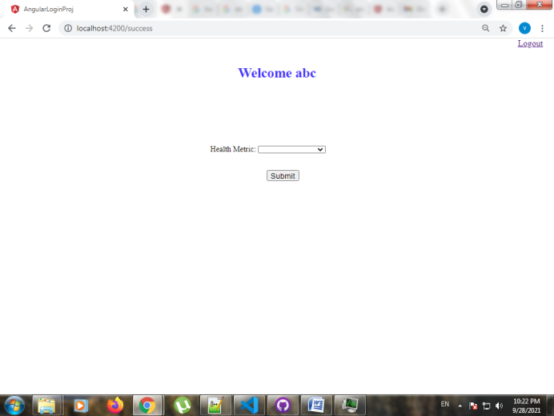

Select the Health metric in the drop-down.

a) When no value is selected and click on submit

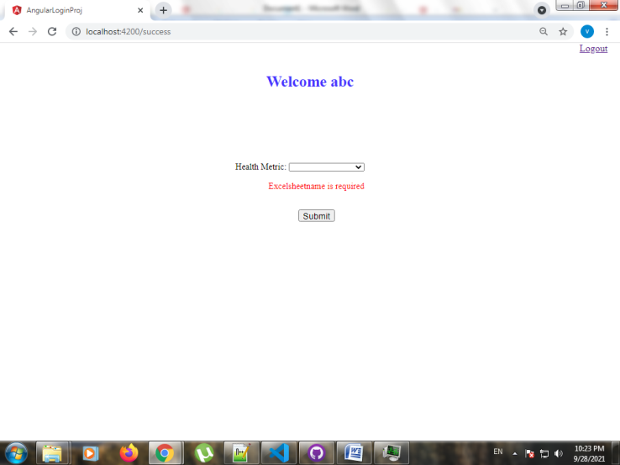

b) Select one of the health metric from drop-down

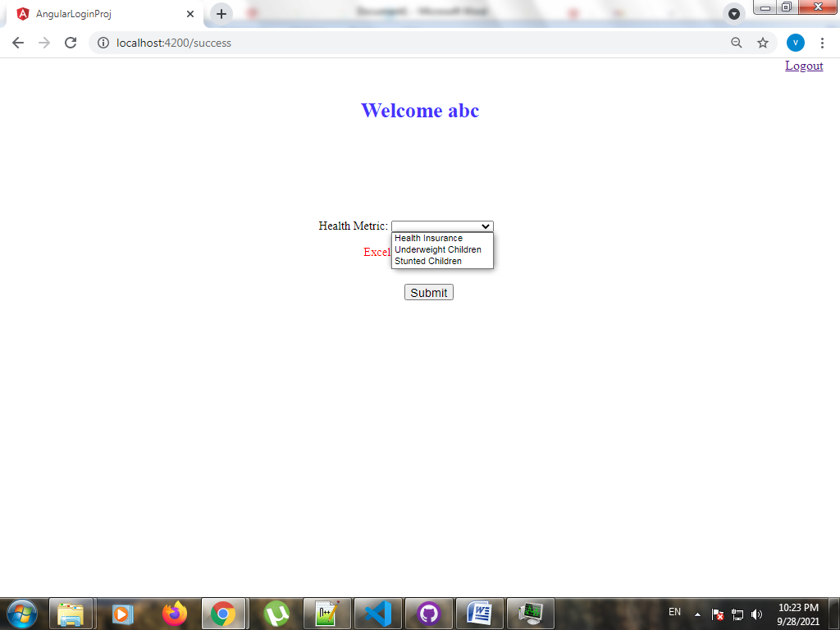

c) When Health Insurance metric is selected

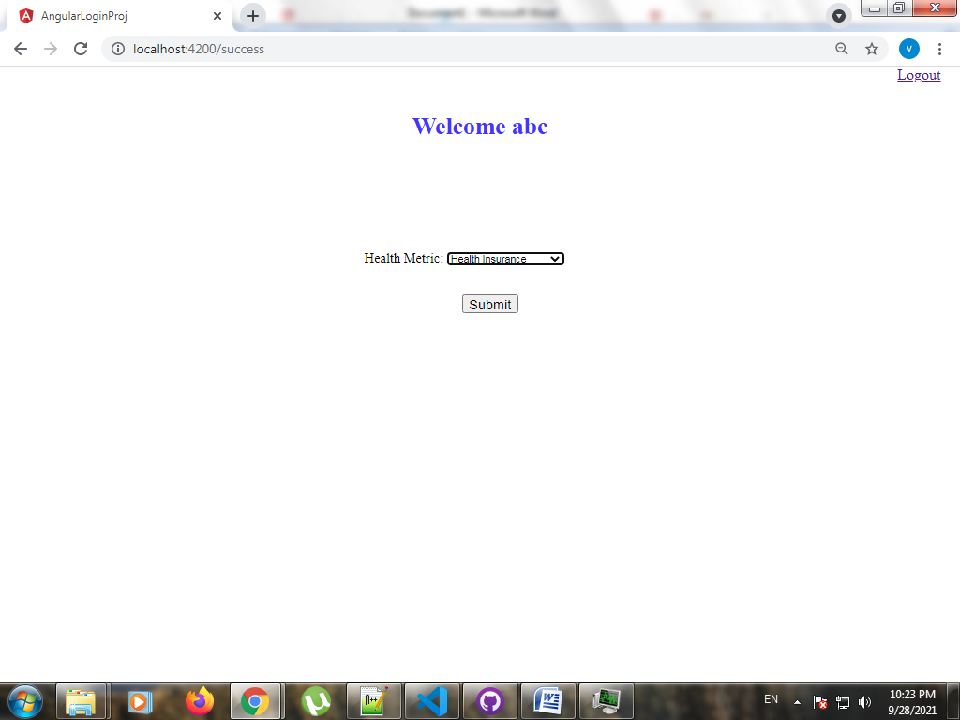

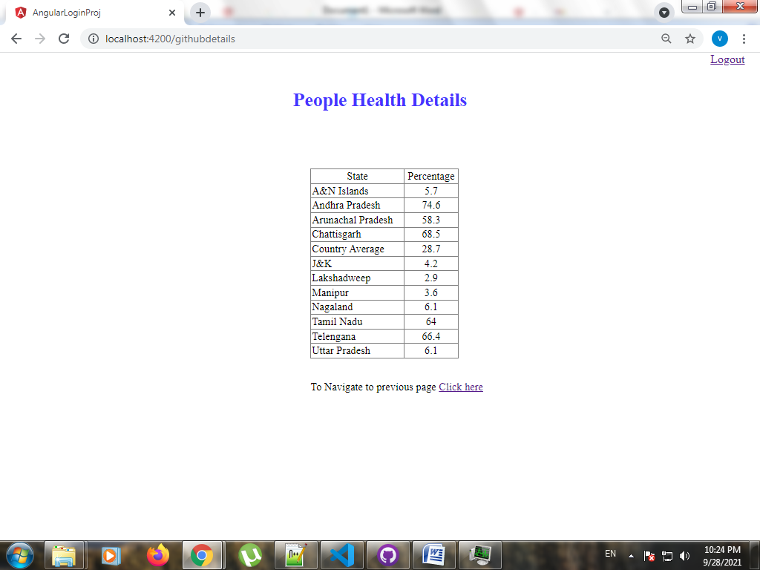

d) When Underweight Children metric is selected

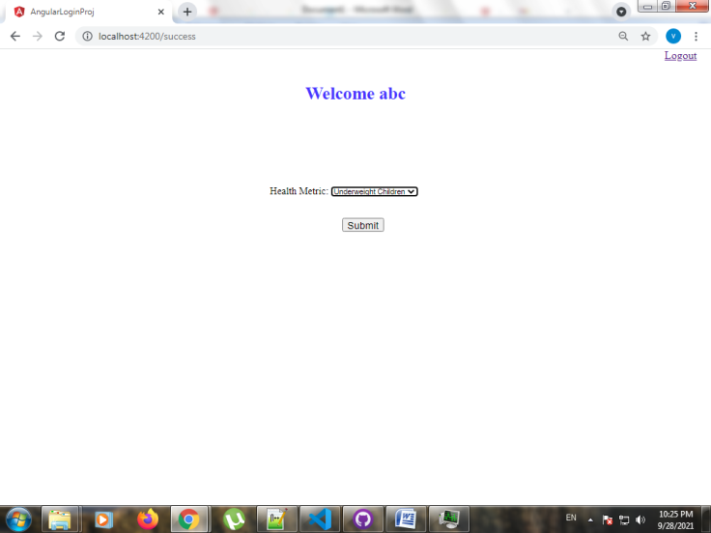

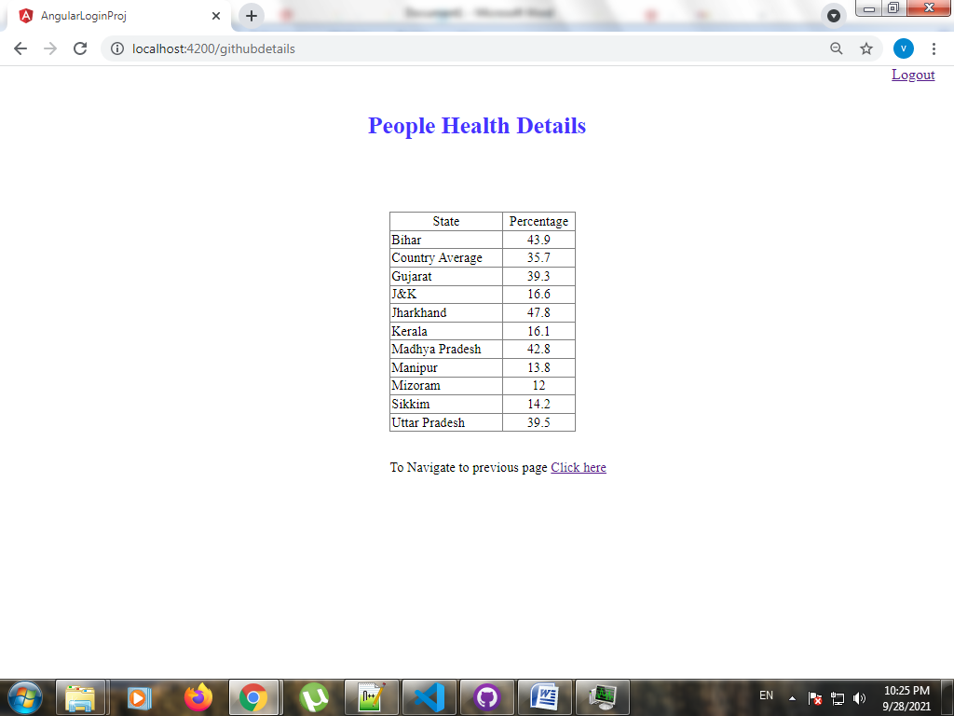

e) When Stunted Children metric is selected

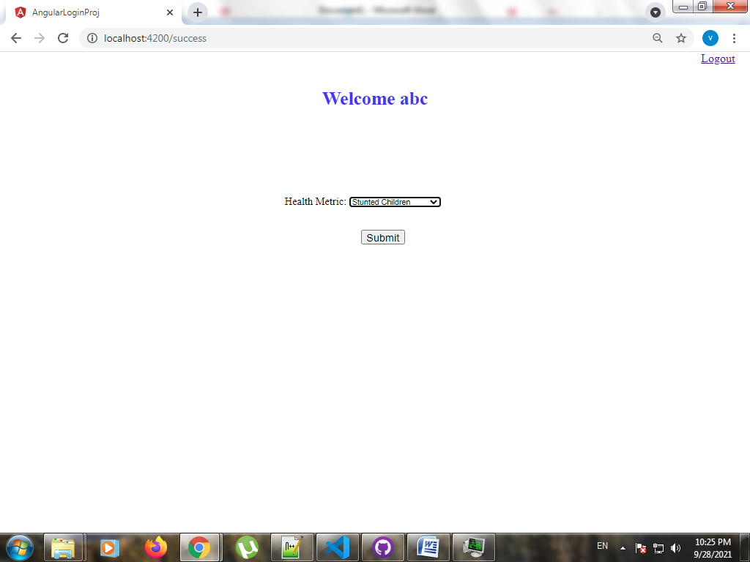

If we want to navigate to previous screen, Select **Click here** hyperlink

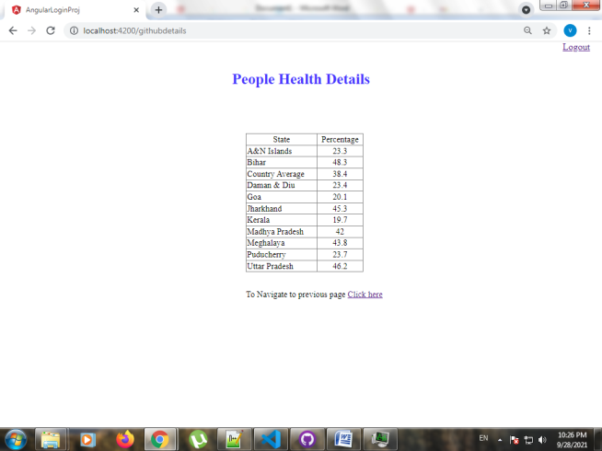

If we click on Logout hyperlink in top-right corner Logout Page appears.

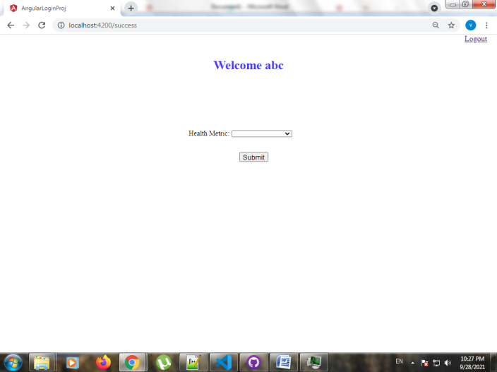

Select **“Click to Login again”** hyperlink to navigate to Login Page.

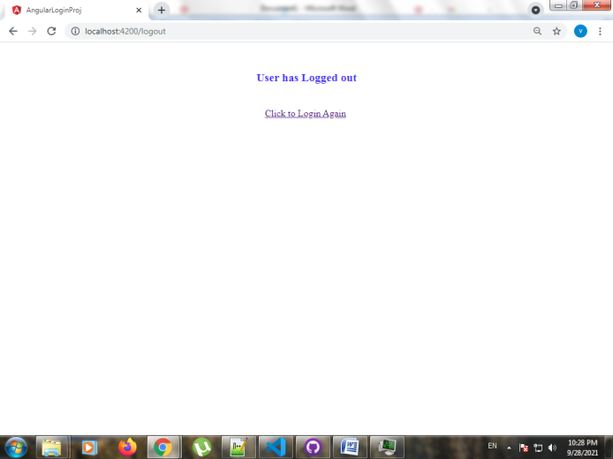

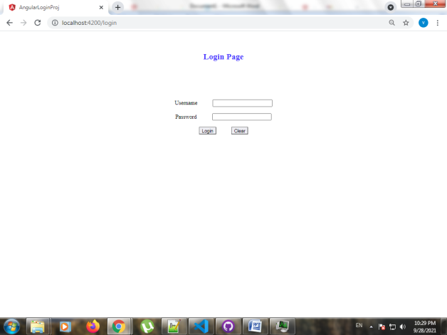

When wrong url is entered.

Click **“here”** hyperlink to be selected to navigate to Login Page



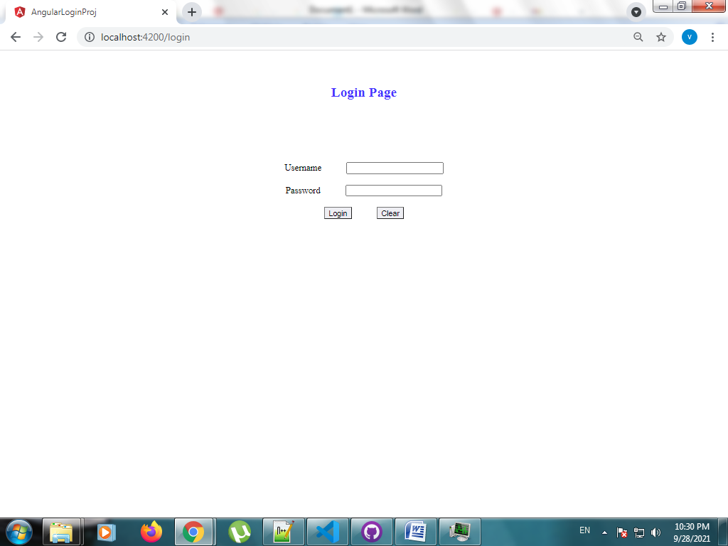

These details are obtained from below excel sheet

**healthdata_2019_2020_new_data.xlsx**

**Health Metric:**

a) Health Insurance

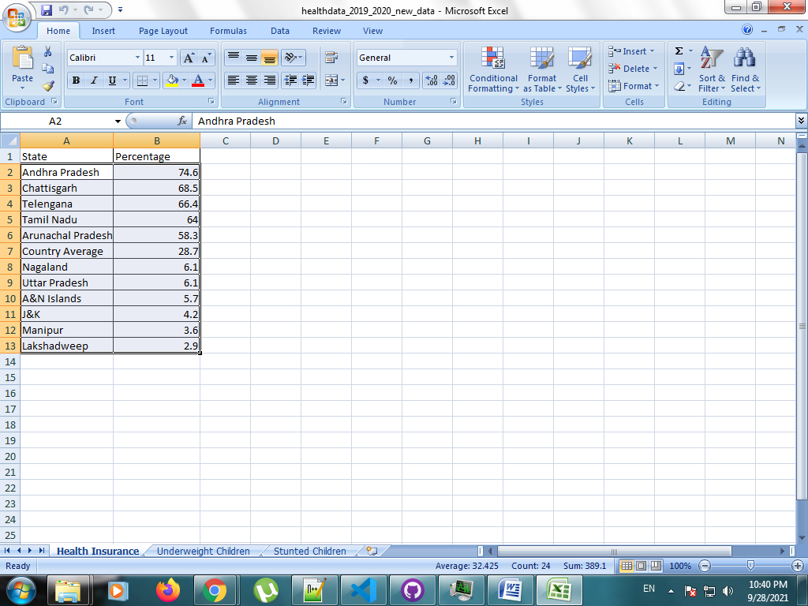

b) Underweight Children

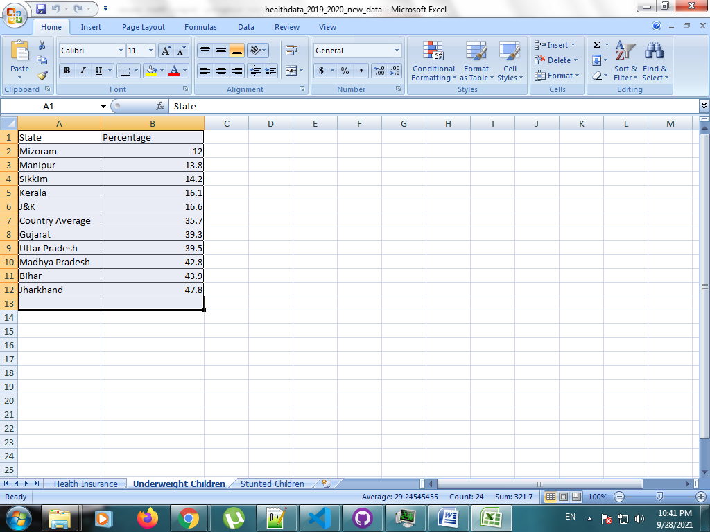

c) Stunted Children

