Home Page:

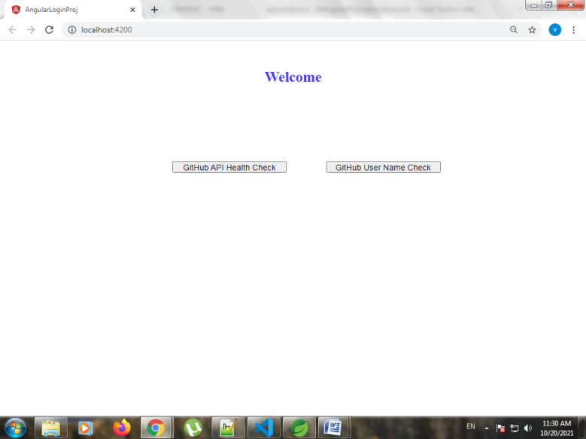

When GitHub API Health Check button is selected but Spring Boot Service (SBGitHubHealthCheck project is **not** up and running in **port 5003).**

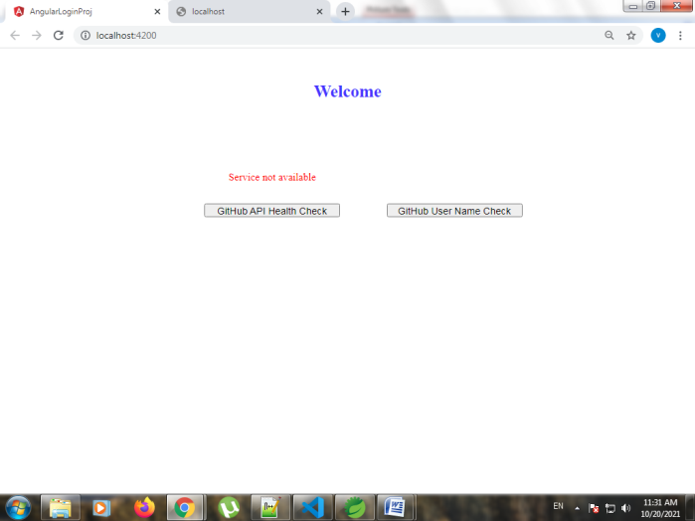

To Check for 5003 port Spring Boot project availability

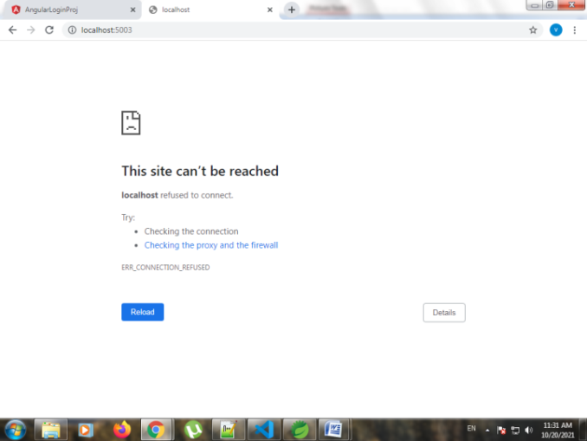

When **GitHub User Name Check** button is selected it navigates to GitHub User Name Check Page.

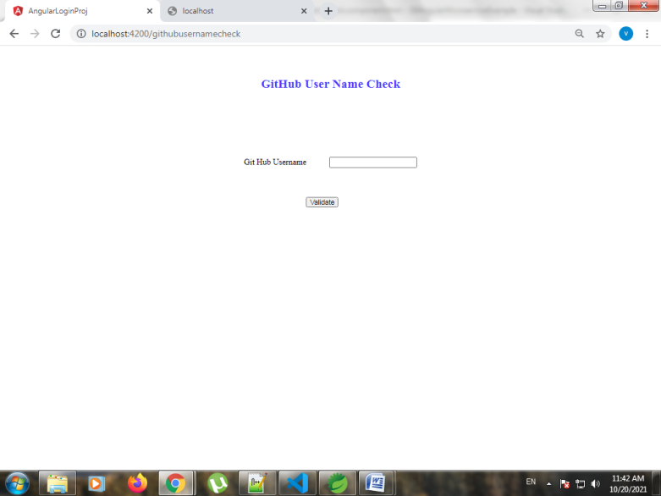

When SBGitHubUserCheck Validate button is selected and Spring Boot Service (SBGitHubUserCheck project is **not** up and running in **port 5004).**

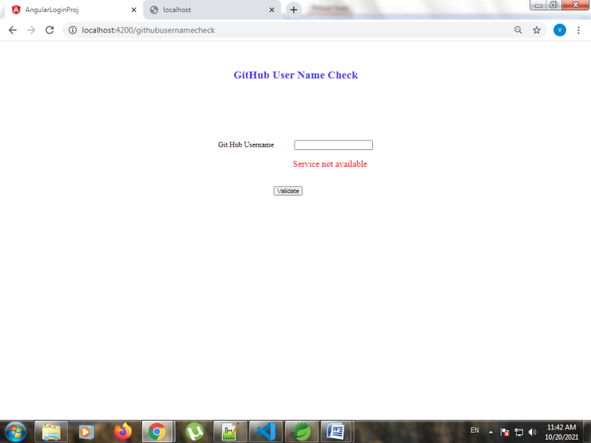

To Check for 5004 port Spring Boot project availability

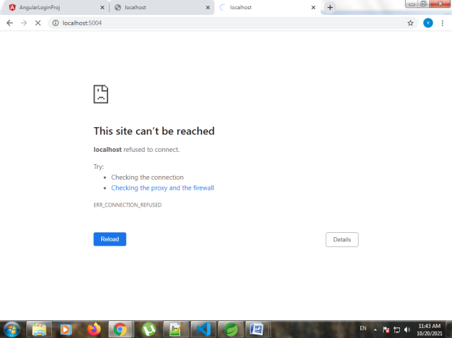

When SpringBoot GitHub Health Check application is started (port 5003)

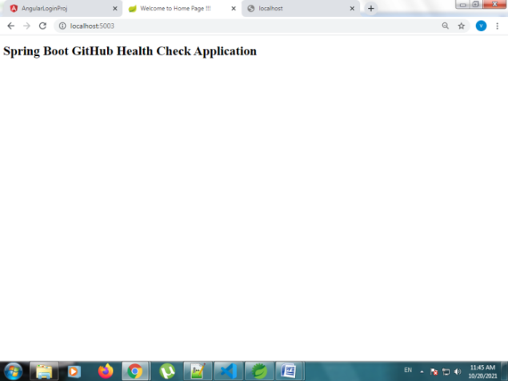

Now from home page, **GitHub API Health Check** button is selected

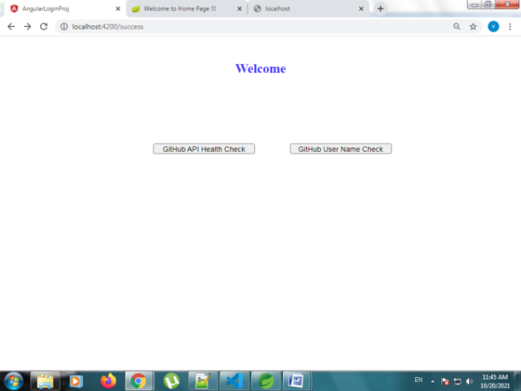

GitHub Status Code appears

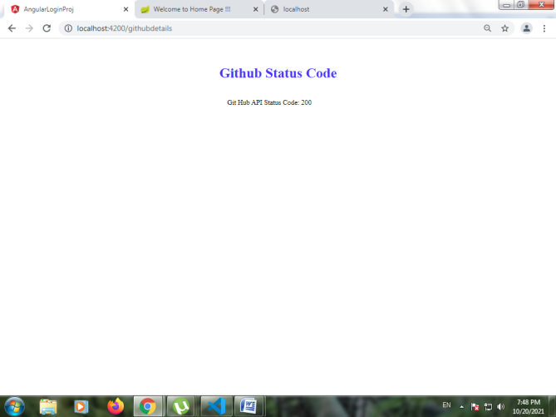

We can confirm that GitHub User Name validation is still not available by selecting **GitHub User Name Check** in home page which takes us to GitHub User Name check Page.

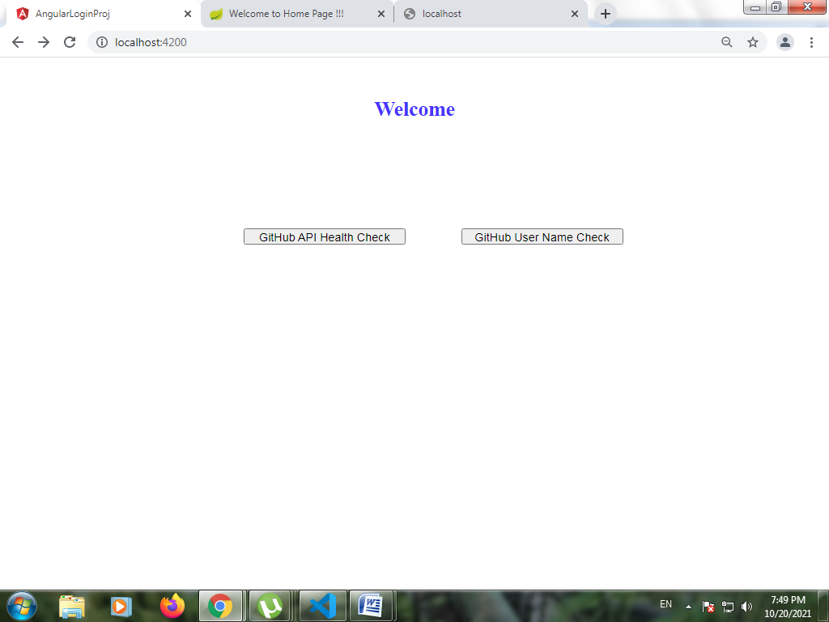

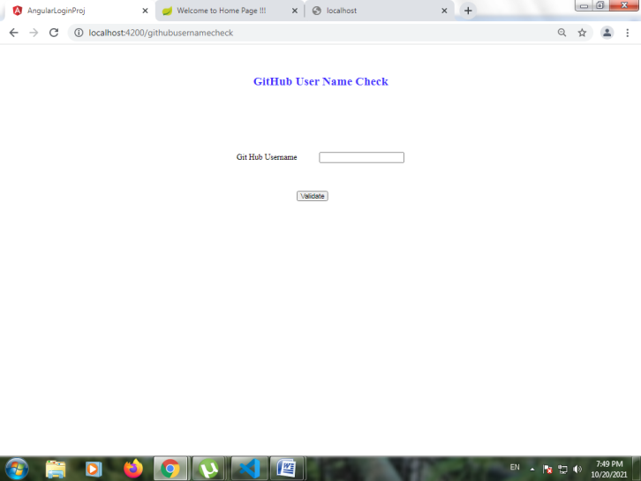

Click on Validate Button.

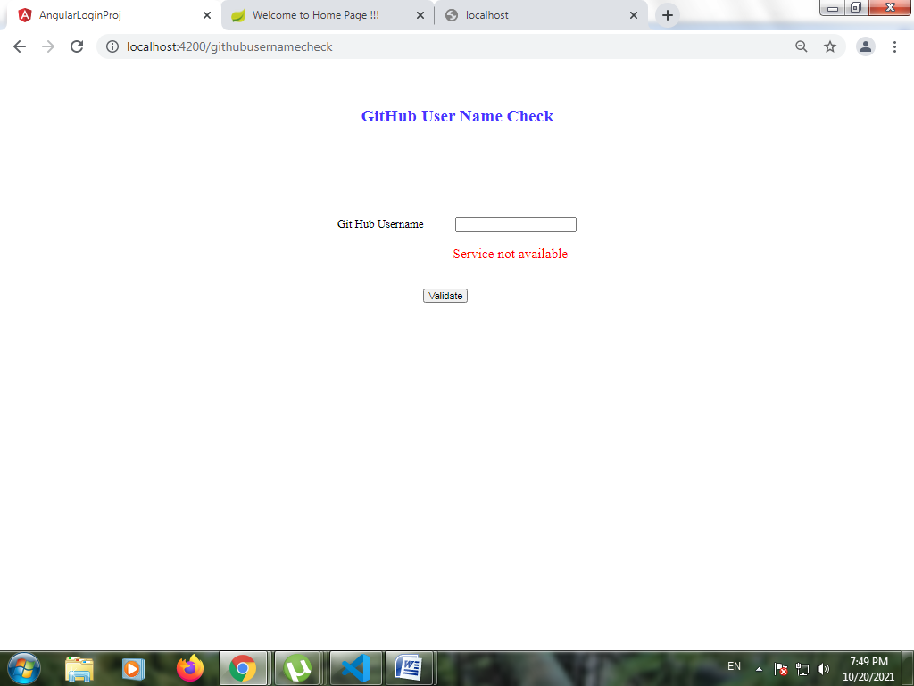

Both buttons in home page GitHub Api Health Check and GitHub User ID Check button refers to SBGitHubHealthCheck Spring Boot Project(port 5003) and SBGitHubUserCheck(port 5004) respectively.

API Details:

Spring Boot Project 1:

SBGitHubHealthCheck- <https://api.github.com>

Spring Boot Project 2:

SBGitHubUserCheck- <https://api.github.com/users> **/githubusername** is appended to the api to get details of input github user name.

Eg: If githubusername is vvijaycse97 then the API is **https://api.github.com/users/vvijaycse97**

Currently SBGitHubHealthCheck Spring Boot Project is available and hence we got 200 as response code when GitHub Api Health Check button is selected.

Now when SBGitHubUserCheck Spring Boot project is made available(port 5004).

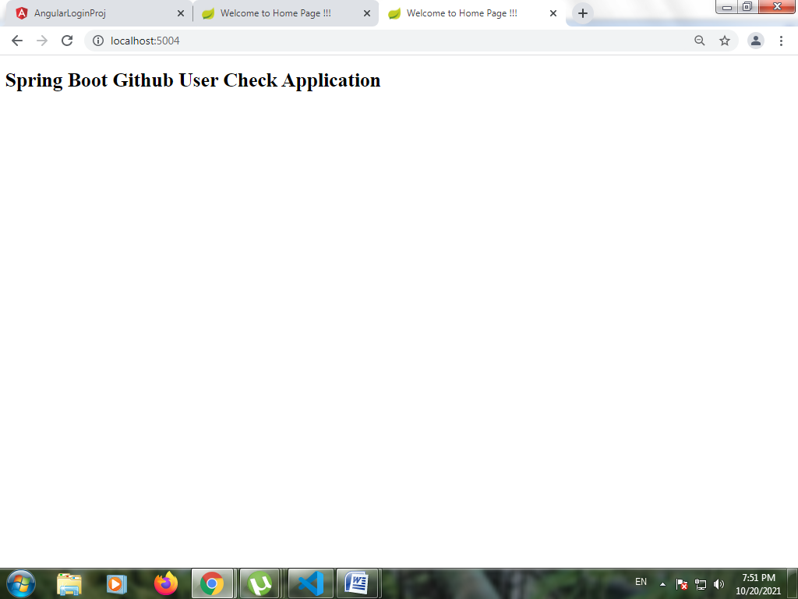

Select GitHub User Name Check

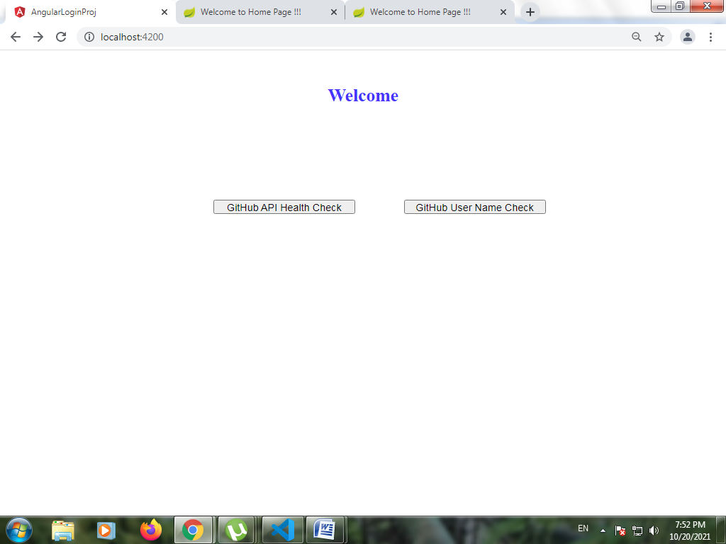

Enter a valid GitHub User Name

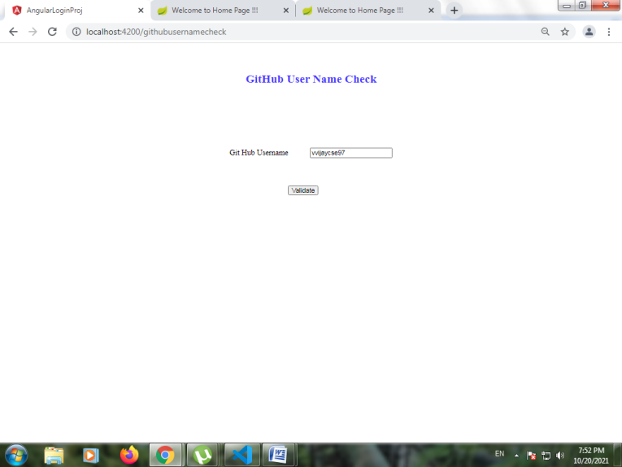

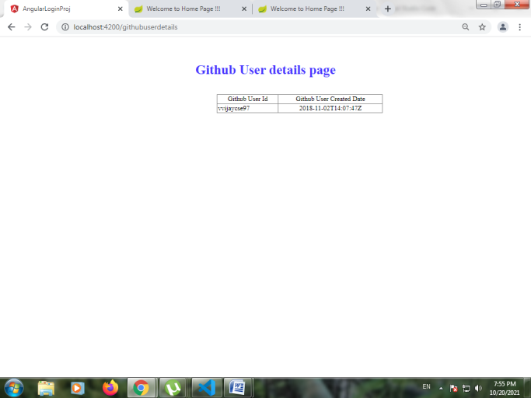

In case we give empty/invalid GitHub User Name

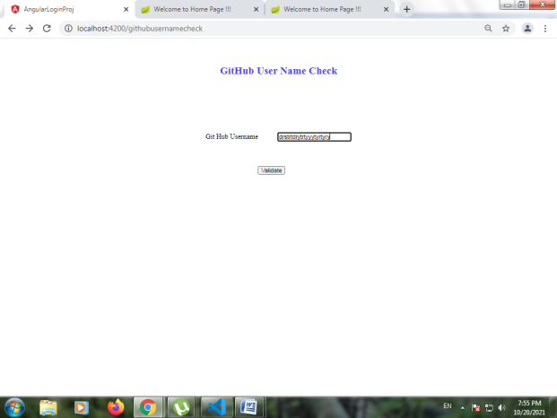

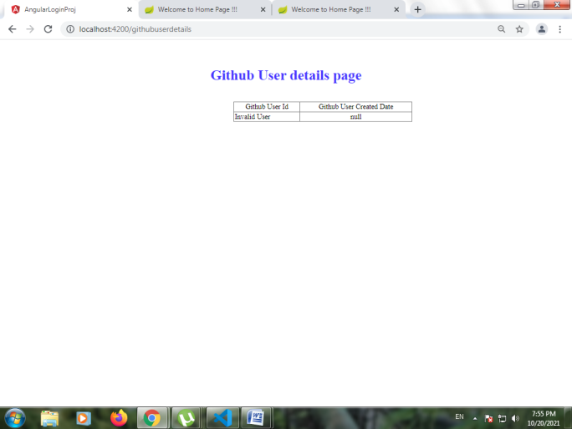

For Incorrect URL



Click on **here** hyperlink to navigate to Home Page.

