***<https://www.youtube.com/c/RaiGenics/playlists>***

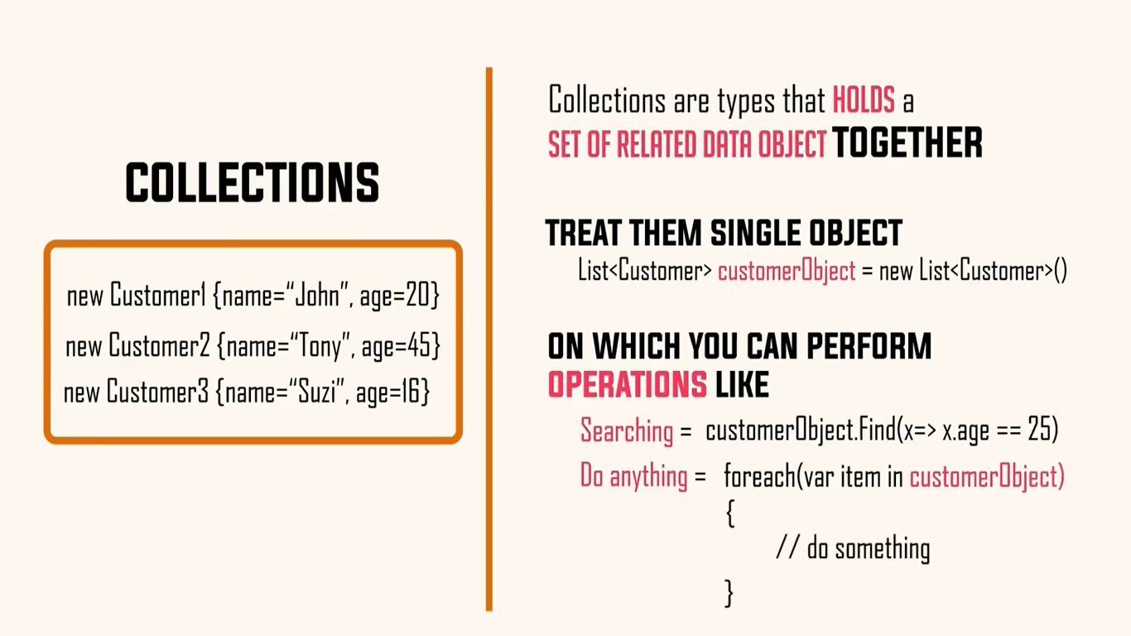

***Types of storing multiple data items***

1. Array
2. ArrayList
3. Hashtable
4. List
5. SortedList
6. HashSet
7. SortedSet
8. Dictionary
9. SortedDictionary
10. ReadOnlyDictionary
11. ReadOnlyCollection
12. Stack
13. Queue
14. LinkedList

Non-Generic Collections are not type safe and store data as :



IEnumerable (Provides iteration over data collection)

🡺 ICollection ( Additonaly, Count, & Generic version : Add, Remove)

🡺 IList (Additionaly, Index based access, Insertion, removal )

IEnumerable (Provides iteration over data collection)

🡺 ICollection ( Additonaly, Count, & Generic version : Add, Remove)

🡺 IDictionary

Array

1. [] are reference type
2. Every [] has “Array” as the base class
3. Array implements ILIst instead it does not provide add, remove implementation ; reason: IList are of three types 1) read-only, 2) fixed-size, 3) variable size (Add/Remove available for variable-sized arrays)





* 
* sequenceequal method to compare two arrays are same

ArrayList

* Resize automatically
* Insert in between
* Delete in between

Initial capacity 0 then 4 then 8 then 16 so on so fourth

Remove using item or index

Hashtable

* The Hashtable class represents a dictionary of associated keys and values with constant lookup time.
* The Hashtable class represents a collection of key-and-value pairs that are organized based on the hash code of the key. It uses the key to access the elements in the collection.
* Objects used as keys in a Hashtable must implement the GetHashCode and Equals methods (or they can rely on the default implementations
* Foreach will not iterate in sequential order as it was inserted reason being the hash code of the keys



Hash code, Hash algorithm, Collision, Open addressing (Linear probing), Closed Addressing (Chained list)

List

Fnfnlsndf

Dictionary

Dictionary Internal Representation:

<https://www.red-gate.com/simple-talk/blogs/the-net-dictionary/>

IComparable<T>,IComparer<T> (overrides CompareTo within class with external logic of IComparer)