In Eclipse the input file has to be here for the Prog to work

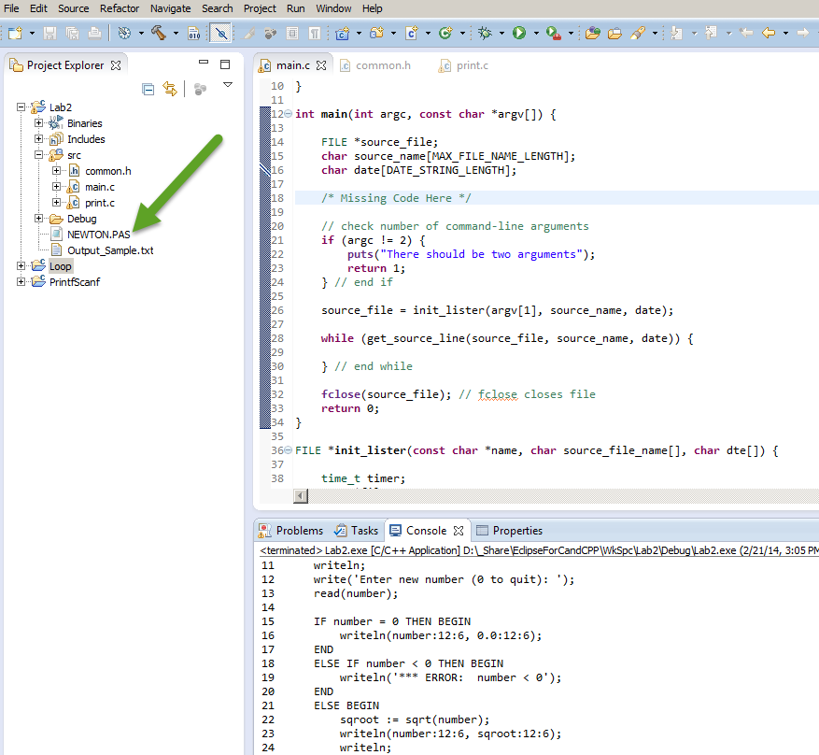

This issue is resolved:

I move these here to get me going due to a hiccup. I need to figure out how to move these back to print.c file.

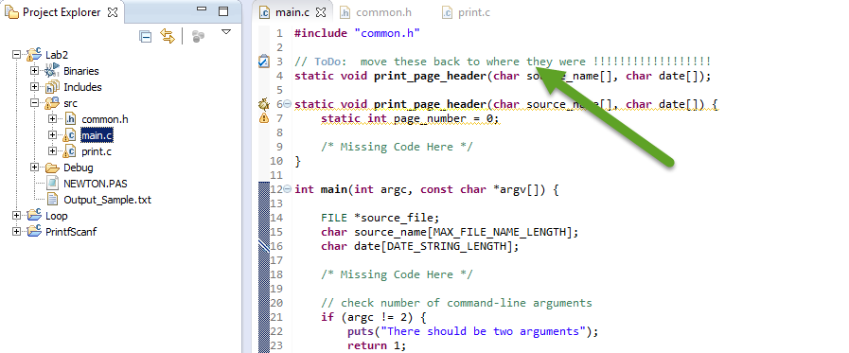

Added for testing only:

