**MEMORANDUM**

**______________________________________________________________________________**

**To:** Prof. Charlie Refvem - crefvem@calpoly.edu

Prof. Eric Espinoza-Wade - erwade@calpoly.edu

Department of Mechanical Engineering, Cal Poly SLO

**From:** Vinh T. Vo – [vvo11@calpoly.edu](mailto:vvo11@calpoly.edu)

Department of Mechanical Engineering, Cal Poly SLO

**Course:** ME 507 - Mechanical Control System Design

**Group:** MECHA08

**Date:** 05/10/2024

**RE:** Final Project Reflection – Basketball Laucher

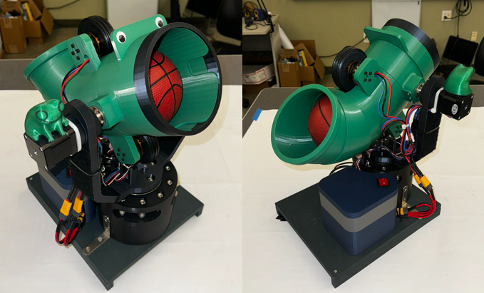

# Contributions

# Our term project involved designing and implementing a system with both mechanical and electronic components. Below is a breakdown of the work done by each team member and the relative magnitude of their contributions.

# I was responsible for designing and fabricating the 3D printed mechanical parts, which involved creating CAD models and ensuring the parts fit together correctly. Additionally, I designed two PCBAs for the controller and the launcher, which included schematic design, layout. I also worked on integrating the mechanical and electronic components to ensure they functioned together.

# My teammate focused on coding and programming for the controller. He developed and implemented the FSM to run the launcher. Additionally, he sourced and selected the components for the PCBA, handling the Bill of Materials (BOM) management to ensure that all necessary components were available.

# To highlight the individual contributions, we can consider a hypothetical scenario where we are awarded $10,000 for completing the project. The distribution of this amount would be: $6000 for me and $4000 for my teammate.

# Suggestions

After 10 weeks of working on the project, here are my suggestions:

* Focus on PCB design, especially on how to power the MCU correctly. This is important for making the project work well.
* The project is already complex enough for the course, so there's no need to add more complexity to the PCBA.
* Reduce lecture time and have more lab time. This will give students more hands-on experience, which is helpful, especially for those who are not familiar with programming in C.
* The pre-lab is not required (maybe optional) unless someone is not familiar with C, as the lab is straightforward.

For future teams, avoid making the PCBA design too complicated. Keep it simple and focus on powering the MCU correctly.