

GROWTH SEGMENTS

BUSINESS GROWTH

**TARGET MARKET**

**PRODUCT**
* What does the customer want from the product?
* What features does it have to meet these needs?
* How and where will the customer use it?
* What does it look like?
* What size(s), color(s), should it be?
* What is it to be called?
* How is it branded?
* How is it differentiated versus your competitors?

**PRICE**
* What is the value of the product or service to the buyer?
* Are there established price points for products or services in this area?
* Is the customer price sensitive?
* What discounts should be offered to trade customers?
* How will your price compare with your competitors?

**PLACE**
* Where do buyers look for your product or service?
* If they look in a store, what kind?
* How can you access the right distribution channels?
* Do you need to use a sales force?
* What do you competitors do, and how can you learn from that and/or differentiate?

**PROMOTION**
* Where and when can you get across your marketing messages to your target market?
* Will you reach your audience by advertising in the press, or on TV, or radio, or on billboards?
* When is the best time to promote?
* How do your competitors do their promotions? And how does that influence your choice of promotional activity?

MARKET MEASURES

Total Addressable Market (TAM)

Serviceable Addressable Market (SAM)
@Marketing / Awareness

Serviceable Obtainable Market (SOM)
@Growth / Acquisition + Activation

Market Penetration
- Increase market share in existing markets.
- Enhance customer retention.
- Expand distribution channels.
- Optimize pricing strategy.
- Boost marketing efforts.
- Strengthen brand presence.
Market Development
- Enter new geographic markets.
- Target new customer segments.
- Develop strategic partnerships.
- Explore new sales channels.
- Localize products and services.
Product Development
- Innovate new products and services.
- Improve existing product features.
- Invest in R&D initiatives.
- Accelerate product launch cycles.
- Gather customer feedback.
- Enhance product quality.
Business Diversification
- Explore new industry opportunities.
- Invest in related businesses.
- Develop unique business models.
- Mitigate market risks.
- Pursue vertical integration.
- Expand into digital markets.

Unq. Value Proposition (UVP)

MARKETING

CROSS-FUNCTIONAL PARTNERSHIPS
Awareness (A3R3)
Brand Awareness
Consideration
Competitiveness
@Business Growth / Unq. Value Proposition

Loyalty
@Growth / Retention > @Business / Offerings
@Growth / Referral > @Business / Rewards & Benefits

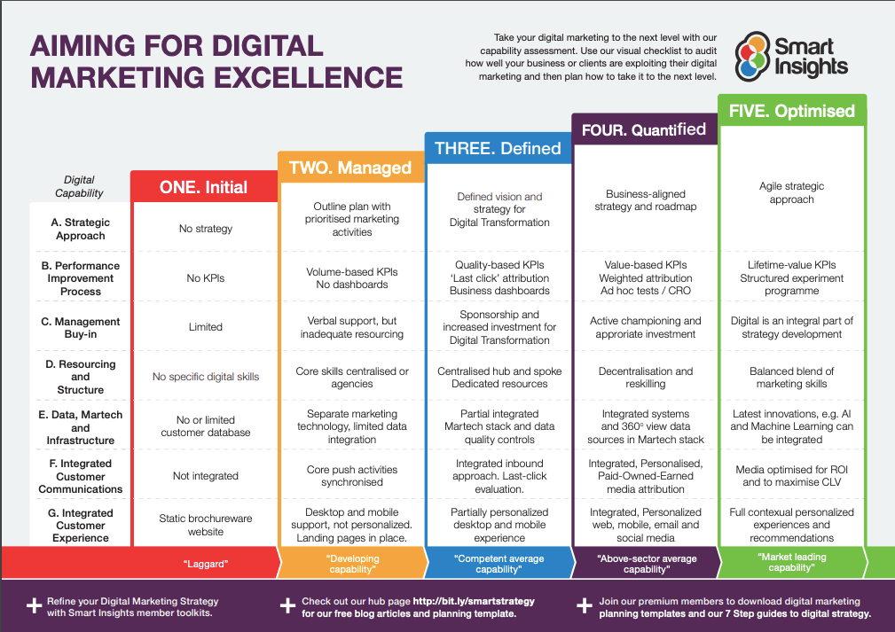

7 Steps of Marketing Strategy Process
Step 01 Conduct Market Research and Analysis
Step 02 Define Marketing Objectives
Step 03 Create a Buyer Persona
Step 04 Develop a Value Proposition
Step 05 Select the Right Marketing Channels
Step 06 Implement the Marketing Plan
Step 07 Evaluate the Performance of Your Marketing Efforts

GROWTH (A3R3)
product and market analysis
data-driven decision-making
experimentation,
scalability,
customer retention,
continuous improvement

Metrics Framework
Sourced: Affirm AARRR Framework Metrics Analysis - Claude

1. AARRR Framework Metrics

Acquisition Metrics
 | METRIC | DESCRIPTION | MEASUREMENT METHOD | TARGETS & BENCHMARKS
 | Website Traffic | Total visitors to Affirm.com | Google Analytics | Month-over-month growth
 | Cost Per Acquisition (CPA) | Cost to acquire new user | Marketing spend / New users | <$50 per user
 | Channel-specific CAC | Acquisition cost by channel | Channel spend / acquisitions | Varies by channel
 | Merchant Partner Growth | New merchant partnerships | Monthly new merchant signups | 10% MoM growth
 | App Downloads | Mobile app installations | App store analytics | 100K+ monthly
 | Organic Search Traffic | SEO-driven visitors | Search console data | 30% of total traffic
 | Partner Referral Traffic | Traffic from merchant sites | UTM tracking | 40% of acquisitions

Activation Metrics
Metric | Description | Measurement Method | Target/Benchmark
Account Creation Rate | % visitors who create account | Signups / Visitors | >15%
First Purchase Rate | % users completing first transaction | First purchases / New users | >25%
Pre-qualification Rate | % users checking eligibility | Pre-quals / Visitors | >30%
Application Completion Rate | % starting who finish application | Completed apps / Started apps | >70%
Time to First Purchase | Days from signup to first transaction | Cohort analysis | <7 days
Merchant Integration Usage | % users via merchant checkout | Merchant transactions / Total | >60%
Credit Limit Utilization | % of approved limit used | Used credit / Available credit | 30-50%

Metric | Description | Measurement Method | Target/Benchmark
Account Creation Rate | % visitors who create account | Signups / Visitors | >15%
First Purchase Rate | % users completing first transaction | First purchases / New users | >25%
Pre-qualification Rate | % users checking eligibility | Pre-quals / Visitors | >30%
Application Completion Rate | % starting who finish application | Completed apps / Started apps | >70%
Time to First Purchase | Days from signup to first transaction | Cohort analysis | <7 days
Merchant Integration Usage | % users via merchant checkout | Merchant transactions / Total | >60%
Credit Limit Utilization | % of approved limit used | Used credit / Available credit | 30-50%

Retention Metrics
Metric | Description | Measurement Method | Target/Benchmark
Monthly Active Users (MAU) | Users with activity in 30 days | Unique active users | 20% MoM growth
Repeat Purchase Rate | % users making 2+ purchases | Repeat users / Total users | >40%
90-Day Retention | Users active after 90 days | Cohort retention analysis | >35%
Churn Rate | % users becoming inactive | Inactive users / Total users | <5% monthly
Payment On-Time Rate | % payments made on schedule | On-time payments / Total due | >85%
Cross-Merchant Usage | Users shopping multiple merchants | Multi-merchant users / Total | >25%
App Engagement Rate | % users using mobile app monthly | App MAU / Total MAU | >50%

Referral Metrics
Metric | Description | Measurement Method | Target/Benchmark
Referral Program Participation | % users referring others | Referring users / Total users | >10%
Viral Coefficient | New users from referrals | Referred users / Referring users | >0.5
Referral Conversion Rate | % referrals becoming users | Converted referrals / Total referrals | >20%
Social Share Rate | Users sharing on social media | Social shares / Active users | >5%
Net Promoter Score (NPS) | Likelihood to recommend | Survey methodology | >50
Word-of-Mouth Attribution | Acquisitions from WOM | Survey/attribution modeling | >15% of new users
Merchant Referral Rate | Merchants referring other merchants | New merchant referrals / Total | >20%

Revenue Metrics
Metric | Description | Measurement Method | Target/Benchmark
Gross Merchandise Volume (GMV) | Total transaction volume | Sum of all transactions | $15B+ annually
Average Order Value (AOV) | Average transaction size | Total GMV / Transactions | $300-500
Take Rate | Revenue as % of GMV | Total revenue / GMV | 4-8%
Interest Income | Revenue from customer interest | Total interest collected | 40% of revenue
Merchant Fee Revenue | Fees from merchant partners | Total merchant fees | 60% of revenue
Customer Lifetime Value (CLV) | Total revenue per customer | Cohort revenue analysis | >$500
Revenue Per User (RPU) | Average revenue per active user | Total revenue / MAU | $50-100

2. Growth Marketing Metrics

User Acquisition & Growth
Metric | Description | Measurement Method | Target/Benchmark
Growth Rate | Month-over-month user growth | (New users - Churned) / Total | >10% MoM
Organic vs Paid Split | Source of new users | Attribution tracking | 60/40 organic/paid
Conversion Rate by Channel | Channel effectiveness | Channel conversions / Traffic | Varies by channel
Cost Per Install (CPI) | App installation cost | Ad spend / Installs | <$5
Activation Velocity | Speed to first purchase | Time-to-event analysis | Decreasing trend
K-Factor | Viral growth coefficient | (Invites × Conversion rate) | >1.0
Cohort Revenue Growth | Revenue growth by user cohort | Cohort analysis | Positive expansion

Campaign Performance
Metric | Description | Measurement Method | Target/Benchmark
Campaign ROI | Return on marketing investment | Revenue / Campaign cost | >3:1
Email Open Rate | Email engagement | Opens / Delivered | >25%
Click-Through Rate (CTR) | Ad/email effectiveness | Clicks / Impressions | >2%
Conversion Rate | Campaign conversions | Conversions / Clicks | >5%
Cost Per Thousand (CPM) | Display ad efficiency | Cost / (Impressions/1000) | <$10
Attribution Window Impact | Conversion timing | Multi-touch attribution | 7-day optimal
A/B Test Win Rate | Successful experiments | Winning tests / Total tests | >40%

Channel-Specific Metrics
Metric | Description | Measurement Method | Target/Benchmark
SEO Rankings | Keyword positions | Rank tracking tools | Top 10 for key terms
Paid Search CPC | Cost per click | Ad platform data | <$2 average
Social Media Engagement | Follower interaction rate | Engagements / Followers | >3%
Affiliate Performance | Partner-driven revenue | Affiliate tracking | 15% of revenue
Content Marketing ROI | Blog/content effectiveness | Attributed revenue / Cost | >5:1
Influencer Campaign Reach | Influencer impact | Impressions + conversions | 1M+ reach
Partnership Contribution | Strategic partner value | Partner-attributed GMV | >20% of GMV

3. Product Marketing Metrics

Product Adoption
Metric | Description | Measurement Method | Target/Benchmark
Feature Adoption Rate | % using new features | Feature users / Total users | >30% in 30 days
Product-Market Fit Score | User satisfaction measure | Survey + retention data | >40% "very disappointed"
Time to Value | Speed to user benefit | First value event timing | <1 day
Feature Engagement Depth | Intensity of feature use | Actions per user | Increasing trend
Cross-Product Usage | Users of multiple products | Multi-product users / Total | >40%
Mobile vs Web Usage | Platform preference | Platform MAU comparison | 60/40 mobile/web
API Integration Rate | Merchant API adoption | API users / Total merchants | >70%

User Experience Metrics
Metric | Description | Measurement Method | Target/Benchmark
User Satisfaction (CSAT) | Customer satisfaction score | Post-interaction surveys | >4.5/5
Task Completion Rate | % successfully completing tasks | Completed / Attempted | >90%
Error Rate | Application/payment errors | Errors / Total attempts | <2%
Support Ticket Volume | Customer service needs | Tickets / Active users | <5%
Time to Resolution | Support response time | Average resolution time | <24 hours
In-App Feedback Score | Real-time satisfaction | In-app rating prompts | >4.0/5
Checkout Abandonment | Drop-off during purchase | Abandoned / Initiated | <30%

Product Performance
Metric | Description | Measurement Method | Target/Benchmark
Load Time | Page/app performance | Performance monitoring | <3 seconds
Uptime | System availability | Monitoring tools | >99.9%
Transaction Success Rate | Successful payments | Successful / Attempted | >98%
Approval Rate | Credit approval percentage | Approved / Applied | >80%
Fraud Rate | Fraudulent transactions | Fraud losses / GMV | <0.1%
Default Rate | Payment defaults | Defaults / Total loans | <2%
Feature Usage Analytics | Detailed feature metrics | Product analytics tools | Varies by feature

4. Overall Business Scope Metrics

Financial Health
Metric | Description | Measurement Method | Target/Benchmark
Total Revenue | Overall company revenue | Financial reporting | $1.5B+ annually
Gross Profit Margin | Profitability measure | (Revenue - COGS) / Revenue | >35%
Operating Margin | Operational efficiency | Operating income / Revenue | >10%
Burn Rate | Cash consumption | Monthly cash outflow | Decreasing
Runway | Months of operation left | Cash / Burn rate | >24 months
Unit Economics | Per-transaction profitability | Revenue - Costs per transaction | Positive
Capital Efficiency | Return on deployed capital | Revenue / Capital deployed | Improving

Market Position
Metric | Description | Measurement Method | Target/Benchmark
Market Share | % of BNPL market | GMV / Total market GMV | >25%
Merchant Coverage | % of eligible merchants | Partner merchants / Total | >50%
Geographic Expansion | Markets served | Active countries/regions | 5+ countries
Category Penetration | Vertical market presence | Categories with Affirm | All major retail
Competitive Win Rate | Wins vs competitors | Won deals / Total opportunities | >40%
Brand Awareness | Market recognition | Survey methodology | >60% aided
Strategic Partnerships | Major partner count | Enterprise partnerships | 50+ Fortune 500

Risk & Compliance
Metric | Description | Measurement Method | Target/Benchmark
Charge-off Rate | Unrecoverable loans | Charge-offs / Total loans | <3%
Regulatory Compliance Score | Adherence to regulations | Audit results | 100%
Data Security Incidents | Security breaches | Incident count | 0 critical
Credit Loss Rate | Total credit losses | Losses / GMV | <1%
Liquidity Ratio | Available cash position | Liquid assets / Liabilities | >1.5
Debt-to-Equity Ratio | Leverage measure | Total debt / Equity | <2.0
Compliance Cost Ratio | Regulatory cost burden | Compliance cost / Revenue | <5%

Operational Excellence
Metric | Description | Measurement Method | Target/Benchmark
Employee Productivity | Revenue per employee | Revenue / Headcount | >$500K
Customer Service Level | Support quality | SLA achievement | >95%
Technology Spend Ratio | Tech investment level | Tech spend / Revenue | 15-20%
Operational Efficiency | Cost per transaction | Operating cost / Transactions | Decreasing
Merchant Onboarding Time | Partner integration speed | Average time to live | <14 days
System Scalability | Transaction capacity | Peak TPS capability | 10,000+ TPS
Employee Satisfaction | Team engagement | eNPS surveys | >50

Key Performance Indicators (KPIs) Dashboard Priority

Top 10 Critical Metrics for Executive Dashboard
- Gross Merchandise Volume (GMV) - Primary business volume indicator
- Monthly Active Users (MAU) - User engagement and growth
- Take Rate - Revenue efficiency
- Customer Acquisition Cost (CAC) - Growth efficiency
- Default Rate - Risk management
- Repeat Purchase Rate - Customer loyalty
- Merchant Partner Growth - B2B expansion
- Gross Profit Margin - Financial health
- Net Promoter Score (NPS) - Customer satisfaction
- Market Share - Competitive position

Implementation Notes
- Data Collection: Implement robust analytics infrastructure (Segment, Amplitude, Mixpanel)
- Reporting Cadence: Daily operational metrics, weekly growth metrics, monthly strategic metrics
- Benchmarking: Regular competitive analysis and industry benchmarking
- Automation: Automated dashboards and alerts for critical metric thresholds
- Cross-functional Alignment: Ensure all teams understand and own relevant metrics
- Continuous Optimization: Regular review and adjustment of targets based on market conditions

ACQUISITION

OWNED

Domain (Properties)
Research & Whitepapers
Content & Media Publishing
Resources & Tools Library

Social Media Management

Lifecycle Marketing
Email Campaigns
Push Notifications

Mobile (Properties)

Podcasts & Livestreaming (Webinars)

PAID

Social Media Marketing (SMM)
FACEBOOK X (COM) INSTAGRAM REDDIT
TIKTOK LINKEDIN PINTEREST

Search Engine Marketing (SEM/PPC)
GOOGLE ADS BING ADS

Partnerships & Promotions
Influencer Marketing (Promotion)
Sponsored Content (Sponsorship)

Affiliate & Referral Marketing

Native Advertising

Video Ads

EARNED

Brand Management & Reputation
Reviews & Reputation Monitoring
Brand Mentions & Sentiment Tracking
Feedback (Review) Management

Social Media Management & Optimization (SMM-O)
MEDIUMS
FACEBOOK
X (COM)
INSTAGRAM
REDDIT
TIKTOK
TIKTOK
IMPLEMENTATION
- Social Media Engagement
- Social Content Optimization & Distribution

Content Development & Distribution

Referrals Optimization

Search Engine Optimization (SEO)

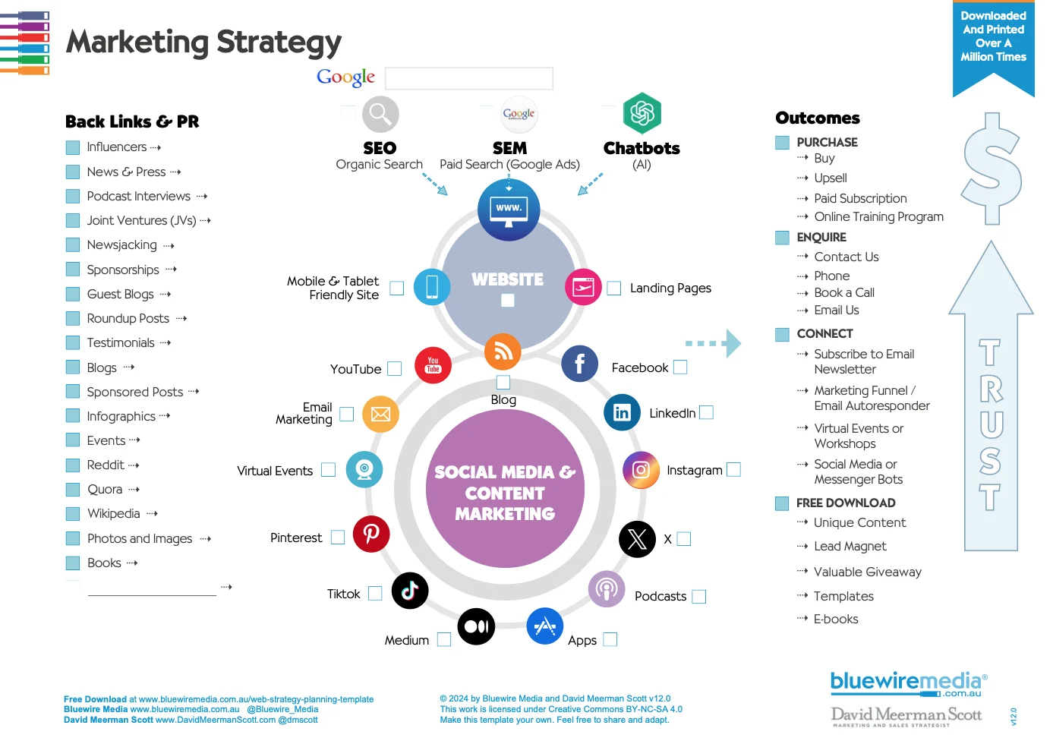

ACTIVATION
CONVERSIONS

REVENUE
LTV, ARPU

RETENTION

REFERRAL

OPTIMIZATION EXPERIMENTS (INCREMENTAL LIFT)

PRESENTATION
Title and introduction
Goal or objective
Market overview
Competitor analysis
Product or service overview
Marketing strategy
Budget and resource allocation
KPIs and performance metrics
Timeline or action plan
Projections or expected outcomes
Next steps
_
Start with a market overview that outlines the current landscape, target audience, and competitive gaps you've identified.
Define 1–3 clear objectives. Make sure they’re measurable, relevant, and realistic within the given timeline and budget.
Present your core marketing strategy. Focus on positioning, messaging, and the channel mix you’ll use to reach the audience.
Break the strategy into an action plan with owned, earned, and paid tactics across platforms. Include who’s responsible for what.
Add a high-level timeline and resource allocation to show how and when things will get done.
Wrap up with KPIs that align with the objectives. Be specific about how success will be tracked and reported.

#MARKETING
Marketing Planning Process
STEP ONE: Mission
- Mission Statement
- Corporate Objectives
STEP TWO: Situation Analysis
3. Identify Opportunities
4. 5C Analysis (Company, Customers, Competitors, Collaborators, Climate)
5. SWOT Analysis (Strengths, Weaknesses, Opportunities, Threats)
6. PEST Analysis (Political, Economic, Social, Technical)
STEP THREE: Marketing Strategy
7. Define Your Target Audience
8. Set Measurable Goals
9. Develop Budget
STEP FOUR: Marketing Mix
10. Product Development
11. Pricing
12. Promotion
13. Place and Distribution
STEP FIVE: Implementation and Control
14. Put Plan into Action
15. Monitor results

B2B Marketing Strategies for 2025: 15 Ways to Get Results
- Content Marketing
- SEO
- Conversion Rate Optimization
- Marketing Automation
- Sponsored Research
- Email Marketing
- Account-based Marketing
- Geo-Targeted Advertising
- Search Advertising
- Display Advertising
- Trade Shows
- Influencer Marketing
- Earned Media & PR
- B2B Social Media
- Sales Enablement

* Expand on tactics/testing implementation strategies for growth @case

JOB DESCRIPTION
Marketing Manager
Description
- Measurement Strategy
- Performance Monitoring
- Customer Insights w/ Optimizations
- Cross-Functional Leadership
Application
- Driving Marketing Effectiveness
- Informing Channel Strategy
- Data-Driven Decision-Making

Holistic Marketing Reporting
Description
- Marketing Performance Tracking & Evaluation
Application
- Goal Setting
- KPI Definitions
- Reporting Frameworks (*Channels)
Experience
@CreditSesame; Unified Marketing Analytics (UMA) Platform & MTA Integration
- Context: Scaling acquisition w/ 15 channels (Google Ads, Meta, Email Marketing, Affiliates)
- Situation: ROI & budget allocation optimizations (lacking clarity)
- Task: Consolidate marketing data (AWS S3/Redshift), MTA (UID)
- Sell: - Wasting 25% of our $10M annual marketing budget
- Budget Allocation Inefficiency
- Goal: Reduce CAC by 25% in 6 months; marketing budget optimizations
- Implement: - Team of 3 analysts, data engineering for data pipelines w/ Airflow, dbt
- Data warehouse w/ AWS Redshift to unify data sources and custom data
- MTA implementation
- Tableau dashboards w/ audience views (strategic, tactical, board)
- Results: - Reduced CAC by > 30% in 5 months w/ reducing underperforming channels
- Affiliate channel was cannibalizing organic (search); $2M saved annually

Metrics & Levers Analytics
Description
- Online/Traditional Marketing Channels Metrics
Application
- User Acquisition Funnels, Engagement Metrics, Lifetime Value Modeling, AARRR,
NMS (w/ customer value, growth focused, measurable + timely, hard to game, mission aligned),
Net Promoter Score (NPS)
Cases
- Growth & Metrics
- “What metrics would you use to evaluate the value of different
marketing channels for Affirm’s merchant dashboard business?”
- Funnel Metrics; CAC, ARPU, ROAS (Payback), Avg. LTV, Total Revenue

Marketing Measurement Frameworks
Description
- Marketing Evaluation
- Tracking & Technology Implementations
Applications
- Attribution (MTA), Marketing Mix Modeling (MMM), Incrementality Testing
- Google Tag Manager, UTM Frameworks, Pixels, Conversion APIs (Meta, Google Ads, TikTok)

Experience
- @Shopify; M^3TA
- Context: Acquisition had 12+ channels driving leads
- Situation: - Lack visibility, conflicting channel ROAS, no data support,
upper-funnel impact
- Customer LTV = $12K, Sales Cycle = 45 days, Monthly Revenue = $15M

- Task:
- Aggregate first-party data, channel performance w/ API, external forces @ Snowflake
- Tracking:
- UTM: @Campaign URL Builder (enforced, approved, backend auto-corrections)
- Pixels: Server-Side;
- UUID (ex. fbclid) --> Meta relay conversion
- Signals; Hashed email, IP address, user-agent, click time-stamp;
- Recovered 35% of "lost conversions"
- MTA = Position-Based 40/20/40
- MMM = - Bayesian Regression w/ adstock transformation + saturation curves for planning
- Bayesian Regression Framework; Response Window (Weekly) w/ Revenue
- Adstock Integration
- Saturation Optimization

- Snowflake Data Lake > Identity Resolution Layer > Attribution Processing (Airflow)
> Attribution Results > Looker

****
Scalable Marketing Analytics Solutions
Description
- Robust + Adaptable Tools & Processes
Application
- Dashboards
- Models (Decision-Making)

Cross-Functional Performance Reviews
Descriptions
- CF Team Meetings
Applications
- Pacing/Forecasting Review
- Major Shifts Investigations
- Actionable Recommendations (Channel)
Experience
- @Adobe; Frictionless Experience
- Search (SEO); keywords declined for high intent searches; lack of product alignment

General Manager
Description
- Broad Business Perspective
Application
- Identifying Growth Opportunities
- Diagnosing Performance Gaps
- Influencing Roadmap Priorities
Cases
- Partnership Strategy
- “Using customer spend data, outline how you’d pick the next co-branded
partner card for Affirm.”
- Segmentation, TAM sizing, and credit-risk trade-offs

Translate Complex Analytics Insights
Description
- Data Insights Communications
Application
- Narratives & Business Recommendations @Leadership

Design & Execute Experiments
Description
- Experimentations (Tactics/Testing)
Design + Analyze Controlled Experiments
Application
- Measuring Incrementality + ROI (Tactics/Tests)
- Channel Effectiveness
Cases
- Retention & Lifecycle
- “An email redesign appears to raise new-user-to-customer conversion
by 5 pp. How would you verify causality?”
- Experiment design (randomization, covariates @control @treatments)
confound checks (dimensions), and incremental lifdddde calculations

__________________

- Test Design:
- Sample Size Calculation; Baseline, Min. Detectable Effect, Confidence/Power
- Test Type; t-test, z-test
- Identify objective, metrics, goals, stat sig/sample size (etc.)
- Favorite Product; Edge - Improve by creating a professional plan subscription w/ extensive customization @professionals
- Affirm North-Star: GMV, Total Loans Processed; Weighted Loans Processed

___

DATA FOR SEO
- Business Data API
- Social Media API
- Reddit
- Facebook
- App Data API
- Google (Android)
- Apple (iOS)
Endpoints
- Categories
- Locations
- App Searches
- App List
- App Info
- App Reviews
- App Listings
- Merchant API
- Google Shopping
- Amazon
Endpoints
- Products
- Sellers
- Product Specifications
- Product Info
- Reviews
- Sellers Ad URL

GROWTH

Fintech Growth Marketing Strategies & Tactics
Category | Strategy | Tactic | Description | Key Metrics | Industry Example | Expected Impact
USER ACQUISITION | Content Marketing | SEO-Optimized Financial Education | Create comprehensive guides on personal finance, budgeting, investing basics, and credit education | Organic traffic, keyword rankings, content engagement | NerdWallet's navigation structure, Spendesk's high-ranking content | 200%+ increase in organic traffic, lower CAC
 |  | Interactive Financial Tools | Build calculators for loans, retirement, credit scores, debt payoff | Tool usage rate, lead conversion, shares | Affirm's payment calculator, retirement planning tools | 40% higher conversion vs static content
 |  | Video Content Marketing | Short-form videos on TikTok/YouTube explaining financial concepts | View count, engagement rate, follower growth | Fintech influencers like Tori Dunlap (47K+ followers) | 67% of Gen Z influenced by video content
 | Paid Acquisition | Google Ads with Precision Targeting | Target high-intent keywords like "buy now pay later," "personal loans," "investment apps" | CPC, conversion rate, CAC | Fintech companies averaging $1,450 CAC | 3:1 LTV:CAC ratio minimum target
 |  | Programmatic Display Advertising | Use AI-driven targeting for lookalike audiences based on best customers | CTR, view-through conversions, ROAS | Payment services averaging $500-800 CAC | 20-30% lower CAC than broad targeting
 |  | Social Media Paid Campaigns | LinkedIn for B2B fintech, Instagram/Facebook for consumer finance | CPM, engagement rate, app installs | Digital banks spending fraction of traditional banks | 76% of users convert within 7 days
 | Partnership Marketing | Merchant Integration Partnerships | Embed BNPL/payment options at checkout for major retailers | Merchant adoption, transaction volume | Affirm with 358,000+ merchant partners, Amazon integration | 60% YoY compound growth potential
 |  | Digital Wallet Integration | Partner with Apple Pay, Google Pay, Samsung Pay | Wallet activation rate, transaction frequency | Affirm in Apple Pay and Google Wallet | Access to $700B+ digital wallet market
 |  | Financial Institution Partnerships | White-label solutions for banks and credit unions | Partnership revenue, user base expansion | JPMorgan Chase partnership with Affirm | Up to $30K transactions, 5-year terms
 | Referral Programs | Tiered Referral Rewards | Offer escalating rewards for multiple successful referrals | Referral rate, viral coefficient, CAC | Revolut's limited-time offers creating FOMO | 25% boost in user acquisition
 |  | Dual-Sided Incentives | Reward both referrer and referee with cash/credits | K-factor, referral conversion rate | Coinbase's Bitcoin rewards, Robinhood's free stock | Lower CAC, higher quality leads
 |  | Milestone-Based Referrals | Reward after specific actions (3 transactions, account funding) | Referral quality, activation rate | Wealthfront's $5K managed free per referral | Higher LTV customers, reduced fraud
REVENUE GROWTH | Pricing Optimization | Dynamic Interest Rate Pricing | Use ML to offer personalized rates based on creditworthiness | Approval rate, average loan size, default rate | Affirm's ML-driven underwriting | Higher approval rates vs competitors
 |  | Merchant Fee Optimization | Test different merchant fee structures for optimal adoption | Merchant retention, fee revenue | Affirm charging merchants 5-6% per transaction | Sustainable revenue model
 |  | Premium Feature Tiers | Offer advanced features for power users | Upgrade rate, ARPU, churn reduction | Trading platforms with premium analytics | 67% more spending from long-term users
 | Cross-Sell/Upsell | Product Expansion Strategy | Launch complementary products (savings, debit cards, investments) | Product adoption rate, revenue per user | Affirm Money Card with 500K users | 40M registered users to tap
 |  | Behavioral Trigger Campaigns | Use AI to identify upsell opportunities based on usage | Campaign conversion rate, incremental revenue | Niyo's 40% conversion boost with personalization | 12% dormant user reactivation
 |  | Partner Product Integration | Offer partner services within app | Cross-sell rate, partnership revenue | Insurance, investment product integrations | 15-30% revenue increase
PRODUCT GROWTH | Onboarding Optimization | Progressive KYC Implementation | Break KYC into micro-steps with progress indicators | Completion rate, time to activation | 52% of users return to saved KYC progress | 15-30% higher conversion
 |  | Mobile-First Onboarding | Optimize entire flow for mobile with biometric auth | Mobile conversion rate, drop-off points | 76% of fintech users on mobile | 14pp increase in clickthrough
 |  | Interactive Product Tours | Guide users to first value moment quickly | Time to first transaction, activation rate | Hi-Books reduced steps from 27 to 6 | 600% traffic growth
 | Gamification | Achievement & Badge Systems | Reward financial milestones and healthy habits | Daily active users, engagement rate | Robinhood's confetti animations | Higher retention, viral sharing
 |  | Savings Challenges | Create social saving competitions | Challenge participation, savings rate | Community-driven features | 200x more engaging than static
 |  | Progress Tracking | Visual representation of financial goals | Goal completion rate, app opens | Cred's gamified experience | Increased user satisfaction
 | Product-Led Growth | Free Tier Strategy | Offer basic features free to drive adoption | Free to paid conversion, viral growth | Many fintech apps with freemium models | Lower CAC, faster growth
 |  | Self-Service Features | Enable users to explore value before committing | Trial conversion rate, support tickets | Segment's self-serve approach | Higher quality conversions
 |  | API-First Development | Make integration seamless for partners | API adoption, developer engagement | Stripe's developer-friendly approach | Network effects, platform growth
CONVERSION OPTIMIZATION | Trust Building | Security Badge Prominence | Display encryption, compliance certifications prominently | Trust survey scores, conversion lift | 15-30% conversion increase with trust signals | Higher first-deposit rates
 |  | Social Proof Integration | Show user testimonials, reviews, success stories | Page dwell time, conversion rate | 64% of BNPL users want it via debit card | Improved credibility
 |  | Transparent Pricing | No hidden fees messaging, clear terms | Cart abandonment reduction | Affirm's "no late fees" positioning | Competitive differentiation
 | A/B Testing | Continuous Experimentation | Test every element of user journey | Test velocity, winning test rate | Leading fintechs run 100+ tests/month | 2-5% monthly conversion gains
 |  | Cohort-Based Testing | Test features on specific user segments | Segment performance, long-term impact | BukuKas 60% conversion increase | Better product-market fit
 |  | Multi-Touch Attribution Testing | Test cross-channel campaign effectiveness | Attribution accuracy, ROAS | Complex fintech customer journeys | Optimized marketing spend
 | Form Optimization | Smart Form Fields | Use conditional logic, auto-fill where possible | Form completion rate, error rate | Real-time validation reduces errors | 40% higher completion
 |  | One-Click Applications | Minimize friction with saved data | Application start to finish rate | Leading fintechs' one-click experiences | Dramatic conversion improvements
DATA & ANALYTICS | Customer Analytics | Cohort Analysis Implementation | Track user behavior by acquisition date, channel, behavior | Retention curves, LTV by cohort | Daily, weekly, monthly cohort tracking | Identify best channels, reduce churn
 |  | Predictive Churn Modeling | Use ML to identify at-risk users | Churn prediction accuracy, save rate | AI-powered insights for intervention | 20% churn reduction possible
 |  | RFM Analysis | Segment by Recency, Frequency, Monetary value | Customer segment performance | Identifying high-value customers | Targeted retention strategies
 | Marketing Analytics | Real-Time Dashboard Creation | Build dashboards for instant insights | Decision speed, data accessibility | Mixpanel, Amplitude implementations | Faster optimization cycles
 |  | Multi-Touch Attribution | Track full customer journey across channels | True ROAS, channel efficiency | 5-20 touchpoints for fintech conversion | 30% better budget allocation
 |  | LTV:CAC Optimization | Continuously improve unit economics | LTV:CAC ratio, payback period | Target 3:1 minimum, 4:1 optimal | Sustainable growth
RETENTION & ENGAGEMENT | Lifecycle Marketing | Automated Nurture Sequences | Trigger emails/push based on user behavior | Open rate, activation rate | CleverTap's automation success | 60% increase in conversions
 |  | Milestone Celebrations | Acknowledge user achievements | Engagement rate, sentiment | First transaction, savings goals | Emotional connection building
 |  | Win-Back Campaigns | Re-engage dormant users with incentives | Reactivation rate, incremental revenue | "Your $500 bonus is waiting" messaging | 12% dormant user recovery
 | Community Building | User Forums & Groups | Create spaces for peer support | Community engagement, NPS | Fintech Facebook groups, Discord servers | Lower support costs, higher retention
 |  | Expert Webinars | Live Q&A with financial experts | Attendance rate, lead quality | Educational content positioning | Trust building, thought leadership
 |  | Ambassador Programs | Turn power users into advocates | Ambassador activity, referral quality | Long-term referral programs | Sustainable acquisition channel
EMERGING STRATEGIES | AI & Personalization | AI Chatbot Integration | 24/7 support, personalized recommendations | Resolution rate, user satisfaction | Custom GPT implementations | Cost reduction, always-on support
 |  | Hyper-Personalized Offers | Individual-level pricing and products | Offer acceptance rate, profitability | Beyond traditional segmentation | Higher conversion, better margins
 | AR/VR Experiences | Augmented Reality Features | Visualize financial goals, spending | User engagement, virality | 200x more engaging than static | Differentiation, social sharing
 |  | Virtual Financial Planning | Immersive planning experiences | Session length, goal setting | Next-gen user experiences | Premium positioning
 | Blockchain Integration | DeFi Features | Tokenized rewards, crypto integration | Crypto user acquisition, engagement | NFT loyalty programs | Access to crypto-native users
 |  | Transparent Transactions | Blockchain-based verification | Trust scores, security perception | Security as marketing feature | Differentiation in crowded market

Implementation Priorities

Quick Wins (0-3 months)
- Implement basic referral program
- Optimize mobile onboarding flow
- Add trust signals to key pages
- Start A/B testing program
- Set up cohort analysis

Medium-term (3-6 months)
- Build financial education content
- Launch partnership integrations
- Implement progressive KYC
- Develop gamification features
- Create automated lifecycle campaigns

Long-term (6+ months)
- AI-powered personalization
- AR/VR experiences
- Comprehensive data analytics platform
- Multi-product ecosystem
- Global expansion strategies

Key Success Metrics
- Acquisition Metrics
  - CAC by channel: Target < $500 for consumer fintech
  - LTV:CAC ratio: Minimum 3:1, optimal 4:1
  - Viral coefficient: Target > 0.5 for referral programs
  - Organic traffic growth: 20%+ MoM
- Conversion Metrics
  - Onboarding completion: Target 70%+
  - First transaction rate: Within 7 days
  - Mobile conversion rate: Should match/exceed desktop
  - A/B test win rate: 30%+ of tests should show improvement
- Retention Metrics
  - D1/D7/D30 retention: 90%/70%/50% benchmarks
  - Monthly active users: 20%+ growth
  - Churn rate: < 5% monthly for subscription products
  - NPS: 50+ for fintech leaders
- Revenue Metrics
  - ARPU growth: 10%+ quarterly
  - Cross-sell rate: 30%+ of users with multiple products
  - Payment volume: For BNPL, track GMV growth
  - Take rate optimization: Balance growth and profitability

