Data Management
CONCEPTS
- Database structures
- Data warehousing
- ETL processes (Extract, Transform, Load)
- Data governance for quality and compliance

Big Data Technologies (Advanced)
TOOLS
- Hadoop
- Spark
- Cloud Platforms (AWS, Google Cloud)

Data Management | Database Structures | Relational Databases | - Tables, primary/foreign keys  - Normalization (1NF, 2NF, 3NF)  - ER diagrams
 |  | Non-Relational Databases | - NoSQL: Document, key-value, graph  - MongoDB, Cassandra basics  - JSON and BSON formats
 | ETL Processes | Extract | - Connecting to APIs, CSVs, databases  - Web scraping basics  - Handling unstructured data
 |  | Transform | - Data cleaning (missing values, outliers)  - Data type conversion  - Standardization and normalization
 |  | Load | - Data warehousing (Redshift, Snowflake)  - Batch vs. real-time loading  - Data integration tools (Talend, Informatica)
 | Data Governance | Quality Assurance | - Data validation and integrity checks  - Handling duplicates and inconsistencies  - Metadata management
 |  | Compliance | - GDPR, CCPA regulations  - Data privacy and security  - Audit trails

Data Engineering
Interview Preparation @Shopify

Technical Deep Dive
Senior Engineering Manager, Jean-Philippe Pellerin
Please come prepared to talk about 1-2 development projects you've worked on that you know very well and can discuss in detail.
We recommend selecting a project or two that align with the scope of the role you’re interviewing for. It could be something you owned from idea to launch, or something that you worked on extensively.
Be sure to choose a project you have a good memory of. Avoid a solo or side project, as those can be hard to dig into and don’t often have business tradeoffs or product components.
We'd like to talk about your approach to and role in the project and are looking for:
- Business impact
- Architecture set-up
- Technical decisions
- Trade-offs and alternatives considered
- Challenges and failures
- Successes
- Lessons learned
- Teamwork and mentorship
- How you might have done things differently
As the interviewer is also an Engineer, he'll want to hear specific technical details.
Notes & References (Job Details)
- Build Scalable Data Warehouses
- Dimensional Modeling
  - Star + Snowflake
  - Hierarchies
  - Conformed Dimensions
  - Facts and Measures
  - Aggregation and Summarization
- Data Architecture & Modeling Concepts
  - Data Modeling, Data Schemas, ERD, Normalization, Dimensional Modeling, Data Dictionaries, Data Integration, Master Data Management, Data Warehousing, Data Lakes, Data Governance, Data Modeling Tools, Big Data, Data Security & Privacy
- Advanced SQL, Python
- Batch Data Pipelines → Tight SLOs, Complex Transformations
- Data Engineering Tooling (ETL) → Ingestion, Testing, Transformations, Lineage, Orchestration, Publishing Data, Metrics Layer
- Collaboration & Communication
- Ambiguity & Leadership

> Functional Experience
SEO & Product Growth
- Primary → Search Engine Optimization (SEO), Content Strategy & Optimization, UI/UX (Design), Product Optimization (Conversions), Brand & PR Strategy, Content Distribution & Partnerships, Domain Architecture & Taxonomy
- Secondary → User Acquisition, Paid Performance Marketing, Search Engine Marketing, Affiliate Marketing, Social Media Marketing, Display Ads, Video Ads, TV Ads & Campaigns, Partnership Marketing
Data Analytics Engineering
- Primary → Marketing Analytics, Data Engineering
- Secondary → Data Science
- Tertiary → DevOps

> Technical Skills
Programming & Scripting
- SQL
Joins: inner join, left join, and self-joins, grouping and aggregating data, HAVING vs. WHERE. Basic window functions are a plus.
- Python
  - General
  - Machine Learning → Scikit-learn

General Tooling & Applications
- Cloud Platforms (AWS, GCP)
  - AWS → EC2, S3, Redshift, Athena, EMR, QuickSight
- Orchestration & Automation
  - Airflow
- Containers & Version Control
  - GitHub, Docker, GitLab CI/CD
- Dashboards & Visualizations
  - Power BI, Adobe Analytics, Tableau, Looker, Google Sheets

> Data Engineering & Analytics Method
Project Management Implementation Overview
Agile Infrastructure Development
- MVP ETL Pipeline
  - Identify data sources
  - Select data ingestion tools
  - Set up infrastructure (manual - local)
  - Build ETL → BI
- Backfill Pipeline
- Unit Testing Integration
- Pipeline Reusability & Transference
- Complexity Layering & Features
- Orchestration & Workflow Management
- Automation & Scheduling
- Data Quality & Validation
- Continuous Integration - Continuous Deployment (CI/CD)
- Scalability and Optimization

> Company Projects Overview
Company | - Adobe  - Course Hero  - Credit Sesame
Codename | - Axseon - driving actionable SEO insights  - Seolytics - technical debt optimization framework  - Growthstyr - cross-functional integrated growth platform
Summary  (GSM) | - Build an analytics platform focused on customization, automation, and features that will allow us to reverse engineer the success of our competitors to drive revenue.  - The main idea here is to focus less on informative insights and more on actionable insights.
Problem  (GSM) | Status quo is difficult to use for managers with too much time required to answer simple questions or for self-served insights - most importantly, actionable insights are unclear (validation) due to the raw state of data.  Pipeline Maturity: Raw Data (Current Stage) → Processed & Calculated Data → Insights Data → Actionable Data  Poor Data Unification (Disparate): Adobe Analytics, PowerBI, Google Search Console, DeepCrawl, Ahrefs → External Team Integration (Metrics)  Management RTB  “Our revenue hasn’t met expectations from last year for DC; what changed since last year? - Sr. Marketing Director, Document Cloud”  Answers Required  Keyword Performance : Weighted (Revenue, Search Volume, etc.) +/- Branded +/- Geo-Targets +/- Trends (Seasonality, Business, etc.) +/- Competitive Forces  Reporting → Change in keyword positions from top 3 for core revenue drivers w/ trends and competitive forces - add incremental growth from initiatives above baseline  TLDR; we spend 90% of our time in high-level informational insights exploration and communication, retrospectively, rather than focusing on actionable insights, proactively, improving core target KPIs.  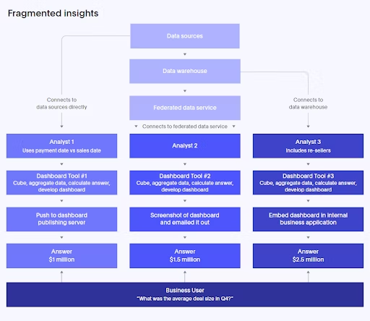
Impact  (GSM) | It’s not feasible to do the best analysis when dealing with 50,000 keywords and 5,000 pages - for instance, to determine which page is best to optimize for revenue targeting this quarter?
  Target 1 | Target 2
  Keyword: Merge PDF  Avg. Weighted Position = 3  SV Target = 10,000  CTR = 20%  CR = 0.08  Traffic = 2,000  Orders = 160  IF Avg. Weighted Position = 2  CTR = 30%  Traffic = 3,000  Orders = 240 | Keyword: Excel to PDF  Avg. Weighted Position = 6  SV Target = 80,000  CTR = 2%  CR = 0.03  Traffic = 1,600  Orders = 48  IF Avg. Weighted Position = 3  CTR = 20%  Traffic = 16,000  Orders = 480
Project  KPI Baselines | Qtr. Avg. Growth Opportunities (QAGO) Identified = 8  Qtr. Avg. Growth Opportunities (QAGO) Implemented = 4  Qtr. Avg. Growth Opportunities (QAGO) Performance Measured (SEO Revenue) = 2.5%
Solution  (GSM) | Build a data ecosystem to support more granular and actionable insights for management to utilize during strategy planning and delegation between partners, agencies, and key stakeholders.  Allowingfor a better view for actionable actions without heavy lifting and resource requirements - with more meaningful data sets, data, calculations and aggregations, data automation, and ML frameworks  Ecosystem Overview  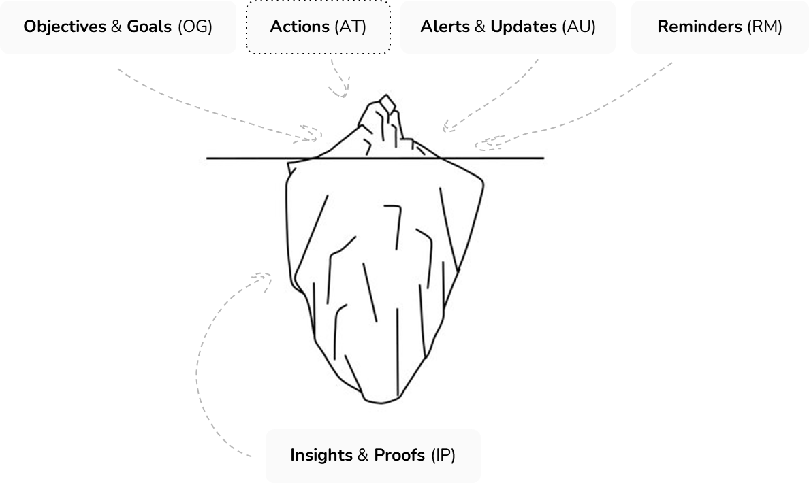  Case Example  Optimization Target: Domain Architecture (Internal Linking)  Keyword: “photo editing software”  Problem: What are the differences between our page and the competitor in position #1 for this keyword that we can act on this quarter?
  Variable | Pos. 1 Competitor | Adobe
  Total Internal Links | 125 | 24
  Total Internal Links (Perc.)  of CC Pages | 85% | 15%
  Total Internal Links (Perc.) of  A.com Pages | 40% | 0.12%
  Total Unique Relevant  Linked Pages (Perc.) | 88% | 10%
  Actionable Gap Identified
  Average Backlink Count of  Pages Linking Internally | 11.5 | 1.3
Value Add (ROI) | Data models will support business impact and ROI calculations based on investments and actions taken to measure incremental growth above baseline:  - Investments  - Content Development = $1,500  - Content Distribution = $40,000  - Actionable Insights Implementation  - Strategic Plan (Quarter) Integration  - Performance (Delayed)  - Assumptions - calculations made based on similar historical trends of revenue changes for related pages based on ranking changes
  Month | Revenue | Returns Net | ROI YTD | Avg.Pos | Upkeep
  1 | $15,000 | $0 | -$40K | 5 | -
  2 | $15,000 | $0 | -$40K | 5 | -
  3 | $25,000 | +$10K | -$30K | 4 | -
  4 | $15,000 | $0 | -$30K | 5 | -
  5 | $45,000 | +$30K | $0 | 3 | -
  6 | $25,000 | +$10K | +$10K | 4 | -
  7 | $45,000 | +$30K | +$30K | 3 | -$10K
  8 | $75,000 | +$60K | +$90K | 2
  9 | $75,000 | +$60K | +$120K | 2 | -$30K
  10 | $115,000 | +$100K | +$220K | 1
Product Requirements  (GSM) | People - Managers, IC, Leadership, Extended Teams  Optimization Segments - Technical Performance (Crawling, Indexation), Content Optimization, Domain Architecture (Internal Links) & Taxonomy, UX & Usability, Engagement & Conversions, Content Distribution & Backlinks (PR), Keyword Targeting & Optimization, Revenue & Acquisition Targets  1. Define the Project Objectives  - Collaborating closely with stakeholders to understand their needs and expectations.  - Aligning project objectives with the organization's overarching business goals.  - Break down the goals into specific, measurable, achievable, relevant, and time-bound (SMART) objectives.  - Objectives should outline the desired outcomes and performance metrics.  - Setting clear milestones and deadlines to measure progress.  - Clearly articulate the overarching goals of the data engineering project.  - Align goals with the organization’s broader objectives and strategic initiatives.  - Identifying the target audience for the project's data outputs  2. Scope Definition:  - Clearly outline the boundaries and extent of the project.  - Specify the data sources, systems, and processes that are within the project’s purview.  3. Data Collection Types:  - Specify the types of data to be collected, whether structured, semi-structured, or unstructured.  - Define the sources of data, such as databases, logs, APIs, or external datasets.  4. Business Problems to be Addressed:  - Identify and document the specific business challenges or opportunities that the project aims to tackle.  - Ensure alignment with organizational priorities and stakeholder needs.  4. Functional Requirements:  - Detail the functionalities and features that the data engineering solution should deliver.  - Align functional requirements with the identified objectives and business problems.  5. Non-functional Requirements:  - Define non-functional aspects such as performance, scalability, security, and reliability expectations.  - Consider factors like data quality, governance, and compliance requirements.  6. Constraints and Assumptions:  - Document any constraints, limitations, or assumptions that could impact the project’s execution.  - Be explicit about any constraints related to budget, time, or technology choices.  7. Stakeholder Identification:  - Identify and list all stakeholders involved in or affected by the data engineering process.  - Clearly define their roles, responsibilities, and expectations.  8. Risk Assessment:  - Conduct a preliminary risk assessment, identifying potential challenges and uncertainties.  - Develop strategies for mitigating or managing identified risks.  10. Project Deliverables:  - Outline the expected deliverables at each stage of the data engineering process.  - Ensure that deliverables align with the project objectives and stakeholder expectations.  Assess Data Sources and Requirements  - ‍Data Profiling: Profiling data to understand its structure, quality, and patterns is essential. This might involve identifying missing values, outliers, and data anomalies.‍  - Data Classification: Categorize data based on its sensitivity and regulatory compliance requirements. This is crucial for ensuring data privacy and security.‍  - Data Volume and Velocity: Understand the expected data growth rates and determine whether your chosen technology stack can handle the anticipated data volumes and velocity.‍  - Data Quality: Establish data quality metrics and data cleansing processes to rectify issues such as duplicate records and inconsistencies.  Choose the Right Technology Stack  - ‍Scalability: Choose technologies that can scale horizontally or vertically to accommodate growing data volumes.‍  - Cost: Analyze the cost implications of different technology choices, including licensing, hardware, and cloud infrastructure.‍  - Integration: Ensure that the selected tools and platforms can seamlessly integrate with your existing systems.‍  - Ecosystem: Consider the availability of third-party plugins, libraries, and community support.  Data Modeling and Schema Design  - ‍Entity-Relationship Diagrams (ERDs): Creating ERDs to visualize data entities and their relationships.  - ‍Normalization vs. Denormalization: Deciding whether to normalize data for data integrity or denormalize for improved query performance.  Develop Data Pipelines  - ‍ETL Framework: Choose an ETL framework that suits your data transformation needs, such as batch processing or real-time streaming.‍  - Data Transformation: Implement transformations to convert data into a format suitable for analytics. This might include aggregations, joins, or data enrichment.‍  - Data Orchestration: Develop a robust workflow for orchestrating data pipelines, ensuring that dependencies are managed efficiently.‍  - Error Handling: Plan for error handling and recovery mechanisms to maintain data pipeline reliability.
 | MVP → Keyword Optimization & Performance (KOP)
Engineering Requirements  (DEM) | Cross-Collaboration & Extended Management  - Data Engineering + extended w/ Data Science + Data Analytics + DevOps  Data Infrastructure Strategy Planning & Management  - Design, develop, implement, and translate business requirements and the overall organizational data strategy, including standards, principles, data sources, storage, pipelines, data flow, data processing, and data security/ governance policies  - Develop and maintain the technology stack (Airflow, Airbyte, Redshift, AWS Athena) to include commercial or open-source integration platforms  - Knowledge of enterprise architecture, systems architecture, integration architecture and data architecture standards, frameworks, and practices  - General Considerations  - Cloud-native architecture  - Data warehousing and data lakes  - Enterprise data needs  - Business intelligence and analytics tools  - Machine learning and AI tools  - Data governance and security  - Data Considerations  - Relational databases: Examples include MySQL, Oracle, Microsoft SQL Server, and PostgreSQL.  - Data warehouses: Examples include Amazon Redshift, Microsoft Azure Synapse Analytics, Snowflake, and Google BigQuery.  - Data lakes: Examples include Amazon S3, Microsoft Azure Data Lake Storage, and Google Cloud Storage.  - Graph databases: Examples include Neo4j, Amazon Neptune, and Microsoft Azure Cosmos DB.  - Object storage: Examples include Amazon S3, Microsoft Azure Blob Storage, and Google Cloud Storage.  - NoSQL databases: Examples include MongoDB, Cassandra, Couchbase, and Amazon DynamoDB.
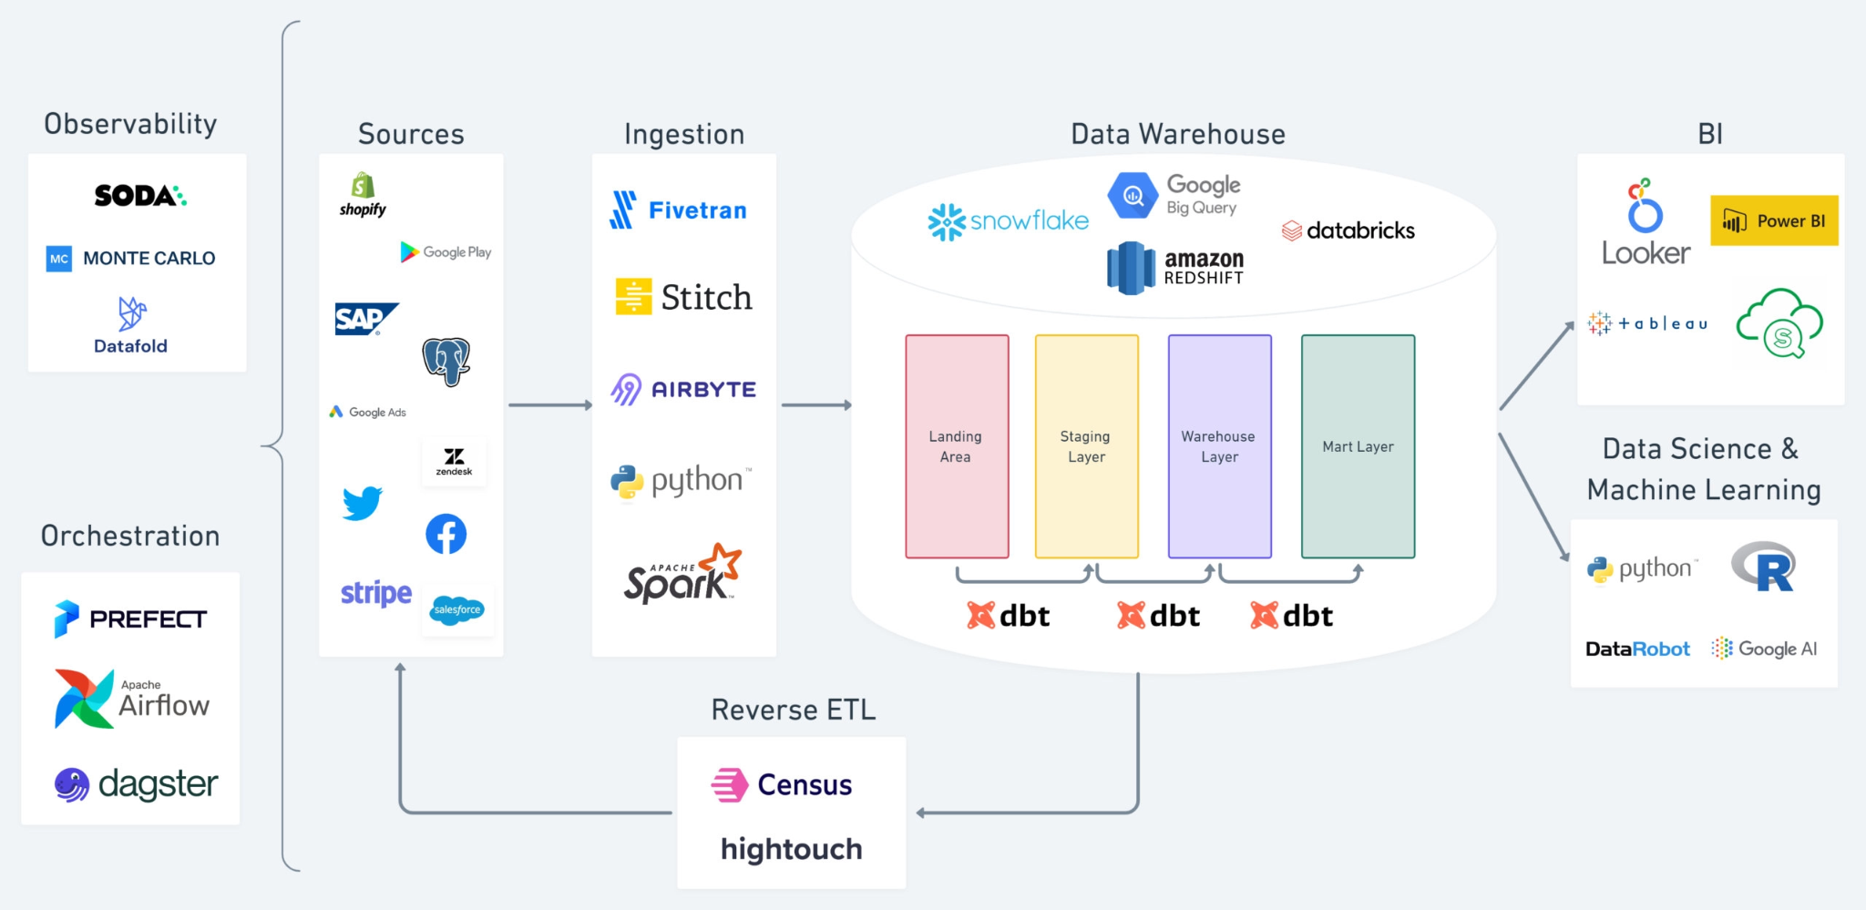
Architecture  Plan | Data Extraction (Ingestion)  - Python, 3rd-party endpoints (APIs)  Data Transformation  - AWS Glue → serverless and scalable solution + integration w/ Redshift  - Apache Spark → processing massive volumes of data in batch mode, exploratory data analysis (EDA) + data preprocessing  Data Staging (Pre-Load)  - S3 → data staging (accessibility purposes)  Data Loading ⇒ Warehousing  - Amazon Redshift → due to its scalability and speed with large datasets  - Database Schema → AWS Glue ETL  Data Visualisation  - Power BI, Adobe Analytics
Technical Decisions | - Choice of Data Storage:  - Decision: Selecting the type of data storage (data warehouse, data lake, or database) based on the project's needs.  - Factors: Data volume, velocity, variety, and the specific use cases (e.g., OLAP vs. OLTP, real-time processing).  - Data Modeling and Schema Design:  - Decision: Designing the data model and schema (e.g., star schema, snowflake schema, denormalized schema).  - Factors: Query performance, data relationships, and the nature of the analytical processes.  - Data Modeling and Schema Design:  - Decision: Designing the data model and schema (e.g., star schema, snowflake schema, denormalized schema).  - Factors: Query performance, data relationships, and the nature of the analytical processes.  - ETL Tools and Technologies:  - Decision: Choosing appropriate ETL tools or platforms (e.g., Apache NiFi, Talend, AWS Glue).  - Factors: Data volume, complexity of data transformations, integration capabilities, and ease of maintenance.  - Data Integration Strategy:  - Decision: Planning how to integrate data from various sources (APIs, databases, cloud storage, etc.).  - Factors: Data format consistency, integration frequency (batch vs. real-time), and data quality control.  - Data Processing Frameworks:  - Decision: Selecting data processing frameworks (e.g., Apache Spark, Apache Flink).  - Factors: Processing speed, fault tolerance, scalability, and in-memory processing needs.  - Cloud vs. On-Premises Infrastructure:  - Decision: Determining whether to use cloud-based services or on-premises solutions.  - Factors: Cost, scalability, security requirements, and existing organizational infrastructure.  - Scalability and Performance Optimization:  - Decision: Strategies for scaling (vertical vs. horizontal scaling) and performance optimization techniques.  - Factors: Expected data growth, workload patterns, and resource utilization efficiency.  - Automation and Orchestration:  - Decision: Automating ETL processes and workflow orchestration (e.g., using Apache Airflow).  - Factors: Complexity of data workflows, scheduling needs, and dependency management.  - Data Quality Management:  - Decision: Implementing data quality checks and validation processes.  - Factors: Data accuracy, consistency, and completeness requirements.
Trade-Offs & Alternatives | - On-Premise Self-Hosted Data Infrastructure → Apache Hive, Hadoop  - Reduce the need for extensive infrastructure management, making it easier to focus on data transformation and analytics  - Performance vs. Cost  - Trade-off: Balancing the need for high-performance systems against the costs associated with such solutions. High-performance computing resources, faster storage solutions, and advanced data processing tools can significantly increase the cost.  - Scalability vs. Complexity  - Trade-off: Designing systems that are highly scalable can introduce complexity in terms of maintenance, monitoring, and management.  - Example: Implementing a microservices architecture for data processing can offer great scalability but may increase system complexity compared to a monolithic approach.  - Consideration: The choice often depends on anticipated future growth and the organization's ability to manage complex systems. While scalability is crucial for long-term growth, it should not overly complicate the current operational capacity.  - Flexibility vs. Standardization  - Trade-off: Striking a balance between flexible data systems that can handle a wide variety of data types and sources, and standardized systems that are more uniform and easier to manage.  - Example: A flexible schema (like in a NoSQL database) can handle diverse data types but may lead to inconsistent data formats, whereas a rigid relational database schema enforces consistency but may lack flexibility.  - Consideration: The decision often hinges on the nature of the data being handled and the specific requirements of the business. Industries dealing with diverse and unstructured data may prioritize flexibility, while those with well-defined data types might opt for standardization.
Challenges & Failures | - Metrics Reporting → Inconsistency between reported metrics (revenue) based on channel attributions due to filtering  - Trust and Reputation: Inaccurate data can lead to customer dissatisfaction and harm the organization's reputation  - Resource Drain: A significant amount of time and resources may be spent cleansing and rectifying data, which is inefficient and costly  - User Frustration: Slow system performance can frustrate users and analysts, leading to reduced productivity
Successes | Project Data Accomplishment  - Data Availability, Accessibility, and Actionable Utility  Project KPI Targets & Actuals  - Qtr. Avg. Growth Opportunities (QAGO) Identified  - Baseline = 8 → Target = 12 → Actuals = 26  - Qtr. Avg. Growth Opportunities (QAGO) Implemented  - Baseline = 4 → Target = 7 → Actuals = 15
Lessons Learned | - DataOps for Improved Collaboration and Efficiency  - This includes version control, continuous integration/continuous deployment (CI/CD), and automated testing  - Data Quality and Consistency  - Implement robust data governance policies, employ data quality tools, and establish clear data standards and validation processes.
Retrospective Changes | - Define Data Ownership and Stewardship Roles  - Data Quality Tools  - Validation and Verification Processes  - Data Cataloging and Metadata Management

References
- https://baotramduong.medium.com/end-to-end-data-engineering-project-dc03f8b0fd54
- What Is The Modern Data Stack - Intro To Data Infrastructure Part 1 (youtube.com)

Notes

Adopted Pain Points & Challenges Addressed
- Lack of centralized business logic creates workflow bottlenecks and siloed data
- Business users don’t know where data in dashboards came from or how to interpret it
  - Data Lineage
- Data pipeline issues are discovered too late
- It’s difficult to deploy data pipelines and keep them updated over time

Questions
- What is the priority of building a pipeline?
- How will you design ETL pipelines for the model?
- What strategy will you adopt to implement new technology or process within your team?
  - Assessment and Needs Analysis
  - Set Clear Objectives
  - Involve Stakeholders
  - Research and Selection
  - Proof of Concept (PoC)
  - Create an Implementation Plan
  - Training and Education
  - Pilot Phase
  - Communication and Change Management
  - Continuous Feedback Loop
  - Documentation
  - Monitoring and Evaluation
  - Scalability and Optimization
  - Celebrate Successes
  - Feedback Integration
- Tell me about a time you encountered a challenge?
  - Challenge
    - Handling massive amounts of raw data - lack of calculated business metrics, actionable insights
    - Performance bottlenecks in our data processing pipelines
  - Identification
    - Profiling our existing ETL processes using tools like Apache Spark and analyzing query execution plans in our database. I identified several areas where we could optimize our data transformation and aggregation steps. Additionally, I worked closely with our infrastructure team to allocate more resources to our data processing clusters
  - Continuous Monitoring and Optimization
- How would you manage conflicting priorities?
  - Prioritization Framework
  - Communication
  - Business Goals Alignment
  - Flexibility
  - Data-Driven Decision-Making
  - Resource Allocation
  - Risk Assessment
  - Time Management
  - Delegation & Collaboration
- Do you have any experience with data modeling?
  - Relational Data Model
  - Document Data Model
  - Key-Value Data Model
  - Columnar Data Model
  - Graph Data Model
  - Time-Series Data Model
  - Object-Relational Data Model:
- Can you name the essential frameworks and applications for data engineers?
- Data Engineer
  - Development, testing, and maintenance of architectures.
  - Aligning the design with business requisites.
  - Data acquisition and development of data set processes.
  - Deploying machine learning and statistical models
  - Developing pipelines for various ETL operations and data transformation
  - Simplifying data cleansing and improving the de-duplication and building of data.
  - Identifying ways to improve data reliability, flexibility, accuracy, and quality.
- What is your approach to developing a new analytical product as a data engineer?
- What was the algorithm you used on a recent project?
- Have you ever transformed unstructured data into structured data?
- What is Data Modelling? Do you understand different Data Models?
- Can you list and explain the design schemas in Data Modelling?
- Which Python libraries would you utilize for proficient data processing?
- How can you deploy a big data solution?

Notes 3
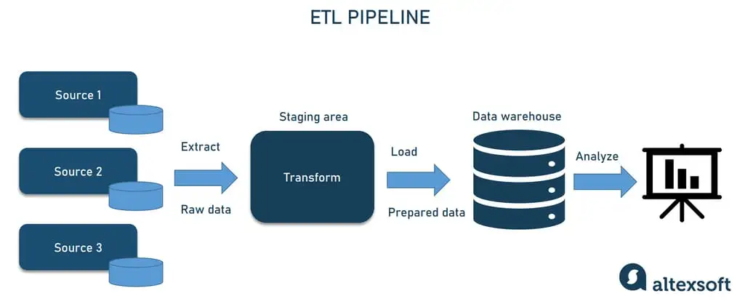
- Setting up secure and reliable data flow is challenging. Many things can go wrong during data transportation: Data can be corrupted, hit bottlenecks causing latency, or data sources may conflict, generating duplicate or incorrect data. Getting data into one place requires careful planning and testing to filter out junk data, eliminating duplicates and incompatible data types to obfuscate sensitive information while not missing critical data.

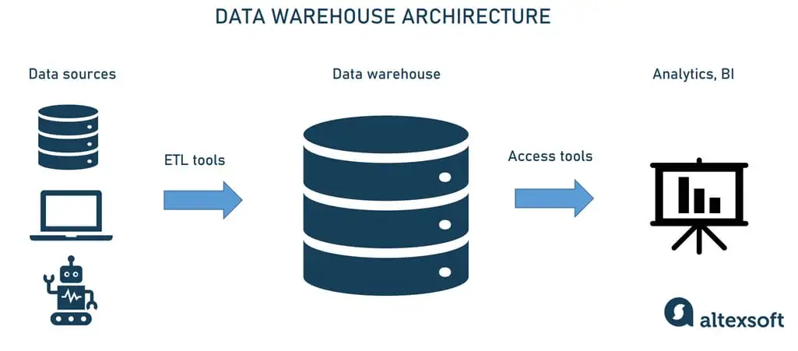

- Data warehouse storage - the foundation of data warehouse architecture is a database that stores all enterprise data allowing business users to access it to draw valuable insights.
- Data architects usually decide between on-premises and cloud-hosted DWs noting how the business can benefit from this or that solution. Although the cloud environment is more cost-efficient, easier to scale up or down, and isn’t limited to a prescribed structure, it may lose to on-prem solutions regarding querying speed and security. We’re going to list the most popular tools further on.
- A data architect can also design collective storage for your data warehouse – multiple databases running in parallel. This will improve the warehouse’s scalability.
- Metadata. Adding business context to data, metadata helps transform it into comprehensible knowledge. Metadata defines how data can be changed and processed. It contains information about any transformations or operations applied to source data while loading it into the data warehouse.

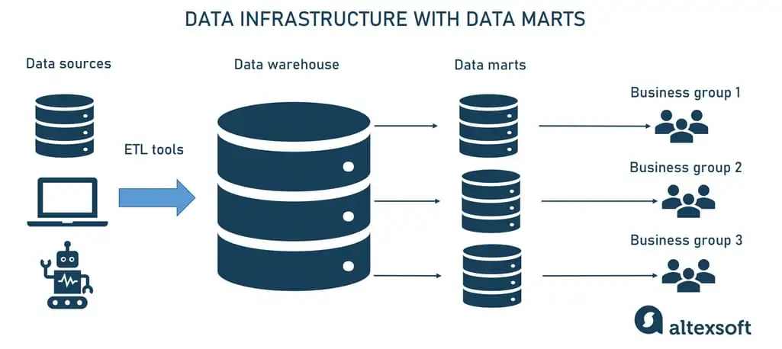

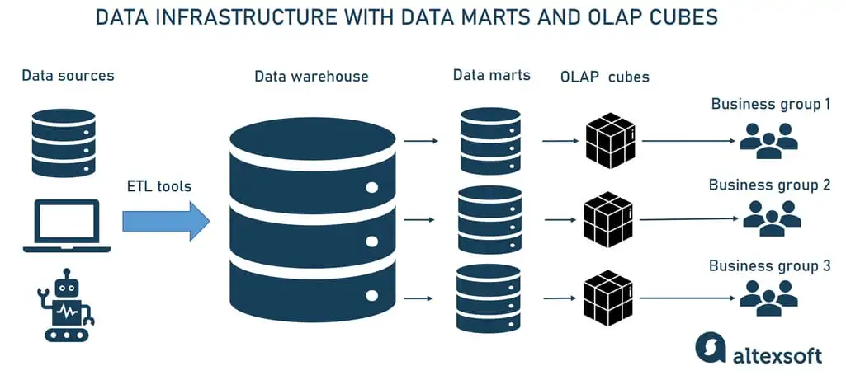

Notes 4
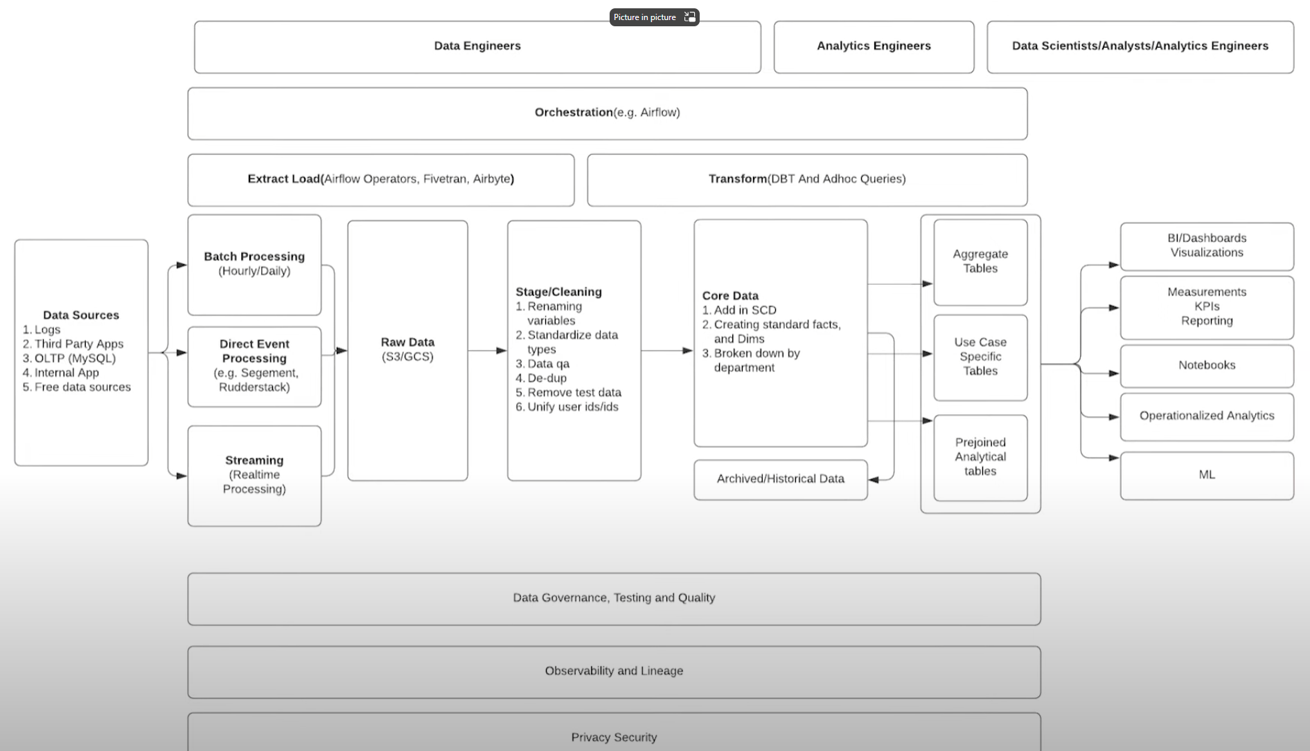

Notes 5
