**Day11_task**

**Create a docker file, file which when build must display your basic details in website**

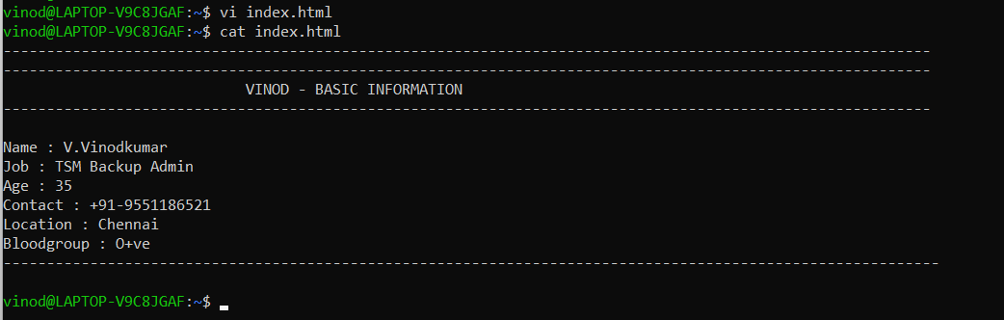

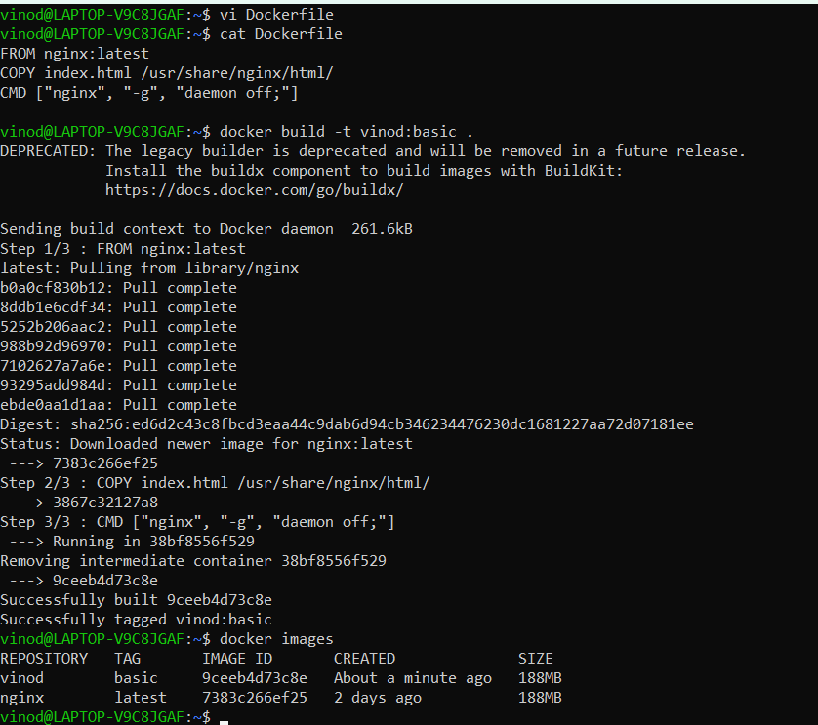



Now our output should be accessible at http://localhost:3008

