**Day12_task**

**Create a custom docker image for nginx and deploy it using docker compose, where the volume bind mount should be at /var/opt/nginx location. Push the created custom docker image to your docker-hub**

**Create the Dockerfile and Index.HTML:**

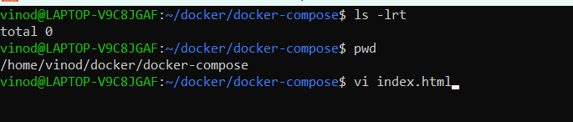

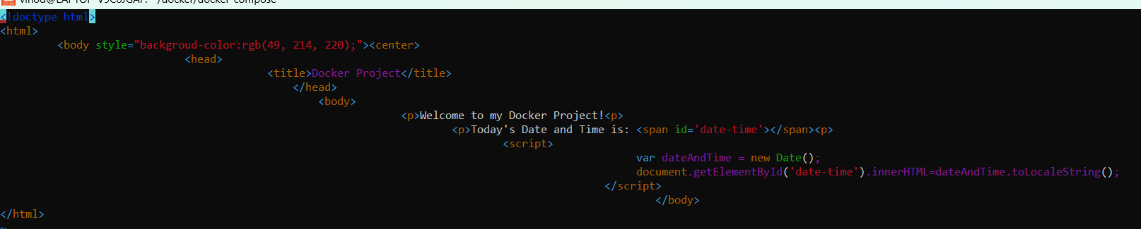

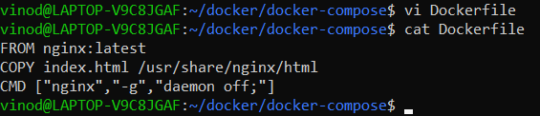

**Build the customized nginx image:**

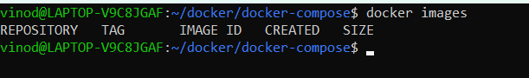

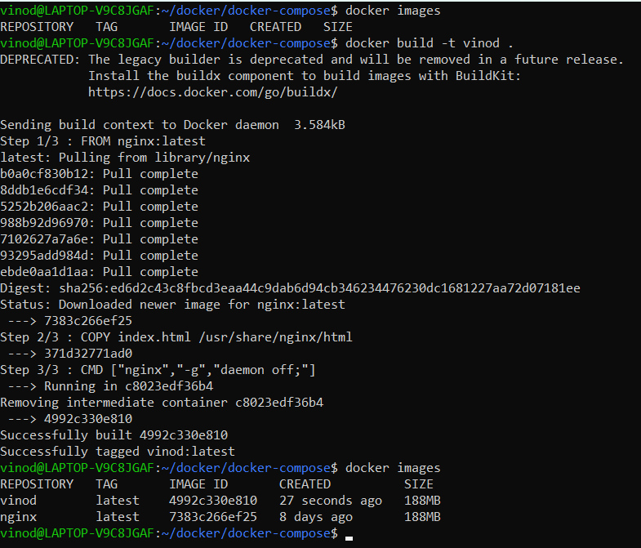

**Deploy the image using Docker-Compose and do volume bind mount at /var/opt/nginx location:**

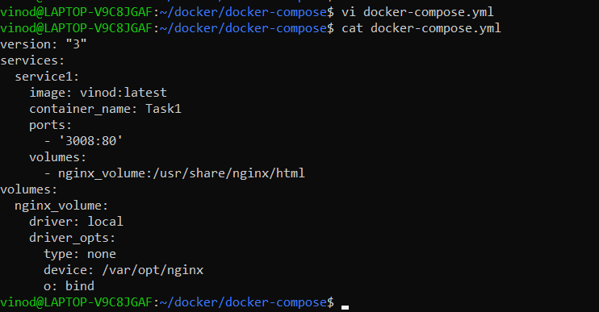

**Verifying volume and mount point status before deployment:**

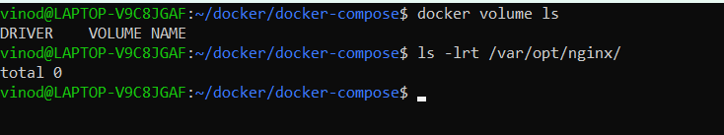

**Deploying customized image and mount point:**

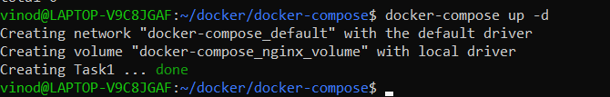

**Image deployed and container running fine:**



**Volume mount point created:**

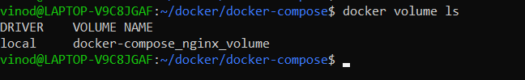

**Volume bind verification at /var/opt/nginx path:**

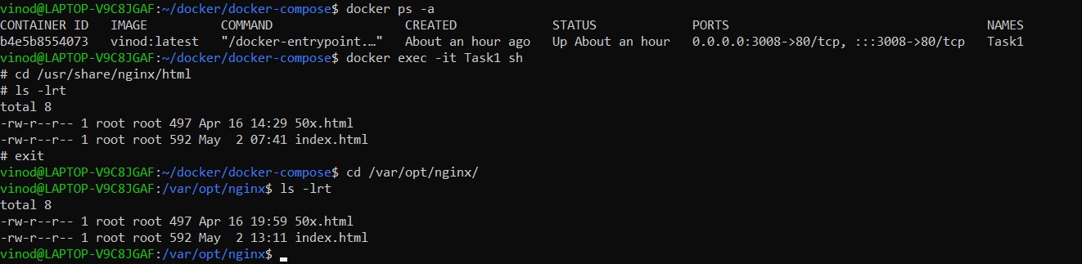

**Output of the customized nginx application:**

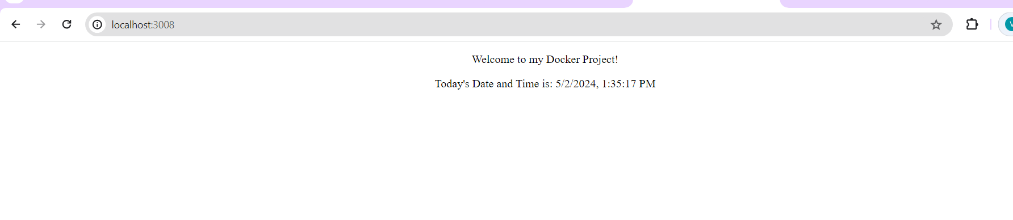

--------------------------------------------------------------------------------------------------------------------------------------

**Push the customized image from local system to docker hub:**

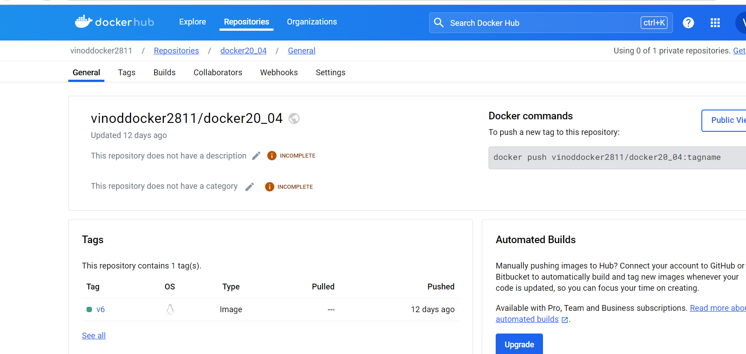

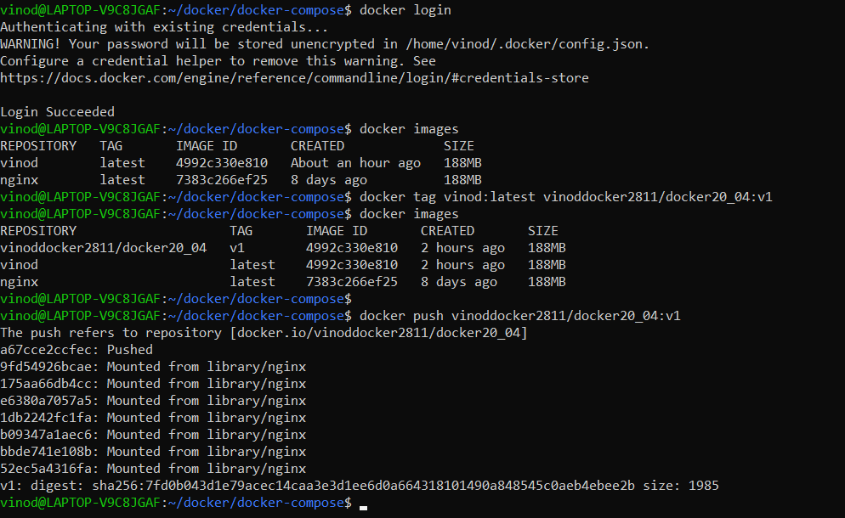

**Validation at Docker Hub:**

