Міністерство освіти і науки України

Національний технічний університет України

“Київський політехнічний інститут ім. Ігоря Сікорського”

Факультет інформатики та обчислювальної техніки

Кафедра автоматизованих систем обробки інформації та управління

ЗВІТ

про виконання лабораторного практикуму №1

Виконав:

студент 1- го курсу ФІОТ

групи *ІП-91*

*Кінчур Вадим Вікторович*

Київ 2020

1. 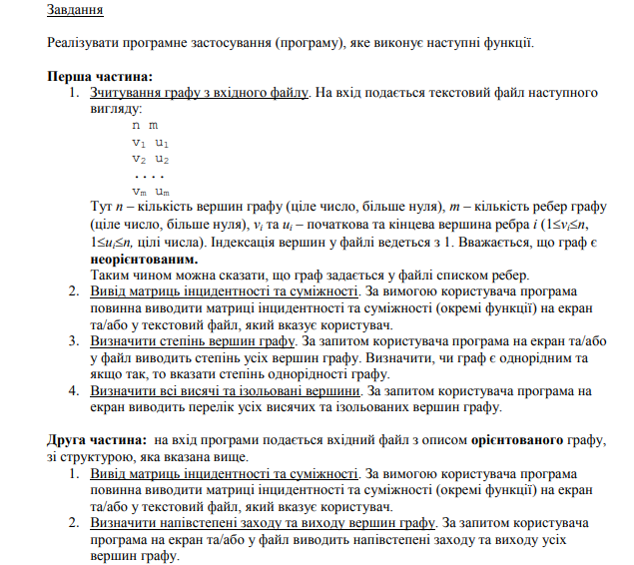Умова лабораторної роботи.
2. Програмний код (Python):

from copy import copy  
  
  
class Graph:  
 def __init__(self, n, m, edges_list): # Constructor of graph  
 self._n = n  
 self._m = m  
 self._edges_list = copy(edges_list)  
  
 def __get_adjacency_matrix(self):  
 pass  
  
 def __get_incidence_matrix(self):  
 pass  
  
 def __enter_number(self):  
 pass  
  
 def __show_menu(self):  
 pass  
  
 def start_menu(self):  
 pass  
  
 def __work_with_number(self, number):  
 pass  
  
  
class NotDirectedGraph(Graph):  
  
 def __get_vertex_degrees(self): # Get degree of each vertex  
 incidence_degree = [0] * self._n  
 for start, finish in self._edges_list:  
 incidence_degree[start - 1] += 1  
 incidence_degree[finish - 1] += 1  
 return incidence_degree  
  
 def __get_isolated_vertices(self): # Return isolated vertices  
 vertex_degree = self.__get_vertex_degrees()  
 isolated_vertices = []  
 for i in range(len(vertex_degree)):  
 if vertex_degree[i] == 0:  
 isolated_vertices.append(i + 1)  
 return isolated_vertices  
  
 def __get_hanging_vertices(self): # Return hanging vertices  
 vertex_degree = self.__get_vertex_degrees()  
 hanging_vertices = []  
 for i in range(len(vertex_degree)):  
 if vertex_degree[i] == 1:  
 hanging_vertices.append(i + 1)  
 return hanging_vertices  
  
 def __get_adjacency_matrix(self): # Return adjacency matrix  
 adj_matrix = [[0 for i in range(self._n)] for j in range(self._n)]  
 for start, finish in self._edges_list:  
 adj_matrix[start - 1][finish - 1] = 1  
 adj_matrix[finish - 1][start - 1] = 1  
 return adj_matrix  
  
 def __get_incidence_matrix(self): # Return incidence matrix  
 inc_matrix = [[0 for i in range(self._m)] for j in range(self._n)]  
 edge_number = 0  
 for edge in self._edges_list:  
 start, finish = edge[0] - 1, edge[1] - 1  
 inc_matrix[start][edge_number] = 1  
 inc_matrix[finish][edge_number] = 1  
 edge_number += 1  
 return inc_matrix  
  
 def __is_regular(self): # Check graph for regulating  
 vertex_degrees = self.__get_vertex_degrees()  
 for value in vertex_degrees:  
 if value != vertex_degrees[0]:  
 return 0  
 return 1  
  
 def __get_regular_degree(self): # Return regular degree  
 vertex_degrees = self.__get_vertex_degrees()  
 return vertex_degrees[0]  
  
 def __enter_number(self): # Enter and check number  
 answer = 0  
 while answer > 5 or answer < 1:  
 answer = input("Type your choice : ")  
 if answer.isdigit():  
 answer = int(answer)  
 else:  
 answer = 0  
 if answer > 5 or answer < 1:  
 print("Invalid input!")  
 return answer  
  
 def __work_with_number(self, number): # Process number  
 if number == 1:  
 print_matrix(self.__get_incidence_matrix())  
 elif number == 2:  
 print_matrix(self.__get_adjacency_matrix())  
 elif number == 3:  
 print(*self.__get_vertex_degrees())  
 elif number == 4:  
 hanging_vertices = self.__get_hanging_vertices()  
 isolated_vertices = self.__get_isolated_vertices()  
 if hanging_vertices:  
 print("Hanging vertices :", *hanging_vertices)  
 else:  
 print("Graph does not have hanging vertices!")  
 if isolated_vertices:  
 print("Isolated vertices :", *isolated_vertices)  
 else:  
 print("Graph does not have isolated vertices")  
 elif number == 5:  
 if self.__is_regular():  
 print("Graph is regular!\nRegular degree is equal to", self.__get_regular_degree())  
 else:  
 print("Graph is not regular!")  
  
 def __show_menu(self): # Show menu  
 print("Choose one of the following : ")  
 print("""  
 1 - show incidence matrix  
 2 - show adjacency matrix  
 3 - show degree of each vertex  
 4 - show hanging and isolated vertices  
 5 - check graph for regularity """)  
  
 def start_menu(self): # Start work with graph  
 self.__show_menu()  
 self.__work_with_number(self.__enter_number())  
  
  
class DirectedGraph(Graph):  
  
 def __get_adjacency_matrix(self): # Return adjacency matrix  
 adj_matrix = [[0 for i in range(self._n)] for j in range(self._n)]  
 for start, finish in self._edges_list:  
 adj_matrix[start - 1][finish - 1] = 1  
 return adj_matrix  
  
 def __get_incidence_matrix(self): # Return incidence matrix  
 inc_matrix = [[0] * len(self._edges_list) for j in range(self._n)]  
 edge_number = 0  
 for edge in self._edges_list:  
 start, finish = edge[0] - 1, edge[1] - 1  
 if start == finish:  
 inc_matrix[start][edge_number] = 2  
 else:  
 inc_matrix[start][edge_number] = -1  
 inc_matrix[finish][edge_number] = 1  
 edge_number += 1  
 return inc_matrix  
  
 def __get_half_in_degrees(self): # Get in-degree of each vertex  
 half_in_degrees = [0] * self._n  
 for start, finish in self._edges_list:  
 half_in_degrees[finish - 1] += 1  
 return half_in_degrees  
  
 def __get_half_out_degrees(self): # Get out-degree of each vertex  
 half_out_degrees = [0] * self._n  
 for start, finish in self._edges_list:  
 half_out_degrees[start - 1] += 1  
 return half_out_degrees  
  
 def __show_menu(self): # Show menu  
 print("Choose one of the following : ")  
 print("""  
 1 - show incidence matrix  
 2 - show adjacency matrix  
 3 - show in-degrees and out-degrees of each vertex """)  
  
 def __enter_number(self): # Enter and check number  
 answer = 0  
 while answer > 3 or answer < 1:  
 answer = input("Type your choice : ")  
 if answer.isdigit():  
 answer = int(answer)  
 else:  
 answer = 0  
 if answer > 3 or answer < 1:  
 print("Invalid input!")  
 return answer  
  
 def __work_with_number(self, number): # Process number  
 if number == 1:  
 print_matrix(self.__get_incidence_matrix())  
 elif number == 2:  
 print_matrix(self.__get_adjacency_matrix())  
 elif number == 3:  
 print("In - degrees :", *self.__get_half_in_degrees())  
 print("Out - degrees :", *self.__get_half_out_degrees())  
  
 def start_menu(self): # Start work with number  
 self.__show_menu()  
 self.__work_with_number(self.__enter_number())  
  
  
def parse_row(string): # Parse row of input data  
 return tuple(map(int, string.split()))  
  
  
def get_input(file_name): # Get data from input file  
 edges_list = []  
 with open(file_name, "r") as input_file:  
 vertex, edges = parse_row(input_file.readline())  
 data = input_file.readlines()  
 for line in data:  
 if line != '\n':  
 edges_list.append(parse_row(line))  
 return vertex, edges, edges_list  
  
  
def print_matrix(matrix): # Print matrix  
 for row in matrix:  
 for i in row:  
 print("{:>3}".format(i), end=" ")  
 print()  
  
  
def main(): # Start of program  
 vertices_amount, edges_amount, edges_list = get_input("input.txt")  
 while 1:  
 type_of_graph = input("Is graph directed?(y/n) : ")  
 if type_of_graph == "y":  
 graph = DirectedGraph(vertices_amount, edges_amount, edges_list)  
 else:  
 graph = NotDirectedGraph(vertices_amount, edges_amount, edges_list)  
 graph.start_menu()  
 if input("If you want to exit type 'exit' else press any key...") == 'exit':  
 break  
  
  
main()

1. Результати виконання:

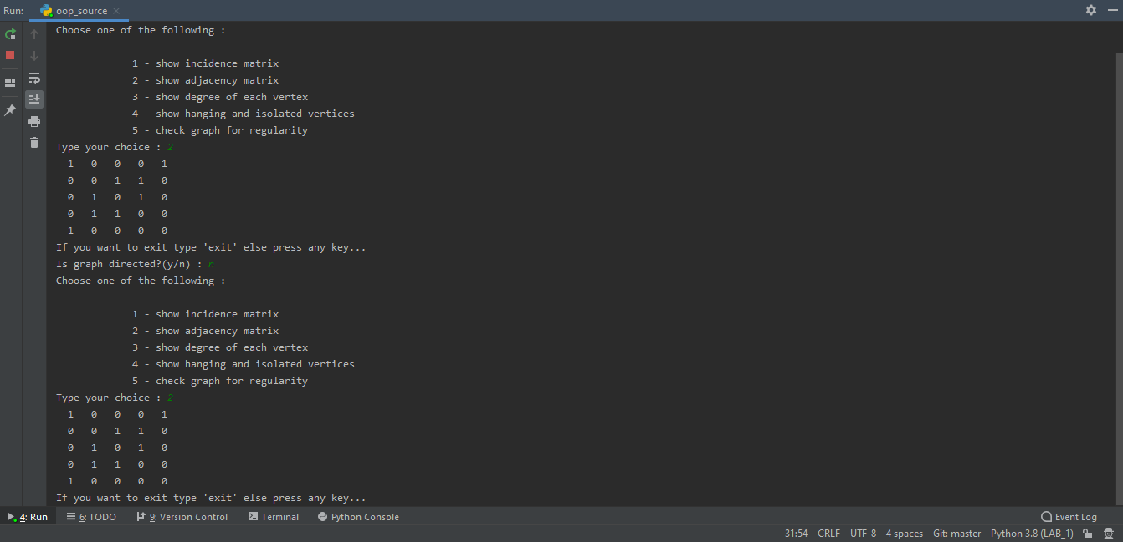

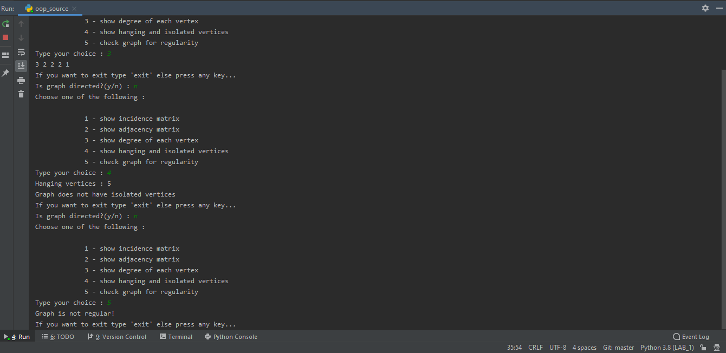

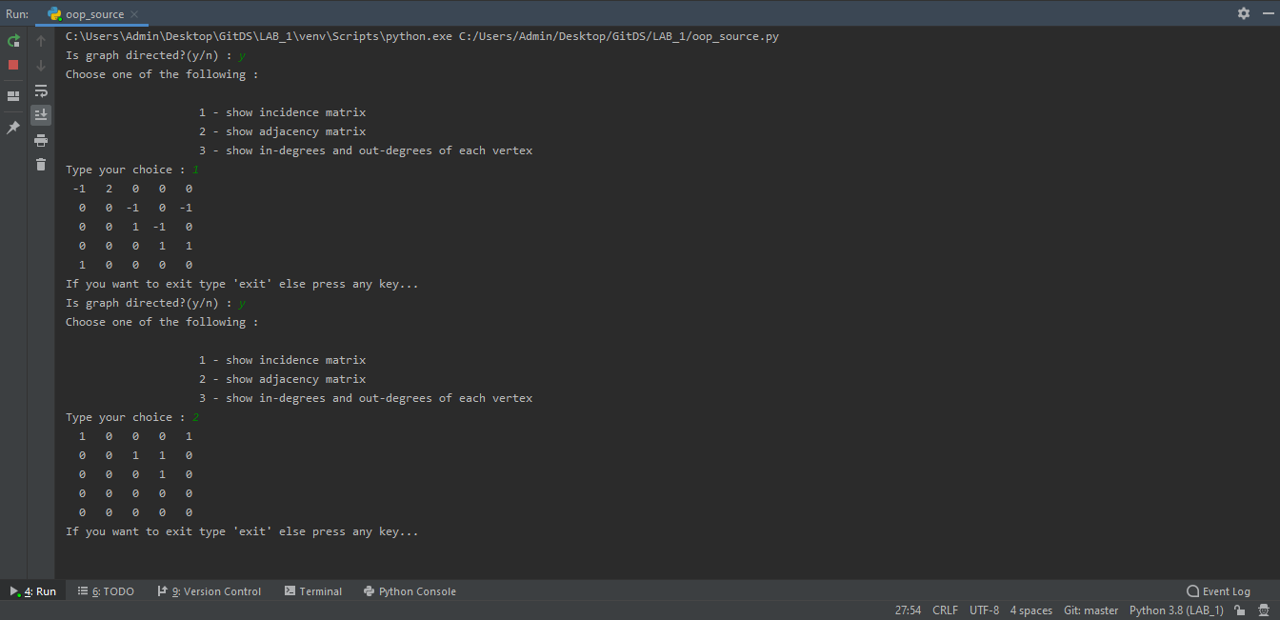

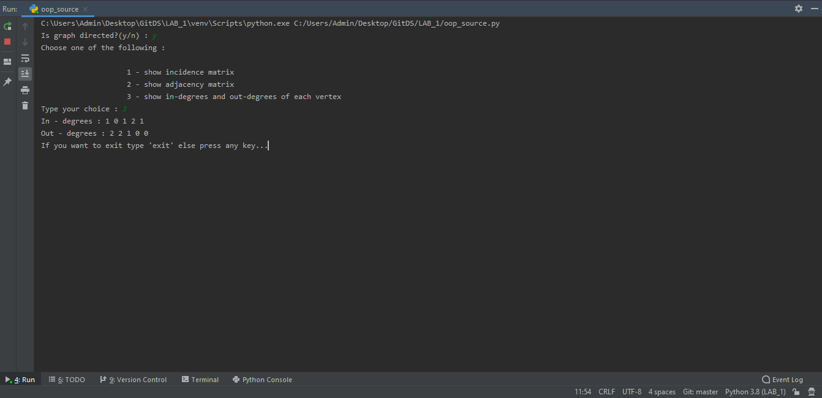

**Вхідний файл:**

5 4  
1 5  
1 1  
2 3  
3 4  
2 4