Міністерство освіти і науки України

Національний технічний університет України

“Київський політехнічний інститут ім. Ігоря Сікорського”

Факультет інформатики та обчислювальної техніки

Кафедра автоматизованих систем обробки інформації та управління

ЗВІТ

про виконання лабораторного практикуму №4(2)

Виконав:

студент 1- го курсу ФІОТ

групи *ІП-91*

*Кінчур Вадим Вікторович*

Київ 2020

2. Умова лабораторної роботи

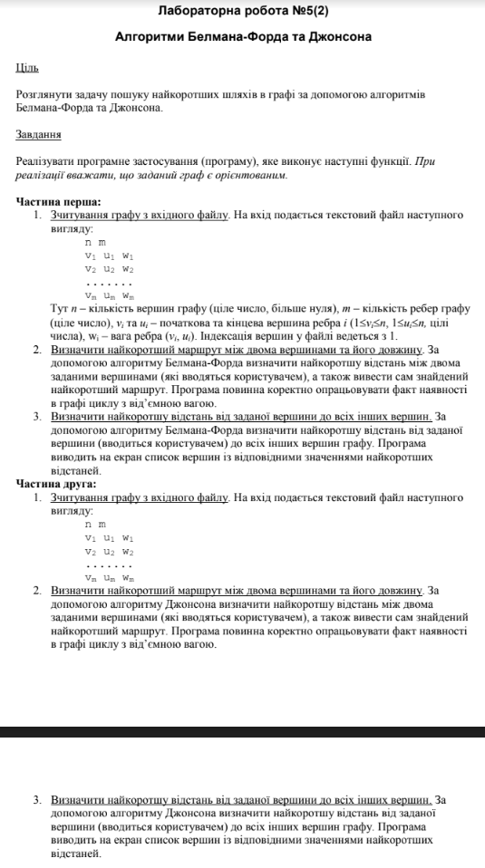

4. Програмний код (С++):

#include <ostream>

#include <iostream>

#include <fstream>

#include <list>

#include <iostream>

#include <iomanip>

#include <queue>

#include <fstream>

const int INF = INT16_MAX;

struct dest_edge {

int destination;

int weight;

dest_edge(int destination, int weight) {

this->destination = destination;

this->weight = weight;

}

};

struct edge {

int start, end, weight;

edge(int start, int end, int weight) {

this->start = start;

this->end = end;

this->weight = weight;

}

};

class Graph

{

private:

std::list<dest_edge>* dest_adj_list;

std::list<edge> adj_list;

int vertex_number;

int** adj_matrix;

void fill_adj_matrix();

public:

Graph(int);

Graph(Graph&);

~Graph();

void rebuilt();

void add_edge(int, int, int);

int** get_adj_matrix();

bool contains_negative_edges();

friend class Algorithm;

};

struct bellman_result {

int* dist = nullptr;

int* path = nullptr;

};

struct johnson_result {

int** dist_m = nullptr;

int** path_m = nullptr;

};

struct dijkstra_result {

int* dist = nullptr;

int* path = nullptr;

};

class Algorithm {

private:

static std::ostream* out;

static bellman_result bellman(Graph&, int);

static void print_path(int*, int, int);

static dijkstra_result dijkstra(Graph&, int);

static johnson_result johnson(Graph&);

static void print_path_between(Graph&, int, int);

static void print_all_paths(Graph&, int);

static void print_johnson_between(Graph&, int, int);

static void print_all_johnson_paths(Graph&);

template<typename T>

static void delete_matrix(T**, const int);

template<typename T>

static void print_matrix(T**, const int, const int);

static void do_work(Graph&);

static void show_menu();

public:

static void start_menu(Graph&);

};

int main() {

std::ifstream file_handler("input.txt");

int vertex_number, edges_number;

file_handler >> vertex_number >> edges_number;

Graph graph(vertex_number);

for (auto i = 0; i < edges_number; ++i) {

int start, end, weight;

file_handler >> start >> end >> weight;

graph.add_edge(start, end, weight);

}

file_handler.close();

Algorithm::start_menu(graph);

}

Graph::Graph(int vertex_number) {

this->vertex_number = vertex_number;

fill_adj_matrix();

dest_adj_list = new std::list<dest_edge>[vertex_number];

}

Graph::Graph(Graph& graph) {

vertex_number = graph.vertex_number;

fill_adj_matrix();

dest_adj_list = new std::list<dest_edge>[vertex_number];

for (auto i = 0; i < vertex_number; ++i) {

for (auto j = 0; j < vertex_number; ++i) {

if (graph.adj_matrix[i][j] != INF) {

add_edge(i + 1, j + 1, adj_matrix[i][j]);

}

}

}

}

Graph::~Graph() {

delete[] dest_adj_list;

for (auto i = 0; i < vertex_number; ++i)

delete[] adj_matrix[i];

delete[] adj_matrix;

}

void Graph::rebuilt() {

for (auto i = 0; i < vertex_number; ++i) {

dest_adj_list[i].clear();

}

for (auto& el : adj_list) {

if (el.start < vertex_number) {

dest_adj_list[el.start].push_back(dest_edge(el.end, el.weight));

adj_matrix[el.start][el.end] = el.weight;

}

}

}

void Graph::add_edge(int start, int end, int weight) {

dest_adj_list[start - 1].push_back(dest_edge(end - 1, weight));

adj_list.push_back(edge(start - 1, end - 1, weight));

adj_matrix[start - 1][end - 1] = weight;

}

int** Graph::get_adj_matrix() {

return adj_matrix;

}

bool Graph::contains_negative_edges()

{

for (auto el : adj_list) {

if (el.weight < 0)

return true;

}

return false;

}

void Graph::fill_adj_matrix() {

adj_matrix = new int* [vertex_number];

for (auto i = 0; i < vertex_number; ++i)

adj_matrix[i] = new int[vertex_number];

for (auto i = 0; i < vertex_number; ++i) {

for (auto j = 0; j < vertex_number; ++j) {

adj_matrix[i][j] = INF;

}

}

}

std::ostream* Algorithm::out;

template<typename T>

void Algorithm::print_matrix(T** matrix, const int row_size, const int col_size) {

for (auto i = 0; i < row_size; ++i) {

for (auto j = 0; j < col_size; ++j) {

if (matrix[i][j] != INF)

* out << std::setw(4) << matrix[i][j];

else

*out << std::setw(4) << '?';

}

*out << '\n';

}

}

template<typename T>

void Algorithm::delete_matrix(T** matrix, const int row_size) {

for (auto i = 0; i < row_size; ++i) delete[] matrix[i];

delete[] matrix;

}

bellman_result Algorithm::bellman(Graph& graph, int start)

{

bellman_result result;

const int n = graph.vertex_number;

int* dist = new int[n];

int* prev = new int[n];

for (auto i = 0; i < n; ++i) {

dist[i] = INF;

prev[i] = -1;

}

dist[start] = 0;

for (auto i = 0; i < n - 1; ++i) {

for (auto& edge_ : graph.adj_list) {

int u = edge_.start, v = edge_.end;

if (dist[v] > dist[u] + edge_.weight && dist[u] != INF) {

dist[v] = dist[u] + edge_.weight;

prev[v] = u;

}

}

}

for (auto& el : graph.adj_list) {

if (dist[el.end] != INF && dist[el.end] > dist[el.start] + el.weight) {

delete[] dist;

delete[] prev;

return result;

}

}

result.dist = dist;

result.path = prev;

return result;

}

void Algorithm::print_path(int* path, int start, int end) {

auto current = end - 1;

std::list<int> way;

while (current != start - 1) {

way.push_front(current + 1);

current = path[current];

}

way.push_front(start);

for (auto el : way) {

if (el != way.back())* out << el << "->";

else *out << el;

}

}

void Algorithm::print_path_between(Graph& graph, int start, int end) {

auto result = bellman(graph, start - 1);

if (result.dist == nullptr) {

*out << "Graph contains negative cycles!\n";

return;

}

if (result.dist[end - 1] != INF) {

*out << "The distance between vertices is equal to " << result.dist[end - 1] << '\n';

print_path(result.path, start, end);

}

else {

*out << "The path doesn`t exist!\n";

}

delete[] result.dist;

delete[] result.path;

}

void Algorithm::print_all_paths(Graph& graph, int start) {

auto result = bellman(graph, start - 1);

if (result.dist == nullptr) {

*out << "Graph contains negative cycles!\n";

return;

}

for (auto i = 0; i < graph.vertex_number; ++i) {

if (i != start - 1) {

if (result.dist[i] == INF) {

*out << "The distance between " << start << " and " << i + 1 << " is equal to infinity\n";

}

else {

*out << "The distance between " << start << " and " << i + 1 << " is equal to "

<< result.dist[i] << '\n';

}

}

}

delete[] result.dist;

delete[] result.path;

}

dijkstra_result Algorithm::dijkstra(Graph& graph, int start)

{

struct compare {

bool operator()(dest_edge& a, dest_edge& b) const {

return a.weight > b.weight;

}

};

dijkstra_result result;

int* dist = new int[graph.vertex_number];

int* path = new int[graph.vertex_number];

std::priority_queue<dest_edge, std::vector<dest_edge>, compare> que;

for (auto i = 0; i < graph.vertex_number; ++i) {

dist[i] = INF;

path[i] = -1;

}

que.push(dest_edge(start, 0));

dist[start] = 0;

while (!que.empty()) {

auto u = que.top().destination; que.pop();

for (auto& el : graph.dest_adj_list[u]) {

if (dist[el.destination] > dist[u] + el.weight) {

dist[el.destination] = dist[u] + el.weight;

path[el.destination] = u;

que.push(el);

}

}

}

result.dist = dist;

result.path = path;

return result;

}

johnson_result Algorithm::johnson(Graph& graph) {

Graph new_graph(graph.vertex_number + 1);

for (auto& el : graph.adj_list)

new_graph.add_edge(el.start + 1, el.end + 1, el.weight);

for (auto i = 0; i < graph.vertex_number; ++i)

new_graph.add_edge(graph.vertex_number + 1, i + 1, 0);

const int n = graph.vertex_number;

johnson_result res;

int** dist_m = new int* [n];

int** path_m = new int* [n];

auto bellman_res = bellman(new_graph, n);

if (bellman_res.dist == nullptr) {

delete[] dist_m;

delete[] path_m;

return res;

}

auto h = bellman_res.dist;

--new_graph.vertex_number;

for (auto& el : new_graph.adj_list) {

if (el.start != n)

{

el.weight += h[el.start] - h[el.end];

}

}

new_graph.rebuilt();

for (auto i = 0; i < n; ++i) {

auto result = dijkstra(new_graph, i);

dist_m[i] = result.dist;

path_m[i] = result.path;

}

for (auto i = 0; i < n; ++i) {

for (auto j = 0; j < n; ++j) {

if (dist_m[i][j] != INF) {

dist_m[i][j] += h[j] - h[i];

}

}

}

res.dist_m = dist_m;

res.path_m = path_m;

return res;

}

void Algorithm::print_johnson_between(Graph& graph, int start, int end) {

auto result = johnson(graph);

if (result.dist_m == nullptr) {

*out << "Graph contains negative cycle!\n";

return;

}

const int n = graph.vertex_number;

if (result.dist_m[start - 1][end - 1] != INF) {

*out << "The distance between vertices is equal to " << result.dist_m[start - 1][end - 1] << '\n';

print_path(result.path_m[start - 1], start, end);

}

else {

*out << "The path doesn`t exist!\n";

}

delete_matrix(result.dist_m, n);

delete_matrix(result.path_m, n);

}

void Algorithm::print_all_johnson_paths(Graph& graph) {

auto result = johnson(graph);

if (result.dist_m == nullptr) {

*out << "Graph contains negative cycle!\n";

return;

}

const int n = graph.vertex_number;

*out << "Distance matrix : \n";

print_matrix(result.dist_m, n, n);

delete_matrix(result.path_m, n);

delete_matrix(result.dist_m, n);

}

void Algorithm::do_work(Graph& graph) {

int input = -1, start, end;

while (input < 1 || input > 4) {

std::cout << "\nType your choice : ";

std::cin >> input;

}

switch (input)

{

case 1:

std::cout << "Print vertices to find path for : ";

std::cin >> start >> end;

print_path_between(graph, start, end);

break;

case 2:

std::cout << "Type the start vertex : ";

std::cin >> start;

print_all_paths(graph, start);

break;

case 3:

std::cout << "Type vertices to find path for : ";

std::cin >> start >> end;

print_johnson_between(graph, start, end);

break;

case 4:

print_all_johnson_paths(graph);

break;

}

}

void Algorithm::show_menu() {

std::cout << "Choose one of the next options : \n";

std::cout << "1 - Find shortest path between two vertices with Ford - Bellman algorithm\n"

<< "2 - Find shortest paths from source to other vertices with Ford - Bellman algorithm\n"

<< "3 - Find shorted path between vertices with Johnson algorithm\n"

<< "4 - Show shortest paths between all vertices with Johnson - Algorithm algorithm\n";

}

void Algorithm::start_menu(Graph& graph) {

std::cout << "Do you want to work with file or console?(file/console)\n";

std::string answer;

std::cin >> answer;

std::ofstream file;

if (answer == "file") {

std::cout << "Type the name of the file :\n";

std::string file_name;

std::cin >> file_name;

file.open(file_name, std::ios::out);

out = &file;

}

else out = &std::cout;

while (answer != "exit") {

show_menu();

do_work(graph);

*out << "\n";

std::cout << "If you to exit print \'exit\' else press any key ...\n";

std::cin >> answer;

*out << '\n';

}

file.close();

}

4. Результати виконання:

**Вхідні дані**

4 8

1 2 -2

1 3 3

1 4 -3

2 3 2

3 4 -3

4 1 4

4 2 5

4 3 5

