Міністерство освіти і науки України

Національний технічний університет України

“Київський політехнічний інститут ім. Ігоря Сікорського”

Факультет інформатики та обчислювальної техніки

Кафедра автоматизованих систем обробки інформації та управління

ЗВІТ

про виконання лабораторного практикуму №9

Виконав:

студент 1- го курсу ФІОТ

групи *ІП-91*

*Кінчур Вадим Вікторович*

Київ 2020

1. Умова лабораторної роботи

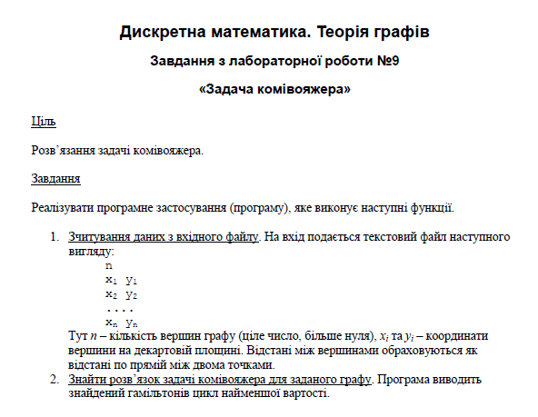

1. Програмний код (Python)

# Modules  
from math import hypot  
from copy import copy  
from math import ceil  
  
# Const  
INF = float('inf')  
  
  
# Static methods  
def get_input(file_name):  
 with open(file_name, 'r') as file_handler:  
 v_num = int(file_handler.readline())  
 return [tuple(map(int, line.split())) for line in file_handler.readlines()]  
  
  
# Calculate distance between points  
def get_distance(p1, p2):  
 return hypot(p1[0] - p2[0], p1[1] - p2[1])  
  
  
# Get n order minimal element in array  
def n_min(arr, n):  
 return sorted(arr)[n - 1]  
  
  
# Form adjacency matrix  
def get_adj_matrix(points):  
 v_num = len(points)  
 adj_m = [[INF] * v_num for _ in range(v_num)]  
 for i in range(v_num):  
 for j in range(v_num):  
 if i != j:  
 adj_m[i][j] = get_distance(points[i], points[j])  
 return adj_m  
  
  
# Class for solving TSP problem  
class Solver:  
 def __init__(self, adj_m):  
 self._adj_m = copy(adj_m)  
 self._cost = INF  
 self._v_num = len(adj_m)  
 self._path = [-1] * (self._v_num + 1)  
 self._visited = [False] * self._v_num  
  
 # Save temporary solution  
 def __copy_path(self, curr_path):  
 self._path[:self._v_num + 1] = copy(curr_path)  
 self._path[self._v_num] = curr_path[0]  
  
 # Do main work  
 def __TSPRecursive(self, curr_bound, curr_cost, level, curr_path):  
 # Form answer on last level  
 if level == self._v_num:  
 curr_result = curr_cost + self._adj_m[curr_path[-1]][curr_path[0]]  
 if curr_result < self._cost:  
 self.__copy_path(curr_path)  
 self._cost = curr_result  
 return  
 # Else form new tree on this level  
 for i in range(self._v_num):  
 if not self._visited[i]:  
 temp_bound = curr_bound  
 curr_cost += self._adj_m[curr_path[level - 1]][i]  
 if level == 1:  
 curr_bound -= (n_min(self._adj_m[curr_path[0]], 1) + n_min(self._adj_m[i], 1)) / 2  
 else:  
 curr_bound -= (n_min(self._adj_m[curr_path[0]], 2) + n_min(self._adj_m[i], 1)) / 2  
 # If found new minimal  
 if curr_bound + curr_cost < self._cost:  
 self._visited[i] = True  
 curr_path[level] = i  
 self.__TSPRecursive(curr_bound, curr_cost, level + 1, curr_path)  
 # Else backtrack and reset all changes  
 curr_cost -= self._adj_m[curr_path[level - 1]][i]  
 curr_bound = temp_bound  
 self._visited = [False] * self._v_num  
 for index in range(self._v_num):  
 if curr_path[index] != -1:  
 self._visited[index] = True  
  
 # Form answer  
 def __TSP(self):  
 curr_bound = 0  
 curr_path = [-1] * (self._v_num + 1)  
 visited = [False] * self._v_num  
  
 for row in self._adj_m:  
 curr_bound += n_min(row, 1) + n_min(row, 2)  
 curr_bound = ceil(curr_bound / 2)  
 self._visited[0] = True  
 curr_path[0] = 0  
 self.__TSPRecursive(curr_bound, 0, 1, curr_path)  
  
 # Print formed result  
 def print_result(self):  
 self.__TSP()  
 print(f'Minimal way cost is equal to {self._cost:.4f}')  
 print('Current way :')  
 for i in range(self._v_num + 1):  
 print(self._path[i] + 1, end=' ')  
 if i != self._v_num:  
 print('-> ', end='')  
  
  
# Main method  
def main():  
 points = get_input('input.txt')  
 adj_m = get_adj_matrix(points)  
 solver = Solver(adj_m)  
 solver.print_result()  
  
  
main()

1. Результати виконання

**Вхідні дані:**

4

1 2

2 5

3 7

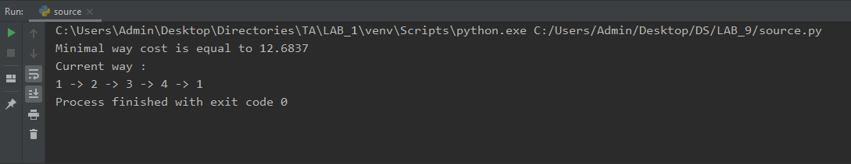4 3

**Вхідні дані:**

5

1 3

2 1

3 5

6 3

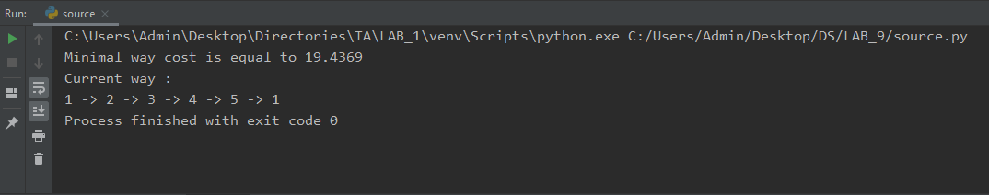4 7