## Dart Program for input/output and loops.

import 'dart:io';

void main() {

  stdout.write('Enter a positive integer: ');

  String? line = stdin.readLineSync();

  if (line == null || line.trim().isEmpty) {

    print('No input provided. Exiting.');

    return;

  }

  int? n = int.tryParse(line.trim());

  if (n == null || n <= 0) {

    print('Please enter a valid positive integer.');

    return;

  }

  // 1) for loop: print numbers 1..n

  print('\nNumbers from 1 to $n (for loop):');

  for (int i = 1; i <= n; i++) {

    stdout.write('$i ');

  }

  print('\n');

  // 2) while loop: sum numbers 1..n

  int sum = 0;

  int j = 1;

  while (j <= n) {

    sum += j;

    j++;

  }

  print('Sum of numbers 1 to $n (while loop): $sum');

  // 3) do-while loop: count digits of n (example do-while)

  int temp = n;

  int digits = 0;

  do {

    digits++;

    temp ~/= 10; // integer division

  } while (temp > 0);

  print('Number of digits in $n (do-while loop): $digits');

  // 4) for-in (iterable) demonstration: print multiples of n (first 5)

  print('\nFirst 5 multiples of $n (for-in simulated with List):');

  List<int> multiples = [1, 2, 3, 4, 5].map((m) => m * n).toList();

  for (var m in multiples) {

    print(m);

  }

}

## Output:

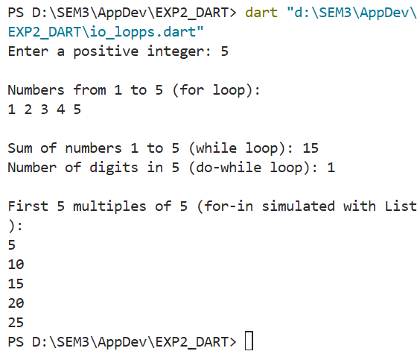

# Activity_main.xml

<?xml version="1.0" encoding="utf-8"?>  
<LinearLayout xmlns:android="http://schemas.android.com/apk/res/android"  
 android:layout_width="match_parent"  
 android:layout_height="match_parent"  
 android:gravity="center"  
 android:orientation="vertical"  
 android:padding="20dp">  
  
 <TextView  
 android:id="@+id/tvCounter"  
 android:layout_width="wrap_content"  
 android:layout_height="wrap_content"  
 android:text="0"  
 android:textSize="40sp"  
 android:textStyle="bold"  
 android:layout_marginBottom="20dp"/>  
  
 <Button  
 android:id="@+id/btnIncrement"  
 android:layout_width="wrap_content"  
 android:layout_height="wrap_content"  
 android:text="Increment" />  
  
 <Button  
 android:id="@+id/btnDecrement"  
 android:layout_width="wrap_content"  
 android:layout_height="wrap_content"  
 android:text="Decrement"  
 android:layout_marginTop="10dp"/>  
  
 <Button  
 android:id="@+id/btnReset"  
 android:layout_width="wrap_content"  
 android:layout_height="wrap_content"  
 android:text="Reset"  
 android:layout_marginTop="10dp"/>  
  
</LinearLayout>

# MainActivity.kt

var counter = 0

btnIncrement.setOnClickListener {

counter++

tvCounter.text = counter.toString()

}

btnDecrement.setOnClickListener {

if (counter > 0) counter--

tvCounter.text = counter.toString()

}

btnReset.setOnClickListener {

counter = 0

tvCounter.text = counter.toString()

}

# Output:

## Setting up Flutter SDK and create calculator app.

## String display = '';

## double num1 = 0;

## double num2 = 0;

## String operator = '';

## void buttonPressed(String value) {

## setState(() {

## if (value == 'C') {

## display = '';

## num1 = 0;

## num2 = 0;

## operator = '';

## } else if (value == '+' || value == '-' || value == '×' || value == '÷') {

## num1 = double.tryParse(display) ?? 0;

## operator = value;

## display = '';

## } else if (value == '=') {

## num2 = double.tryParse(display) ?? 0;

## switch (operator) {

## case '+':

## display = (num1 + num2).toString();

## break;

## case '-':

## display = (num1 - num2).toString();

## break;

## case '×':

## display = (num1 * num2).toString();

## break;

## case '÷':

## display = num2 != 0 ? (num1 / num2).toString() : 'Error';

## break;

## }

## } else {

## display += value;

## }

## });

## }

## Output:

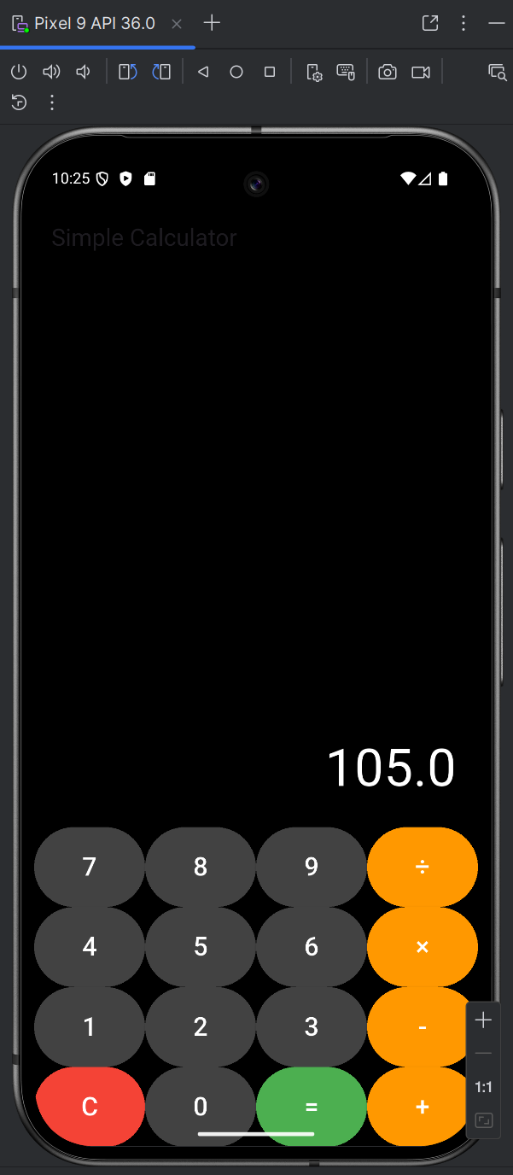

## Setting up React Native and create to do list app.

## const [task, setTask] = useState('');

## const [tasks, setTasks] = useState([]);

## const addTask = () => {

## if (task.trim()) {

## setTasks([...tasks, { id: Date.now().toString(), title: task }]);

## setTask('');

## }

## };

## const deleteTask = (id) => {

## setTasks(tasks.filter((t) => t.id !== id));

## };Output:

