# ASSIGNMENT-9

**Vayu Nandhan Valluri-700747722**

**GitHub Link: https://github.com/vvnandhan/ICP_9**

import pandas as pd # data processing, CSV file I/O (e.g. pd.read_csv) from keras.preprocessing.text import Tokenizer

from tensorflow.keras.preprocessing.sequence import pad_sequences from keras.models import Sequential

from keras.layers import Dense, Embedding, LSTM, SpatialDropout1D from matplotlib import pyplot

from sklearn.model_selection import train_test_split from keras.utils.np_utils import to_categorical import re

from sklearn.preprocessing import LabelEncoder

data = pd.read_csv('Sentiment.csv')

# Keeping only the neccessary columns data = data[['text','sentiment']]

data['text'] = data['text'].apply(lambda x: x.lower())

data['text'] = data['text'].apply((lambda x: re.sub('[^a-zA-z0-9\s]', '', x)))

for idx, row in data.iterrows(): row[0] = row[0].replace('rt', ' ')

max_fatures = 2000

tokenizer = Tokenizer(num_words=max_fatures, split=' ') tokenizer.fit_on_texts(data['text'].values)

X = tokenizer.texts_to_sequences(data['text'].values) X = pad_sequences(X)

embed_dim = 128

lstm_out = 196

def createmodel():

model = Sequential()

model.add(Embedding(max_fatures, embed_dim,input_length = X.shape[1]))

model.add(LSTM(lstm_out, dropout=0.2, recurrent_dropout=0.2)) model.add(Dense(3,activation='softmax'))

model.compile(loss = 'categorical_crossentropy', optimizer='adam',metrics = ['accuracy'])

return model

# print(model.summary())

labelencoder = LabelEncoder()

integer_encoded = labelencoder.fit_transform(data['sentiment']) y = to_categorical(integer_encoded)

X_train, X_test, Y_train, Y_test = train_test_split(X,y, test_size = 0.33, random_state = 42)

batch_size = 32

model = createmodel()

model.fit(X_train, Y_train, epochs = 1, batch_size=batch_size, verbose

= 2)

score,acc = model.evaluate(X_test,Y_test,verbose=2,batch_size=batch_size) print(score)

print(acc) print(model.metrics_names)

Output:

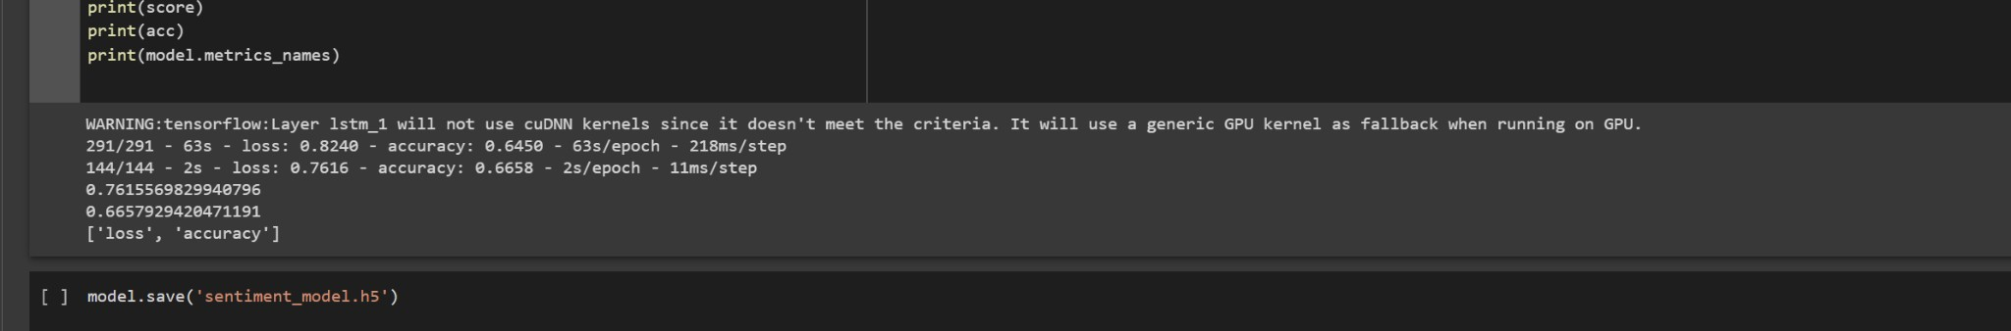

model.save('sentiment_model.h5')

This code loads the saved model using the load_model function, and then preprocesses the new text data in the same way as the training data. The predict method is called on the loaded model to get the predicted

class probabilities for the new text data. The class with the highest probability is chosen as the predicted sentiment. The predicted sentiment and probabilities are then printed to the console.

To apply GridSearchCV on the provided source code, we can use the GridSearchCV class from sklearn to search for the best combination of hyperparameters for the LSTM model. The hyperparameters that can be tuned are the number of LSTM units, the dropout rate, and the learning rate of the optimizer.

from keras.models import load_model import numpy as np

loaded_model = load_model('sentiment_model.h5')

new_text = ["A lot of good things are happening. We are respected again throughout the world, and that's a great thing.@realDonaldTrump"] new_text = tokenizer.texts_to_sequences(new_text)

new_text = pad_sequences(new_text, maxlen=X.shape[1], dtype='int32', value=0)

sentiment_prob = loaded_model.predict(new_text, batch_size=1, verbose=2)[0]

sentiment_classes = ['Negative', 'Neutral', 'Positive'] sentiment_pred = sentiment_classes[np.argmax(sentiment_prob)]

print("Predicted sentiment: ", sentiment_pred) print("Predicted probabilities: ", sentiment_prob)

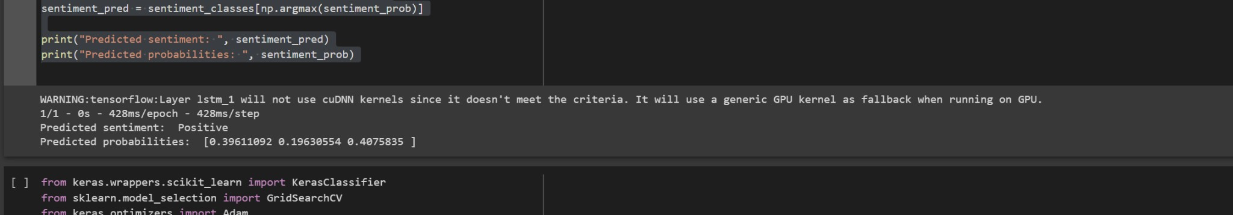

from keras.wrappers.scikit_learn import KerasClassifier from sklearn.model_selection import GridSearchCV

from keras.optimizers import Adam

def create_model(units=196, dropout=0.2, learning_rate=0.001): model = Sequential()

model.add(Embedding(max_fatures, embed_dim,input_length = X.shape[1]))

model.add(LSTM(units, dropout=dropout, recurrent_dropout=dropout)) model.add(Dense(3, activation='softmax'))

optimizer = Adam(lr=learning_rate) model.compile(loss='categorical_crossentropy', optimizer=optimizer,

metrics=['accuracy']) return model

model = KerasClassifier(build_fn=create_model, verbose=2)

units = [64, 128, 196]

dropout = [0.1, 0.2, 0.3]

learning_rate = [0.001, 0.01, 0.1]

epochs = [1]

batch_size = [32]

param_grid = dict(units=units, dropout=dropout, learning_rate=learning_rate, epochs=epochs, batch_size=batch_size) grid = GridSearchCV(estimator=model, param_grid=param_grid, cv=3, verbose=2)

grid_result = grid.fit(X_train, Y_train)

print("Best: %f using %s" % (grid_result.best_score_, grid_result.best_params_))

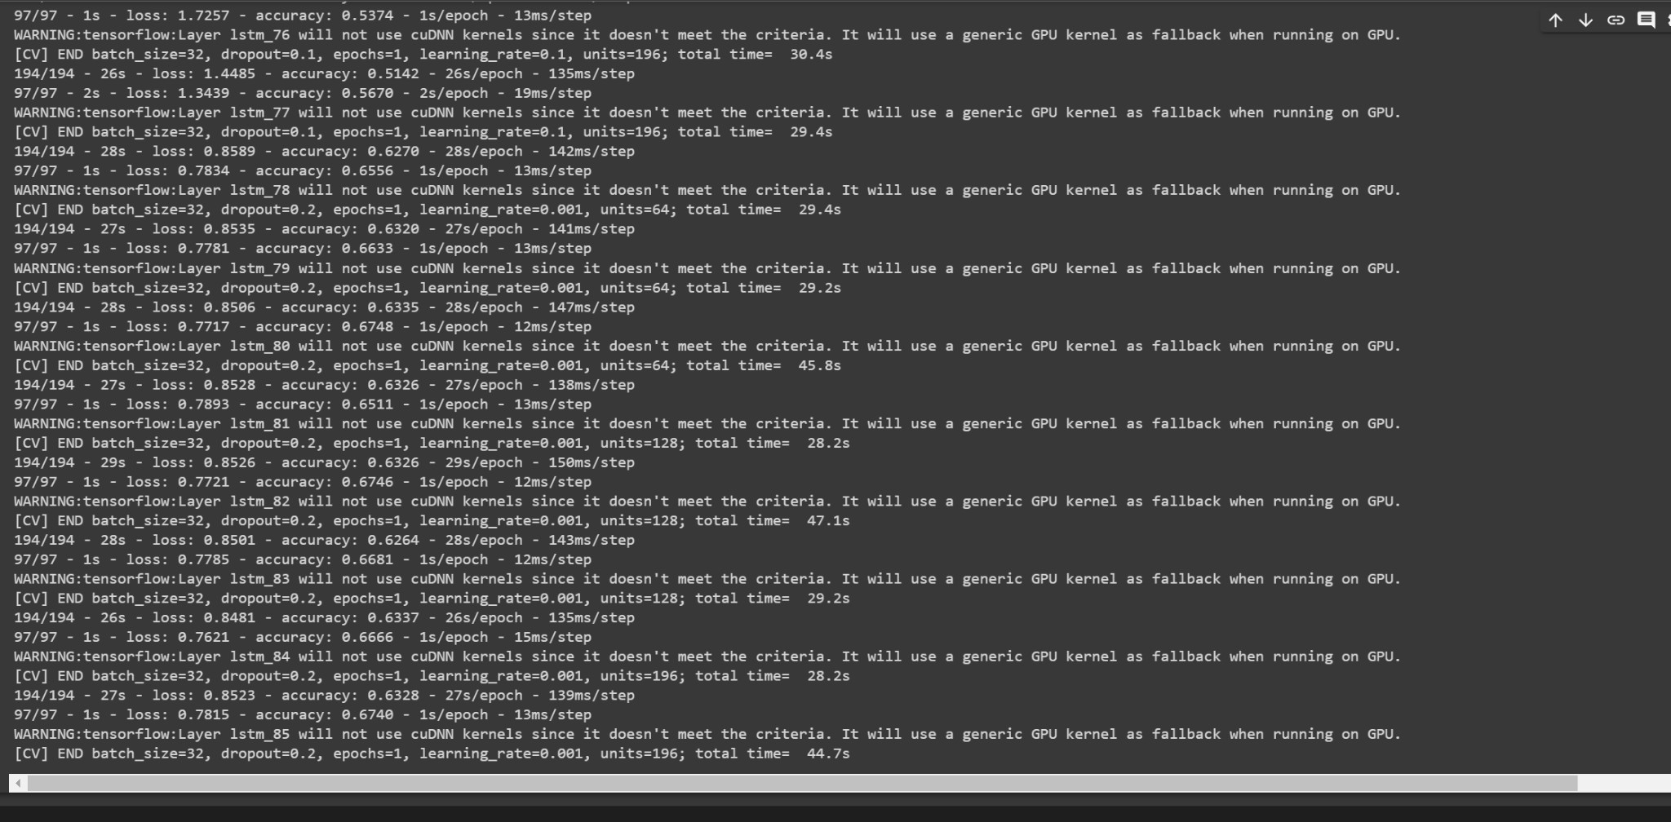

This code defines the create_model function that returns a Keras model with the specified hyperparameters. The KerasClassifier class is used to create a wrapper for the create_model function,

which can be used as an estimator for GridSearchCV. The hyperparameters to be tuned are defined in the param_grid dictionary. GridSearchCV is then called with the KerasClassifier object, the param_grid dictionary