

**Báo cáo Lab 6**

**GVHD:** **Trần Thế Bảy**

**SVTH: Võ Văn Quang Huy( ps38367)**

**TPHCM – 2024**

**PHẦN 1: CODE LAB6_1**

package Lab6;

import java.util.Scanner;

public class Lab6_Bai1 {

public static void main(String args[]) {

// TODO code application logic here

Scanner scanner = new Scanner(System.in);

String hoten;

System.out.print("Nhap ho va ten: ");

hoten = scanner.nextLine();

String ho = hoten.substring(0, hoten.indexOf(" "));

String tendem = hoten.substring(hoten.indexOf(" "), hoten.lastIndexOf(" "));

String ten = hoten.substring(hoten.lastIndexOf(" "));

System.out.println("\n Ho ten viet hoa:" + ho.toUpperCase() + tendem + ten.toUpperCase());

}

}

**PHẦN 2: HÌNH ẢNH CODE**

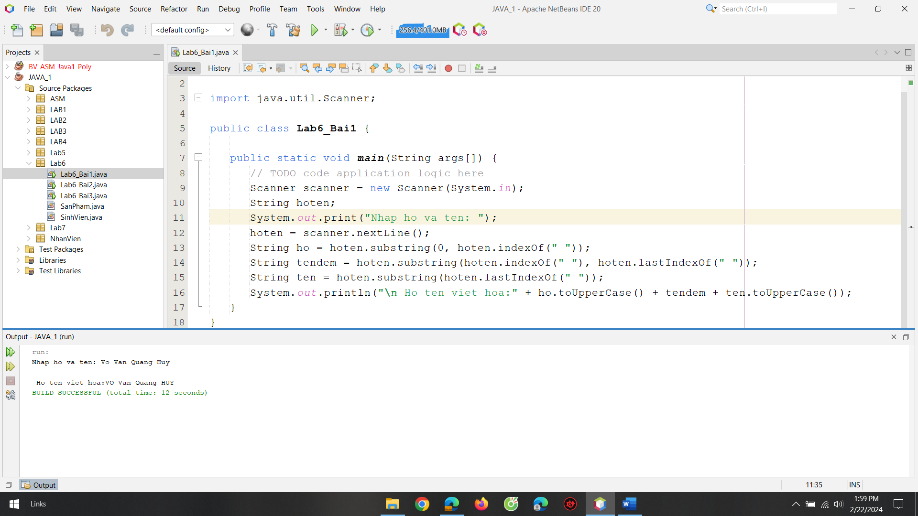

**PHẦN 3: CODE LAB6_2**

package Lab6;

import java.util.*;

public class Lab6_Bai2 {

public static void main(String args[]) {

ArrayList<SanPham> sanPham = new ArrayList<SanPham>();

Scanner scanner = new Scanner(System.in);

System.out.print("Nhap so lunog san pham muon nhap: ");

int a= scanner.nextInt();

for(int i=0; i<a ; i++){

SanPham sp = new SanPham();

sp.input();

sanPham.add(sp);

}

for(SanPham sp: sanPham){

if(sp.getHang().equalsIgnoreCase("nokia")){

sp.output();

}

}

}

}

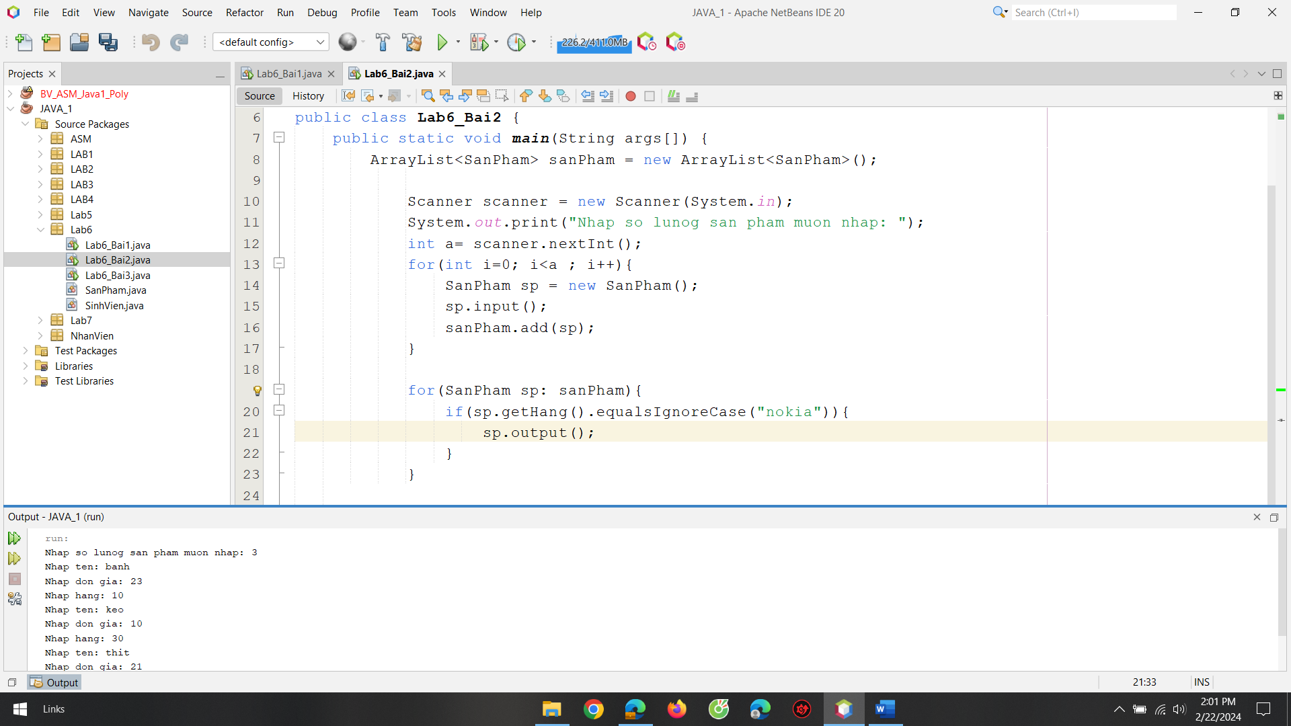

**CODE LAB6_3**

package Lab6;

import java.util.*;

public class Lab6_Bai3 {

public static void main(String args[]) {

ArrayList<SinhVien> sinhVien = new ArrayList<SinhVien>();

Scanner scanner = new Scanner(System.in);

System.out.print("Nhap so luong sinh vien muon nhap: ");

int a= scanner.nextInt();

for(int i=0; i<a ; i++){

SinhVien sv = new SinhVien();

sv.input();

sinhVien.add(sv);

}

for(SinhVien sv: sinhVien){

sv.output();

}

}

}

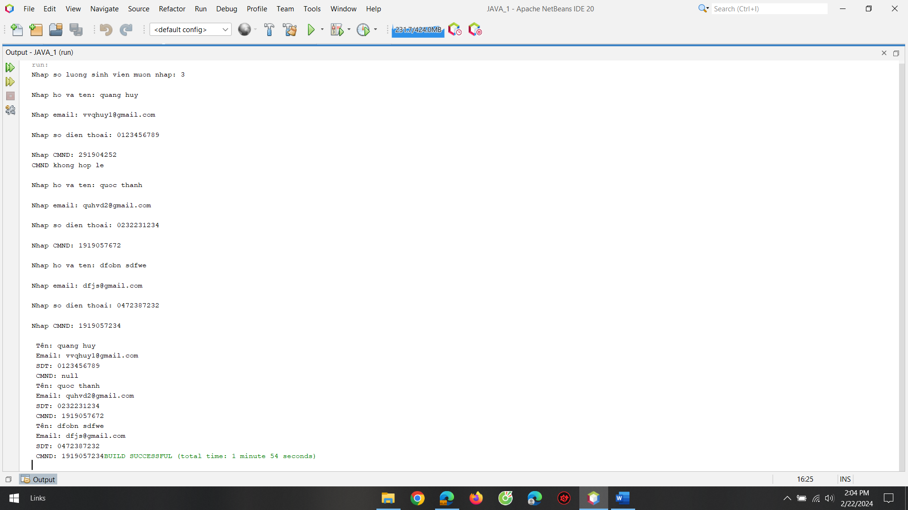

**CODE SanPham**

package Lab6;

import java.util.Scanner;

public class SanPham {

private String tenSP;

private double donGia;

private String hang;

public SanPham(String tenSP, double donGia, String hang) {

this.tenSP = tenSP;

this.donGia = donGia;

this.hang = hang;

}

public SanPham() {

}

public String getTenSP() {

return tenSP;

}

public void setTenSP(String tenSP) {

this.tenSP = tenSP;

}

public double getDonGia() {

return donGia;

}

public void setDonGia(double donGia) {

this.donGia = donGia;

}

public String getHang() {

return hang;

}

public void setHang(String hang) {

this.hang = hang;

}

public void input(){

Scanner scanner = new Scanner(System.in);

System.out.print("Nhap ten: ");

String tenSp = scanner.nextLine();

this.tenSP = tenSp;

System.out.print("Nhap don gia: ");

double donGia = scanner.nextDouble();

this.donGia = donGia;

scanner.nextLine();

System.out.print("Nhap hang: ");

String hang = scanner.nextLine();

this.hang = hang;

}

public void output(){

System.out.printf("\n Ten: %s",this.tenSP);

System.out.printf("\n Don gia: %.1f",this.donGia);

System.out.printf("\n Hang: %s",this.hang);

}

}

**CODE SinhVien**

package Lab6;

import java.util.Scanner;

public class SinhVien {

private String hoTen;

private String email;

private String sdt;

private String cmnd;

public SinhVien(String hoTen, String email, String sdt, String cmnd) {

this.hoTen = hoTen;

this.email = email;

this.sdt = sdt;

this.cmnd = cmnd;

}

public SinhVien() {

}

public String getHoTen() {

return hoTen;

}

public void setHoTen(String hoTen) {

this.hoTen = hoTen;

}

public String getEmail() {

return email;

}

public void setEmail(String email) {

this.email = email;

}

public String getSdt() {

return sdt;

}

public void setSdt(String sdt) {

this.sdt = sdt;

}

public String getCmnd() {

return cmnd;

}

public void setCmnd(String cmnd) {

this.cmnd = cmnd;

}

public void input(){

Scanner scanner = new Scanner(System.in);

System.out.print("\nNhap ho va ten: ");

String hoTen = scanner.nextLine();

System.out.print("\nNhap email: ");

String email = scanner.nextLine();

System.out.print("\nNhap so dien thoai: ");

String sdt = scanner.nextLine();

System.out.print("\nNhap CMND: ");

String cmnd = scanner.nextLine();

String reHoTen ="[a-zA-Z ]+";

if(!hoTen.matches(reHoTen)){

System.out.println("Ho và ten khong hop le");

}else{

this.hoTen = hoTen;

}

String reEmail = "\\w+@\\w+\\.\\w+";

if(!email.matches(reEmail)){

System.out.println("Email khong hop le");

}else{

this.email = email;

}

String reSDT= "0\\d{9,10}";

if(!sdt.matches(reSDT)){

System.out.println("So dien thoai khong hop le");

}else{

this.sdt = sdt;

}

String reCMND="\\d{10}";

if(!cmnd.matches(reCMND)){

System.out.println("CMND khong hop le");

}else{

this.cmnd = cmnd;

}

}

public void output(){

System.out.printf("\n Tên: %s",this.hoTen);

System.out.printf("\n Email: %s",this.email);

System.out.printf("\n SDT: %s",this.sdt);

System.out.printf("\n CMND: %s",this.cmnd);

}

}