
BECAMEX BUSINESS SCHOOL

FINAL EXAM

Course: MIS 443 - BUSINESS DATA MANAGEMENT
Lecturer: Mr. Dang Thai Doan

Student’s Name | Student’s IRN | GitHub Repository Link
Văn Vũ Quỳnh Như | 2232300079 | https://github.com/vvqnhu204/MIS443-Q4-2025_2026

Quarter 4, Academic Year 2025-2026

Question 1 – Database Setup (10 marks)
(a) Load the database – 5 marks
Create a PostgreSQL database using your full name in lowercase, without spaces or Vietnamese diacritics. Connect to the database and execute:
MIS443_Customer_Insights_PostgreSQL.sql
Confirm that country, customers, orders, products, and baskets are available in the public schema.
(b) Create the student table – 5 marks
Create public.students with:
- student_id: exactly 10 characters and primary key;
- full_name: required;
- email: required and unique.
Insert your actual information and display the inserted record.
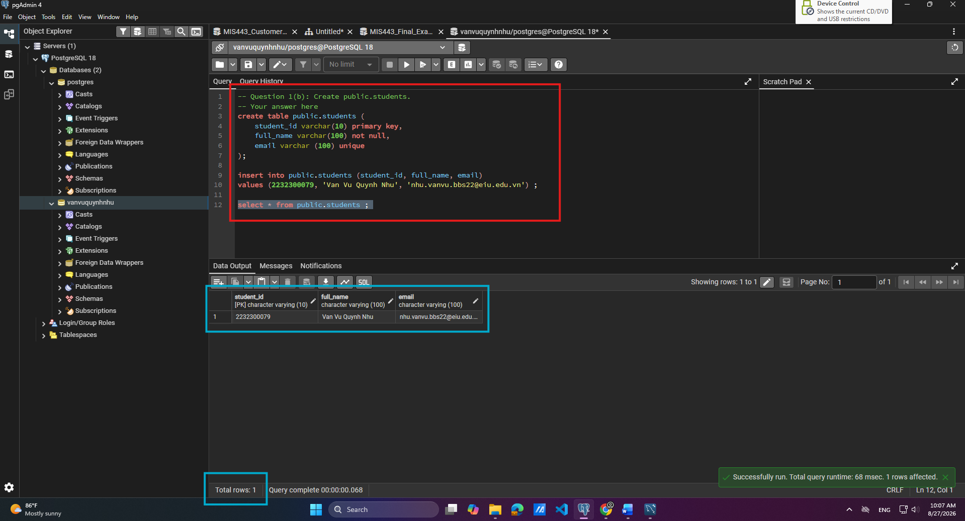
Question 2 – Customer Profile (10 marks)
The Marketing Manager wants to understand customers who permit marketing emails. Calculate their average age, name the result average_age, and round it to two decimal places.
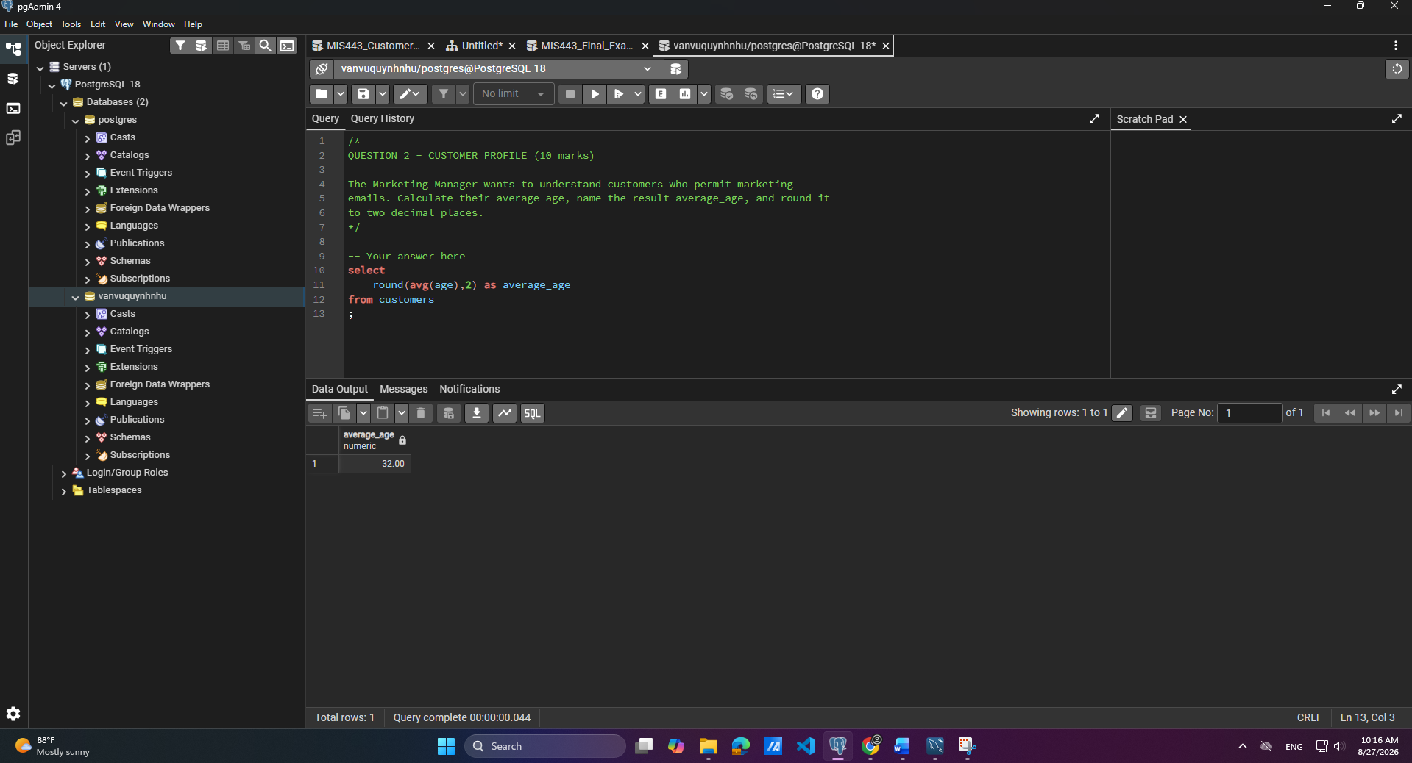
Question 3 – Customer and Channel Activity (20 marks)
(a) Sales-channel activity – 10 marks
The Sales Manager wants to compare retail and online channel usage. Calculate the number of orders for each sales_channel. Name the result total_orders and sort it from highest to lowest.
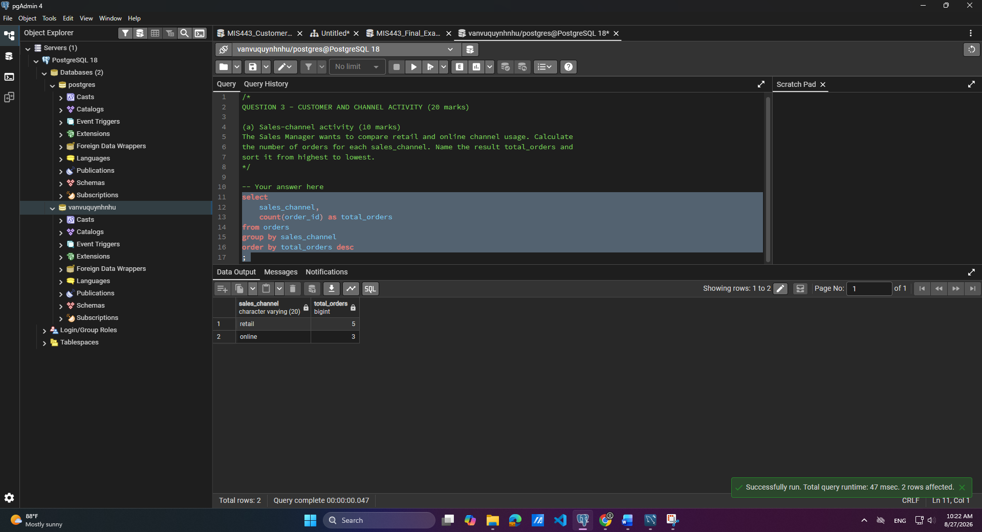
(b) Repeat customers – 10 marks
The Customer Relationship Manager wants to identify customers who placed more than one order. Display customer_id, age, and total_orders. Sort by total_orders descending and then customer_id ascending.
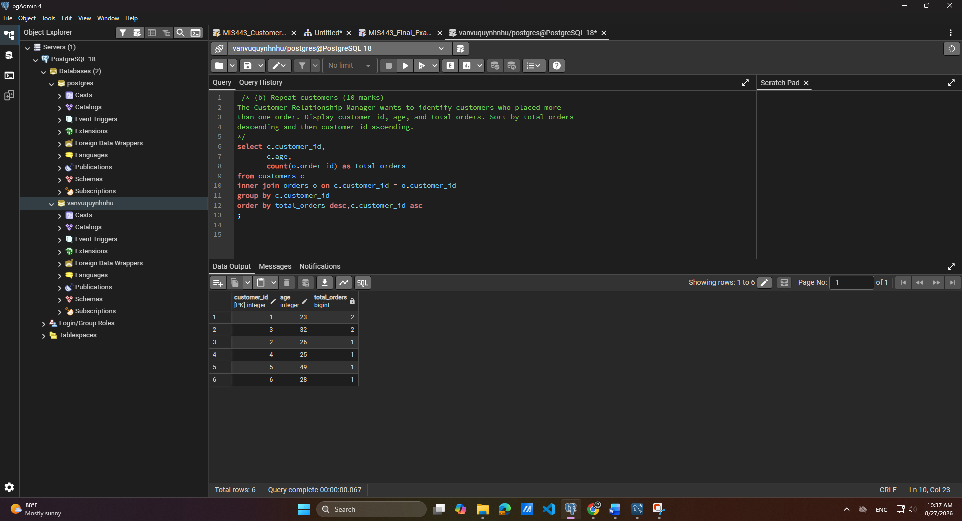
Question 4 – Order and Country Analysis (20 marks)
(a) Order-monitoring report – 10 marks
Create an order report showing order_id, date_shop, sales_channel, customer age as customer_age, and country_name. Sort by the newest order date and then by order_id.
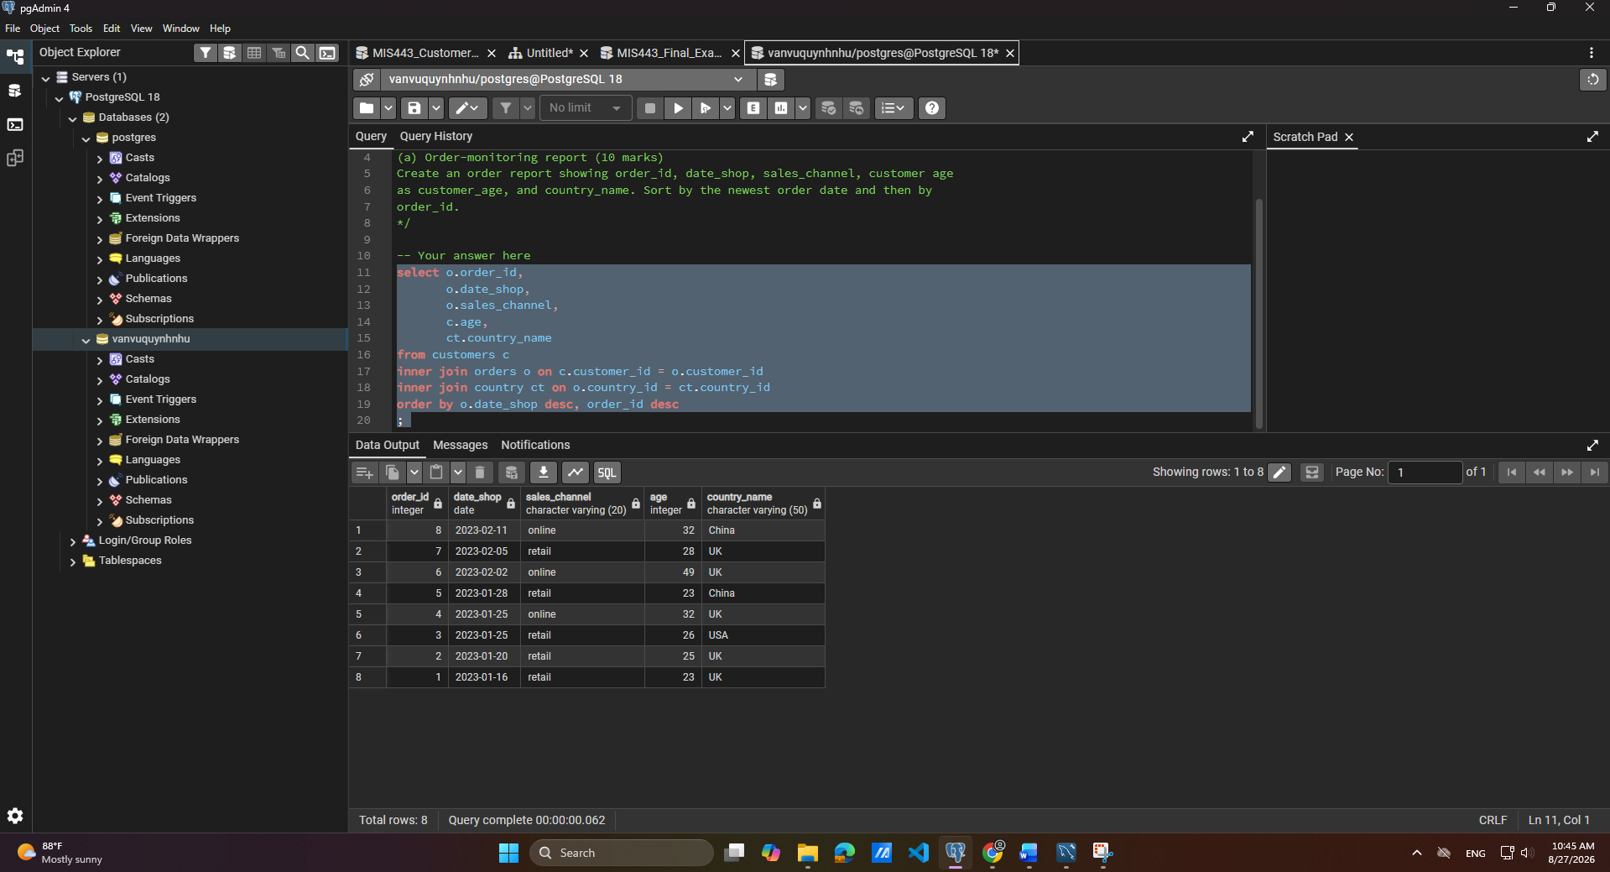
(b) Country performance – 10 marks
Calculate the number of orders for each country, including countries with no orders. Display country_name and total_orders. Sort by total_orders descending and then country_name alphabetically.
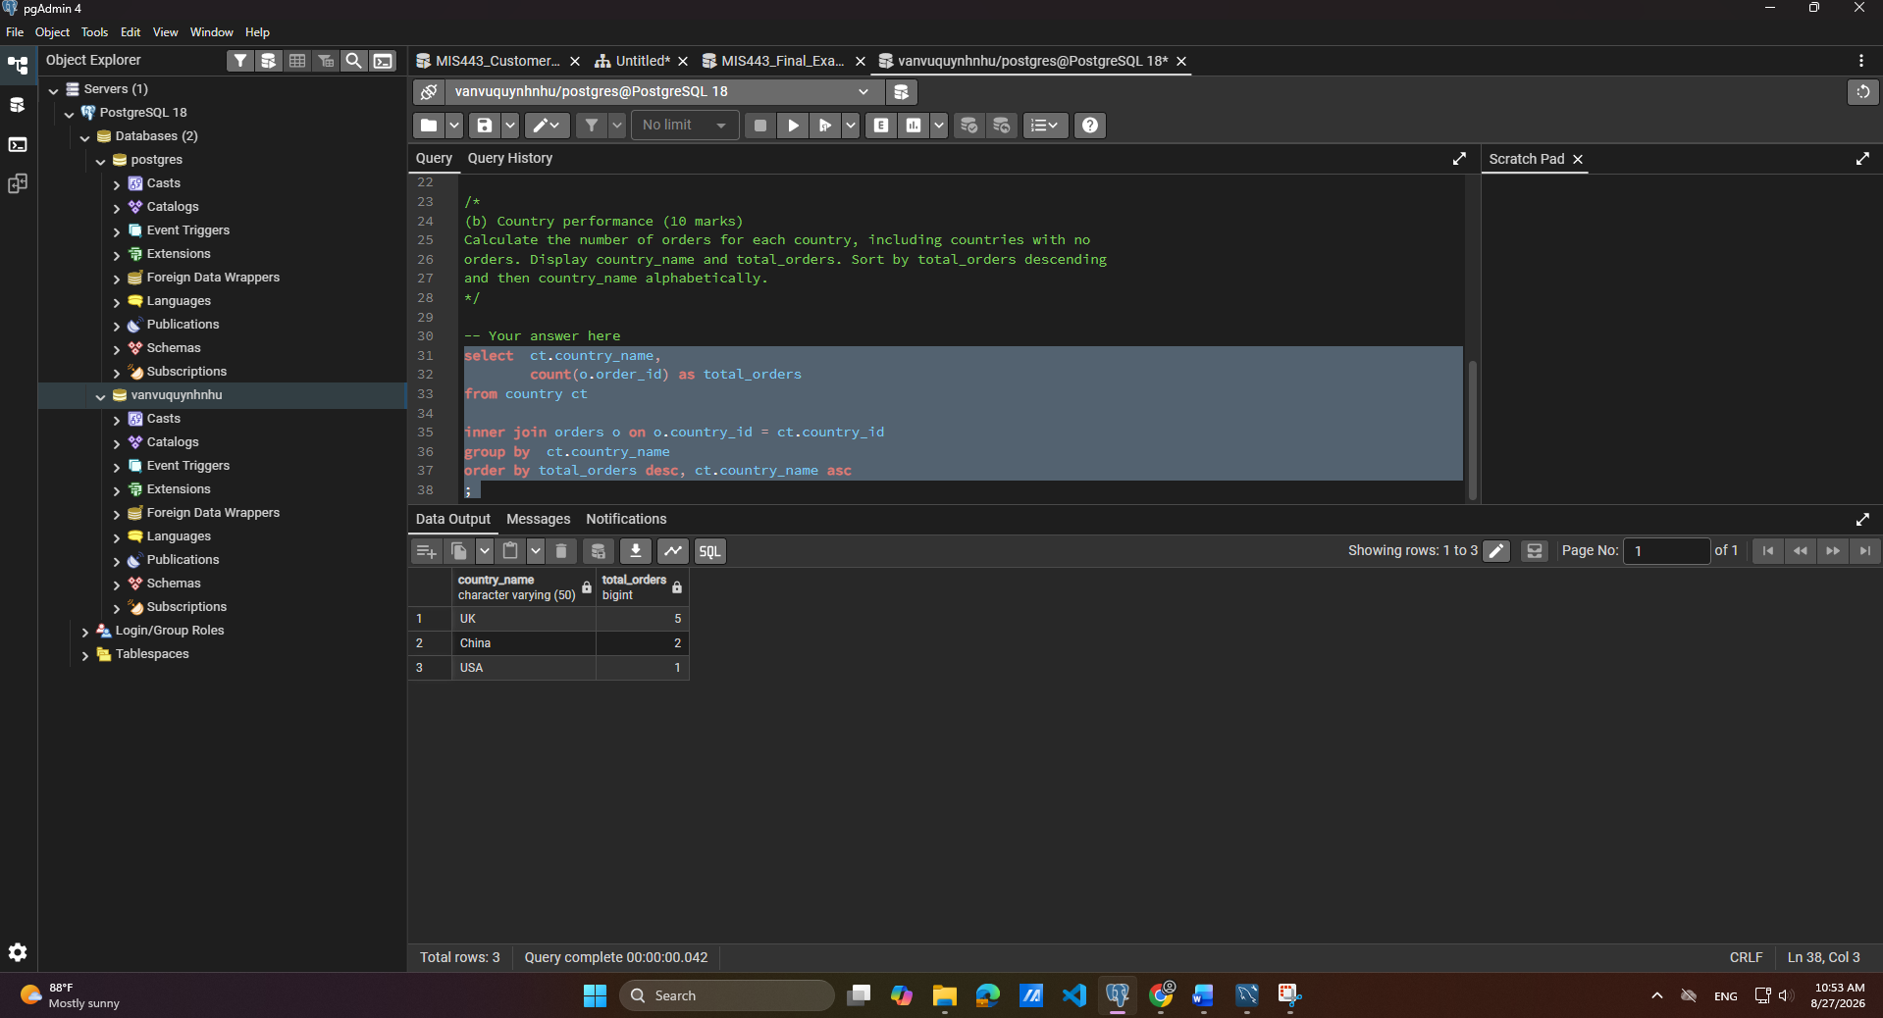
Question 5 – Product and Revenue Analysis (20 marks)
(a) Category performance – 10 marks
For each product category, calculate total_quantity and total_revenue. Revenue equals price multiplied by quantity. Round revenue to two decimal places and sort from highest to lowest revenue.
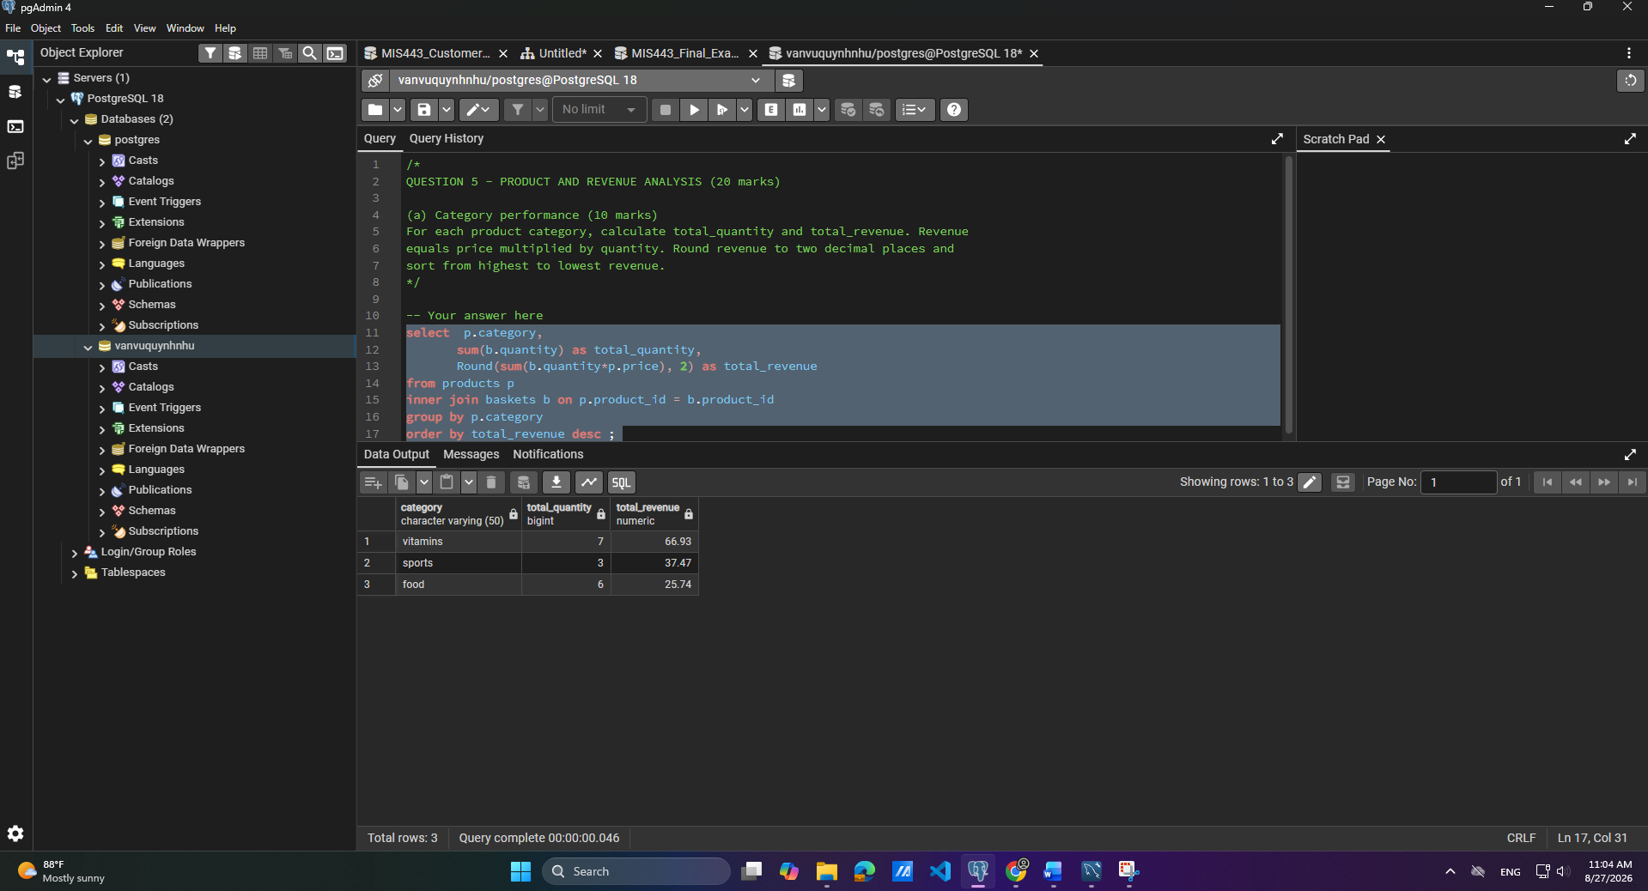
(b) High-value orders – 10 marks
Calculate the total value of each order and return only orders worth more than 20.00. Display order_id and total_order_value, rounded to two decimal places. Sort from highest to lowest value.
Question 6 – Advanced Business Analysis (20 marks)
(a) Customer purchase recency – 10 marks
For every customer who permits marketing emails, display customer_id, age, and their latest order date as latest_order_date. Include eligible customers with no orders and sort by customer_id.
(b) Customer activity ranking – 5 marks
Rank all customers by their number of orders. Customers with equal totals must receive the same rank without ranking gaps. Include customers with no orders.
Display customer_id, age, total_orders, and activity_rank. Do not use a CTE.
(c) Channel performance using a CTE – 5 marks
Use a CTE to calculate each order’s total value. Then summarise performance by sales_channel.
Display:
- sales_channel;
- total_orders;
- total_revenue;
- average_order_value.
Round monetary values to two decimal places and sort by total_revenue descending.

