EXPIREMENT - 01

Step 1: Open browser search for jira login

Step 2 : Continue with your g-mail account or login jira

Step3: Click on jira software & select project from top menu bar then select create project from drop down menu-

Step 4: Select scrum click on template & check on create

Step 5: Give a name to your project & give a description of your project.

Step 6: Click on create.

Step 7: Select Issues from top menu bar and select issue type (this will be the default settings)

Step 8:- Give a summary to your project.

Step9:- Now write a user story in description box

Step 10: Now your study will go into the backlog to be assign and action by the propet manager, product owner or other stake holders & then click on start print.

Step 1: Click on board & select insights.

Ship 12: Click on insights & click sprint burn dawn

Step: And click on dearn more.

EXPIREMENT – 02

Create and manage product backlog using appropriate tool like jira for a shopping cart application.

→ Summary: Customer Registration functionality.

Description

As a customer

I want to have registration functionality.
So that I can successfully registrer

Scope

1. Build a registration page.

2. Customer validation

3. Customer should be able to change the phone number

4. It should work in all browser

5. It should also work as mobile devices

Pre-condition

Customer should have an email & phone number

Acceptance Griteria.

Scenario 1: Customa can successfully registrer
1 .Given I am on registeration page.
2.And I provide a valid customer name & phone number & I click on "sign in"
3.Then I will successfully register.

Scenario 2: Customer cannot succerfuly register
1.Given Tam on the registration page
2.And I provide an invalid
customer name & phone number.
3.Then I will get on error message as registration failed incorrect customer name.

2.Summary: Password reset functionality.

Description

As a customer
I want to have the ability to reset my parsword.
So that I can regain access to my account

Scope:
Build a pasword reset page
Email validation for reset Ability to set a new password.

Precondition:-
Customer should have a registered email

Acceptance Criteria:
Scenario 1 : Succesful password reset

Given I am on the password reset page.
And I click on "Send reset link"
Then I will recieve a resent link in my email.
When I click the reset link & set a new password
Then my password is successfully updated

Scenario 2 - Unsuccessful password reset due to unregistered email.

Given I am on the password reset page.
And I provide an unregistered email
Then I will get an error message as "email not found".

3: shopping cart functionality:

Decreption:
As a customer
I want to add items to my shopping cart
So that I can purchase them later.

Scope:
Build a shopping cart page. Ability to add /remove items. Cart should show total price.

Preconditions:
Customer Should be logged in

Acceptance Criteria:

Scenario1: Add item to cart.

given I am logged in
and i am on a product page when I click on "Add to cart" Then the item is added to my cart
And the cart shows the updated totel price

Scenario 2: Remove item from cart:

Given I am the shopping cart page.
And I have item's in my cart. When I click on "Remove" next to an item
Then the item is removed from my cast
And The cart shows the updated total price.

4) Summary: Order Tracking functionality.

Description:
As a customer
I want to track my order status
So that I can know my order will arrive.

Scope:

Build an order tracking page Integrate with shopping provider API
Display order status updates

Precondition:-

Customer should have an order ID

Acceptance criteria

Scenarios1 : Successful Order tracking
Given I am on the order tracking page
And I provide a valid order ID
Then I see the current status of my order

Scenario 2:- Unsuccessful order tracking device to invalid order ID.

Given I am on the order tracking page
And I provide invalid order ID Then I will get an error message as "order not found".

EXPIREMENT - 03

1. Sign Up and Log In:

Go to the Visily website and create an account.
Log in to access the design tools.

2. Start a New Project:

Click on "New Project" from the dashboard.
Choose a template or start with a blank canvas.
Name your project and select the design type (Web or Mobile).

3.. Create a Basic Layout:

Drag and drop UI components (buttons, text boxes, images) onto the canvas.
Arrange these components to build the basic structure of your design.

4. . Customize Your Design:

Adjust colors, fonts, and sizes to fit your design preferences.
Use the alignment tools to ensure everything is neatly organized.

5. Add Interactions:

Link different screens or elements to create a clickable prototype.
Test these interactions by previewing your design.

6. Review and Export:

Check your design in Preview Mode to see how it looks and works.
Make any necessary changes.
Export your design as an image, PDF, or share it as a prototype link.

EXPIREMENT – 04

<!DOCTYPE html>
<html lang="en">
<head>
<meta charset="UTF-8" />
<meta name="viewport" content="width=device-width, initial-scale=1.0" />
<title>Registration and Feedback Form</title>
<link rel="stylesheet" href="styles.css" />
<style>
body {
font-family: Arial, sans-serif;
display: flex;
justify-content: center;
align-items: center;
height: 100vh;
margin: 0;
background-color: #f0f0f0;
}
#form-container {
background: lightblue;
padding: 20px;
border-radius: 8px;
box-shadow: 0 0 10px red;
width: 300px;
}
h2 {
margin-top: 0;
}
label {
display: block;
margin: 10px 0 5px;
}
input {
width: 100%;
padding: 8px;
margin-bottom: 10px;
border: 1px solid black;
border-radius: 4px;
}
button {
padding: 10px 15px;
border: none;
border-radius: 4px;
background-color: #28a745;
color: white;
cursor: pointer;
}
button:hover {
background-color: #218838;
}
#feedback-form {
text-align: center;
}
.hidden {
display: none;
}
</style>
</head>
<body>
<div id="form-container">
<!-- Registration Form -->
<div id="registration-form">
<h2>Registration Form</h2>
<form id="regForm">
<label for="name">Name:</label>
<input type="text" id="name" name="name" required />
<label for="email">Email:</label>
<input type="email" id="email" name="email" required />
<button type="submit">Submit</button>
</form>
</div>
<!-- Feedback Form -->
<div id="feedback-form" class="hidden">
<h2>Feedback</h2>
<p id="feedback"></p>
</div>
</div>
<script>
document.getElementById("regForm").onsubmit = function (event) {
event.preventDefault();
document.getElementById("registration-form").classList.add("hidden");
const { value: name } = document.getElementById("name");
const { value: email } = document.getElementById("email");
document.getElementById(
"feedback"
).innerText = `Thank you for registering, ${name}! We have sent a confirmation email to ${email}.`;
document.getElementById("feedback-form").classList.remove("hidden");
};
</script>
</body>
</html>

EXPIREMENT – 05

<!DOCTYPE html>
<html lang="en">
<head>
<meta charset="UTF-8">
<meta name="viewport" content="width=device-width, initial-scale=1.0">
<title>Basketball Scoreboard</title>
<link rel="stylesheet" href="styles.css">
</head>
<body>
<h1>Basketball Scoreboard</h1>
<div class="scoreboard">
<div>
<h2>Team A</h2>
<p id="teamA-score">0</p>
<button onclick="increaseScore('teamA')">+1 Point</button>
</div>
<div>
<h2>Team B</h2>
<p id="teamB-score">0</p>
<button onclick="increaseScore('teamB')">+1 Point</button>
</div>
</div>

<script src="script.js"></script>
</body>
</html>

Css --

body {
font-family: Arial, sans-serif;
text-align: center;
}

.scoreboard {
display: flex;
justify-content: space-around;
margin-top: 20px;
}

.scoreboard div {
padding: 10px;
border: 1px solid #000;
width: 100px;
}

h2 {
font-size: 1.2em;
}

button {
margin-top: 10px;
padding: 5px;
}

JS

let teamAScore = 0;
let teamBScore = 0;

function increaseScore(team) {
if (team === 'teamA') {
teamAScore++;
document.getElementById('teamA-score').textContent = teamAScore;
} else if (team === 'teamB') {
teamBScore++;
document.getElementById('teamB-score').textContent = teamBScore;
}
}

EXPIREMENT – 06

<!DOCTYPE html>
<html lang="en">
<head>
<meta charset="UTF-8" />
<meta name="viewport" content="width=device-width, initial-scale=1.0" />
<title>JS Objects Example</title>
</head>
<body>
<h1>Player Info</h1>
<div id="player-output"></div> <!-- This will display the output -->

<script>
// Constructor function for a Player object
function Player(name, team, points) {
this.name = name;
this.team = team;
this.points = points;

// Method to display player info
this.displayInfo = function() {
return `${this.name} from team ${this.team} has scored ${this.points} points.`;
};

// Method to add points to the player's score
this.addPoints = function(newPoints) {
this.points += newPoints;
return `${this.name} now has ${this.points} points.`;
};
}

// Creating new player objects
const player1 = new Player("John", "Team A", 10);
const player2 = new Player("Alex", "Team B", 12);

// Get the output div
const outputDiv = document.getElementById('player-output');

// Display player info in the div
outputDiv.innerHTML += "<p>" + player1.displayInfo() + "</p>";
outputDiv.innerHTML += "<p>" + player1.addPoints(5) + "</p>";
outputDiv.innerHTML += "<p>" + player2.displayInfo() + "</p>";
outputDiv.innerHTML += "<p>" + player2.addPoints(3) + "</p>";
</script>
</body>
</html>
EXPIREMENT – 07

Step-1 Install Node.js. It is used to set up Typescript on our local computer. To install Node.js on Windows, Open google chrome and search: node.js download(click on first link).

Step-2 Install Typescript. To install Typescript, enter the following command in Command prompt or node js command prompt
•npm install -g typescript
Step-3 To verify the installation was successful, enter the command $ tsc -v in the Terminal Window.

Install Live server in VS code (Extension)
Create and run first program in Typescript
• Open visual studio code
• Create a New Folder : typescript
• Create a New File inside the folder typescript : app.ts
• Write the below code and save it (inside the file app.ts)

// TypeScript function to generate Fibonacci series
function fibonacci(n: number): number[] {
let series: number[] =[0, 1];
// Initial two numbers in the series

for (let i = 2; i < n; i++) {
series[i] = series[i - 1] + series[i - 2];
// Calculate the next number
}

return series;
}

// Example usage
let count: number = 10;
// Define how many numbers in the Fibonacci series you want
let result: number[] = fibonacci(count);
console.log(”Fibonacci series of ${count} numbers:”, result);

Go to Terminal and type the below commands cd typescript Set-ExecutionPolicy -Scope Process -ExecutionPolicy Bypass tsc app.ts node app.js
• Observe the output

NOTE : When we use the command “tsc app.ts” it it converts the program into JavaScript by creating a new file app.js.

EXPIREMENT - 08

App.js------------------------------ // src/App.js
import React from 'react';
import RegistrationForm from './RegistrationForm';
import './App.css'; // Ensure you have your CSS for styling

const App = () => {
return (
<div className="app-container">
<h1>Registration Form</h1>
<RegistrationForm />
</div>
);
};

export default App;

App.css ---------------------------------- /* src/App.css */
body {
margin: 0;
font-family: Arial, sans-serif;
background: linear-gradient(135deg, #80eab0, #90bac0); /* Gradient background */
}

.app-container {
display: flex;
flex-direction: column;
align-items: center;
justify-content: center;
min-height: 100vh;
}

h1 {
color: #042e7a; /* Dark teal color */
margin-bottom: 20px;
}

.form-container {
background-color: white; /* White background for the form */
border-radius: 12px; /* Rounded corners */
padding: 30px; /* More padding */
box-shadow: 0 4px 20px grey; /* Enhanced shadow for a 3D effect */
transition: transform 0.2s; /* Smooth transform effect */
}

.form-container:hover {
transform: translateY(-5px); /* Lift effect on hover */
}

input {
width: 100%;
padding: 12px;
margin: 10px 0;
border: 1px solid #ccc;
border-radius: 6px; /* Rounded corners */
transition: border-color 0.3s; /* Smooth border color change */
}

input:focus {
border-color: #00796b; /* Dark teal border on focus */
outline: none; /* Remove outline */
}

button {
background-color: #00796b; /* Dark teal color */
color: white;
padding: 12px;
border: none;
border-radius: 6px; /* Rounded corners */
cursor: pointer;
transition: background-color 0.3s; /* Smooth background color change */
}

button:hover {
background-color: #004d40; /* Darker teal on hover */
}

.success-message {
margin-top: 15px;
color: green;
font-weight: bold;
}

RegisrationForm.js --------------------------- // src/RegistrationForm.js
import React, { useState } from 'react';

const RegistrationForm = () => {
const [name, setName] = useState('');
const [email, setEmail] = useState('');
const [password, setPassword] = useState('');
const [message, setMessage] = useState('');

const handleSubmit = (e) => {
e.preventDefault();
// Here you can handle the registration logic (e.g., send data to an API)
setMessage('User registered successfully!');
// Clear the form fields
setName('');
setEmail('');
setPassword('');
};

return (
<div className="form-container">
<h2>Register</h2>
<form onSubmit={handleSubmit}>
<input
type="text"
placeholder="Name"
value={name}
onChange={(e) => setName(e.target.value)}
required
/>
<input
type="email"
placeholder="Email"
value={email}
onChange={(e) => setEmail(e.target.value)}
required
/>
<input
type="password"
placeholder="Password"
value={password}
onChange={(e) => setPassword(e.target.value)}
required
/>
<button type="submit">Register</button>
</form>
{message && <p className="success-message">{message}</p>}
</div>
);
};

export default RegistrationForm;

TERMINAL CODE FOR THIS EXPERIMENT
Set-ExecutionPolicy -Scope Process -ExecutionPolicy Bypass
npx create-react-app registrationform
cd registrationform
npm start

EXPIREMENT – 09

Step-1 : launch visual studio code
Step2 : open terminal
Step3: npx create-react-app myshop
Step4: create a file in src - Productlist.js
Step5 : create a file in src - AddProduct.js
Step6: link the ProductList.js and AddProduct.js in App.js
Step7: add css stylings in App.css file inside src
step8: in terminal
cd myshop
Step9: npm start

APP.JS
import React, { useState } from 'react';
import ProductList from './ProductList';
import AddProduct from './AddProduct';
import './App.css';

const App = () => {
const [products, setProducts] = useState([]);

const addProduct = (product) => {
setProducts([...products, product]);
};

const deleteProduct = (index) => {
const newProducts = products.filter((_, i) => i !== index);
setProducts(newProducts);
};

return (
<div className="container">
<h1>MyShop</h1>
<AddProduct onAdd={addProduct} />
<div className="product-box">
<ProductList products={products} onDelete={deleteProduct} />
</div>
</div>
);
};

export default App;

APP.CSS
body {
margin: 0;
font-family: Arial, sans-serif;
background-color: #e0f7fa;
}

.container {
display: flex;
flex-direction: column;
align-items: center;
justify-content: center;
min-height: 100vh;
}

h1 {
margin-bottom: 20px;
color: #00796b;
}

form {
margin-bottom: 20px;
}

.product-box {
background-color: white;
border: 1px solid #b2ebf2;
border-radius: 8px;
padding: 20px;
box-shadow: 0 2px 10px rgba(0, 0, 0, 0.1);
}

h2 {
margin: 0;
color: #00796b;
}

PRODUCTLIST.JS
import React from 'react';

const ProductList = ({ products, onDelete }) => {
return (
<div>
<h2>Product List</h2>
<ul>
{products.map((product, index) => (
<li key={index}>
{product}
<button
onClick={() => onDelete(index)}
style={{ marginLeft: '10px' }}
>
Delete
</button>
</li>
))}
</ul>
</div>
);
};

export default ProductList;

ADD PRODUCT.JS
import React, { useState } from 'react';

const AddProduct = ({ onAdd }) => {
const [product, setProduct] = useState('');

const handleSubmit = (e) => {
e.preventDefault();
if (product.trim() === '') return;
onAdd(product);
setProduct('');
};

return (
<form onSubmit={handleSubmit}>
<input
type="text"
placeholder="Enter product name"
value={product}
onChange={(e) => setProduct(e.target.value)}
style={{ padding: '8px', marginRight: '10px' }}
/>
<button type="submit" style={{ padding: '8px' }}>
Add Product
</button>
</form>
);
};

export default AddProduct;

EXPIREMENT – 10

To create a new repository in GitHub:
- Go to the GitHub website (https://github.com/) and sign in to your account.
- Click on the "+" icon in the top right corner of the page, and select "New repository" from the dropdown menu.
- On the "Create a new repository" page, enter a name “GitDemo”, a short description (optional), and select whether the repository should be public or private.
- If you want to create a repository from an existing local repository, you can select the "Import code" option and follow the prompts to import the code from your local repository.
- If you want to create an empty repository, you can leave the "Initialize this repository with a README" option unchecked.
- Click the "Create repository" button to create the repository.
After the repository is created, you will be taken to the repository page, where you can view the repository's code, make changes, and collaborate with others.

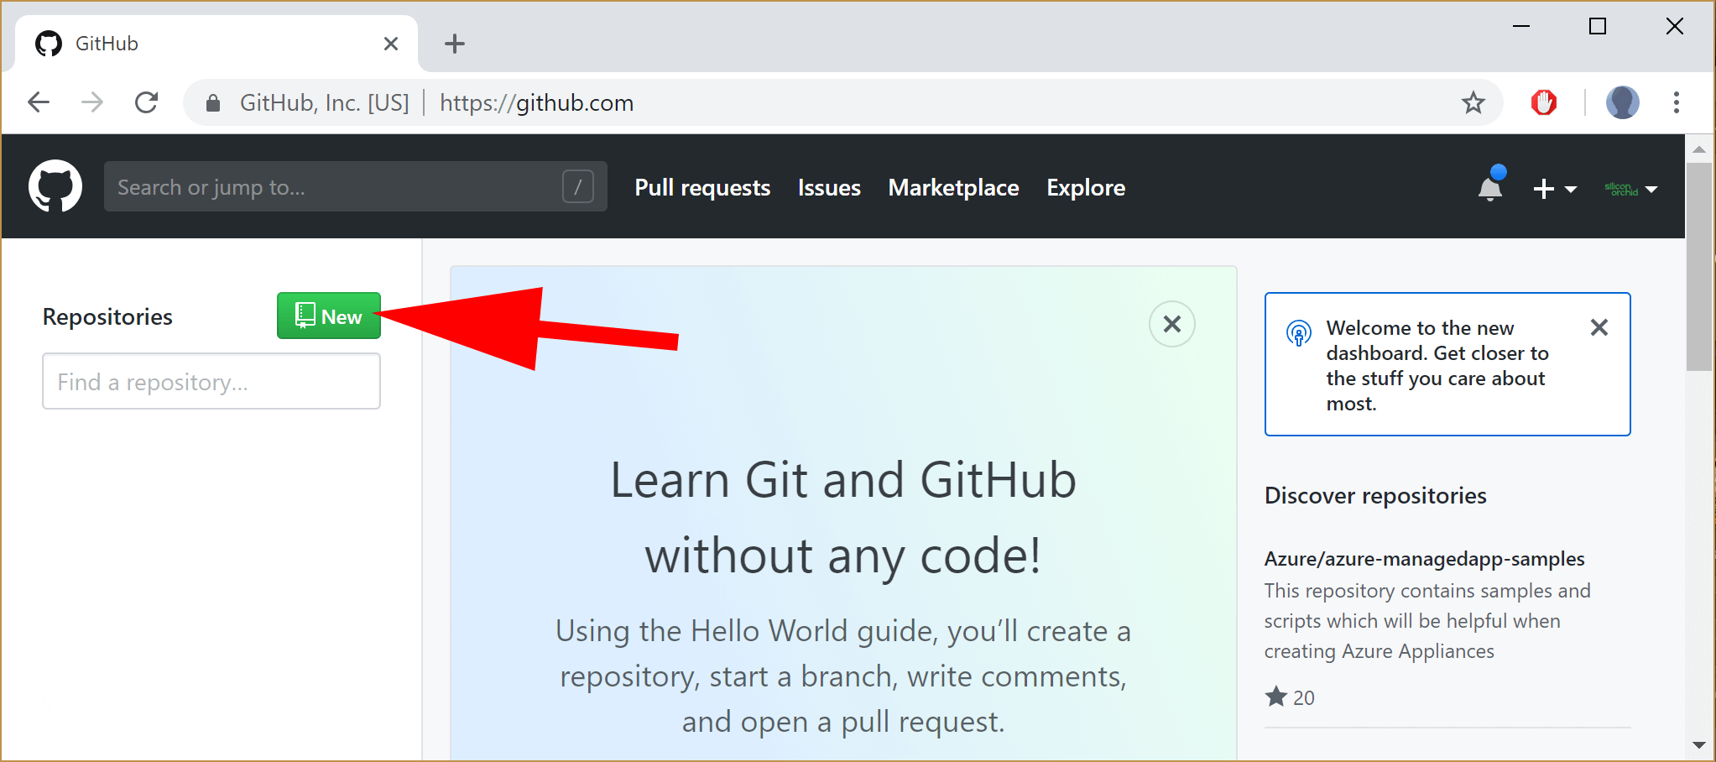

Cloning the Repository:
To clone a repository from GitHub:
- Go to the repository page on the GitHub website and copy the repository's URL.
- Open a terminal or command prompt on your local machine.
- Change to the directory where you want to clone the repository.
- Use the git clone command to clone the repository. For example:
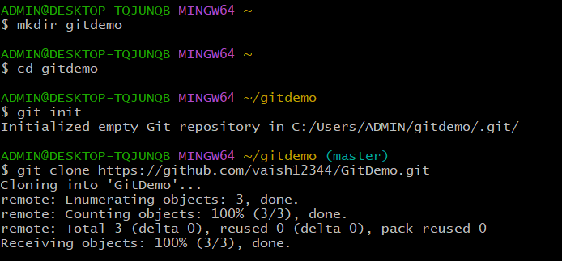

- Replace " https://github.com/vaish12344/GitDemo.git " with the URL of the repository that you copied in step 1.
- Press Enter to start the cloning process.
- When the cloning is complete, you will have a copy of the repository on your local machine, and you will be able to view the repository's code and make changes.
By following these steps, you should be able to clone a repository from GitHub to your local machine.
Pushing code to remote repository:
- Enter into your local repository
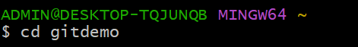
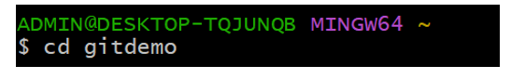

- In your local repository, use the git remote add command to add the GitHub repository as a remote.

- Create a new file that you want to push it into your remote repository and git status is used to check the status of the files:
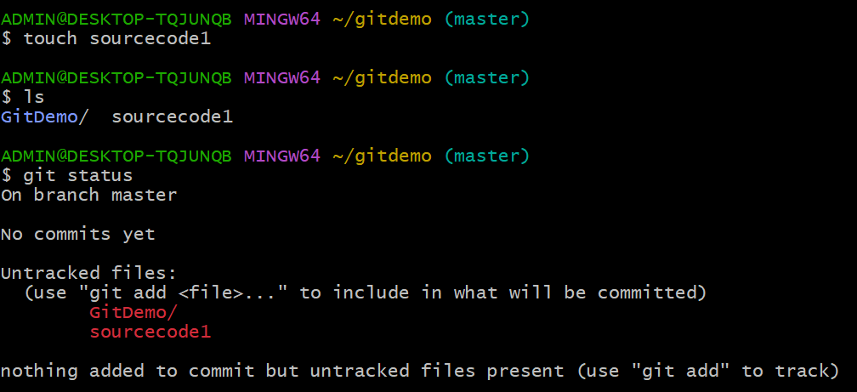
- Add the file (file1.txt) to the repository
- Commit the File and check the git status
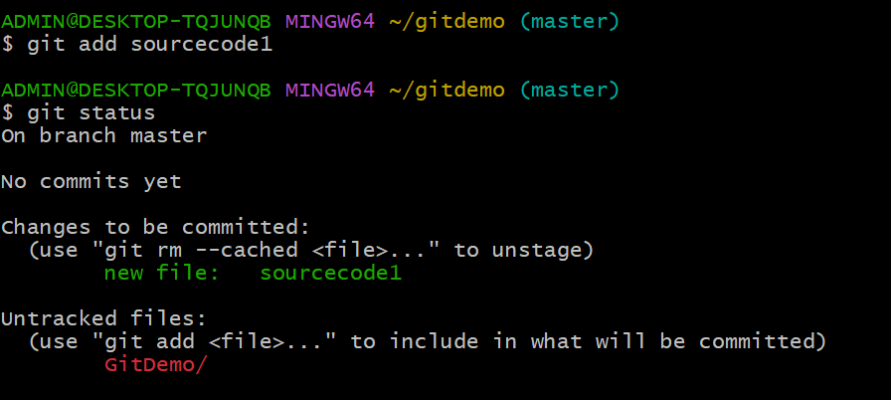
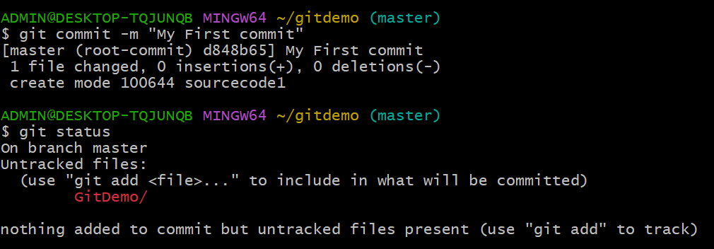

- Now push your code using git push origin command followed by your branch name (this case : Master)
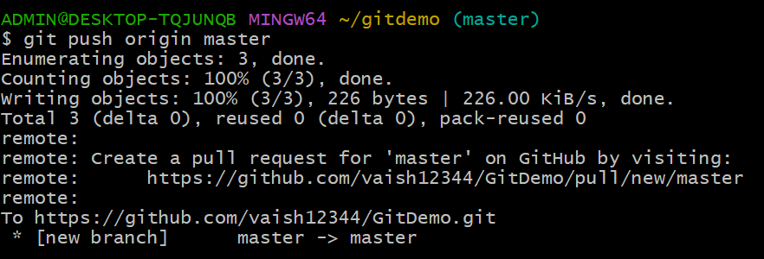
- Establish connection between Remote and Local repository
- Reload your github page (Remote Repository):

