**BUSINESS DATA MINING**

**(IDS 572)**

**Solutions to Homework 5**

**Group Members**

* Amey Pophali (apopha2@uic.edu)
* Karthik Varanasi (vvaran3@uic.edu)
* Mrinal Dhawan (mdhawa3@uic.edu)

**Problem 1 –**

|  |  |  |  |
| --- | --- | --- | --- |
| Status | Department | Age | Salary |
| Senior  Junior  Junior  Junior  Senior  Junior  Senior  Senior  Junior  Senior  Junior | Sales  Sales  Sales  Systems  Systems  Systems  Systems  Marketing  Marketing  Secretary  Secretary | 31-35  26-30  31-35  21-25  36-40  26-30  41-45  36-40  31-35  46-50  26-30 | 46K-50K 26K-30K 31K-35K 46K-50K 66K-70K 66K-70K 66K-70K 46K-50K 41K-45K 36K-40K 26K-30K |

**Solutions**

1. p(status):

p(Junior) = 6/11

P(Senior) = 5/11

1. P(department|status)

|  |  |
| --- | --- |
| **Department** | |
| P(Sales/Junior) | 1/3 |
| P(Sales/Senior) | 1/6 |
| P(Systems/Junior) | 1/3 |
| P(Systems/Senior) | 2/5 |
| P(Marketing/Junior) | 1/6 |
| P(Marketing/senior) | 1/5 |
| P(Secretary/Junior) | 1/6 |
| P(Secretary/Senior) | 1/5 |

P(age|status)

|  |  |
| --- | --- |
| **Age** | |
| P(21-25/Junior) | 1/6 |
| P(21-25/senior) | 0 |
| P(26-30/junior) | 1/2 |
| P(26-30/senior) | 0 |
| P(31-35/junior) | 1/3 |
| P(31-35/senior) | 1/5 |
| P(36-40/junior) | 0 |
| P(36-40/senior) | 2/5 |
| P(41-45/Junior) | 0 |
| P(41-45/senior) | 1/5 |
| P(46-50/senior) | 1/5 |
| P(46-50/junior) | 0 |

P(Salary|status)

|  |  |
| --- | --- |
| Salary | |
| P(26k-30k/Junior) | 1/3 |
| P(26k-30k/senior) | 0 |
| P(31k - 35k/ junior) | 1/6 |
| P(31k - 35k/ senior) | 0 |
| P(36k - 40k/ senior) | 1/5 |
| P(36k - 40k/ junior) | 0 |
| P(41k - 45k/ junior) | 1/6 |
| P(41k - 45k/ senior) | 0 |
| P(46k - 50k/ junior) | 1/6 |
| P(46k - 50k/ junior) | 2/5 |
| P(66k-70k/junior) | 1/6 |
| P(66k-70k/senior) | 2/5 |

1. A= *{*Marketing, 31-35, 46K-50K*}* and B= *{*Sales, 31-35, 66K-70K}

P(A) = P(Marketing, 31-35, 46K-50K)*P(Junior)+ P(Marketing, 31-35, 46K-50K)*P(senior)

= 1/11*6/11 +1/11*5/11 = 0.0123

P(B) = P(Sales, 31-35, 66K-70K)*P(Junior) + P(Sales, 31-35, 66K-70K)*P(Senior)

= 0.017

P(Junior|A) = P(A|Junior)*P(Junior)/p(A) = P(Marketing|Junior)*P(31-35|Junior)*P(46k-50k|junior)*P(Junior)/P(A)

= (1/6*1/5*1/6*6/11)/0.0123 = 0.24

P(Senior|A) = P(A|Senior)*P(Senior)/p(A) = P(Marketing| Senior)*P(31-35| Senior)*P(46k-50k| Senior)*P(Senior)/P(A)

= (1/5*1/5*2/5*5/11)/0.0123 = .42

P(Junior|B) = P(B|Junior)*P(Junior)/p(B) = P(Sales | Junior)*P(31-35| Junior)*P(66K-70K | Junior)*P(Junior)/P(B)

= (1/3*1/3*1/6*6/11)/0.017 = 0.59

P(Senior|B) = P(B| Senior)*P(Senior)/p(B) = P(Sales | Senior)*P(31-35| Senior)*P(66K-70K | Senior)*P(Senior)/P(B)

= (1/5*1/5*2/5*5/11)/0.017 = 0.42

1. New Table has Salary duplicate column:

|  |  |  |  |  |
| --- | --- | --- | --- | --- |
| Status | Department | Age | Salary | Salary_duplicate |
| Senior | Sales | 31-35 | 46K-50K | 46K-50K |
| Junior | Sales | 26-30 | 26K-30K | 26K-30K |
| Junior | Sales | 31-35 | 31K-35K | 31K-35K |
| Junior | Systems | 21-25 | 46K-50K | 46K-50K |
| Senior | Systems | 36-40 | 66K-70K | 66K-70K |
| Junior | Systems | 26-30 | 66K-70K | 66K-70K |
| Senior | Systems | 41-45 | 66K-70K | 66K-70K |
| Senior | Marketing | 36-40 | 46K-50K | 46K-50K |
| Junior | Marketing | 31-35 | 41K-45K | 41K-45K |
| Senior | Secretary | 46-50 | 36K-40K | 36K-40K |
| Junior | Secretary | 26-30 | 26K-30K | 26K-30K |

Now the new A and B are

A= *{*Marketing, 31-35, 46K-50K,46K-50K*}* and B= *{*Sales, 31-35, 66K-70K, 66K-70K }

P(A)= P(A|Junior)*P(Junior) + P(A|Senior)*P(Senior)

P(B)= P(B|Junior)*P(Junior) + P(B|Senior)*P(Senior)

1. c, d gives different results because there is an extra factor of the salary duplicate which gets multiplied to the probability. Hence we get a different result.

Drawing from this mathematical formula we can say that the extra factor of consideration that comes to the play with the addition of the salary which we consider as an attribute/condition to satisfy for constructing a classification model.

**Problem 2 –**

1. For the analysis of the Data, we followed the following steps:
2. Get the attributes of the data.

Code:

*#Check the dimensions of Data*

*dim(German.Credit)*

*# Check the Variabls of the Data*

*names(German.Credit)*

*str(German.Credit)*

Output:

The given data has 100 records in total and 32 variables (NOT considering the OBS field)

The names off the fields in the data are:

[1] "OBS" “CHK_ACCT" "DURATION" "HISTORY" "NEW_CAR"

[6] "USED_CAR" "FURNITURE" "RADIO.TV" "EDUCATION" "RETRAINING"

[11] "AMOUNT" "SAV_ACCT" "EMPLOYMENT" "INSTALL_RATE" "MALE_DIV"

[16] "MALE_SINGLE" "MALE_MAR_or_WID" "CO.APPLICANT" "GUARANTOR" "PRESENT_RESIDENT"

[21] "REAL_ESTATE" "PROP_UNKN_NONE" "AGE" "OTHER_INSTALL" "RENT"

[26] "OWN_RES" "NUM_CREDITS" "JOB" "NUM_DEPENDENTS" "TELEPHONE"

[31] "FOREIGN" "RESPONSE" "MALE_MAR_WID"

1. Check the data and how it is organized:

To check the data, we look at the actual records of the data using “head”.

Code:

*Head(German.Credit)* [German.Credit is the name of the dataset that we imported from the file)

1. Get the Summary Statistics of the data:

Snippet: *summary(German.Credit)*

Output:

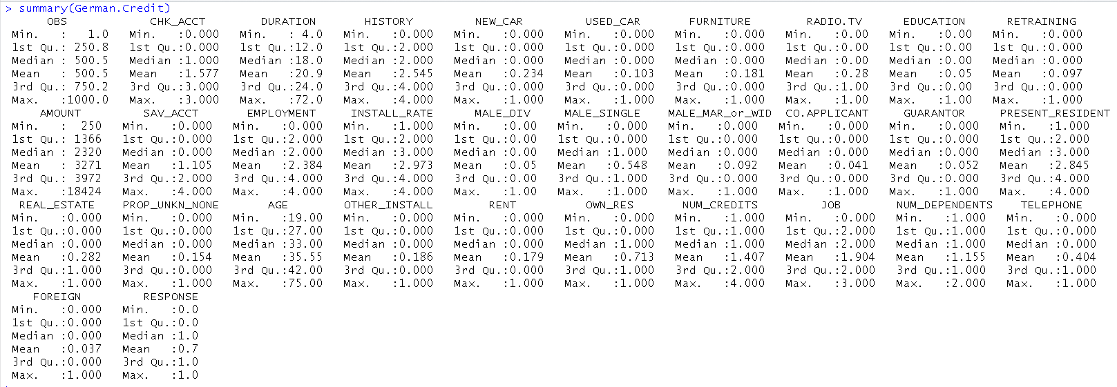

1. Get the number of Missing values in the Data

Code : *sapply(German.Credit, function(x) sum(is.na(x)))*

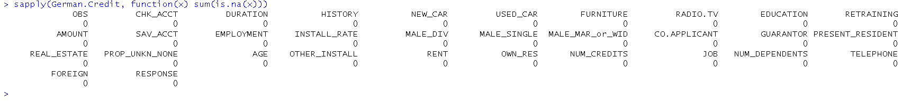

1. Get the Target variable details

Snippet:

*#Get the summary of Good and Bad Creditors*

*summary(German.Credit$RESPONSE)*

*#plot the frequencies*

*hist(German.Credit$RESPONSE)*

*# Get the number of good vs Bad credit risks*

*resp=table(German.Credit$RESPONSE)*

*t=as.data.frame(resp)*

*names(t)[1]='Credit Risk'*

*View(t)*

Output:

> summary(German.Credit$RESPONSE)

Min. 1st Qu. Median Mean 3rd Qu. Max.

0.0 0.0 1.0 0.7 1.0 1.0

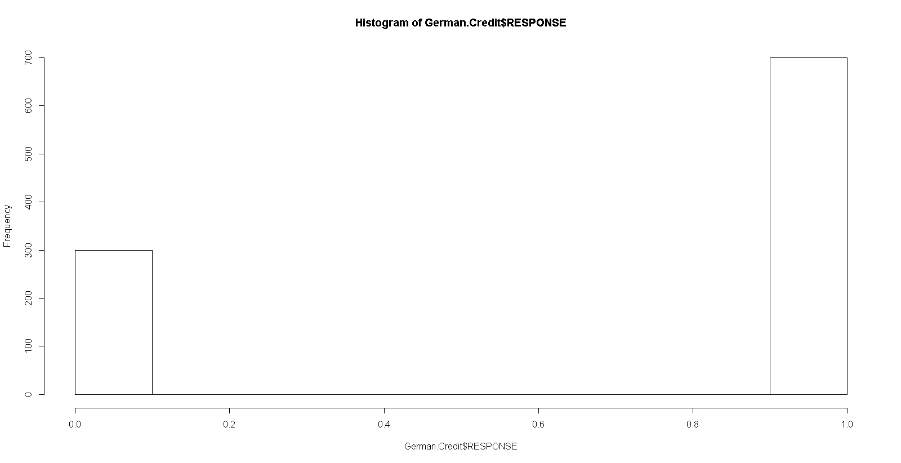

Tabular representation of the

|  | **Credit Risk** | **Freq** |  |
| --- | --- | --- | --- |
| **1** | **0** | **300** |
| **2** | **1** | **700** |

Going deeper into the data, we analysed the data in the following steps:

1. Aggregate the data based on the various variables and look at the distribution in each category

**Account (CHK_ACCT)**

Description: Checking account status

Type: Categorical

Description: The categories of the variable provided here are as follows -

0: < 0 DM

1: 0 < ...< 200 DM

2: => 200 DM

3: no checking account

Code:

*#Aggregate of the table based on the type of account*

*agg_acct=table(German.Credit$CHK_ACCT)*

*#look at the aggregation*

*View(agg_acct)*

|  |  |  |
| --- | --- | --- |
|  | Type | Frequency |
| **1** | 0 | 274 |
| **2** | 1 | 269 |
| **3** | 2 | 63 |
| **4** | 3 | 394 |

Code:

*# Split the data based onthe account type*

*split_acct= split(German.Credit,German.Credit$CHK_ACCT)*

*#look at the split data*

*#View(split_acct)*

*#Look for the distribution of 'Response' in each category of Account*

*dist_acct_0 = table(split_acct$`0`$RESPONSE)*

*dist_acct_1 = table(split_acct$`1`$RESPONSE)*

*dist_acct_2 = table(split_acct$`2`$RESPONSE)*

*dist_acct_3 = table(split_acct$`3`$RESPONSE)*

*#Look at the distribution*

*View(dist_acct_0)*

*View(dist_acct_1)*

*View(dist_acct_2)*

*View(dist_acct_3)*

Result:

Category :

|  |  |
| --- | --- |
| Category | Frequency |
|  |  |
| 0 | 274 |
| 1 | 269 |
| 2 | 63 |
| 3 | 394 |

Category 0 :

|  |  |
| --- | --- |
| Response | Frequency |
| 0 | 135 |
| 1 | 139 |

Category 1

|  |  |
| --- | --- |
| Response | Frequency |
| 0 | 105 |
| 1 | 164 |

Category 2

|  |  |
| --- | --- |
| Response | Frequency |
| 0 | 14 |
| 1 | 49 |

Category 3:

|  |  |
| --- | --- |
| Response | Frequency |
| 0 | 46 |
| 1 | 348 |

Inference:

By looking at the data, we can say that a significant number of people do not have a checking account. The number of people in the categories 0 and 1 are almost the same. The response variable for category 0 is equally distributed between 0 and 1. The highest disproportion of response variable could be seen in Category 3.

**HISTORY:**

Description: Credit history

Type: Categorical

Description: The categories of the variable provided here are as follows -

0: no credits taken

1: all credits at this bank paid back duly

2: existing credits paid back duly till now

3: delay in paying off in the past

4: critical account

Code:

*#Aggregate of the table based on the History*

*agg_hist=table(German.Credit$HISTORY)*

*#look at the aggregation*

*View(agg_hist)*

*# Split the data based onthe history*

*split_hist= split(German.Credit,German.Credit$HISTORY)*

*#look at the split data*

*#View(split_hist)*

*#Look for the distribution of 'Response' in each category of history*

*dist_hist_0 = table(split_hist$`0`$RESPONSE)*

*dist_hist_1 = table(split_hist$`1`$RESPONSE)*

*dist_hist_2 = table(split_hist$`2`$RESPONSE)*

*dist_hist_3 = table(split_hist$`3`$RESPONSE)*

*dist_hist_4 = table(split_hist$`4`$RESPONSE)*

*#Look at the distribution / QA the distribution*

*View(dist_hist_0)*

*View(dist_hist_1)*

*View(dist_hist_2)*

*View(dist_hist_3)*

*View(dist_hist_4)*

Results:

Category wise Aggregate:

|  |  |
| --- | --- |
| Category | Frequency |
| 0 | 40 |
| 1 | 49 |
| 2 | 530 |
| 3 | 88 |
| 4 | 293 |

Category 0:

|  |  |
| --- | --- |
| Response | Frequency |
| 0 | 25 |
| 1 | 15 |

Category 1:

|  |  |
| --- | --- |
| Response | Frequency |
| 0 | 28 |
| 1 | 21 |

Category 2:

|  |  |
| --- | --- |
| Response | Frequency |
| 0 | 169 |
| 1 | 361 |

Category 3:

|  |  |
| --- | --- |
| Response | Frequency |
| 0 | 28 |
| 1 | 60 |
|  |  |

Category 4:

|  |  |
| --- | --- |
| Response | Frequency |
| 0 | 50 |
| 1 | 243 |

Inference:

By looking at the data, we can say that a mostly all the existing credits are/were paid back duly till now. The number of people in the categories 0 and 1 are almost the same. A large portion(293) of the credit history is in ‘Critical Account Status’.

**EMPLOYMENT:**

Description: Present employment since

Type: Categorical

Description: The categories of the variable provided here are as follows -

0: unemployed

1: < 1 year

2: 1 <= ... < 4 years

3: 4 <=... < 7 years

4: >= 7 years

Code:

*#Aggregate of the table based on the Employment*

*agg_emp=table(German.Credit$EMPLOYMENT)*

*#look at the aggregation*

*View(agg_emp)*

*# Split the data based onthe history*

*split_emp= split(German.Credit,German.Credit$EMPLOYMENT)*

*#look at the split data*

*#View(split_emp)*

*#Look for the distribution of 'Response' in each category of EMPLOYMENT*

*dist_emp_0 = table(split_emp$`0`$RESPONSE)*

*dist_emp_1 = table(split_emp$`1`$RESPONSE)*

*dist_emp_2 = table(split_emp$`2`$RESPONSE)*

*dist_emp_3 = table(split_emp$`3`$RESPONSE)*

*dist_emp_4 = table(split_emp$`4`$RESPONSE)*

*#Look at the distribution / QA the distribution*

*View(dist_emp_0)*

*View(dist_emp_1)*

*View(dist_emp_2)*

*View(dist_emp_3)*

*View(dist_emp_4)*

Category wise agg:

|  |  |
| --- | --- |
| Category | Frequency |
| 0 | 62 |
| 1 | 172 |
| 2 | 339 |
| 3 | 174 |
| 4 | 253 |

Category 0:

|  |  |
| --- | --- |
| Response | Frequency |
| 0 | 23 |
| 1 | 39 |

Category 1:

|  |  |
| --- | --- |
| Response | Frequency |
| 0 | 70 |
| 1 | 102 |

Category 2:

|  |  |
| --- | --- |
| Response | Frequency |
| 0 | 104 |
| 1 | 235 |

Category 3:

|  |  |
| --- | --- |
| Response | Frequency |
| 0 | 39 |
| 1 | 135 |

Category 4:

|  |  |
| --- | --- |
| Response | Frequency |
| 0 | 64 |
| 1 | 189 |

Inference:

By looking at the data, we can say that almost everyone is currently employed. Looking at the data above, we can infer that 938 are employed against 62 unemployed. Most number of employments are in the category 2 i.e. 1 <= ... < 4 years.

**RESIDENCE STATUS (PRESENT_RESIDENT):**

Description: Present resident since - years

Type: Categorical

Description: The categories of the variable provided here are as follows -

0: <= 1 year

1: <=2 years

2: 2<…<=3 years

3: > 4years

Code:

#Aggregate of the table based on the Present residence status

agg_res=table(German.Credit$PRESENT_RESIDENT)

#look at the aggregation

View(agg_res)

# Split the data based onthe history

split_res= split(German.Credit,German.Credit$PRESENT_RESIDENT)

#look at the split data

#View(split_res)

#Look for the distribution of 'Response' in each category of EMPLOYMENT

dist_res_0 = table(split_res$`0`$RESPONSE)

dist_res_1 = table(split_res$`1`$RESPONSE)

dist_res_2 = table(split_res$`2`$RESPONSE)

dist_res_3 = table(split_res$`3`$RESPONSE)

#Look at the distribution / QA the distribution

View(dist_res_0)

View(dist_res_1)

View(dist_res_2)

View(dist_res_3)

Results:

Category wise agg:

|  |  |
| --- | --- |
| Category | Frequency |
| 1 | 130 |
| 2 | 308 |
| 3 | 149 |
| 4 | 413 |
|  |  |

Category 1:

|  |  |
| --- | --- |
| Response | Frequency |
| 0 | 36 |
| 1 | 94 |

Category 2:

|  |  |
| --- | --- |
| Response | Frequency |
| 0 | 97 |
| 1 | 211 |

Category 3:

|  |  |
| --- | --- |
| Response | Frequency |
| 0 | 43 |
| 1 | 106 |

Category 4:

|  |  |
| --- | --- |
| Response | Frequency |
| 0 | 124 |
| 1 | 289 |

Inference:

By looking at the data, we can see that category 4 (> 4years) of residence has the most number of records, followed by the category 2 (<=2 years) of residence. Incidentally, the residence status of category 1 and category 3 is identical with values nearing ~150.

**JOB:**

Description: Nature of job

Type: Categorical

Description: The categories of the variable provided here are as follows -

0: unemployed/unskilled/non-resident

1: unskilled-resident

2: skilled employee / official

3: management/self-employed/highly qualified employee/officer

Code:

*#Aggregate of the table based on the Job*

*agg_job=table(German.Credit$JOB)*

*#look at the aggregation*

*View(agg_job)*

*# Split the data based onthe history*

*split_job= split(German.Credit,German.Credit$JOB)*

*#Look for the distribution of 'Response' in each category of EMPLOYMENT*

*dist_job_0 = table(split_job$`0`$RESPONSE)*

*dist_job_1 = table(split_job$`1`$RESPONSE)*

*dist_job_2 = table(split_job$`2`$RESPONSE)*

*dist_job_3 = table(split_job$`3`$RESPONSE)*

*#Look at the distribution / QA the distribution*

*View(dist_job_0)*

*View(dist_job_1)*

*View(dist_job_2)*

*View(dist_job_3)*

*#Look at the distribution / QA the distribution*

*View(dist_res_0)*

*View(dist_res_1)*

*View(dist_res_2)*

*View(dist_res_3)*

Results:

Category wise agg:

|  |  |
| --- | --- |
| Category | Frequency |
| 0 | 22 |
| 1 | 200 |
| 2 | 630 |
| 3 | 148 |

Category01:

|  |  |
| --- | --- |
| Response | Frequency |
| 0 | 7 |
| 1 | 15 |

Category 1:

|  |  |
| --- | --- |
| Response | Frequency |
| 0 | 56 |
| 1 | 144 |

Category 2:

|  |  |
| --- | --- |
| Response | Frequency |
| 0 | 186 |
| 1 | 444 |

Category 3:

|  |  |
| --- | --- |
| Response | Frequency |
| 0 | 51 |
| 1 | 97 |

Inference:

By looking at the data, we can infer that most number of jobs are of the category 2 (skilled employee / official) with number 630. There are very less number of people who fall in the category 0 i.e. unemployed/unskilled/non-resident (22). This is very less when compared to total of 978 total jobs.

**FOREIGN:**

Description: Foreign worker

Type: Binary

Description: The categories of the variable provided here are as follows -

0: No

1: Yes

Code:

*#Aggregate of the table based on the Nationality*

*agg_frn=table(German.Credit$FOREIGN)*

*#look at the aggregation*

*View(agg_frn)*

*# Split the data based onthe history*

*split_frn= split(German.Credit,German.Credit$FOREIGN)*

*#Look for the distribution of 'Response' in each category of EMPLOYMENT*

*dist_frn_0 = table(split_frn$`0`$RESPONSE)*

*dist_frn_1 = table(split_frn$`1`$RESPONSE)*

*#Look at the distribution / QA the distribution*

*View(dist_frn_0)*

*View(dist_frn_1)*

Results:

Category wise agg:

|  |  |
| --- | --- |
| Category | Frequency |
| 0 | 963 |
| 1 | 37 |

Category01:

|  |  |
| --- | --- |
| Response | Frequency |
| 0 | 296 |
| 1 | 667 |

Category 1:

|  |  |
| --- | --- |
| Response | Frequency |
| 0 | 4 |
| 1 | 33 |

Inference:

By looking at the data, we can infer that for every 1000 people working, we have 963 people who are residents of the nation vs 37 people who are foreigners.

1. Incomplete Answer.

The main variables that we seemed as important are:

"CHK_ACCT","DURATION","HISTORY", "OBS","SAV_ACCT", "OTHER_INSTALL"

The Misclassification error rate of using the following model is: 0.235 = 235 / 1000

As the variables are considered as continuous variables, before everything, we convert the variable into respective factors. This is achieved by using the following code:

**Code:**

*#Look at the data*

*str(German.Credit)*

*#observe that the values are taken as continous values but actually they are categorical.*

*#Converting them to categorical values*

*German.Credit$RESPONSE= factor(German.Credit$RESPONSE)*

*German.Credit$FOREIGN = factor(German.Credit$FOREIGN)*

*German.Credit$TELEPHONE = factor (German.Credit$TELEPHONE)*

*German.Credit$JOB = factor(German.Credit$JOB)*

*German.Credit$OWN_RES = factor(German.Credit$OWN_RES)*

*German.Credit$RENT = factor(German.Credit$RENT)*

*German.Credit$OTHER_INSTALL = factor(German.Credit$OTHER_INSTALL)*

*German.Credit$PROP_UNKN_NONE = factor(German.Credit$PROP_UNKN_NONE)*

*German.Credit$REAL_ESTATE = factor(German.Credit$REAL_ESTATE)*

*German.Credit$PRESENT_RESIDENT = factor(German.Credit$PRESENT_RESIDENT)*

*German.Credit$GUARANTOR = factor(German.Credit$GUARANTOR)*

*German.Credit$CO.APPLICANT = factor(German.Credit$CO.APPLICANT)*

*German.Credit$MALE_MAR_WID = factor(German.Credit$MALE_MAR_or_WID)*

*German.Credit$MALE_SINGLE = factor(German.Credit$MALE_SINGLE)*

*German.Credit$MALE_DIV = factor(German.Credit$MALE_DIV)*

*German.Credit$EMPLOYMENT = factor(German.Credit$EMPLOYMENT)*

*German.Credit$SAV_ACCT = factor(German.Credit$SAV_ACCT)*

*German.Credit$RETRAINING = factor(German.Credit$RETRAINING)*

*German.Credit$EDUCATION = factor(German.Credit$EDUCATION)*

*German.Credit$RADIO.TV = factor(German.Credit$RADIO.TV)*

*German.Credit$FURNITURE = factor(German.Credit$FURNITURE)*

*German.Credit$USED_CAR = factor(German.Credit$USED_CAR)*

*German.Credit$NEW_CAR = factor(German.Credit$NEW_CAR)*

*German.Credit$HISTORY = factor(German.Credit$HISTORY)*

*German.Credit$CHK_ACCT = factor(German.Credit$CHK_ACCT)*

**Plot the Decision Tree:**

Code:

*# Plot the Decision Tree*

*fit = rpart(German.Credit$RESPONSE ~ . , method="class", data = German.Credit[,2:32])*

*plot(fit, uniform = T,main ='Decision tree with Entropy impurity function')*

*text(fit, use.n = T, all = T, cex = 0.7, xpd = T)*

*summary(fit)*

**Graph:**

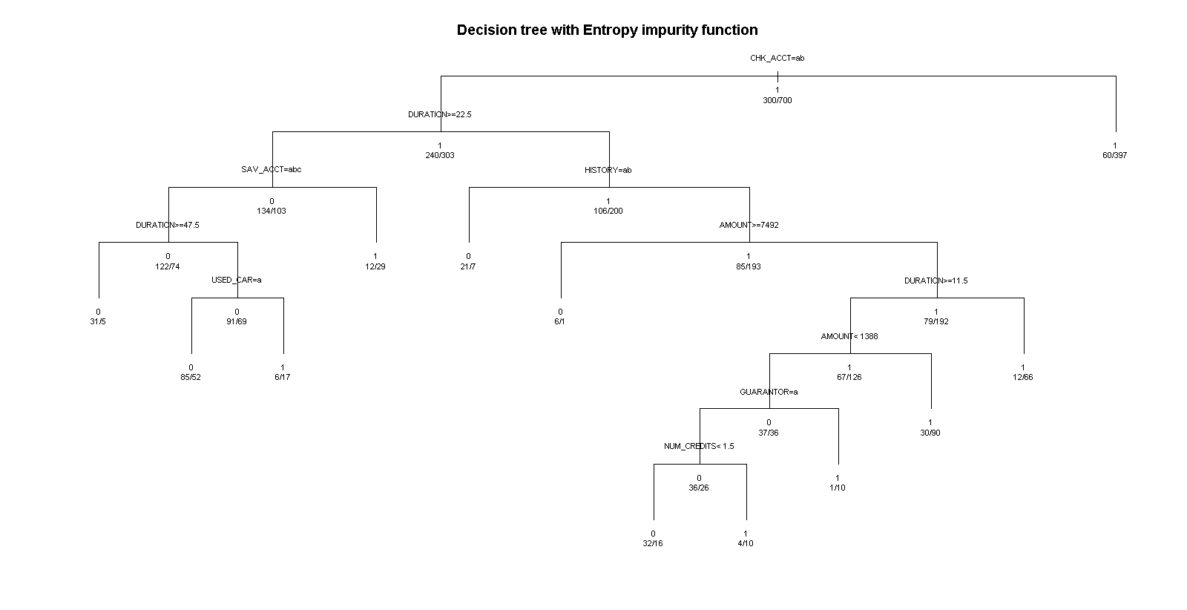

**For the classification tree, the following are the summary statistics obtained from summary(fit)**

rpart(formula = German.Credit$RESPONSE ~ ., data = German.Credit[,

2:32], method = "class")

n= 1000

CP nsplit rel error xerror xstd

1 0.05166667 0 1.0000000 1.0000000 0.04830459

2 0.04666667 3 0.8400000 1.0033333 0.04835046

3 0.01833333 4 0.7933333 0.8666667 0.04623611

4 0.01666667 6 0.7566667 0.8366667 0.04570424

5 0.01111111 7 0.7400000 0.8200000 0.04539750

6 0.01000000 11 0.6866667 0.8466667 0.04588440

Variable importance

CHK_ACCT DURATION HISTORY AMOUNT SAV_ACCT USED_CAR GUARANTOR

33 15 12 12 10 4 3

NUM_CREDITS PRESENT_RESIDENT PROP_UNKN_NONE RADIO.TV EMPLOYMENT AGE REAL_ESTATE

2 2 2 2 1 1 1

JOB

1

Node number 1: 1000 observations, complexity param=0.05166667

predicted class=1 expected loss=0.3 P(node) =1

class counts: 300 700

probabilities: 0.300 0.700

left son=2 (543 obs) right son=3 (457 obs)

Primary splits:

CHK_ACCT splits as LLRR, improve=47.90962, (0 missing)

HISTORY splits as LLRRR, improve=17.06212, (0 missing)

SAV_ACCT splits as LLRRR, improve=14.80642, (0 missing)

DURATION < 34.5 to the right, improve=13.62155, (0 missing)

AMOUNT < 3913.5 to the right, improve=11.32017, (0 missing)

Surrogate splits:

SAV_ACCT splits as LLRRR, agree=0.611, adj=0.149, (0 split)

HISTORY splits as LLLLR, agree=0.592, adj=0.107, (0 split)

PRESENT_RESIDENT splits as LRLL, agree=0.567, adj=0.053, (0 split)

RADIO.TV splits as LR, agree=0.565, adj=0.048, (0 split)

EMPLOYMENT splits as LLLLR, agree=0.554, adj=0.024, (0 split)

Node number 2: 543 observations, complexity param=0.05166667

predicted class=1 expected loss=0.441989 P(node) =0.543

class counts: 240 303

probabilities: 0.442 0.558

left son=4 (237 obs) right son=5 (306 obs)

Primary splits:

DURATION < 22.5 to the right, improve=12.810640, (0 missing)

HISTORY splits as LLRRR, improve= 9.653787, (0 missing)

REAL_ESTATE splits as LR, improve= 9.181363, (0 missing)

SAV_ACCT splits as LLRRR, improve= 8.890786, (0 missing)

AMOUNT < 8079 to the right, improve= 6.601270, (0 missing)

Surrogate splits:

AMOUNT < 2805.5 to the right, agree=0.748, adj=0.422, (0 split)

PROP_UNKN_NONE splits as RL, agree=0.643, adj=0.181, (0 split)

HISTORY splits as LLRLR, agree=0.610, adj=0.105, (0 split)

USED_CAR splits as RL, agree=0.599, adj=0.080, (0 split)

REAL_ESTATE splits as LR, agree=0.597, adj=0.076, (0 split)

Node number 3: 457 observations

predicted class=1 expected loss=0.131291 P(node) =0.457

class counts: 60 397

probabilities: 0.131 0.869

Node number 4: 237 observations, complexity param=0.05166667

predicted class=0 expected loss=0.4345992 P(node) =0.237

class counts: 134 103

probabilities: 0.565 0.435

left son=8 (196 obs) right son=9 (41 obs)

Primary splits:

SAV_ACCT splits as LLLRR, improve=7.374515, (0 missing)

USED_CAR splits as LR, improve=4.129437, (0 missing)

AMOUNT < 1381.5 to the left, improve=3.289316, (0 missing)

INSTALL_RATE < 2.5 to the right, improve=3.067516, (0 missing)

DURATION < 43.5 to the right, improve=2.564920, (0 missing)

Node number 5: 306 observations, complexity param=0.04666667

predicted class=1 expected loss=0.3464052 P(node) =0.306

class counts: 106 200

probabilities: 0.346 0.654

left son=10 (28 obs) right son=11 (278 obs)

Primary splits:

HISTORY splits as LLRRR, improve=10.040510, (0 missing)

REAL_ESTATE splits as LR, improve= 5.585685, (0 missing)

GUARANTOR splits as LR, improve= 3.782059, (0 missing)

DURATION < 11.5 to the right, improve= 3.766531, (0 missing)

AMOUNT < 7491.5 to the right, improve= 3.737438, (0 missing)

Node number 8: 196 observations, complexity param=0.01833333

predicted class=0 expected loss=0.377551 P(node) =0.196

class counts: 122 74

probabilities: 0.622 0.378

left son=16 (36 obs) right son=17 (160 obs)

Primary splits:

DURATION < 47.5 to the right, improve=5.023838, (0 missing)

USED_CAR splits as LR, improve=4.598639, (0 missing)

INSTALL_RATE < 2.5 to the right, improve=2.682485, (0 missing)

PRESENT_RESIDENT splits as RLRL, improve=2.610062, (0 missing)

AMOUNT < 11788 to the right, improve=2.516732, (0 missing)

Surrogate splits:

AMOUNT < 13319.5 to the right, agree=0.837, adj=0.111, (0 split)

Node number 9: 41 observations

predicted class=1 expected loss=0.2926829 P(node) =0.041

class counts: 12 29

probabilities: 0.293 0.707

Node number 10: 28 observations

predicted class=0 expected loss=0.25 P(node) =0.028

class counts: 21 7

probabilities: 0.750 0.250

Node number 11: 278 observations, complexity param=0.01666667

predicted class=1 expected loss=0.3057554 P(node) =0.278

class counts: 85 193

probabilities: 0.306 0.694

left son=22 (7 obs) right son=23 (271 obs)

Primary splits:

AMOUNT < 7491.5 to the right, improve=4.366338, (0 missing)

DURATION < 11.5 to the right, improve=3.840775, (0 missing)

REAL_ESTATE splits as LR, improve=3.589042, (0 missing)

EMPLOYMENT splits as LLLRL, improve=3.449347, (0 missing)

HISTORY splits as --LRR, improve=2.954088, (0 missing)

Node number 16: 36 observations

predicted class=0 expected loss=0.1388889 P(node) =0.036

class counts: 31 5

probabilities: 0.861 0.139

Node number 17: 160 observations, complexity param=0.01833333

predicted class=0 expected loss=0.43125 P(node) =0.16

class counts: 91 69

probabilities: 0.569 0.431

left son=34 (137 obs) right son=35 (23 obs)

Primary splits:

USED_CAR splits as LR, improve=5.092387, (0 missing)

AMOUNT < 2313 to the left, improve=3.402464, (0 missing)

INSTALL_RATE < 2.5 to the right, improve=2.374236, (0 missing)

NEW_CAR splits as RL, improve=2.000321, (0 missing)

AGE < 57.5 to the left, improve=1.711184, (0 missing)

Surrogate splits:

AGE < 62 to the left, agree=0.862, adj=0.043, (0 split)

Node number 22: 7 observations

predicted class=0 expected loss=0.1428571 P(node) =0.007

class counts: 6 1

probabilities: 0.857 0.143

Node number 23: 271 observations, complexity param=0.01111111

predicted class=1 expected loss=0.2915129 P(node) =0.271

class counts: 79 192

probabilities: 0.292 0.708

left son=46 (193 obs) right son=47 (78 obs)

Primary splits:

DURATION < 11.5 to the right, improve=4.151402, (0 missing)

AMOUNT < 1373 to the left, improve=3.770882, (0 missing)

EDUCATION splits as RL, improve=3.465097, (0 missing)

EMPLOYMENT splits as LLLRL, improve=2.956763, (0 missing)

REAL_ESTATE splits as LR, improve=2.672491, (0 missing)

Surrogate splits:

AMOUNT < 527.5 to the right, agree=0.742, adj=0.103, (0 split)

FOREIGN splits as LR, agree=0.723, adj=0.038, (0 split)

AGE < 66.5 to the left, agree=0.720, adj=0.026, (0 split)

Node number 34: 137 observations

predicted class=0 expected loss=0.379562 P(node) =0.137

class counts: 85 52

probabilities: 0.620 0.380

Node number 35: 23 observations

predicted class=1 expected loss=0.2608696 P(node) =0.023

class counts: 6 17

probabilities: 0.261 0.739

Node number 46: 193 observations, complexity param=0.01111111

predicted class=1 expected loss=0.3471503 P(node) =0.193

class counts: 67 126

probabilities: 0.347 0.653

left son=92 (73 obs) right son=93 (120 obs)

Primary splits:

AMOUNT < 1387.5 to the left, improve=5.988715, (0 missing)

CHK_ACCT splits as LR--, improve=2.224992, (0 missing)

EMPLOYMENT splits as LLLRL, improve=2.084052, (0 missing)

GUARANTOR splits as LR, improve=1.966915, (0 missing)

SAV_ACCT splits as LLRRL, improve=1.963817, (0 missing)

Surrogate splits:

INSTALL_RATE < 3.5 to the right, agree=0.658, adj=0.096, (0 split)

JOB splits as RLRR, agree=0.658, adj=0.096, (0 split)

AGE < 21.5 to the left, agree=0.653, adj=0.082, (0 split)

DURATION < 12.5 to the left, agree=0.648, adj=0.068, (0 split)

EDUCATION splits as RL, agree=0.642, adj=0.055, (0 split)

Node number 47: 78 observations

predicted class=1 expected loss=0.1538462 P(node) =0.078

class counts: 12 66

probabilities: 0.154 0.846

Node number 92: 73 observations, complexity param=0.01111111

predicted class=0 expected loss=0.4931507 P(node) =0.073

class counts: 37 36

probabilities: 0.507 0.493

left son=184 (62 obs) right son=185 (11 obs)

Primary splits:

GUARANTOR splits as LR, improve=4.481420, (0 missing)

REAL_ESTATE splits as LR, improve=4.304126, (0 missing)

NUM_CREDITS < 1.5 to the left, improve=3.050656, (0 missing)

NEW_CAR splits as RL, improve=2.394020, (0 missing)

JOB splits as LRLR, improve=2.001678, (0 missing)

Node number 93: 120 observations

predicted class=1 expected loss=0.25 P(node) =0.12

class counts: 30 90

probabilities: 0.250 0.750

Node number 184: 62 observations, complexity param=0.01111111

predicted class=0 expected loss=0.4193548 P(node) =0.062

class counts: 36 26

probabilities: 0.581 0.419

left son=368 (48 obs) right son=369 (14 obs)

Primary splits:

NUM_CREDITS < 1.5 to the left, improve=3.145929, (0 missing)

REAL_ESTATE splits as LR, improve=2.621642, (0 missing)

HISTORY splits as --LRR, improve=2.451005, (0 missing)

PRESENT_RESIDENT splits as LLLR, improve=2.105829, (0 missing)

OTHER_INSTALL splits as RL, improve=2.000676, (0 missing)

Surrogate splits:

HISTORY splits as --LRR, agree=0.887, adj=0.500, (0 split)

AMOUNT < 612 to the right, agree=0.823, adj=0.214, (0 split)

CO.APPLICANT splits as LR, agree=0.790, adj=0.071, (0 split)

AGE < 54.5 to the left, agree=0.790, adj=0.071, (0 split)

JOB splits as RLLL, agree=0.790, adj=0.071, (0 split)

Node number 185: 11 observations

predicted class=1 expected loss=0.09090909 P(node) =0.011

class counts: 1 10

probabilities: 0.091 0.909

Node number 368: 48 observations

predicted class=0 expected loss=0.3333333 P(node) =0.048

class counts: 32 16

probabilities: 0.667 0.333

Node number 369: 14 observations

predicted class=1 expected loss=0.2857143 P(node) =0.014

class counts: 4 10

probabilities: 0.286 0.714

1. Building a tree for 50% Test and 50 % Training dataset.

Code:

*ind = sample(2, nrow(German.Credit), replace = T, prob = c(0.5, 0.5))*

*GCTrain=German.Credit[ind==1,]*

*GCTest=German.Credit[ind==2,]*

*GCTrain4rpart = GCTrain[,2:32]*

*formula=as.formula(German.Credit$RESPONSE~DURATION+HISTORY+AMOUNT+SAV_ACCT+USED_CAR+GUARANTOR+NUM_CREDITS+PRESENT_RESIDENT+PROP_UNKN_NONE+RADIO.TV+EMPLOYMENT+AGE+REAL_ESTATE+JOB)*

*fit = rpart(RESPONSE ~ ., method="class", data=GCTrain[,2:33])*

*plot(fit, uniform = T,main ='Decision tree with 50 % Taining and 50% Test')*

*text(fit, use.n = T, all = T, cex = 0.7, xpd = T)*

*printcp(fit)*

Graph:

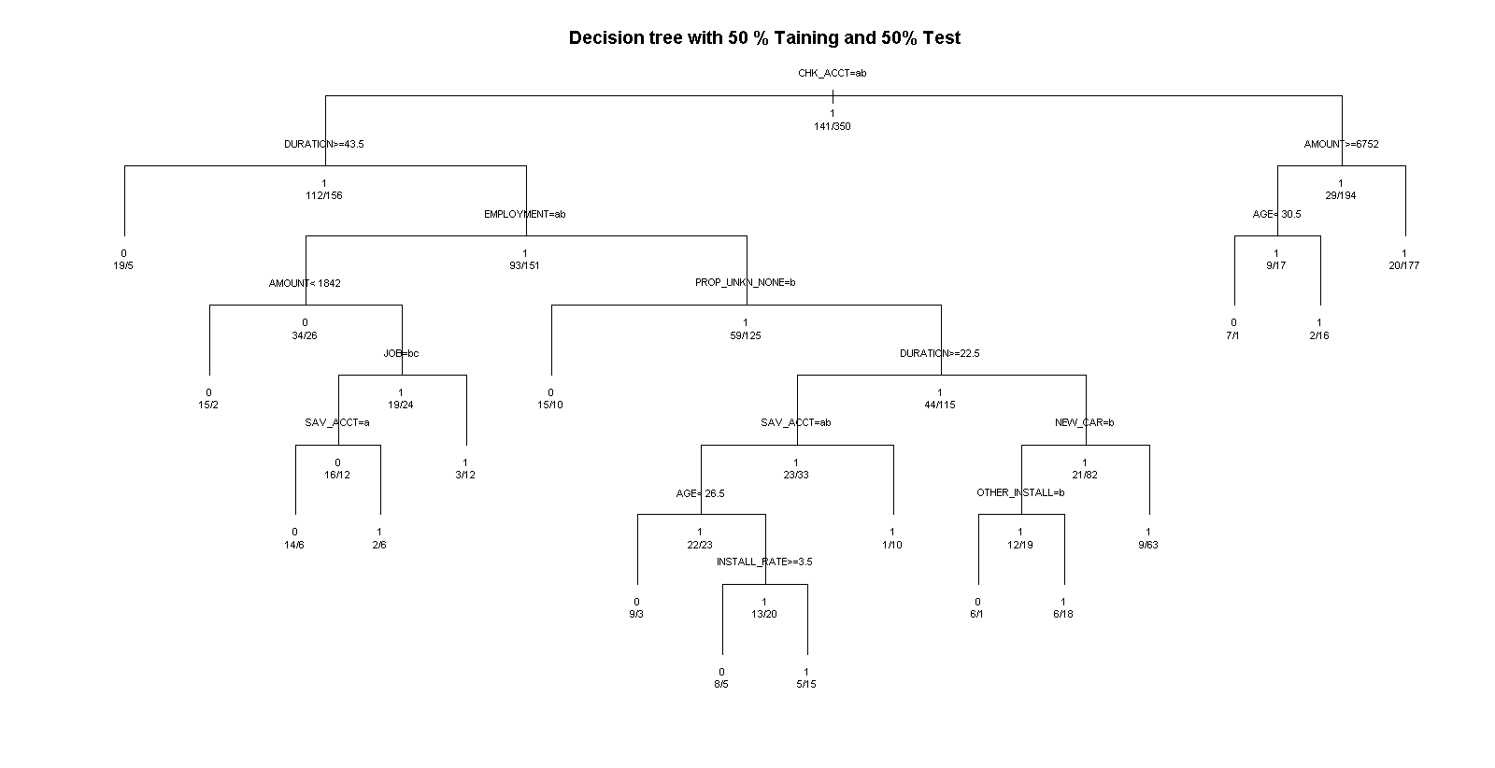

**Output:**

|  |
| --- |
| printcp(fit)  Classification tree:  rpart(formula = RESPONSE ~ ., data = GCTrain[, 2:33], method = "class")  Variables actually used in tree construction:  [1] AGE AMOUNT CHK_ACCT DURATION EMPLOYMENT INSTALL_RATE JOB NEW_CAR  [9] OTHER_INSTALL PROP_UNKN_NONE SAV_ACCT  Root node error: 141/491 = 0.28717  n= 491  CP nsplit rel error xerror xstd  1 0.049645 0 1.00000 1.00000 0.071102  2 0.035461 3 0.84397 1.04965 0.072114  3 0.028369 5 0.77305 1.02837 0.071691  4 0.021277 7 0.71631 1.00709 0.071252  5 0.015603 9 0.67376 0.97163 0.070486  6 0.010000 15 0.57447 0.99291 0.070951 |
|  |

**After Pruning:**

**Code:**

*opt = which.min(fit$cptable[,"xerror"])*

*cp = fit$cptable[opt, "CP"]*

*tree.prune = prune(fit, cp = cp)*

*plot(tree.prune, uniform = T, main = "Pruned rpart decision tree with Entropy impurity function")*

*text(tree.prune, use.n = T, xpd = T )*

**Plot:**

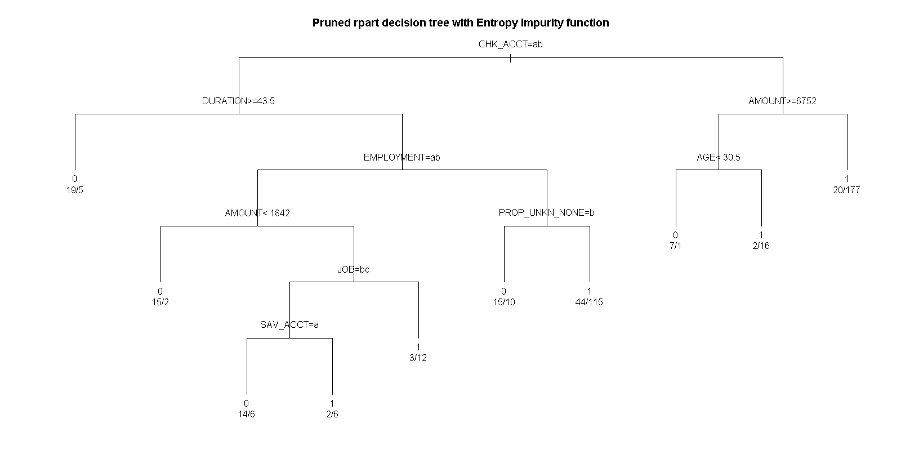

**Output:**

printcp(fit)

Classification tree:

rpart(formula = RESPONSE ~ ., data = GCTrain[, 2:33], method = "class")

Variables actually used in tree construction:

[1] AGE AMOUNT CHK_ACCT DURATION EMPLOYMENT INSTALL_RATE JOB NEW_CAR

[9] OTHER_INSTALL PROP_UNKN_NONE SAV_ACCT

Root node error: 141/491 = 0.28717

n= 491

CP nsplit rel error xerror xstd

1 0.049645 0 1.00000 1.00000 0.071102

2 0.035461 3 0.84397 1.04965 0.072114

3 0.028369 5 0.77305 1.02837 0.071691

4 0.021277 7 0.71631 1.00709 0.071252

5 0.015603 9 0.67376 0.97163 0.070486

6 0.010000 15 0.57447 0.99291 0.070951

**With Training= 70 % and Testing = 30 %**

Code:

# Training = 70% testing=30%

ind = sample(2, nrow(German.Credit), replace = T, prob = c(0.7, 0.3))

GCTrain=German.Credit[ind==1,]

GCTest=German.Credit[ind==2,]

fit = rpart(RESPONSE ~ ., method="class", data = GCTrain[,2:33])

plot(fit, uniform = T,main ='Decision tree with 70 % Taining and 30% Test')

text(fit, use.n = T, all = T, cex = 0.7, xpd = T)

printcp(fit)

Plot:

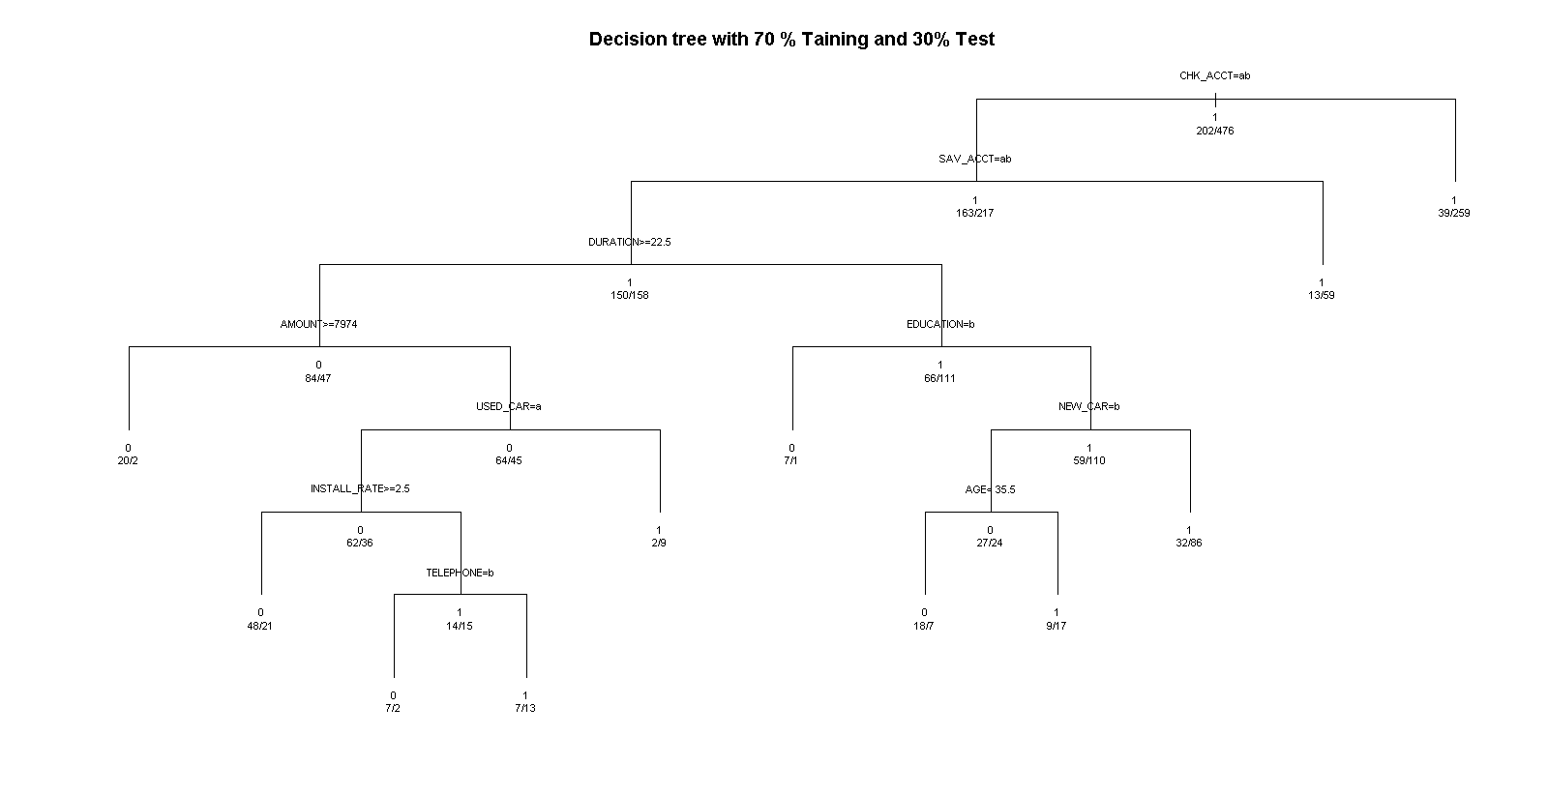

Output:

Classification tree:

rpart(formula = RESPONSE ~ ., data = GCTrain[, 2:33], method = "class")

Variables actually used in tree construction:

[1] AGE AMOUNT CHK_ACCT DURATION EDUCATION INSTALL_RATE NEW_CAR SAV_ACCT TELEPHONE

[10] USED_CAR

Root node error: 202/678 = 0.29794

n= 678

CP nsplit rel error xerror xstd

1 0.061056 0 1.00000 1.00000 0.058954

2 0.029703 3 0.81683 0.91089 0.057320

3 0.027228 4 0.78713 0.88614 0.056821

4 0.017327 6 0.73267 0.88119 0.056719

5 0.014851 8 0.69802 0.91584 0.057417

6 0.010000 10 0.66832 0.93564 0.057799

**Pruning:**

Code:

#Pruning

opt = which.min(fit$cptable[,"xerror"])

cp = fit$cptable[opt, "CP"]

tree.prune = prune(fit, cp = cp)

plot(tree.prune, uniform = T, main = "Pruned rpart decision tree with Entropy impurity function")

text(tree.prune, use.n = T, xpd = T )

printcp(fit)

Plot:

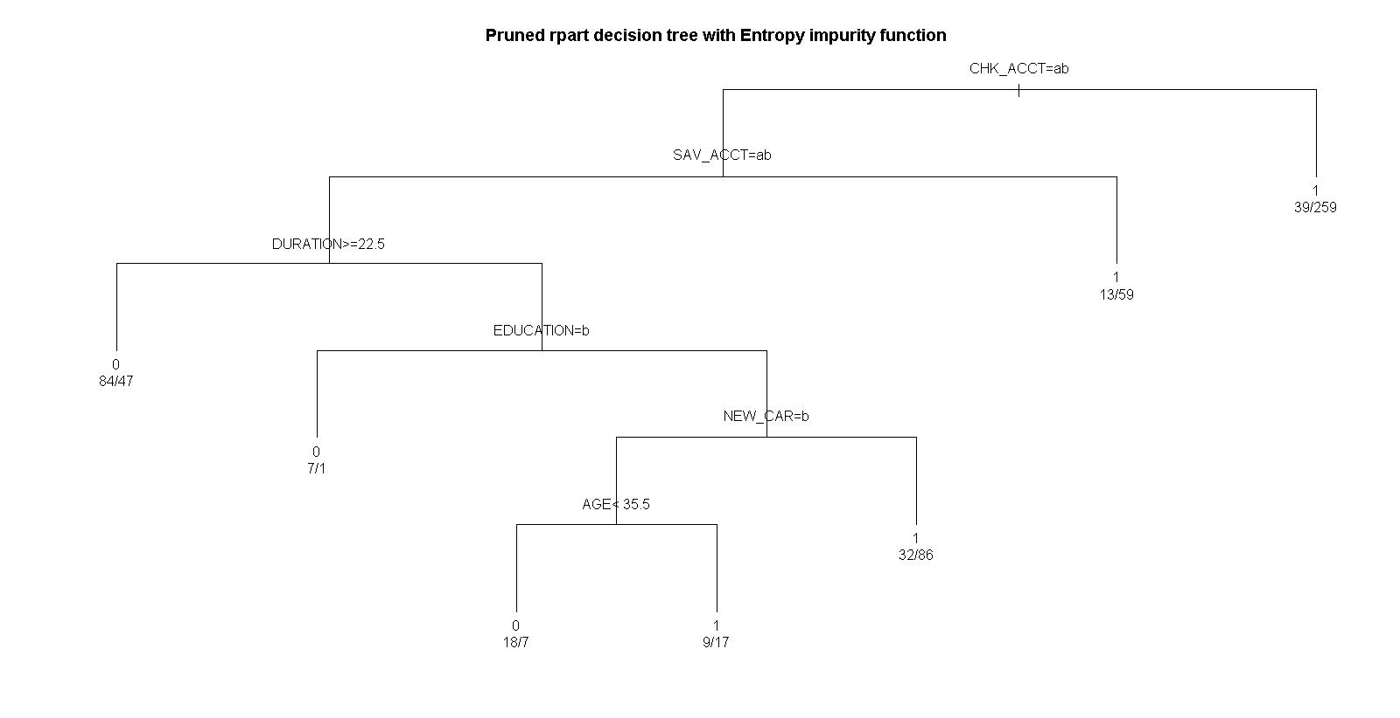

Results:

|  |
| --- |
| printcp(fit)  Classification tree:  rpart(formula = RESPONSE ~ ., data = GCTrain[, 2:33], method = "class")  Variables actually used in tree construction:  [1] AGE AMOUNT CHK_ACCT DURATION EDUCATION  INSTALL_RATE NEW_CAR SAV_ACCT TELEPHONE  [10] USED_CAR  Root node error: 202/678 = 0.29794  n= 678  CP nsplit rel error xerror xstd  1 0.061056 0 1.00000 1.00000 0.058954  2 0.029703 3 0.81683 0.91089 0.057320  3 0.027228 4 0.78713 0.88614 0.056821  4 0.017327 6 0.73267 0.88119 0.056719  5 0.014851 8 0.69802 0.91584 0.057417  6 0.010000 10 0.66832 0.93564 0.057799 |
| printcp(fit)  Classification tree:  rpart(formula = RESPONSE ~ ., data = GCTrain[, 2:33], method = "class")  Variables actually used in tree construction:  [1] AGE AMOUNT CHK_ACCT DURATION EDUCATION INSTALL_RATE NEW_CAR SAV_ACCT TELEPHONE  [10] USED_CAR  Root node error: 202/678 = 0.29794  n= 678  CP nsplit rel error xerror xstd  1 0.061056 0 1.00000 1.00000 0.058954  2 0.029703 3 0.81683 0.91089 0.057320  3 0.027228 4 0.78713 0.88614 0.056821  4 0.017327 6 0.73267 0.88119 0.056719  5 0.014851 8 0.69802 0.91584 0.057417  6 0.010000 10 0.66832 0.93564 0.057799 |

**80 % training and 20 % test:**

Code:

*# Training = 80% testing=20%*

*ind = sample(2, nrow(German.Credit), replace = T, prob = c(0.8, 0.2))*

*GCTrain=German.Credit[ind==1,]*

*GCTest=German.Credit[ind==2,]*

*fit = rpart(RESPONSE ~ ., method="class",data=GCTrain[,2:33])*

*plot(fit, uniform = T,main ='Decision tree with 80 % Taining and 20% Test')*

*text(fit, use.n = T, all = T, cex = 0.7, xpd = T)*

*printcp(fit)*

Plot:

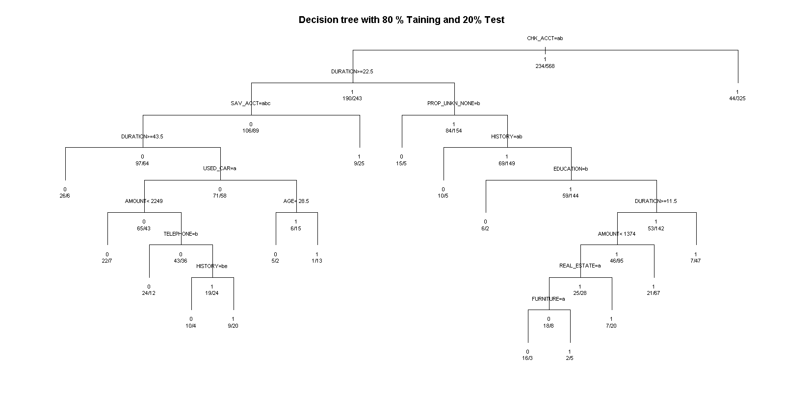

Output:

|  |  |  |  |  |
| --- | --- | --- | --- | --- |
| |  | | --- | | printcp(fit)  Classification tree:  rpart(formula = RESPONSE ~ ., data = GCTrain[, 2:33], method = "class")  Variables actually used in tree construction:  [1] AGE AMOUNT CHK_ACCT DURATION EDUCATION  FURNITURE HISTORY PROP_UNKN_NONE  [9] REAL_ESTATE SAV_ACCT TELEPHONE USED_CAR  Root node error: 234/802 = 0.29177  n= 802  CP nsplit rel error xerror xstd  1 0.036325 0 1.00000 1.00000 0.055015  2 0.021368 4 0.81624 0.89316 0.053125  3 0.019231 5 0.79487 0.92735 0.053766  4 0.017094 7 0.75641 0.91880 0.053609  5 0.015670 8 0.73932 0.91880 0.053609  6 0.014245 11 0.69231 0.91026 0.053450  7 0.012821 14 0.64957 0.93590 0.053920  8 0.010000 16 0.62393 0.95299 0.054224 | |  | | **Pruning:**  Code:  *#Pruning*  *opt = which.min(fit$cptable[,"xerror"])*  *cp = fit$cptable[opt, "CP"]*  *tree.prune = prune(fit, cp = cp)*  *plot(tree.prune, uniform = T, main = "Pruned rpart decision tree with Entropy*  *impurity function")*  *text(tree.prune, use.n = T, xpd = T )*  *printcp(fit)*  Plot: | |  | |

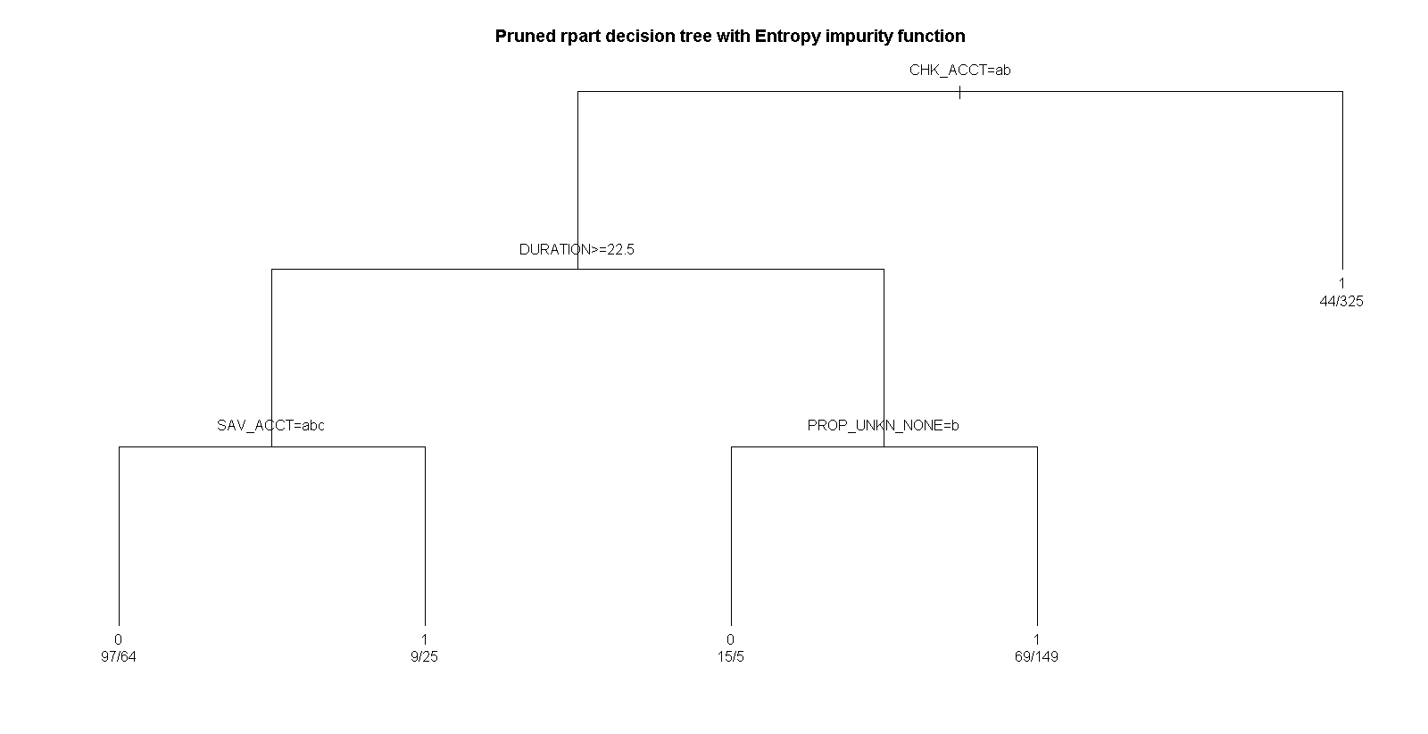

Output:

|  |
| --- |
| printcp(fit)  Classification tree:  rpart(formula = RESPONSE ~ ., data = GCTrain[, 2:33], method = "class")  Variables actually used in tree construction:  [1] AGE AMOUNT CHK_ACCT DURATION EDUCATION  FURNITURE HISTORY PROP_UNKN_NONE  [9] REAL_ESTATE SAV_ACCT TELEPHONE USED_CAR  Root node error: 234/802 = 0.29177  n= 802  CP nsplit rel error xerror xstd  1 0.036325 0 1.00000 1.00000 0.055015  2 0.021368 4 0.81624 0.89316 0.053125  3 0.019231 5 0.79487 0.92735 0.053766  4 0.017094 7 0.75641 0.91880 0.053609  5 0.015670 8 0.73932 0.91880 0.053609  6 0.014245 11 0.69231 0.91026 0.053450  7 0.012821 14 0.64957 0.93590 0.053920  8 0.010000 16 0.62393 0.95299 0.054224 |

We can observe that as we increase the percentage of data for testing, the decision tree becomes more and more compact and the amount of root node error decreases. This shows that a better model can be constructed with more data for training.

As explained in the given question it is not always conceivable that the data will always have values or will be carrying reliable data. In such cases we have to look at the abnormal data and have to take a judgement call on how to handle the data.

For Missing data, we can use Multiple Imputation Techniques to plug the data with respective values. These values can be the mean of the existing values or any different values based on the requirements of the model and the way the variables are defined.

Unreliable data may lead us to false conclusions which are not true for the model. For the unreliable data, we can follow best practices in cleaning the data and using only the cleaned data for the analysis purposes. Ideally in a project 60 % of time goes in to cleaning and getting the appropriate data.