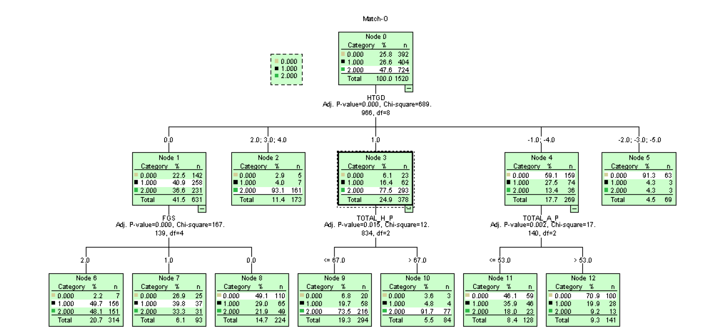

If( (HTGD = 1) and (Total_H_P <= 67)) then

P(0) = 6.8%

P(1) = 19.7%

P(2) = 73.5%

If( (HTGD = 1) and (Total_H_P > 67)) then

P(0) = 3.6%

P(1) = 4.8%

P(2) = 91.7%

If( (HTGD = -1 or HTGD = -4 or HTGD = -5) and (Total_A_P > 53.0)) then

P(0) = 91.3%

P(1) = 4.3%

P(2) = 4.3%

If( (HTGD = -1 or HTGD = -4) and (Total_A_P > 53.0)) then

P(0) = 70.9%

P(1) = 19.9%

P(2) = 9.2%

If( (HTGD = -1 or HTGD = -4) and (Total_A_P <= 53.0)) then

P(0) = 46.1%

P(1) = 35.9%

P(2) = 18.0%