# 1.删除重复数据

delete from AMLCONFIG.T_RSK_POINT_RULE_RD_BAK t where t.pk_id in

(select t.pk_id from AMLCONFIG.T_RSK_POINT_RULE_RD_BAK t group by t.pk_id having count(t.pk_id)>1)

and t.rowid not in (select min(t.rowid) from AMLCONFIG.T_RSK_POINT_RULE_RD_BAK t group by t.pk_id having count(t.Pk_Id)>1);

commit;

alter table AMLCONFIG.T_RSK_POINT_RULE_RD_BAK add constraint PK_RSK_POINT_RULE_RD_BAK primary key (PK_ID );

select * from CF_SETT.T_PUB_DATE t where (t.busi_date,t.market_no,t.trade_flag) in

(select a.busi_date,a.market_no,a.trade_flag from CF_SETT.T_PUB_DATE a group by a.busi_date,a.market_no,a.trade_flag having count(*)>1)

and t.rowid not in (select min(t.rowid) from CF_SETT.T_PUB_DATE t group by t.busi_date,t.market_no,t.trade_flag having count(*)>1)

# 2.筛选无主键表

SELECT b.TABLE_NAME FROM all_tables b WHERE b.OWNER='AMLCONFIG' and b.TABLE_NAME not in

(select c.table_name from user_cons_columns c,user_constraints a where c.constraint_name=a.constraint_name and a.constraint_type='P' and c.owner = 'AMLCONFIG');

# 扩展表空间

查看当前库中有多少表空间

select * from dba_temp_files t where t.TABLESPACE_NAME='USER_TEMP'

找到相应的DBF文件扩展，默认每次增加50M无限大

alter database tempfile 'C:\APP\WEI.ZHOU\ORADATA\AML105\TS_USER_TEMP.DBF' autoextend on next 50M maxsize unlimited;

commit;

查看内存占用：

select c.tablespace_name,

to_char(c.bytes/1024/1024/1024,'99,999.999') total_gb,

to_char( (c.bytes-d.bytes_used)/1024/1024/1024,'99,999.999') free_gb,

to_char(d.bytes_used/1024/1024/1024,'99,999.999') use_gb,

to_char(d.bytes_used*100/c.bytes,'99.99') || '%'use

from (select tablespace_name,sum(bytes) bytes

from dba_temp_files GROUP by tablespace_name) c,

(select tablespace_name,sum(bytes_cached) bytes_used

from v$temp_extent_pool GROUP by tablespace_name) d

where c.tablespace_name = d.tablespace_name;

# 查询关联存储过程

SELECT DISTINCT name FROM all_source WHERE lower(text) LIKE '%[color=darkblue]table_you_want_to_find[/color]%'

# 5.命令

设置logs目录锁定：

svn update --set-depth=exclude logs

windows重启计算机：

shutdown -r

linux重启：

shutdown -r now 立刻重启

删除logs文件:

rm -r logs

修改文件名

mv file1 file2

传递文件：

业务核心替换：

scp -r kfts@10.243.140.108:/kfts/ITSCompiler/compiler_output/branch/its_service/V2.6

/home/kfts/its/its_service

查看电脑配置cmd：

msinfo32

linux：free -g

free -h

启动监听程序并注册数据库服务：

启动 Net Manager，在LISTENER中选数据库服务，添加数据库，oracle主目录C:\app\wei.zhou\product\11.2.0\dbhome_1

保存后在命令行输入lsnrctl reloa

执行lsnrctl reloa时报错INS-01153：未能处理字符串

删除C:\app\its\diag\tnslsnr\KS-SHA-VM190013\listener\trace下listener.log文件

ORA-01109: 数据库未打开------------------------（手动删除了表空间文件）

sqlplus 用户名/密码 as sysdba

shutdown immediate

startup mount

alter database datafile 'C:\app\wei.zhou\oradata\ac\TS_WOLF.DBF' offline drop;

alter database open;

drop tablespace 表空间名字 including contents;

（未指定数据库就进去之前 set ORACLE_SID=XE）

drop user CORE cascade;不能删除查看进程

select username, sid, serial# from v$session where username='CORE';

alter system kill session'**,**'; 杀掉进程资源

c:>orakill orcl sid

查看进程 ps -u kfts

杀死进程 killall -9 java

关闭防火墙

service firewalld stop

禁用防火墙

firewall-cmd --state //状态

[root@rhel7 ~]# systemctl stop firewalld.service //关闭一个服务

[root@rhel7 ~]# systemctl disable firewalld.service //开机时禁用

systemctl enable firewalld.service //开机时启用

[root@rhel7 ~]# systemctl status firewalld.service //显示状态

查看端口是否打开 lsof -i:8060

查看所有开启的端口号：netstat -aptn

查看Tomcat占用进程号：ps -ef|grep tomcat

根据进程号查看端口：sudo netstat -apn | grep 2077

访问服务器命令 curl http://10.243.140.222:8080/ks/

pip install pyinstaller

报错后输入：python -m pip install --upgrade pip -i https://pypi.douban.com/simple

pip install cx_Oracle

pyinstaller -F

免密登录

cd ~/.ssh

ssh-keygen -t rsa

scp id_rsa.pub kfts@10.243.140.108:~/.ssh

进入101服务器，将公钥导入到~/.ssh/authorized_keys，

cd ~/.ssh

cat ~/.ssh/id_rsa.pub >> ~/.ssh/authorized_keys

~/.ssh权限设置为700

~/.ssh/authorized_keys的权限设置为600

远程桌面不能复制

rdpclip.exe重启

# 6.连接池满了

Show parameter processes;

Select count(*) from v$process;

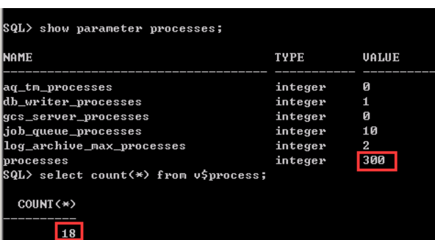

修改语句如下：

alter system set processes=1000 scope=spfile;

alter system set sessions=1105 scope=spfile;



最后重启一下Oracle服务即可