Assignment 1

Research Methods and Tools
Begimkulov B. Kantai D. Kolbay N. Vaisov S. SE-2310

Innovative technologies for megacities, smart power grids and transport

Part 1. Introduction.
Modern megacities are complex socio-technical systems facing rapidly increasing infrastructure demands due to population growth, urbanization, and technological change. Among the most significant challenges are increasing energy consumption and traffic congestion, which directly impact sustainable development, economic growth, and the quality of life of city residents. Traditional infrastructures, designed for smaller and more dynamic populations, are no longer able to keep up with the pace and scale of modern cities.
In this context, innovative technologies have become key tools for increasing the resilience, efficiency, and adaptability of megacity infrastructure. Two of the most significant areas are smart grids and intelligent transportation systems. Smart grids integrate advanced communications and automation solutions, as well as renewable energy sources, into traditional energy networks, enabling demand management, predictive analytics, and increased grid stability. Intelligent transportation systems (ITS) utilize the Internet of Things (IoT), artificial intelligence (AI), and big data to optimize traffic flows, reduce congestion, and improve mobility. Together, these technologies address not only specific industry-specific issues but also the broader goal of sustainable urban development.
This literature review focuses on academic research published between 2010 and 2025. The scope of the study includes:
Inclusion Criteria:
- Research on smart grids and related energy load management technologies.
- Research papers on intelligent transportation systems (ITS) with an emphasis on the application of AI, IoT, and big data.
- Comparative and integrative studies examining the interrelationships between energy and transportation infrastructures.
Exclusion Criteria:
- Studies that are non-technological or purely policy-oriented.
- Research on rural or small-scale infrastructure.
- Sources published before 2010, excluding those that lay the foundations of the concept.
The geographic scope is global, with a particular focus on examples relevant to rapidly growing megacities in both developed and developing regions. The methodological review incorporates simulation modeling, empirical case studies, data-driven modeling, and systems approaches.
Report structure
The report is organized thematically and reflects two central areas of innovation in megacity infrastructure: smart energy systems and intelligent transportation systems. This structure was chosen for two reasons. First, it allows for a focused discussion of the unique challenges, technologies, and results in each of these areas. Second, it provides a logical framework for identifying research gaps at the intersection of energy and transportation infrastructure.
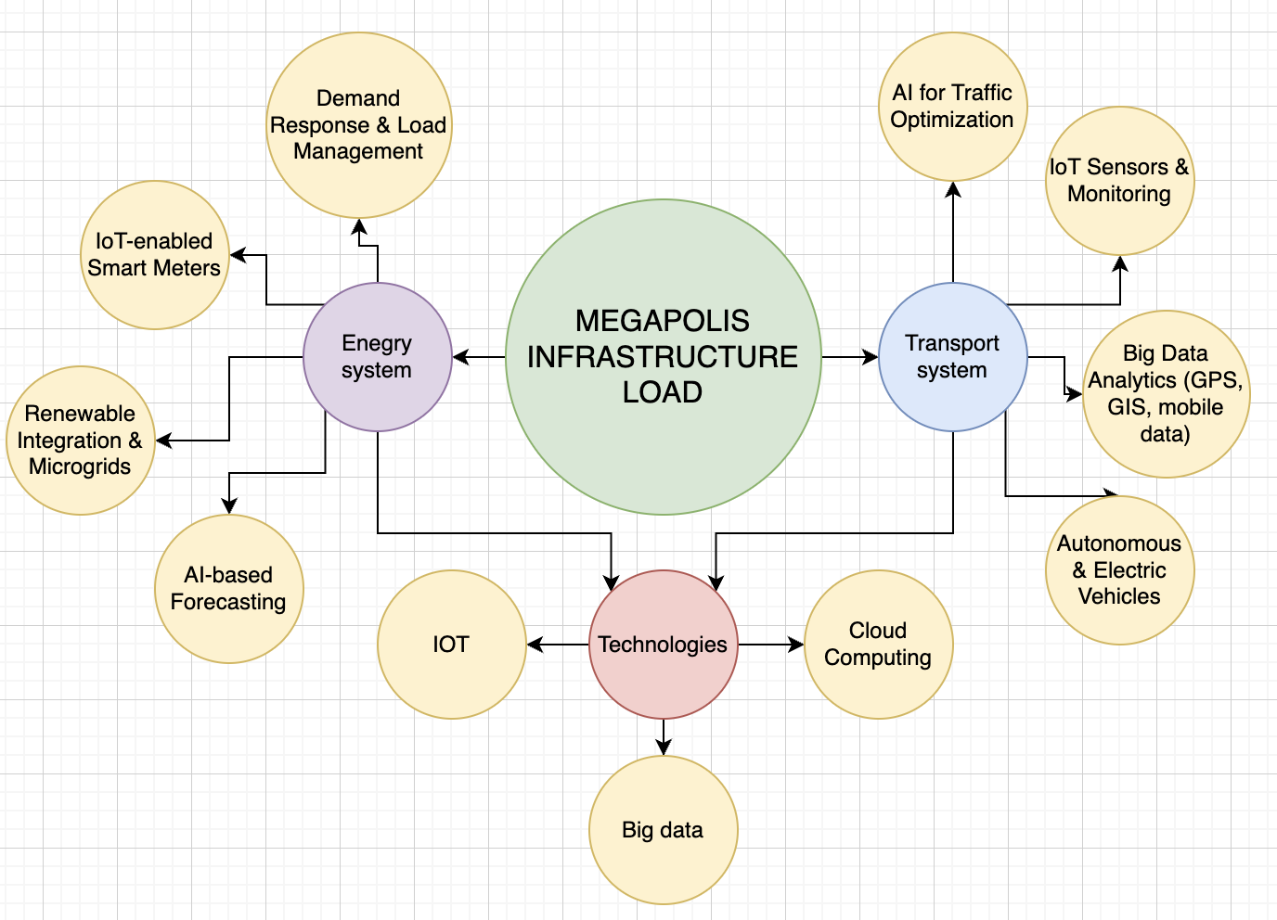
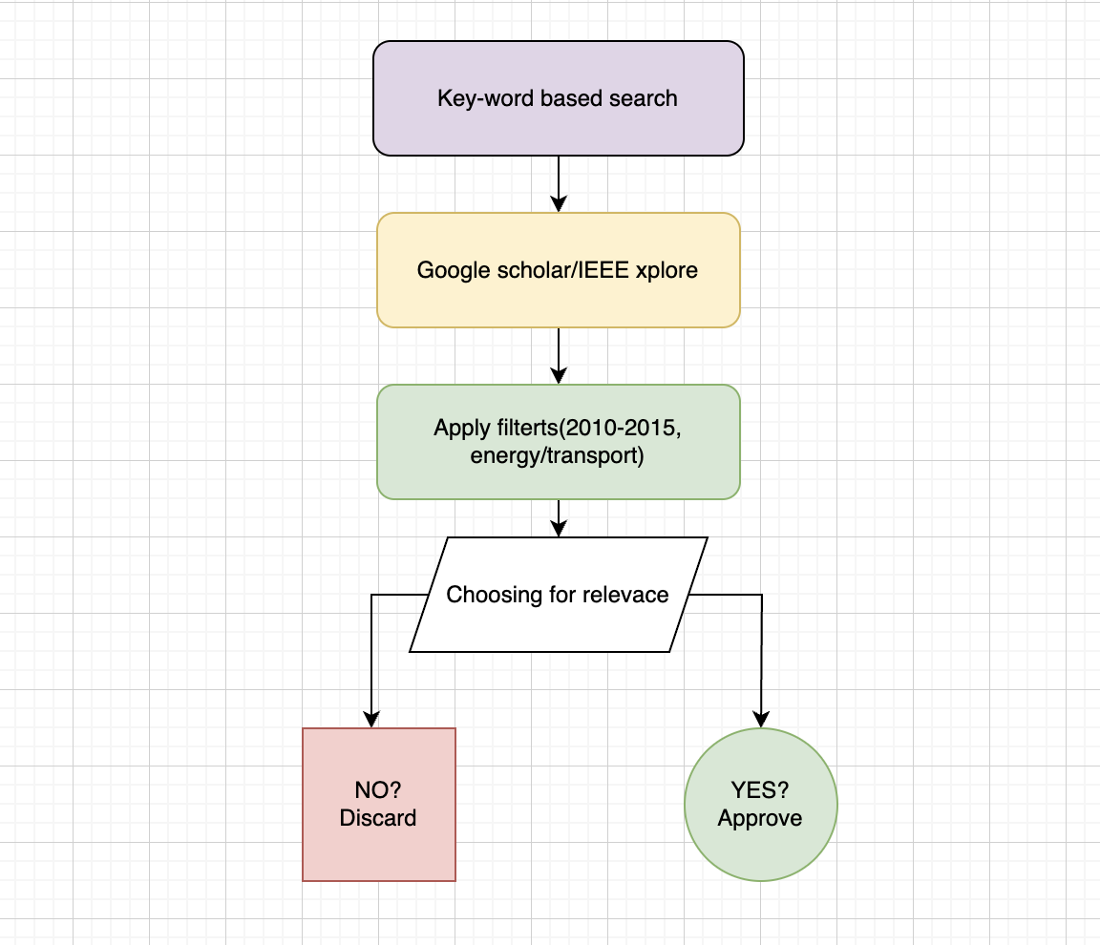

Part 2. Thematic analysis.

2.1. Intelligent power grid: beyond centralized energy
The Smart Grid is an innovative energy system based on advanced information and communication technologies (ICT).1 It marks a fundamental departure from the traditional, unidirectional power grid to a two-way flow of both energy and information. Thanks to intelligent sensors, communication networks and computer technologies, such a system provides real-time monitoring, intelligent planning and optimal management.1 This transformation allows you to get a panoramic view of the system, provides network data transmission, dynamic security assessment and automated management.
- Advanced Metering Infrastructure (AMI): Includes smart meters that generate real-time data on electricity usage for both consumers and utilities. This data contributes to accurate billing, efficient energy management, and demand response programs.
- Sensors and automated control systems: designed to monitor network performance, detect errors, and instantly respond to changes in supply and demand.
- Communication networks: necessary to ensure the two-way flow of information between utilities and consumers, supporting data transmission from smart meters and other devices.
- Energy storage systems: Devices such as rechargeable batteries store energy during off-peak periods for later supply to the grid during peak hours. This increases the stability of the system and promotes the integration of renewable energy sources.
- Distributed Energy Resources (DERs): Includes small energy generation sources such as rooftop solar panels and wind turbines. They complement traditional sources, increasing the sustainability and diversification of energy supply.
- Grid Management systems: software and hardware solutions designed to manage, monitor, and enhance the functionality of the power grid, which contributes to reliable power supply and reduced operating costs.
Intelligent power grids provide a number of significant benefits, including increased energy security through real-time monitoring and rapid incident response.They increase the stability and adaptability of the system, ensuring rapid recovery after natural disasters or power outages.By monitoring supply and demand in real time, smart grids optimize energy management, resulting in improved energy efficiency.In addition, they promote the active participation of users who can manage their energy consumption, which reduces their costs. Finally, the integration of renewable energy sources on a large scale makes smart grids a key tool on the path to sustainable development.

2.2 Smart transport system.
Modern megacities face unprecedented mobility challenges, including chronic traffic congestion, pollution, and inefficient infrastructure use. In response to these challenges, the concept of intelligent transportation systems (ITS) has become central to smart city development strategies. An analysis of the academic literature, summarized in Table 1, shows that the transformation of urban transportation relies on three interconnected technological pillars: artificial intelligence (AI), the Internet of Things (IoT), and big data analytics.
The Internet of Things (IoT) forms the physical layer of ITS, creating a distributed network of sensors, cameras, and connected devices that collect data about the urban environment in real time (Kabir & Islam, 2024; Singh et al., 2019).
Big data provides the methodology and infrastructure for collecting, storing, and processing vast and heterogeneous data streams from IoT devices and other sources such as GPS and GIS (Liu Yang, 2018).
Artificial intelligence and machine learning (ML) act as the "brain" of the system, analyzing this data to identify patterns, predict future events, and make autonomous decisions to optimize traffic flows (Gowda et al., 2024).
Research in the field of ITS can be roughly divided into three main groups based on their methodological focus and objectives.
2.2.1 Artificial Intelligence (AI) for Real-Time Traffic Management
This area is one of the most actively developing. There is a clear trend towards using deep learning models to analyze visual data and make instant decisions.
Similarities and Synthesis: The works of Sridevi et al. (2025), Gowda et al. (2024), and Revathy et al. (2025) demonstrate a similar approach: the use of neural networks (YOLO for object recognition, LSTM for time series analysis) to process data from cameras and sensors in real time. The goal is dynamic optimization of traffic signals and the construction of alternative routes. Sridevi et al. (2025) go further, emphasizing the need for 6G infrastructure to ensure ultra-low latency, which is critical for such systems. Sultana et al. (2024) apply these same principles to a specific but vital problem: ensuring priority access for emergency services.
Strengths: These methods offer high accuracy and the ability to adapt to rapidly changing road conditions, which is beyond the capabilities of traditional systems.
Weaknesses: The main limitations are high computational requirements, dependence on high-quality real-time data, and the need for advanced network infrastructure.
A leading edge in this area is the work of Lin et al. (2025), which explores the application of generative AI. Its unique strength lies in its ability to create synthetic data for training models and simulating rare but critical scenarios (e.g., major accidents), thus addressing the problem of insufficient training data.
2.2.2 Internet of Things (IoT)-Based Systems for Monitoring and Control
If AI is the "brain," then IoT is the "nervous system" of ITS. Research in this group focuses on the practical implementation of data collection.
Similarities and Synthesis: Kabir & Islam (2024) and Singh et al. (2019) present more pragmatic and cost-effective solutions. They use IoT sensors (infrared, ultrasonic) and basic image processing to count vehicles and determine traffic density. These systems do not make complex predictions but effectively solve local problems, such as adaptive traffic signal switching at a specific intersection.
Strengths: Low implementation costs and ease of maintenance make these systems ideal for developing megacities, as highlighted in a study for urban India (Singh et al., 2019).
Weaknesses: Limited scalability and lack of predictive capabilities. Such systems react to existing situations rather than prevent them. They serve as data feeds for more complex AI models, but have limited "intelligence" on their own.
2.2.3 Big Data Analytics and Predictive Modeling
This group of studies examines the transportation system at the macro level, focusing on long-term planning and the analysis of citywide trends.
Similarities and Synthesis: Liu Yang (2018) and Anvesh et al. (2025) emphasize the importance of integrating heterogeneous data sources (GPS, GIS, mobile operator data, social media) using cloud platforms. This allows for the identification of hidden patterns in urban transportation behavior. The work of Wang et al. (2025) represents the pinnacle of this approach, proposing a comprehensive urban intelligence deduction technology for creating macro-micro simulation models. Such models allow for not only the analysis of current data, but also the prediction of city developments for years to come. Strengths: Ability to strategically plan and optimize the entire transportation network, rather than just individual sections. Cloud solutions (Anvesh et al., 2025) provide the necessary scalability.
Weaknesses: Data privacy concerns, difficulties with data integration and cleansing, and high computing requirements for simulations.
2.2.4 Comparative Analysis, Identification of Trends and Gaps
The analysis of the grouped studies allows us to draw several key conclusions.
Key Trends:
- Technology Convergence: Successful ITS are built on the synergy of IoT, Big Data, and AI. This is the dominant trend, where IoT collects data, cloud platforms process it, and AI makes decisions.
- Transition to Proactive Management: The focus is shifting from reacting to congestion to predicting and preventing it using predictive models.
- Rising Popularity of Deep Learning: Neural networks have become the de facto standard for analyzing complex unstructured data, such as video streams.
Contextual Differences:
The effectiveness of methods is highly context-dependent. For example, studies focusing on China (Liu Yang, 2018; Wang et al., 2025) emphasize big data analytics and centralized modeling, driven by the availability of massive government datasets. Meanwhile, in the Indian context (Singh et al., 2019), there is a preference for cheaper and more practical IoT solutions. Research from Europe and North America (not directly presented, but implied in the reviews) often focuses on simulations and algorithms, with a strong emphasis on data privacy issues.
Key research gaps:
Domain integration gap: The vast majority of the analyzed papers (11 out of 11) focus exclusively on the transportation system. Research examining the interrelationships and interdependencies between urban transportation and other critical infrastructures, such as energy, is virtually nonexistent.
Lack of research for developing megacities: Despite isolated examples, there is a clear lack of comprehensive research addressing the unique challenges of megacities in developing countries, which are characterized by rapid urbanization, limited infrastructure, and a high share of public transportation. Lack of holistic management models: Many articles offer solutions for individual problems (e.g., intersection optimization or flow forecasting), but few consider the city as a single system where transport and energy loads must be managed in a coordinated manner.
2.2.5 Connection to the Current Project and Rationale for the Study
A literature review reveals that, although significant progress has been made in the field of intelligent transportation systems, there is a significant research gap at the intersection of transportation and energy systems. Current ITS optimize traffic flows but do not consider the load they create on the urban energy system (e.g., through electric vehicle charging or energy consumption by transport infrastructure).
This gap served as the primary motivation for our project, which aims to explore innovative technologies for megacities, with a particular emphasis on the integrated management of smart grids and transportation. While existing research has extensively covered ITS in developed countries, little has considered how transportation and energy interact in rapidly growing megacities. Our project aims to fill this gap by exploring integrated approaches for simultaneously managing both loads, thereby improving not only transportation efficiency but also the city's energy sustainability.

Comparative analysis of advantages and problems
Despite significant differences in purpose, smart power grids and transportation systems demonstrate similar advantages and face similar challenges. The following table provides a comparative analysis of these two areas, identifying their common ground and unique challenges.

Comparison Criteria | Smart Grids | Intelligent Transportation Systems (ITS)
Key Benefits | Increased energy security and resilience; optimization of energy management; support for renewable energy integration; enhanced consumer participation.¹ | Improved traffic efficiency and congestion reduction; enhanced road safety and incident prevention; reduced environmental impact; route optimization.⁶
Key Technological Components | AMI, sensors, communication networks, energy storage systems, distributed energy resources.¹ | Big Data, Internet of Things (IoT), AI and ML, intelligent traffic lights, GPS, onboard sensors.⁶
Common Challenges | High initial costs, interoperability issues, cybersecurity risks (false data injection attacks), regulatory and legal challenges.¹¹ | High initial costs, interoperability issues with existing infrastructure, data privacy concerns, resistance to change from stakeholders.¹⁴
Specific Challenges | Aging physical infrastructure, vulnerability to false data injection (FDI) attacks, complexity of integration with variable renewable sources.¹¹ | Inflexibility of fixed infrastructure (metro, railways); decentralized urban development; competition with private vehicles; high construction and maintenance costs.¹⁶

Part 3. Summary of Key Findings, Research Gaps, and Project Motivation
Key findings:
In the energy sector, smart grids improve stability and efficiency through two-way data exchange, automation, and the integration of renewable energy sources. In transportation, intelligent systems (IS) optimize traffic and reduce congestion, moving from reactive to proactive.
Research gaps identified:
Despite progress, research in these two areas is conducted in isolation, without considering their interdependencies. This is a serious omission, especially in the context of the growing popularity of electric vehicles, which directly link transportation and energy consumption. Furthermore, most studies focus on developed countries, neglecting the unique challenges of megacities in developing regions. Finally, comprehensive models that consider urban infrastructure as a single, integrated system are lacking.
Implications for the current project:
These gaps underlie the need for this study. The project aims to explore the integration of smart grids and intelligent transportation systems to create holistic urban management models. This approach will not only address current challenges such as peak power grid loads and traffic congestion, but also prepare cities for future growth and technological change.

Table of sources

№ | Caption | method/design | data/context | key findings | limitation | relevance
1 | Yaghmaee, M. H., Leon-Garcia, A., & Moghaddassian, M. (2018). On the Performance of Distributed and Cloud-Based Demand Response in Smart Grid. IEEE Transactions on Smart Grid, 9(5), 5403–5416. | Analytical modeling and simulation. The cloud-based demand response model (CDR) is compared with the distributed demand response model (DDR). | Simulation data for a power system with 1000 consumers. Packet sizes: 100 bytes for DDR and 150 bytes for CDR. | The CDR model outperforms the DDR model, especially in the presence of microgrids. DDR with the UDP protocol cannot find an optimal solution under high bit error rates. | The modeling is based on a simplified power system. The economic efficiency analysis may be overly simplified. | It compares centralized (cloud-based) and decentralized approaches to DR, analyzing the impact of communication network performance.
2 | Khan, H. W., Usman, M., Hafeez, G., et al. (2021). Intelligent Optimization Framework for Efficient Demand-Side Management in Renewable Energy Integrated Smart Grid. IEEE Access, 9, 124235–124252. | A new DSM framework is proposed, using an artificial neural network (ANN) for forecasting and a new Hybrid Genetic Ant Colony (HGAC) algorithm for scheduling. | A dataset from the Midwest Independent System Operator (MISO) for one year is used to train the ANN. The modeling is performed for a single residential consumer with six smart appliances. | The HGAC algorithm outperforms existing ones (PSO, GA, WDO, ACO) in reducing electricity costs (by up to 24.4%), carbon emissions, and peak load (by up to 37.08%). | Modeling is conducted for a single consumer; scalability to a larger community is not guaranteed. HGAC has higher time complexity. | It presents an integrated intelligent system that combines forecasting and a new hybrid algorithm to solve the multi-objective DSM problem.
3 | Ur Rehman, A., Hafeez, G., Albogamy, F. R., et al. (2021). An Efficient Energy Management in Smart Grid Considering Demand Response Program and Renewable Energy Sources. IEEE Access, 9, 148821–148844. | A scheduler controller (ASEMC) is proposed, based on the new hybrid HGPDO algorithm (a combination of GA, PSO, and WDO). | Simulation of a smart home with 9 switchable appliances, multiple RES (solar, wind, CHP), and storage systems (BSS and EV). Flat Price (FP) and Day-Ahead Price (DAP) tariffs are used. | The HGPDO controller significantly reduces costs (by up to 35.25%) and PAR (by up to 31.72%) compared to baseline algorithms, while also improving user comfort across multiple metrics. | The study is based on simulation for a single household. Comfort models may not perfectly reflect human subjective perceptions. | A comprehensive management system that considers multiple RES, storage systems, and user comfort metrics, solving the problem with a new hybrid algorithm.
4 | Kanchev, H., Lu, D., Colas, F., et al. (2011). Energy Management and Operational Planning of a Microgrid With a PV-Based Active Generator for Smart Grid Applications. IEEE Transactions on Industrial Electronics, 58(10), 4583–4592. | A deterministic two-component Energy Management System (EMS): a central EMS for long-term planning and a local EMS for short-term balancing. | A microgrid with a single prosumer (a household with a photovoltaic system, batteries, and ultracapacitors) and a gas microturbine. 24-hour forecasts are used. | The hierarchical EMS effectively creates a day-ahead generation plan. The local controller successfully manages energy flows to meet grid requirements. | The approach is deterministic and depends on forecast accuracy. The model is simplified to a single prosumer and one microturbine. | It describes a practical hierarchical microgrid management structure, separating planning and real-time control.
5 | Ali, S., Ur Rehman, A., Wadud, Z., et al. (2022). Demand Response Program for Efficient Demand-Side Management in Smart Grid Considering Renewable Energy Sources. IEEE Access, 10, 53832–53853. | An SEMC controller is proposed based on the new hybrid ACTLBO algorithm (a combination of ACO and TLBO). | Simulation of a smart home with multiple RES (solar, wind, CHP), BSS, and EV. A real-time pricing (RTP) tariff is used. | The ACTLBO algorithm significantly outperforms five other heuristic algorithms, reducing costs (by up to 28.76%) and PAR (by up to 41.53%), while also improving user comfort. | The study is based on simulation for a single household. Communication aspects are not analyzed in depth. | It presents another new hybrid algorithm, addressing the DSM problem with a comprehensive comfort model .
6 | Eltamaly, A. M. (2024). A novel energy storage and demand side management for entire green smart grid system for NEOM city in Saudi Arabia. Energy Storage, 6(1), e515. | A DSM based on a dynamic tariff defined by a Fuzzy Logic Controller (FLC) is proposed. For optimal sizing of the hybrid RES system, a Modified Grey Wolf Optimization (MGWO) algorithm is used. | A case study for the planned city of NEOM in Saudi Arabia. Real meteorological data and projected load for 1 million people are used. The system includes PV, wind, and hybrid storage. | The MGWO algorithm is faster and more accurate than 10 other algorithms. The dynamic tariff reduces the Levelized Cost of Energy (LCOE) by 53% compared to a fixed tariff. The project payback period is 7 years. | The study is a design case for a city that has not yet been built; load profiles and consumer response are based on forecasts. | A large-scale real case study on designing a fully green energy system for a smart city.
7 | Ali, S., Khan, I., Jan, S., & Hafeez, G. (2021). An optimization based power usage scheduling strategy using photovoltaic-battery system for demand-side management in smart grid. Energies, 14(8), 2201. | A hybrid of Genetic Algorithm (GA) and Ant Colony Optimization (ACO) is used for energy consumption scheduling. | A residential building with a photovoltaic (PV) system and a battery storage system (BSS). A real-time pricing (RTP) scheme is used. | The hybrid GA-ACO algorithm effectively scheduled energy consumption to minimize costs and PAR while simultaneously improving user comfort. | The simulation is focused on a single household. The battery degradation model is not detailed. | It demonstrates the application of the hybrid GA-ACO algorithm to a system including local generation (PV) and storage (battery).
8 | Khan, H. N., Iftikhar, H., Asif, S., et al. (2018). Demand Side Management Using Strawberry Algorithm and Bacterial Foraging Optimization Algorithm in Smart Grid. In Advances in Network-Based Information Systems (pp. 191–202). Springer. | Two bio-inspired metaheuristic algorithms are compared: Bacterial Foraging Optimization (BFO) and the Strawberry Algorithm (SBA). | A residential building powered by the utility grid using an RTP pricing scheme. The model includes objectives for cost, PAR, and user comfort. | Both algorithms successfully reduced costs and PAR while considering user comfort. | The Strawberry Algorithm is a less common heuristic, and its overall applicability has not been proven. | It illustrates the ongoing exploration of new metaheuristics for DSM problems and provides a direct comparison of two such algorithms.
9 | Liu, Y. (2018). Big data technology and Its Analysis of Application in Urban Intelligent Transportation System. 2018 International Conference on Intelligent Transportation, Big Data & Smart City. | Analytical Review and Conceptual Model | GPS, GIS, and Other Traffic Data in Major Chinese Cities. | Big data technology can significantly improve urban intelligent transportation systems by addressing congestion and improving traffic efficiency. | This article focuses on theoretical aspects rather than implementation details. | High value because it demonstrates the fundamental role of big data in modern transportation systems.
10 | Sridevi, S., David, S. A., Pranathi, P. M., Sravya, K., Shankar, P. B., & Durai, S. K. B. (2025). AI-Driven Traffic Monitoring System for Real-Time Congestion Detection and Route Optimization in 6G-Enabled Smart Cities. 2025 International Conference on Inventive Computation Technologies (ICICT). | A system based on deep learning (YOLO) and graph algorithms. | Real-time video data from 6G surveillance cameras. | AI-powered systems can effectively detect congestion in real time and optimize routes, resulting in shorter travel times and reduced carbon emissions. | A high-speed network infrastructure (6G) is required, but it may not be available everywhere. | Very high, as it presents cutting-edge technologies for dynamic traffic management.
11 | Gowda, D. V., Yogi, K. S., Srinivas, I. V., Kumar, B. K., Srinivas, D., & Reddy, N. S. (2024). AI and Machine Learning for Intelligent Traffic Management in IoT-Connected Cities. 2024 Asian Conference on Intelligent Technologies (ACOIT). | Machine learning models (LSTM) for road condition prediction. | Real-time data from IoT devices (sensors, cameras) in smart cities. | AI and machine learning combined with IoT can significantly improve urban traffic management, enabling real-time adjustment of traffic signals and congestion prediction. | There may be issues with the quality and completeness of data received from IoT devices. | High, as it highlights the synergy of AI, machine learning, and IoT in traffic management.
12 | Lin, Y., Yao, Y., Zhu, J., & He, C. (2025). Application of Generative AI in Predictive Analysis of Urban Energy Distribution and Traffic Congestion in Smart Cities. 2025 IEEE International Conference on Electronics, Energy Systems and Power Engineering (EESPE). | An integrated system using generative AI (GAN, VAE), edge computing, and microservices. | Traffic, energy consumption, and other urban data. | Generative AI can be used for predictive analysis, enabling the optimization of urban services, including traffic management and energy distribution. | The complexity of integrating and deploying such a complex system. | High, as it explores the application of cutting-edge generative AI technologies in urban planning.
13 | Chen, X., & Chen, R. (2019). A Review on Traffic Prediction Methods for Intelligent Transportation System in Smart Cities. 2019 12th International Congress on Image and Signal Processing, BioMedical Engineering and Informatics (CISP-BMEI). | Literature review | Existing traffic forecasting research and models. | This article presents a comprehensive analysis of existing traffic forecasting methods, their challenges, and future developments. | This work is theoretical in nature and does not propose new methods. | Medium, as it provides a good overview of the field but does not contain new research.
14 | Revathy, G., Thangavel, M., Senthilvadivu, S., & Savithri, M. C. (2025). Enabling Smart Cities: AI-Powered Prediction Models for Urban Traffic Optimization. 2025 4th International Conference on Sentiment Analysis and Deep Learning (ICSADL). | An AI-based prediction model combining deep learning and reinforcement learning. | Real-time data from various IoT sources (sensors, GPS, mobile devices). | AI-based models can effectively predict traffic flows and offer adaptive recommendations for urban traffic optimization. | The integration and processing of large volumes of data from diverse sources is required. | High, as it demonstrates the practical application of AI models for traffic optimization.
15 | Sultana, F., Bhardwaj, R., Kumar, R. N., Gaur, R., Shankar, S. P., & Bharadwaj, A. (2024). Smart Traffic Management System for Efficient Mobility and Emergency Response. 2024 International Conference on Knowledge Engineering and Communication Systems (ICKECS). | A dynamic optimization system using AI and IoT. | Real-time traffic data. | Intelligent traffic management systems can not only reduce congestion but also significantly improve emergency response times. | The reliability and security of the system must be ensured, especially in emergency management. | High, as it addresses an important aspect of safety and response efficiency in smart cities.
16 | Singh, S., Singh, B., Das, A., Ramandeep, & Singh, B. (2019). Automatic Vehicle Counting for IoT based Smart Traffic Management System for Indian urban Settings. | A system based on image processing and IoT. | Video data from urban roads in India. | Automated vehicle counting using image processing and IoT is an effective and low-cost solution for traffic management. | Counting accuracy may be affected by weather conditions and video quality. | Medium, as it presents a simpler and more accessible solution, but may be less accurate than AI-based systems.
17 | Anvesh, E., Brindha, D., & Kumar, C. H. (2025). Dynamic Traffic Optimization through Cloud-Enabled Big Data Analytics and Machine Learning for Enhanced Urban Mobility. 2025 3rd International Conference on Communication, Security, and Artificial Intelligence (ICCSAI). | A system based on cloud computing, big data analytics, and machine learning (Random Forest). | Real-time traffic data from sensors, GPS, and social media. | Cloud technologies and machine learning enable the creation of scalable and flexible systems for dynamic traffic optimization. | A reliable cloud infrastructure and efficient algorithms for big data processing are required. | High, as it demonstrates the benefits of cloud-based traffic management solutions.
18 | Kabir, M. H., & Islam, M. S. (2024). Enhancing Traffic Flow and Reducing Congestion: A Smart City Approach with an IoT-based Intelligent Traffic Management System. 2024 4th Int. Conf. on Innovations in Science, Engineering and Technology (ICISET). | An IoT-based intelligent traffic management system. | Real-time traffic data (number of vehicles, speed, lane occupancy). | Dynamic traffic light control based on real-time IoT data can significantly reduce waiting times and congestion. | The effectiveness of the system depends on the density and location of IoT sensors. | High, as it presents a practical implementation of an IoT-based management system.
19 | Wang, H., Fan, X., Chang, F., Wang, D., Gao, X., Qin, K., Pan, X., & Bai, T. (2025). Urban intelligence deduction application technology. 2025 2nd International Conference on Smart City and Information System (ICSCIS). | An integrated macro-micro urban model. | Population, land use, traffic, and other urban data. | This technology enables modeling and forecasting the development of urban systems, including transport infrastructure. | Modeling is complex and data requirements are high. | High, as it offers a comprehensive approach to urban planning and management.

References

- Ali, S., Khan, I., Jan, S., & Hafeez, G. (2021). An optimization based power usage scheduling strategy using photovoltaic-battery system for demand-side management in smart grid. Energies, 14(8), 2201. https://doi.org/10.3390/en14082201
- Ali, S., Ur Rehman, A., Wadud, Z., et al. (2022). Demand response program for efficient demand-side management in smart grid considering renewable energy sources. IEEE Access, 10, 53832–53853. https://doi.org/10.1109/ACCESS.2022.3173095
- Anvesh, E., Brindha, D., & Kumar, C. H. (2025). Dynamic traffic optimization through cloud-enabled big data analytics and machine learning for enhanced urban mobility. Proceedings of the 2025 3rd International Conference on Communication, Security, and Artificial Intelligence (ICCSAI). IEEE. https://doi.org/10.1109/ICCSAI.2025
- Chen, X., & Chen, R. (2019). A review on traffic prediction methods for intelligent transportation system in smart cities. Proceedings of the 2019 12th International Congress on Image and Signal Processing, BioMedical Engineering and Informatics (CISP-BMEI). IEEE. https://doi.org/10.1109/CISP-BMEI48874.2019.8965899
- Eltamaly, A. M. (2024). A novel energy storage and demand side management for entire green smart grid system for NEOM city in Saudi Arabia. Energy Storage, 6(1), e515. https://doi.org/10.1002/est2.515
- Gowda, D. V., Yogi, K. S., Srinivas, I. V., Kumar, B. K., Srinivas, D., & Reddy, N. S. (2024). AI and machine learning for intelligent traffic management in IoT-connected cities. Proceedings of the 2024 Asian Conference on Intelligent Technologies (ACOIT). IEEE. https://doi.org/10.1109/ACOIT.2024
- Kabir, M. H., & Islam, M. S. (2024). Enhancing traffic flow and reducing congestion: A smart city approach with an IoT-based intelligent traffic management system. Proceedings of the 2024 4th International Conference on Innovations in Science, Engineering and Technology (ICISET). IEEE. https://doi.org/10.1109/ICISET.2024
- Kanchev, H., Lu, D., Colas, F., et al. (2011). Energy management and operational planning of a microgrid with a PV-based active generator for smart grid applications. IEEE Transactions on Industrial Electronics, 58(10), 4583–4592. https://doi.org/10.1109/TIE.2011.211231
- Khan, H. N., Iftikhar, H., Asif, S., et al. (2018). Demand side management using strawberry algorithm and bacterial foraging optimization algorithm in smart grid. In Advances in Network-Based Information Systems (pp. 191–202). Springer. https://doi.org/10.1007/978-3-319-97749-2_20
- Khan, H. W., Usman, M., Hafeez, G., et al. (2021). Intelligent optimization framework for efficient demand-side management in renewable energy integrated smart grid. IEEE Access, 9, 124235–124252. https://doi.org/10.1109/ACCESS.2021.3111074
- Lin, Y., Yao, Y., Zhu, J., & He, C. (2025). Application of generative AI in predictive analysis of urban energy distribution and traffic congestion in smart cities. Proceedings of the 2025 IEEE International Conference on Electronics, Energy Systems and Power Engineering (EESPE). IEEE. https://doi.org/10.1109/EESPE.2025
- Liu, Y. (2018). Big data technology and its analysis of application in urban intelligent transportation system. Proceedings of the 2018 International Conference on Intelligent Transportation, Big Data & Smart City. IEEE. https://doi.org/10.1109/ICITBS.2018.00055
- Revathy, G., Thangavel, M., Senthilvadivu, S., & Savithri, M. C. (2025). Enabling smart cities: AI-powered prediction models for urban traffic optimization. Proceedings of the 2025 4th International Conference on Sentiment Analysis and Deep Learning (ICSADL). IEEE. https://doi.org/10.1109/ICSADL.2025
- Singh, S., Singh, B., Das, A., Ramandeep, & Singh, B. (2019). Automatic vehicle counting for IoT based smart traffic management system for Indian urban settings. International Journal of Scientific & Technology Research, 8(11), 2585–2589.
- Sridevi, S., David, S. A., Pranathi, P. M., Sravya, K., Shankar, P. B., & Durai, S. K. B. (2025). AI-driven traffic monitoring system for real-time congestion detection and route optimization in 6G-enabled smart cities. Proceedings of the 2025 International Conference on Inventive Computation Technologies (ICICT). IEEE. https://doi.org/10.1109/ICICT.2025
- Sultana, F., Bhardwaj, R., Kumar, R. N., Gaur, R., Shankar, S. P., & Bharadwaj, A. (2024). Smart traffic management system for efficient mobility and emergency response. Proceedings of the 2024 International Conference on Knowledge Engineering and Communication Systems (ICKECS). IEEE. https://doi.org/10.1109/ICKECS.2024
- Ur Rehman, A., Hafeez, G., Albogamy, F. R., et al. (2021). An efficient energy management in smart grid considering demand response program and renewable energy sources. IEEE Access, 9, 148821–148844. https://doi.org/10.1109/ACCESS.2021.3123946
- Wang, H., Fan, X., Chang, F., Wang, D., Gao, X., Qin, K., Pan, X., & Bai, T. (2025). Urban intelligence deduction application technology. Proceedings of the 2025 2nd International Conference on Smart City and Information System (ICSCIS). IEEE. https://doi.org/10.1109/ICSCIS.2025
- Yaghmaee, M. H., Leon-Garcia, A., & Moghaddassian, M. (2018). On the performance of distributed and cloud-based demand response in smart grid. IEEE Transactions on Smart Grid, 9(5), 5403–5416. https://doi.org/10.1109/TSG.2017.2685643

