**PROJECT NAME: SMART RESTAURANT BOT**

* CATEGORY: IBM CLOUD APPLICATION
* SKILLS GAINED:
* IBM Watson
* Text to Speech,
* Speech to Text,
* NODE-RED App,
* IBM Watson Assistant,
* IBM Cloudant DB

**PROJECT DESCRIPTION:**

**Project Idea:**

Artificial intelligence is on its way to a faster human lifestyle in an efficient way. Virtual bots have become handy nowadays by supporting various domains for smooth lives. Chatbots are helping many sectors by providing services in the form of information agents by effectively accomplishing tasks.

**Solution Requirements:**

Develop an end to end mobile application capable of managing/placing orders, displaying recommendations, showing the menu, prompting the best deals or collecting the customer feedback using the IBM Watson Assistant. The customer and the order details are stored in the Cloudant DB. Alert is sent when the order is confirmed using the Cloud Messaging. Speech to Text and Text to Speech Services must be used to take the speech input and give out the speech output.

**Features**

* Using chatbot we can manage users’ reservations and orders
* We can give food recommendations and display the menu to the users
* We can Promote best deals and offers on that day
* We will store the customer’s details and orders in the database
* Chat will send a notification to customers if the order is confirmed
* The chatbot is also useful in Follow up on customer feedback

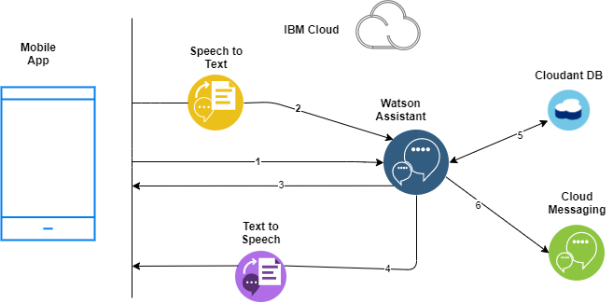**Proposed Technical Architecture:**